To: Rachel Richesson, Ph.D. <rachel.richesson@duke.edu>; Bob McCarter <RMcCarte@childrensnational.org>; Izem, Rima (rizem@childrensnational.org); Sreenath Nagamani, Sandesh Chakravarthy <nagamani@bcm.edu>; Eric Monson, Ph.D. <eric.monson@duke.edu>; Sigfried Gold <sigfried@sigfried.org>; Prajwal Vijendra <prajwal.vijendra@duke.edu>; Pedersen, Jay G <jay.pedersen@unmc.edu>

Regarding UCD team meeting, May 21, 2020

Hello Everyone,

During our meeting on Thursday, we were a bit puzzled as to why ARG disappeared from the graph when we expanded the motor dysfunction (MD) concept. Recall that prior to expanding MD, we had something like this:

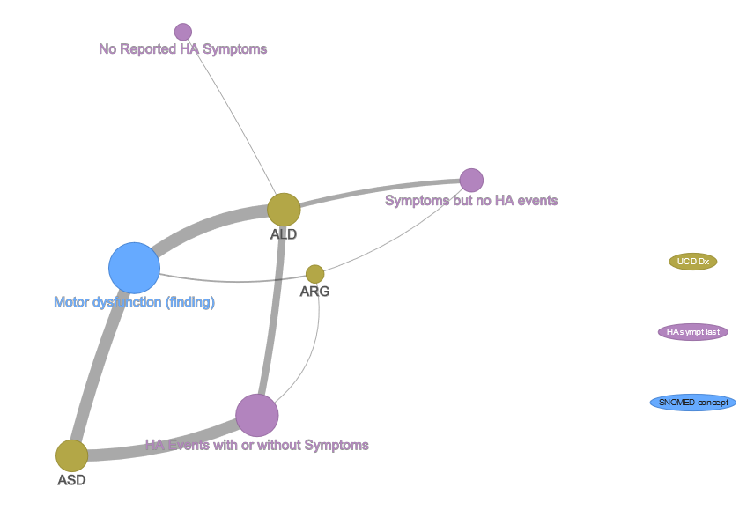

Because there is an edge from ARG to MD, we would expect to see ARG connected to at least one child concept of MD after expansion. But, we actually saw something like this:

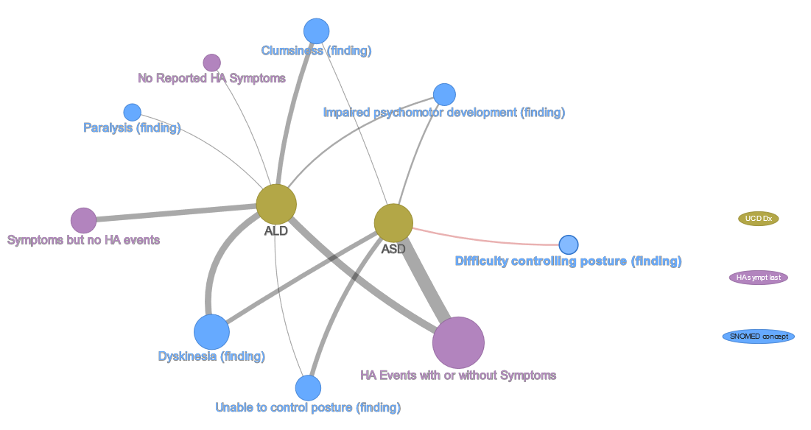

ARG is missing, which is incorrect. The cause of this was a new feature that filters prescriptions. Unfortunately, I had implemented this such that only nodes with edges to the specified prescriptions are retained, even if prescriptions do not appear as nodes. The astute observer will recall that I had two prescriptions specified (actually, we need only specify leading characters): arg (for arginine derivatives) and something else I do not recall (I will use asp, for aspirin, here). These appeared in the “Rx leading character filter” prompt:

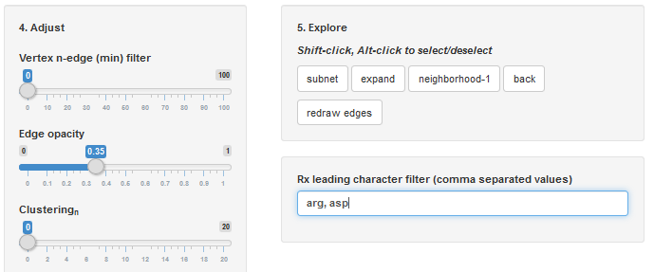

Since, as we will see, Dx ARG has no participants with prescription beginning in either “arg” or “asp” it was omitted after subnetting. I corrected the logic and, now, prescription filters are applied only when they are selected in one of the connection radio button groups as, for example, here, where we instruct to display prescription nodes connected to Dx:

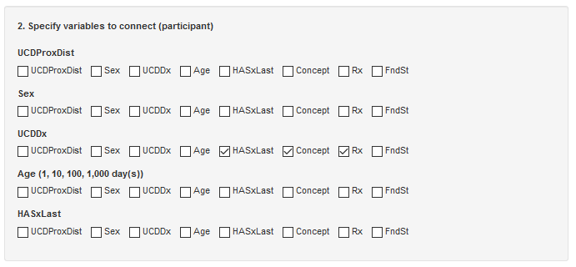

By selecting the ASD, ALD, ARG, and “Motor dysfunction” nodes as here:

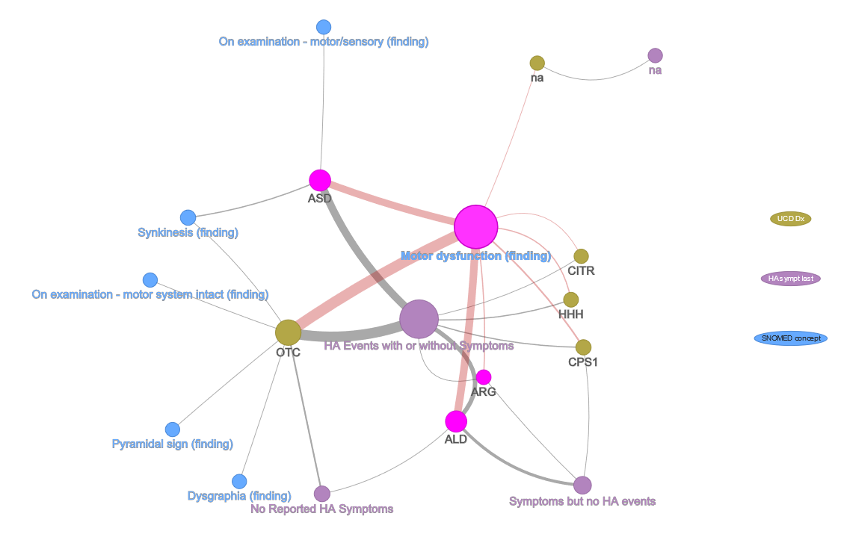

and clicking expand:



gives something more like what we expected during our meeting:

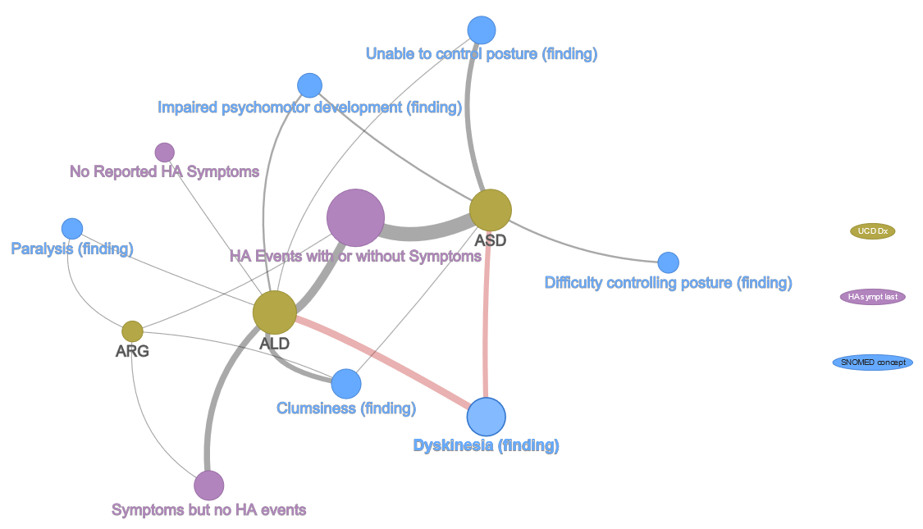

Here, we see ARG associated with paralysis, clumsiness, and “HA symptoms but no events” (note that the n for ARG is two, which is a small sample) and ASD associated with a single HA level (HA events with or without symptoms) as discussed on Thursday.

After reviewing the previous graph, I decided to add edges between HA and concepts, so that all pair-wise relationships between the three variables (Dx, HA, and concept) are visible. Result:

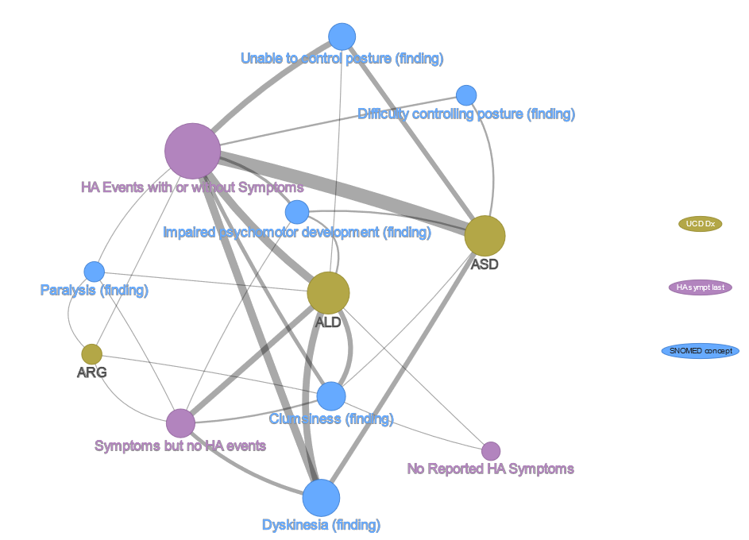

This is a bit busy, so I decided to align nodes linearly to see if patterns become apparent between variables and levels. Result:

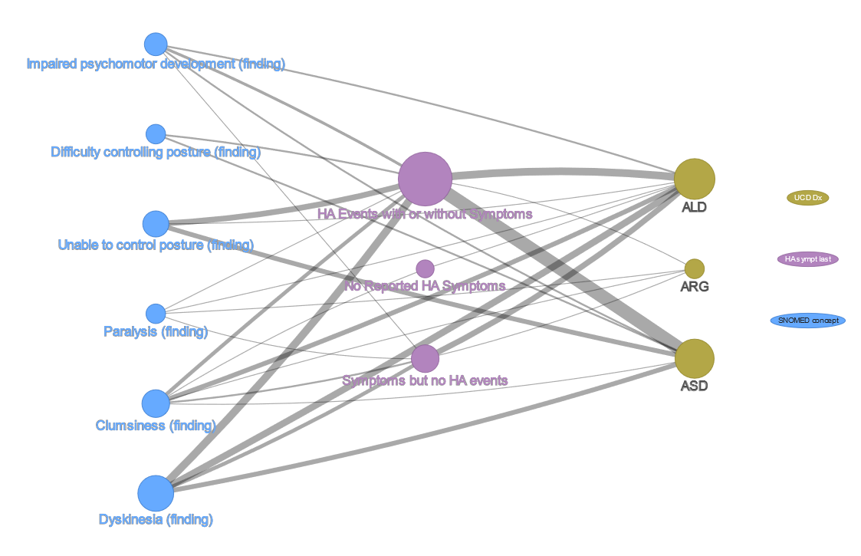

Here, we see relationships, for instance, between ALD, two HA levels, and dyskinesia, but we do not know, from the graph, what proportion of the HA-dyskinesia relationship is due to ALD. To examine this, I first omitted the Dx to concept edges:

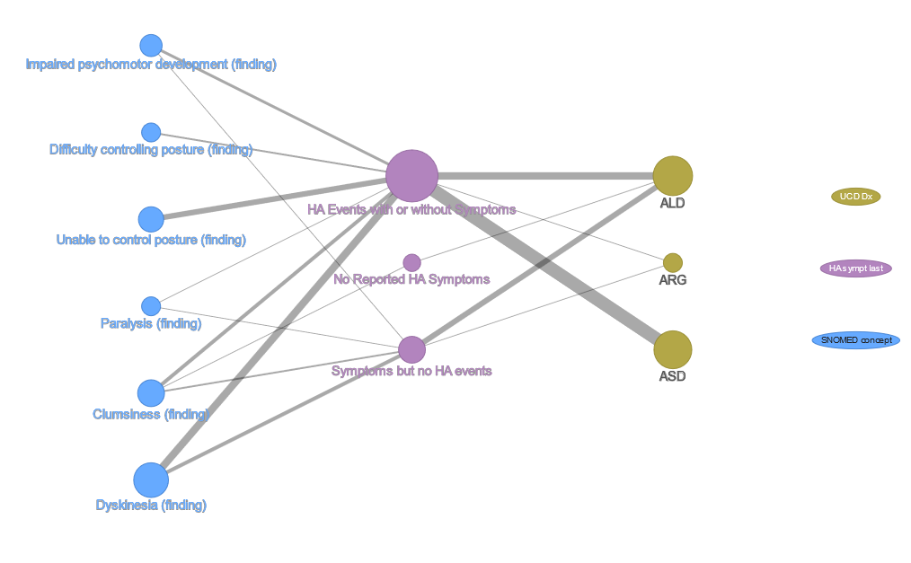

This is a bit cleaner and, although no information is available for Dx to concept relationships, we do see how Dx and concept are related to a third, common variable (HA).

Next, I combined Dx and HA (interaction):

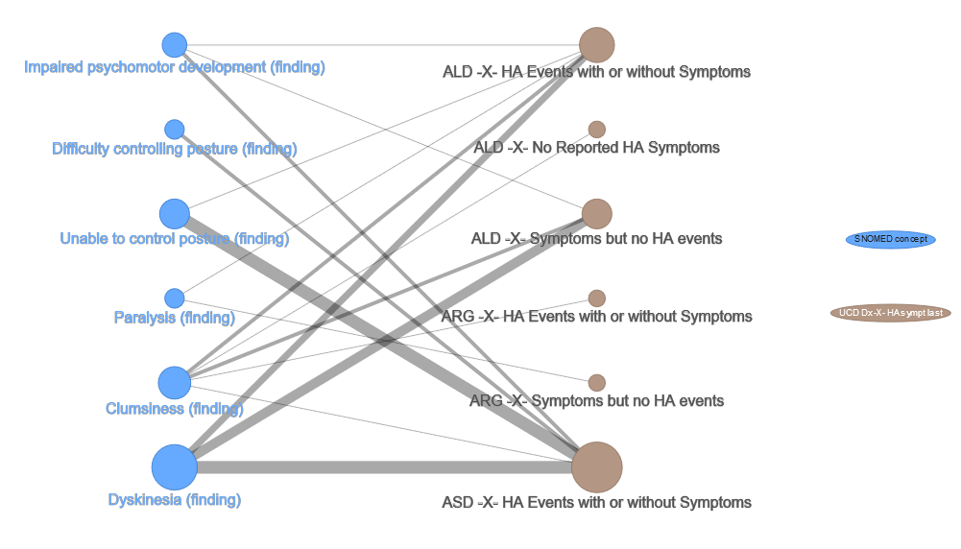

We see that two levels of ALD-HA are associated with dyskinesia (“HA events with or without symptoms” and “Symptoms but no HA events”), a third is not. Also, although ALD combined with “Symptoms but no HA events” has fewer participants than does ALD with “HA events with or without symptoms,” (its bubble is smaller) it has greater representation in dyskinesia than does ALD with “HA with or without symptoms.” I am not sure whether this is medically significant, but it is what our data report. Also, as expected, ASD is combined with only one HA level (“events with or without symptoms”) and represents nearly all of “Unable to control posture” concept observations.

Adding prescriptions to the previous graph gives:

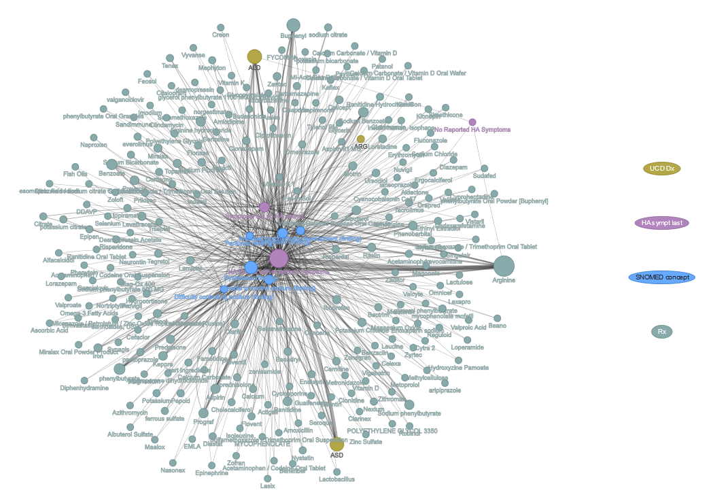

which is a bit noisy. Filtering this by Arginine (the largest Rx node) and Aspirin (something I am familiar with) gives:

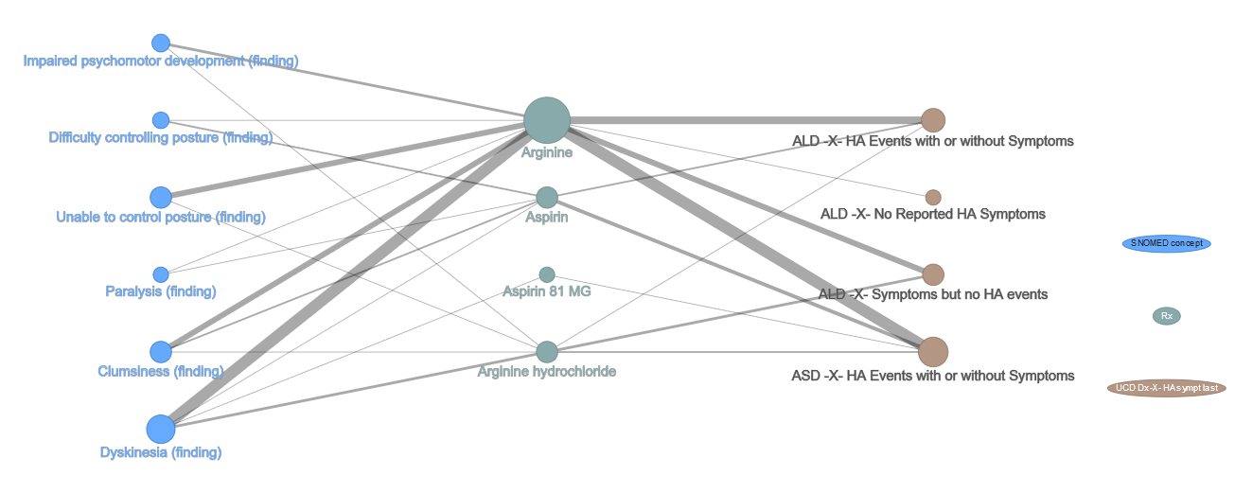

Two varieties of Arginine and two of Aspirin appear due to my leading character filter parameter of “arg, asp” which instructs to retrieve all prescriptions beginning in either “arg” or “asp.” We see that, in our study, Arginine is prescribed in all motor dysfunction concepts and Dx-HA combinations in this subset, but Aspirin is not. Further, in this subset, it appears that Aspirin is associated with participants with HA events. Finally, we can combine Dx, HA, and Rx, then relate those combinations to concepts. This is done by selecting the three variables to combine and specifying a connection to concept:

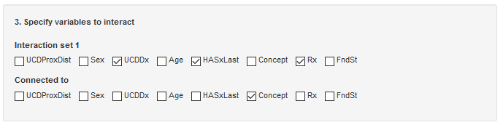

The result is:

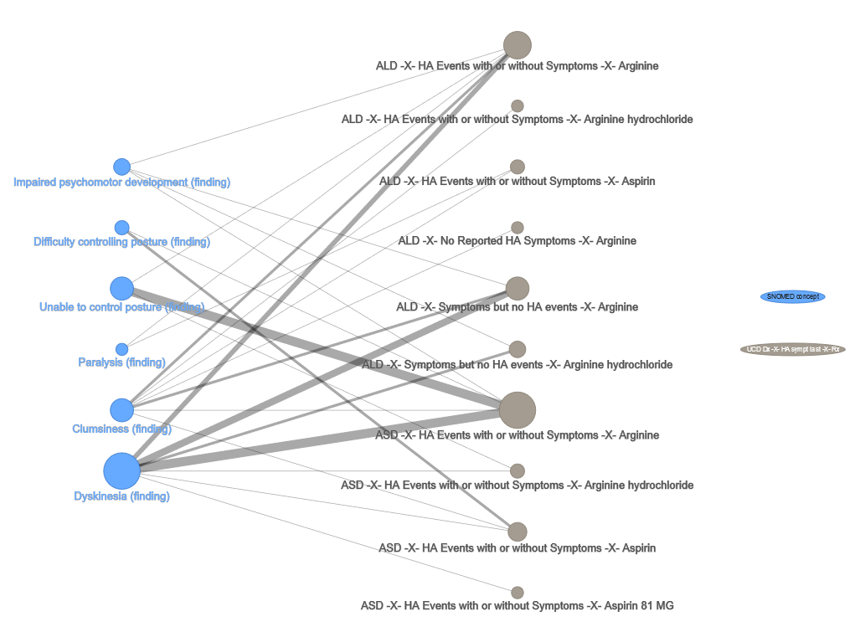

We see, for instance, that ASD with “HA events with or without symptoms” is primarily associated with Arginine, “Unable to control posture,” and “Dyskinesia.” Also, ASD with “HA events with or without symptoms” is the largest contributor to these two concepts. ALD with “HA events with or without symptoms” has a somewhat uniform association with motor dysfunction concepts.

Please comment on the approach I took here and offer any ideas you might have for exploring relationships and displaying results.

Thanks,

Tom