To: Rachel Richesson, Ph.D. <rachel.richesson@duke.edu>; Bob McCarter <RMcCarte@childrensnational.org>; Izem, Rima (rizem@childrensnational.org); Sreenath Nagamani, Sandesh Chakravarthy <nagamani@bcm.edu>; Eric Monson, Ph.D. <eric.monson@duke.edu>; Sigfried Gold <sigfried@sigfried.org>; Prajwal Vijendra <prajwal.vijendra@duke.edu>; Pedersen, Jay G <jay.pedersen@unmc.edu>

Regarding UCD team meeting, May 8, 2020

Hello Everyone,

I would like to follow our meeting yesterday with an example set of graphs. During the meeting, I had a bit of trouble drilling into subsets of observations, especially when combining variables (assessing interactions). After some thought, I realized that displaying a graph with main variables (no interactions), filtering, adding interactions, then removing main variables is easier than displaying interactions involving all levels, then selecting just those we are interested in. Following is an example.

Say we are interested in combining UCDDx (ASD and ALD) and hyper-ammonemia and want to relate those groups to SNOMED concepts.

1. Query motor nervous system findings:

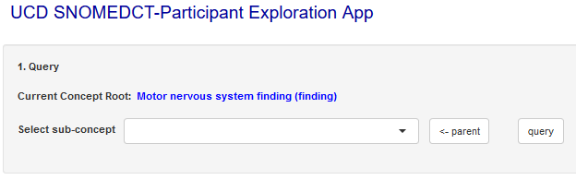

2. Select primary variables involved (here, we instruct to make UCDDx, HA, and concept nodes then make edges from UCDDx to HA and concepts:

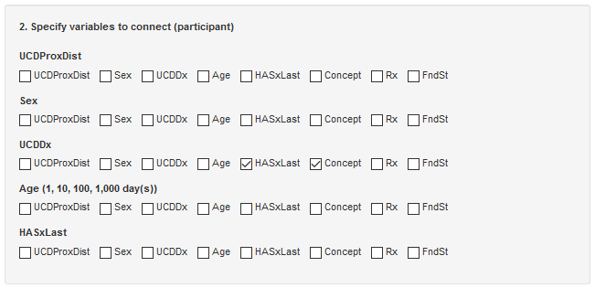

Result:

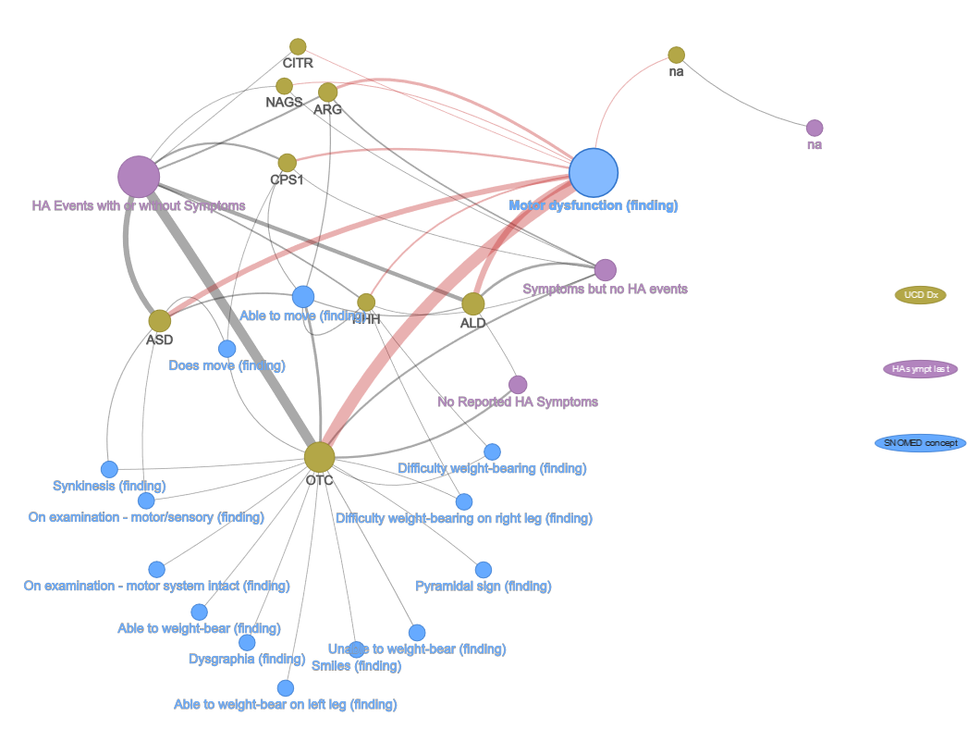

3. Select the ASD and ALD nodes:

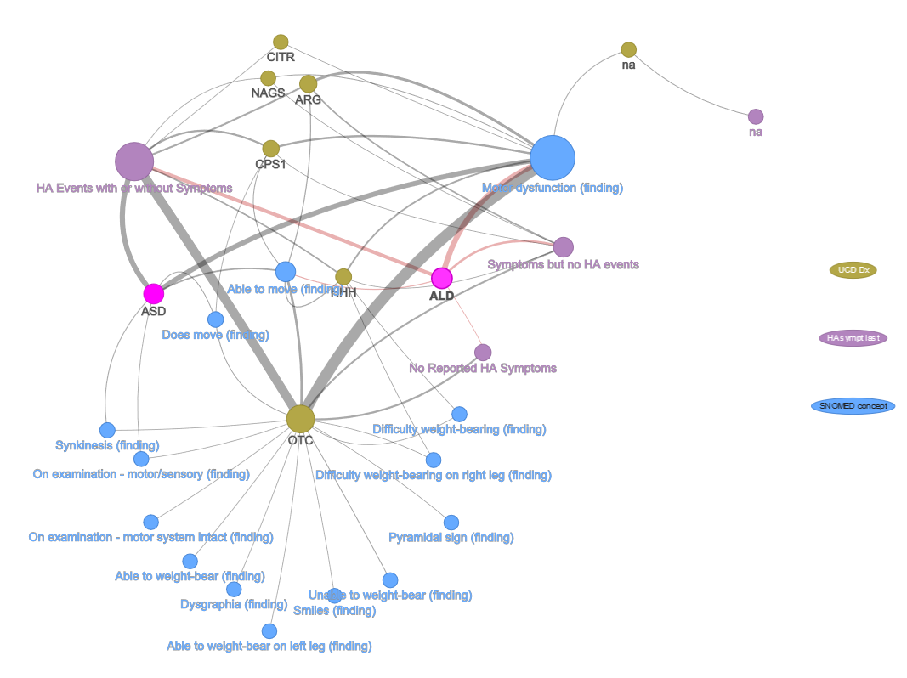

4. Subset (subnet?):

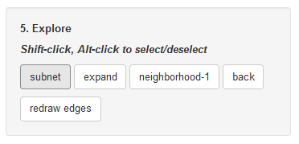

Result: Our selection includes only ASD and ALD but, because the current configuration continues to include HA and concepts, the related HA and concept nodes are retained, along with edges to UCDDx:

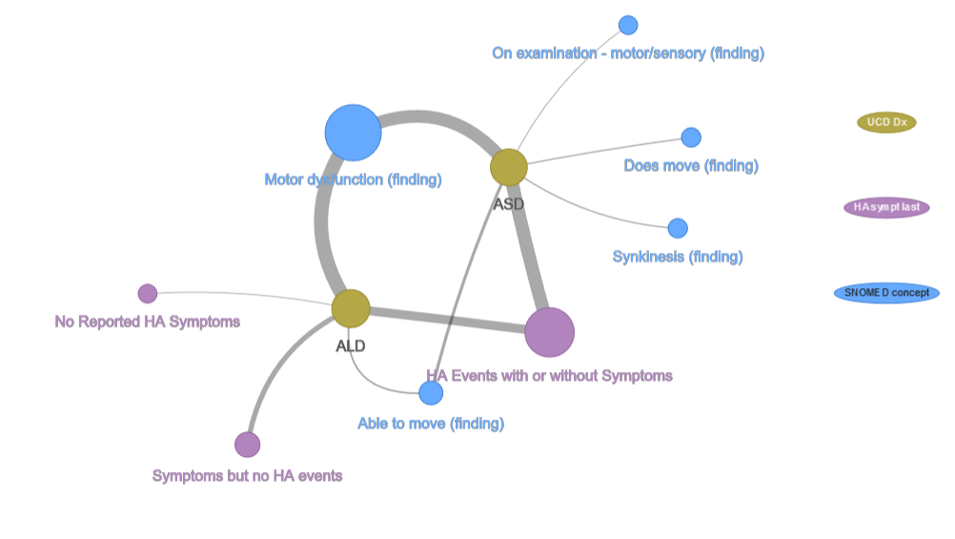

5. Include interactions (combine UCDDx and HA levels, connect to concept):

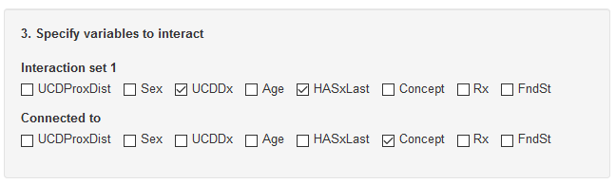

Result:

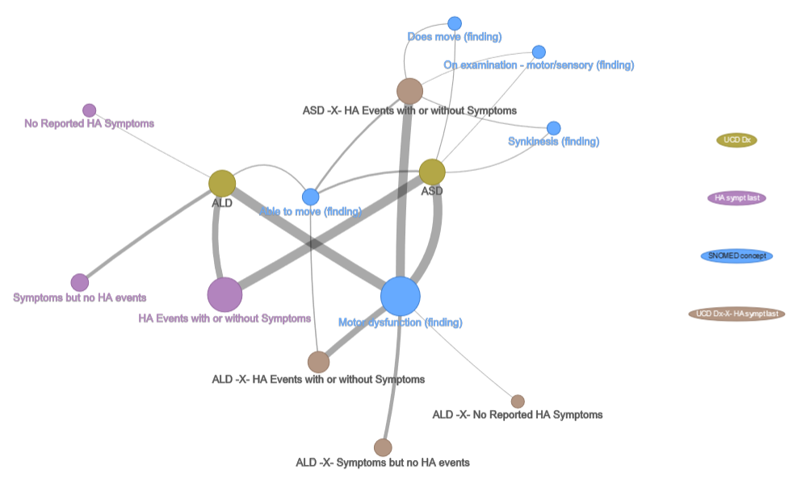

6. Remove primary variable configuration:

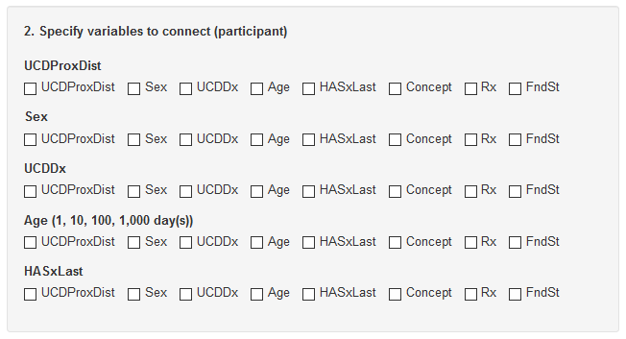

Result:

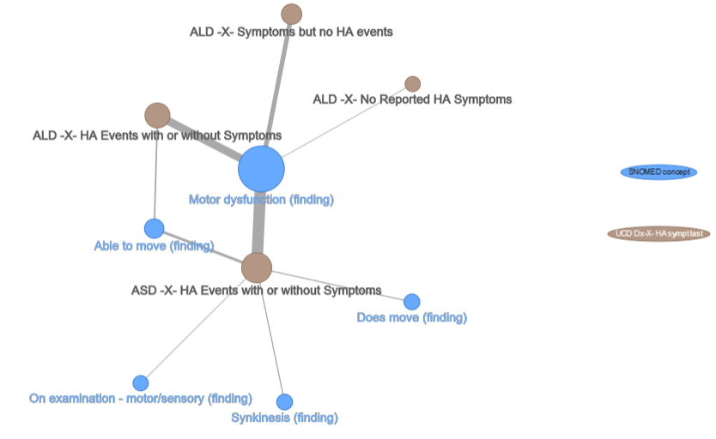

7. Finally, select motor dysfunction and expand:

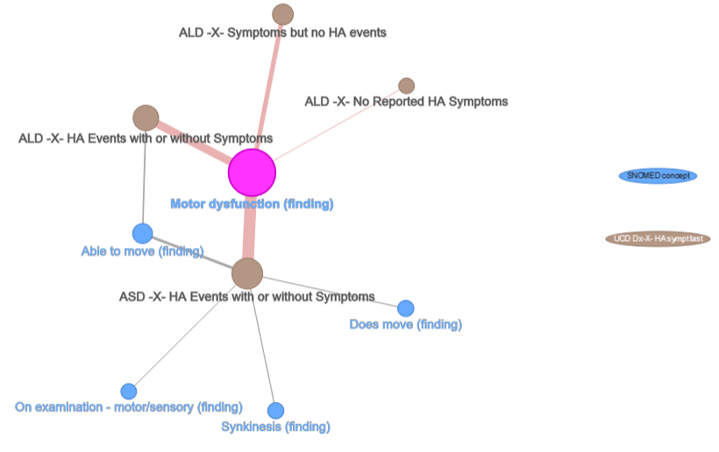

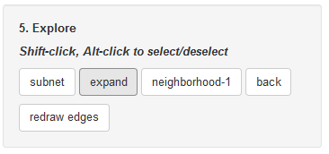

Result:

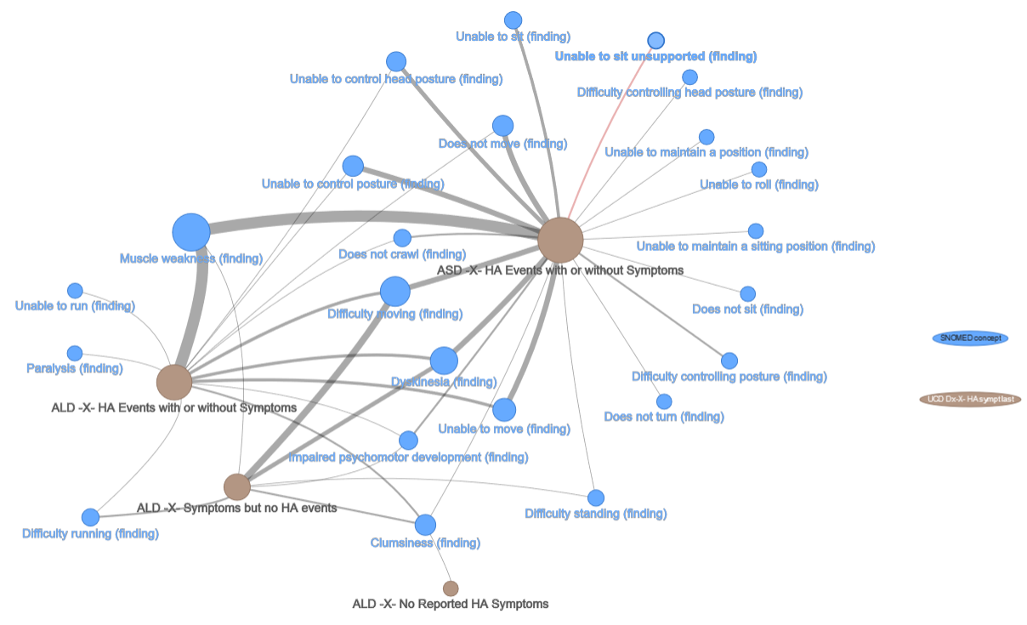

Notice that, because “motor dysfunction” was the only concept selected, “able to move,” “does not move,” “on examination,” and “synkinesis” are not retained (selecting them would have included their expanded children sets also). As expected, edge widths prior to expansion correlate with edge width after. The edge between “ASD-X-HA-events with or without symptoms” to “motor dysfunction” is heavy prior to expansion and shows the greatest activity afterward. “ALD-X-HA no reported symptoms” has a light relationship to “motor dysfunction” prior to expansion and is related to a single concept afterward (clumsiness).

I hope that the expansion feature is what the team (especially Bob and Rima) have in mind. The combining of variables (interactions) is motivated by Eric’s comments. Following are three graphs that layer on finding sites (Rachel seems especially interested in these) and Rx. Prescriptions add a lot of noise because there are so many. One option is to restrict Rx to a minimum frequency. The third plot, below, is a variation on a dendrogram (edge bundled) that includes only the highest frequency prescriptions. Creating an interactive version of the dendrogram, where hover actions highlight connecting lines, might reveal contrasts that are not apparent in a static plot. For instance, there appears to be an association between “HA events with or without symptoms,” Difficulty moving,” and “Arginine.” An interesting question is whether the association is stronger in either of ASD or ALD. Alternately highlighting connections to ASD and ALD might reveal something. Also, because ASD and ALD have different participant counts (dot size), scaling to proportion observations might be useful. Of course, then we are effectively sampling and might consider including some sort of confidence statement, bounds, etc.

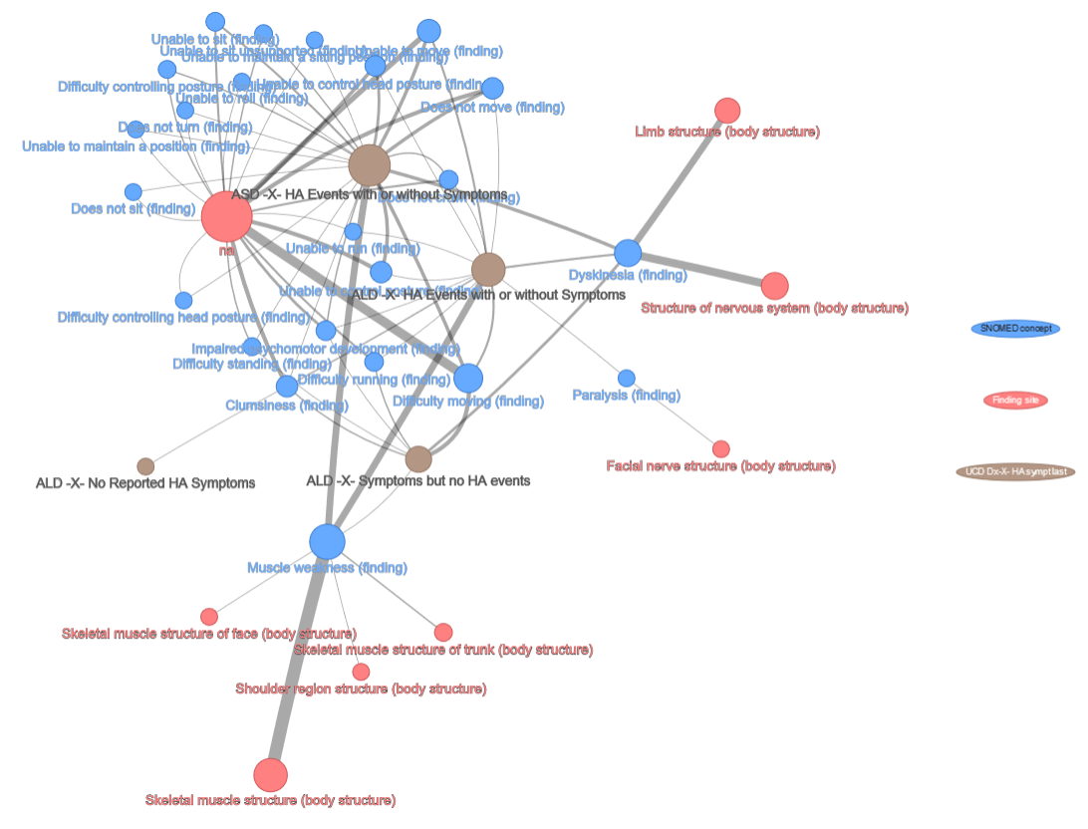

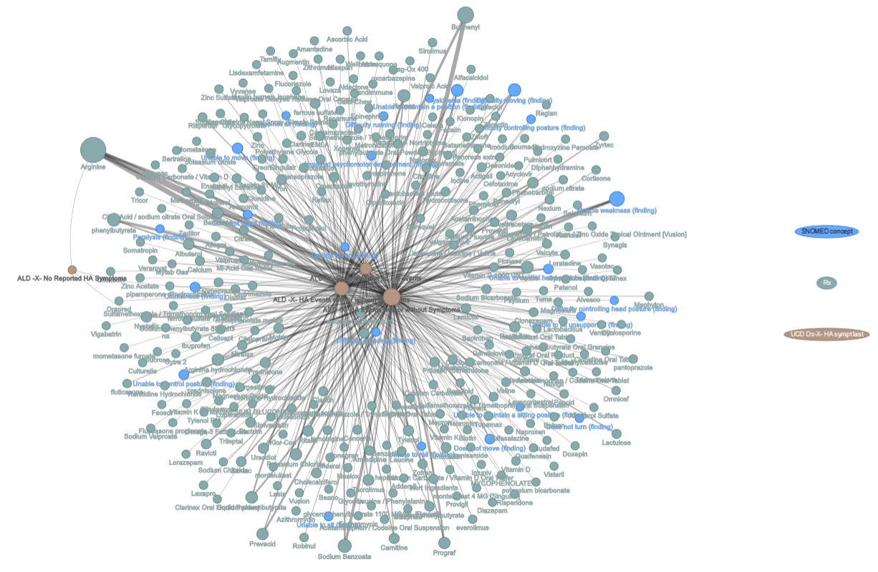

Please comment on the approach I took here and offer any ideas you might have for using the interface, combining and subsetting observations, and displaying results.

Thanks,

Tom