Hi, everyone. Just a few ideas and SNOMED background for the meeting on Wednesday….

There are different sources of mappings between ICD 9 and 10 and SNOMED CT, but the process of moving between the coding system is not straightforward due to the fact that they are structured and conceptually organized in very different ways (so there is no easy 1:1 translation or mapping between the coding systems). One big difference between SNOMED and ICD is that SNOMED codes can have multiple “parent” codes but ICD is a strict classification and therefor a code can fit into one and only one parent category. A good example is Conduct Disorder.

In ICD, Conduct Disorder is classified/can be found using this path: Mental and Behavioural disorders à Behavioural and emotional disorders with onset usually occurring in childhood and adolescence (F90-F98) à Conduct disorder (F91) à …various types (socialized, unsocialized, etc)

But in SNOMED CT, conduct disorder has at least 2 paths through 2 different high-level parents: mental disorder and developmental disorder:

Clinical Finding à Disease (disorder) à Mental disorder (disorder) à Neurodevelopmental disorder (disorder) à Developmental mental disorder (disorder) à Disruptive behavior disorder (disorder) à Conduct Disorder

Clinical Finding à Disease (disorder) à Developmental disorder (disorder) à Disruptive Behavior Disorder (disorder) à Conduct Disorder (disorder)

These different “paths” in SNOMED represent different ways we could aggregate the data.

Incidentally, in SNOMED, the concept ‘conduct disorder’ has 9 “child” concepts:
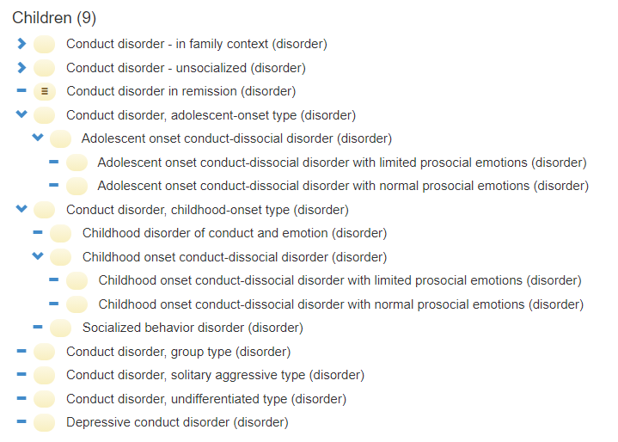

It is also important to note that a broader term Disruptive Behavior Disorder (disorder) has some other child concepts that you have expressed interest in:
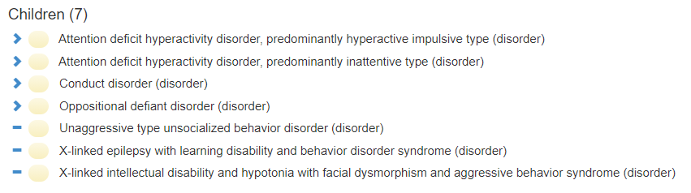

In theory, the UCD research staff could have used any of these detailed or broader codes when coding data for the UCD Natural History Study, but we have to look at the data to see what we find in practice. Anecdotally, I have seen very detailed concepts and very broad concepts in the data. (My gut tells me that most coders choose the easiest and often a broad code, rather than spending a lot of time searching for a detailed code in a busy research visit…) With that said, one potential benefit of SNOMED (that I hope we can demonstrate together) is that we can choose the right level of semantic detail (i.e. code) based on the number of records we have in the data. Even if we go to broader concepts to make bigger groups for analysis, we are not really losing data – we might lose detail but we can keep the concepts. I think finding that right level of semantic detail requires both clinical and data science expertise, and I am thrilled that we have a team that includes both.

Tom and I will be prepared to explore with you some of the specific SNOMED codes that seem to match the ICD groups you requested. As I have been preparing for this call, I had a revelation. Since our data in this particular dataset is natively coded in SNOMED (rather than ICD), it may add un-necessary complication to translate large numbers of ICD codes into SNOMED CT. I am thinking it might be more efficient if we navigate SNOMED to find the parent concepts of interest there, and then explore them in the context of the data with Tom’s tool. I can show the SNOMED structure on our call to show you how it is organized. (Note: If you are linking to EHR or claims data, there might be value in the use of ICD codes to create SNOMED queries, and perhaps we can discuss this strategy on Wednesday.)

This is not necessary for the call, but if you get a chance and have interest, you can explore SNOMED through this free online browser here: https://browser.ihtsdotools.org/
Select “Go Browsing - International edition”. Once you are there, you can either browse or search. To BROWSE (recommended), choose the “Taxonomy” tab on the far left to navigate the trees structure of SNOMED. You will see the highest lever SNOMED categories. Explore “Clinical Finding” à “Diseases and Disorders” and you can keep expanding to go into more detail. Mental Health Disorders will be of primary interest given your questions.
Other paths you might explore are:
Clinical finding (finding) à Neurological finding
Clinical finding (finding) à Finding of movement (finding) à Motor dysfunction (finding)

If you care to contrast with ICD-10, I use the WHO browser: https://icd.who.int/browse10/2019/en#

Regardless of any preparation you get to do with SNOMED, Tom and I will be prepared to share his latest version of the tool and explore the areas you requested. Some brief information on the tool itself is attached if you are interested. We look forward to a interactive discussion on Wednesday afternoon!

Thanks,
Rachel

From: Sreenath Nagamani, Sandesh Chakravarthy <nagamani@bcm.edu>
Sent: Monday, August 31, 2020 10:02 AM
To: Rachel Richesson, Ph.D. <rachel.richesson@duke.edu>; Yesso, Abigail Marie <Abigail.Yesso@bcm.edu>
Cc: Burrage, Lindsay <burrage@bcm.edu>; Tom Balmat <thomas.balmat@duke.edu>; Bob McCarter <RMcCarte@childrensnational.org>; Izem, Rima (rizem@childrensnational.org) <rizem@childrensnational.org>
Subject: Re: UCDC neuropsychiatric disorders project

Dear Rachel, Bob, and Rima
Just circling back to see whether this time works for all – I don’t think we got a zoom invite. We are happy to set up the same as well if that helps.
Many thanks for your help on the project.

Best regards,

Sandesh C S Nagamani, MD
Associate Professor
Director of Clinical Research, Molecular and Human Genetics
Baylor College of Medicine,
One Baylor Plaza MS 227, R812
Houston, TX 77030
Phone: 713-798-8335
Fax: 713-798-5168
https://www.bcm.edu/people/view/b22371a1-ffed-11e2-be68-080027880ca6

From: "Rachel Richesson, Ph.D." <rachel.richesson@duke.edu>
Date: Wednesday, August 26, 2020 at 9:08 PM
To: "Yesso, Abigail Marie" <Abigail.Yesso@bcm.edu>, "Sreenath Nagamani, Sandesh Chakravarthy" <nagamani@bcm.edu>
Cc: "Burrage, Lindsay" <burrage@bcm.edu>, Tom Balmat <thomas.balmat@duke.edu>, Robert McCarter <RMcCarte@childrensnational.org>, "Izem, Rima (rizem@childrensnational.org)" <rizem@childrensnational.org>
Subject: RE: UCDC neuropsychiatric disorders project

Thanks, Abby.
That time on Sept 2 will work for Tom and me, and I have put a hold on our calendars.
Bob and Rima –
Can one or both of you make this time?

Once we set the time, I can send a Zoom meeting invite and we can offer others on the them to join and listen if they wish.
This is exciting – thanks for making the time on your calendars to help evaluate and improve this tool!
Thanks,
Rachel

From: Yesso, Abigail Marie <Abigail.Yesso@bcm.edu>
Sent: Wednesday, August 26, 2020 6:52 PM
To: Rachel Richesson, Ph.D. <rachel.richesson@duke.edu>; Sreenath Nagamani, Sandesh Chakravarthy <nagamani@bcm.edu>
Cc: Burrage, Lindsay <burrage@bcm.edu>; Tom Balmat <thomas.balmat@duke.edu>; Bob McCarter <RMcCarte@childrensnational.org>; Izem, Rima (rizem@childrensnational.org) <rizem@childrensnational.org>
Subject: Re: UCDC neuropsychiatric disorders project

Dear Rachel,

Thank you for your email. Dr. Burrage, Dr. Nagamani, and I appear to have some availability on Wednesday, September 2nd. Would a call at 3:00 pm CST work for your schedule? If not, we should have some flexibility in our schedules for another time that day.

Best,
Abby
Abigail Yesso, MS
Genetic Counseling Intern II

Baylor College of Medicine
School of Health Professions

Program: 713.798.5400
Email: abigail.yesso@bcm.edu

www.bcm.edu/gcp

From: Rachel Richesson, Ph.D. <rachel.richesson@duke.edu>
Sent: Wednesday, August 26, 2020 11:54 AM
To: Sreenath Nagamani, Sandesh Chakravarthy <nagamani@bcm.edu>
Cc: Burrage, Lindsay <burrage@bcm.edu>; Yesso, Abigail Marie <Abigail.Yesso@bcm.edu>; Tom Balmat <thomas.balmat@duke.edu>; Bob McCarter <RMcCarte@childrensnational.org>; Izem, Rima (rizem@childrensnational.org) <rizem@childrensnational.org>
Subject: RE: UCDC neuropsychiatric disorders project

Woops! Now copying Tom, Bob, and Rima to keep them in the loop as they will be important for the call.

Thanks,
Rachel

From: Rachel Richesson, Ph.D. <rachel.richesson@duke.edu>
Sent: Wednesday, August 26, 2020 12:53 PM
To: Sreenath Nagamani, Sandesh Chakravarthy <nagamani@bcm.edu>
Cc: Burrage, Lindsay <burrage@bcm.edu>; Yesso, Abigail Marie <Abigail.Yesso@bcm.edu>
Subject: RE: UCDC neuropsychiatric disorders project

Hi, Sandesh and Abigail –

Again – sorry for my delays on this request. I am in process of transitioning from Duke to the University of Michigan and am just getting my family settled in Ann Arbor. Despite that business, I am interested in your question as it presents the opportunity to do one more last test case with Tom’s data visualization tool that we can describe in a journal article and share with potential future sponsors.

I can come up with the parent SNOMED codes you are requesting below and we can explore them with the UCD data together on a call if you are willing. At the same time, we can test out some of the new features Tom has been implementing (including side-by-side view to compare 2 different diseases/groups at a time).

I think your schedule will be the most challenging to accommodate. Can you tell me a couple of days and times in the next 1-2 weeks that might be convenient, and I can pull other schedules to get a call set-up.

Thanks,
Rachel

p.s.. - Copying Tom, Bob, and Rima to keep them in the loop as they will be important for the call.

From: Sreenath Nagamani, Sandesh Chakravarthy <nagamani@bcm.edu>
Sent: Friday, August 21, 2020 3:36 PM
To: Rachel Richesson, Ph.D. <rachel.richesson@duke.edu>
Cc: Burrage, Lindsay <burrage@bcm.edu>; Yesso, Abigail Marie <Abigail.Yesso@bcm.edu>
Subject: Re: UCDC neuropsychiatric disorders project

Dear Rachel,
Hope you are doing well. I am circling back to you regarding this. Thanks much for your help.

Best regards,

Sandesh C S Nagamani, MD
Associate Professor
Director of Clinical Research, Molecular and Human Genetics
Baylor College of Medicine,
One Baylor Plaza MS 227, R812
Houston, TX 77030
Phone: 713-798-8335
Fax: 713-798-5168
https://www.bcm.edu/people/view/b22371a1-ffed-11e2-be68-080027880ca6

From: "Rachel Richesson, Ph.D." <rachel.richesson@duke.edu>
Date: Tuesday, July 21, 2020 at 11:06 AM
To: "Sreenath Nagamani, Sandesh Chakravarthy" <nagamani@bcm.edu>
Cc: "Burrage, Lindsay" <burrage@bcm.edu>, "Yesso, Abigail Marie" <Abigail.Yesso@bcm.edu>
Subject: RE: UCDC neuropsychiatric disorders project

***CAUTION:*** This email is not from a BCM Source. Only click links or open attachments you know are safe.

Apologies for my slow reply. I have been absorbed in another project but will look into this and respond again soon. Looks interesting!
Thanks for your patience,
Rachel

From: Sreenath Nagamani, Sandesh Chakravarthy <nagamani@bcm.edu>
Sent: Thursday, July 16, 2020 11:45 AM
To: Rachel Richesson, Ph.D. <rachel.richesson@duke.edu>
Cc: Burrage, Lindsay <burrage@bcm.edu>; Yesso, Abigail Marie <Abigail.Yesso@bcm.edu>
Subject: UCDC neuropsychiatric disorders project

Dear Rachel,
I hope that you are doing well and staying safe. I am reaching out to you regarding the neuropsychiatric disease in Urea Cycle disorders. We ahve briefly spoken about this. This project is a Master’s Degree Thesis project for Abigail Yesso who is a student in the Genetic counseling program at BCM. While we are looking at the data in multiple ways, we also wanted to identify whether we could pull some of the data using the SNOMED codes form the Graph database that Bob has generated. We wanted to request your group’s help in identifying a board SNOMED code that would help identify specific class of psychiatric diseases highlighted in yellow. Thank you for your help and support.

SNOMED codes that can be mapped to ICD-10 codes for diagnosis of mood disorder: F30, F31, F32, F33, F34, F39 Yes/NO ICD-10 code
SNOMED codes that can be mapped to ICD-10 codes for diagnosis of behavior, conduct, personality disorder: F07, F90, F91, F60, F93 Yes/NO ICD-10 code
SNOMED codes that can be mapped to ICD-10 codes for diagnosis of dementia disorder: F01, F02, F03, F04, F05 Yes/NO ICD-10 code
SNOMED codes that can be mapped to ICD-10 codes for diagnosis of delusional/psychoses disorder: F20, F21, F22, F23, F24, F25, F28, F29 Yes/NO ICD-10 code
SNOMED codes that can be mapped to ICD-10 codes for diagnosis of anxiety/obsessive/impulse control disorder: F40, F41, F42, F43, F44, F59, F63, F95 Yes/NO ICD-10 code
SNOMED codes that can be mapped to ICD-10 codes for diagnosis of intellectual disability/developmental delay: F70, F71, F72, F73, F78, F79, F80, F81, F82, F84, F88, F89 Yes/NO ICD-10 code
SNOMED codes that can be mapped to ICD-10 codes for diagnosis of other neuropsychiatric disorders: F06, F09, F45, F48, F50, F54, F68, F69, F94, F98 Yes/NO ICD-10 code

Best regards,

Sandesh C S Nagamani, MD
Associate Professor
Director of Clinical Research, Molecular and Human Genetics
Baylor College of Medicine,
One Baylor Plaza MS 227, R812
Houston, TX 77030
Phone: 713-798-8335
Fax: 713-798-5168
https://www.bcm.edu/people/view/b22371a1-ffed-11e2-be68-080027880ca6

