Name: ___________________________________________

Quiz #1 (Lectures 1-6)

1. For batch reactors we have used the equation below to the left, while we use the one on the right for CSTRs. What is the difference? Why can’t we just use one equation for both?
$$C\left(t\right)=C_{0}e^{-kt}$$ | $$C\left(t\right)=C_{0}e^{-λt}$$

2. Steady-state vs. time-variable solutions
a. What is meant by steady-state? When is this a good assumption to make?

b. Provide one example of a case that you would use a time-variable solution?

3. A proposed factory will discharge a waste stream of 0.1 m³/s (or 8640 m³/day) of water to a nearby river. Discharge from the factory contains 5000 g/m³ of ‘Hoosiercide’ (a dissolved and reactive chemical that I’ve made up!). Velocity in the river is 2,000 m/day downstream of the factory. The concentration in the river at cannot exceed 0.2 g/m³ at the point where the drinking water treatment plant withdraws water 10-km downstream of the factory. Hoosiercide undergoes first-order decay at a rate of 1/day in the treatment pond, and 0.1/day in the river.
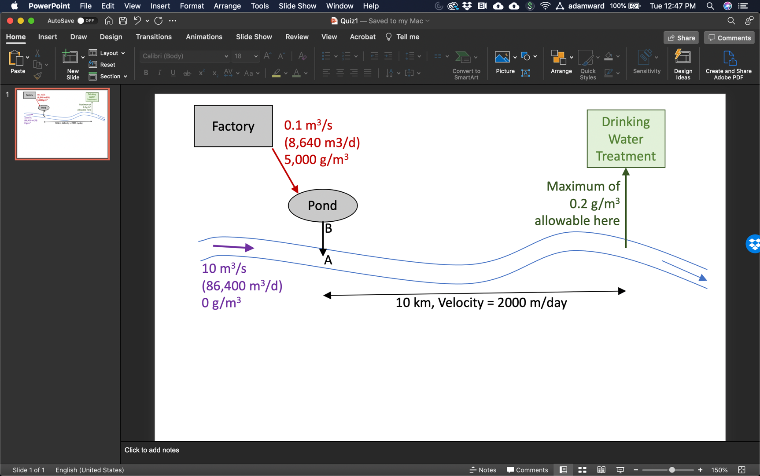

a. To meet the concentration limit at the drinking water intake, what is the highest concentration 10-km upstream when the river and effluent from the pond have mixed? In other words, what is the maximum allowable concentration of Hoosiercide in the river at Point A in the figure above?

b. What is the maximum concentration that can flow out of the treatment pond and into the river? (i.e., find concentration at point B in the figure that achieves your desired well-mixed stream concentration calculated at point A)

c. What volume of treatment pond is required to meet the concentration you calculated in part B?

d. Your client wants to use less space on the property for wastewater treatment. What are TWO possible options to implement that could meet this objective?

Option 1:

Option 2:

