Name: ___________________________________________

Quiz #4 (Lectures 15-18)

1. Conceptual function of Wastewater Treatment Plant
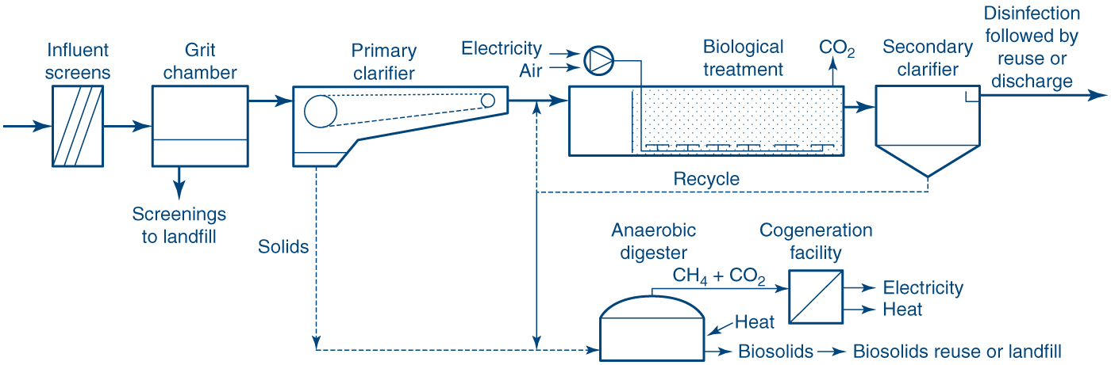
Pictured above is a schematic typical wastewater treatment plant. Below, please explain the purpose of each unit process in a few sentences and plain language. No equations allowed. Your answers should convey that you understand the purpose or function of each unit process:

1a: Aeration basin (labeled ‘biological treatment’ in the image above)

1b: Secondary Clarifier

1c: Anaerobic Digester

2. At Indiana University, the population of about 44,000 students (in a non-COVID year) generate wastewater at a rate of about 0.57 m³ per person per day. Wastewater has a typical concentration of 240 g TSS/m³. In this problem we will analyze the energy potential in this waste stream.

A. What is the mass rate of TSS arriving at the wastewater treatment plant each day? (kg TSS/d)

B. Using a quantitative flow diagram approach (Lecture 18), what is the mass rate arriving at the anaerobic digester each day? (kg TSS/d)

C. Assume 35% of the mass arriving at the anaerobic digester is converted to gas, and the produced gas contains 65% CH₄. What mass rate of CH₄ is produced? (kg/d)

D. Methane contains about 10.3 kW-hr per m³ of total energy. Of this, about 25% can be recovered as electrical energy after combustion. What is the electrical energy that could be produced from digesting sludge generated by IU students? (kW-hr / d)

E. Methane contains about 39 MJ/m³ of total energy. If this energy is released in the form of heat, what volume of water could be heated from 20 deg-C to 100 deg-C by burning the methane produced? (m³/d)

F. The electrical generation potential (part D) represents about 0.52% of IU’s electrical use on a typical day. The heat generation (part E) represents about 2.6% of IU’s peak demand for steam to heat and cool campus buildings. In your opinion, would it be logical for IU to invest in operating a WWTP to recover this energy for on-campus use? Why or why not? (no wrong answers, just provide your opinion and rationale).

