17/07/2017
Tutorial Sigma Toolbox
Data Visualisation
BCI Team
ESPCI Paris

Table des matières
Filtering the signal : 4
Single time selection : 5
3D potential mapping 5
2D potential Mapping 6
Electrodes 6
Period of time selection: 7
The potential mapping : 8
The ERP matrix : 8
The power spectral density : 9
The Butterfly/GFD 10
The time-frequency diagram : 11
Bad channels /Channels of interest : 11
Source localization : 13

Basic Visualization
When you click on the « Visualize data » on the Sigma GUI, if your data are under the good format (the one the Sigma toolbox is using), it will open a GUI as this one below :
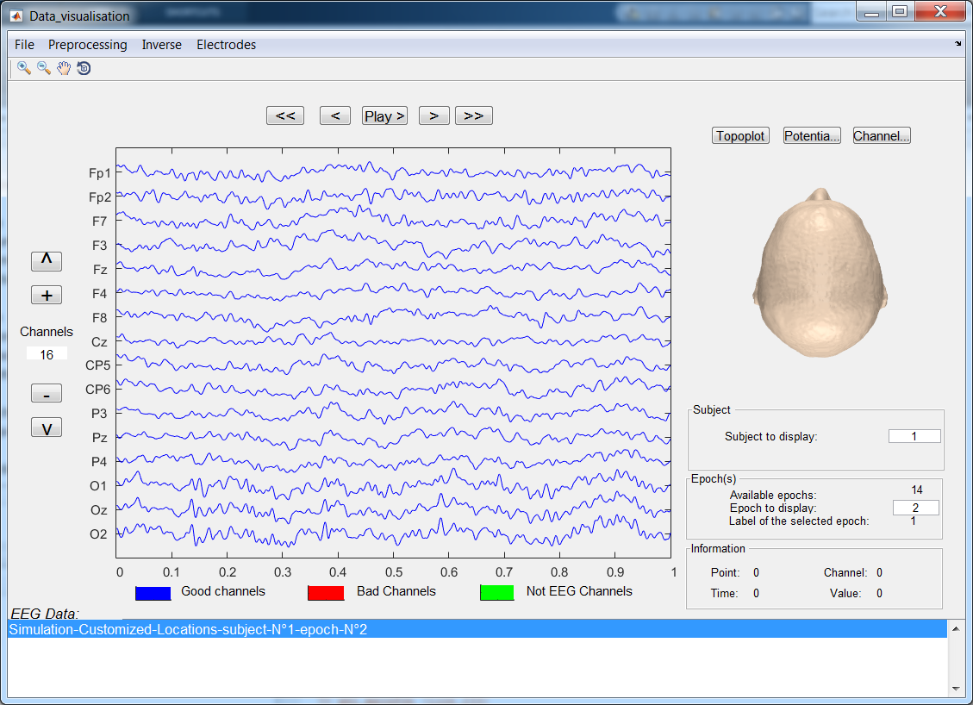
IMPORTANT : This part of the Sigma toolbox is based on the eConnectome and the EEGLab toolbox, for more information about the possibilities, visit their own website :
- http://econnectome.umn.edu/
- https://sccn.ucsd.edu/eeglab/index.php

This is the base window that shows up the first time before any user input. Only 1S of the signal is displayed at the same time by channel. You can navigate through the signal using the buttons at the top of the window :

« << » bring back the visualization to the first second of the signal.
« < » bring back the current time window 1S before.
« Play> » automatically navigate from the beginning to the end of the signal.
« > » bring back the current time window 1S after.
« >> » bring back the visualization to the last second of the signal.
Information about the signals are displayed in boxes below the scalp mapping. What you are visualizing at this moment is a single epoch from a single subject. But it possible if you have different subjects or epochs in your data to switch the current visualization to a different one by changing the subject or the epoch.

Changing the epoch will change the current visualization but this will remain the same file on the « EEG data » selection Menu:
- The graph will change to display the correct epoch.
- The name of the file will change to fit what is on screen.
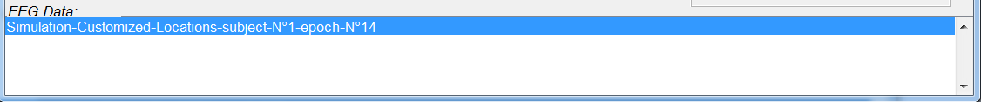
Changing the subject on the other hand, will open a new file on the « EEG data » selection Menu.
You can change the subject by either :
- Import a new EEG file.
- Change the number of the subject in the « subject » box.
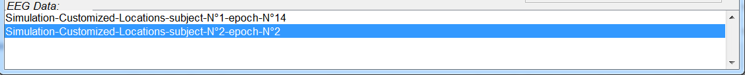
The highlighted file is the one currently being displayed, but this can be changed by double clicking on the desired file name on the « EEG data » selection Menu.

Filtering the signal :

By clicking on the « Preprocessing » menu, it opens the following window :
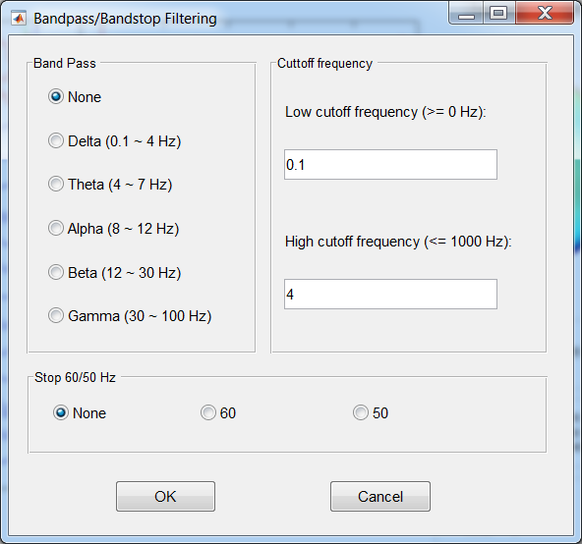
On this window, it is possible to filter the signal in order to get one of the different rhythms. The lower and the higher cutoff frequency are by default define to the generally acknowledged values. For those who want to personally define the cutoff frequency it is possible after selecting the desired band.
The user can also define a specific other cutoff frequency at 50 or 60 Hz, this done for example to reduce the effect of the electrical supply system effect on the signal.

Once all parameters of the preprocessing are defined and validated, the following window opens :
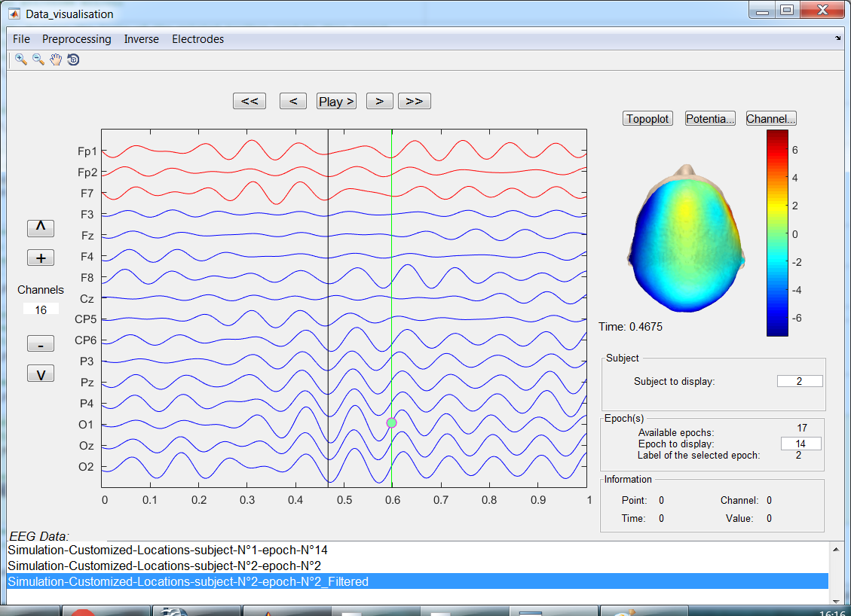
We can see that this option duplicate the original subject and create a new file on the « EEG data » selection Menu, so it is still possible to keep the original non-filtered signal.

Single time selection :

The green line on the signals represent where is the cursor pointing to. By right clicking on any time of the currently displayed signals, the window will now display the following window :

3D potential mapping

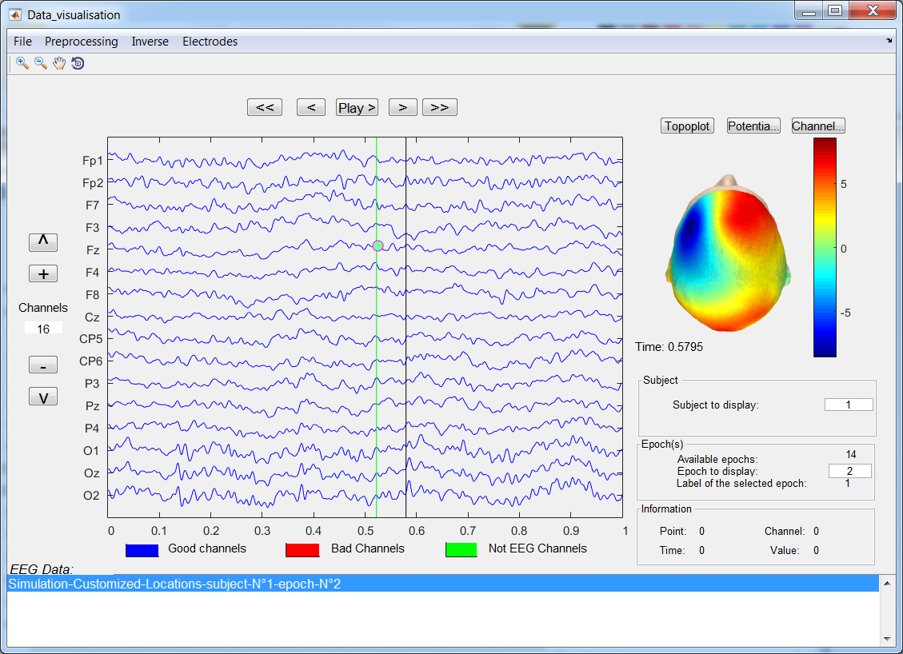
This display a new black line where the right click was performed corresponding to a certain time. In addition to that black line, the head is now updated in order to indicate to the user an estimation of the scalp potential mapping.

If you want this scalp mapping to be in 2D rather than 3D, the « topoplot » button can access the time corresponding to the black line to perform the 2D spatial representation of the potential on the scalp.

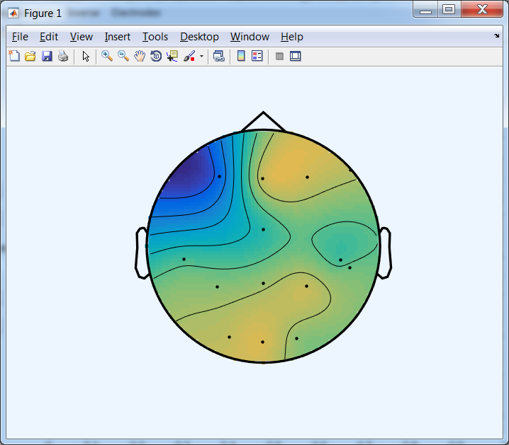
2D potential Mapping
By right clicking on everywhere of the window except for the signal and the head, it is possible to change the head plot, to have the positions of the electrodes and their labels on screen.

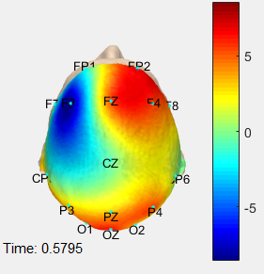
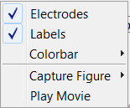
Electrodes
It is also possible to check the electrodes positions on the « electrodes » menu :
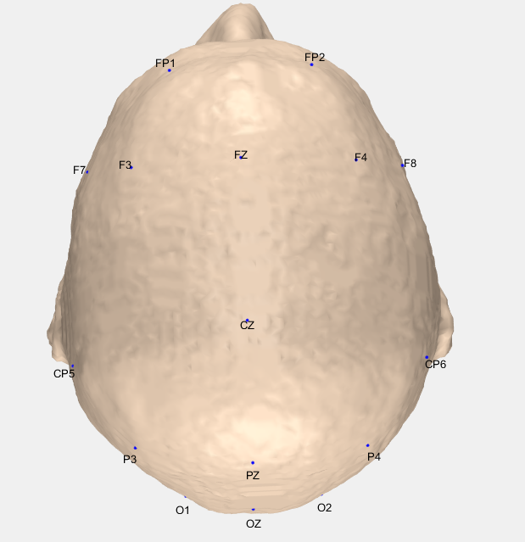
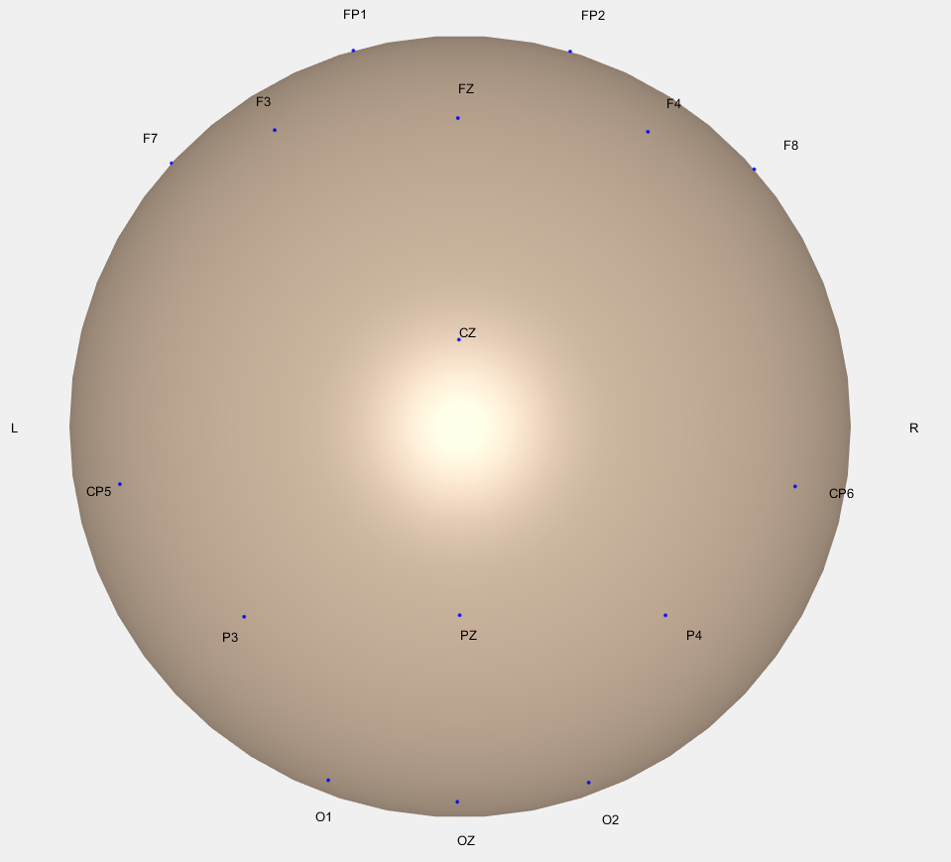
Two options, you can visualize the electrodes positions on a real scalp model or on a spherical model. In additions to the electrodes names, the references are also displayed. It allows the user to detect if something is going wrong with the positions of the electrodes

Period of time selection:
On the other hand, when right clicking on the data, there is other possible uses.
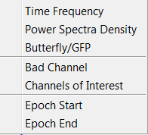
« Time frequency » : Compute and display the wavelet transform of the signal.
« Power Spectra Density » : Compute and display the power spectral density of the signal.
« butterfly/GFD » Compute and display the butterfly of the signal.
«Bad channels» : exclude the channel from computations.
«Channels of interest»: selection of the interesting channels for computations.
«Epoch start» : start of the interesting time window for computations.
«Epoch end»: end of the interesting time window for computations.

The logical order to explain this possibilities is from the last to the first so I will go this way.

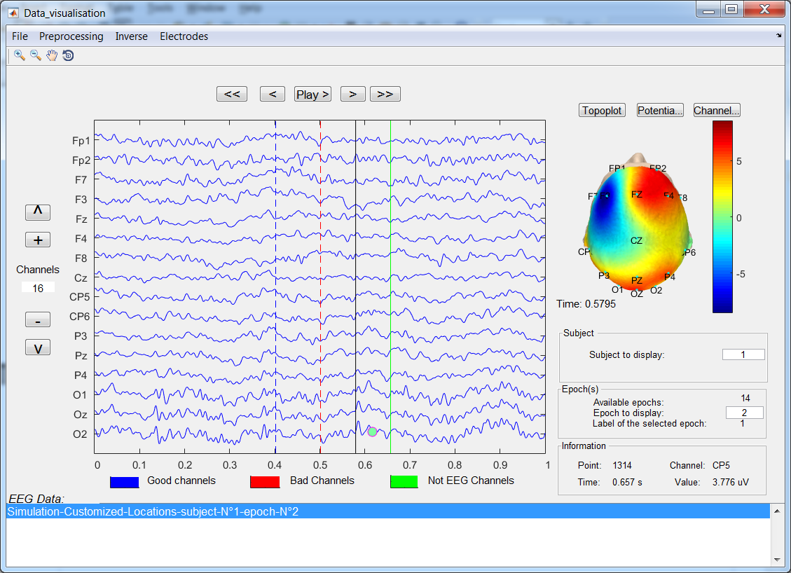
The epochs options offer the possibility to the user to set new limits for computations. To set this limit, right click on the signal where you want to put this limit and then select epoch start and epoch end according to your choices.

The blue line represent the epoch start and the red one the end. In order to work properly, the « start time » has to be placed before the « end time ».

From now on, computations will be performed between those two limits. If no limits are declared then the computations are made on the whole signal.

The potential mapping :

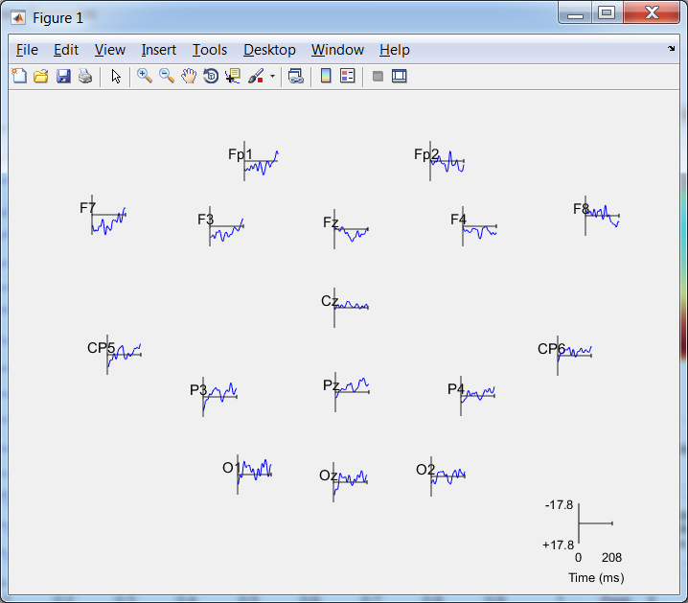
This represent the signal during the selected time specified for each electrodes. The electrodes are themselves located on a 2D plan according to their positions to give an added spatial information.

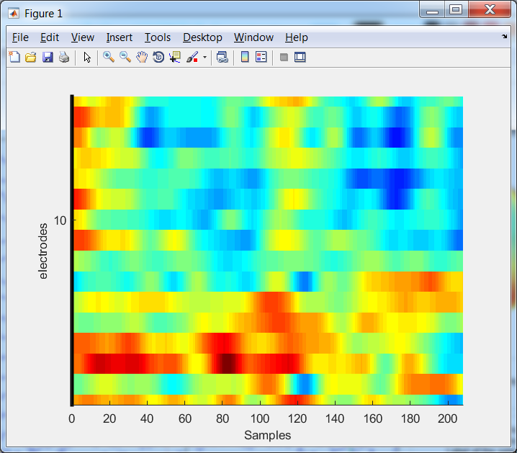
The ERP matrix :

This matrix is a tool that help to visualize where are the points on which the potential was particularly high during the selected time period. It is useful in order to visually detect the ERP (event related potentials) of the signal.

The power spectral density :
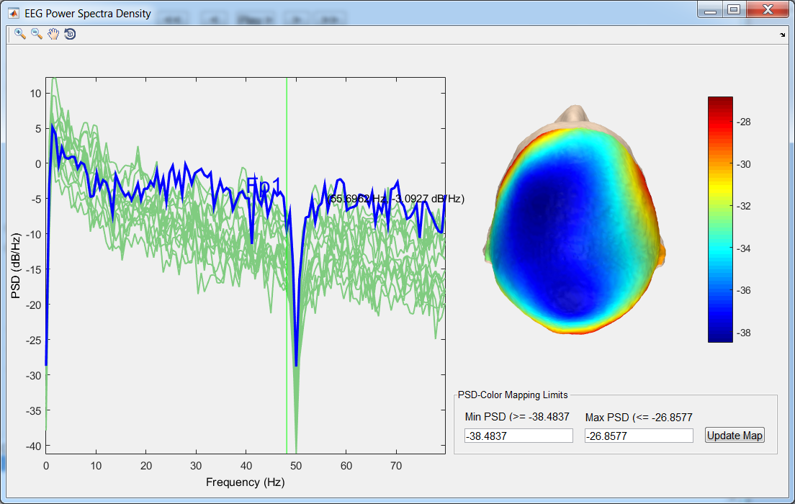
Display the spectrum of the signal. It describes the distribution of power into frequency components composing that signal.

The channel that is displayed in blue is the first one in the list of the channel considered as « good »,if you want to change of channel make the other channel be stated as « bad » one the “data visualization” window and compute again

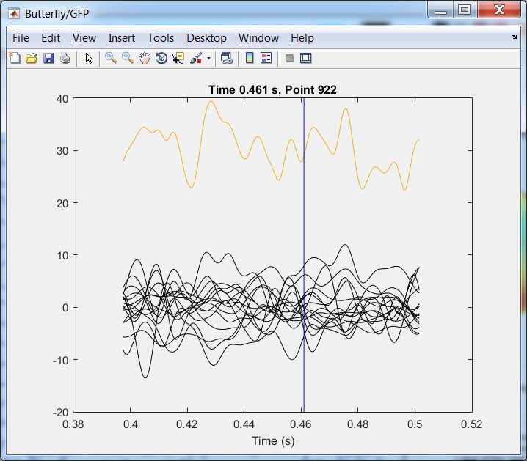
The Butterfly/GFD

Butterfly and global field power (GFP) of the waveforms in the selected time interval.

The measure of global field power (GFP) corresponds to the spatial standard deviation, and it quantifies the amount of activity at each time point in the field considering the data from all recording electrodes simultaneously resulting in a reference-independent descriptor of the potential field. Global field power is plotted as a function of time, and the occurrence times of GFP maxima are used to determine the latencies of evoked potential components.

The time-frequency diagram :
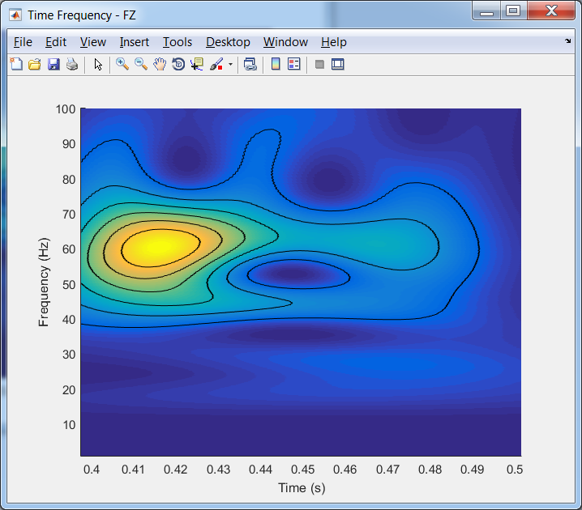

This compute the Time frequency diagram for the channel on which the right click was performed on.

This plot gives a time-frequency information. We can now see at what time and frequency does the high voltage occurs.

Bad channels /Channels of interest :

It is possible to exclude certain channels from the computations by defining them as « bad channels ». This can be done channel by channel by right clicking on the channel and clicking on « bad channel ». Or by selecting all the channel that have to be computed by the « channel of interest » UI.
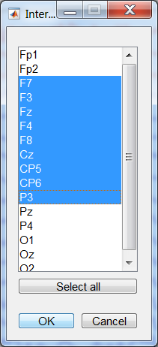
Once a channel is defined as bad, the channel will be colored in red and be excluded from computations and scalp mapping.

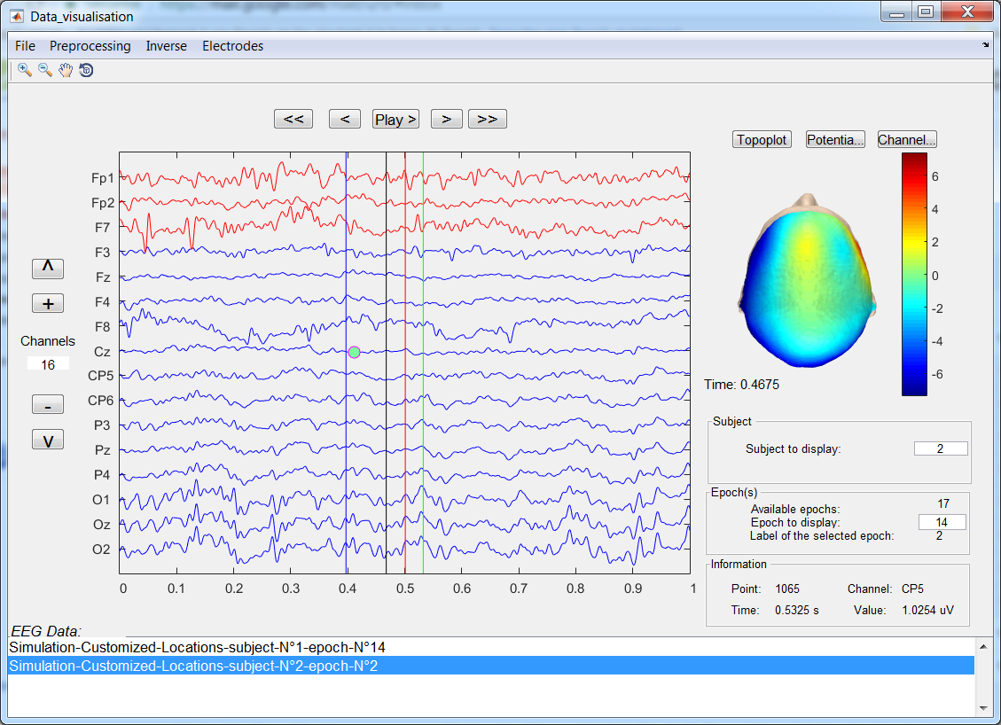
The channels that have been spotted out by the program as non EEG signals are colored in green.
They are excluded from the scalp mapping as they would false the results. But they are still counting for the other computations. So, if you want the not EEG channels not to be counted in computation, first make them « bad channels »

Source localization :

It is possible to locate the estimated source of the signal on the cortex. This can be done by clicking on the source imaging button in the « imaging »dropdown menu :

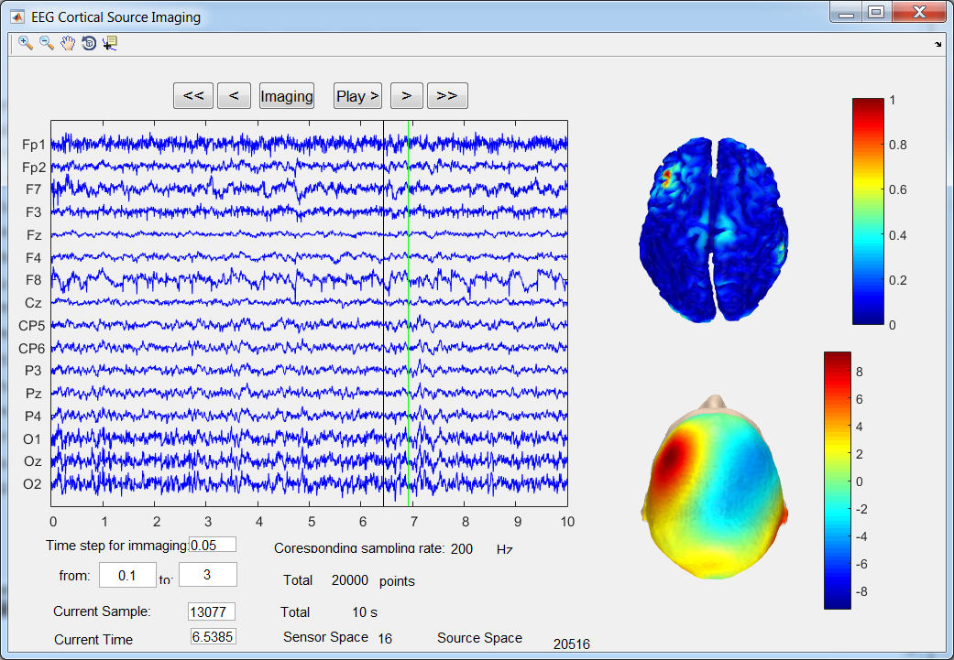
From this window, it is possible to click on a specific time on the main graph in order to perform the source localization for this specific time.

Or if the source location has to be performed over a specific period of time, it's possible to define a start time, an end time and a time step.

The program will down sample the signal to a frequency corresponding to the specified time-step. The study will only take place between the start and the end time.

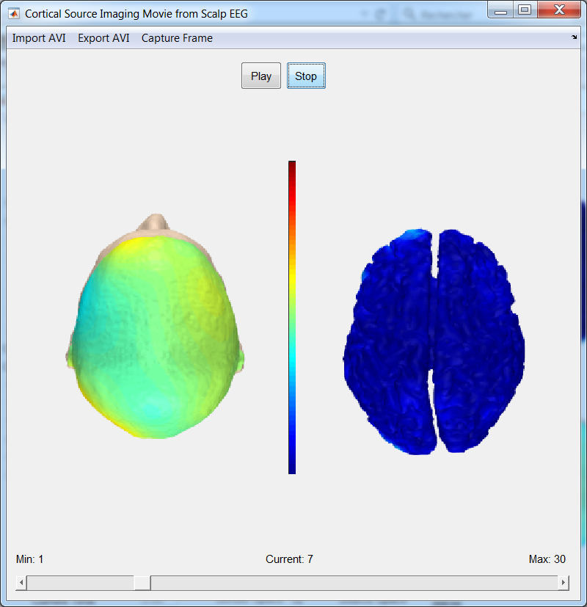
After the desired inputs are specified, click on the « imaging » button and wait for the computation end. When « Done » is written at the lower right corner click on « play » and this will open a visualization window :
It is possible to play the generated window from the discretized signal. Then if you find the results interesting, you can export the video to an « .avi » file to watch it later on.

Sources :

- http://econnectome.umn.edu/
- https://sccn.ucsd.edu/eeglab/index.php
- https://www.ncbi.nlm.nih.gov/pubmed/2094301

