REVOLUTION QUICK START
SET UP YOUR OWN REVOLUTION ON QUICK START AND AZURE

CREATE AN AZURE VIRTUAL MACHINE
USE WINDOWS SERVER 2022
WE USED SIZING OF 2 CORE 16GB.
ALSO TESTED ON XEON 9480 MAX 56 CORES 112 THREADS
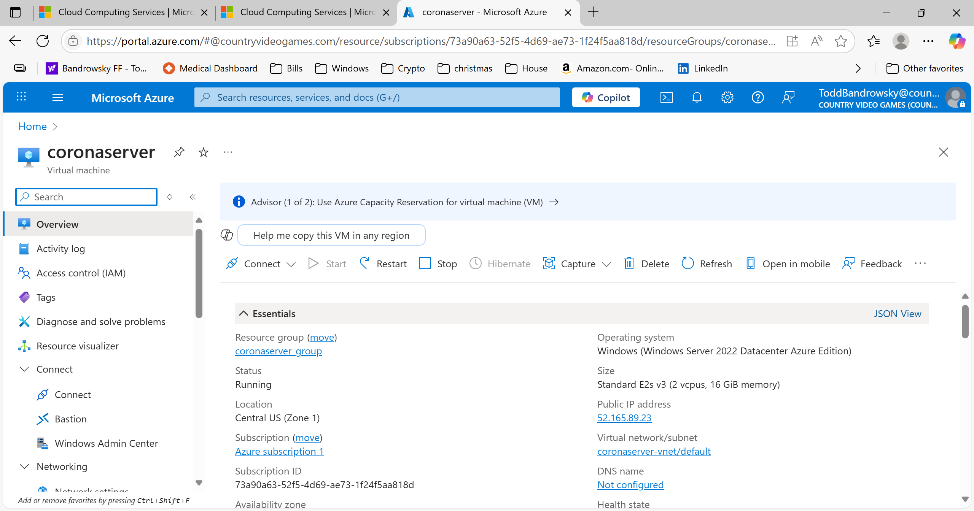

INSTALL REVOLUTION ON THE VIRTUAL MACHINE
On the virtual machine you just created,
- go to the https://countryvideogames.com/revolutionabout.
- Download the zip file containing coronaserver.msi and setup.exe
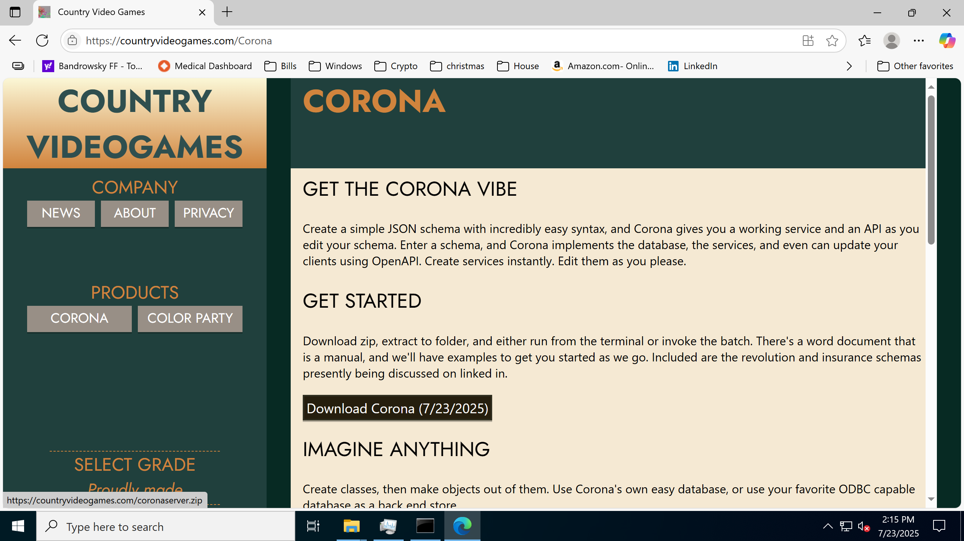

OPEN INBOUND 443 AND 80 WITH FIREWALL
- OPEN THE PORT ON AZURE NETWORKING
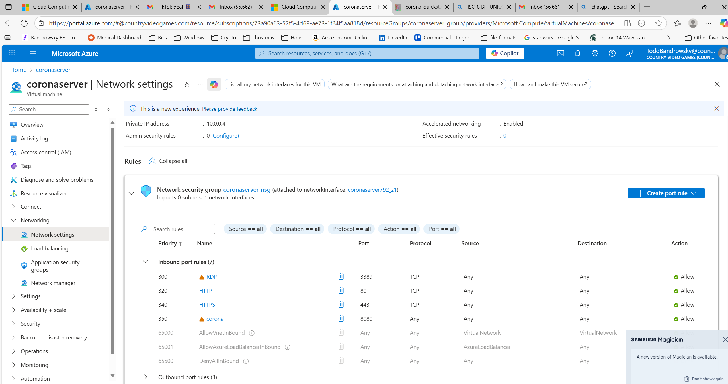

- OPEN THE PORT ON THE VM ITSELF. LOG INTO THE VM YOU CREATED, THEN, ACCESS WINDOWS FIREWALL AND ADVANCED SETTINGS
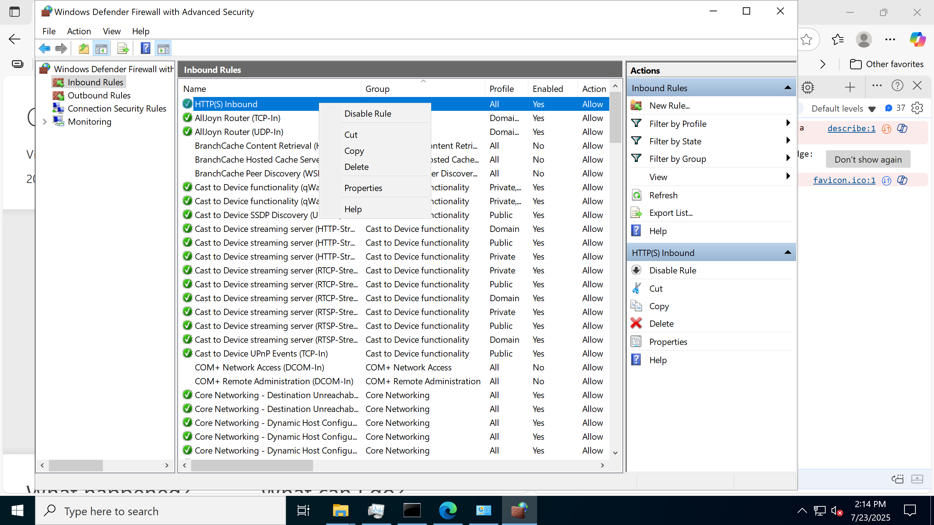

CONFIGURE SENDGRID ENVIRONMENT VARIABLE
REVOLUTION has the MFA ceremony built in for login, account creation and secret code send. Email rather than mobile is used, for the moment, although plans are there to support both.
REVOLUTION will check the environment variable first for the SendGrid secret.
SendGrid is used to send emails.
If you have never used SendGrid, you can create a free or cheap account and get an api key for it. That API KEY goes into an environment variable.
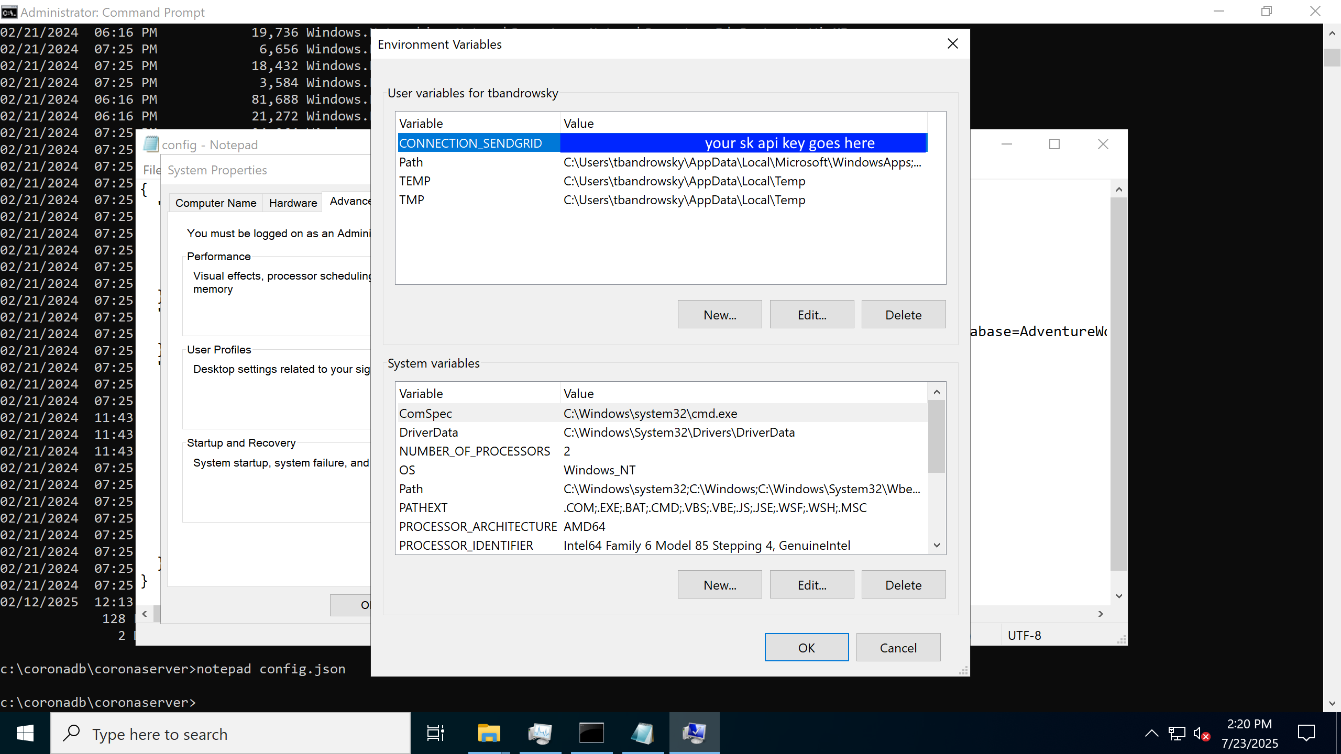

EXAMINE THE SERVER DIRECTORY
NOTICE THERE ARE TWO SETS OF .JSON FILES.
CONFIG.JSON – DATABASE SERVER CONFIGURATION
*_SCHEMA.JSON – A SCHEMA REFERENCED BY CONFIG.JSON.
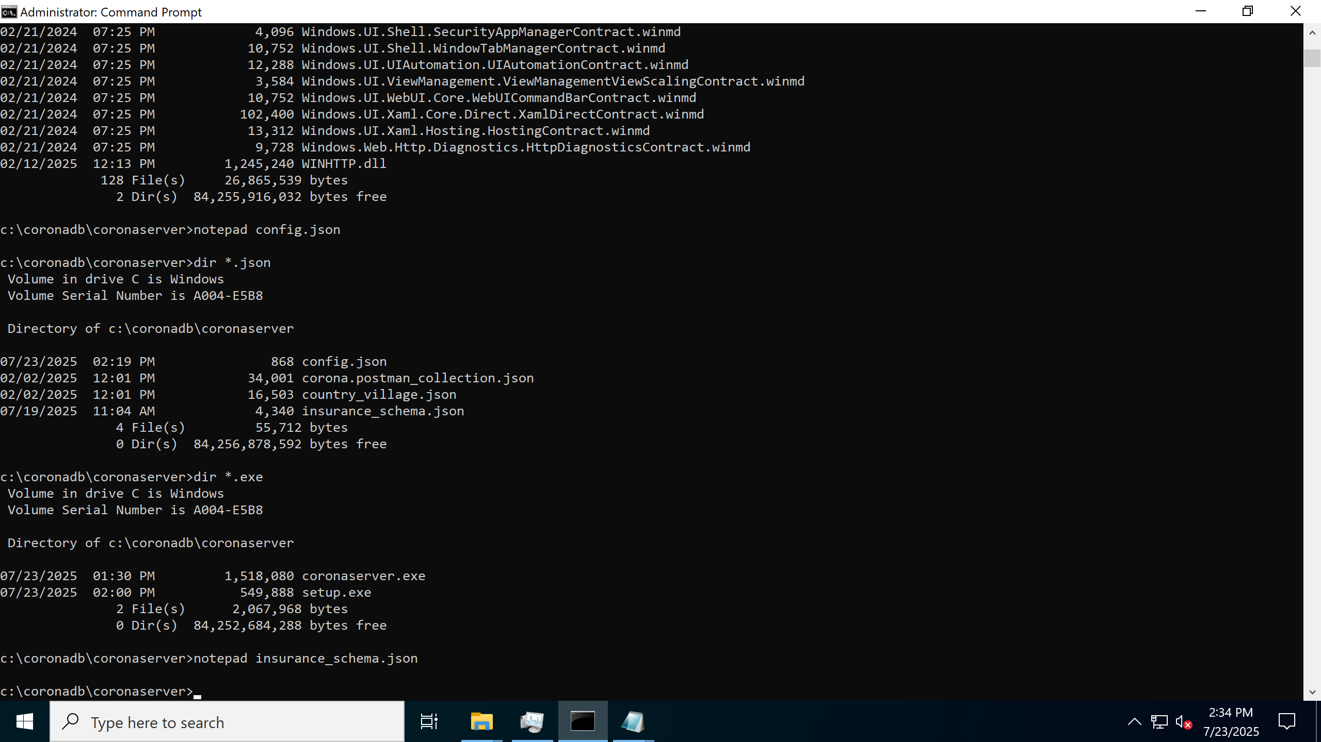

EDIT CONFIG.JSON
SenderName, SenderEmail, and UserConfirmationTitle are used to create the body of the email(s) being sent. Change those to you.
Server Listen_Point is the bind to. The port in this URL MUST be specified, even if 80/443.
Note that, you must use NETSH to register your URL as above.
Generally, a url looks like https://myrl.com:443/somepath. You would put that in config.json, then, as an administrator,
Application_Name is your friendliest application name.
Schema_filename says where your schema file lives.
Database_Filename where you want the database file itself to live .
Database_threads how many server threads to devote to corona.
Sys_user_name and sys_user_password, etc, are all the SA stuff, so like, you’ll want to change all this
You can also define SQL Server connection strings in there, and set up a schema to use a SQL Server table transparently within Revolution.
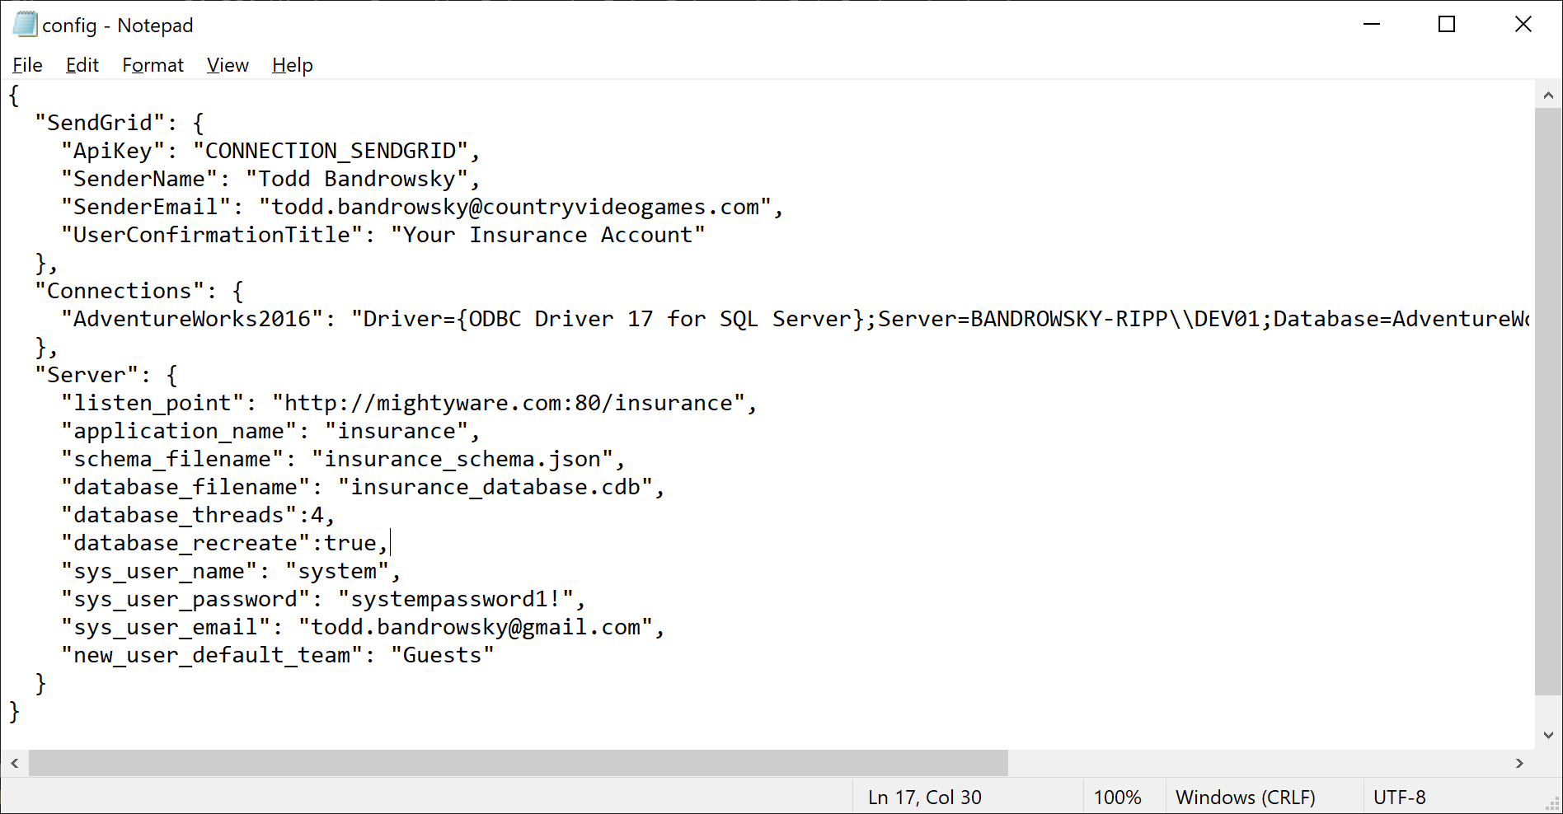

CUSTOMIZE YOUR REVOLUTION
Revolution is driven by a schema that consists of class definitions, and data definitions, and validation rules. Schemas are named and stored in the database, refreshing from changes in whatever other files a schema may reference.
You can vibe code Revolution. Changes to the Schema are applied immediately, even when Revolution is running.

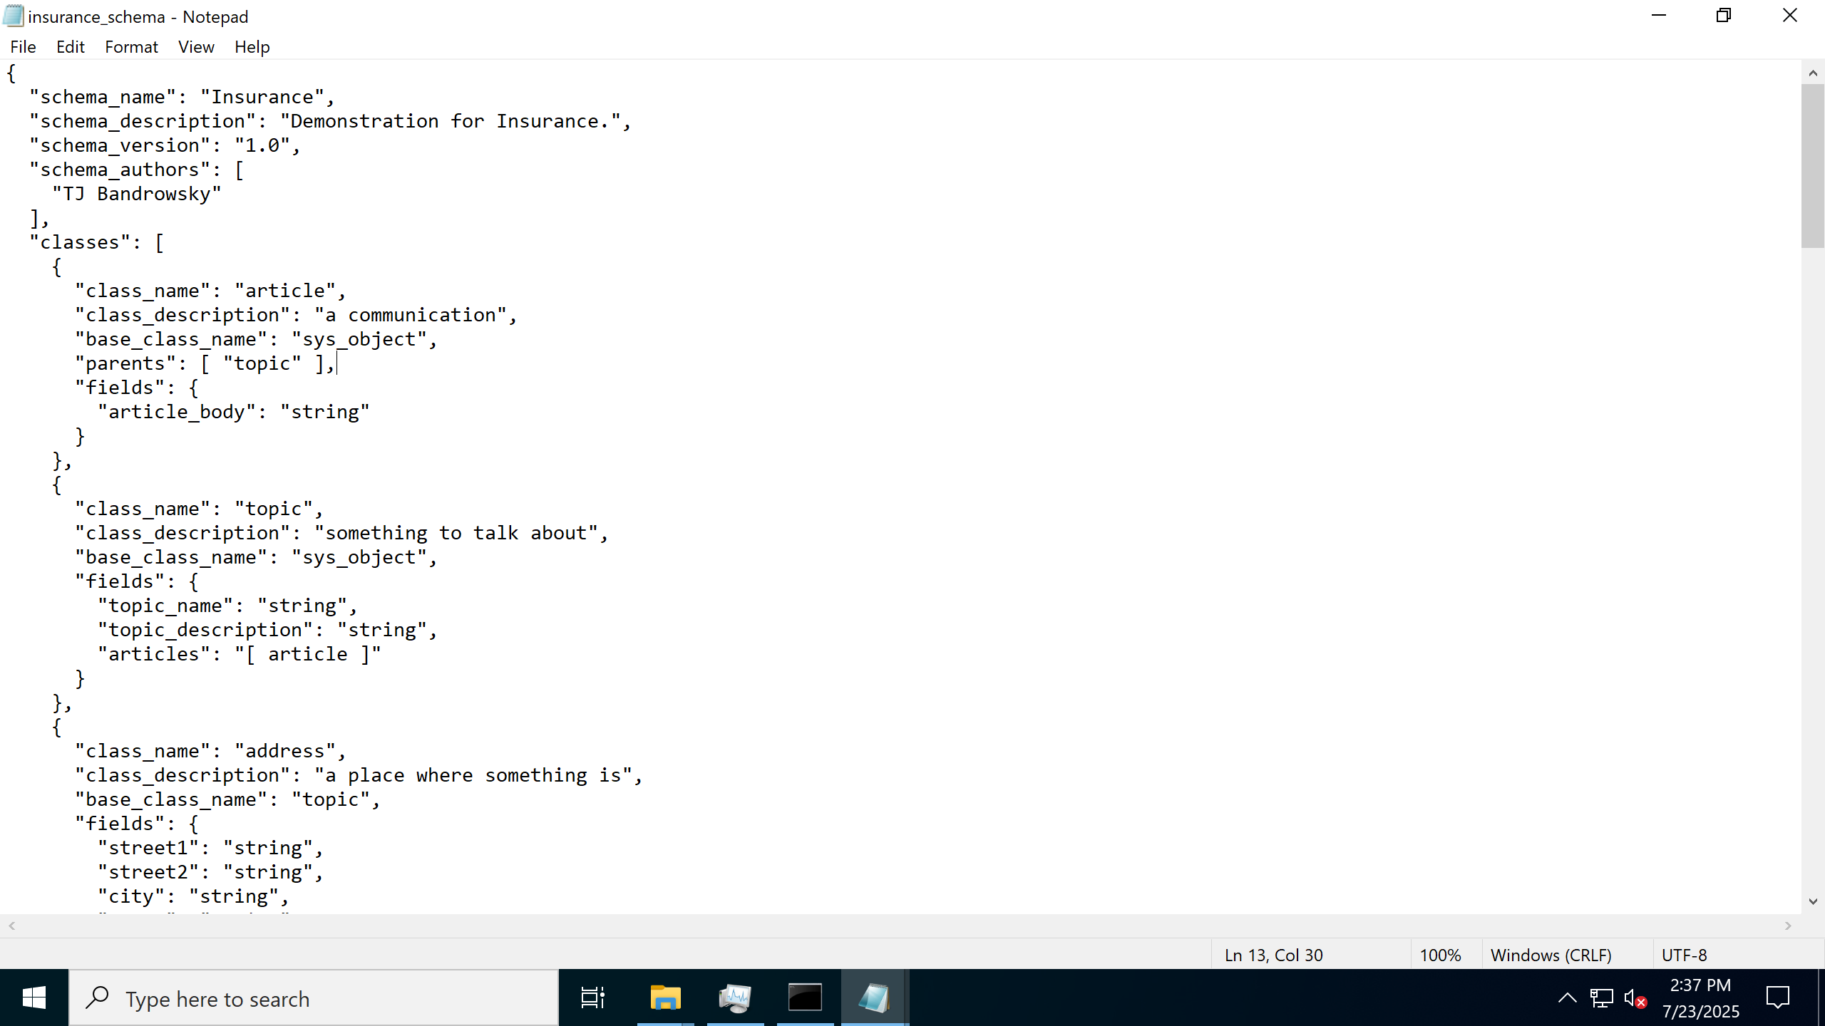

CONSIDER CLOUDFLARE
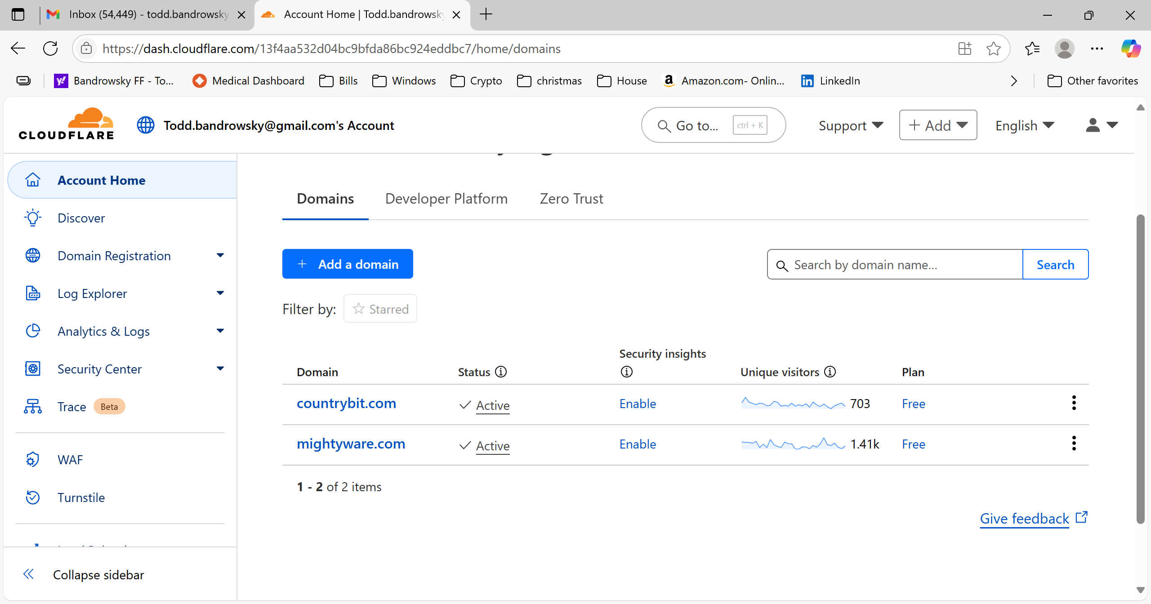

LAUNCH REVOLUTION
CD to your Corona directory.
Open Command Prompt
./revolutionserver console
End points appear in list.

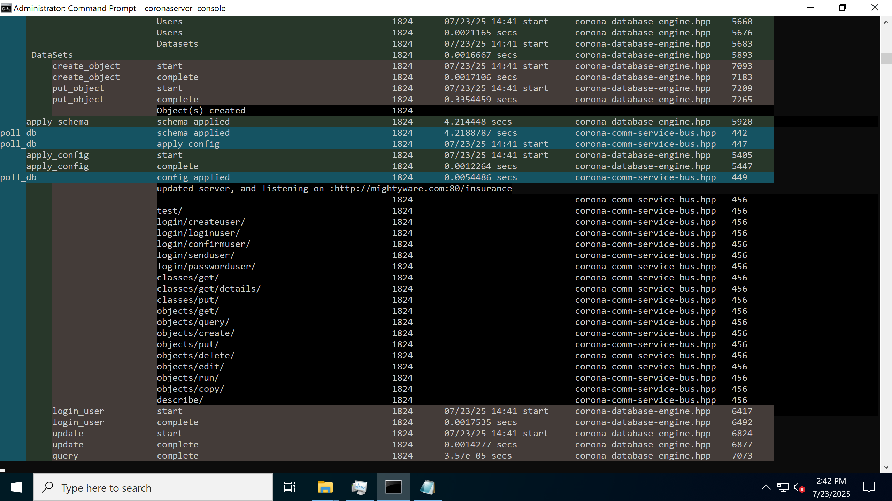

QUICK TEST.
First off, you can see the URLs for any of the end points in the console window.
https://mightyware.com/revolution/test

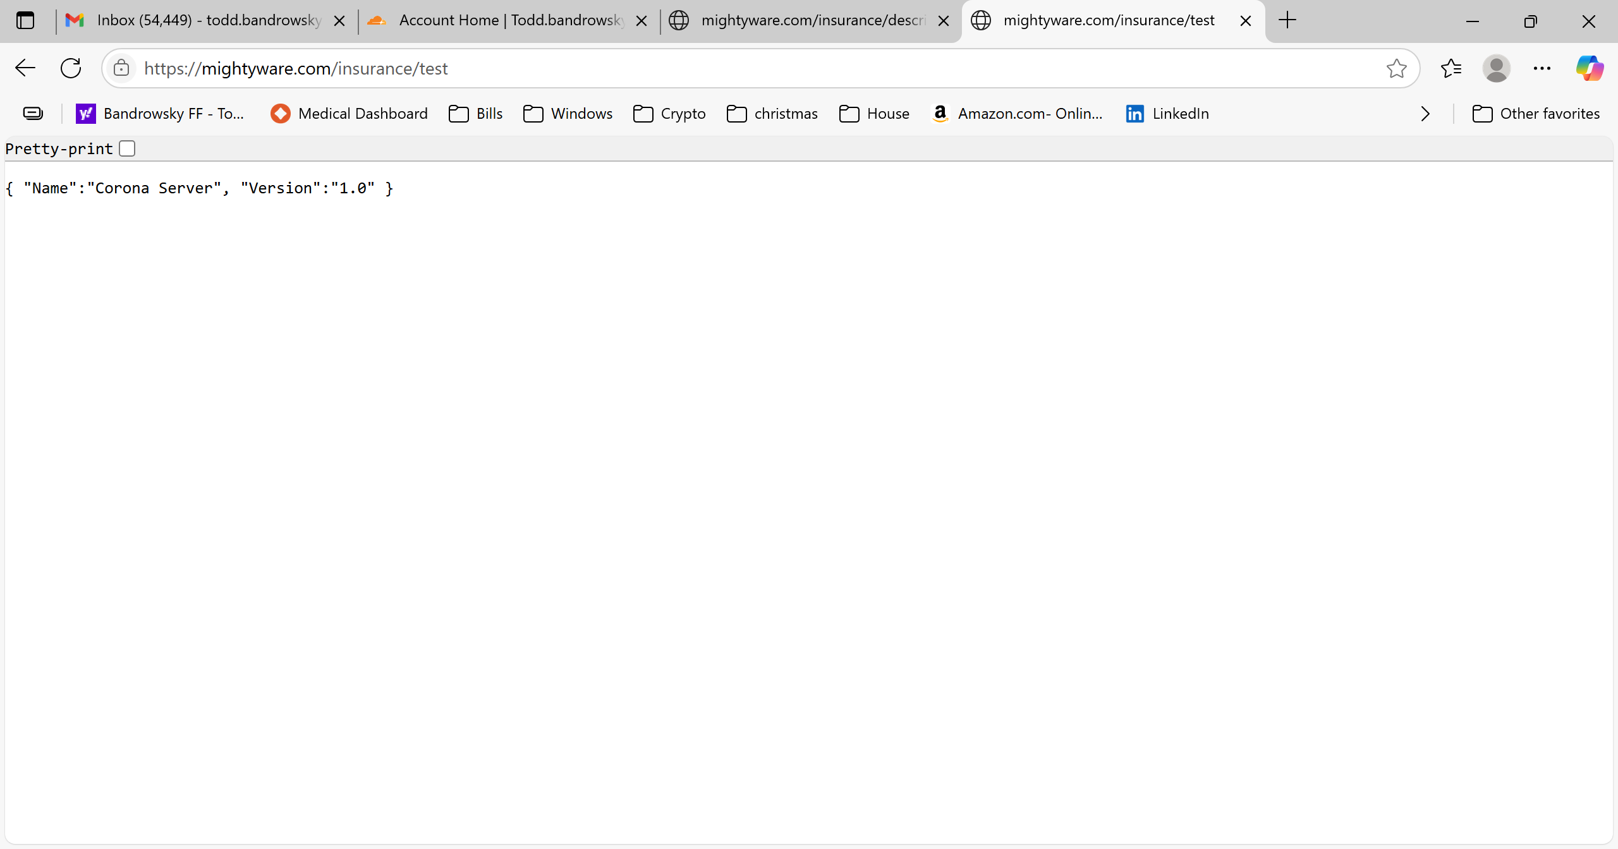

OPEN API CALL
https://mightyware.com/revolution/describe

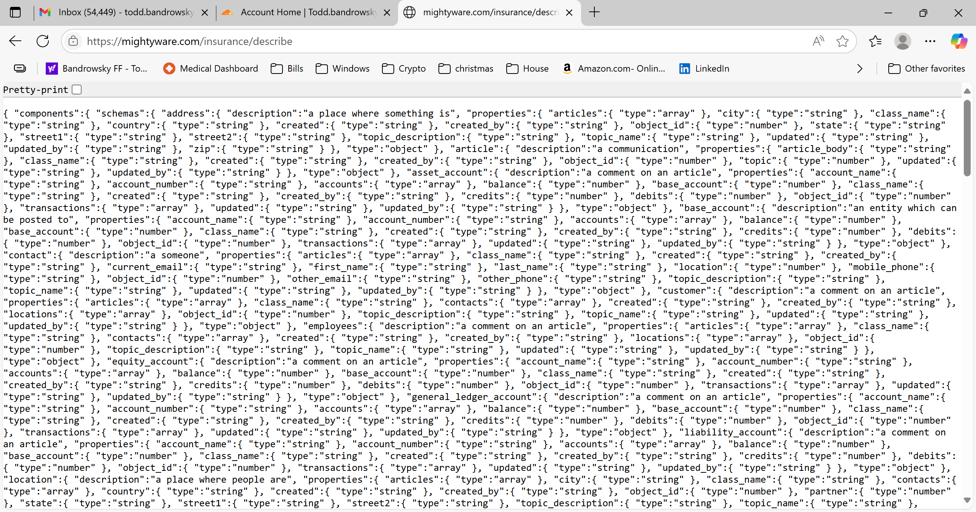

FIRE UP OPENAPI
You’ll give your url to open API to try this out.
