CORONA QUICK START FOR AZURE
THIS GUIDE EXPLAINS HOW TO SET UP CORONA ON A VIRTUAL MACHINE IN AZURE

CREATE AN AZURE VIRTUAL MACHINE
USE WINDOWS SERVER 2022
WE USED SIZING OF 2 CORE 16GB.
ALSO TESTED ON XEON 9480 MAX 56 CORES 112 THREADS
EXPLORING THOSE FREE MACHINES OUT THERE.

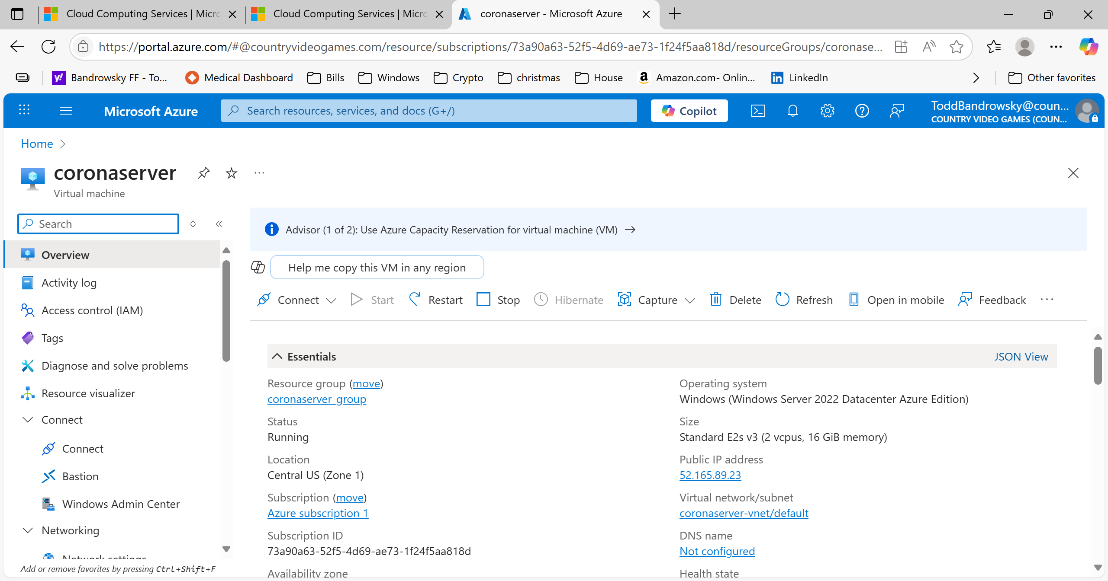

INSTALL CORONA ON THE VIRTUAL MACHINE
On the virtual machine you just created,
- go to the https://countryvideogames.com/corona.
- Download the zip file containing coronaserver.msi and setup.exe
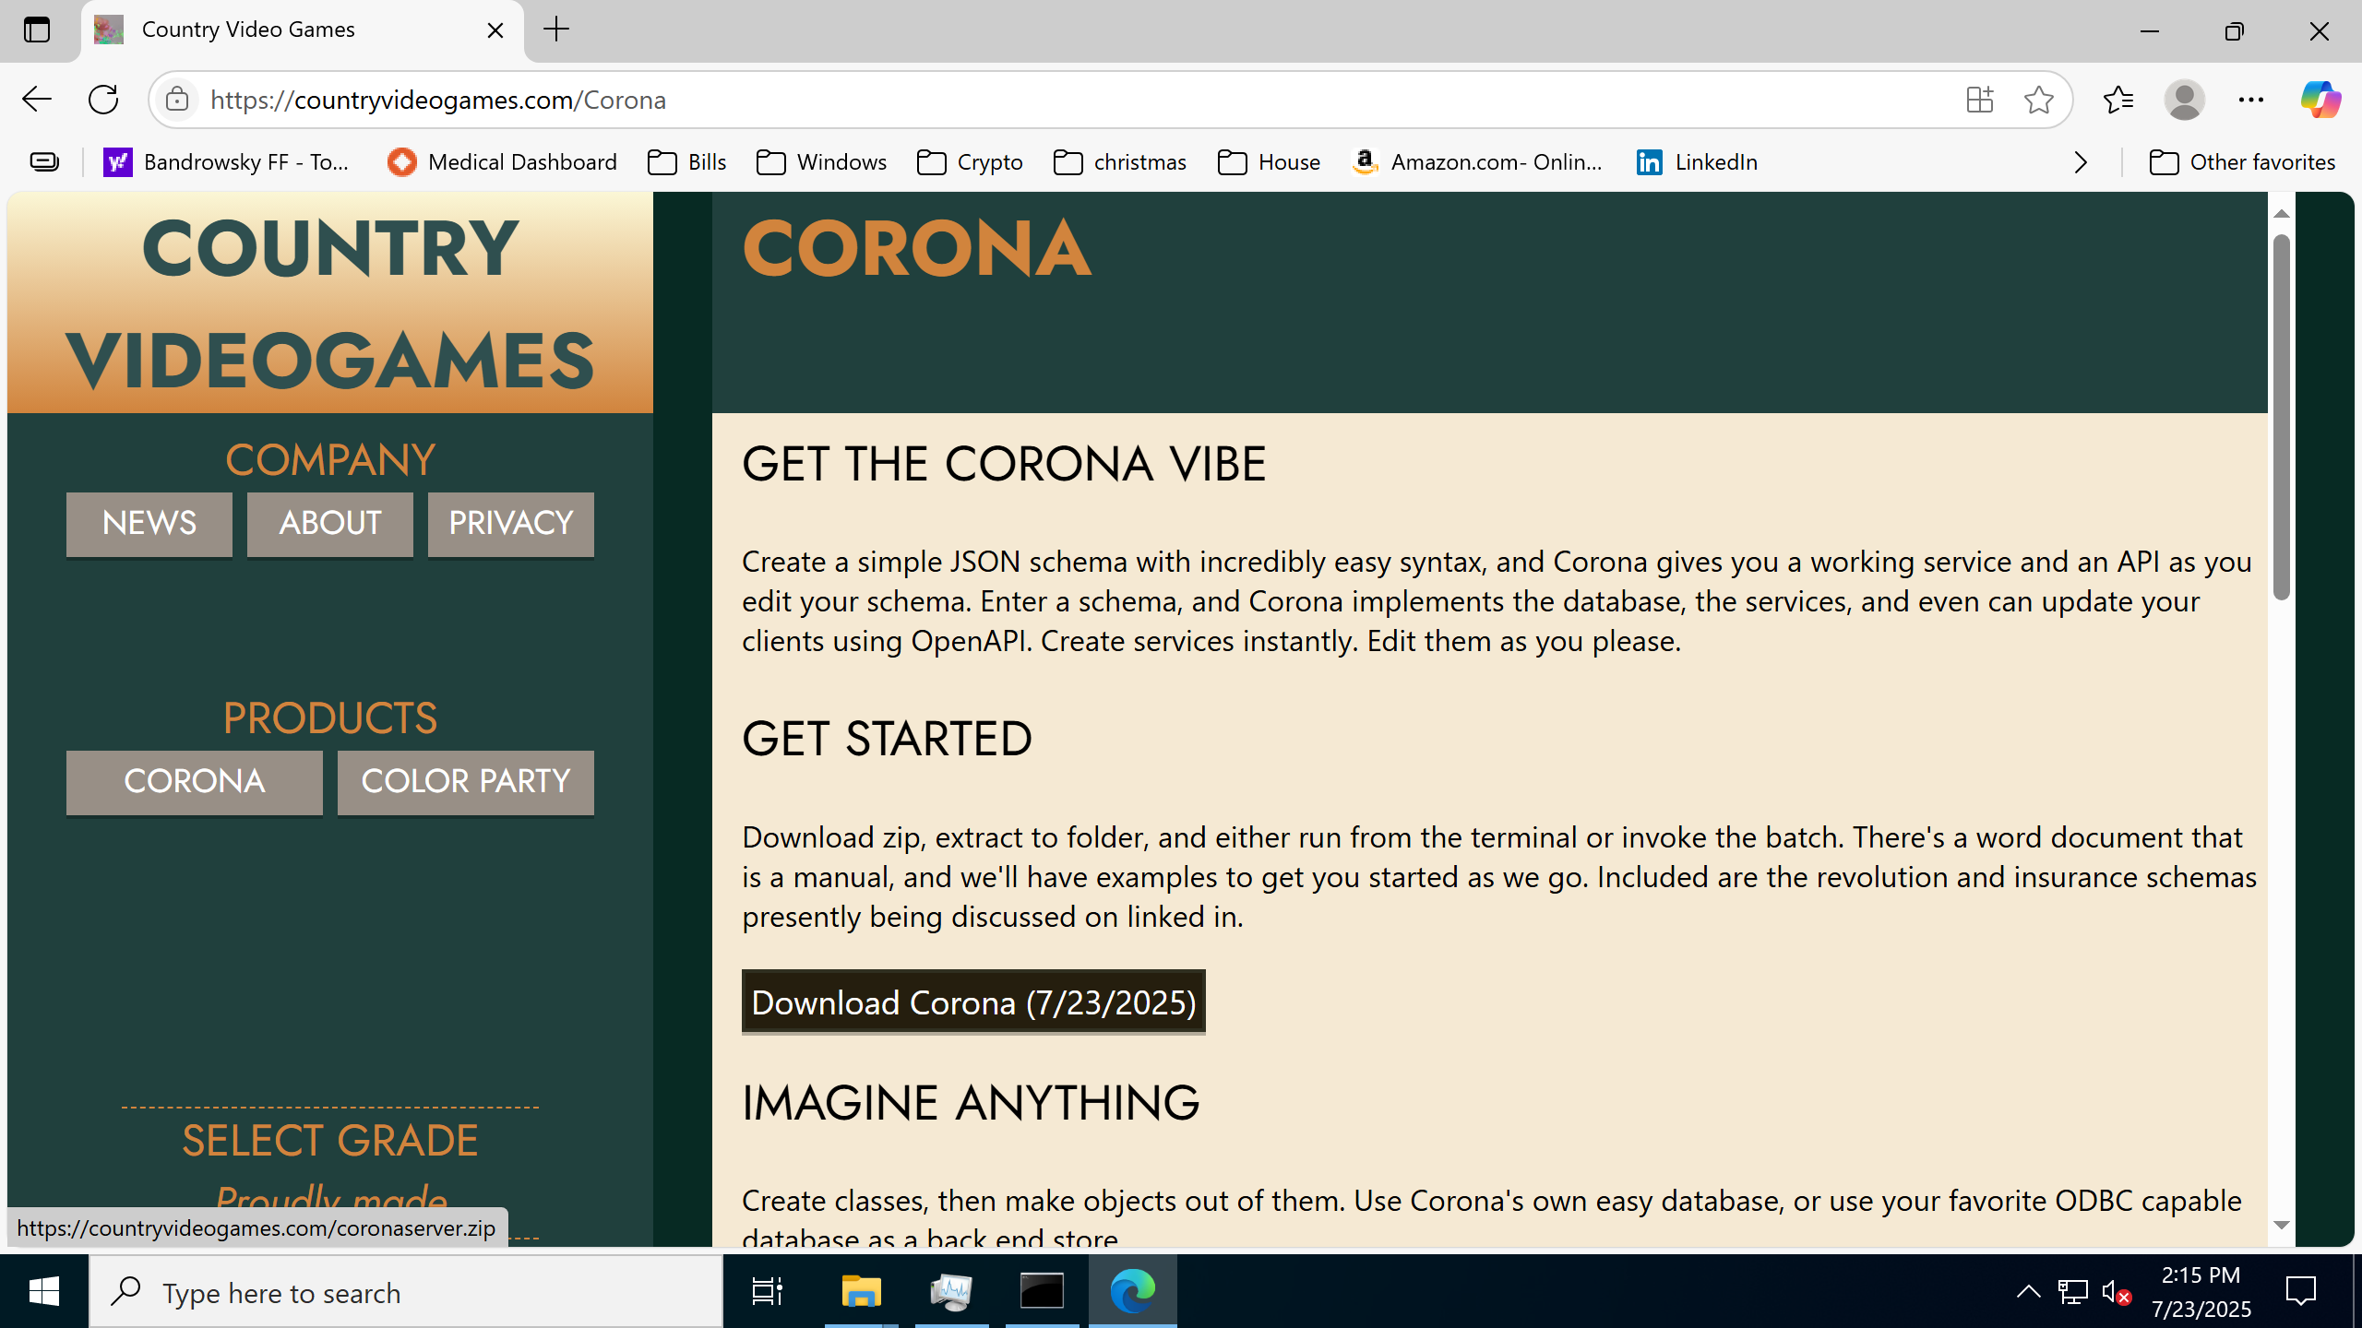

OPEN INBOUND 443 AND 80 WITH FIREWALL
- OPEN THE PORT ON AZURE NETWORKING
- OPEN THE PORT ON THE VM ITSELF

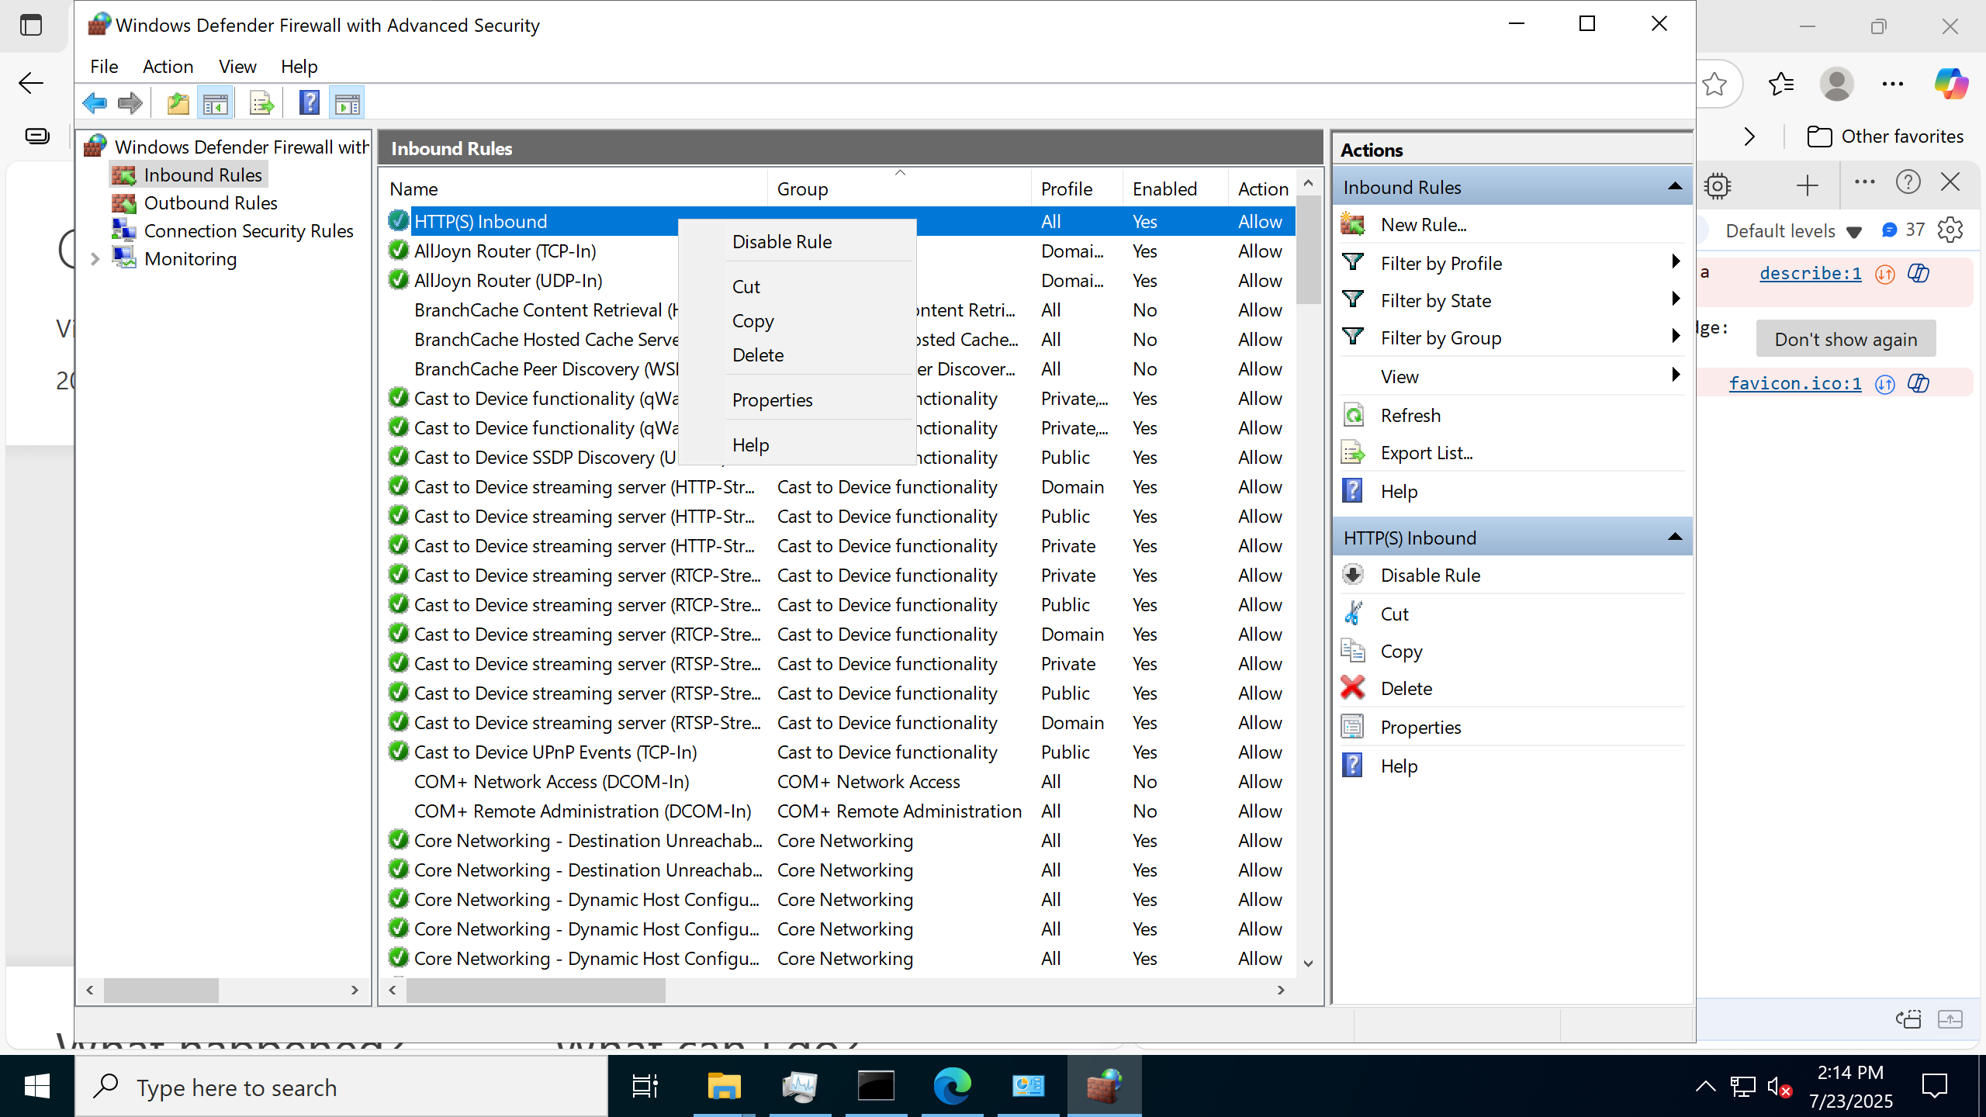

CONFIGURE SENDGRID ENVIRONMENT VARIABLE
CORONA has the MFA ceremony built in for login, account creation and secret code send. Email rather than mobile is used, for the moment, although plans are there to support both.
CORONA will check the environment variable first for the SendGrid secret.
SendGrid is used to send emails.

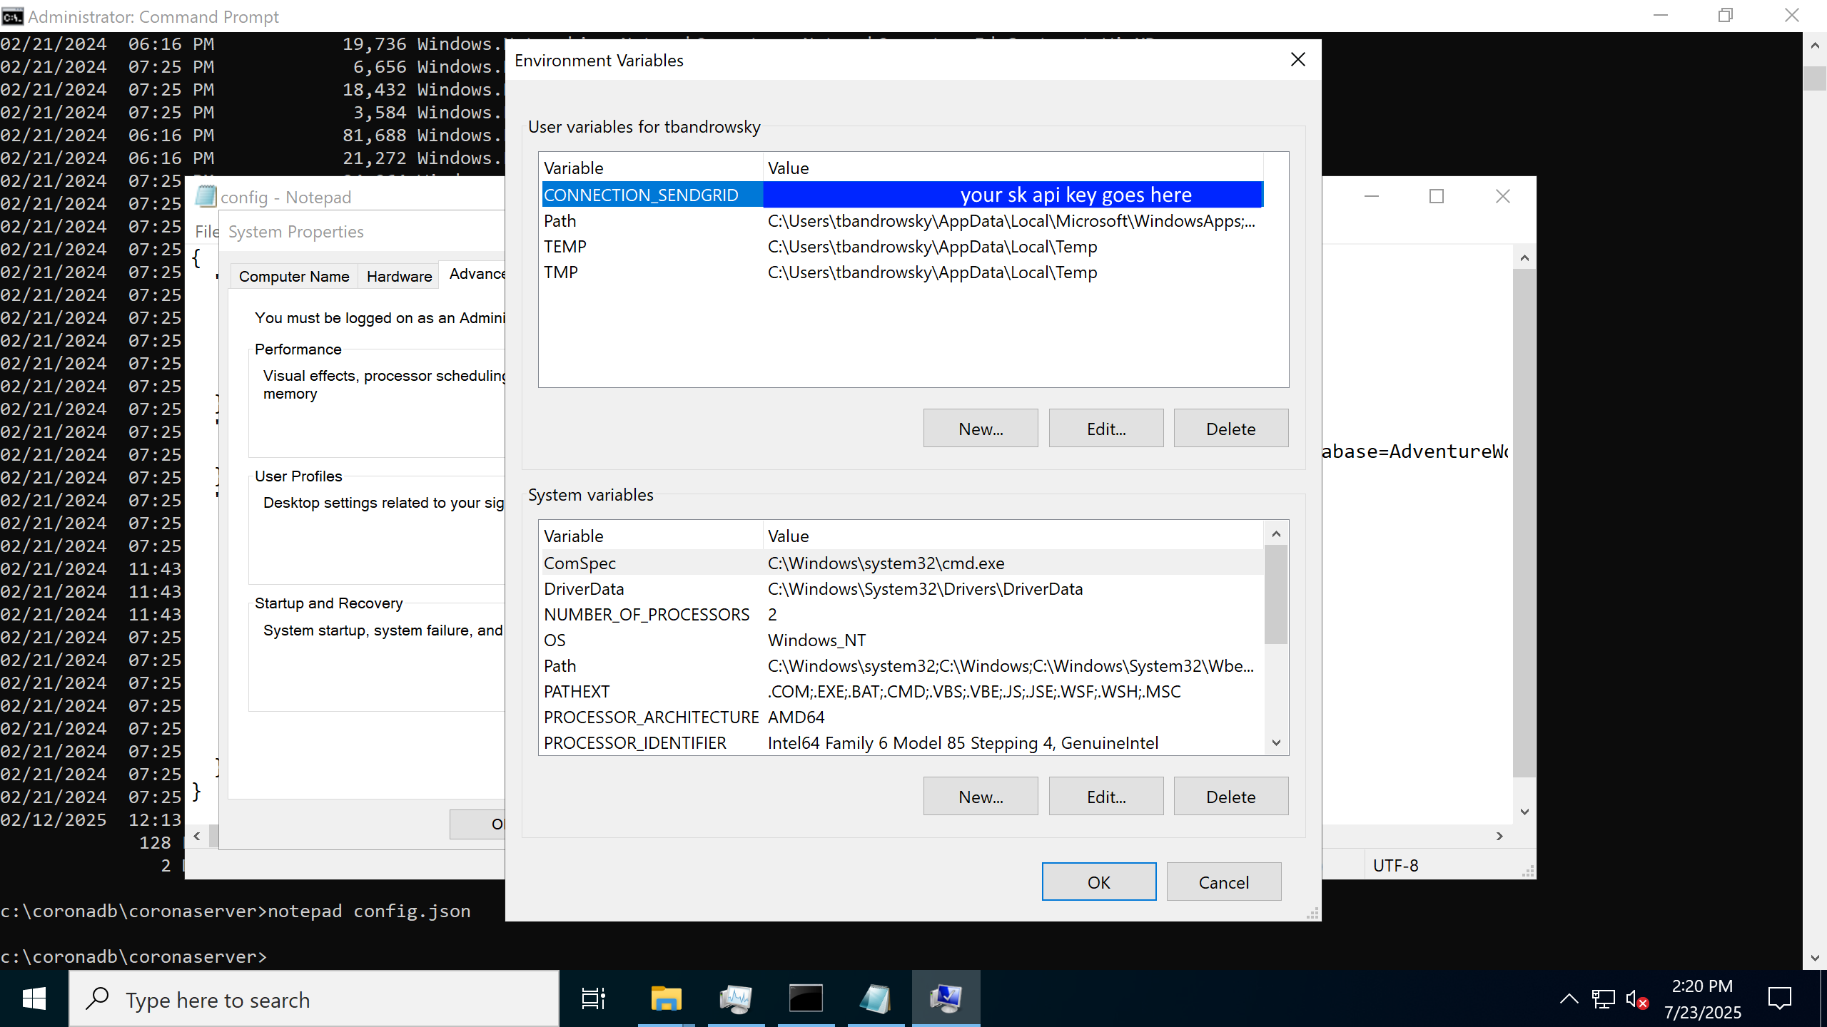

EXAMINE THE SERVER DIRECTORY
NOTICE THERE ARE TWO SETS OF .JSON FILES.
CONFIG.JSON – DATABASE SERVER CONFIGURATION
*_SCHEMA.JSON – A SCHEMA REFERENCED BY CONFIG.JSON. ALSO NOTE THAT DATABASE FILES CAN BE PLACED ANYWHERE.
CORONA SUPPORTS ONE DATABASE AT A TIME.
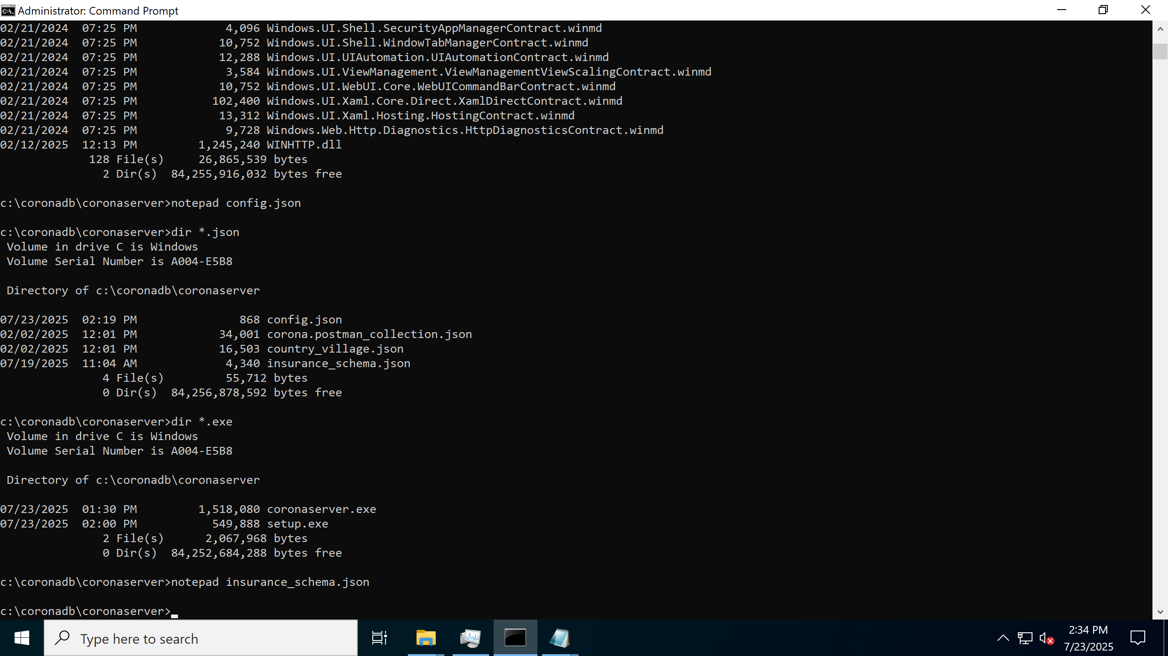

CONFIGURE CONFIG.JSON
SenderName, SenderEmail, and UserConfirmationTitle are used to create the body of the email(s) being sent. Change those to you.
Server Listen_Point is the bind to. The port in this URL MUST be specified, even if 80/443.
Application_Name is your friendliest application name.
Schema_filename says where your schema file lives.
Database_Filename where you want the database file itself to live .
Database_threads how many server threads to devote to corona.
Sys_user_name and sys_user_password, etc, are all the SA stuff, so like, you’ll want to change all this

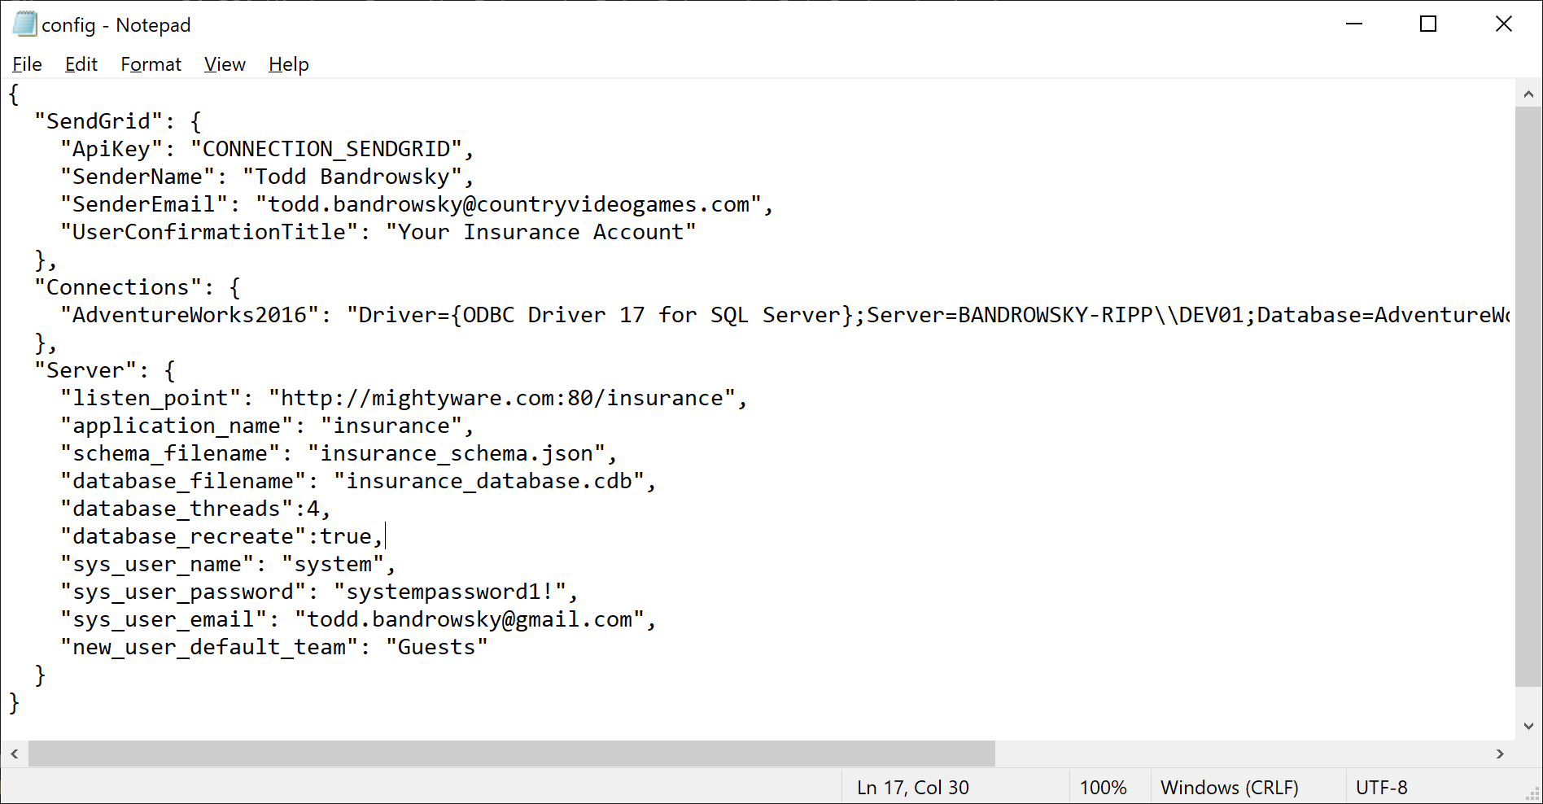

CONFIGURE SCHEMA
A Schema in Corona consists of class definitions, and data definitions. Schemas are named and stored in the database.
Changes to the Schema are applied immediately, even when Corona is running.

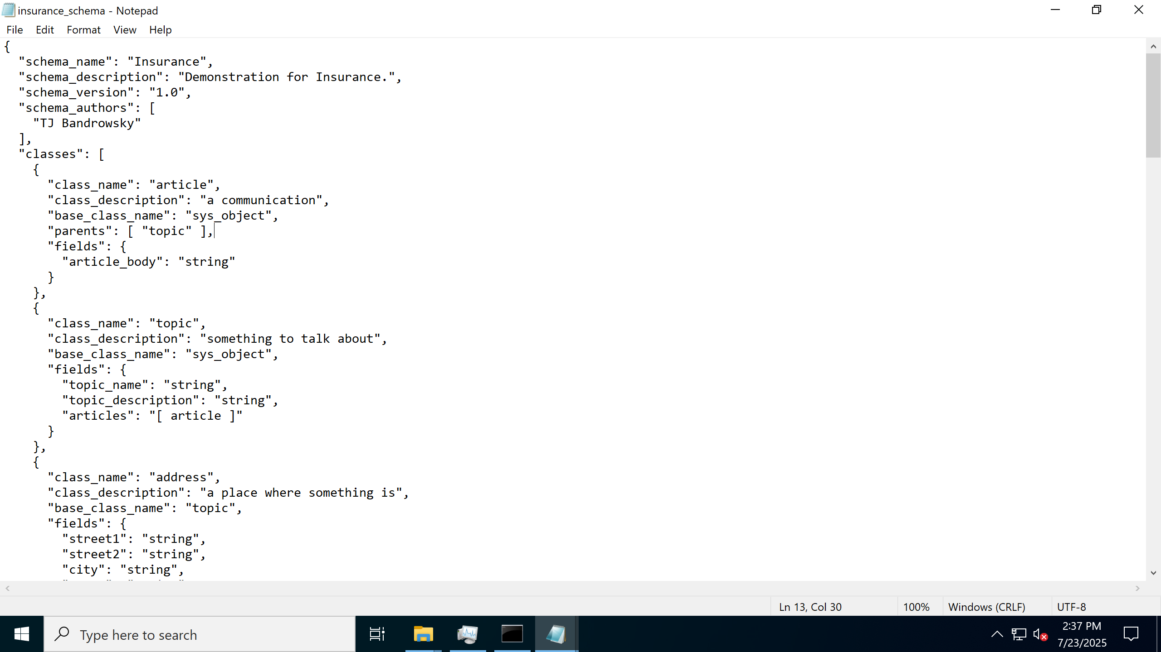

CONSIDER CLOUDFLARE
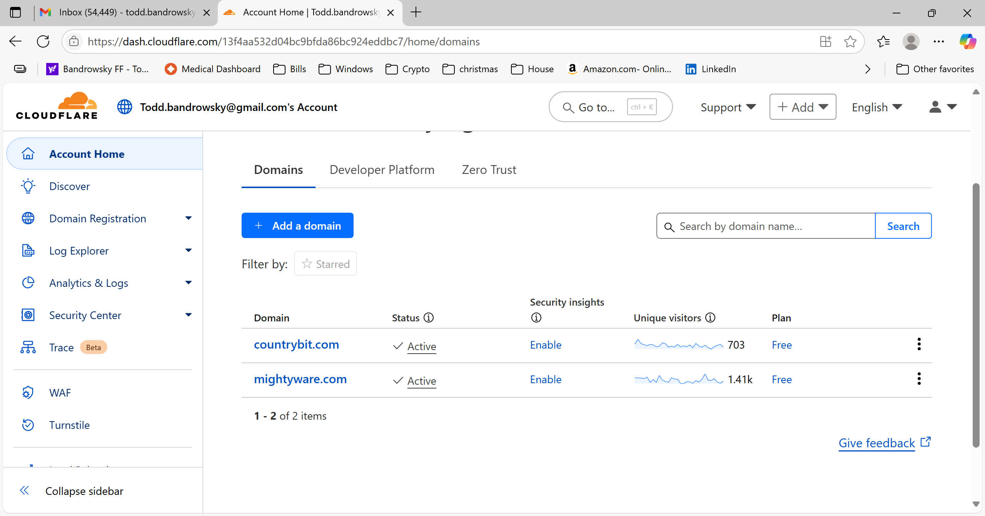

LAUNCH CORONA
CD to your Corona directory.
Open Command Prompt
./coronaserver console
End points appear in list.

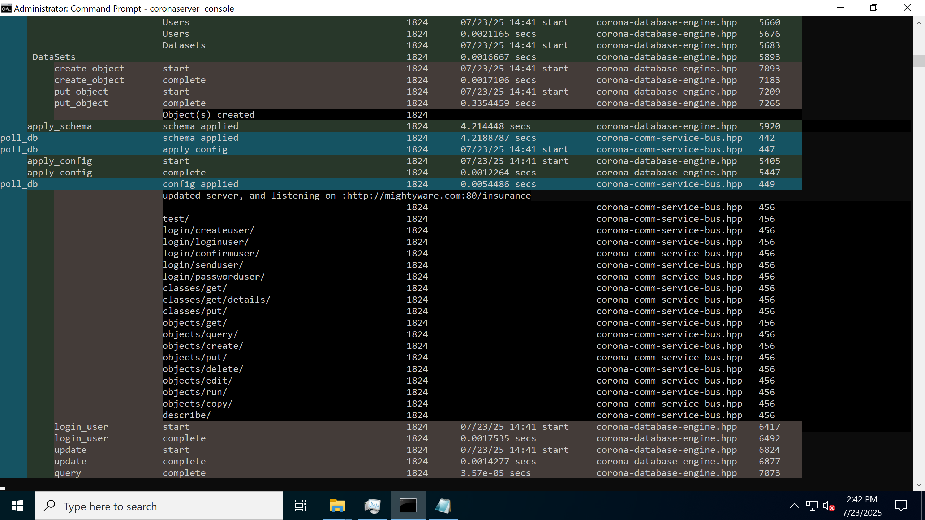

QUICK TEST.
First off, you can see the URLs for any of the end points in the console window.
http://mightyware.com/insurance/test

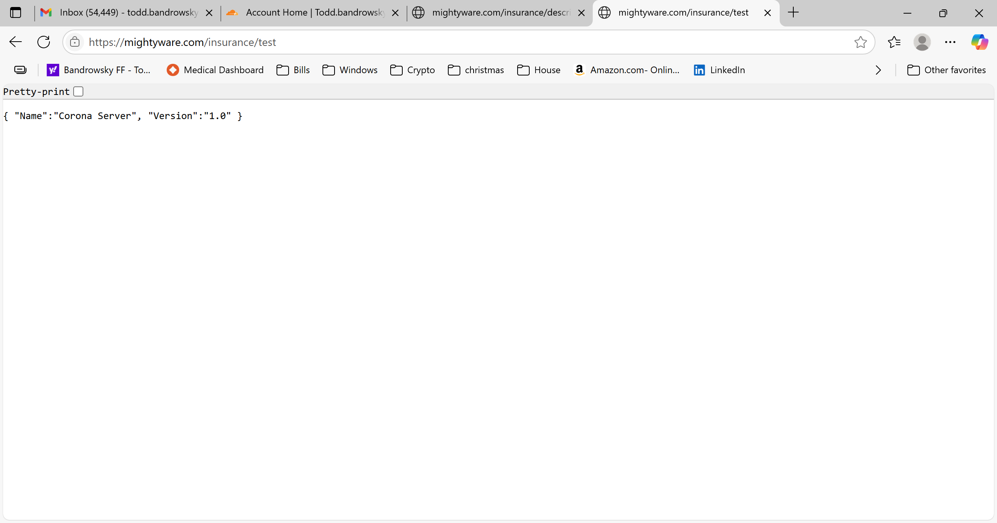

OPEN API CALL
http://mightyware.com/insurance/describe

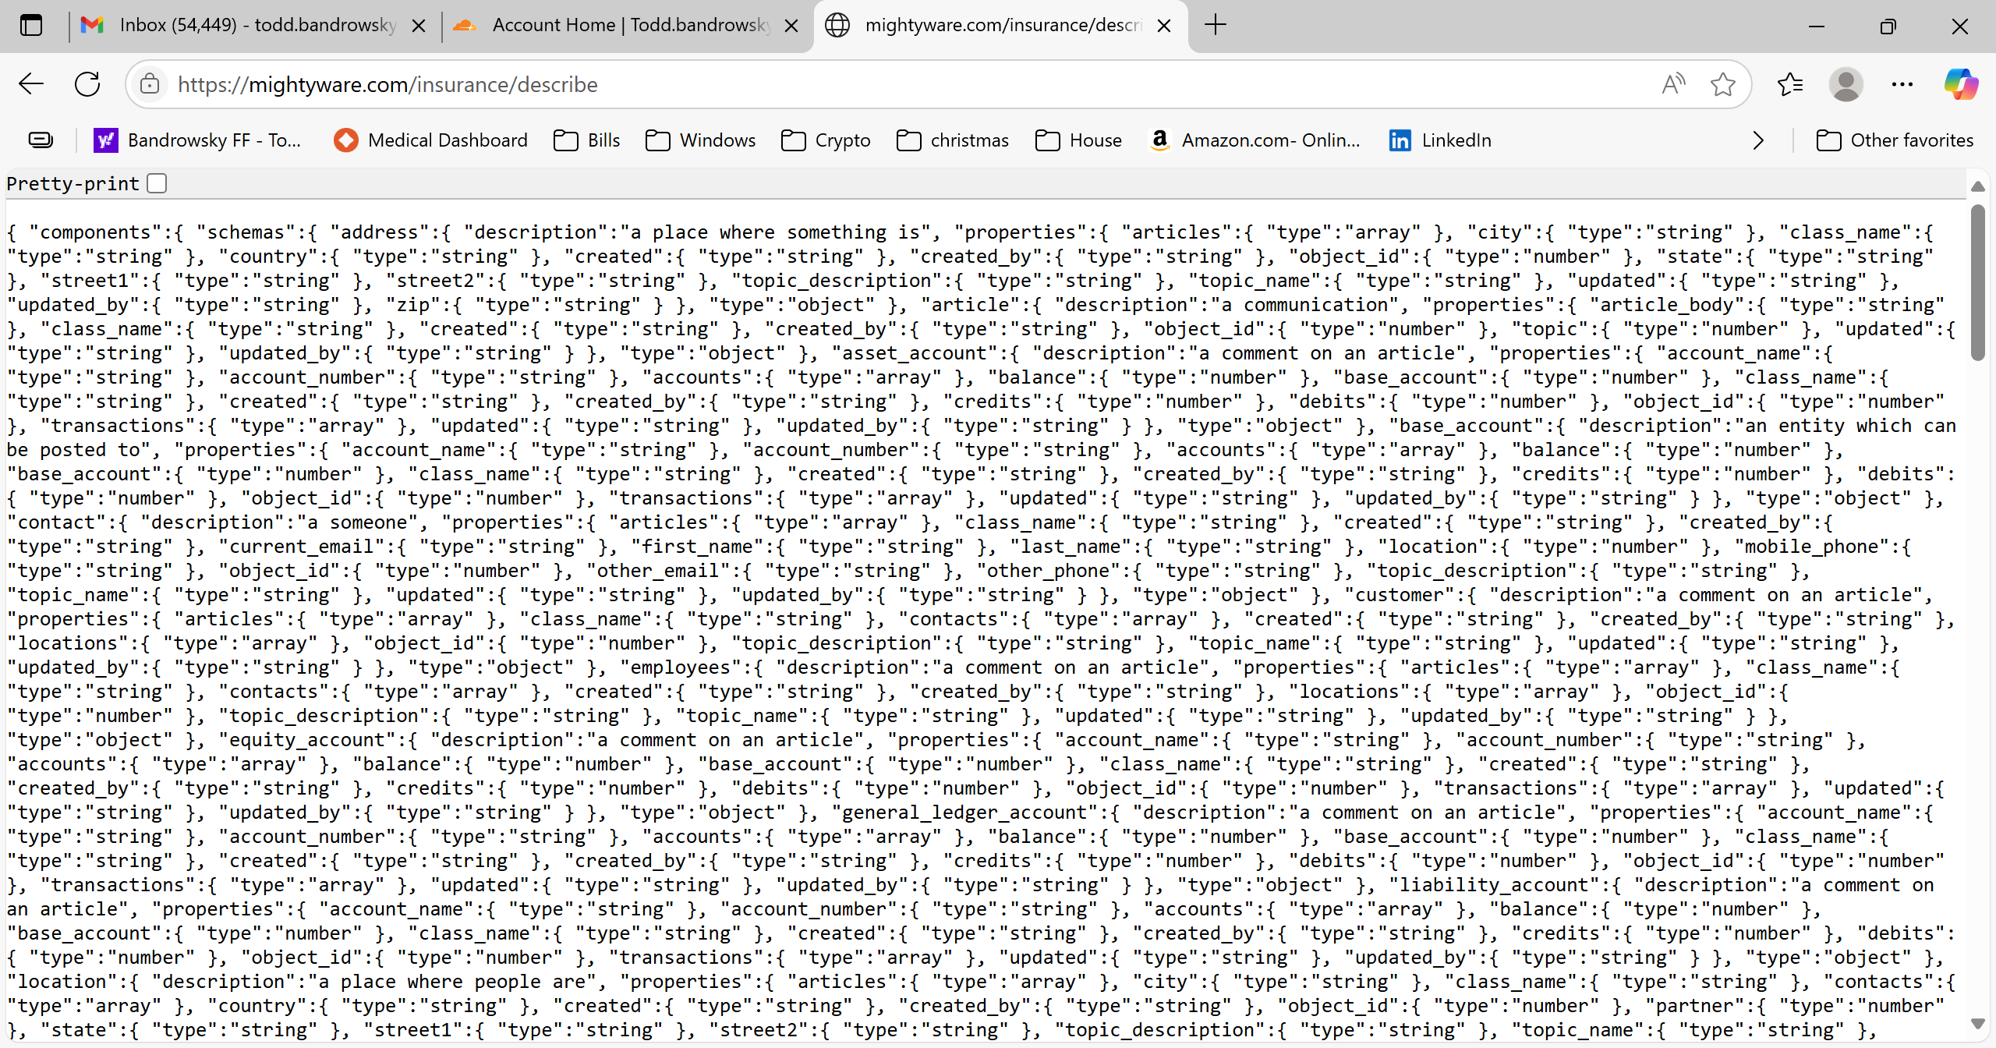

FIRE UP OPENAPI
You’ll give your url to open API to try this out.
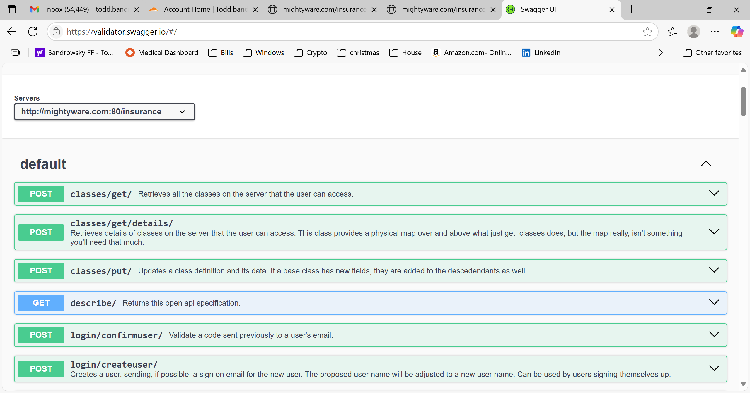

THE POINT OF CORONA

EDIT A NEW CLASS IN YOUR CORONA SCHEMA…
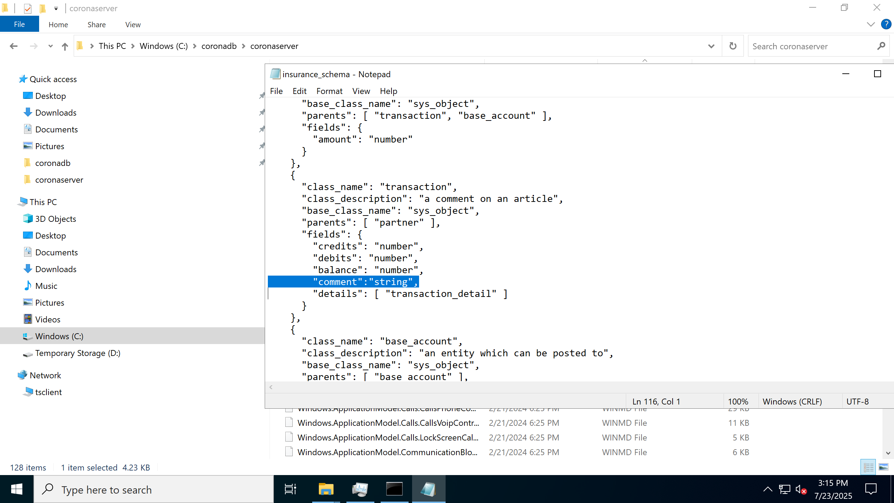

CORONA UPDATES THE DATABASE WITH THE CHANGED SCHEMA
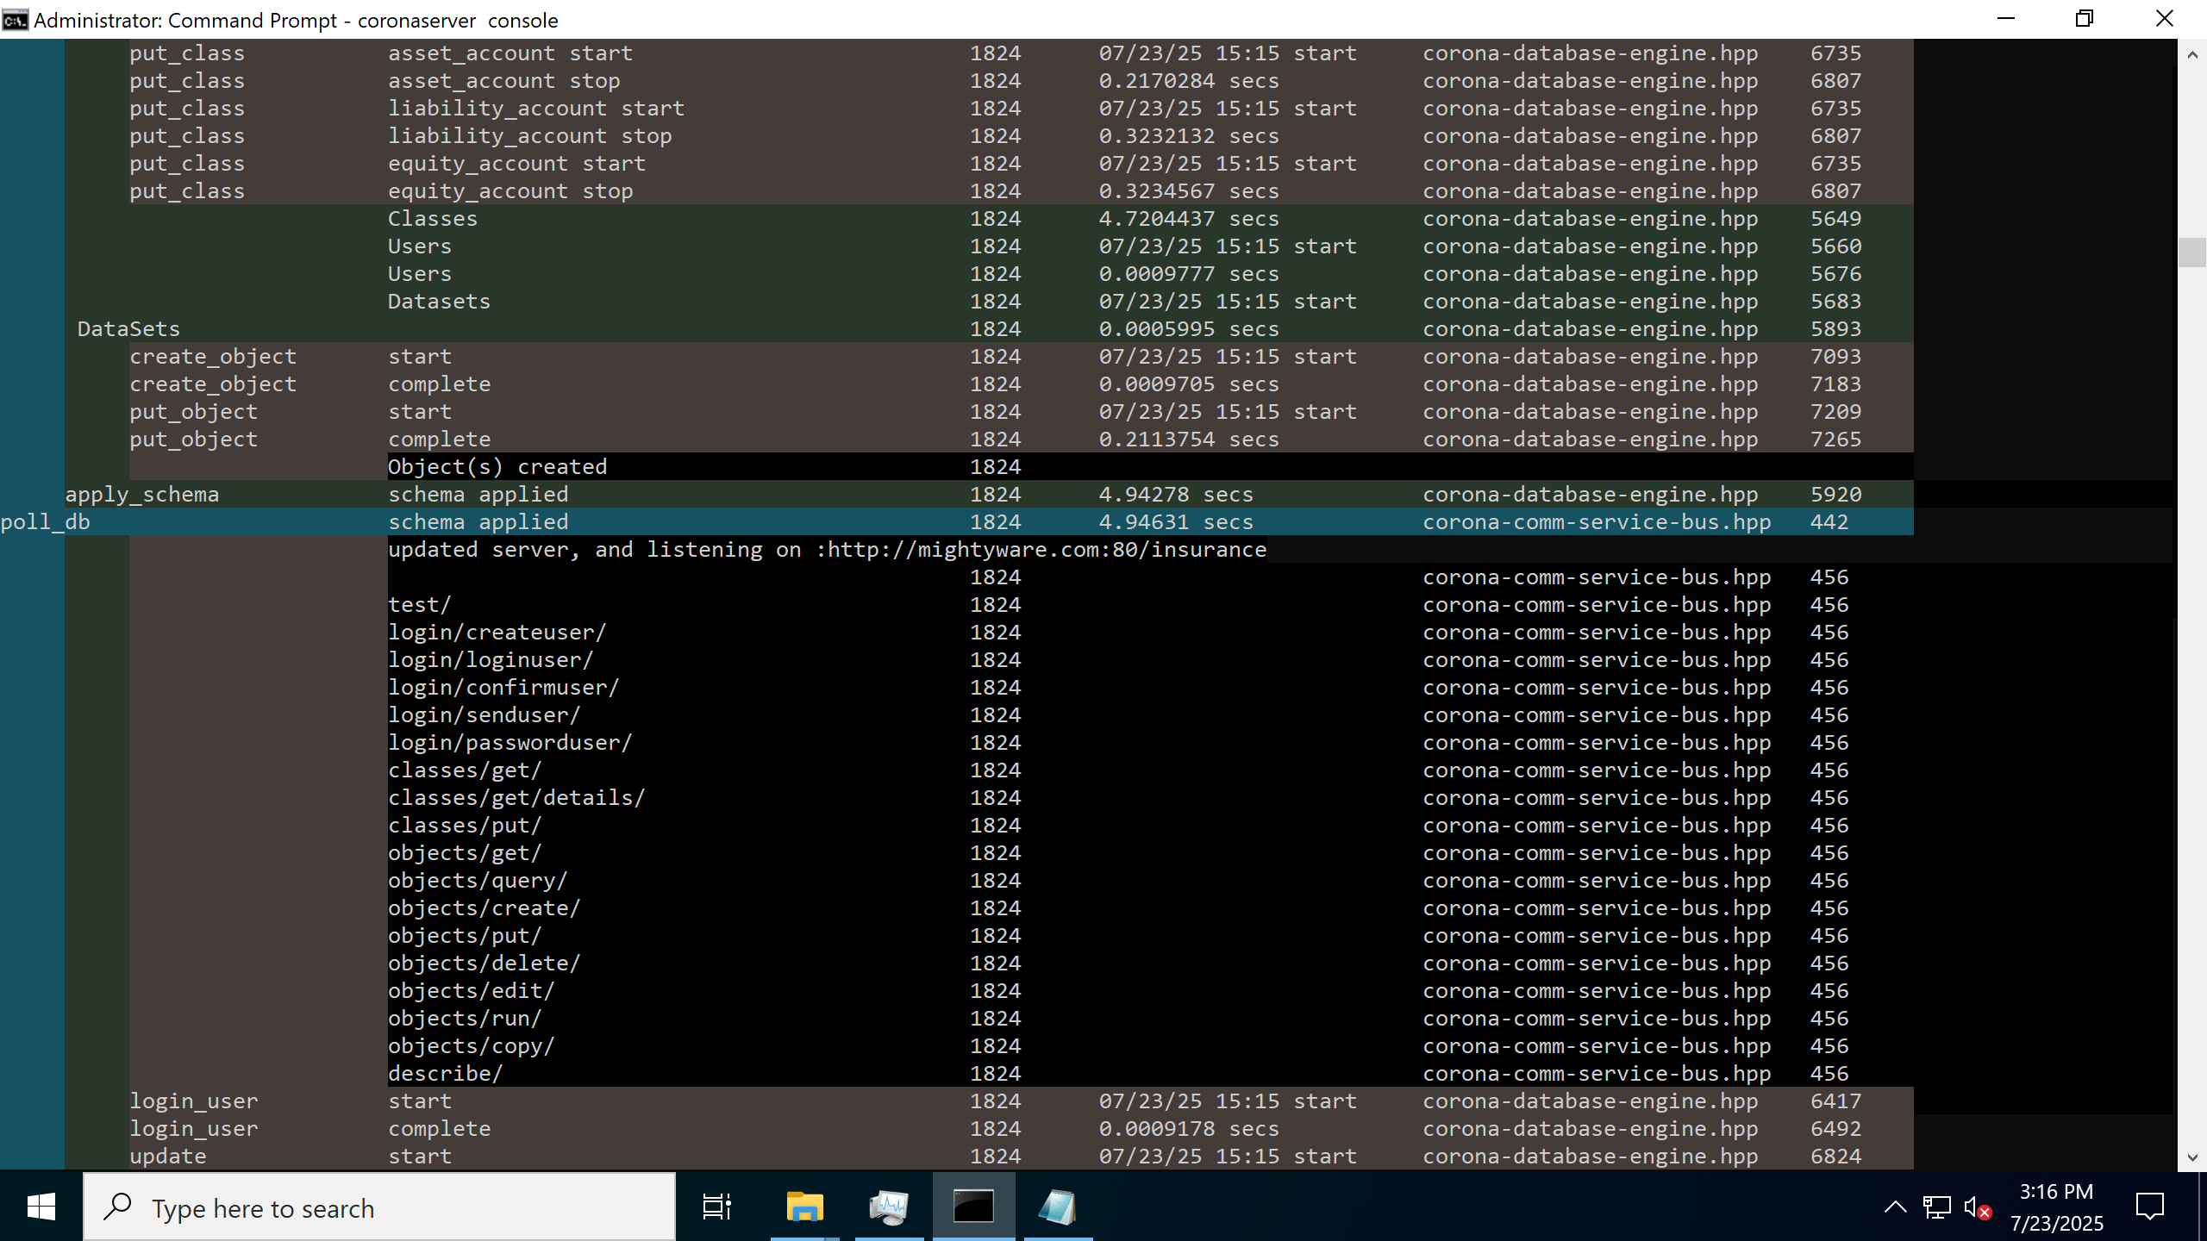
AND YOUR SERVICE STACK IS DONE, DATABASE, API, THE WHOLE THING.
DONE.
