Bao Lam

810989245

**GAME ENGINE CONCEPT**

**ASSIGNMENT 3**

**Things I have done to the game.**

* Finish the tutorials from Jimmy Vegas.
* Having 3 levels: 1 from the tutorial, 2 added by myself.
* Level 1: Added moving platform and build a simple level.
* Level 2: There are two paths: normal and hard one.
  + Create 2 signs having: “Hard” and “Normal” on them
  + The platform will disappear after amount of time (2.5s or 1.5s)
  + There are blocks after the player move away from them, they will disappear. (Disappear after exit).
  + There are blocks after the player enter for some time, they will disappear. (Disappear after enter).
  + There are fake blocks, the player will fall through them if she steps on them. They instantly reveals a hole there when the player enters them.
* Level 3: a whole different scene. Like a park.
  + Trees: staying near the trees for a while will give you gems or things will kill you when you touch them.
  + Pools: there are gems underwater, you can’t see them. You can just swim around and hope to find them. Don’t stay underwater for too long, you’ll drown. You can still hop in and out, just don’t stay too long.
  + Textures and materials for the scene.
  + Animation: gems come from the ground near the tree.
* Added tips on loading screen before going into levels.

Level 2

Level 2


Level 3

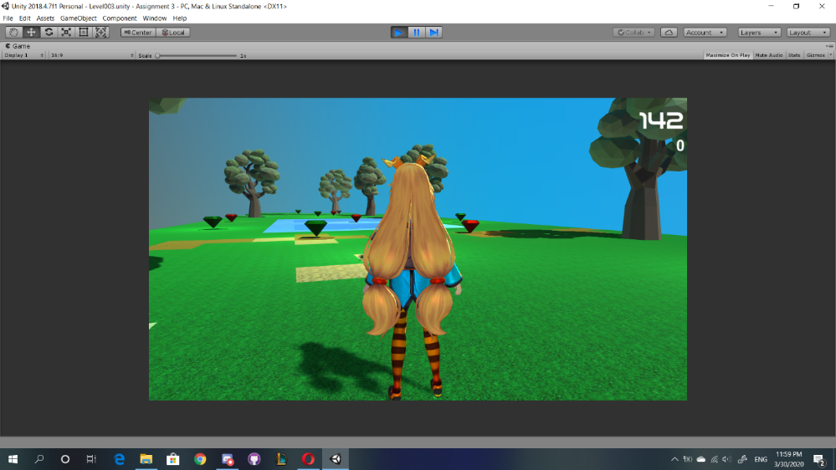

Tip for level 3

Loading screen with tips for level 3


Blocks disappearing

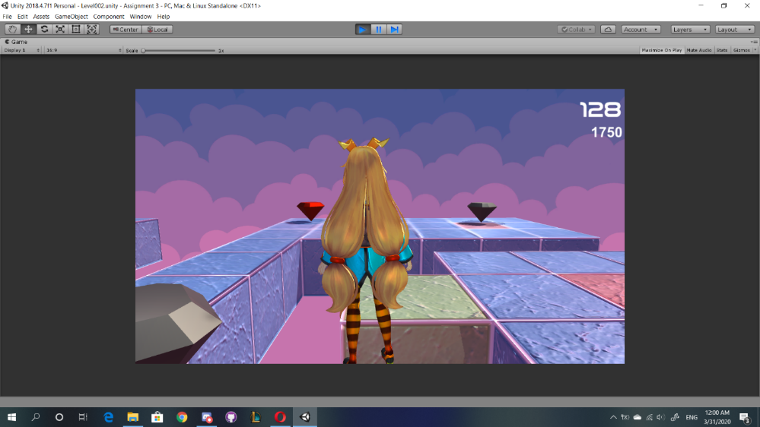

Staying near the tree for 1s (I think).

