**Local, Real-Space Averaging of Electron Density Maps**

*Thomas Barends, MPI for Medical Research, Heidelberg*

**Goal:**

While looking for damage effects in protein crystallography data collected with free-electron lasers, faint features were noticed in difference electron density maps. These include peaks around peptide units, aromatic rings and iron-sulfur clusters. To increase the signal for these features, software was written to average the local electron density around such moieties. For instance, for the 129 residues in lysozyme, this yields 129-fold averaging of the density.

For iron-sulfur clusters, the averaging is not only performed over the various clusters present in the structure, but also for all 12 symmetry-related orientations of each cluster.

**Description of the software:**

The software requires map coefficients (amplitudes and phases, optionally with a weighting factor such as a figure-of-merit) as well as atomic coordinates of at least the units around which the map is to be averaged. Moreover, it requires identifiers to select the units around which averaging needs to take place as well as some settings such as the unit cell, the size of the map to be used and the desired grid spacing.

In the first step, the map coefficients are read, and if necessary converted from degrees or radians/π into radians. This file must be in *P*1. The first record in the file is listed for checking purposes.

Then, the pdb file is read and the averaging loop starts.

The program will identify each listed peptide, phenylalanine (or tyrosine or both) or iron/sulfur cluster and extract the coordinates.

From these coordinates, a Cartesian coordinate system is set up that is used to define a grid around the unit under study. Then, the electron density at all grid points in this box is calculated by direct summation (not FFT!)

All boxes are added together and the result is normalized by the standard deviation. The resulting map is written out in XPLOR format along with a pdb file containing one of the moieties being used to average around centered in the output map. Commands to read the whole into pymol are suggested.

To set up the coordinate system, the program defines an x and a y direction from the atomic coordinates. For peptides and phenyl rings, this is done as indicated below:

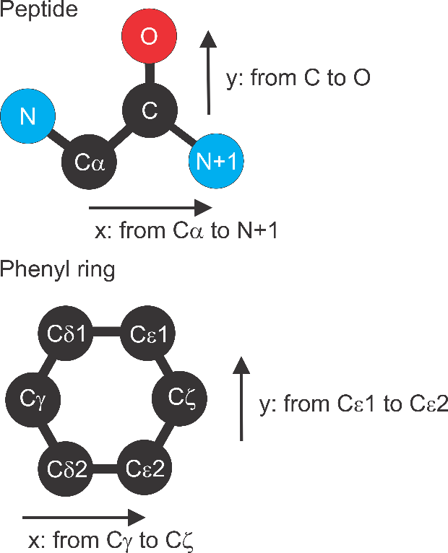

The x and y directions are turned into normalized **x** and **y** vectors. The **z** vector is then defined as the cross product between the two.For iron-sulfur clusters, there is also averaging over the various orientations of the cluster. This is done by swapping the atoms used for the definition of the coordinate system for all 12 possible permutations:

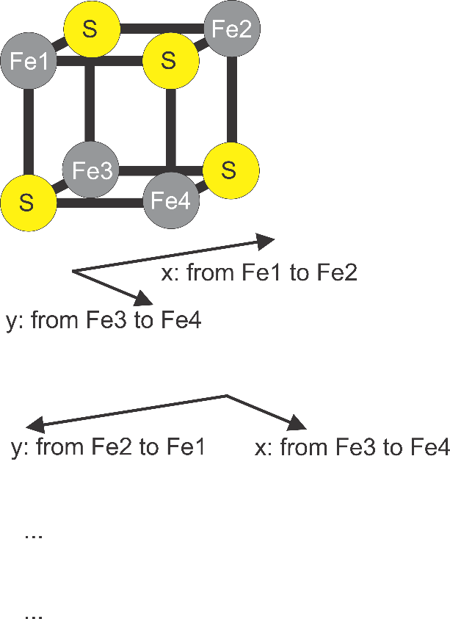

**Dependencies and other crucial points:**

1-The software was written for python2.7

2-Numpy for python2.7 must be installed

3-The input map coefficients should be in eye-readable ASCII, space delimited. Each line should contain h,k,l,F,phi and in some cases FOM

4-It is crucial that before exporting the map coefficients to this format, they are expanded to *P*1. Both expansion and export can be performed easily using SFTOOLS using the following commands:

expand

write myfile.hkl col 1 2

format(4i3,2f14.6)