Tyler Bartlett   
02/10/2019  
Dr. Breeann Flesch  
CS361 – Algorithms

Lab 2 Report

I verified the radix Sort worked by printing off the first ten numbers read into the file and printed them again after the sort. I also ran it through the *flgIsSorted()* method to verify sort as well. Output of this:

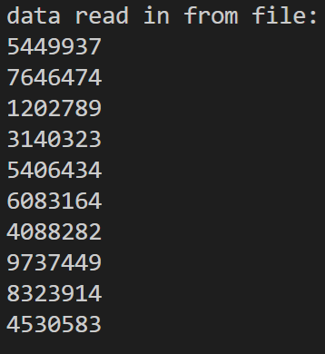 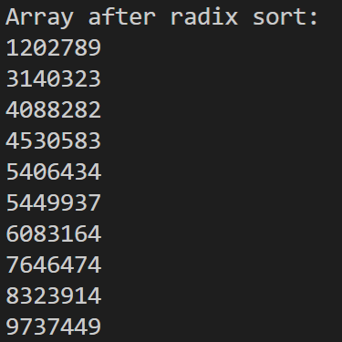 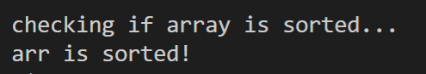

I waited to the last minute to write the lab and did not get the bucket sort algorithm to work in time. I have skipped it for this lab and may come back later to fix it. I will not be able to test my algorithm at 1 million or 10 million numbers read in as the time taken will exceed what I can do for this report to be turned in on time. I copied the merge sort from lab 1 to lab 2 to compare my radix sort against. Below is a table of measured times.

|  |  |  |  |  |  |  |
| --- | --- | --- | --- | --- | --- | --- |
| Lines Read: | Run Number: | time (seconds) taken to read file: | time (seconds) taken on radix sort: | time (seconds) taken to verify sort after radix sort: | time (seconds) taken on merge sort: | time (seconds) taken to verify sort after merge sort: |
| 1000 | Run 1: | 0 | 0.006 | 0 | 1.204 | 0 |
| Run 2: | 0.001 | 0.005 | 0.001 | 1.002 | 0 |
| Run 3: | 0.001 | 0.011 | 0.001 | 1.311 | 0 |
| Average: | 0.000666667 | 0.007333333 | 0.000666667 | 1.172333333 | 0 |
| 10000 | Run 1: | 0.008 | 0.104 | 0 | 14.725 | 0 |
| Run 2: | 0.005 | 0.144 | 0.001 | 14.941 | 0 |
| Run 3: | 0.003 | 0.119 | 0 | 14.601 | 0 |
| Average: | 0.005333333 | 0.122333333 | 0.000333333 | 14.75566667 | 0 |
| 100000 | Run 1: | 0.074 | 1.118 | 0.001 | 129.86 | 0.002 |
| Run 2: | 0.074 | 1.353 | 0.001 | 115.414 | 0.001 |
| Run 3: | 0.043 | 1.1 | 0.002 | 104.743 | 0.002 |
| Average: | 0.063666667 | 1.190333333 | 0.001333333 | 116.6723333 | 0.001666667 |
| 1000000 | Run 1: | 0.691 | 17.275 | 0.016 |  |  |
| Run 2: |  |  |  |  |  |
| Run 3: |  |  |  |  |  |
| Average: | 0.691 | 17.275 | 0.016 | #DIV/0! | #DIV/0! |