Bartlett, Tyler
May 31, 2019
CS 365 – Operating Systems

Homework Assignment 4: Chapter 7

7.12. Assume a multithreaded application uses only reader — writer locks for synchronization. Applying the four necessary conditions for deadlock, is deadlock still possible if multiple reader — writer locks are used?

7.19. Consider the version of the dining-philosophers problem in which the chopsticks are placed at the center of the table and any two of them can be used by a philosopher. Assume that requests for chopsticks are made one at a time. Describe a simple rule for determining whether a particular request can be satisfied without causing deadlock given the current allocation of chopsticks to philosophers.

7.22. Consider the following snapshot of a system:
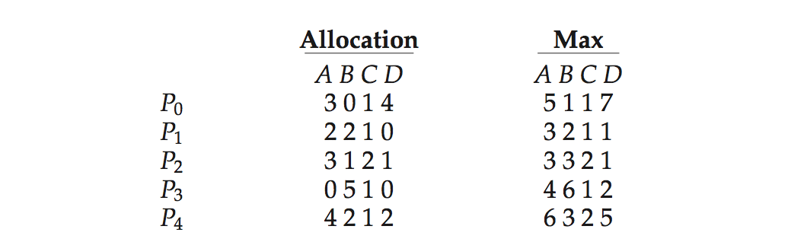
Using the banker’s algorithm, determine whether or not each of the following states is unsafe. If the state is safe, illustrate the order in which the processes may complete. Otherwise, illustrate why the state is unsafe.
a) Available = (0, 3, 0, 1)
b) Available = (1, 0, 0, 2)

7.23. Consider the following snapshot of a system:
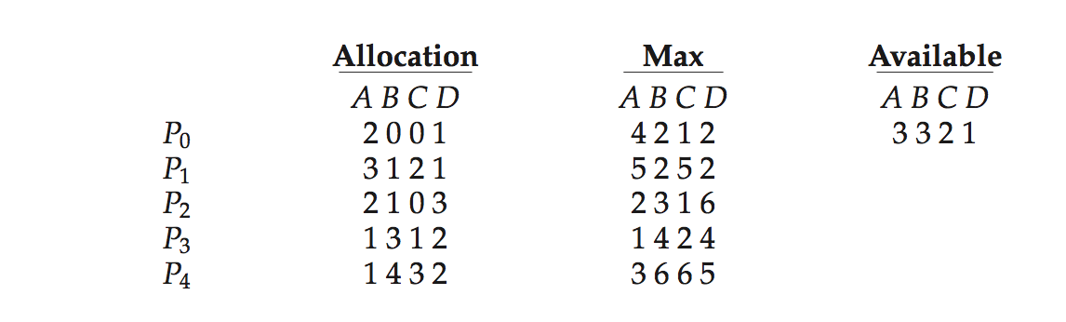
Answer the following questions using the banker’s algorithm:
a) Illustrate that the system is in a safe state by demonstrating an order in which the m processes may complete.
b) If a request from process P1 arrives for (1, 1, 0, 0), can the request be granted Immediately?
c) If a request from process P4 arrives for (0, 0, 2, 0), can the request be granted immediately?

7.12. Yes. mutual exclusuion still exists because they can’t share the same writer. Hold-and-wait exists because a thread can hold one reader – writer lock while waiting to take get another one. No preemption exists because locks cant be removed and a circular wait for between all the threads is possible.

7.19. When a philosopher makes a request for their first chopstick, do not satisfy the request only if there is no other philosopher with two chopsticks and if there is only one chopstick remaining.

7.22. Its not safe. P0 and P4 get deadlocked and the rest finish in the order P2, P1, P3. When P2 finishes Available = (3, 4, 2, 2), when P1 finishes Available = (5, 6, 3, 2), and when P3 finishes Available = (5, 11, 4, 2). for P0 to run Available must equal (5, 1, 1, 7) but there are only 8 of resource R3 total and P4 has 2 of them. In order to run P4 Availble must equal (6, 3, 2, 5) but 5 of resource R3 are needed and only 2 are available. R3 causes the deadlock.

7.23. a) the order is P0, P3, P1, P2, P4
b) yes and the processess finish in the same order
c) no, no process will finish because all of the need values in the third column are greater than 0.

