6

**Fundamentals of Machine**

**Learning**

“Now, it’s my belief that Python is a lot easier then to teach to students programming and teach them C or C++ or Java at the same time because all the details of the languages are so much harder. Other scripting languages really don’t work very well there either.”

~Guido van Rossum

Topics covered in this Chapter

6.1 What is Machine Learning

6.2 History of Machine Learning

6.3 Why Python in mobile app

6.4 Kivy Architecture

6.5 Python developed mobile apps

6.6 History of Kivy

6.7 Why not Cordova

6.8 Kivy Versions

6.9 How, its different from cross-platform app development framework?

6.10 System Requirements

6.11 Installation of Kivy in various platforms

6.11.1 Installation in Windows

6.11.2 Installation in Mac OS

6.11.3 Installation in Linux

6.11.4 what are Wheels and pip

6.11.5 Cython Installation in Linux

6.11.6 Verifying installation

6.12 Creating First Hello World App

6.12.1 Event Handling in Kivy

6.12.2 Event Dispatcher

6.12.3 Main Loop

6.12.4 Custom Events

6.13 Anatomy of Kivy application

6.13.1 Running Kivy Application

6.13.2 Listing and uninstalling Kivy

Summary

Key terms

Review Questions

1. What is Machine Learning?

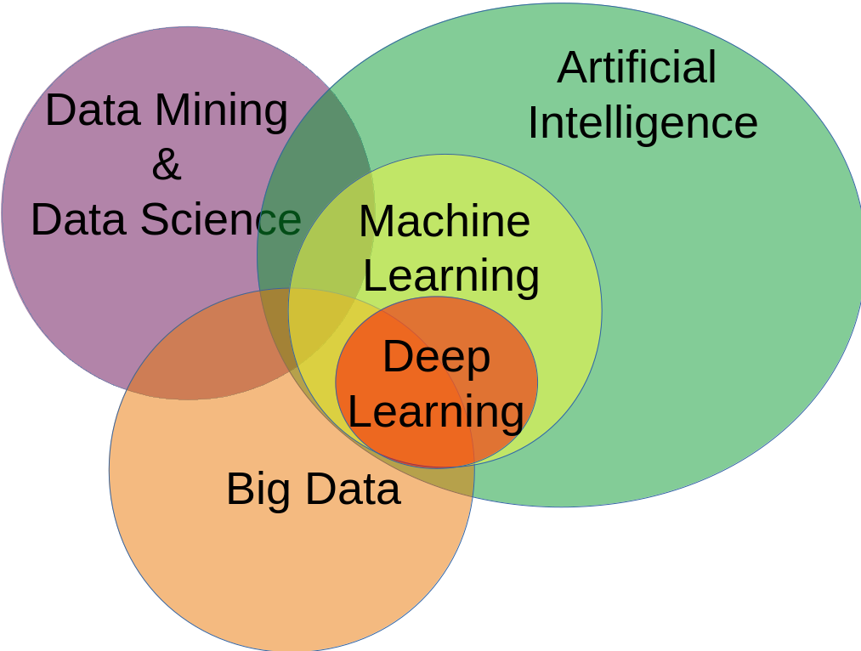 Machine Learning is a part of Artificial Intelligence as given in the *figure 6.1 classification of machine learning.* which works on the concept of building systems from data that can function with minimal intervention. Machine Learning can be defined as the division of computer science that uses statistical functions and techniques to give computer systems the capability to learn from data (given data could be structured or unstructured) without being explicitly programmed. Machine learning two steps in which first step is to identify patterns in the existing data. Based on these patterns in the data classifiers that label the pattern are build. But in the second step the new data that comes sorted using the classifiers to make forecasting based on this data.

Machine learning enables analysis of colossal quantities of varied data. It delivers most

1. *Classification**of Machine Learning*

accurate results with fast speed that help to identify major opportunities or serious risks by analyzing the business constraints over wide spectrum, which may either be significant or non-significant. The combination of machine learning, Artificial Intelligence and cognitive technologies can bring more efficiency in processing huge volume of data. Machine Learning is the process of parsing data through algorithms. Learning from the data then making forecasting, getting insight and relevant inferences to aid business development is the objective of machine learning. Entire machine learning goes around classification and forecasting as given in the *figure 6.2 Machine Learning areas.* The classification is the problem of identifying to which of a set of categories, a new observation belongs, on the bases of a training set of data containing observations whose category membership is known as classification. The forecast is a process of making predictions of the future based upon the past and present data most commonly by analysis of trends. An algorithm can forecast the number of person who may order hot an spicy food online in the winter that are the age group of 20-30 year with a disposable income of $25USD who spend 30 minutes on our website. The analysis was done in the rainy season helps make this forecasting for winter and plan the suppliers accordingly.

1. *Classification**of Machine Learning*
2. History of Machine Learning

Geoffrey E. Hinton is known as father of machine learning he is a English Canadian cognitive psychologist and computer scientist. He has worked on Google Brain project and designed artificial neural network. The first time word **“Machine Learning”** used by Arthur Lee Samuel in 1959 at IBM. Mr. Samuel has developed an application for playing checkers that observes positions and learns an implicit model that results in accurate moves. He has disapproved that machines can’t go beyond the written code and learn patterns like human.

* In the year1950, Alan Turning created the “Turning Test” that tests a computer if it was intelligent enough to fool humans into believing it is also a a human. Thus, was born the concept of artificial intelligence.
* In the year 1957, Arthur Samuel designed the first computer learning program which was for the game of checkers. The computer begin improving its game as it played by analyzing the moves that could build strategies to win and incorporated them into its program.
* In the year 1967, “nearest neighbor” algorithm was formulated that enabled computers to use a basic pattern recognition. This was used to provide a route map to salesmen who had a travel a number of cities. The advantage of this algorithms was that a salesmen could begin from any city but the map insured that they visit all the cities during their tour.
* In the year 1979, Stanford University student has created a cart which was called “Stanford Cart”. It could navigate obstacle in the room on its own.
* In the year 1981, Gerald Dejong introduced the idea of explanation based learning. In this theory a computer would analyses the training data and would create a general rules to follow by discarding unimportant data.
* In the year 1990, work on machine learning is driven by data rather then knowledge. Scientist has moved their focus on creating programs for computers that were able to analyses a large amount of data and reach on the conclusion from it. In other words you can say that computers has started to **“learn”** from the results.
* In the year 1997, IBM’s Deep Blue beat the world champion at chess.
* In the year 2000, it has been noticed exponential growth in the development and application of machine learning.
* In the year 2006, Geoffrey E. Hinton coined the term **“Deep Learning”.** It explained new algorithms that would enable computer to see and differentiate objects and text in images and videos.
* In the year 2010, The Microsoft Kinect could track 20 human features at a rate of 30 times per second which enables persons to to interact with the computer through the movements and gestures.
* In the year 2011, IBM’s Watson won over it’s opponents at jeopardy.
* In the year 2011, Google Brain is developed and its deep neural network enables to learn and classify objects similar to a cat.
* In the year 2012, Google X Lab developed a machine learning algorithm that was capable of browsing through YouTube videos and could identify the videos that contained cats in it.
* In the year 2014, Facebook developed DeepFace, a algorithm that was capable of recognizing individuals in the picture that was as good as human.
* In the year 2015, Amazon has created its own machine learning platform.
* In the year 2016, Googles artificial intelligence algorithms won over a professional player at the Chinese board game. Google DeepMind developed the AlphaGo, increase in self driving cars and TensorFlow’s influence on neural network technology.

1. Traditional Programming vs Machine Learning

In the traditional programming techniques programs are intended to perform a task by making use of software schedules and instructions. Where as in machine learning will have the capability to make algorithms learn how to perform a task, where as in standard programming technique programs will be based on logic and instructions developed by programmers during application development. Easy standard programming consists of following three major segments:

* **Input:** It will be the sequence of alphanumeric symbols presented and stored as per some given set of predefined policy and that utilize a restricted set of communication media such as keyboard, mouse and so on. In the machine learning input could be image, audio, video, or data. Images may refer to one dimensional symbols such as types text, two dimensional objects and three dimensional pictures, video and audios. Audio input may contain music, spoken language, noise or other sounds made by humans and objects. Some aberrant inputs will also be taken into consideration in machine learning like touch smell and taste. Measures of temperature, smoothness, resistance to pressure are some good characteristics example for touch.
* **Processing:** In normal programming, processing is about manipulation of the stored symbols by a set of predefined set of predefined algorithms while in machine learning processing is all about knowledge demonstration and representation, pattern matching, search operations, application of logic, problem solving and learning.
* **Output:** In standard programming, output is a series of alphanumeric data , might be given in a given set of colors, that symbolize the result of processing and that is placed on such a medium as a CRT screen, paper, or magnetic disk. In machine learning the output will be summary of statistical and mathematical functions which can be unearth business insights and above all an output can be a any form of image or synthesize speech recognition.

1. 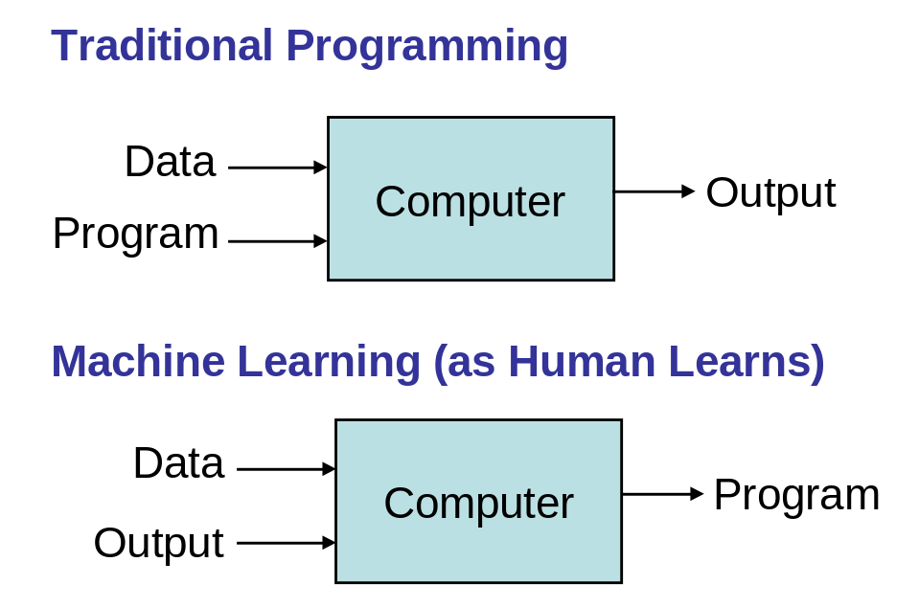*Traditional Programming vs Machine Learning*
2. Applications of Machine Learning

An Individual who has logged into YouTube with his account has experienced the outcome of this technology because his home page is a Machine Learning output, recommended products on Amazon, friends suggestion on Facebook recommended movies on Netflix are real life application of Artificial Intelligence and machine learning algorithm. Some other example are Self-driving Google/Tesla car, I-phone X, which uses face recognition for unlocking, OK Google, and Alexa.

Now most of the banking, finance and investment companies are using the machine learning to avoid Cyber crime, fraud detection and so on. Machines can help in filtering valuable chunks of information or data that will be helpful in major advancements and we are already considering how this technology can be implemented in wide range of industries. Machine learning addresses several business problems which can not be identified or extracted by using normal analytical method. It is the hidden facts with a degree of supporting statistical function and makes the business easy.

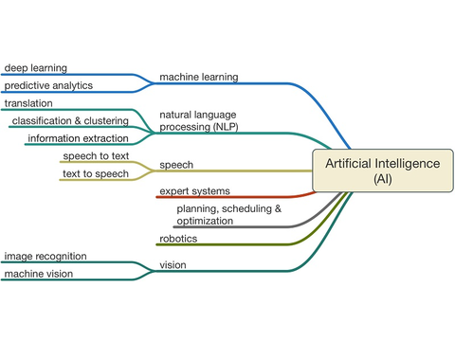

1. *Artificial Intelligence Classification*
2. **Challenges of Machine Learning**

Machine Learning is creating major strides with BFSI, FMCG domains and autonomous cars. This technology still has a long to go. The reason being ML hasn’t been able to triumph over a number of challenges that still stands in the way of its advancement. Some of them challenges are given below:

**Memory Augmented Neural Networks –** memory network still need anormous memory space to store data such kind of neural network desire to be captivated up to a memory block that can be both written and read by the network. This is the major hurdel in the machine learning which need to be surmount. We have to find the best solution for the network to ascertain facts, store then and seamlessly access and process them whenever required.

**Natural Language Processing (NLP) –** even though huge money and time has been invested but still not reached the point to achieve natural language processing and comprehensive of a language. This is a big challenge even for deep neural networks. Now we train out computer to understand and signify language and simulate reasoning based on these criteria however this is substantially no up to the mark and there is a long way to go.

**Attention –** Human visual system utilities attention in a robust way to integrate a wide variety of features. Right now Machine learning is only focusing on small chunks of inputs step by step and assimilate the result in the end. To achieve this we need mechanism that will incorporate human visual and auditory system into atrificial neural network. Currently we are using softmax function (Most probable classification while several inputs are given) to access memory blocks. Attention is intended to be non-differentiable.

**On-time Learning –** even after evolution of several neural networks application and algorithms still we have not able to achieve one-time learning, also known as one-shot learning. Hitherto, traditional gradient-based models require huge amount of data to get trained and this is often in the form of epochs. That is why we have to find out the solution facilitate artificial neural network to learn via one or two examples.

**Deep Reinforcement Learning –** How to enable deep reinforcement learning to control and manage robots. We can make humanoid robot characters like C-3PO a reality. Deep reinforcement learning enables ML to address harder problems.

**Object Recognition –** Object recognition still a tough nut for algorithms to crack because image classification and recognition in ML still not done accurately. The best way to over come this challenge is to supply more resources and time till reach the point where solution are capable to providing accurate result.

1. Programming Languages for Machine Learning

The most popular programming language for machine learning languages are:

1. Python
2. R
3. Java
4. JavaScript
5. C
6. C++
7. Scala
8. Julia

R and python are per-dominant machine leaning language because of their easy learning curve. These languages are excellent at abstracting the complexity in addressing the statistical and analytical issues. These programming languages to no longer dependency and rely on IT professionals for everyday data solutions. Data scientist and software professionals are functioning collectively to fill the space between the complex algorithms and higher order programming language

1. Elements of Machine Learning

The elements of machine learning are given below:

1. Comprehending the problem
2. Gathering data
3. Exploring data
4. Identifying the method of learning
5. Selecting the appropriate algorithms
6. Analyzing the results
7. Machine Learning in Practice

with all buzz around AI big data, ML and deep learning business is becoming inquisitive about the application and advantages of ML and how it can help the drive into the world of opportunity. Most of us have heard about Machine Learning but are not sure what exactly it is all about, how can ML solve the business related challenges or and its value add to a business. ML is a data analysis process which leverages ML algorithms to iterativly learn from the existing data and help computers find hidden insights without being programmed for.

Amazon, Google, Microsoft Azure introduced cloud machine learning platforms, which signifies the gaining prominence of ML in the recent years. Amazon using its cloud ML in various aspects like data analytic data mining and recommending system and many other scenarios. Your YouTube account has a customized homepage based on your browsing history and other personal aspects identified by ML. Also the Facebook recommendation of friends is also one of the basic example of ML in practice. Apple phone face recognition and many such real time scenarios will keep burgeoning according to the industry experts, as well as still pioneering stages of ML.

## **Summary**

* Machine Learning is a part of Artificial Intelligence which works on the concept of building systems from data that can function with minimal intervention.
* Machine Learning can also be defined as the division of a computer science that uses statistical functions and techniques to give computer system the capability to learn from data without being explicitly programmed to provide valuable business insights.
* Two major area of application of machine learning are forecasting and classification of data.
* Basically in standard programming the input will be sequence of alphanumeric symbols presented and sorted as per given some set of predefined policy and that utilizes a restricted set of communication media such as keyboard and mouse and so on
* The input might be an image, audio, video and data, images may refer to one dimension symbols such as types text, two dimensional text or three dimensional pictures.
* Processing is all about knowledge demonstration and representation, pattern matching, search operations, application of logic. Problem solving and learning.
* Output will be the summary of statistical and mathematical functions which can unearth business insight and above all an output can be any form of image or synthesis speech recognition.
* Recommended products of Amazon, friends suggestion of Facebook, recommend movie on Netflix are all real life use cases of machine learning algorithms.
* R and Python are per-dominant two machine learning languages because of their easy learning curve. These language are excellent at abstracting the complexity in addressing the statical and analytical uses whereas the other lower level languages fail to do so.Key terms

In this chapter you have been learn what is Machine Learning. You have also look at the specific domains in which this technology is used. You have learn the elements of the machine leaning and real life examples.

## Review Questions

1. What is Kivy and it architecture?
2. How to create custom event handler?
3. What are benefits using Kivy over Cordova like cross platform frameworks?
4. What is the main Kivy developed application?
5. Write is Cython and how it’s good for your program?
6. How to install Cython?
7. What is life cycle of Kivy Application?

## **Exercise**

**Learning Check** and **Tick the correct option**

1. The first step in machine learning is ________ in the existing data.
   1. Gathering information
   2. Classification data
   3. Identifying patterns
   4. Analyzing data
2. The two major areas of application of machine learning are ________________.
   1. Analyzing and standard programming
   2. Forecasting and classification of data
   3. Algorithm selection and user interaction
   4. Exploring and gathering data
3. “Turning Test” tested a computer if it was intelligent enough to fool humans into believing it is also a human.
   1. True
   2. False
4. Which of the following is not a element of Machine Learning?
   1. Identifying the method of learning
   2. Exploring data
   3. Analyzing the result
   4. User interaction
5. Which of the following is still a great challenges in ML?
   1. Data Processing
   2. Natural Language Processing
   3. Data analytic
   4. Data mining

**Answer:**

1. C Identifying patterns
2. B Forecasting and classification of data
3. A True
4. D User interaction
5. B Natural Language Processing

**Fill in the Blanks**

1. Kivy has powerful support of _________algorithms to minimize big operation in this channel we supports CPU, GPU, TPU, etc.
2. Every iteration of loop events are generated from_____________________ are rendered to display.
3. Kivy helps you to export______________ for each and every platform for production environment.
4. Easily you can describe your UI with ___________________.
5. inputs are handled by __________________class.

Answers

1. Cython C lavel
2. user input, hardware sensors and frames
3. executable code
4. Kivy language
5. tourch()