Meta Allocator Report
New methodology, full backtest, production decision, and implementation structure
Research window: 2010-04-26 to 2025-12-12 | Live policy date: 2026-03-13
Current core methodology: state engine plus learned beta sizing plus dynamic hedge switching.

1. Executive Summary
The project has now been reframed around one central decision problem: how much equity risk to hold, and what hedge to use when risk should be reduced. This is a cleaner and more defensible objective than forcing a stock picker to carry the full burden.
- SPY buy and hold: CAGR 13.7%, Sharpe 0.79, max drawdown -33.7%.
- Heuristic state overlay: CAGR 12.2%, Sharpe 1.06, max drawdown -24.0%.
- Policy overlay: CAGR 11.4%, Sharpe 1.10, max drawdown -15.1%.
- Conclusion: the new policy overlay now improves on the heuristic overlay in Sharpe and drawdown, but it still does not beat the strongest simple benchmark such as trend following.

2. The Idea In Plain Language
A simple investor in SPY stays fully exposed almost all the time. This system does something more specific: it tries to decide how much equity exposure is justified today, and what protection asset is best if the answer is not 100%.
- Question 1: how dangerous is the current regime?
- Question 2: should equity exposure be high, medium, or low?
- Question 3: if risk should be reduced, is the best hedge SHY, IEF, GLD, UUP, BIL, or TLT?
The live recommendation today is easy to read even for a non-technical user: hold roughly 25.0% in SPY and use SHY as the main hedge.

3. Methodology
The current methodology is no longer a generic allocator. It is a two-part overlay:
- State engine: estimates fragility using Fin_model signals, tail-risk probabilities, macro variables, and cross-asset structure.
- Decision engine: learns a beta bucket and then pairs it with the highest-ranked hedge from the hedge engine.

4. Data And Feature Stack
- Price history: S&P 500 universe prices plus ETF proxies for sectors, rates, gold, dollar, and international markets.
- Macro and liquidity: FRED term spread, Fed funds, M2, balance sheet, and credit spreads.
- State inputs: crash probability, legitimacy risk, crowding, tension, recurrence, and multi-horizon tail-loss probabilities.
- Opportunity context: sector and international maps are retained as supporting context, not as the main decision driver.
- Hedge features: down-market behavior, stress behavior, correlation to SPY, carry, volatility, and recent drawdown.

5. Learning Target
The learned overlay does not try to predict exact returns. Instead, for each historical date it asks: which beta bucket would have produced the best forward utility over the next 5, 10, and 20 trading days, given the hedge that the hedge engine would have selected at that time?
- Utility rewards forward compounding.
- Utility penalizes drawdown and downside deviation.
- Training is walk-forward with embargo and monthly refits.
- When confidence is low, the system can fall back to a neutral bucket instead of pretending certainty.

6. Current Production Decision
- Date: 2026-03-13
- Recommended beta bucket: 25.0%
- Selected hedge: SHY
- Alternative action: beta_040
- Model confidence: 69.8%
- Why: memory_p_fail supported beta target 25%
- Why: tlt_score supported beta target 25%
- Why: tail_loss_10d supported beta target 25%

7. Implementation Structure
The implementation is now organized so the system can be maintained and extended without rethinking the whole repo each time.
Layer | Responsibility | Current Output
Data | Load local history, FMP market proxies, FRED macro series, and defensive ETF history | clean panels for prices, state, volume, macro
Research | Build state features, tail-risk probabilities, hedge rankings, and walk-forward backtests | research_summary.json, policy_backtest_summary.json
Decision | Map state into beta bucket plus hedge choice | current_policy_decision.json
Production | Emit live policy, sector/international context, and hedge ranking | current_allocator_decision.json and supporting csv files
The most important design choice is separation of concerns. The state engine senses conditions, the hedge engine ranks protection assets, and the policy engine only decides exposure size.

8. Backtest Results
Legacy allocator context:
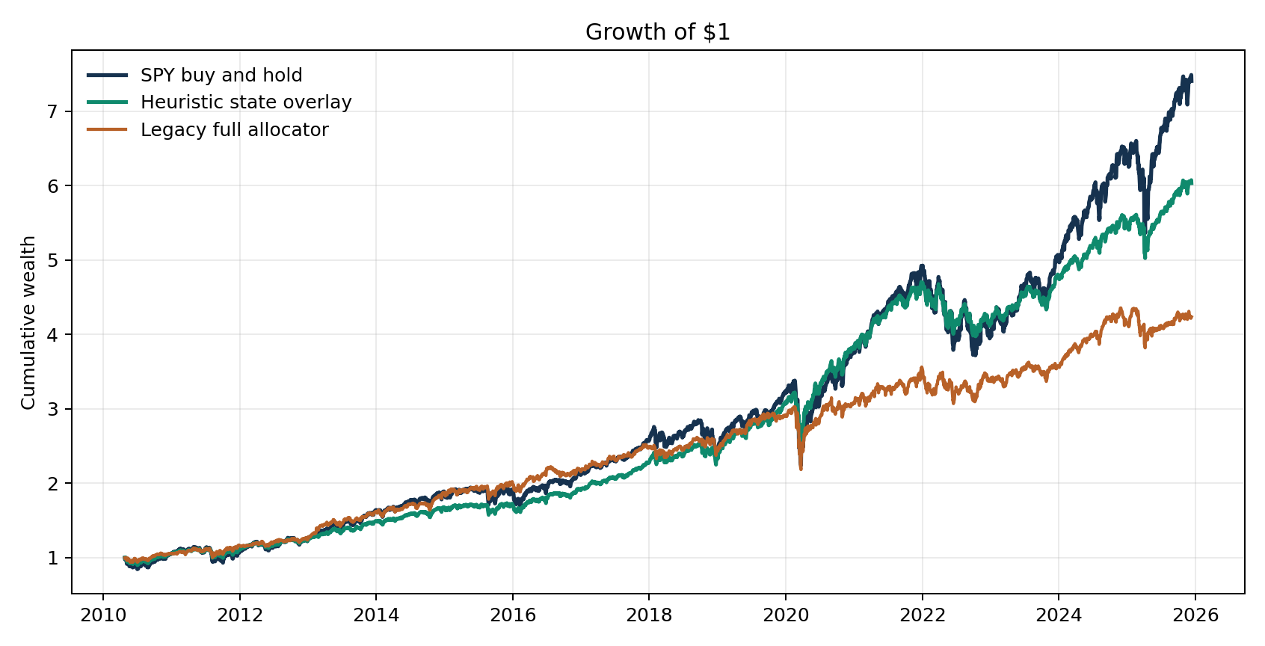
Current overlay comparison:
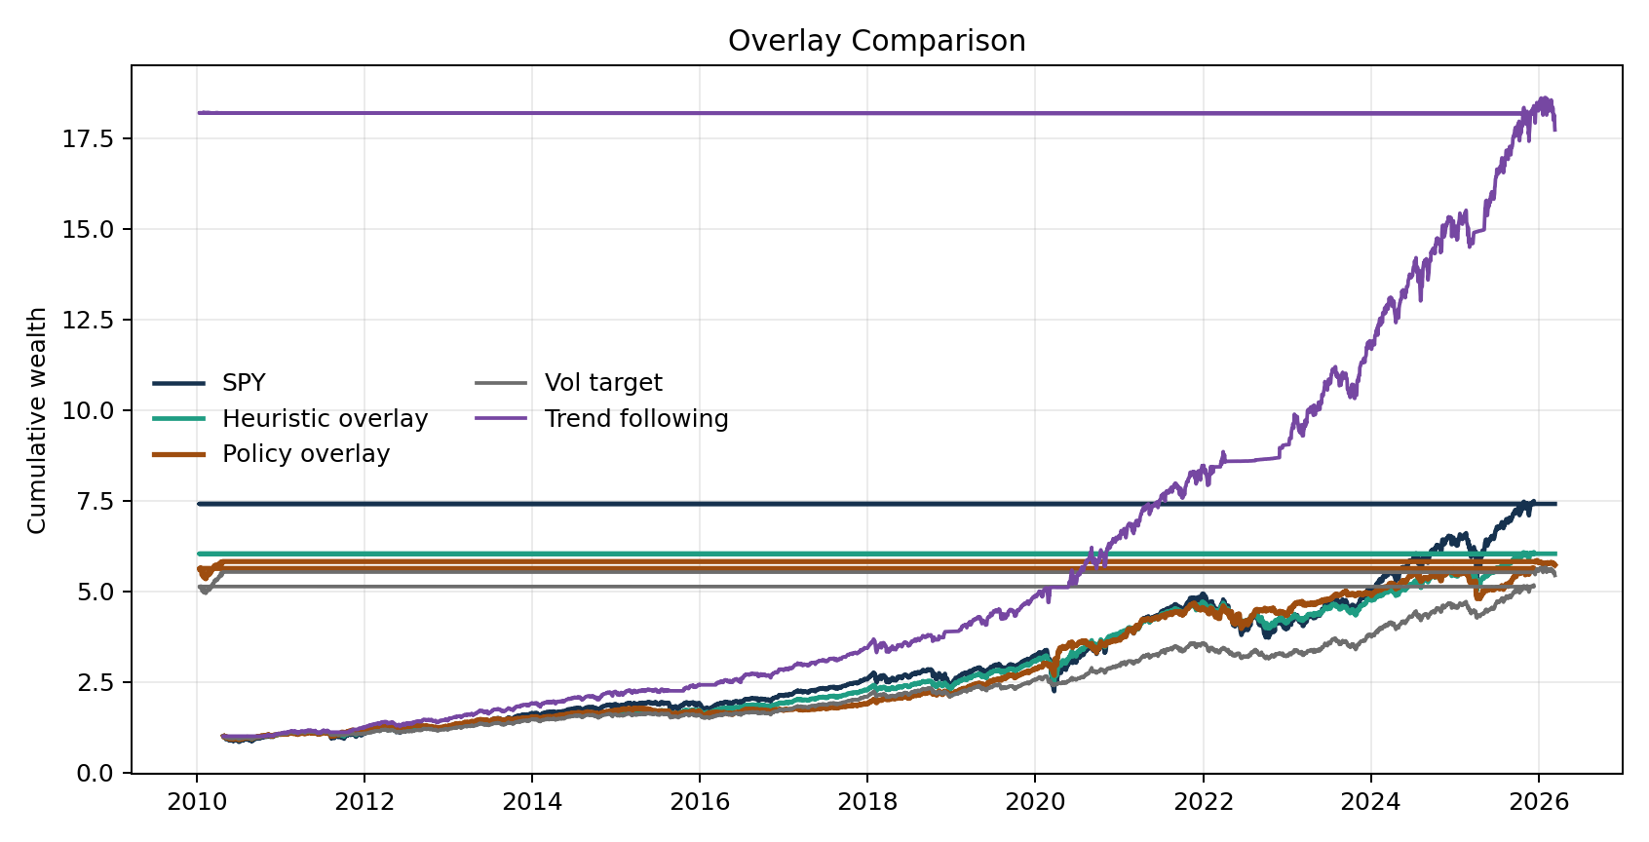
Strategy | Total Return | CAGR | Vol | Sharpe | Max Drawdown
SPY buy and hold | 640.7% | 13.7% | 17.3% | 0.79 | -33.7%
Selection standalone | 649.3% | 13.8% | 15.8% | 0.87 | -33.5%
Heuristic state overlay | 503.2% | 12.2% | 11.5% | 1.06 | -24.0%
Policy overlay | 471.7% | 11.4% | 10.4% | 1.10 | -15.1%

9. Benchmarking The Overlay
Overlay Benchmark | CAGR | Sharpe | Max Drawdown
Heuristic overlay | 11.8% | 1.04 | -24.0%
Policy overlay | 11.4% | 1.10 | -15.1%
Static 60/40 | 9.6% | 0.96 | -21.0%
Vol target | 11.1% | 1.16 | -12.1%
Trend following | 19.5% | 1.71 | -10.1%
This is the honest ranking: the policy overlay now beats the heuristic overlay on Sharpe and on drawdown, but a strong trend-following baseline is still better overall.

10. Out-of-Sample And Confidence Behavior
Block | Start | End | CAGR | Sharpe | Max Drawdown
1 | 2010-04-26 | 2015-07-09 | 13.2% | 1.18 | -11.4%
2 | 2015-07-10 | 2020-09-22 | 8.9% | 0.60 | -27.9%
3 | 2020-09-23 | 2025-12-12 | 7.1% | 0.65 | -13.8%
Confidence bucket | CAGR | Sharpe | Max Drawdown
High confidence | 16.8% | 1.63 | -14.1%
Low confidence | 6.2% | 0.59 | -18.4%
The confidence split is important. High-confidence policy decisions materially outperform low-confidence ones, which suggests the model is learning something real even if the full overlay is not yet the best benchmark in the stack.

11. Why This Can Be Better Than Buy And Hold SPY
The correct claim is not that the system always beats SPY on raw return. It does not. The better claim is that it gives a more controllable risk profile and a more explicit defense process.
- Policy overlay drawdown: -15.1% versus -33.7% for SPY.
- Policy overlay Sharpe: 1.10 versus 0.79 for SPY.
- The system can rotate between cash-like bills, short Treasuries, intermediate Treasuries, gold, and the dollar instead of assuming one hedge is always best.
- The decision is operationally interpretable: choose a beta bucket and a hedge, not a black-box portfolio.
- A shallower drawdown profile is easier to hold through stress, which matters in real life more than a theoretical optimal line.

12. Limitations And Next Steps
- Trend following is still the strongest simple benchmark in the current comparison set.
- The policy overlay still gives up CAGR relative to SPY and to the strongest trend baseline.
- The state model likely still needs calibration work in extreme tail-risk regimes.
- The opportunity mapper is currently supporting context, not yet a validated source of independent return.
- The next rational upgrade is not more stock picking; it is stronger hedge-switching calibration and cleaner beta sizing under regime transitions.

13. Glossary
- Beta: how much market exposure is being carried.
- Hedge: the asset used to reduce damage when equities become fragile.
- CAGR: annualized growth rate over the full test.
- Sharpe: return per unit of volatility.
- Max drawdown: worst peak-to-trough decline.
- Out-of-sample: periods not used to fit the model at the time of the decision.

