User’s Guide

Welcome to the SeaPortProgram. This program is contained within a single .zip file. First time users should save the .zip file to their desktop and extract the files there. Once the files have been extracted to the desktop, open an instance of Command Prompt. This can be done by typing “CMD” in the search bar located in the bottom left corner of your taskbar. Once Command Prompt is open, type %USERPROFILE%\Desktop\Sea Port Program on the command line to change your directory to the extracted folder (see figure 1.1). Once the directory within command prompt has been changed appropriately, type javac seaportprogram\SeaPortProgram.java and press enter. Finally, type java seaportprogram\SeaPortProgram to run the program.

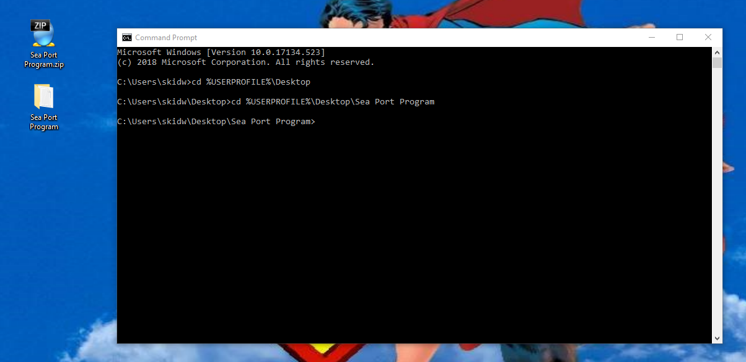

Figure 1.1

Once the program starts running, an interface will be displayed which contains a menu with two options, and a large text area. Click the File menu object and select the Open File option to select a file. Users must pick the text file titled aSPae.txt located in the Sea Port Program folder (see figure 1.2). After selecting the txt file, users will have the option of choosing the to display the sorted contents of the file by selecting the Display Tree option in the menu, searching the contents of the tree for a specific value, or sorting the ships within the tree based on certain sort perimeters. Upon clicking the display option, users will have the ability to browse the contents of the entire file by utilizing the scroll bar to the right on the large window below the buttons.

Figure 1.2

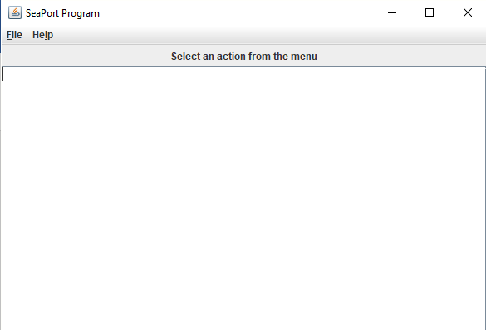

Users who wish to search the contents have the option of searching by name, index, skill, and type. The name search searches for any proper name within the provided data, and returns the name along with all subordinate elements. An index search, similar to the name search, will also the entire data structure for any element matching the provided index and all subordinate elements. Users who wish to use the skill search can search for any skill and find the name of the person who can perform that skill. Finally, users can utilize the type search to find all ships of the selected type: Passenger Ship or Cargo Ship. Figure 1.3 shows an example of a name search for a passenger ship.

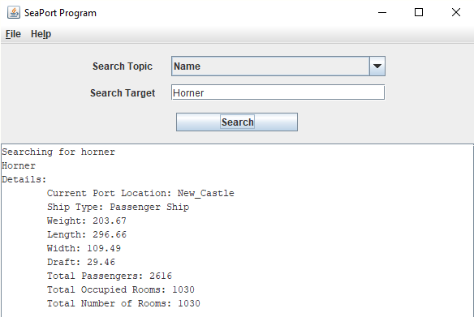

Figure 1.3

Finally, users may sort all ships by Weight, Length, Width, and Draft. Users can do this by selecting the Sort Ships in Queue option from the dropdown menu. In doing so, a panel will be displayed allowing the user to select one of the four sort options. Then, by pressing the sort button, the sorted ships will be displayed in the below window. Figure 1.4 shows a sort by Width.

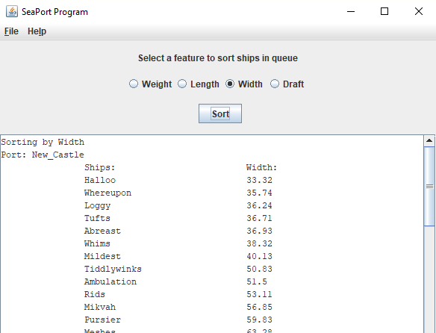

Figure 1.4