# Advanced Web Engineering (Component 1)

Name: Pramudita Thapaliya

Subject: BSc (Hons.) Computing

Level: 6

# Development Choice

Visual Studio Code

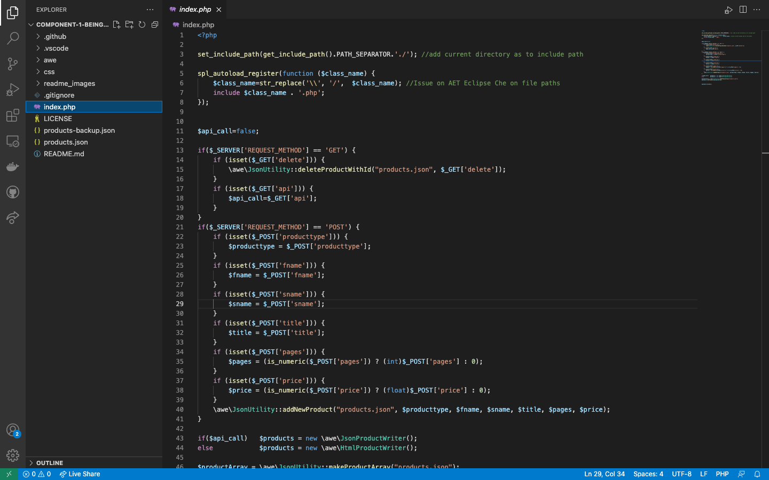

# PHP Version being used

PHP Version: 8.0.12

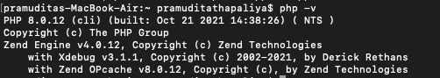

Composer:

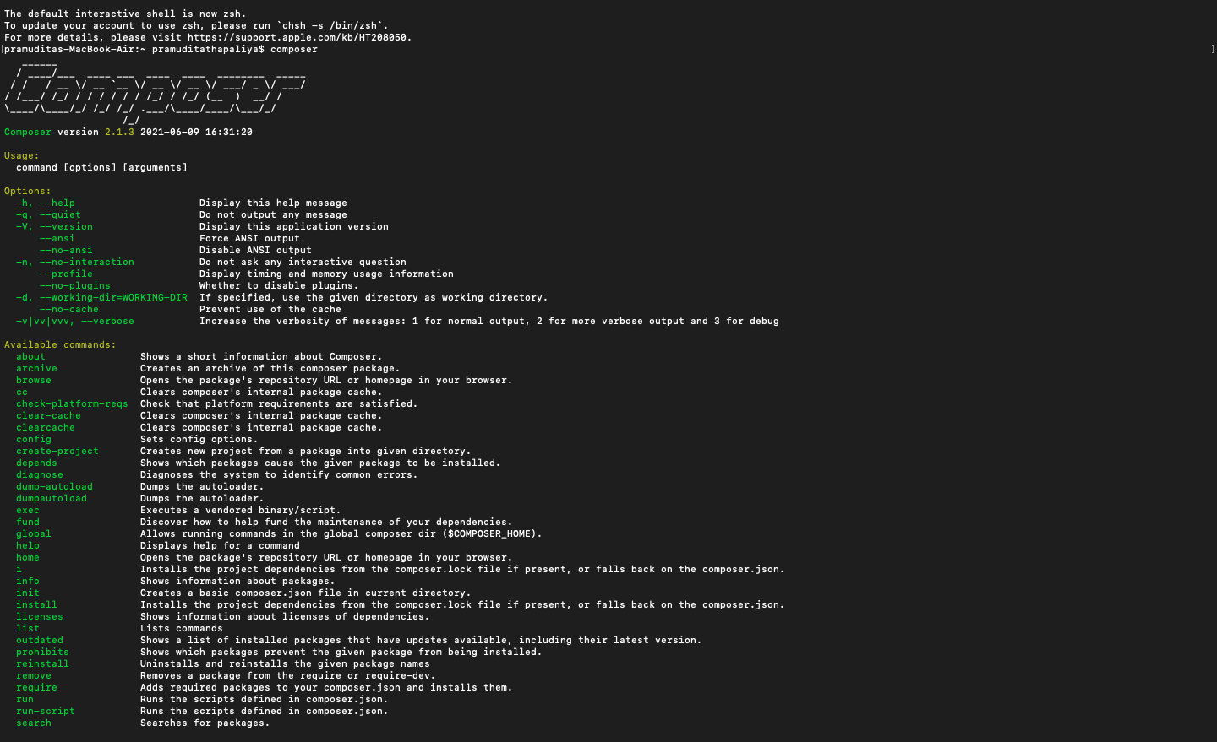

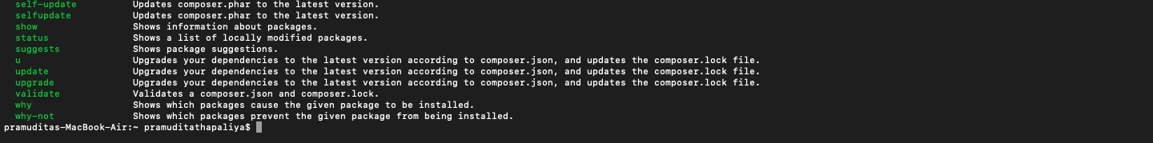

MAMP:

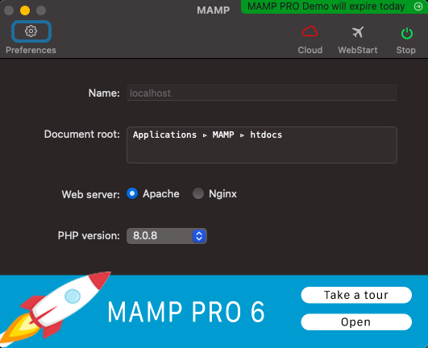

# GitHub Account Component 1 Repository Link

Link: <https://github.com/tbc-bsc-l6/component-1-beingpramudita>

# PHP Exercise in Component 1 completed?

YES

Changes made in Source Code:

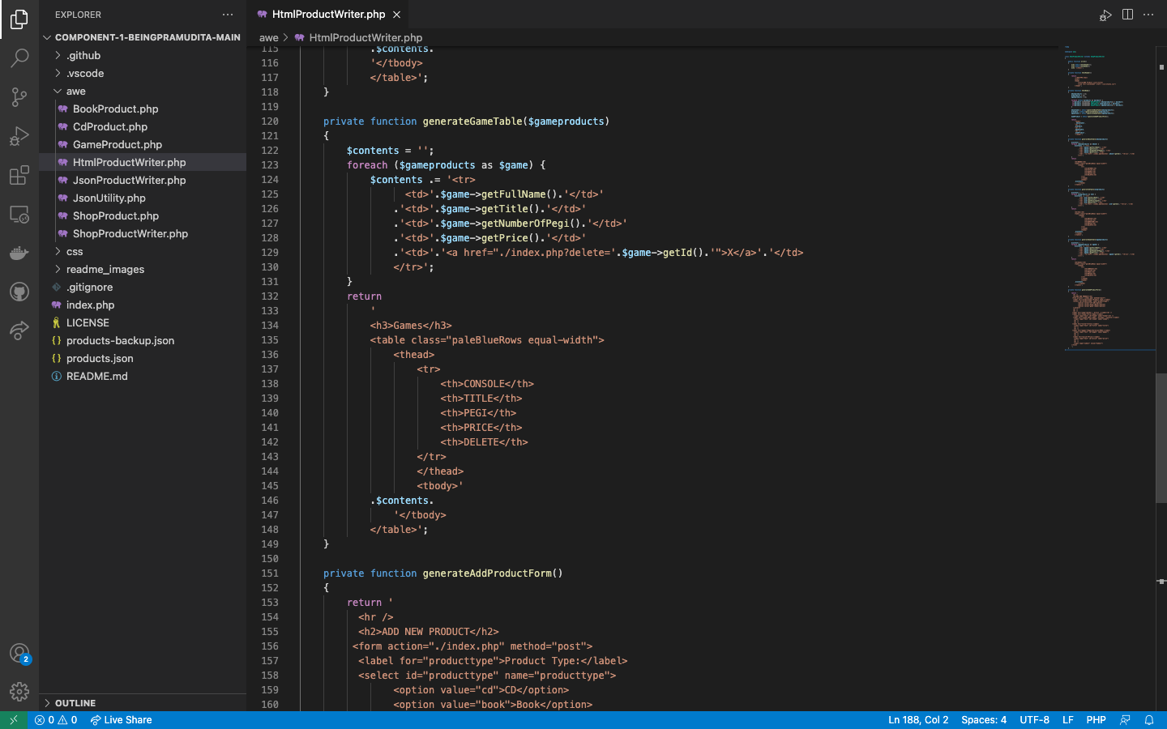

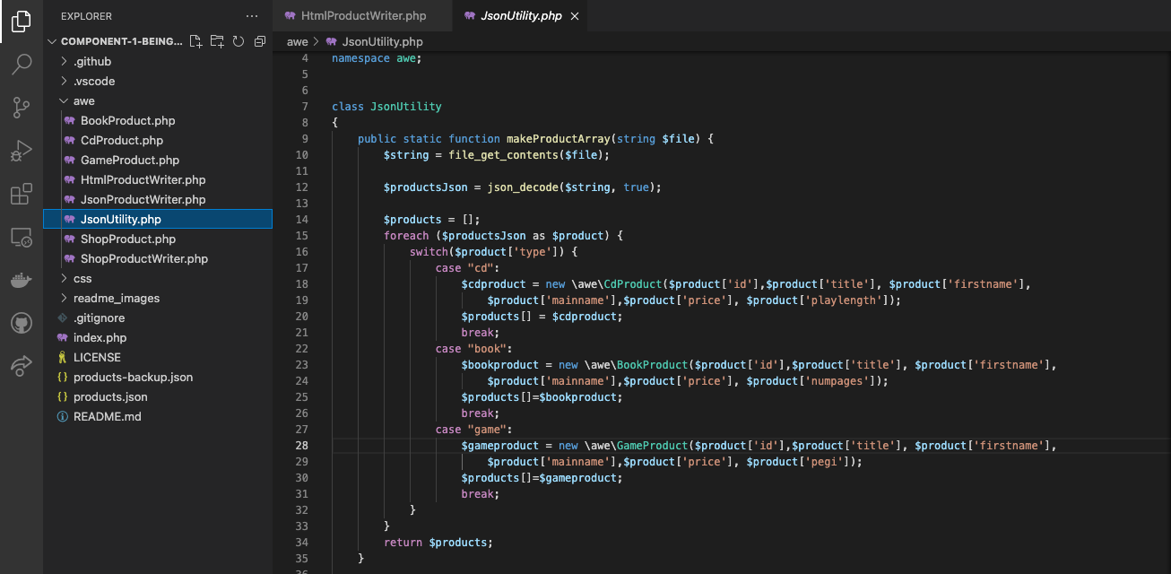

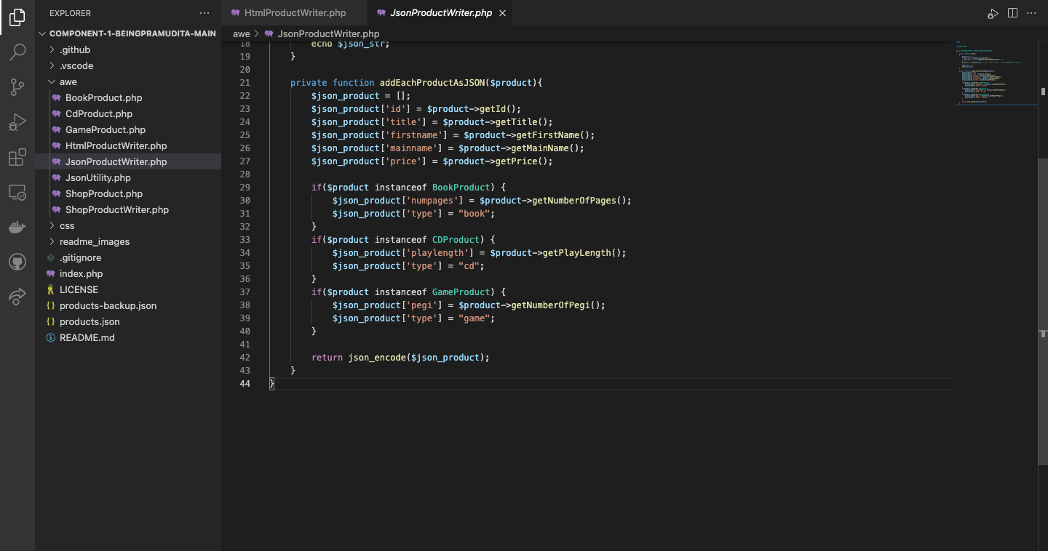

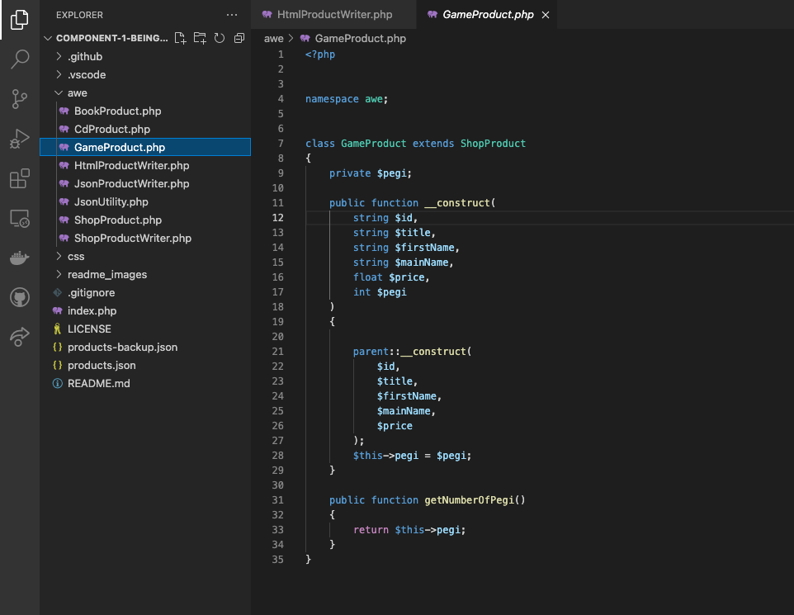

Front-End:

