**THE BRITISH COLLEGE**

**KATHMANDU, NEPAL**



Advanced Web Engineering Assignment Component 1

**SUBMITTED BY: SUBMITTED TO:**

**James Lamichhane PRATIK SHRESTHA**

**University ID: 77227202 Module Tutor**

**Level: 6 (Semester 1) Advanced Web Engineering**

1. **DEVELOPMENT CHOICE : Visual Studio Code**

Code is open in visual studio code.

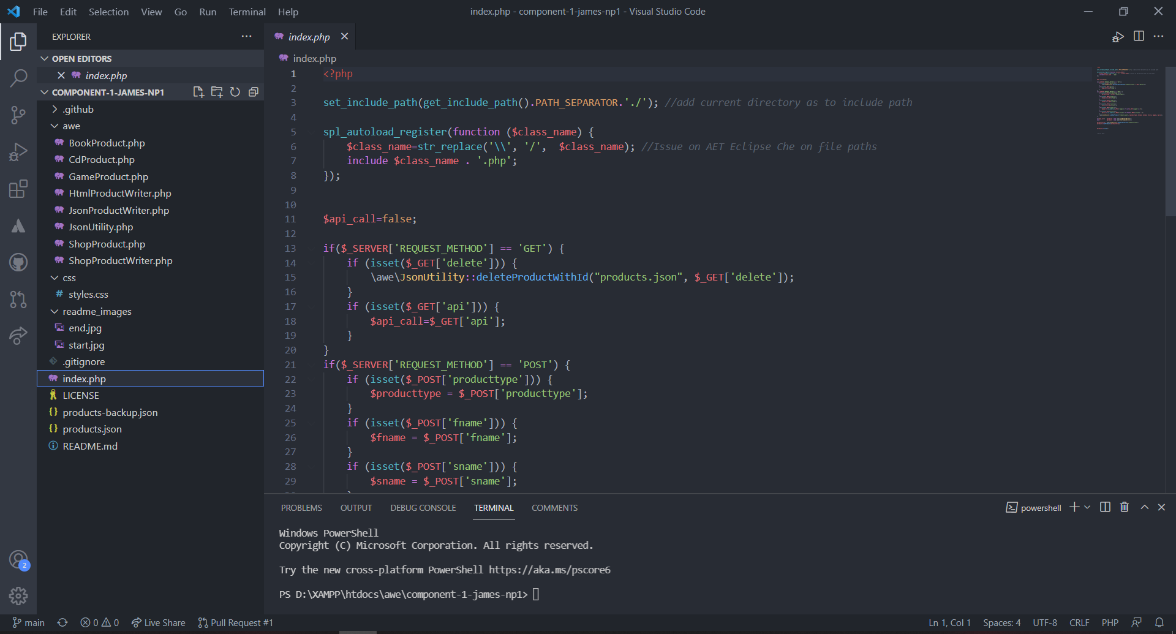

**2. PHP VERSION being used: 8.0.12**

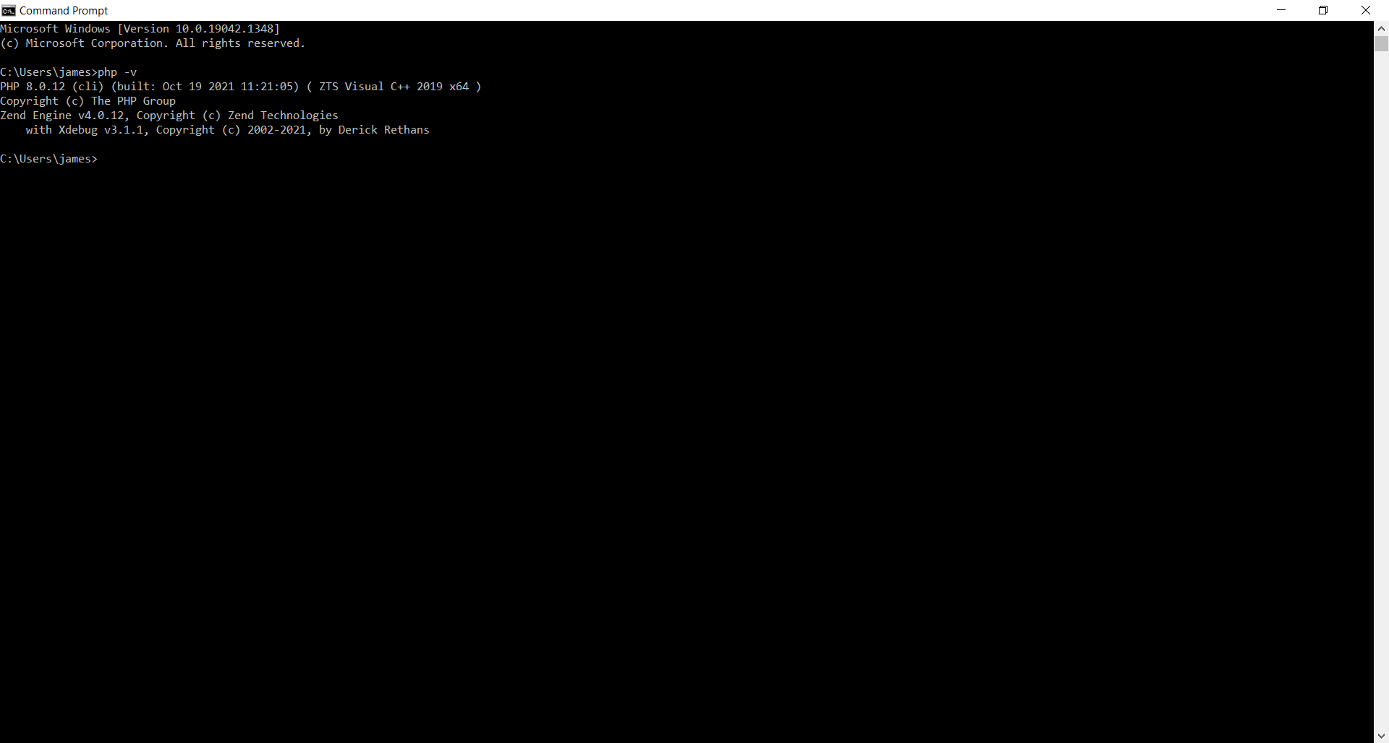

**XDEBUG**

XDEBUG added in system.



Added PHP debug extension for XDebug in IDE:

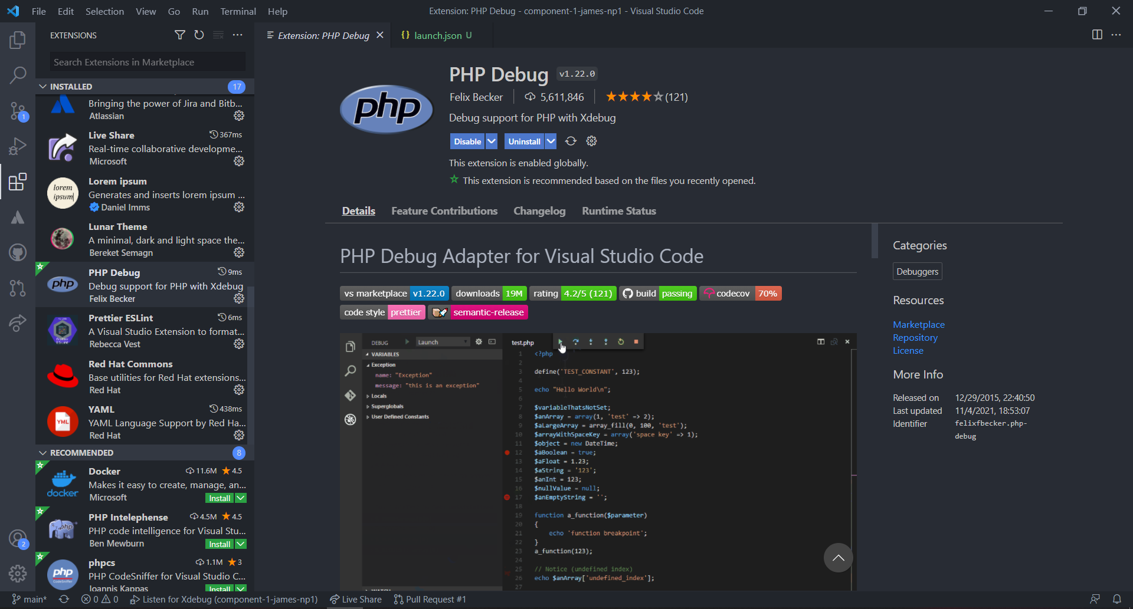

XDEBUG added in IDE ( Visual Studio Code ):

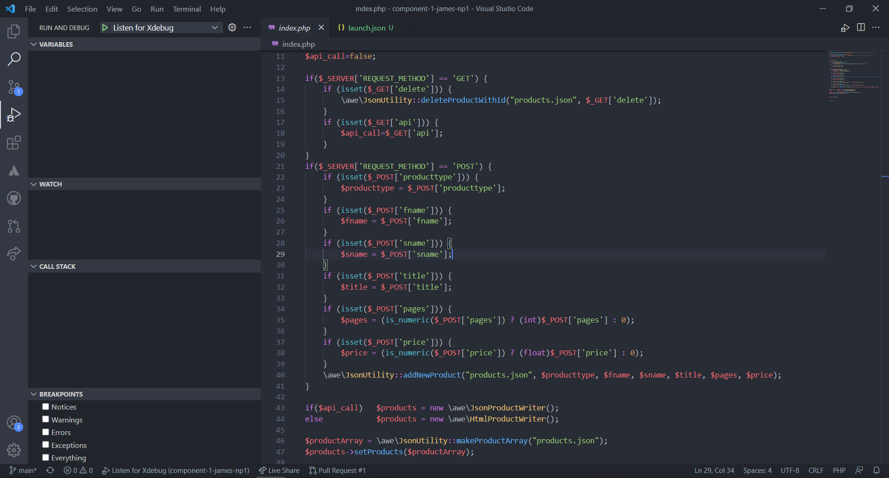

**COMPOSER**

Installed composer in system.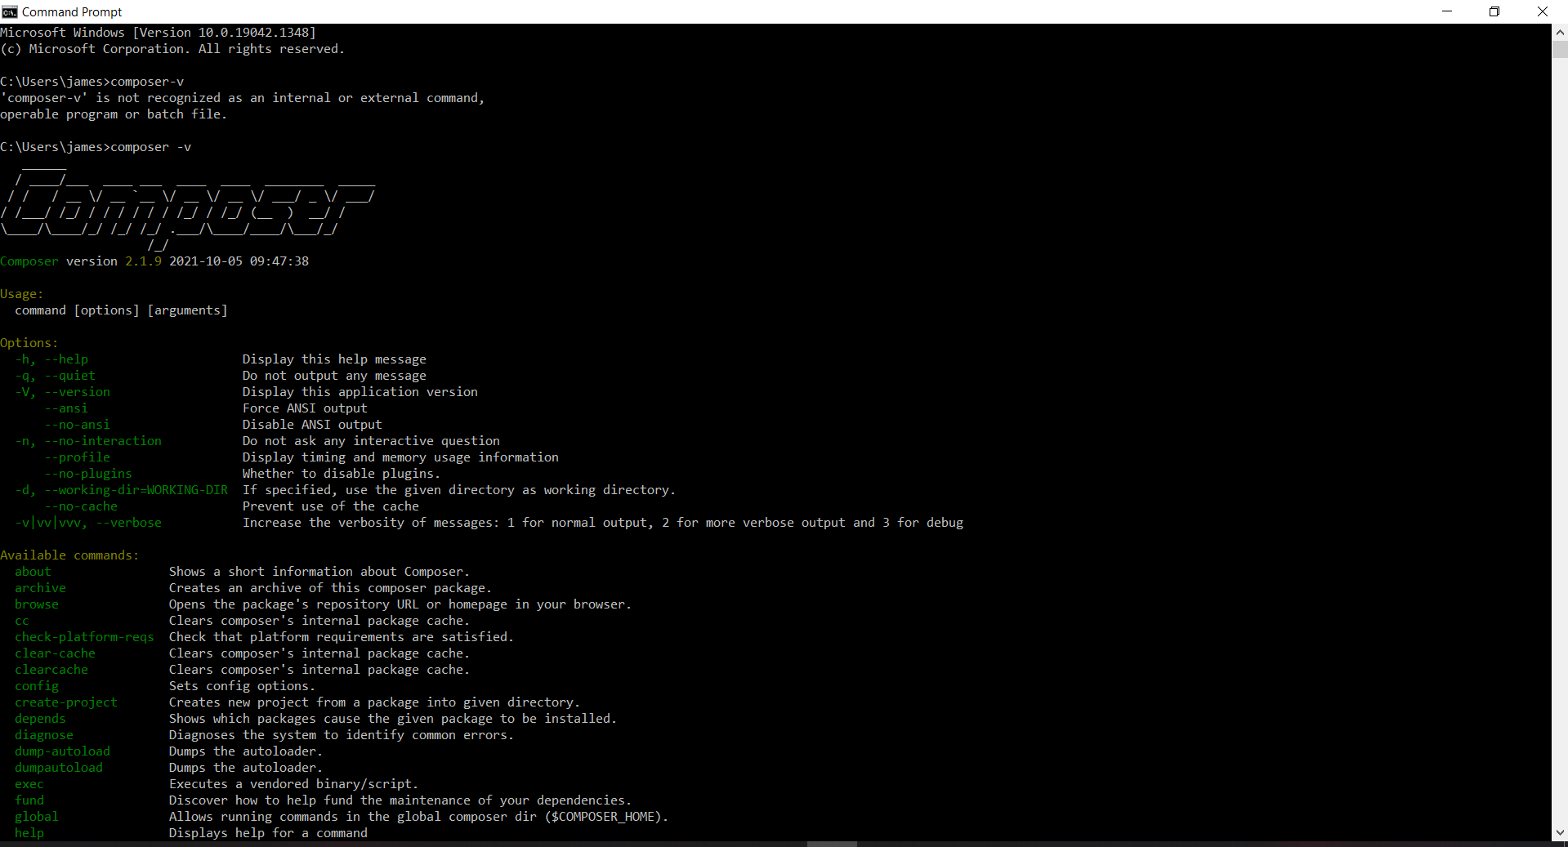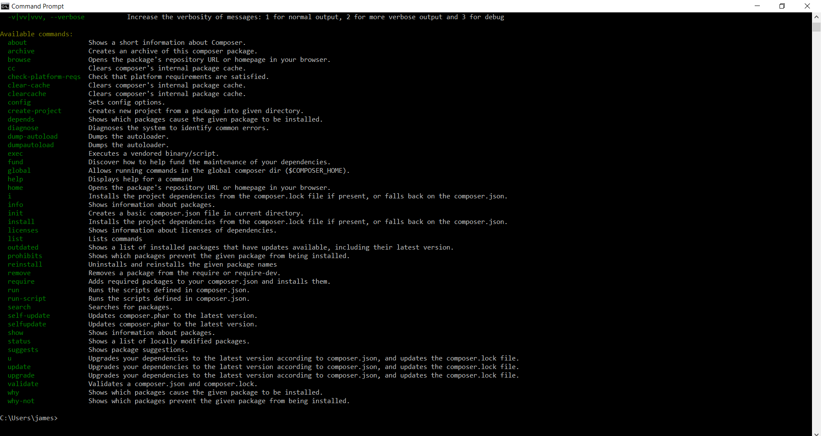

**XAMPP**

Installed Xampp in system and added new PHP and Xdebug versions in Xampp.

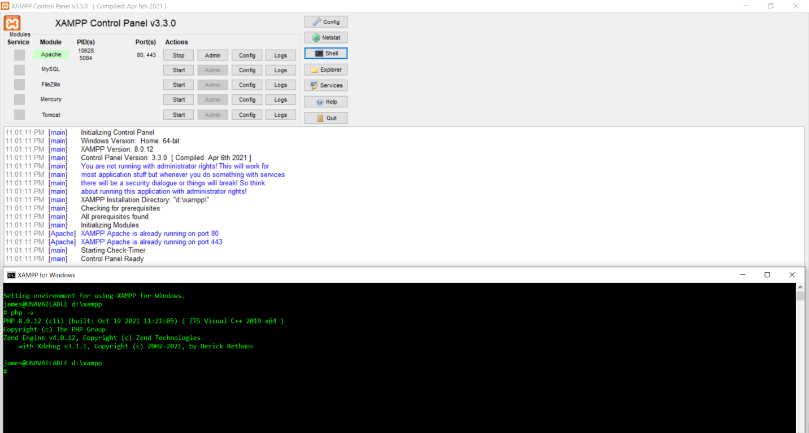

1. **Github account component 1 repository link :**

<https://github.com/tbc-bsc-l6/component-1-james-np1.git>

1. **PHP Exercise in component 1 completed**

Frontend :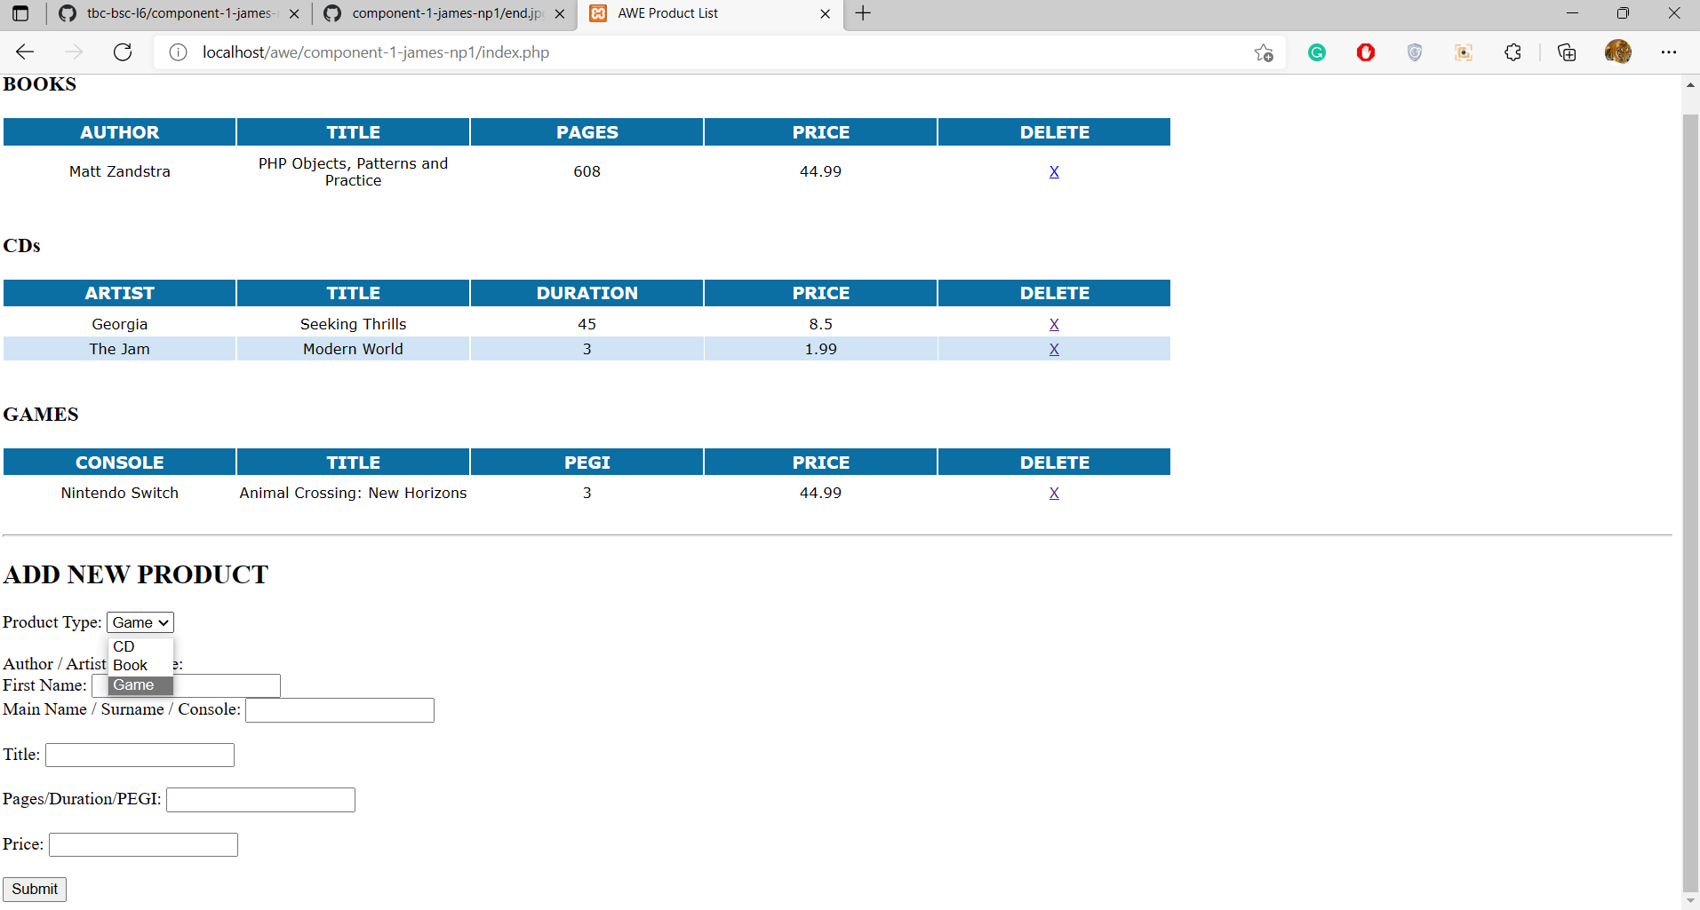

**Source code**

Added Gameproduct.php:

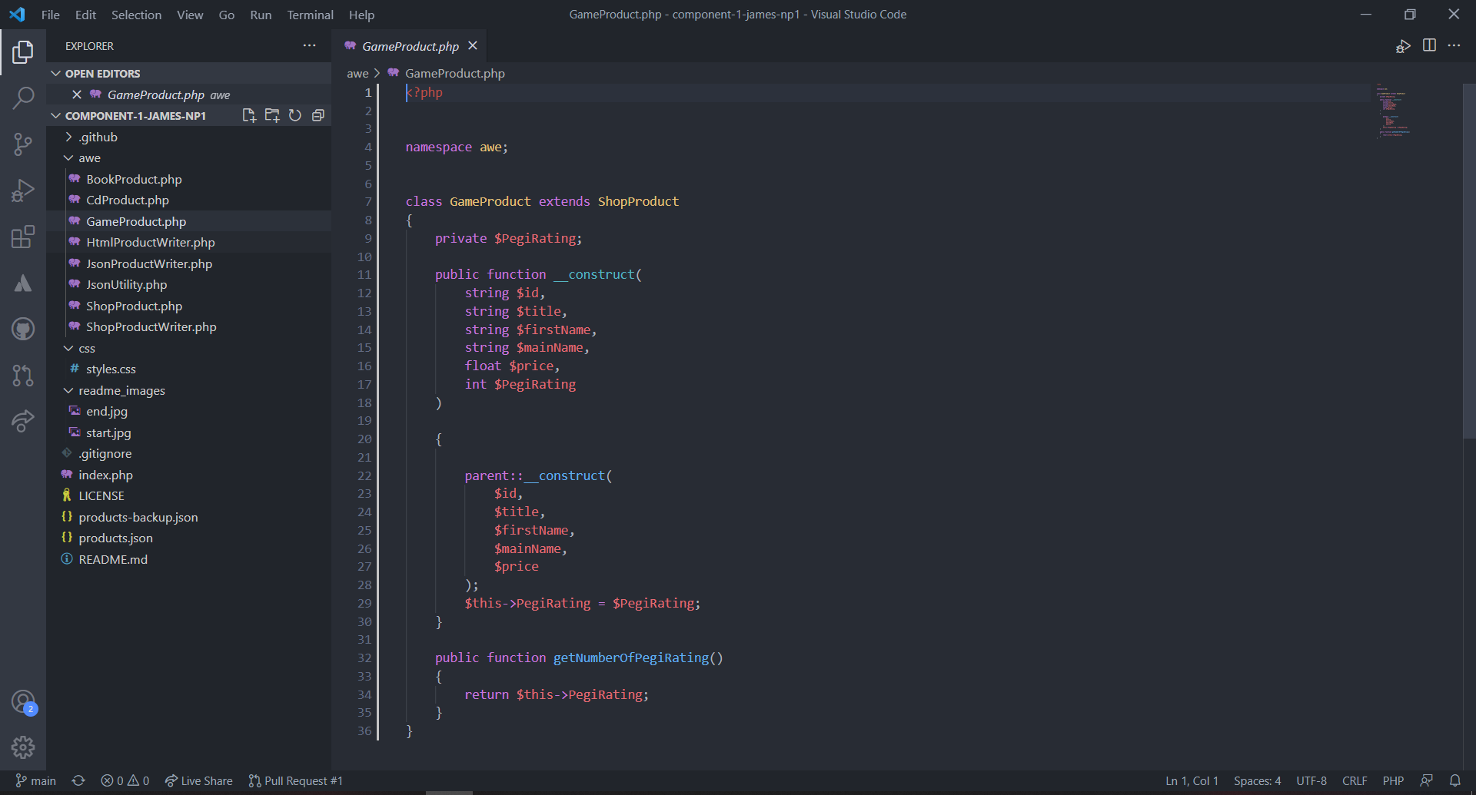

Changes in HtmlProductWriter.php:

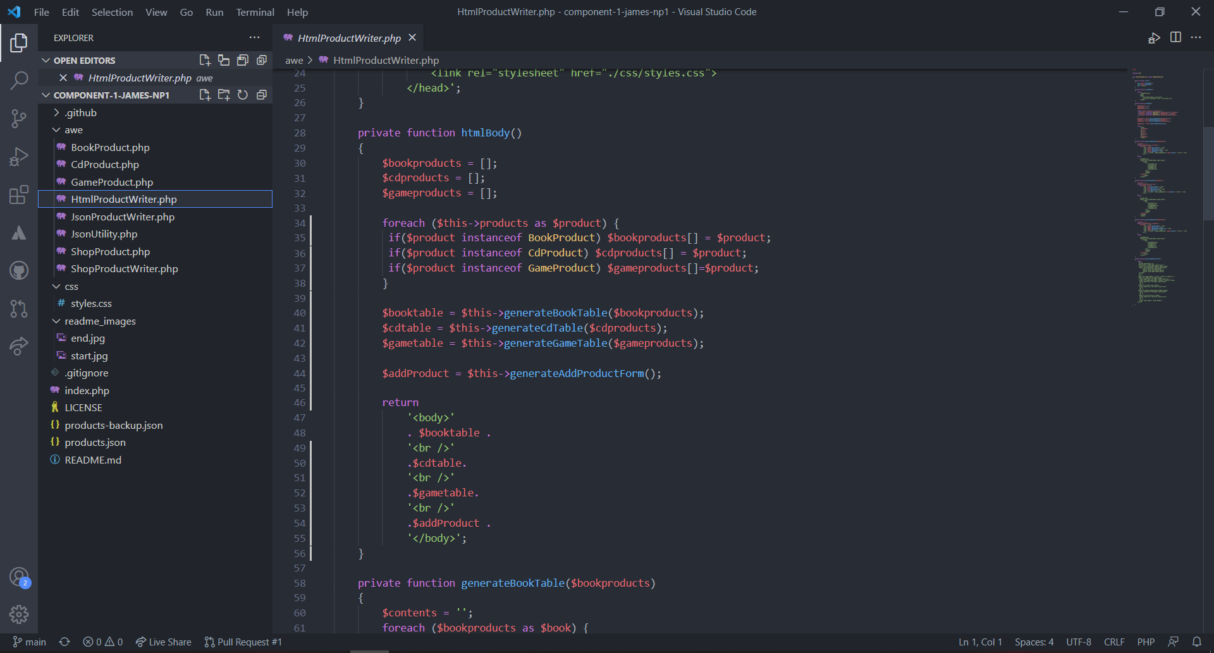

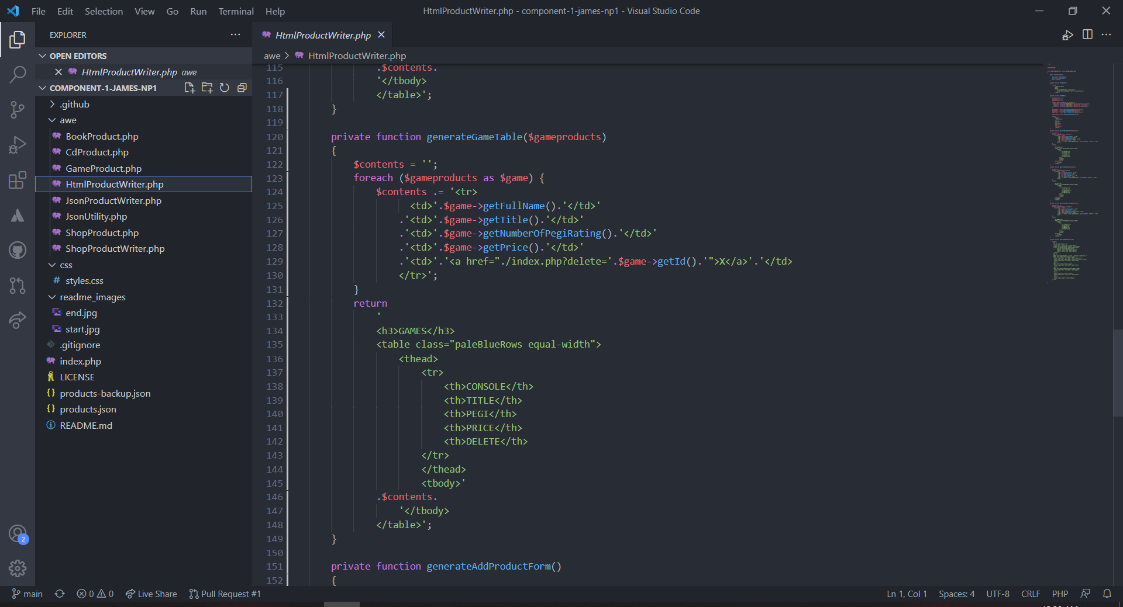

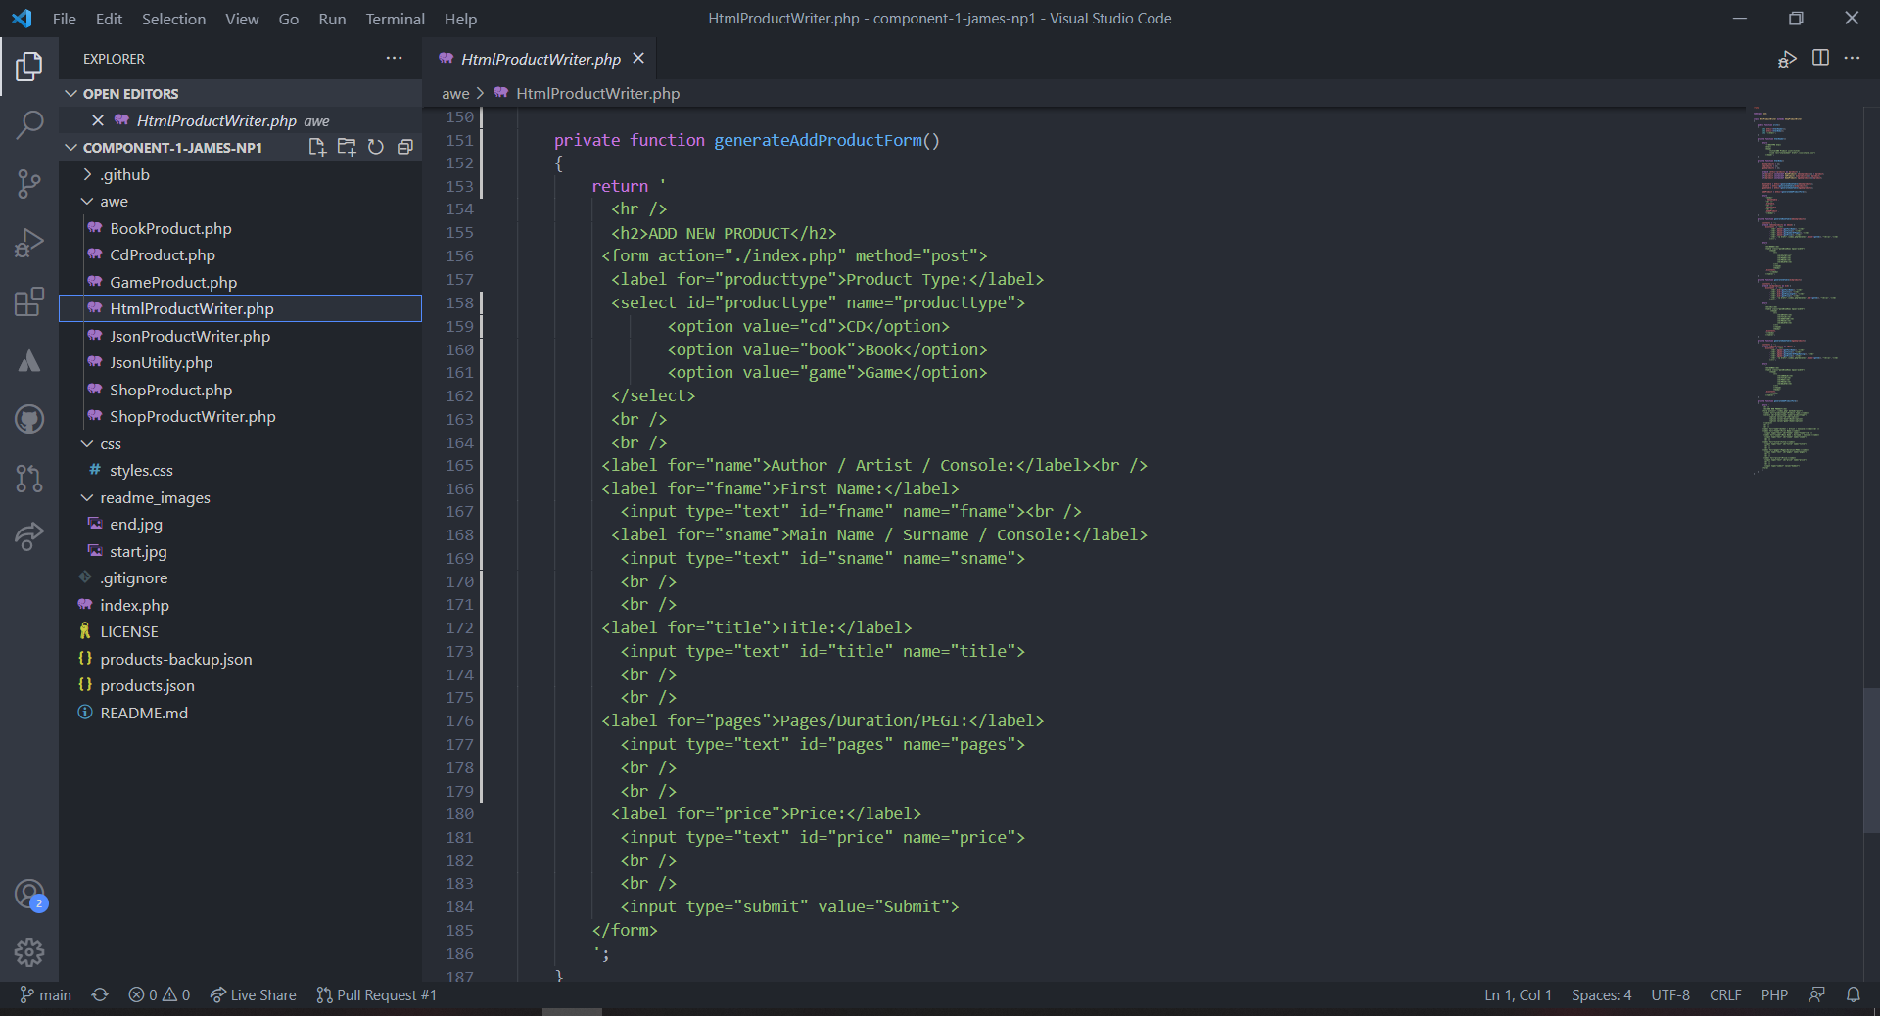

Changes in JsonProductwriter.php:

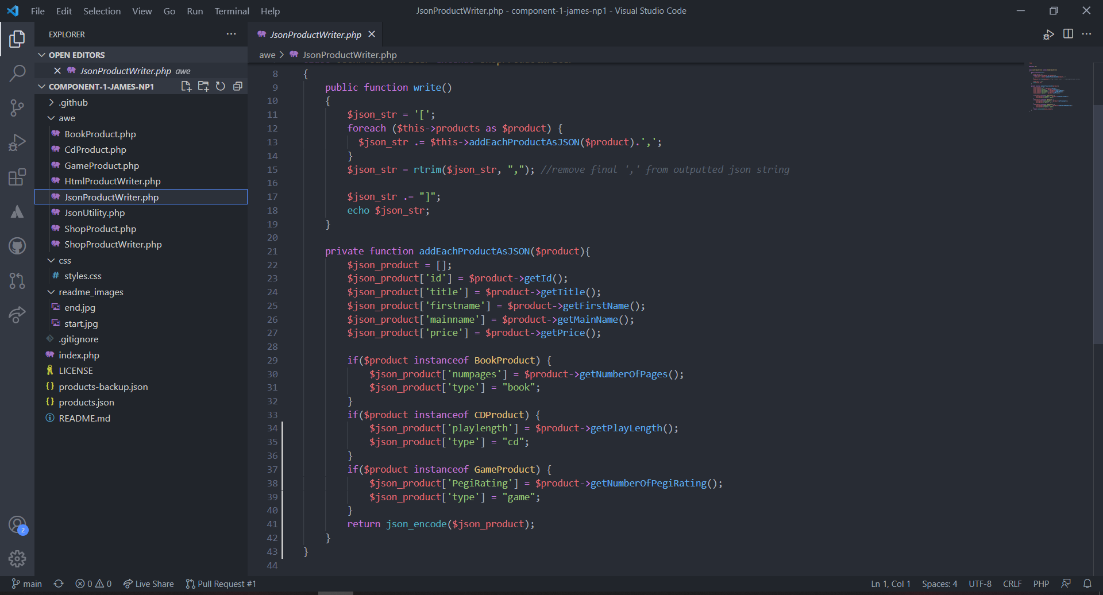

Changes in JsonUtility.php:

