** THE BRITISH COLLEGE**

**SUBMITTED BY: SUBMITTED TO:**

**NAME: SUNAM POKHAREL**

**PROGRAM: B.SC. (Computing)**

**COLLEGE ID: c7229151 (PRATIK SHRESTHA)**

**1.  
Development Choice**

**Sublime Text**

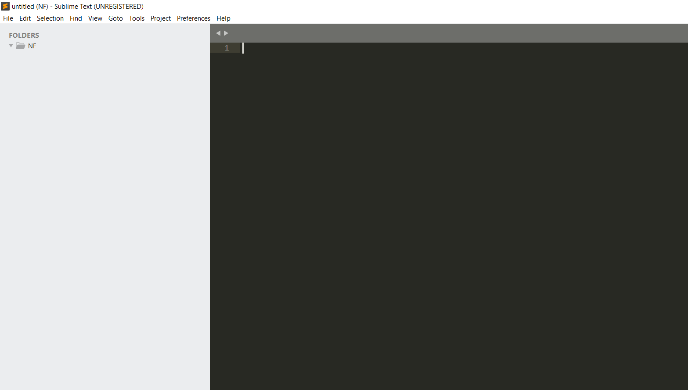

**2.  
PHP version**

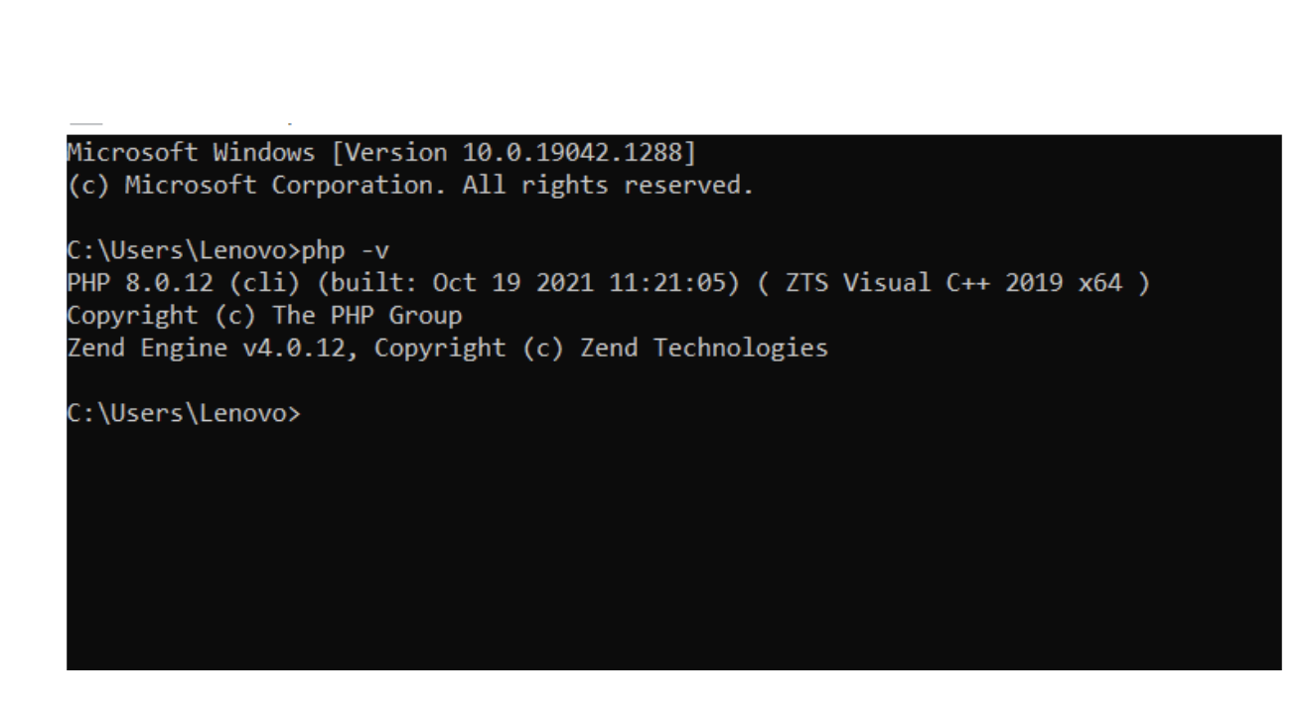

**3.  
XDebug in IDE**

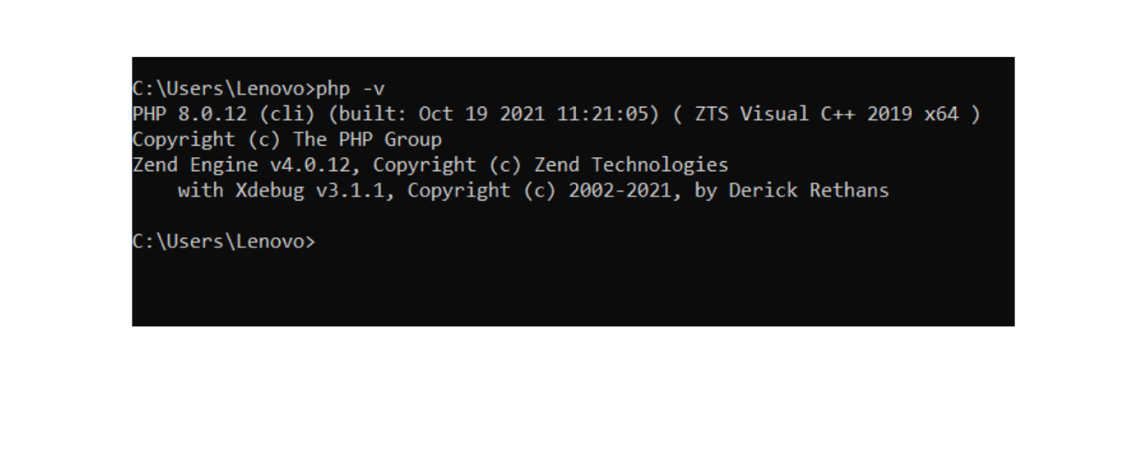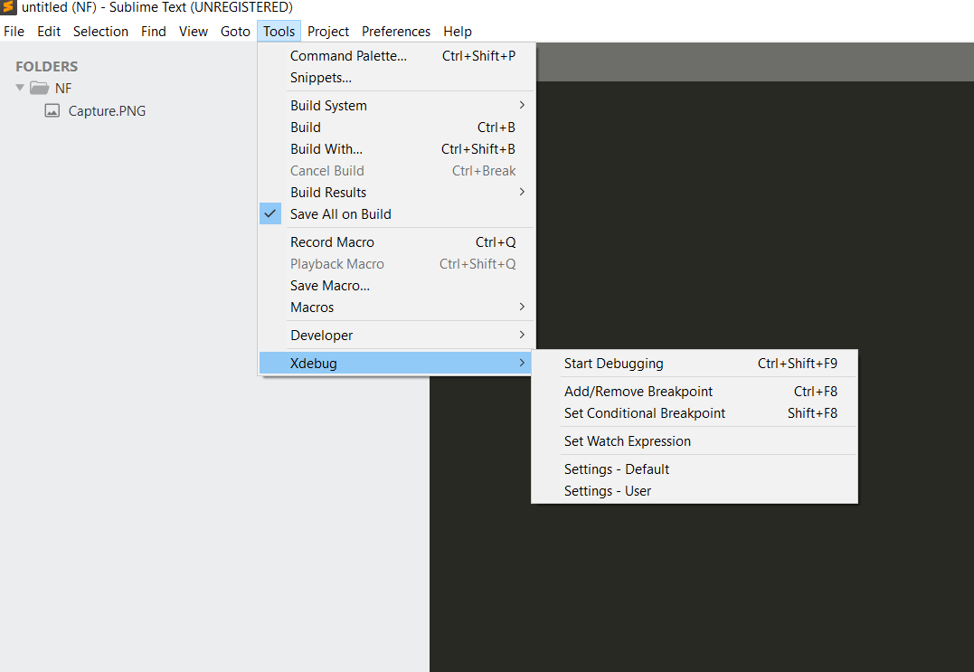

**4.  
GitHub repository link**

[**https://github.com/tbc-bsc-l6/component-1-s1999-glitch.git**](https://github.com/tbc-bsc-l6/component-1-s1999-glitch.git)

**5. Screenshots of Projects in IDE**

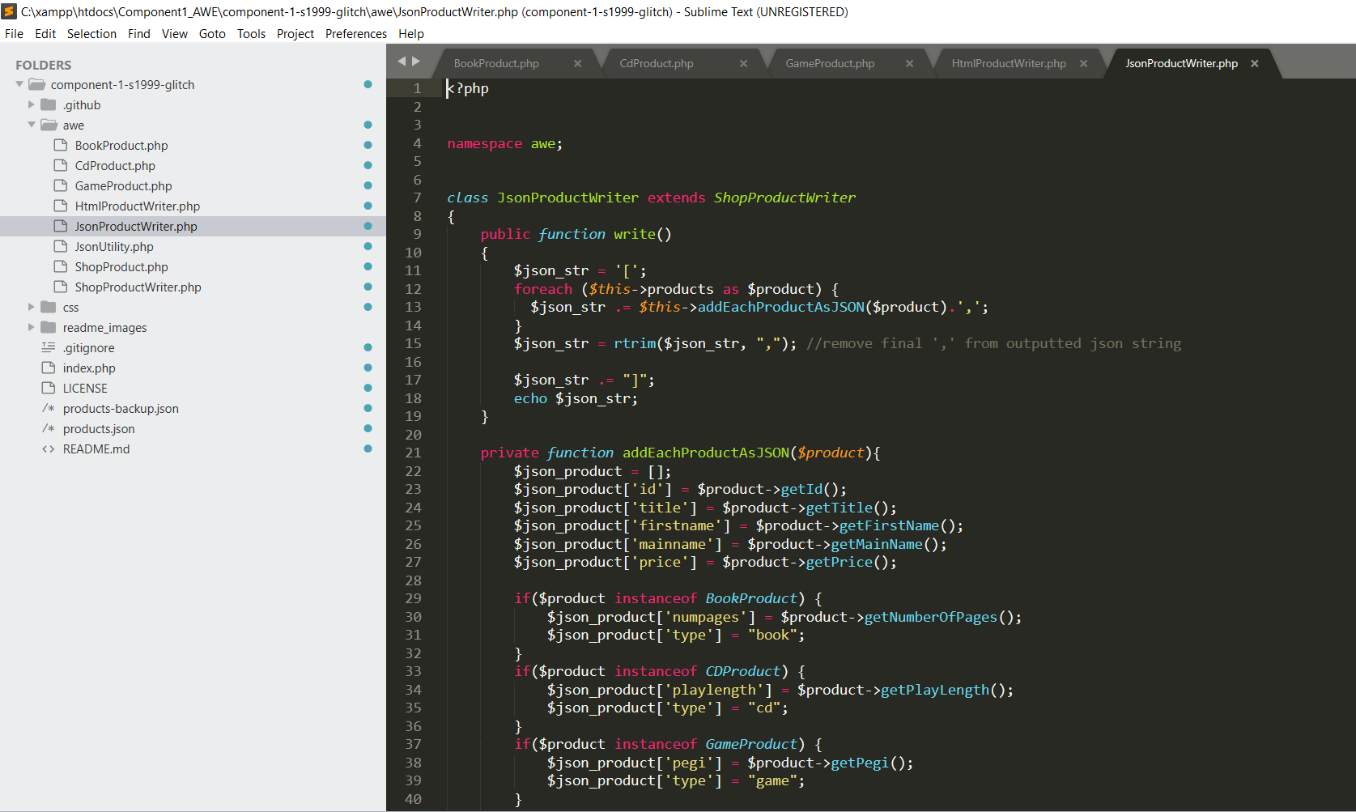

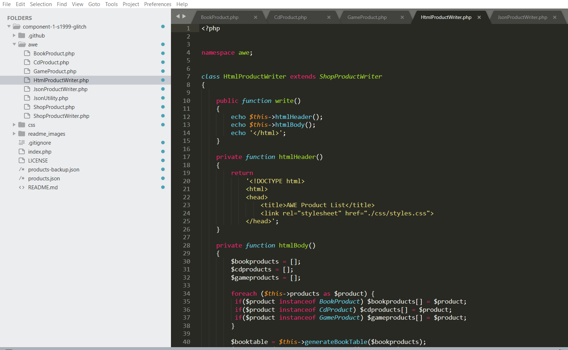

**6. UI/Front end of the application after changes are implemented  
