**Component 2**

**Student Name/ID: Krishna Narayan sah/c7227246**

**1.Composer**

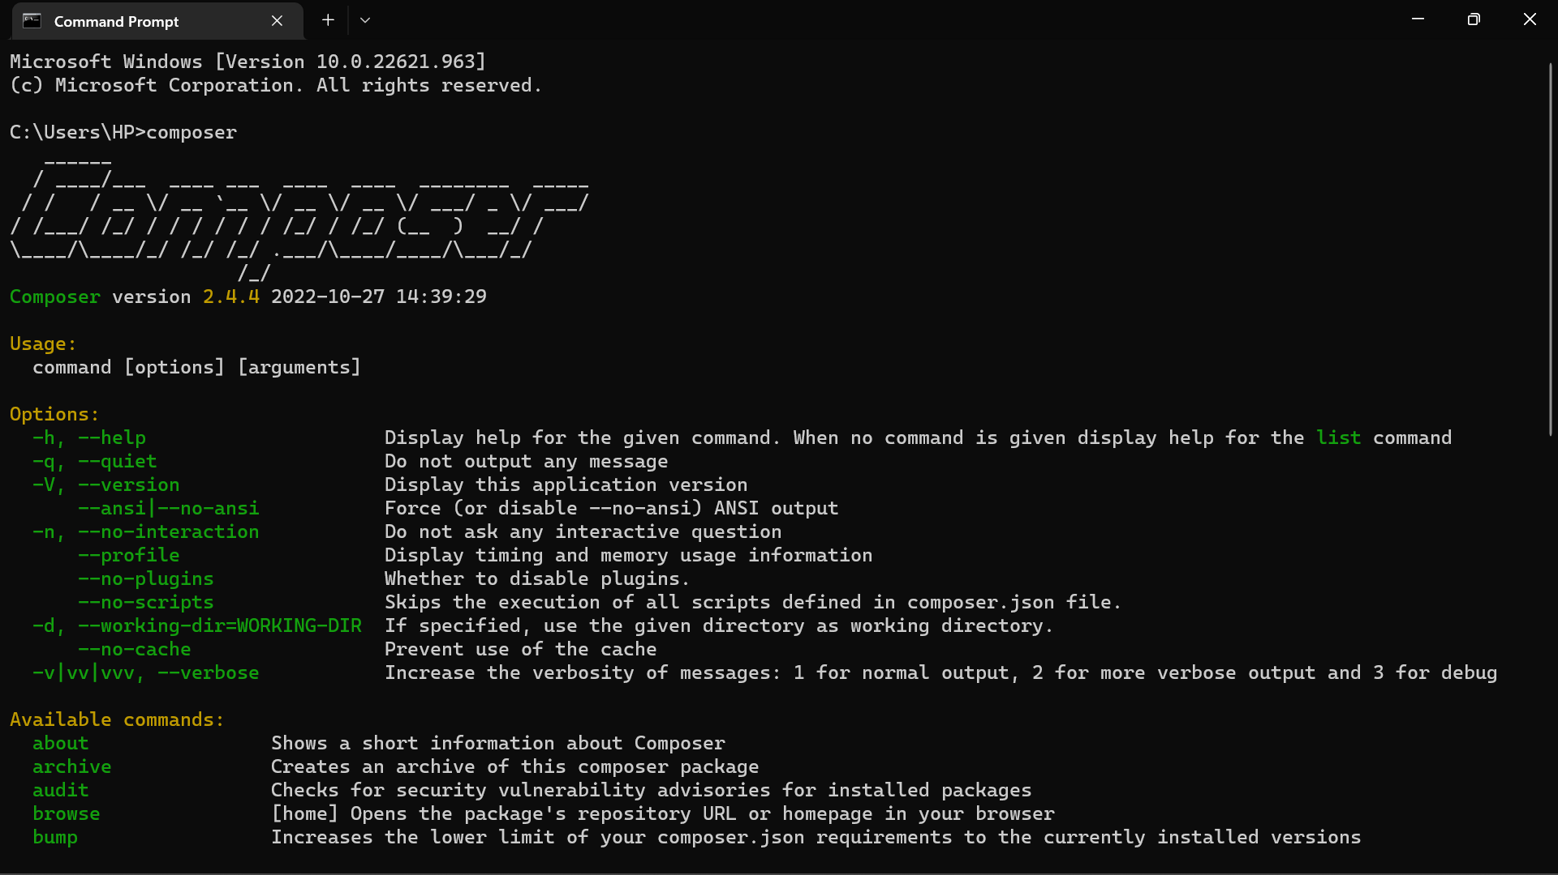

I have installed composer version 2.4.4

**2.Laravel**

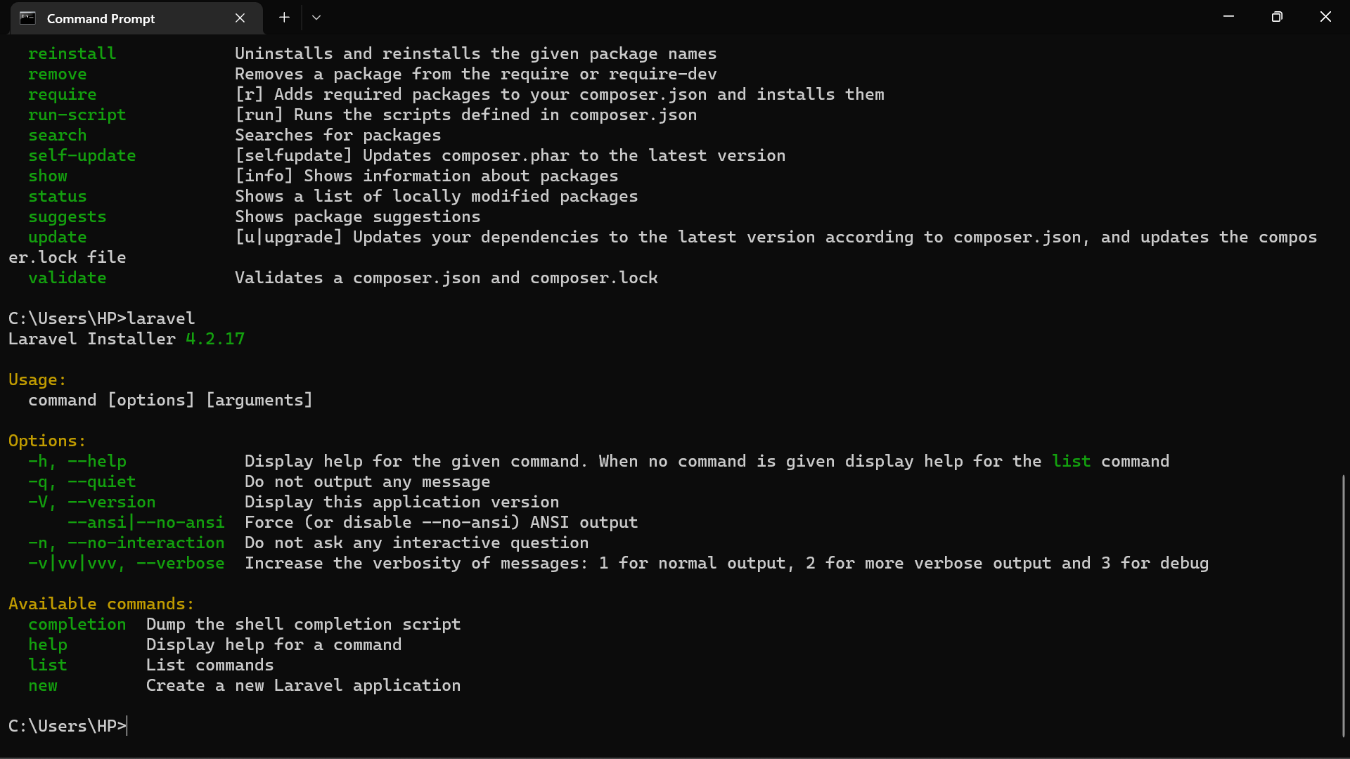

**3.IDE. Visual Studio**

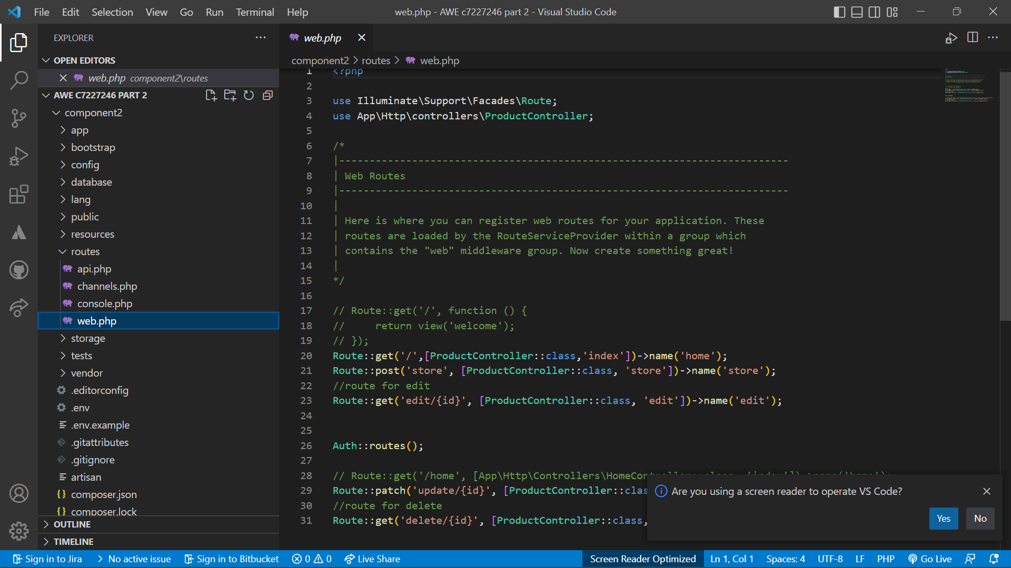

I have used visual studio code to run my Laravel project.

**4.Debug**

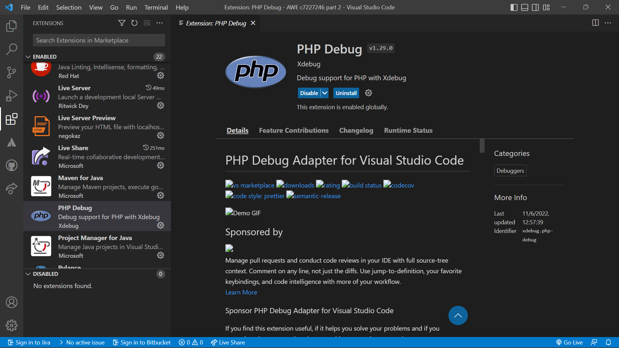

**5. Output**

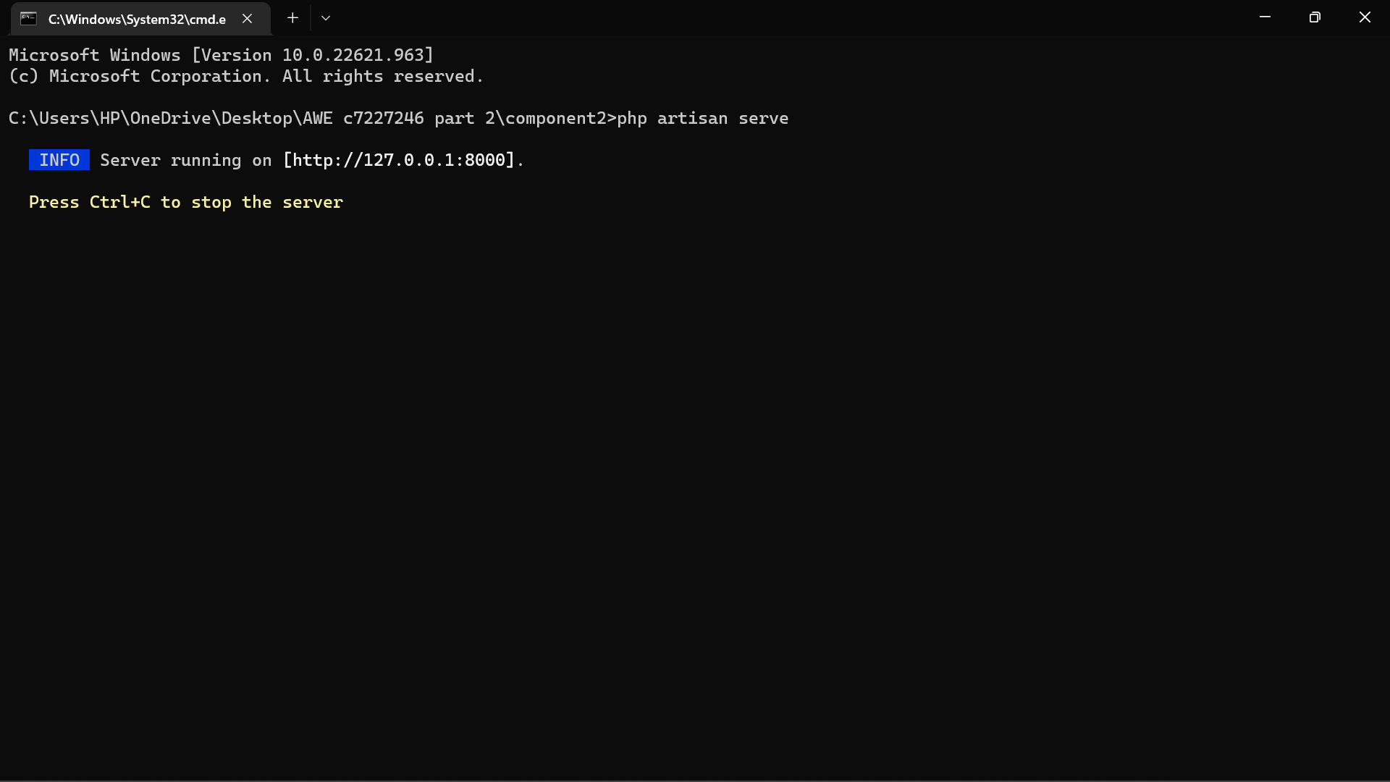

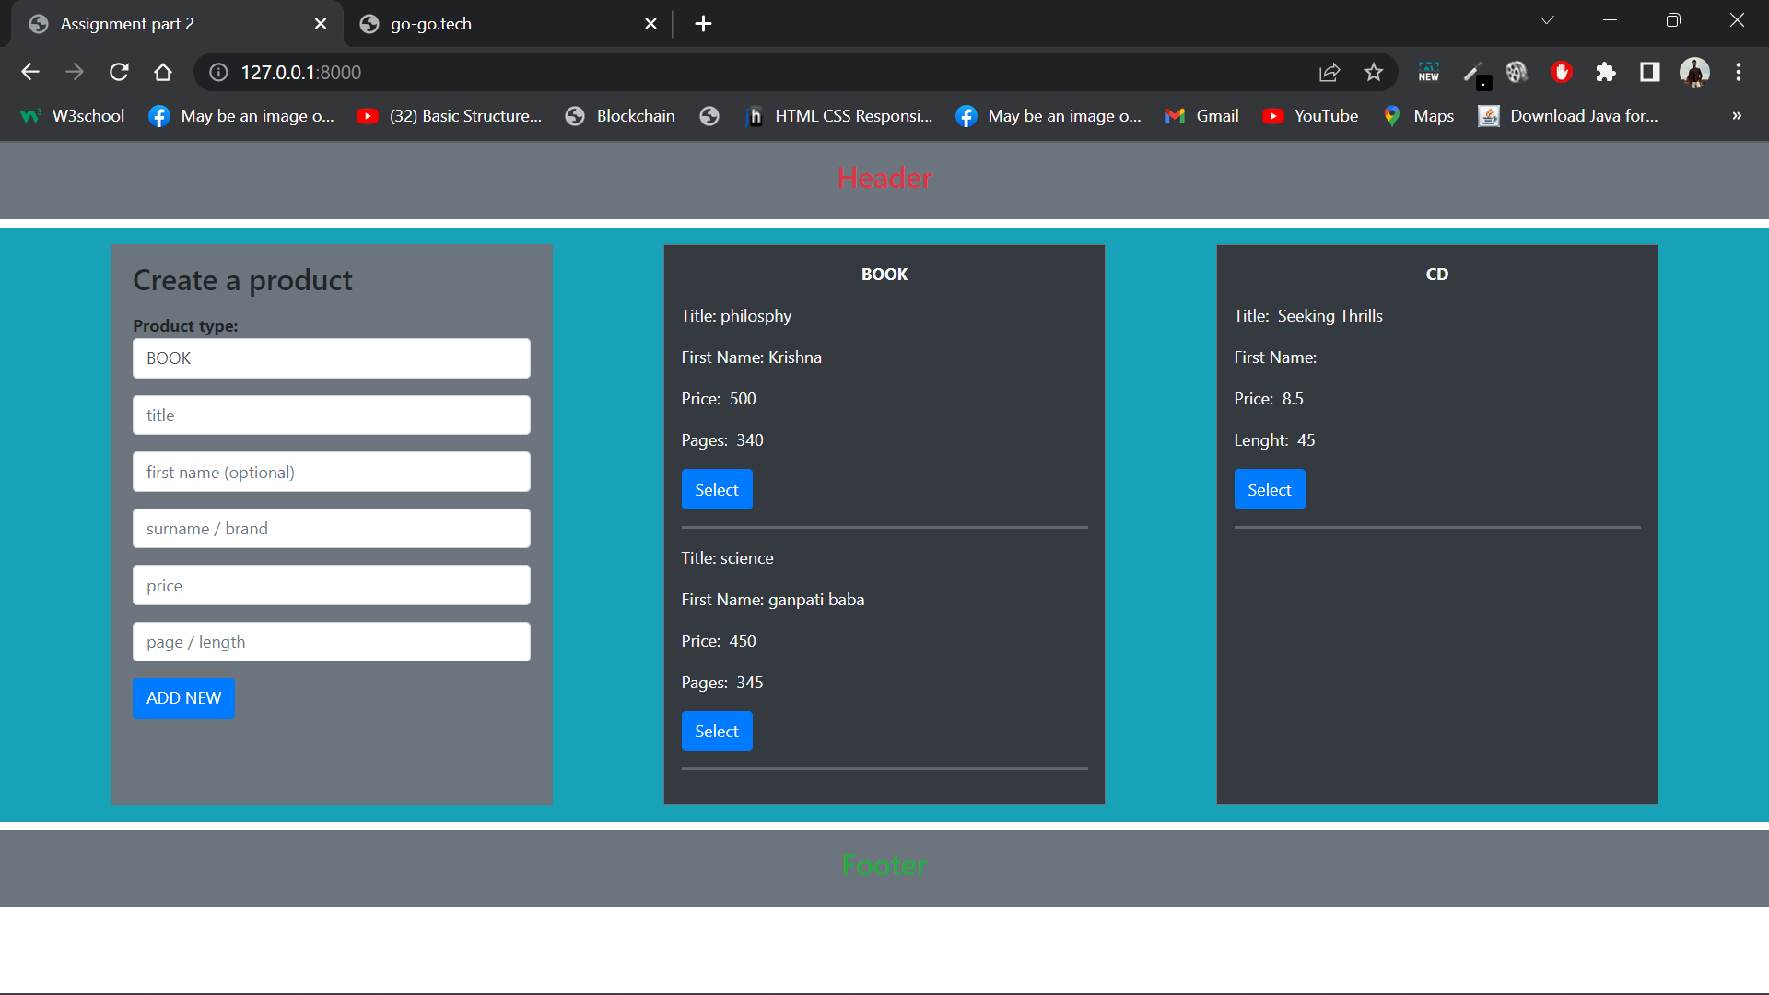 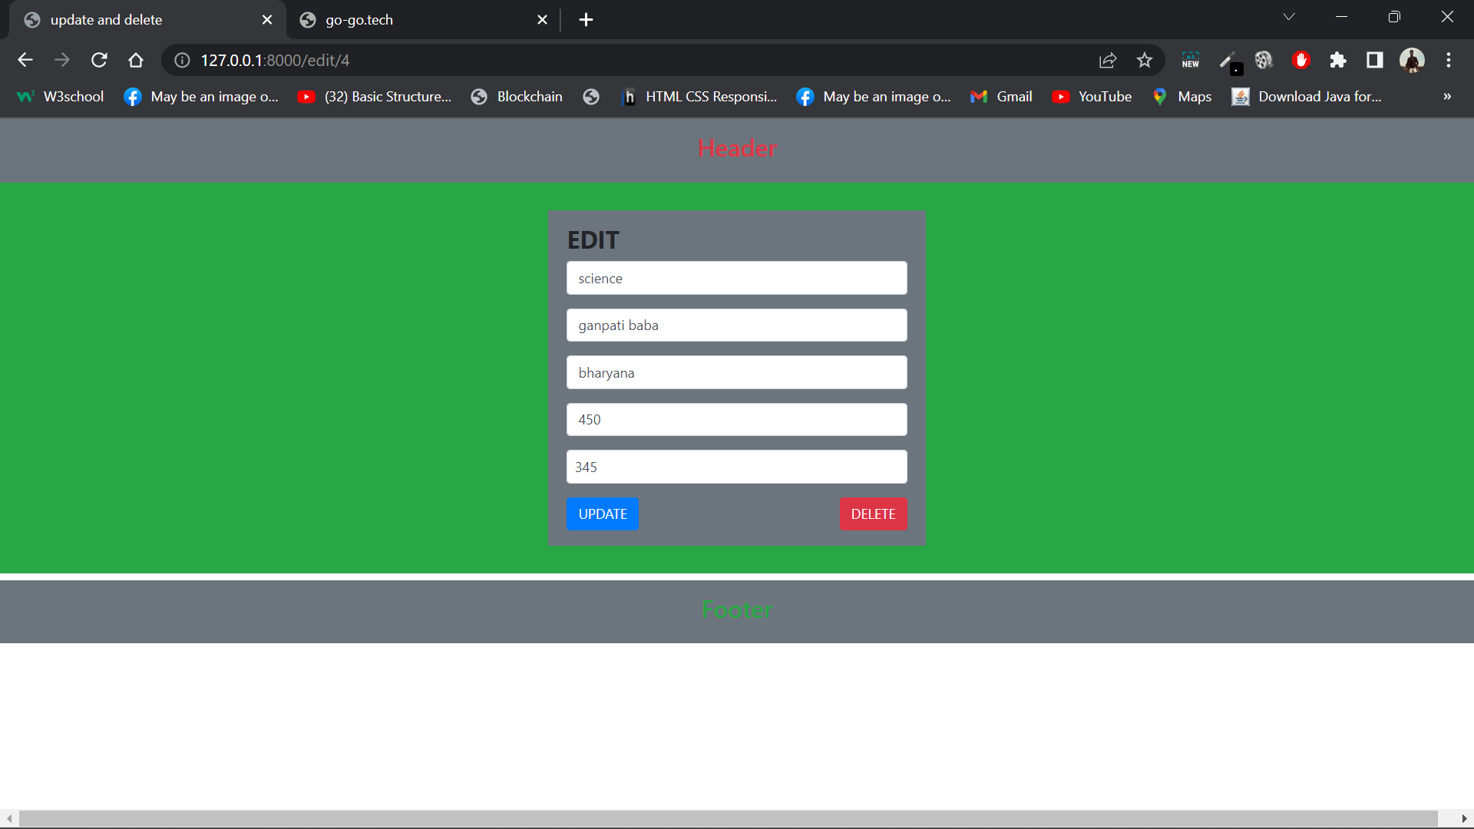

6. Git Repository

https://github.com/Krishna43210/Component2AWE.git