Full project Adavance Web Engineering

Name-Rahul kumar Yadav STUDENT ID-77356864

Youtube:- https://youtu.be/5wQKhWs0jx0

repo link of

university-https://github.com/tbc-bsc-l6/component-2-RjMonchit

This is my project which is based on php framework I.e laravel. I have created an ecommerce project in which there is user and admin in which admin have all the access to update, delete, create the product. When admin will log in there will be different dashboard where product related information will be displayed. User have different landing when they will logged in. New user can register their account and it will be verified by email verification. User can add the item to their cart by clicking a single button. Some the screenshot are given below of my laravel project.

1. Home page

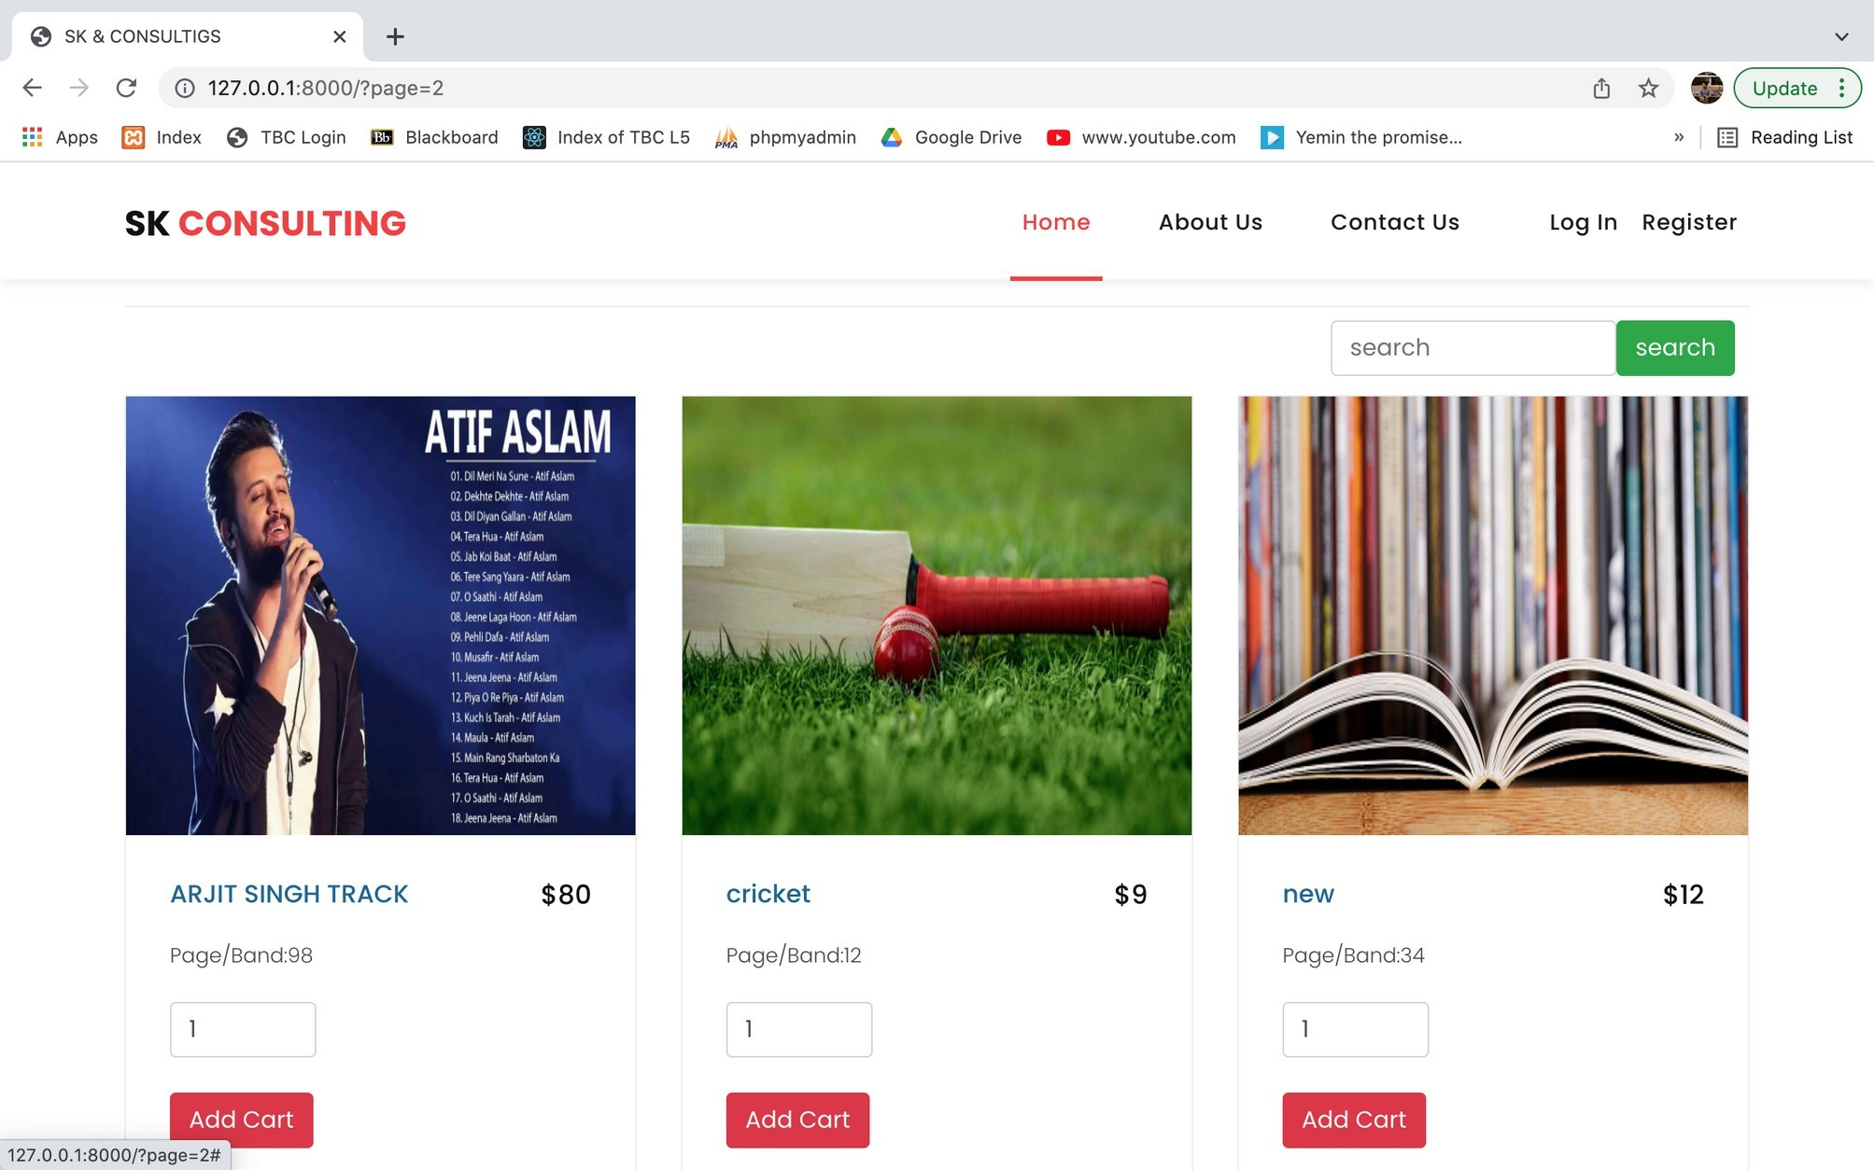

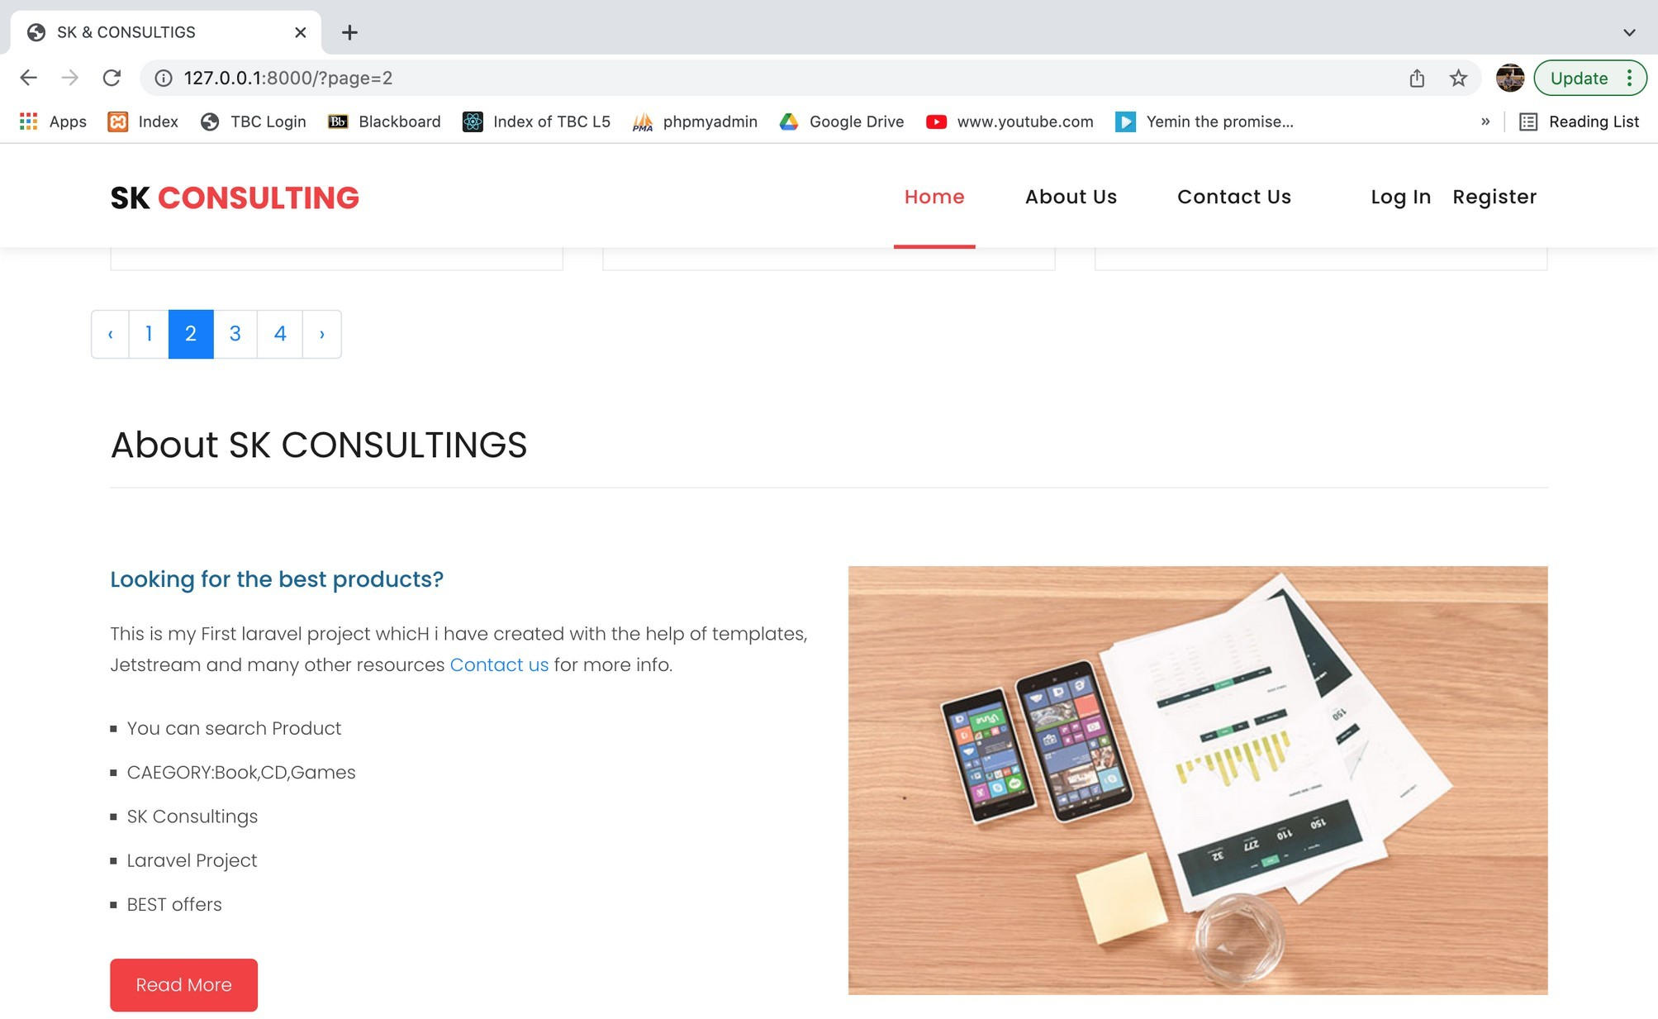In the above images you can see the home page where all the product are displayed entered by the admin and well managed pagination is also seen

1. 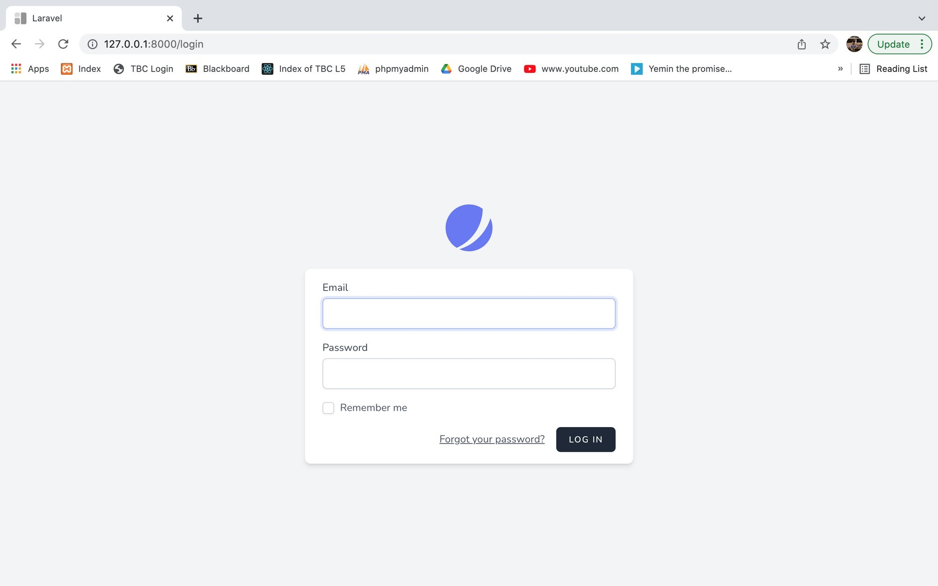login page

This is the page where user and admin both can log in.

1. 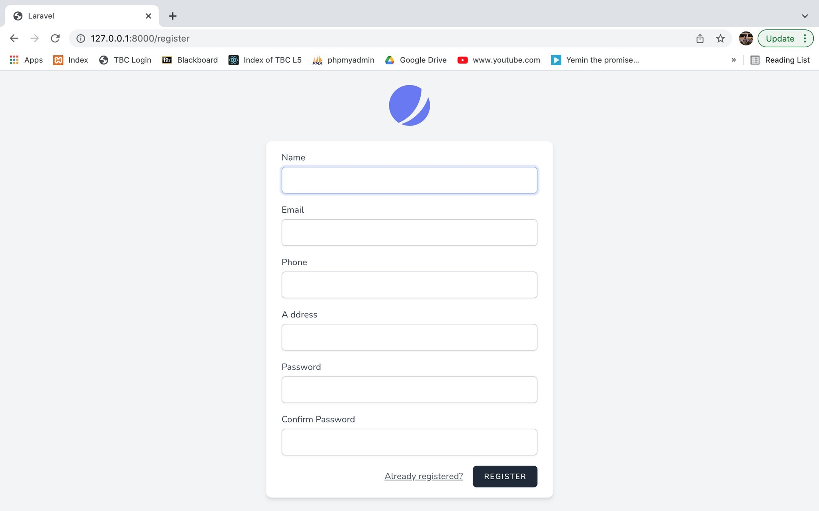registration page
2. admin add product page

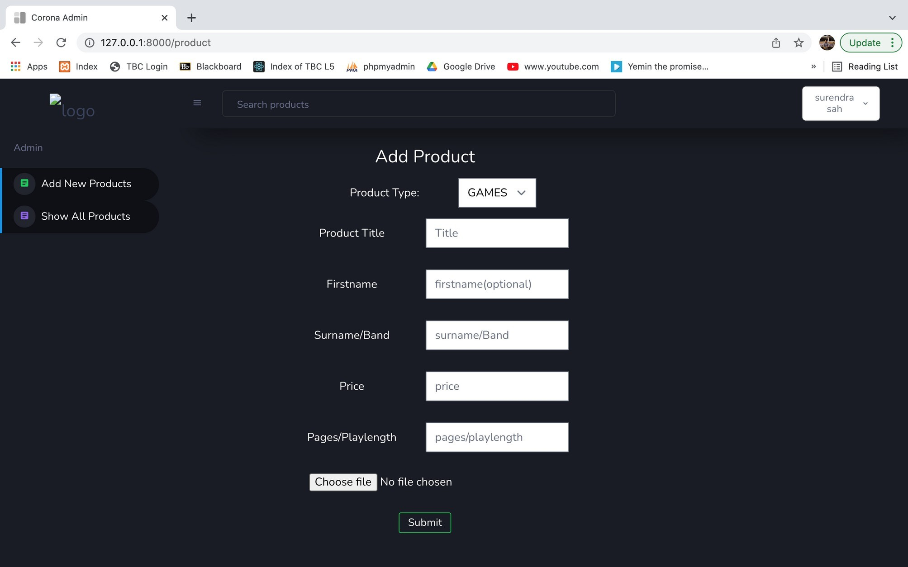

In this admin can add the product .

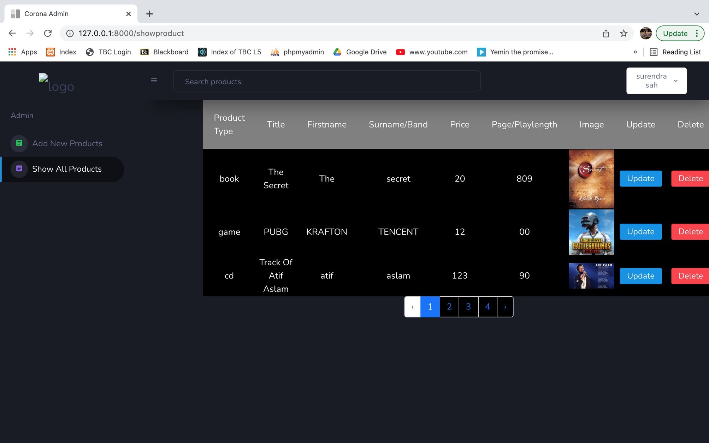All the product admin added

In this admin can view all the product added in the project Route page

All the routes that is created to link the page is given below

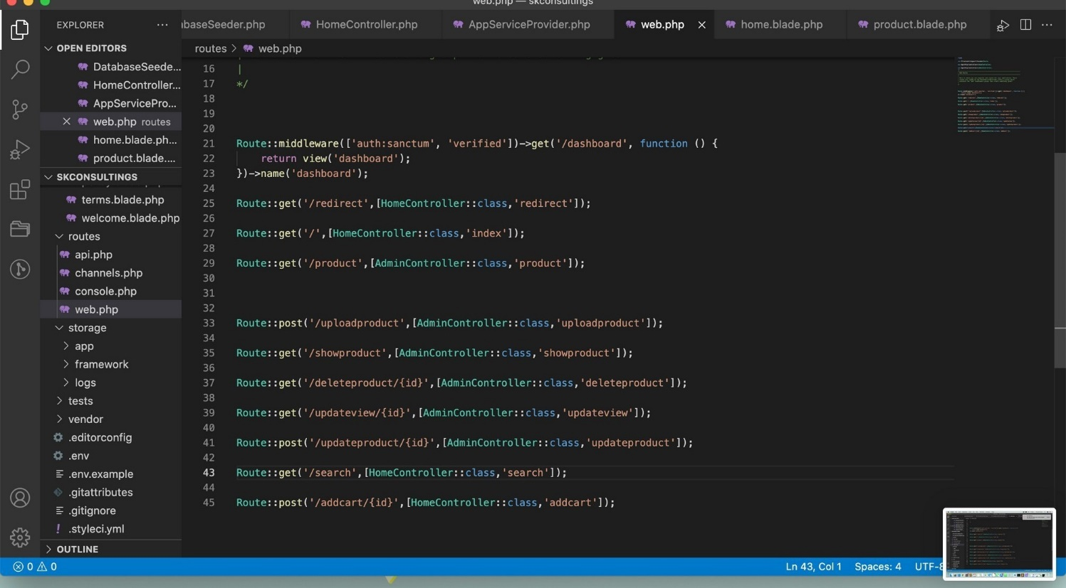

Product page

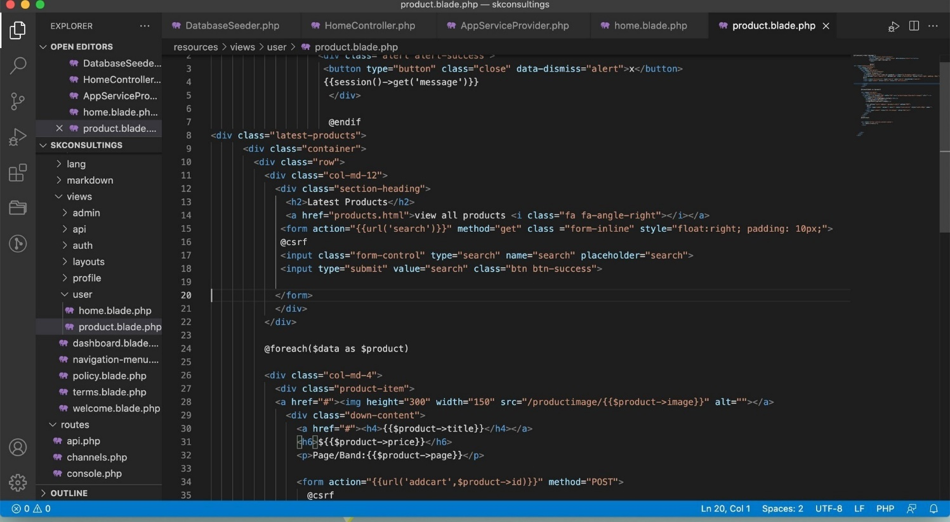

This page is the back end of my product table by which I have displayed all the product in my project.