**Composer Installation**

*The Composer version installed is 2.1.9*

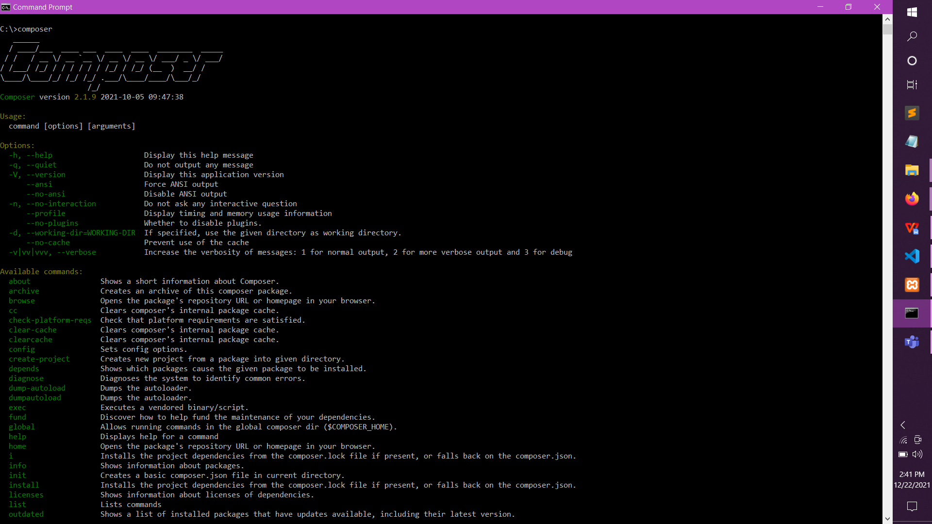

**Laravel Version**

*The Laravel version installed is 8.77.1* 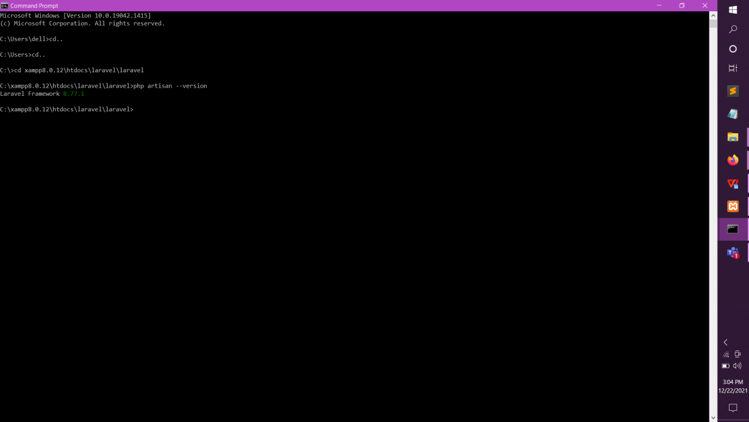

**Laravel Project**

*The new Laravel project is opened via php artisan serve*

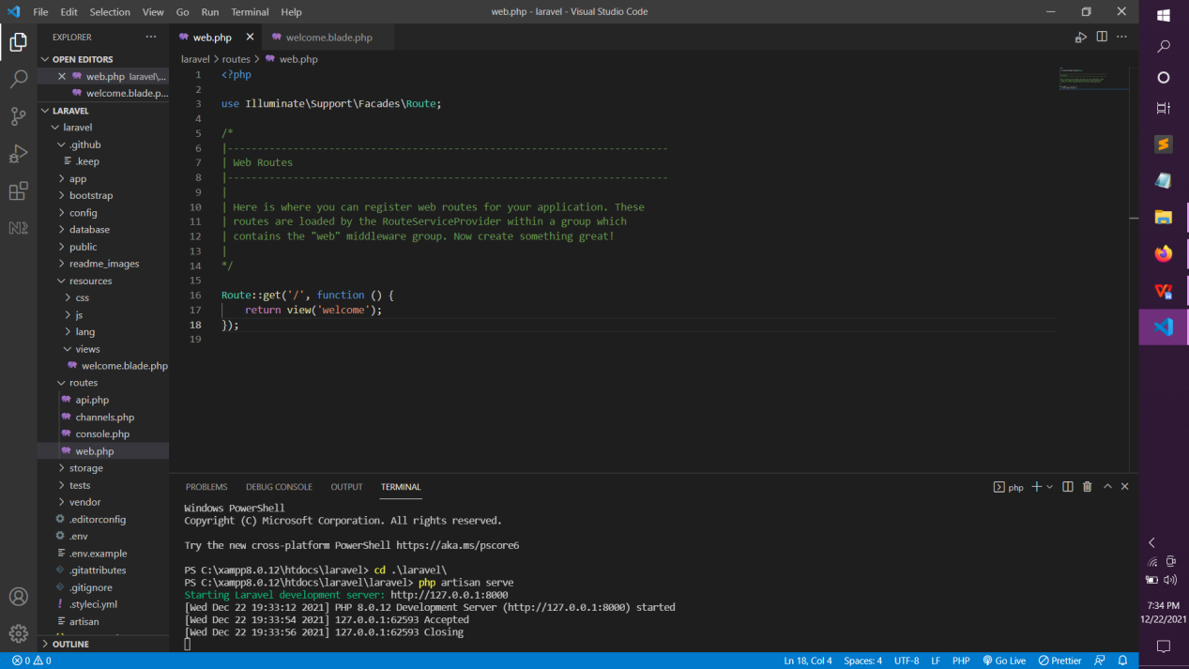

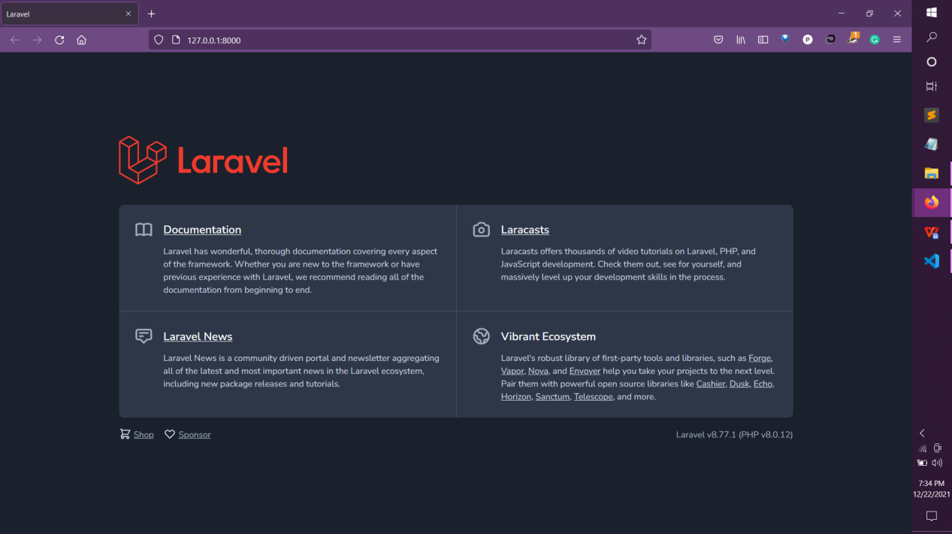

**Version Control**

*The version control is setup locally to embed the given files into Laravel structure*

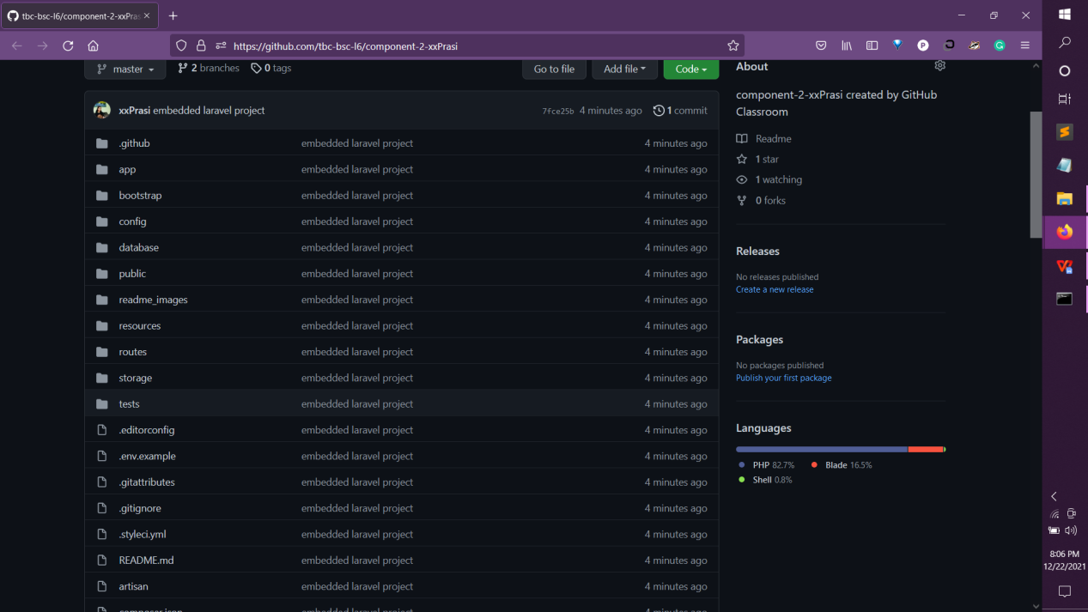

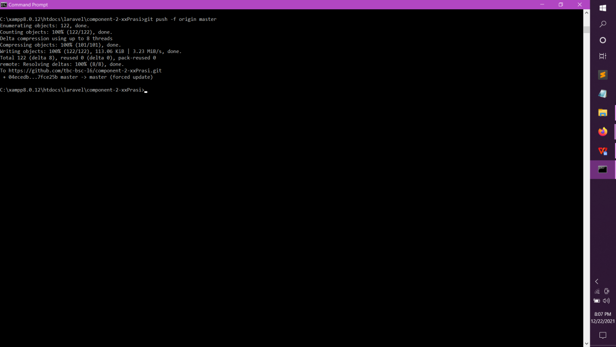

**Table Migration**

*The database tables are created and migrated into PHPmyAdmin*

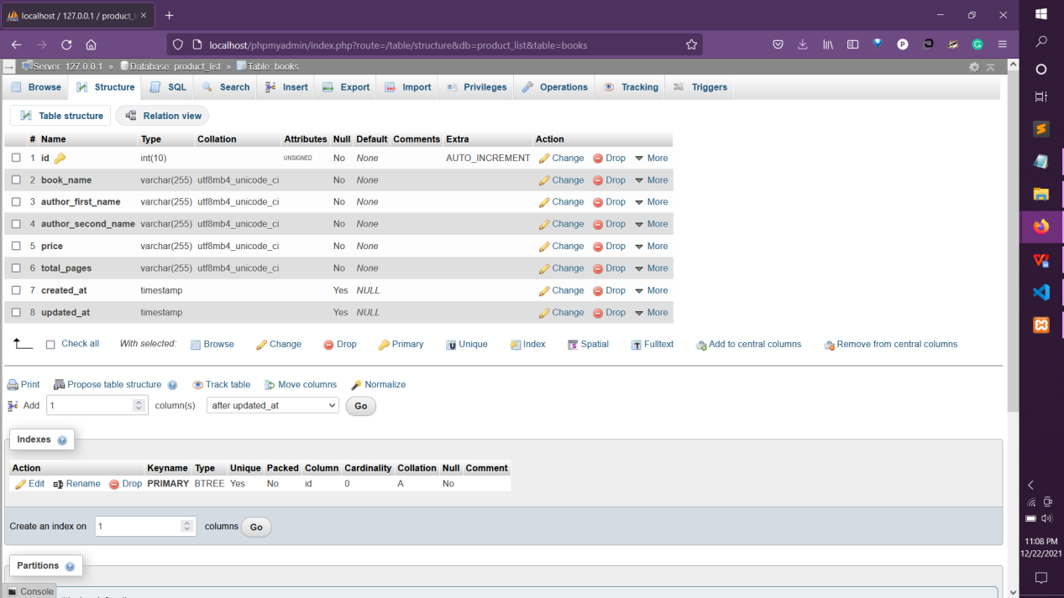

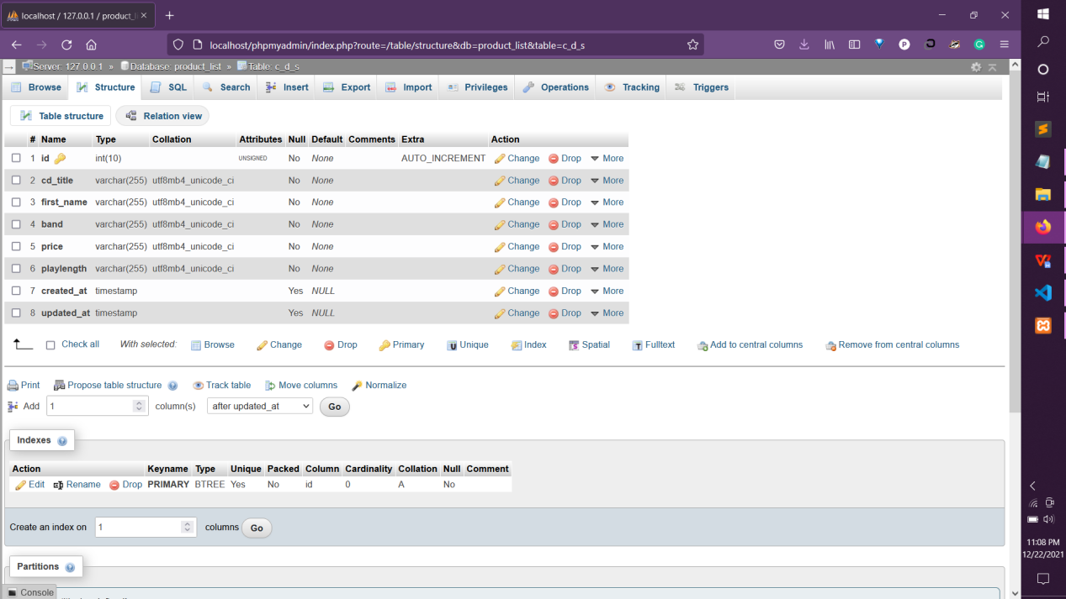

**View Templates**

*The view templates files are made*

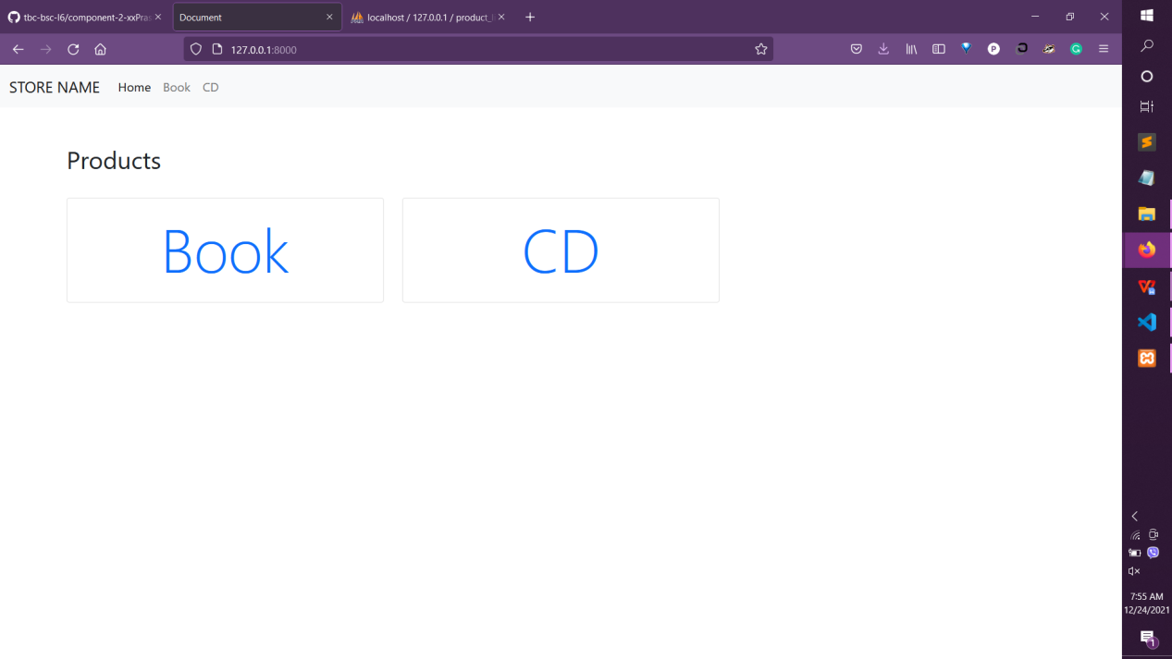

*Landing page - welcome.blade.php*

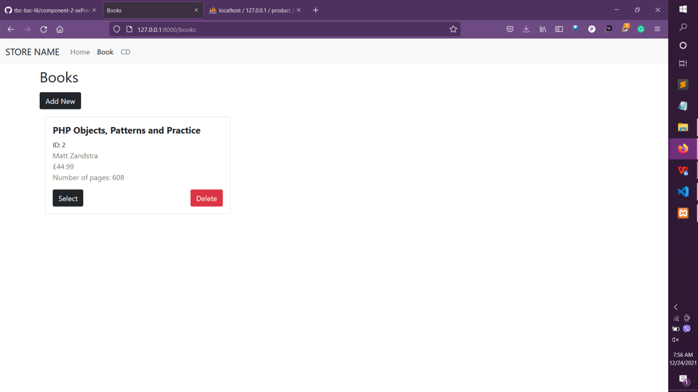

*Book - Books/index.blade.php*

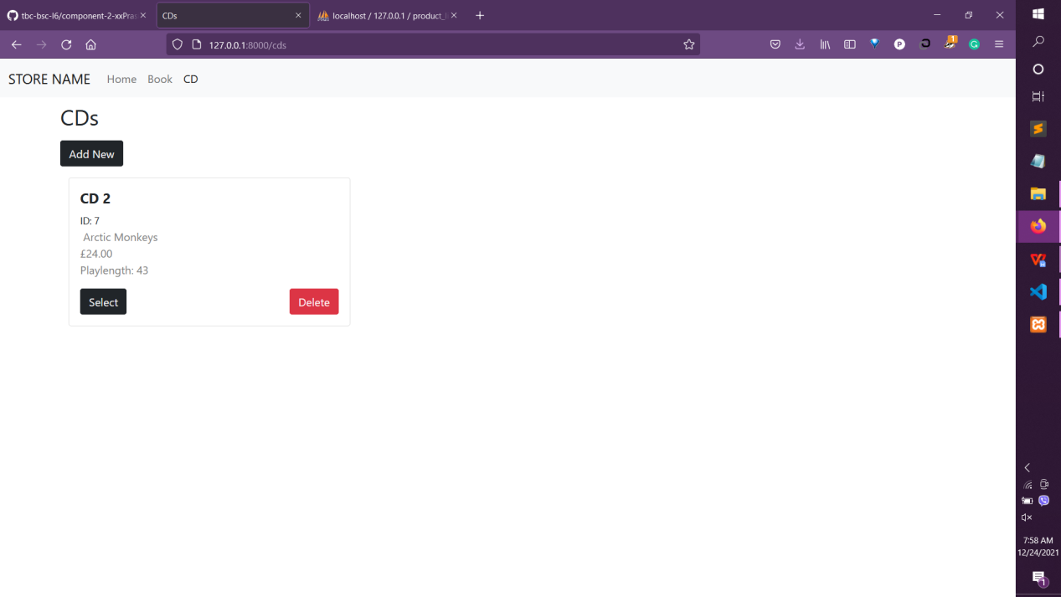

*CD-CDs/index.blade.php*

**CRUD- Book**

**Create**

*New product item is created*

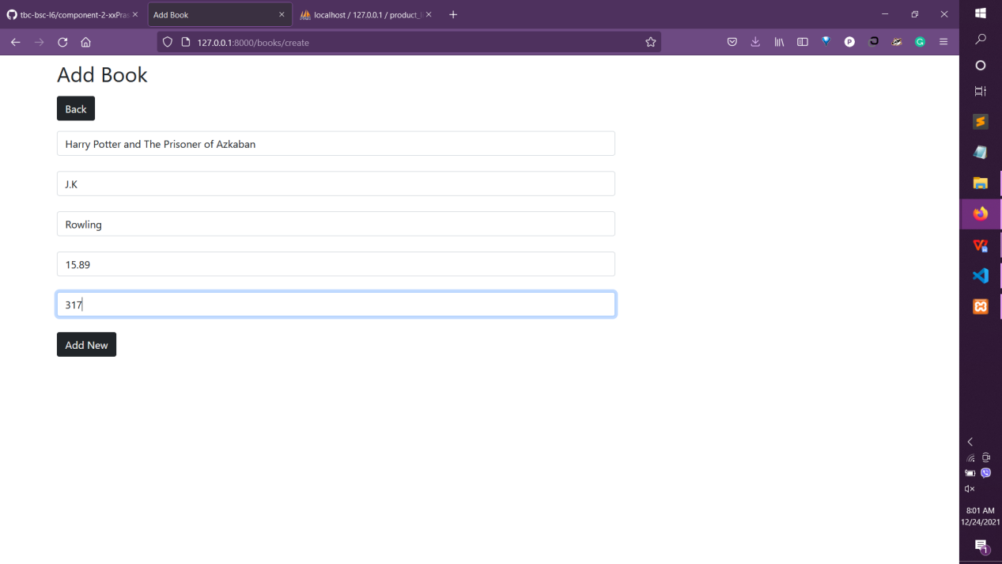

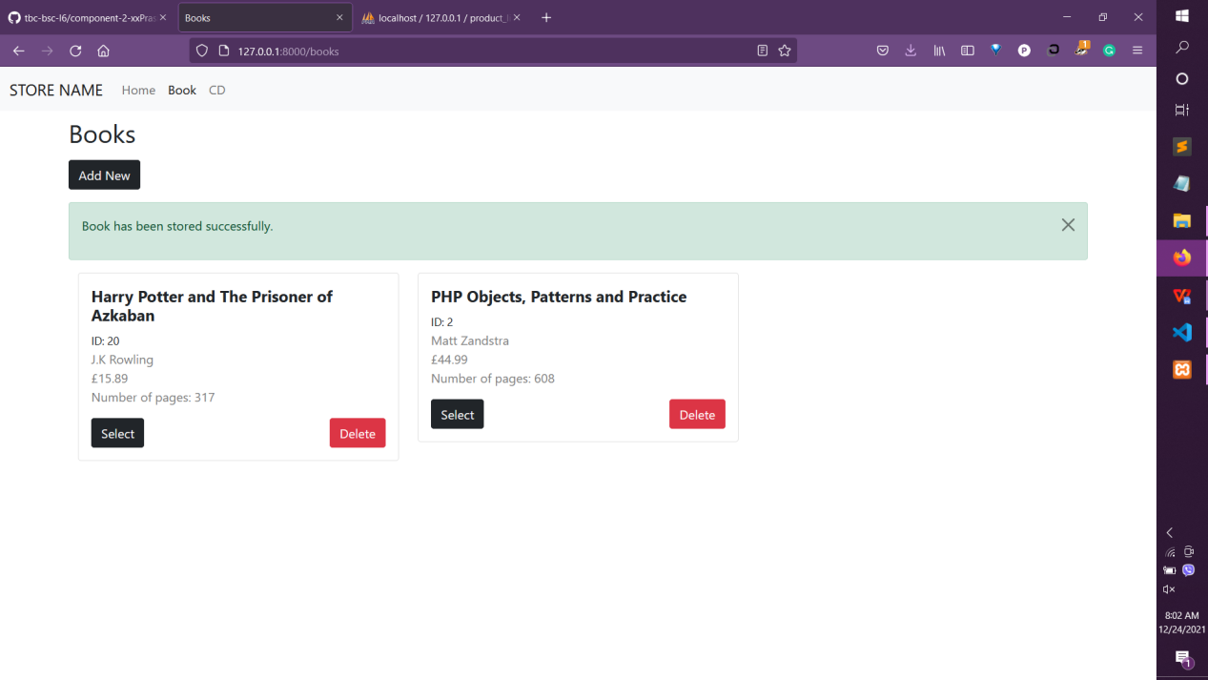

**Update**

*Details of product item is changed*

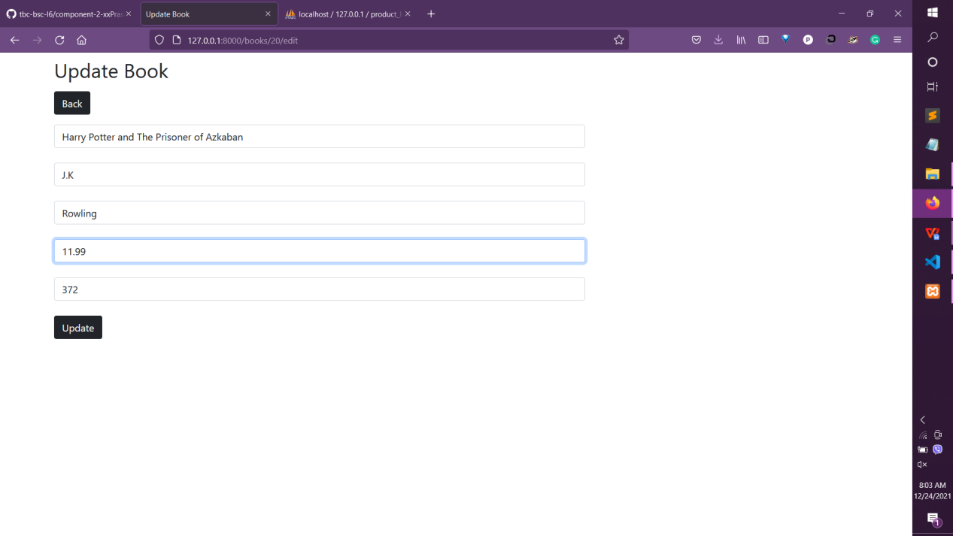

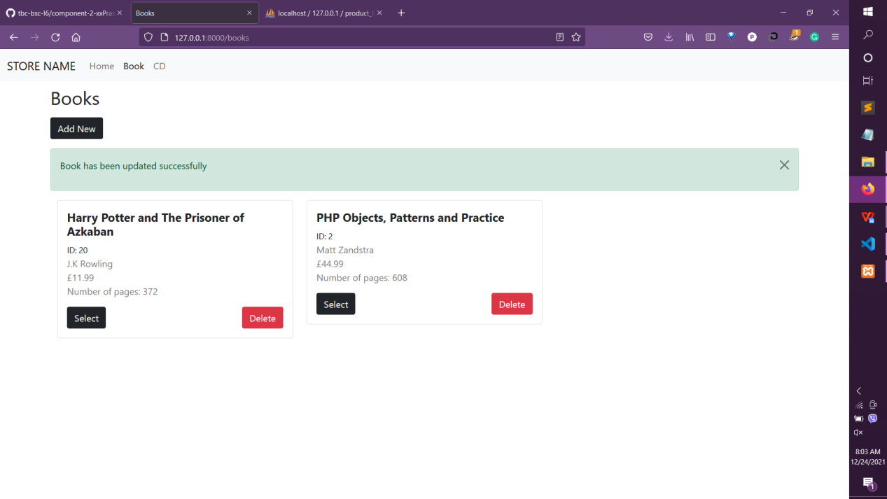

**Delete**

*Product item can be deleted*

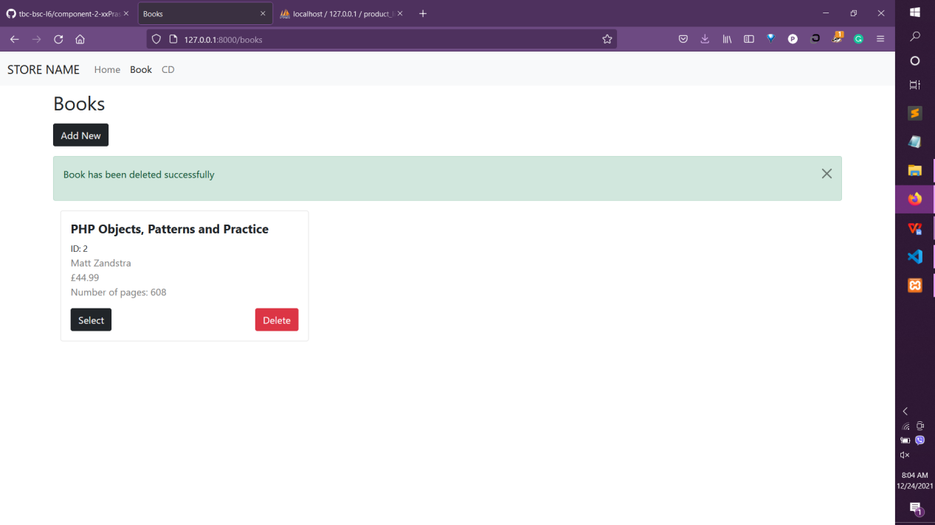

**CRUD- CD**

**Create**

*New product item is created*

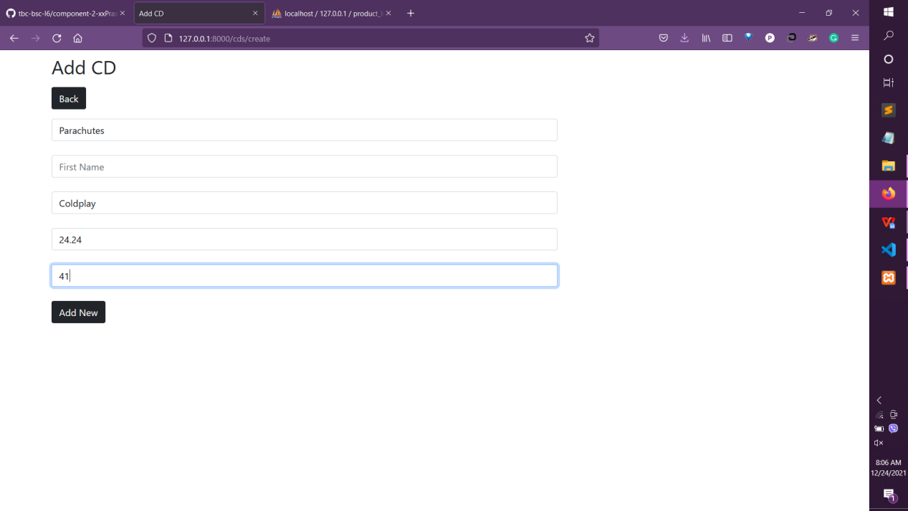

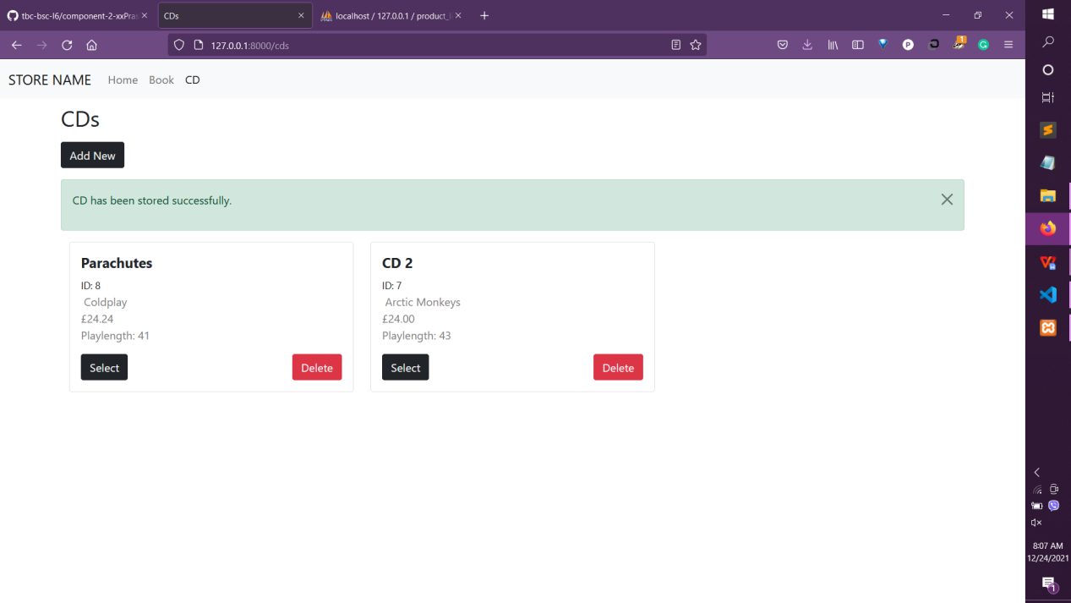

**Update**

*Details of product item is changed*

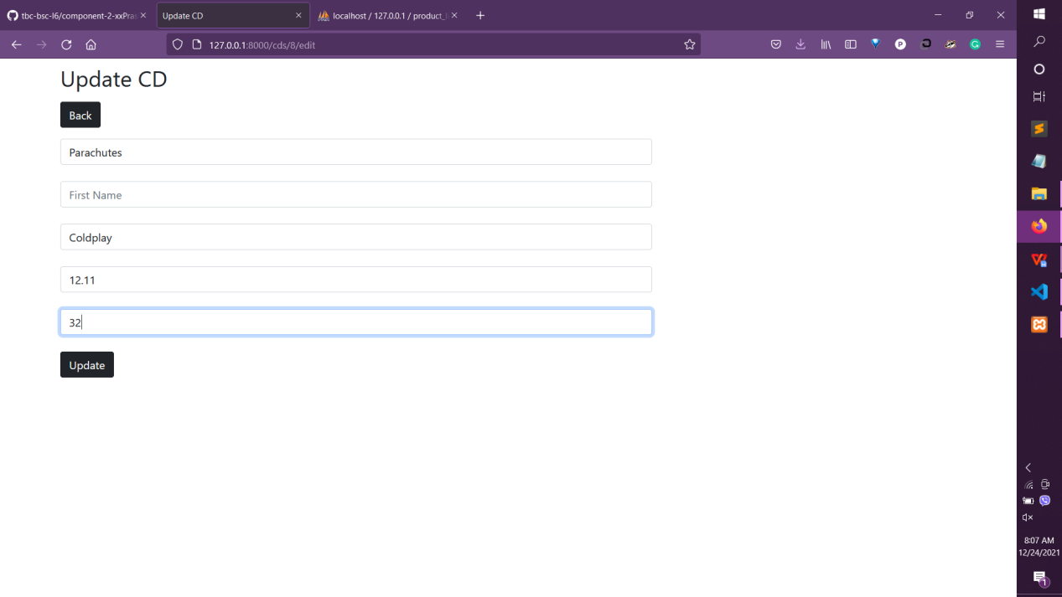

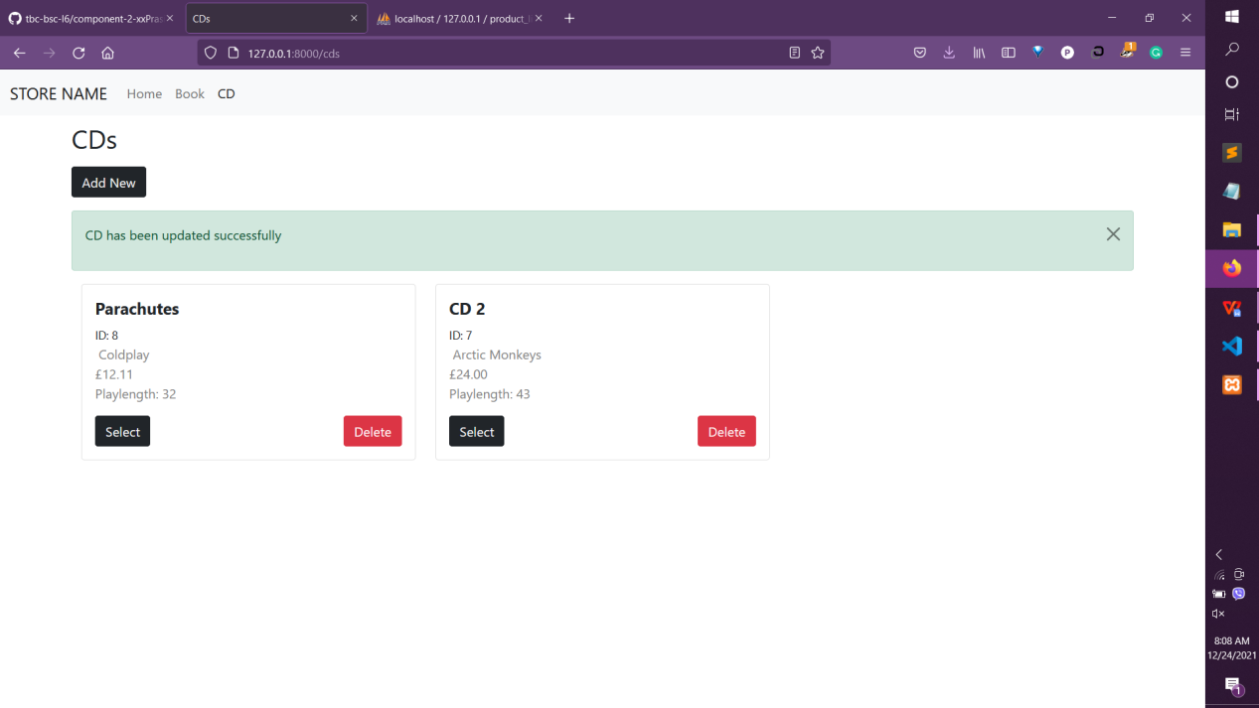

**Delete**

*Product item can be deleted*

