# 

# 

**Award name : BSc (Hons) Computing**

**Module Name: Advance Web engineering**

**Student Name : Prasiddhi Bhattarai**

**Student ID : C7227164**

**Submission Date : 13th January, 2022**

**Module Tutor (TBC): Pratik Shrestha**

Project Features :

-Welcome Page

-Login and Register Page

-Separate admin and user views

-Authenticated URLs

-Admin has access to all crud functionalities

-User can view all products

-Pagination

-All products,data and users recorded in database

-Use of factory class

-Routing with middleware

-Version Control

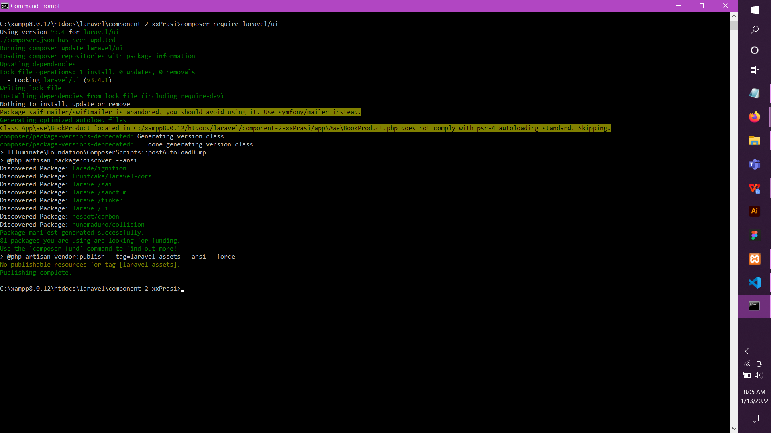

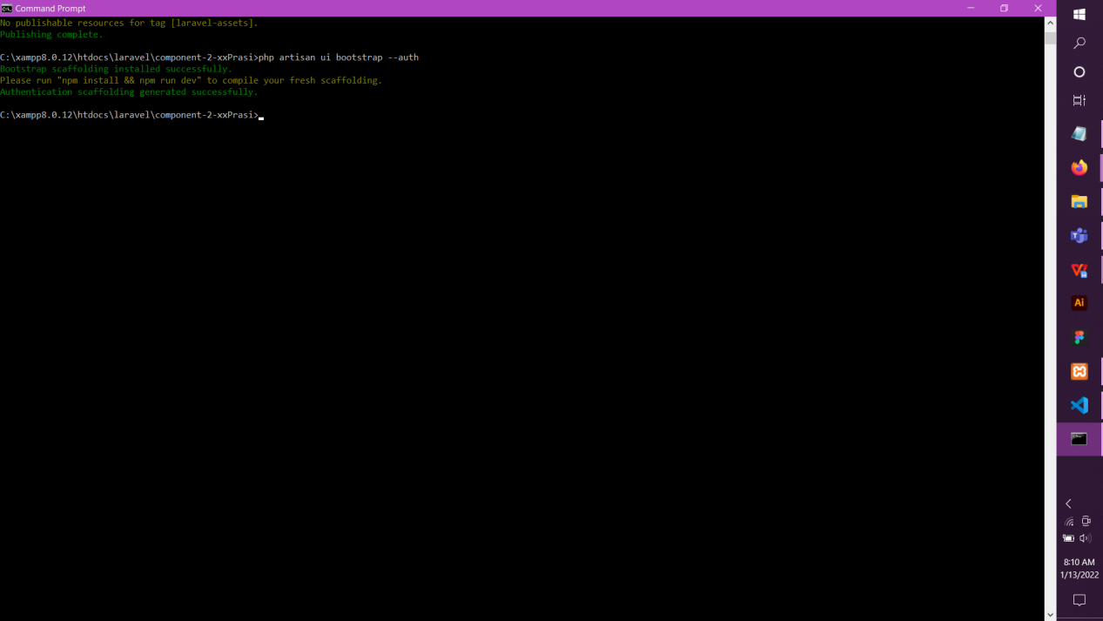

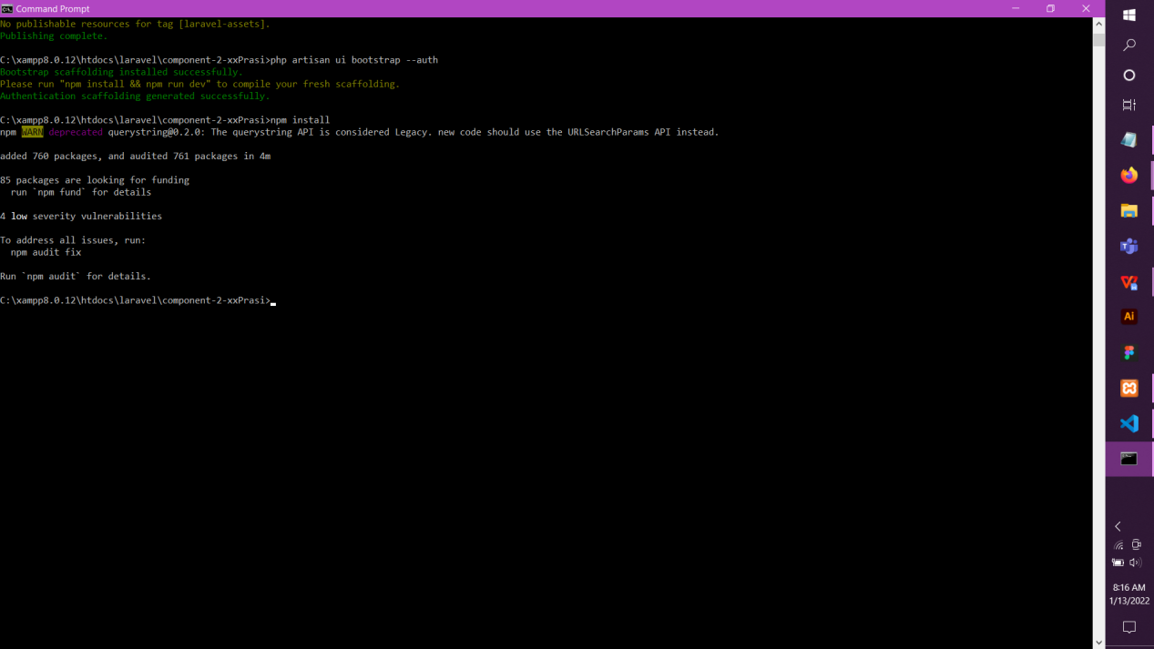

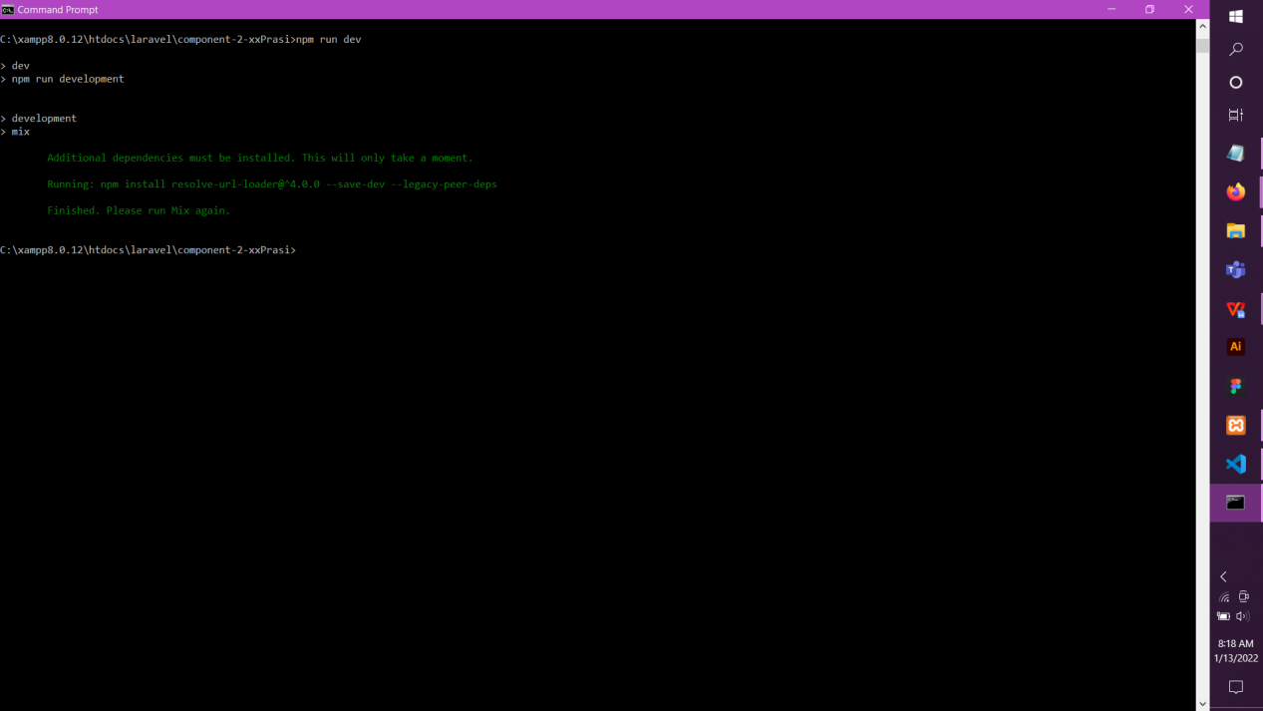

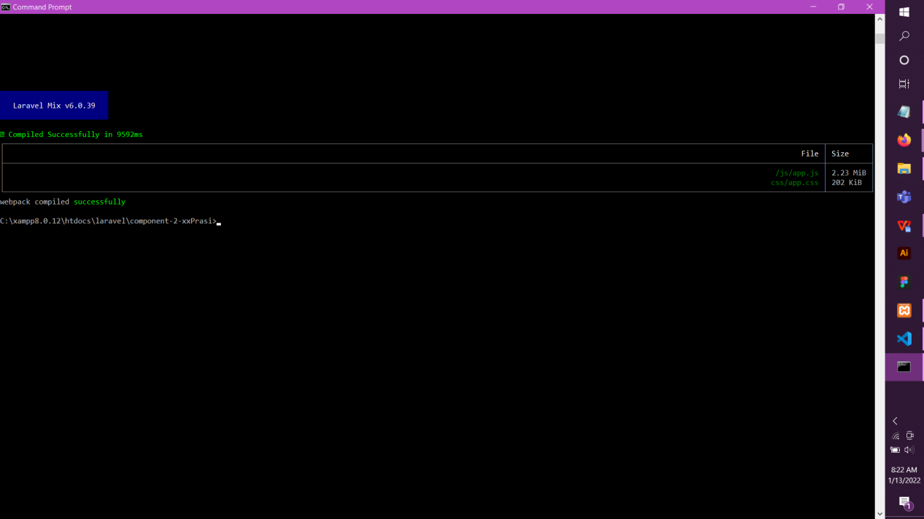

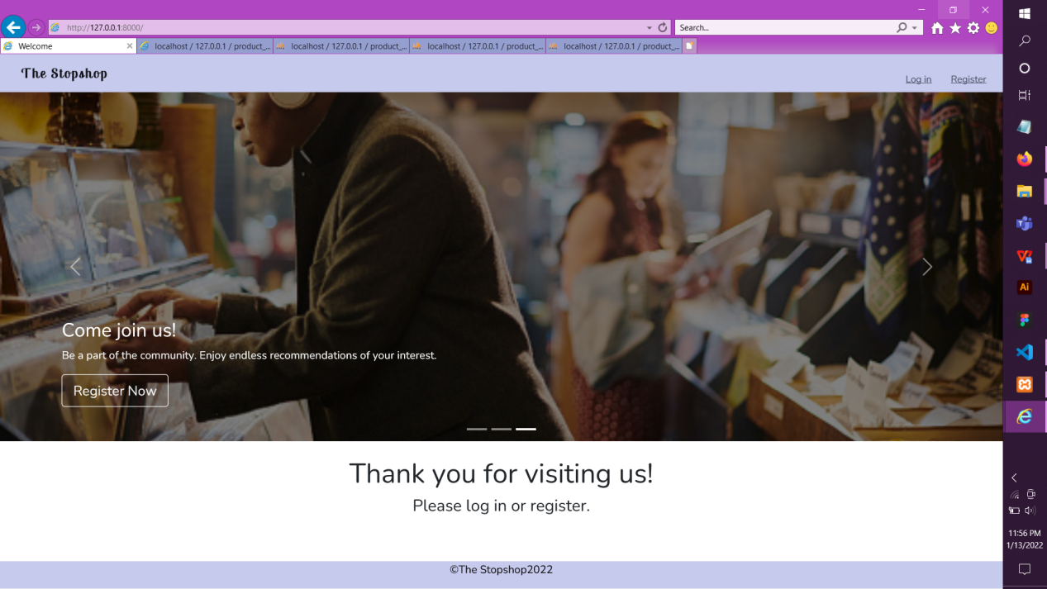

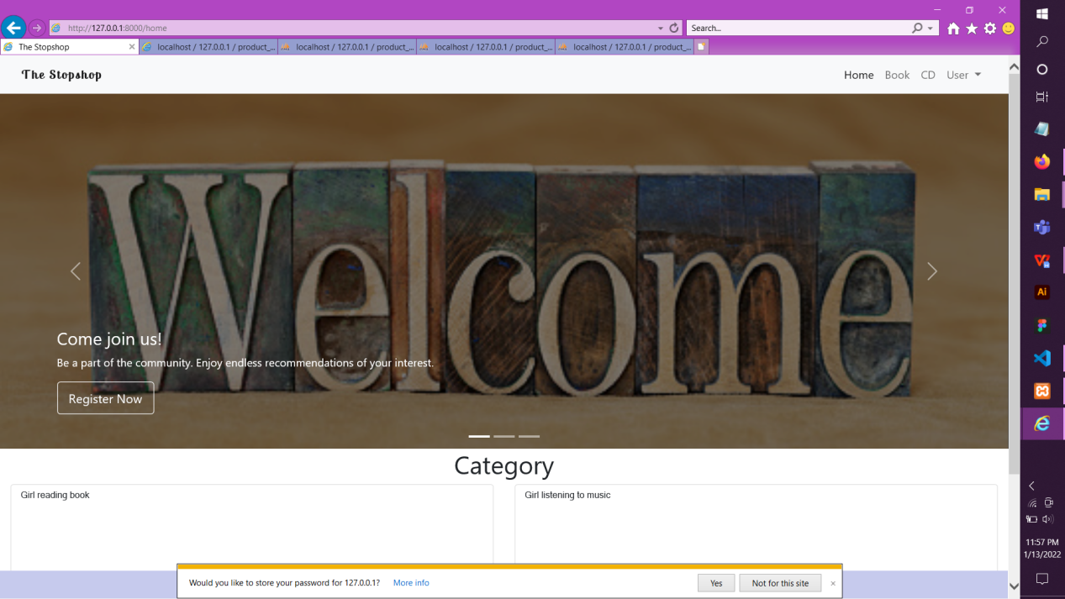

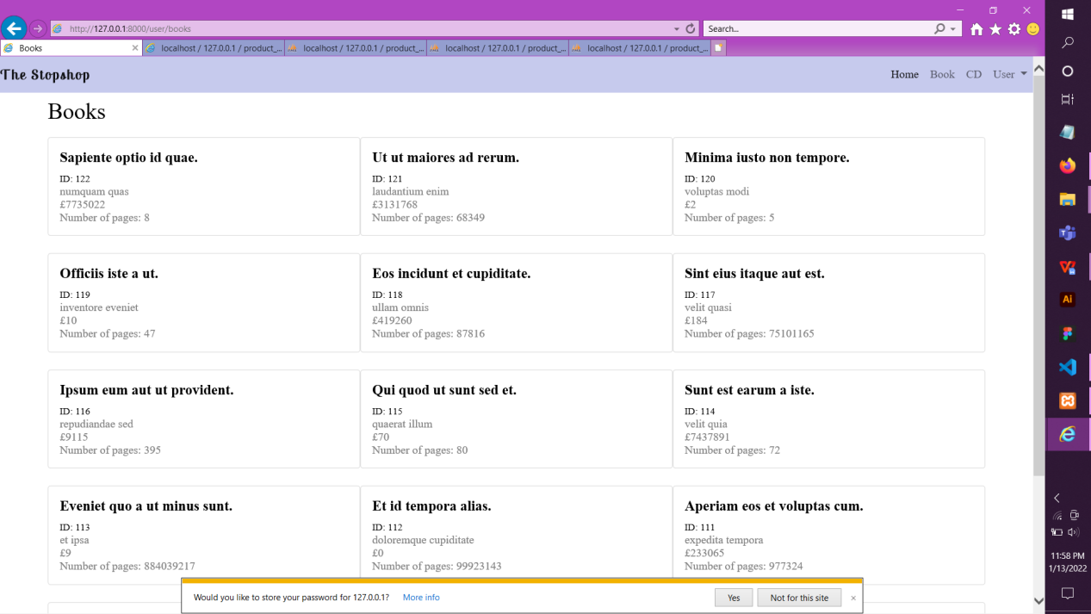

*User has no edit or delete access*

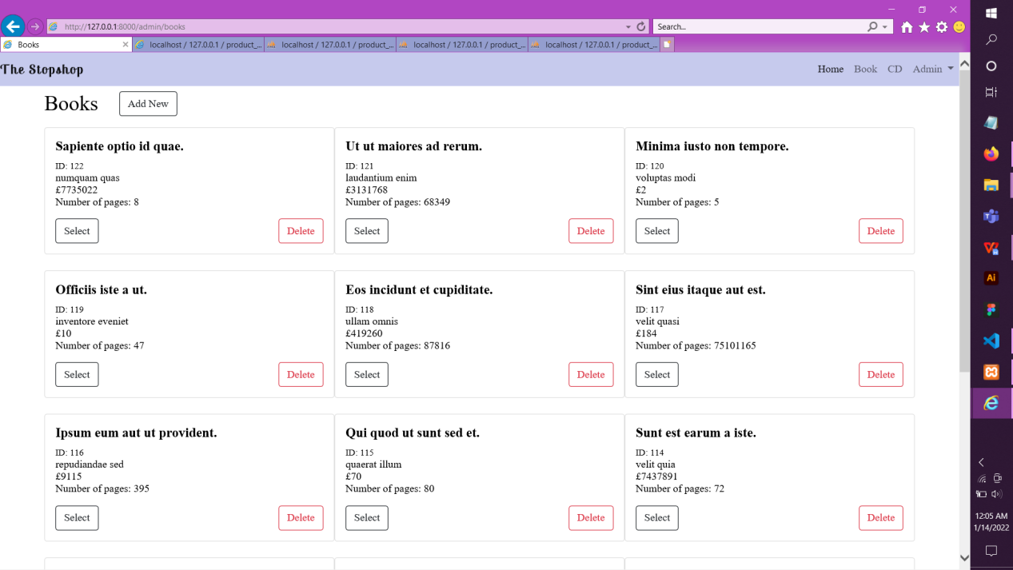

*Admin can perform all CRUD operations*

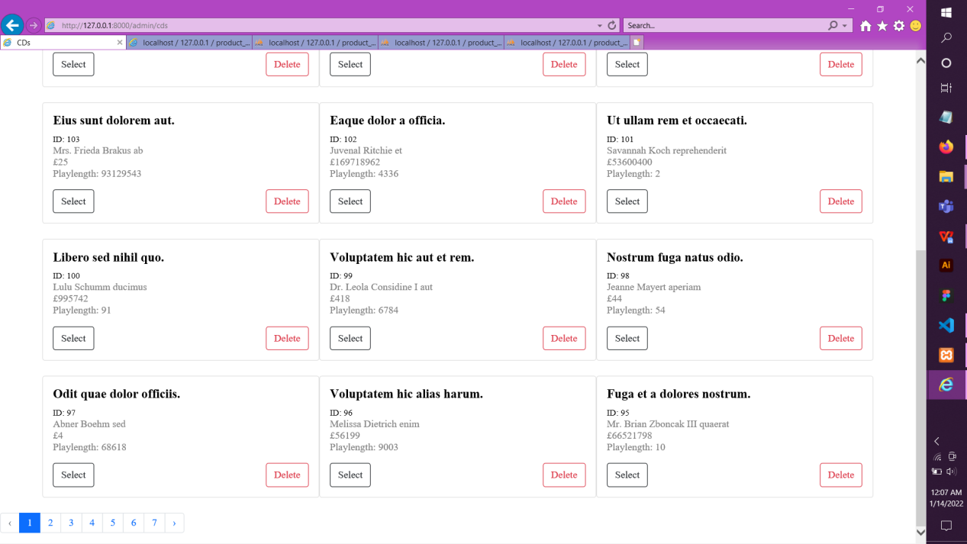

*Pagination*

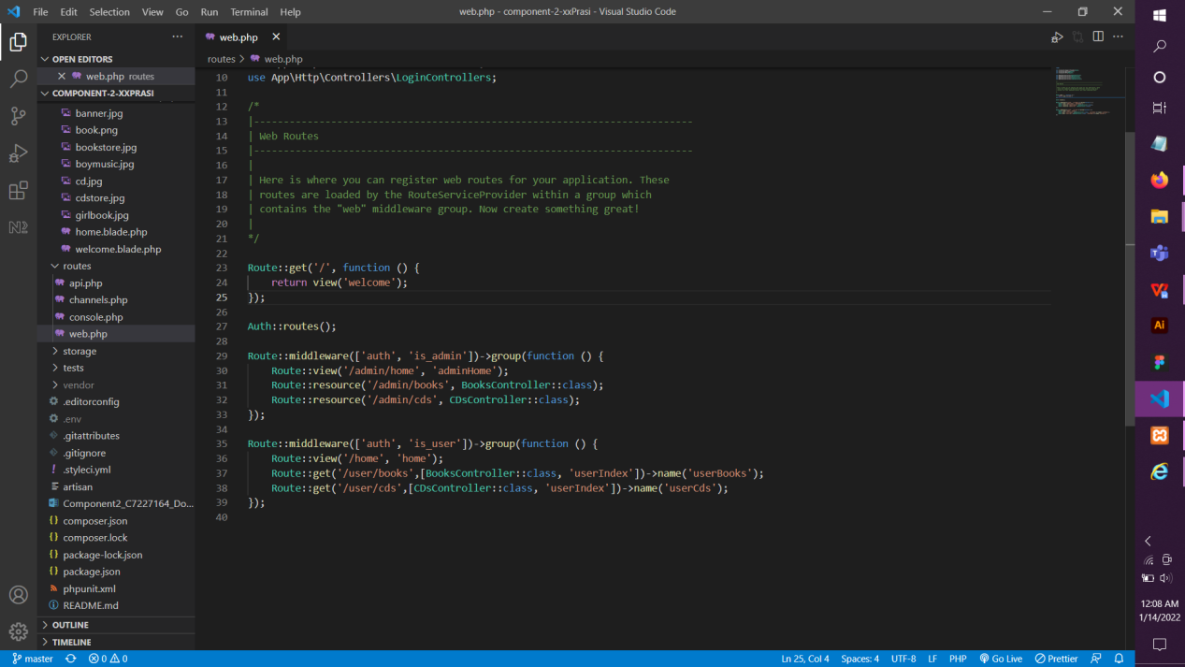

*Routes with middleware*