Climate
Precipitation

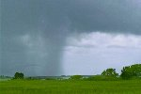
Picture taken from:
http://www.savannah-weather.com/weather/gallery/indexg.shtml

Table of Contents

Section Page

Lesson Objectives 3

Curriculum Expectations 3

Teacher Package (Academic Lesson) 4

Teacher Package (Applied Lesson) 5

Academic Performance Task, Expectations and Rubric 6

Applied Performance Task, Expectations and Rubric 8

Climate and Precipitation 10

Climate and Precipitation Student Activity Sheets 15

Ecozone Map of Canada 17

Climate and Precipitation Internet Resources 18

Climate Precipitation – ArcView Lesson 19

Climate Precipitation – ArcView Lesson Activity Sheets 33

Climate and Precipitation

Lesson Objectives

- Explore the climatic nature of Canada.
- Study the relationships between climate and physiography.
- Learn about the climatic characteristics of the ecozones of Canada.
- Investigate the topic of climate change.
- Build maps to display the climate of the Canadian ecozones.
- Use deductive reasoning to study the relationships between climatic attributes.
- Model climate change and look at the potential impacts on Canadians.
- Build a map layout.

Curriculum Expectations

The Ontario grade 9 curriculum expectations were used as a basis for preparing the lessons in this series. Although there is no direct correlation between Ontario expectations and other provinces, in general, the issues covered in the lessons do relate to many of the curriculum requirements in other jurisdictions. The full curriculum expectations can be found at the Ontario Ministry of Education Web site

English http://www.edu.gov.on.ca/eng/document/curricul/secondary/canadian/canaful.html
French http://www.edu.gov.on.ca/fre/document/curricul/secondary/canadian/canaful.html

The performance tasks for Grade 9 Academic were based directly on curriculum expectations selected from the policy document for Canadian and World Studies. The tasks encompassed the four categories of knowledge and skills (i.e., Knowledge/Understanding, Thinking/Inquiry, Communication, and Application), requiring students to integrate their knowledge and skills in meaningful learning experiences.

The rubric for a specific performance task is intended to provide teachers and students with an overview of the expected final product with regard to the knowledge and skills being assessed as a whole. The rubric identifies key criteria by which the students’ work is to be assessed, and it provides descriptions that indicate the degree to which the key criteria have been met. The teacher can use the descriptions of the different levels of achievement given in the rubric to assess student achievement on a particular task.

Teacher Package

Academic Lesson

Title: Climate Change

Time requirement: Prior learning and skill development:
1 period of 70 minutes each
ArcView lesson:
1 to 2 periods of 70 minutes each
Student research and proposal writing:
1 period of 70 minutes each
Teacher Instructions:
- Description of the Task
(see Academic Performance Task, Expectations and Rubric).

- Final Product
Students are to write a short report outlining how climate change will effect selected ecozones in Canada. The report is to present collected research on the issue of climate change. Student are instructed to include supporting visuals, such as maps, graphs, charts, diagrams, or pictures, in their report.

- Assessment and Evaluation
The final product will be assessed using the Expectations and the Performance Task Rubric.
Formal and informal assessment of the students based on prior knowledge, lesson objectives, production of their ArcView Map, research process done using the Background Information, the students’ activity sheets (on the Background and on the ArcView lesson) and the Rubric for assessing Maps. Self- or peer assessments and collaboration may be useful to the teacher and students.

- Accommodations
Accommodations that are normally provided in the regular classroom for students with special needs should be provided in the administration of this performance task.

- Rubric
Introduce the task-specific rubric to the students before giving the administrative task. Review the rubric with the students and ensure that each student understands the criteria and descriptions for achievement at each level.
Some students may perform below level 1. It will be important to note the characteristics of their work in relation to the criteria in the assessment rubric and to provide feedback to help them improve.

Teacher Package

Applied Lesson

Title: Climate Change

Time requirement: Prior learning and skill development:
1 period of 70 minutes each
ArcView lesson:
1 to 2 periods of 70 minutes each
Computer Presentation
1 period of 70 minutes each
Teacher Instructions:
- Description of the Task
(see Applied Performance Task, Expectations and Rubric)

- Final Product
Students are to write a short report outlining how climate change will effect selected ecozones in Canada. The report is to present collected research on the issue of climate change. Student are instructed to include supporting visuals, such as maps, graphs, charts, diagrams, or pictures, in their report.

- Assessment and Evaluation
The final product will be assessed using the Expectations and the Performance Task Rubric.
Formal and informal assessment of the students based on prior knowledge, lesson objectives, production of their ArcView Map, research process done using the Background Information, the students’ activity sheets (on the Background and on the ArcView lesson) and the Rubric for assessing Maps. Self- or peer assessments and collaboration may be useful to the teacher and students.

- Accommodations
Accommodations that are normally provided in the regular classroom for students with special needs should be provided in the administration of this performance task.

- Rubric
Introduce the task-specific rubric to the students before giving the administrative task. Review the rubric with the students and ensure that each student understands the criteria and descriptions for achievement at each level.
Some students may perform below level 1. It will be important to note the characteristics of their work in relation to the criteria in the assessment rubric and to provide feedback to help them improve.

Academic Performance Task, Expectations and Rubric

The Task
Students begin by examining various aspects of Canada’s climate. The initial inquiry explores precipitation patterns by ecozone. The task is to create a simple model to determine the effects of climate change. Students are to write a short report outlining how climate change will effect selected ecozones in Canada. The report is to present collected research on the issue of climate change. Student are instructed to include supporting visuals, such as maps, graphs, charts, diagrams, or pictures, in their report.

Expectations
This task gives students the opportunity to demonstrate achievement of the following selected expectations from three strands: Geographic Foundations: Space and Systems; Understanding and Managing Change; and Methods of Geographic Inquiry.

Students will:

- demonstrate an understanding of how natural and human systems interact within ecozones;
- analyze the ways in which natural systems interact with human systems, then make predictions about the outcomes of these interactions;
- research and report on global concerns that affect Canadians (e.g., wilderness protection, economic impact of globalization);
- predict the consequences of human activities (e.g., agriculture, recreation) on natural systems (e.g., soil depletion, climate change);
- select and use appropriate methods for displaying geographic data.

Prior Knowledge and Skills
To complete this task, students are expected to be able to demonstrate the following:

- knowledge of the definition of and ecozone;
- knowledge of some of Canada’s ecozones and their physical characteristics (e.g. landforms, climate, vegetation, and soils);
- demonstrate an understanding of the regional diversity of Canada’s natural systems (e.g., natural vegetation, climate zones) and human systems (e.g., transportation links, urban hierarchies);
- identify the variables that are used to describe the weather, such as: jet stream, front, wind direction, and cloud cover;
- investigate why is weather significant in our lives;
- learn about the climate system in Canada and the global factors: unequal heating of the Earth’s surface, climate characteristics, climate graphs, latitude as a climate factor, global wind system, ocean currents, elevation as a climate factor, mountain climates, influence of lakes and oceans and climate change;
- understanding of research methods using a variety of source materials;
- ability to read, analyze, and interpret graphs and maps;
- ability to use a variety of tools and technologies for research;
- demonstrate an understanding of the characteristics of natural systems (e.g., climate, landforms, soils, natural vegetation, wildlife);
- demonstrate an understanding of the methods used to collect, organize, manipulate, and interpret geographic data.

Task Rubric – Climate Change
Expectations |  |  | Criteria |  |  | Level 1 (50 – 59) |  |  | Level 2 (60 –69) |  |  | Level 3 (70 – 79) |  |  | Level 4 (80 -100)

Knowledge / understanding
1 |  | - Demonstrates understanding of the relationship between natural and human systems |  |  | - Demonstrates limited understanding of the relationship between natural and human systems |  |  | - Demonstrates some understanding of the relationship between natural and human systems |  |  | - Demonstrates considerable understanding of the relationship between natural and human systems |  |  | - Demonstrates thorough understanding of the relationship between natural and human systems

Thinking / Inquiry
4 |  | - Predicts the consequences of human activities (e.g., agriculture, recreation) on natural systems (e.g., soil depletion, climate change); |  |  | - Shows little prediction of the consequences of human activities on natural systems |  |  | - Shows some predictions of the consequences of human activities on natural systems |  |  | - Shows considerable prediction of the consequences of human activities on natural systems |  |  | - Predicts the consequences of human activities on natural systems to a high degree

Communication
3,5 |  | - Writes a clear and convincing report on global concerns that affect Canadians |  |  | - Writes a report that is not very clear or convincing on global concerns that affect Canadians |  |  | - Writes a report that is somewhat clear and convincing on global concerns that affect Canadians |  |  | - Writes a report that is generally clear and convincing on global concerns that affect Canadians |  |  | - Writes a report that is very clear and convincing on global concerns that affect Canadians
Application
2 |  | - Analyses the ways in which natural systems interact with human systems, then make predictions about the outcomes of these interactions |  |  | - Demonstrates little analyses of the ways in which natural systems interact with human systems |  |  | - Demonstrates some analyses of the ways in which natural systems interact with human systems |  |  | - Demonstrates considerable analyses of the ways in which natural systems interact with human systems |  |  | - Analyses the ways in which natural systems interact with human systems to a high degree

Applied Performance Task, Expectations and Rubric

The Task
Students begin by examining various aspects of Canada’s climate. The initial inquiry explores precipitation patterns by ecozone. The task is to create a simple model to determine the effects of climate change. Students are to write a short report outlining how climate change will effect selected ecozones in Canada. The report is to present collected research on the issue of climate change. Student are instructed to include supporting visuals, such as maps, graphs, charts, diagrams, or pictures, in their report.

Expectations
This task gives students the opportunity to demonstrate achievement of the following selected expectations from three strands: Geographic Foundations: Space and Systems; Understanding and Managing Change; and Methods of Geographic Inquiry.

Students will:

- demonstrate an understanding of how natural and human systems interact within ecozones;
- demonstrate an understanding of the ways in which natural and human systems function as parts of a whole;
- produce research reports on global concerns that affect Canadians (e.g., wilderness protection, economic impact of globalization);
- predict the consequences of human activities (e.g., agriculture, recreation) on natural systems (e.g., soil depletion, climate change);
- select and use appropriate methods for displaying geographic data.

Prior Knowledge and Skills
To complete this task, students are expected to be able to demonstrate the following:

- knowledge of the definition of and ecozone;
- knowledge of some of Canada’s ecozones and their physical characteristics (e.g. landforms, climate, vegetation, and soils);
- demonstrate an understanding of the regional diversity of Canada’s natural systems (e.g., natural vegetation, climate zones) and human systems (e.g., transportation links, urban hierarchies);
- identify the variables that are used to describe the weather, such as: jet stream, front, wind direction, and cloud cover;
- investigate why is weather significant in our lives;
- learn about the climate system in Canada and the global factors: unequal heating of the Earth’s surface, climate characteristics, climate graphs, latitude as a climate factor, global wind system, ocean currents, elevation as a climate factor, mountain climates, influence of lakes and oceans and climate change;
- understanding of research methods using a variety of source materials;
- ability to read, analyse, and interpret graphs and maps;
- ability to use a variety of tools and technologies for research;
- demonstrate an understanding of the characteristics of natural systems (e.g., climate, landforms, soils, natural vegetation, wildlife);
- demonstrate an understanding of the methods used to collect, organize, manipulate, and interpret geographic data.

Task Rubric – Climate Change
Expectations |  |  | Criteria |  |  | Level 1 (50 – 59) |  |  | Level 2 (60 –69) |  |  | Level 3 (70 – 79) |  |  | Level 4 (80 -100)

Knowledge / understanding
1 |  | - Demonstrates understanding of the relationship between natural and human systems |  |  | - Demonstrates limited understanding of the relationship between natural and human systems |  |  | - Demonstrates some understanding of the relationship between natural and human systems |  |  | - Demonstrates considerable understanding of the relationship between natural and human systems |  |  | - Demonstrates thorough understanding of the relationship between natural and human systems

Thinking / Inquiry
4 |  | - Predicts the consequences of human activities (e.g., agriculture, recreation) on natural systems (e.g., soil depletion, climate change); |  |  | - Shows little prediction of the consequences of human activities on natural systems |  |  | - Shows some predictions of the consequences of human activities on natural systems |  |  | - Shows considerable prediction of the consequences of human activities on natural systems |  |  | - Predicts the consequences of human activities on natural systems to a high degree

Communication
3,5 |  | - Writes a clear and convincing report on global concerns that affect Canadians |  |  | - Writes a report that is not very clear or convincing on global concerns that affect Canadians |  |  | - Writes a report that is somewhat clear and convincing on global concerns that affect Canadians |  |  | - Writes a report that is generally clear and convincing on global concerns that affect Canadians |  |  | - Writes a report that is very clear and convincing on global concerns that affect Canadians
Application
2 |  | - Analyses the ways in which natural systems interact with human systems, then make predictions about the outcomes of these interactions |  |  | - Demonstrates little analyses of the ways in which natural systems interact with human systems |  |  | - Demonstrates some analyses of the ways in which natural systems interact with human systems |  |  | - Demonstrates considerable analyses of the ways in which natural systems interact with human systems |  |  | - Analyses the ways in which natural systems interact with human systems to a high degree

Climate and Precipitation

Canada is, probably more than most countries, affected by its latitude. Canada is a land of extremes. It extends from the warm southern regions at latitudes of 42 degrees to the frigid northern polar cap. It has both humid ocean coasts and dry prairie. It reaches from sea level to the top of Mt. Logan at almost 6 000 m. It experiences four rather distinct seasons of spring, summer, autumn and winter with accompanying weather patterns.

How often do we complain it is too hot, too cold, too wet? These are all results of weather. Weather is defined by day-to-day atmospheric conditions of temperature, cloud cover, precipitation, wind direction and speed, humidity and air pressure. The combination of these conditions in certain ways causes weather patterns. For example, we know that when a mass of warm moist air runs into a mass of cold dry air it forms a front and we will get precipitation as rain, snow, hail or sleet. The long-term weather patterns over an area are what define its climate.

Climate is usually referred to as being either maritime or continental. Maritime climate is found near large water bodies which moderate or keep the temperature from being extremely cold in winter or hot in summer. To explain maritime climate we can look at several laws of physics, which come into play here. First, bright shiny objects reflect heat while dark objects absorb it. Since large bodies of water reflect the sun, they absorb heat more slowly than the surrounding land, which absorbs it more quickly. Notice how there is usually a cool breeze near water on a summer day. This is due to a law of physics that says warm air rises cold air falls. As the warm air over the land rises, it is replaced by the cooler air from over the water. As the land cools more quickly at night, the process is reversed and the warm breeze blows out toward the water. Another law of physics says that when two objects of different temperatures are put together, they try and find a common temperature. In this manner, the warm and cold air mix to keep the temperature from changing drastically from summer to winter or day to night. Because oceans are such large bodies of water, they are slow to change temperature and effectively heat the surrounding area in winter and cool it in summer. As well, the air absorbs a large amount of water making this a humid climate. Therefore, maritime climate is found in areas bordering oceans and, to a lesser extent, around very large lakes.

Continental climate refers to inland areas, away from moderating water bodies that are extensively influenced by the large landmass absorbing heat from the sun. The land temperature directly influences the air above these areas. If the landmass is hot, then the air above it will be hot. When the sun goes down, the landmass cools quickly and so does the air temperature. In these areas, not only are the winters colder and the summers warmer, but also there is a significant difference between the daytime and night time temperatures. The continental climate is usually much drier than the maritime climate and precipitation is much less.

By the same process that warm and cold air masses move across our land, warm and cold water masses move across the ocean. Large warm bodies of water that are heated by the sun move northward to mix with the large cold bodies of water from the polar regions rushing south. These moving bodies of water create ocean currents. The air above these currents is either warmed or cooled by the water temperature. Warm water from the Pacific, known as the North Pacific Current, runs up the West Coast of Canada and warms the air above it. This causes the warmer, though wetter Pacific climate. On Canada's East Coast, the Gulf Stream brings warm air from the equatorial Atlantic past Nova Scotia and southern Newfoundland to become the North Atlantic Drift past Greenland. In the opposite direction, cold water of the Labrador Current moves down along the coast of Labrador and northern Newfoundland. Where these two air masses meet off eastern Newfoundland they cause large amounts of precipitation and extensive fog banks.

Let's look at some Canadian figures for annual precipitation.

Table 1: Annual Values for Precipitation (mm) and Temperature (C⁰)
Ecozone names | total precip. | snow | rain | min. temp. | max. temp. | mean temp.
Arctic Cordillera | 249 | 167 | 95 | -22.8 | 1.6 | -13.6
Northern Arctic | 200 | 113 | 94 | -23.2 | -3.7 | -14.0
Southern Arctic | 313 | 141 | 182 | -19.3 | -0.4 | -9.8
Taiga Plains | 325 | 147 | 196 | -16.2 | 6.1 | -4.9
Taiga Shield | 566 | 257 | 327 | -15.7 | 5.1 | -4.8
Boreal Shield | 825 | 255 | 585 | -9.9 | 10.5 | 0.7
Atlantic Maritime | 1186 | 272 | 912 | -3.6 | 12.3 | 4.6
Mixedwood Plains | 941 | 201 | 746 | -0.5 | 13.1 | 6.5
Boreal Plains | 462 | 141 | 331 | -8.7 | 9.6 | 0.6
Prairies | 404 | 111 | 294 | -5.2 | 12.0 | 2.9
Taiga Cordillera | 317 | 152 | 171 | -15.2 | 2.7 | -7.0
Boreal Cordillera | 392 | 172 | 231 | -12.6 | 5.8 | -2.7
Pacific Maritime | 2212 | 139 | 2073 | -11.1 | 14.6 | 7.9
Montane Cordillera | 649 | 217 | 441 | -5.2 | 15.2 | 4.7
Hudson Plains | 656 | 240 | 441 | -11.3 | 5.4 | -1.9

Another law of physics is that warm air absorbs more water than cold air. As air cools, it releases water in the form of precipitation. We have observed this effect on the maritime coast in the form of rain and fog. However, this effect is also observed over mountainous regions. As warm moist air is pushed up the side of a mountain by prevailing winds, it cools and precipitation falls. This cool air, with its moisture now gone, drops down the leeward or sheltered side of the mountain. With no moisture in the air, this area tends to be extremely dry. This is known as rainshadow. If one were to travel across Canada from west to east, this pattern would repeat across each mountain ridge.

Chart 1: Using the precipitation, snow and rain values for each ecozone, a graph was drawn below.
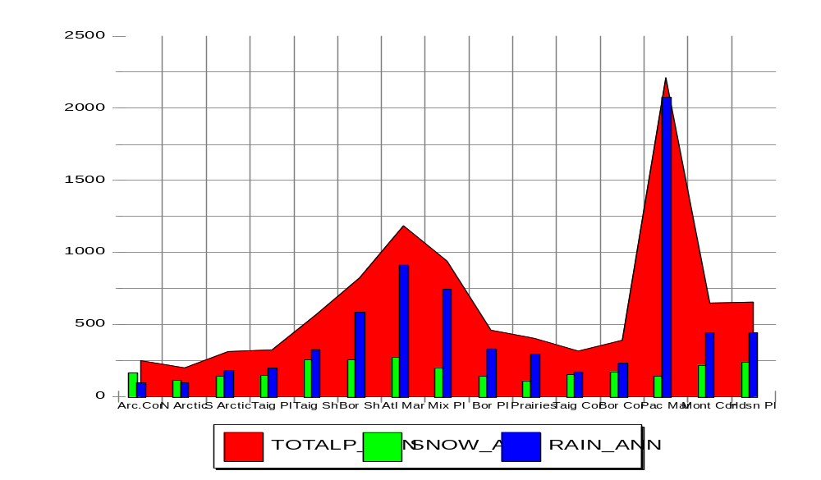

Chart 2 and 3 (see next page): Now using the temperature values for the mean, minimum and maximum, let's graph the ecozones. Remember that these temperatures are averaged over the entire ecozone and may not reflect what you might expect knowing the temperature values for a single city or area.

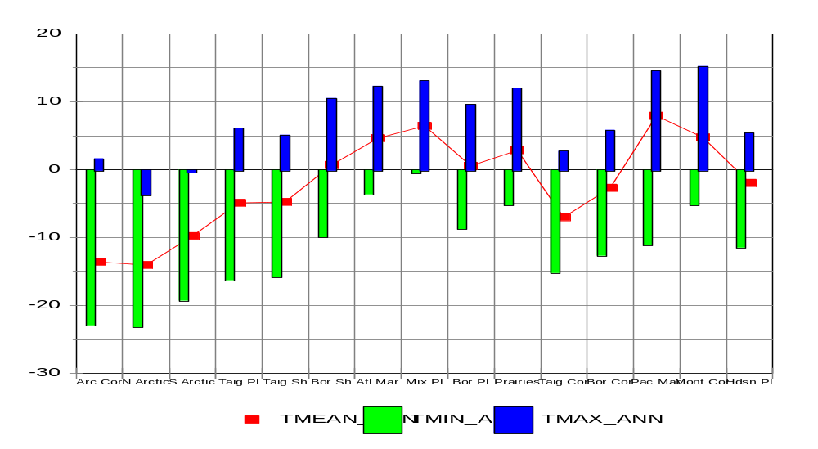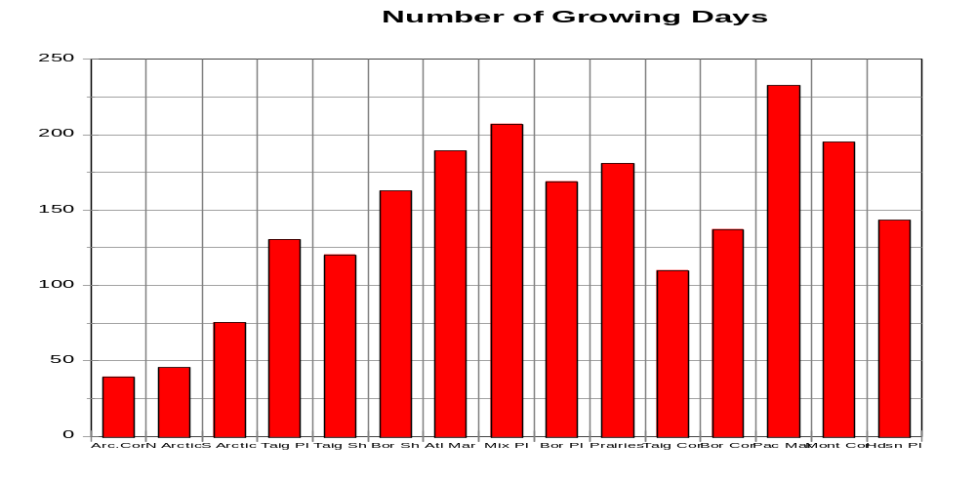

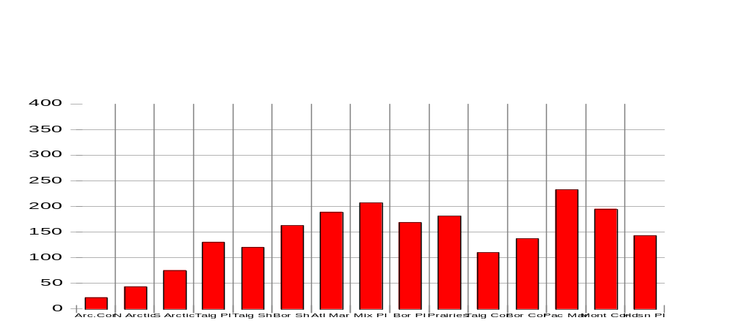Chart 4: Let's look at the number of average growing days in the ecozones (After last frost in spring and before first frost in fall).

Climate Change

One of today's major environmental concerns is climate change. Change in our climate is occurring for a number of reasons. In the same way that heat is trapped in a greenhouse, the sun's energy is trapped in the earth's atmosphere. The gases, which surround our earth, regulate its temperature by trapping heat from the sun and preventing radiation from escaping our atmosphere. These gases, consisting primarily of water vapour, carbon dioxide, methane and nitrous oxide are known as greenhouse gases. These greenhouse gases are important to us, for without them, our average temperature on Earth would drop to well below freezing and we could not exist. However, human activity has produced an excess of greenhouse gases, which is upsetting the natural balance and causing our atmosphere to slowly get warmer.

This "greenhouse effect" is causing concern among scientists. Although the temperature increase over 100 years is just a few degrees, the rate at which greenhouse gases are being produced is rising alarmingly. Greenhouse gases have risen by 30% over the last century, 50% of those increases have occurred in the last 30 years. At this rate, temperatures could increase in some regions by as much as 5 to 10 degrees in the next century. A warmer Canada doesn't sound like such a bad idea, however, there are consequences. Besides changing our annual temperature, climate change affects our weather patterns. It is predicted that we will see more incidents of extreme weather events such as droughts, winter storms, tornadoes and flooding. Consequences of these events would be greater risk to our landscape from erosion; our forests could be damaged by increased pests, diseases and fire; our crops destroyed by drought; our water resources diminished or polluted.

Climate and Precipitation
Student Activity Sheets
Name:
*Most of the answers to these questions can be found in the Climate and Precipitation background sections.

- From Table 1, in the background information of Climate and Precipitation, which two ecozones stand out as receiving greater amounts of precipitation than the average?
_______________________________
_______________________________

- What kind of climate do these ecozones have?

- Which two ecozones do the Great Lakes water bodies affect?
_______________________________
_______________________________

- Although the Arctic regions are basically surrounded by water, why do they not have a maritime climate?

- Using Graph 1, how do the amounts of snow to rain vary across the ecozones?

- Looking at the charts, how can you relate the number of growing days to the location of each ecozone?

- Which two ecozones never get above freezing?
_______________________________
_______________________________

Which ecozone has the warmest minimum low? _______________________________

Which ecozone has the highest annual temperature? _______________________________

Which ecozone has the lowest? _______________________________

- What other factors would have to be considered in growing plants or crops other than the number of growing days?

- Which ecozone would probably be most productive?

- Describe in detail its climate from information gathered from the charts. Which ecozone would you consider to have the worst climate? Describe it.

- Search the web sites listed in the Climate Precipitation Internet Resources for more information on the effects of climate change. Write a short essay on how climate change would affect you in your everyday activities. Use references to the data tables and graphs you have worked with in this exercise.

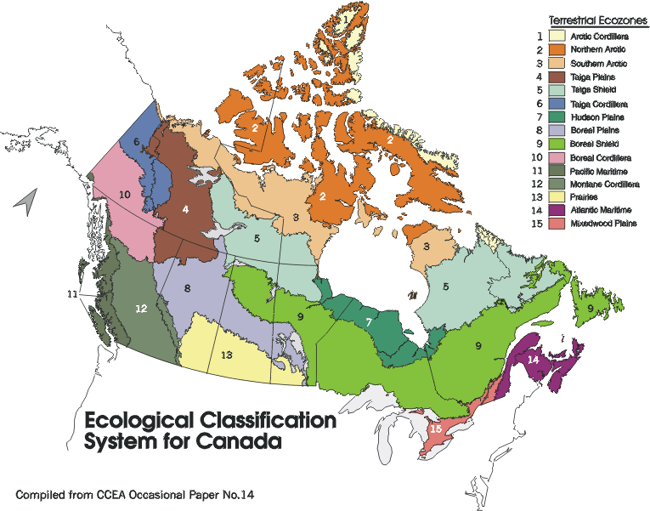

Climate and Precipitation Internet Resources

References

Source
The Green Lane: Environmental Priority - Climate Change
http://www.ec.gc.ca/climate/index.html

Other links

Welcome do the Government of Canada Climate Change Web site
http://climatechange.gc.ca/english/index.shtml

Natural Resources Climate Change Web Site
http://climatechange.nrcan.gc.ca

Fact sheets on air issues such as acid rain, ozone, smog, and wind chill
http://www.msc.ec.gc.ca/cd/factsheets/index_e.cfm

Environment Canada, Meteorological Service of Canada, Climate Research Branch - Climate Trends and Variations Bulletin for Canada
http://www.msc.ec.gc.ca/ccrm/bulletin/

Canadian Climate and water information
http://www.msc-smc.ec.gc.ca/climate/index_e.cfm
Canadian Climate Normals
http://www.msc-smc.ec.gc.ca/climate/climate_normals/index_e.cfm

Explores! For the K-12 community– Direct Readout Services, Basic Skills and Activities
A Web site that provides information: Meteorology, A brief history, Atmospheric composition, The hydrologic cycle, Thermometers, Time conventions (Local, UTC), and Latitude and Longitude.
http://www.met.fsu.edu/explores/skillmenu.html

Climate and Precipitation

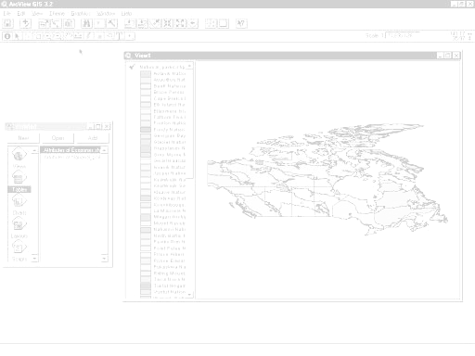
DISPLAYING DATA LAYERS TO DETERMINE RELATIONSHIPS

DEDUCTIVE REASONING USING DATA
CREATE SIMPLE MODEL TO DETERMINE EFFECT OF CHANGE

MAP LAYOUT FOR PRINTING

ArcView Lesson

GIS Information

Here's a list and explanation of important features in ArcView:

Project : In ArcView, a file for organizing your work. Projects use five types of
documents to organize information: views, tables, charts, layouts, and scripts.

View : A component of an ArcView project used for displaying, querying, and
analyzing geographic themes.

Table of Contents: All themes in a View are listed to the left of the map. The Table of
Contents shows the symbols used to draw features in each theme. The check box next to each theme indicates whether or not it is turned on or off in the map (whether it is currently drawn on the map).

Theme: A set of related geographic features, such as streets, parcels, or rivers, and the
characteristics (attributes) of those features.

Tables : Information formatted in rows and columns. A component of an ArcView
project used for displaying Tabular data.

Layout : The design or arrangement of elements in a digital map display or printed
map. A component of an ArcView project used for creating presentation-quality maps.

Hotlink: In ArcView, a way to display data (for example, a file, image, ArcView
document, or project) directly from a view, by clicking on a feature.

ArcView Buttons Reference Guide

View - Buttons
 | Save Project |  | Add Theme |  | Theme Properties | Edit Legend | Open Theme Table |  | Find | Locate Address | Query Builder |  | Zoom to Full Extent | Zoom to Active Theme | Zoom to Selected | Zoom In | Zoom Out | Zoom to Previous Extent |  | Select Features using Graphics | Clear Selected Features |  | Help

View – Tools
 | Identify | Pointer | Vertex Edit | Select Feature | Zoom In | Zoom Out | Pan | Measure | Hot Link | Area of Interest | Label | Text |  | Drawing and Editing Tools |  |  | Scale |  |  | Coordinates

Push and hold to select tool
Point
Line
Polyline
Rectangle
Circle
Polygon
Line Split
Polygon Split
Auto Complete

Table - Buttons
 | Save Project |  | Cut | Copy | Paste |  | Select All | Select None | Switch Selection |  | Create Chart |  | Find | Query Builder | Promote | Join |  | Summarize | Calculate |  | Sort Ascending | Sort Descending | Help

Table - Tools
Record Counter | Select Tool | Edit Tool | Identify Tool

Chart - Buttons
Save Project |  | Undo Erase |  | Area Chart Gallery | Bar Chart Gallery | Column Chart Gallery | Line Chart Gallery | Pie Chart Gallery | Scatter Chart Gallery | Chart Properties | Series From Records/Fields | Find | Help

Chart - Tools
Identify Tool | Erase Tool | Erase Within Polygon Tool | Chart Element Properties Tool | Chart Colour Tool

Layout - Buttons
Save Project | Cut | Copy | Paste | Layout Properties | Group | Ungroup | Bring to Front | Send to Back | Undo | Zoom to Page | Zoom to Actual Size | Zoom to Selected | Zoom In | Zoom Out | Print | Help

Layout - Tools
 |  | Pointer Tool | Vertex Tool | Zoom In Tool | Zoom Out Tool | Pan Tool | Text Tool | Drawing Tools |  | Frame Tools

Push and hold to select tool
View Frame
Legend Frame
Scale Frame
North Arrow Frame
Chart Frame
Table Frame
Picture Frame

For more Information: http://www.esricanada.com

Getting Started

Before you begin, the lesson data folder must be copied into a drive in which the student has writing and editing capabilities. This will probably be the drive containing your own personal account on the school’s system or it may be the C: drive of the machine you are currently working on. If the latter is the case you will have to work on the same machine each day until this assignment is complete. Each school set-up is different so work with your teacher to prepare your data folder.

! (The data for the lesson must first be downloaded from this Web site and placed on the school computer or network. Ask your teacher where to find the data folder that has been downloaded).

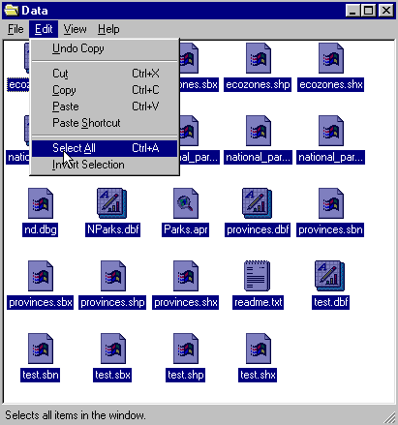To do this, use the file manager program on your computer. For Windows-based systems this will be My Computer / Windows Explorer /.

Once the data folder has been copied to the required destination the files must be made usable by removing the read only attribute. For Windows-based systems follow these instructions:

! (The data downloaded from the Web Site is set as read only so that it cannot be changed or altered by accident.)

1. Open your new data folder.
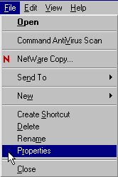2. Choose Edit > Select all (they will all appear Blue)

3. From the menu choose:
File > Properties

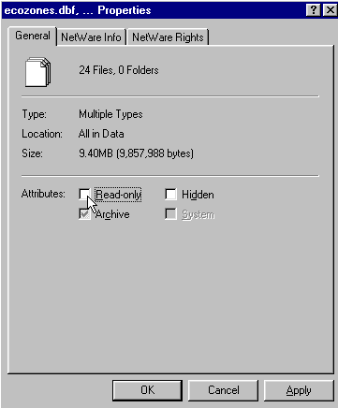

4. Remove the check mark in the
box beside the label read only.

5. Click Apply, then OK.

The data in your new data folder can now be opened, edited and saved using ArcView or other GIS software that can use SHAPE files to carry out the following project.

! Denotes an observation.
? Denotes a question to be answered on the Student Activity Sheet.

STARTING THE PROJECT

This lesson will emphases using geomatic data to determine relationships between data, form conclusions through deductive thinking, create a simple model and determine its effects. Let's begin by looking at the total precipitation by ecozone.

STARTING ArcView

Begin by starting up the ArcView program. If you are not sure how to do this, ask your teacher.

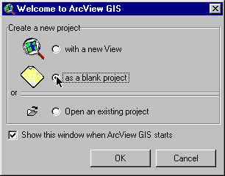
1. Choose as a blank project
2. Click O.K.

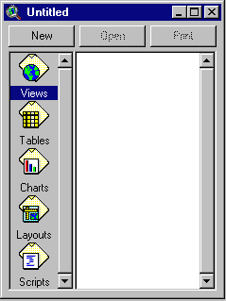When the program starts, it automatically opens a project window titled "Untitled."

If you like, you can maximize the ArcView window to fill the screen.

! In ArcView, you work within a project. A project is a collection of documents (map views, tables, charts, layouts, etc), document user interfaces, (called DocGUIs) and scripts. Only one project is open at a time.

3. Now you are ready to add documents to your new project.

4. With the “Views” icon selected, click on New and
maximize the View1 window.

5. Click the Add Theme button and navigate to the data folder where your data is stored. Hold down your SHIFT key and select the following files:

Admin.shp
Zones_climate.shp

6. Click O.K.

This will add these two themes to the table of contents of the new view. They are now available for display and editing.

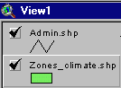
7. Click and drag to move the themes up or down in the table of content to change the order of display if necessary.

! Note the themes are displayed from the bottom to the top so line and point themes should be on top of polygon files to be visible.

8. Click on the square next to the themes you want to display. The theme that appears raised in the table of contents is the current active theme. This can be change by clicking on other themes.

9. Remember to Save your project as you go along. Go to the File menu and select Save Project. Save your work to the appropriate directory (ask your teacher if you are not sure). Give your project a name that will identify your work. (The suffix .apr means that you are saving your work as a project that can be opened up in the future).

ArcView - Changing the Map Projection

! A Map Projection defines the relationship between the map coordinates and the geographic coordinates, (latitude and longitude). Our current display shows what a map of Canada looks like with only a geographic projection.

Now we will give our map “projection coordinates” to make it look more like the maps which are familiar to us.

1. From the View menu, choose Properties.
2. Select Properties.
3. Select Map Units list. Change the map units to decimal degrees.
4. Select Distance Units list. Change the distance units to kilometers
5.Click the Projection button.
6. Select Custom.
7. Select Lambert Conformal Conic from the projection list.
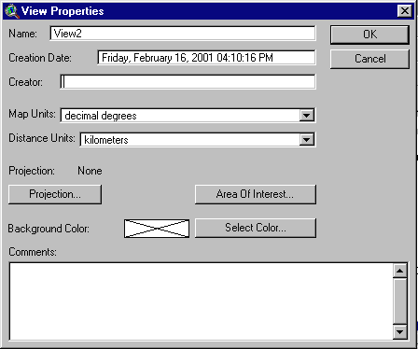
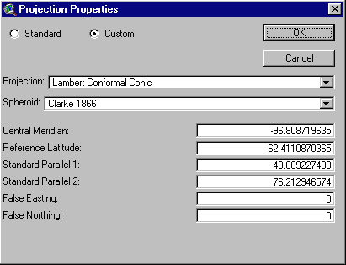

! Take a look at the parameters for this projection. Parameters are the descriptions of how the projection was made.
Note that a spheroid was used. (The earth is a slightly flattened sphere toward the poles).
Conformal implies that all angles are indicated correctly. All angles measured on the earth’s surface are given the same values on the map.
Conical means in the shape of a cone. In this projection, the relative positions on a globe are transferred to a plane in the shape of a cone around the globe. See how
the longitudinal lines are closer together at the top of the image, that is, they are not parallel.

The central meridian, false easting and false northing are used to define the X (easting) and Y (northing) coordinates of the map. The reference latitude and standard parallel 1 and 2 are used to determine the origin of the projection (i.e. the point from which you are viewing the globe).

8. Click O.K.

The bottom of the View Properties window should look like this:

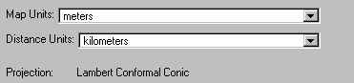

9. Click O.K.

! Note the difference in the map presentation.
? How is it different from the non-referenced map?

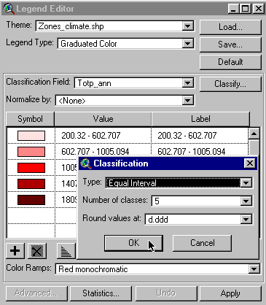
ArcView - DISPLAYING DATA LAYERS TO DETERMINE
RELATIONSHIPS

First let’s make a map to show total annual precipitation by ecozone.

1. Double click zones_climate theme.
2. Open Legend Type list.
3. Select Graduated Colour.
4. Open Classification Field list.
5. Select totp_ann.
6. Click Classify.
7. Open Type list.
8. Select Equal Interval. O.K.
9. Click Apply.
10. Close Legend Editor window.

? Can you identify the ecozone with the highest annual precipitation?
? Which has the second highest?
? What do these two wettest ecozones have in common?
? Why does Newfoundland have lower precipitation than the rest of the Atlantic Provinces?

! Orographic Precipitation is also known as relief precipitation. It is precipitation caused by rapid condensation in moist air that cools as it rises up the side of mountains. Let’s now investigate orographic precipitation in Canada.
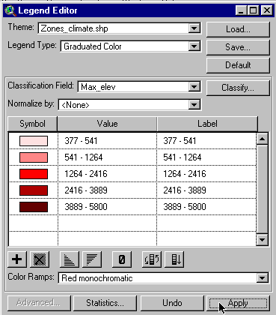

1. Double click zones_climate theme.
2. Select Graduated Colour.
3. Open Classification list.
4. Select max_elev.
5. Click Apply.
6. Close Legend Editor window.

? Which ecozones do you suspect have orographic precipitation?

Compare the ecozones, which have the highest precipitation with the ones that have the highest elevation.

? Which ecozone has the greatest orographic precipitation?
? What other characteristics might contribute to orographic precipitation?

! As air sinks down the leeward side of a mountain barrier it becomes warmer. As it warms, it can hold more moisture. As well, the air is dry from the orographic precipitation effect on the air as it rose over the mountain barrier. This low precipitation region on the leeward side of the mountains is called a rain shadow.

? From the total precipitation map can you identify two ecozones that have rain shadow components?

An important element of climate is temperature. Let's look at temperature by ecozone.

Following the same procedure as before,

1. Double click zones_climate theme.
2. Select Graduated Colour.
3. Open Classification Field list.
4. Select Tmean_an. (Mean annual temperature)
5. Click Apply.
6. Close Legend Editor window.

? Can you describe the pattern of mean annual temperature across Canada?
? Can you describe the maritime and continental effects?

DEDUCTIVE REASONING USING DATA

Precipitation is made up mostly of either rain or snow. Let's look at the ratio of snow over rain as a measure of temperature.

1. With the zones_climate theme active (raised),
2. click Open Theme Table . button.

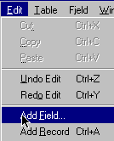
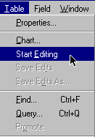

3. From the MENU item, select Tables.
4. Click Start Editing.
5. Select MENU item Edit.
6. Click Add Field.

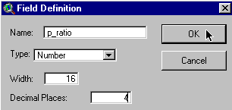
7. Enter name p_ratio. (Precipitation ratio)
8. Enter Decimal Places 4.
9. Click O.K.

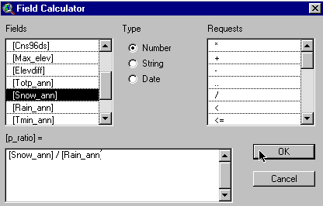
10. Click Calculate button.

11. Double click snow_ann.
12. Double click /.
13. Double click rain_ann.
14. Expression should read [snow_ann]/[rain_ann]
15. Click O.K.

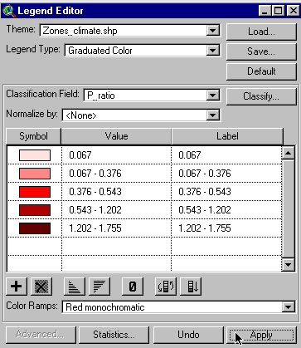
16. Select MENU item Table.
17. Click Stop Editing. To Save Edits click yes.
18. Close table.
19. Double click zones_climate theme.
20. Select Graduated Colour.
21. Open Classification Field list.
22. Select p_ratio.
23. Click Apply.
24. Close Legend Editor window.

? Can you describe the distribution of the snow/rain ratio?
? What does a high ratio mean?
? How does this relate to temperature?
? What about a low ratio?

CREATION OF SIMPLE MODEL TO DETERMINE EFFECT OF CHANGE

Climate affects us in many ways. One of the most important is in agriculture and the food we grow. Let's look at the relationship between agriculture and climate.

Crop X needs at least a 200-day growing season. By looking at the data for number of growing days in each ecozone, we can determine where crop X can grow assuming the soil and other conditions are favorable.
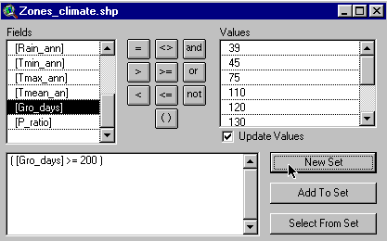

1. Click Query Builder button.
2. Double click gro_days.
3. Click the greater than or equal (>=) button.
4. Type in 200.
5. Expression should read [gro_days]>= 200.
6. Click New Set.
7. Close.

? Identify the ecozones where crop X could be grown if it requires more than 22 growing days?

A climate issue that is of great concern is climate change. This refers to the long-term (over decades) change in our climate caused by global warming.

Assume that global warming will lengthen the growing season by 20 days. Let’s compute a new growing season.

1. Open Theme table.
2. Select MENU item Table.
3. Click Start Editing.
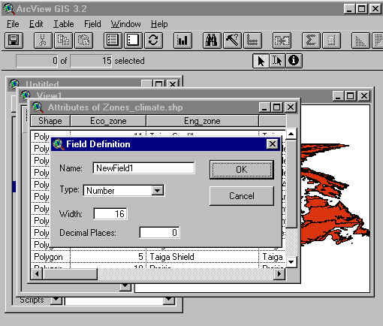

4. Select MENU item Edit.
5. Click Add Field.
- Enter name new_gro. Click O.K.

7. Click Calculate button.
8. Double click gro_days.
9. Double click +.
10. Type in 20.
11. Expression should read [gro_days] + 20.
12. Click O.K.
13. Select MENU item Table.
14. Click Stop Editing. To Save edit click Yes.
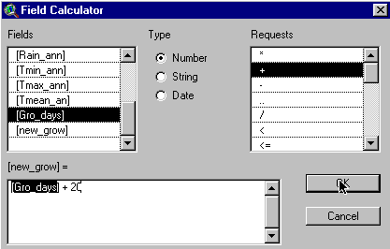
15. Close table.

16. Click Query Builder button.

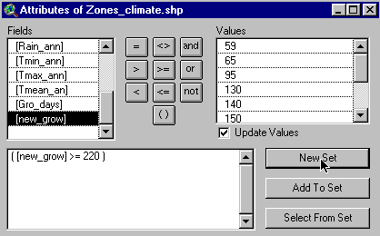
17. Double click new_gro.
18. Click >= button.
19. Type in 220.
20. Click New Set. Close.

? With the addition of 20 more growing days as a result of climate change, how many ecozones can now support growing Crop X?
? Identify the ecozones, which have been added by climate change.

ArcView - MAP LAYOUT FOR PRINTING

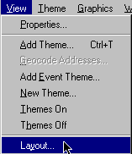
Once you have a map classified and displayed to your satisfaction, you should prepare a map layout that can be used for printing. The purpose of this lesson is to set up your map on a page and annotate it for presentation.

Set up map

1. Click Menu View.
2. Click Layout.
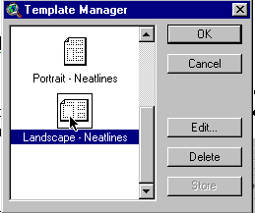
3. Select the Layout Template you want to use
(One of the landscape templates is suggested) .

4. Click O.K.
5. Maximize the Layout screen.

EDIT TITLE

1. Double click on the title View1.
2. Edit the title to reflect the purpose of the map, e.g., forestry, and population.
3. Click O.K.
4. Resize the title using the corner handles and move it into a position that is visually balanced.
5. Click and drag to reposition the legend if necessary.

EDIT NORTH ARROW

1. Double click on the north arrow and select a different presentation. Ensure that the arrow is pointing in the representative north direction of the map.
2. Click and drag to reposition or rotate (using rotation function) as needed.

EDIT SCALE BAR

1. Double click the scale bar.
2. Choose a new style of scale bar. The scale bar has default properties so you will not be able to change everything to the way you want.
3. Change the units to kms.
4. Find a combination of style, scale and divisions that is visually pleasing.
5. Click and drag to position to an appropriate location.

ADD LABELS, TEXT, OTHER INFORMATION

1. Click on the Text tool.
2. Click at the position on your layout where you want the text to appear.
3. In the Text Properties box, enter your text, e.g., “produced by (your name, date)”.
4. Select desired formatting information such as alignment, spacing and rotation.
5. Click O.K. when it appears, as you want it.
6. Click on Pointer tool.
7. Select the new text
8. Click once to change location or size. Click twice to change content.

! Experiment with all of the components of the layout until you have the look you want.

CHANGE THE NAME OF THE LAYOUT

You only have to do this if you want to save your project on the computer or on a disk.

1. Click menu Layout.
2. Select Properties.
3. Change the “name”. Click O.K.

ARRANGING YOUR LAYOUT

! Experiment with the layout buttons (use the tools page provided at the beginning of this lesson if you are unsure of their function).
- to group (tie pieces together so they move as one)
- to ungroup (break apart the ties so that individual pieces move)
- bring to front ( change order that pieces were laid down, e.g., lines on top of polygons)
- send to back ( change order that pieces were laid down, e.g., polygons behind lines)
- zoom ( make image bigger or smaller)
- neat line (border around layout)

PRINT MAP LAYOUT

1. Click Print button.
2. Click Setup.
3. Select your printer properties as outlined by your teacher.
4. Click O.K. to print.

! Note that the map can also be saved to a printer file.

Climate and Precipitation
ArcView Student Activity Sheet

Name:

*Answers to the following questions can be obtained while completing the ArcView Climate and Precipitation Activity.

- How is it different from the non-referenced map?

- Can you identify the ecozone with the highest annual precipitation?

- Which has the second highest?

- What do the two wettest ecozones have in common?

- Why does Newfoundland have lower precipitation than the rest of the Atlantic provinces?

- Which ecozones do you suspect have orographic precipitation?

- Which ecozone has the greatest orographic precipitation?

- What other characteristics contribute to orographic precipitation?

- From the total precipitation map identify two ecozones that have rain shadow components?

- Can you describe the pattern of mean annual temperature across Canada?

- Can you describe the maritime and continental effects?

- Can you describe the distribution of the snow/rain ratio?

- What does a high ratio mean?

- How does this relate to temperature?
- What about a low ratio?

- Identify the ecozones where crop X could be grown if it requires more than 200 growing days?

- With the addition of 20 more growing days as a result of climate change, how many ecozones can now support growing Crop X?

- Identify the ecozones, which have been added due to climate change.

