Geological Diversity and
Geological History
of Canada

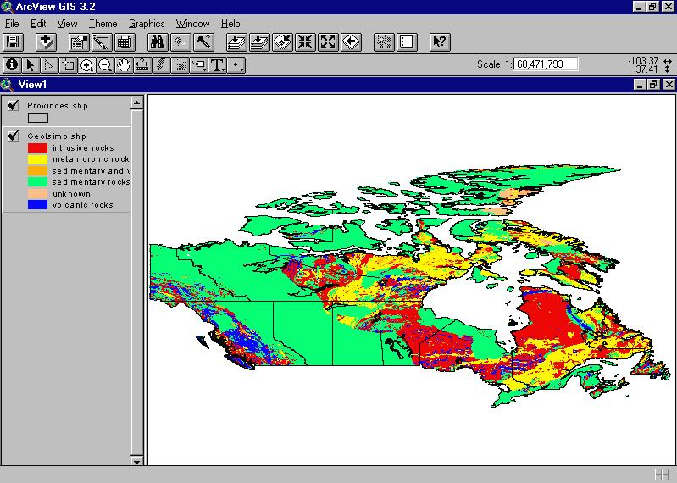



Table of Contents

Section Page

Lesson Objectives 3

Curriculum Expectations 3

Teacher Package (Academic Lesson) 4

Teacher Package (Applied Lesson) 5

Academic Performance Task, Expectations and Rubric 6

Applied Performance Task, Expectations and Rubric 8

Geological Diversity and Geological History of Canada 11

The Rock Cycle 13

Geological Diversity and Geological History of Canada Student Activity Sheets 14
(On background information)

Ecozone Map of Canada 15

Use of the Venn diagram to do comparison between Era and between 16
Rock types for each Ecozone

Geological Diversity and Geological History Internet Resources 18

Geological Diversity and Geological History of Canada – ArcView Lesson 20

Geological Diversity and Geological History – ArcView Lesson Activity Sheets 35

Geological Diversity and Geological History of Canada

Lesson Objectives

- Explore the geological diversity and history of Canada.
- Focus on the Geological make-up of the Ecozones of Canada.
- Learn about the range of rock types and ages in Canada.
- Study the relationships between mining and geology.
- Learn about the “Rock Cycle”
- Produce vector maps showing the rock age and type characteristics of Ecozones.
- Join tables and use new data to map points and chart data.
- Building table queries.
- Projections.
- Map classification.
- Map preparation and layout.

Curriculum Expectations

The Ontario grade 9 curriculum expectations were used as a basis for preparing the lessons in this series. Although there is no direct correlation between Ontario expectations and other provinces, in general, the issues covered in the lessons do relate to many of the curriculum requirements in other jurisdictions. The full curriculum expectations can be found at the Ontario Ministry of Education Web site

English: http://www.edu.gov.on.ca/eng/document/curricul/secondary/canadian/canaful.html
French: http://www.edu.gov.on.ca/fre/document/curricul/secondary/canadian/canaful.html

The performance tasks for Grade 9 Academic were based directly on curriculum expectations selected from the policy document for Canadian and World Studies. The tasks encompassed the four categories of knowledge and skills (i.e., Knowledge/Understanding, Thinking/Inquiry, Communication, and Application), requiring students to integrate their knowledge and skills in meaningful learning experiences.

The rubric for a specific performance task is intended to provide teachers and students with an overview of the expected final product with regard to the knowledge and skills being assessed as a whole. The rubric identifies key criteria by which the students’ work is to be assessed, and it provides descriptions that indicate the degree to which the key criteria have been met. The teacher can use the descriptions of the different levels of achievement given in the rubric to assess student achievement on a particular task.

Teacher Package

Academic Lesson

Title: Proposal for a New Mine Site in Canada

Time requirement: Prior learning and skill development:
1 to 2 periods of 70 minutes each
ArcView lesson:
1 to 2 periods of 70 minutes each
Student research and proposal writing:
1 to 2 periods of 70 minutes each
Teacher Instructions:
- Description of the Task
(see Academic Performance Task, Expectations and Rubric).

- Final Product
Each student will submit a written, illustrated, and supported proposal for a new mine site in Canada

- Assessment and Evaluation
The final product will be assessed using the Expectations and the Performance Task Rubric.
Formal and informal assessment of the students based on prior knowledge, lesson objectives, production of their ArcView Map, research process done using the Background Information, the students’ activity sheets (on the Background and on the ArcView lesson), the Venn Diagram Activity and the Rubric for assessing Maps. We suggest also that the students investigate the web site ‘’Minerals and Metals – A World to Discover’’ (http://www.nrcan.gc.ca/mms/school/e_mine.htm). In ‘’Start a mine’’ students will follow the mining cycle from claim staking through operations to closure of the site and its rehabilitation. You will also find additional information on minerals and metals on this site. Self- or peer assessments and collaboration may be useful to the teacher and students.

- Accommodations
Accommodations that are normally provided in the regular classroom for students with special needs should be provided in the administration of this performance task.

- Rubric
Introduce the task-specific rubric to the students before giving the administrative task. Review the rubric with the students and ensure that each student understands the criteria and descriptions for achievement at each level.
Some students may perform below level 1. It will be important to note the characteristics of their work in relation to the criteria in the assessment rubric and to provide feedback to help them improve.

Teacher Package

Applied Lesson

Title: Minerals and Metals around and in our home Poster

Time requirement: Prior learning and skill development:
1 to 2 periods of 70 minutes each
ArcView lesson:
1 to 2 periods of 70 minutes each
Preparation and presentation of the poster
1 to 2 periods of 70 minutes each
Teacher Instructions:
- Description of the Task
(see Applied Performance Task, Expectations and Rubric)

- Final Product
Each student will submit an 11’’ x 17’’ poster that has their ArcView Mines of Canada Map, 15 illustrated objects of Minerals and Metals around and in our home with description of their Minerals and Metals content, the categories (metallic or non-metallic Minerals, Industrial and Construction Minerals, Fossil Fuels etc.) and the ecozone where it is most probable to find such Minerals and Metals.

- Assessment and Evaluation
The final product will be assessed using the Expectations and the Performance Task Rubric.
Formal and informal assessment of the students based on prior knowledge, lesson objectives, production of their ArcView Map, research process done using the Background Information, the students’ activity sheets (on the Background and on the ArcView lesson), the Venn Diagram Activity and the Rubric for assessing Maps. We suggest also that the students investigate the web site ‘’Minerals and Metals – A World to Discover’’ (http://www.nrcan.gc.ca/mms/school/e_mine.htm). In ‘’Minerals and Metals at Home’’, students will discover how minerals and metals are contributing to the quality of our life. They can visit parts of a house and click on different objects to find out what they are made of, and than they can test themselves. They could also explore ‘’Our Hidden Treasures’’ to find out more about the contributions the minerals and metals industry is making to Canada. Self- or peer assessments and collaboration may be useful to the teacher and students.

- Accommodations
Accommodations that are normally provided in the regular classroom for students with special needs should be provided in the administration of this performance task.

- Rubric
Introduce the task-specific rubric to the students before giving the administrative task. Review the rubric with the students and ensure that each student understands the criteria and descriptions for achievement at each level.
Some students may perform below level 1. It will be important to note the characteristics of their work in relation to the criteria in the assessment rubric and to provide feedback to help them improve.

Academic Performance Task, Expectations and Rubric

The Task
Students are to investigate the areas of mineral exploration in Canada. Choose from building materials, coal, diamonds, metals, non-–metals, peat, or uranium and begin to explore where they would establish a new mine site. In their proposal, students are to justify their site selection and the type of mine they are proposing. The proposal will outline: how the resource will be developed and refined in order to meet the requirements imposed by governments, how it will get to the market, environmental and wildlife concerns and the impact on the local residents. Students are instructed to include supporting visuals, such as maps, graphs, charts, diagrams or pictures, in their proposals.

Expectations
This task gives students the opportunity to demonstrate achievement of the following selected expectations from three strands: Geographic Foundations: Space and Systems; Human-Environment Interactions; and Methods of Geographic Inquiry.

Students will:
- explain the geographical requirements that determine the location of businesses, industries, and transportation systems, and make predictions about future locations of these enterprises and systems;
- demonstrate an understanding of how natural systems (e.g., climate, soils, landforms, wildlife) influence cultural and economic activities (e.g., recreation, transportation, employment opportunities);
- demonstrate an understanding of the methods used to collect, organize, manipulate, and interpret geographic data;
- locate and use effectively geographic material from primary sources (e.g., field research, surveys, interviews) and secondary sources (e.g., mainstream and alternative media, CD-ROMs, Internet) to research a geographic issue;
- select and use appropriate methods for displaying geographic data;
- create and use effectively photographs, charts, graphs, models, and diagrams;
- use geographic data to support conclusions and opinions;
- use cartographic conventions correctly when constructing maps (e.g., scale, legend, direction);
- use graphic organizers (e.g. semantic webs, timelines, future wheels, analogy charts, Venn diagrams) effectively to visualize, clarify, and interpret geographic information.

Prior Knowledge and Skills
To complete this task, students are expected to be able to demonstrate the following:

- an understanding of the rock cycle
- explain the importance of mining in Canada
- describe the steps used by mining companies to discover and develop an ore body
- explain some issues facing Canada’s mining industry
- an understanding of research methods using a variety of source materials
- ability to use graphic organizers
- ability to read, analyse, and interpret graphs and maps
- ability to use a variety of tools and technologies for research.
Task Rubric – Proposal for a New Mine
Expectations |  |  | Criteria |  |  | Level 1 (50 – 59) |  |  | Level 2 (60 –69) |  |  | Level 3 (70 – 79) |  |  | Level 4 (80 -100)

Knowledge / understanding
2 |  | - Demonstrates an understanding of the methods used to collect, organize, manipulate, and interpret geographic data |  |  | - Demonstrates little understanding of the methods used to collect, organize, manipulate, and interpret geographic data |  |  | - Demonstrates some understanding of the methods used to collect, organize, manipulate, and interpret geographic data |  |  | - Demonstrates considerable understanding of the methods used to collect, organize, manipulate, and interpret geographic data |  |  | - Demonstrates an understanding of the methods used to collect, organize, manipulate, and interpret geographic data to a high degree

Thinking / Inquiry
3 |  | - Locates and uses effectively geographic material from primary and secondary sources to research a geographic issue |  |  | - Locates and uses effectively geographic material from primary and secondary sources to research a geographic issue to a little degree |  |  | - Locates and uses effectively geographic material from primary and secondary sources to research a geographic issue to some degree |  |  | - Locates and uses effectively geographic material from primary and secondary sources to research a geographic issue to a considerable degree |  |  | - Locates and uses effectively geographic material from primary and secondary sources to research a geographic issue to a high degree

Communication
1,4,5 |  | - Explains the geographical requirements that determine the location of a mine  - Selects and uses appropriate methods for displaying geographic data;  - Creates and uses effectively photographs, charts, graphs, models, and diagrams |  |  | - Offers little explanation of the geographical requirements that determine the location of a mine  - Selects and uses few methods for displaying geographic data;  - Creates and uses few photographs, charts, graphs, models, and diagrams |  |  | - Offers some explanation of the geographical requirements that determine the location of a mine  - Selects and uses some methods for displaying geographic data;  - Creates and uses some photographs, charts, graphs, models, and diagrams |  |  | - Explains the geographical requirements that determine the location of a mine to a considerable degree  - Selects and uses considerable methods for displaying geographic data;  - Creates and uses a considerable number of photographs, charts, graphs, models, and diagrams |  |  | - Explains the geographical requirements that determine the location of a mine to a high degree  - Selects and uses methods for displaying geographic data to a high degree  - Creates and uses photographs, charts, graphs, models, and diagrams to a high degree
Application
6 |  | - Uses geographic data to support conclusions and opinions |  |  | - Uses geographic data to support conclusions and opinions to a small degree |  |  | - Uses geographic data to support conclusions and opinions to some degree |  |  | - Uses geographic data to support conclusions and opinions to a considerable degree |  |  | - Uses geographic data to support conclusions and opinions to a high degree

Applied Performance Task, Expectations and Rubric

The Task
Students are to investigate the areas of mineral exploration in Canada. They are to create a poster using their ArcView Map.

Not a day passes without each one of us using objects made of minerals and metals. You will investigate where in Canada the minerals and the metals of these objects originate. Each student will have to find 15 pictures of objects around and in our home and identify which minerals and/or metals this specific object is made of. Using their ArcView Map and the web site ‘’Minerals and Metals – A World to Discover’’ (http://www.nrcan.gc.ca/mms/school/e_mine.htm), students are:
- to identify the mineral and metal content of these 15 objects,
- to identify the different categories these minerals or metals belong to,
- to locate the ecozone from which each of the minerals and metals contained within these 15 objects would most likely come from.
They also will have to choose their object so that they would represent at least a minimum of 7 different ecozones and seven different minerals or metals.

Expectations
This task gives students the opportunity to demonstrate achievement of the following selected expectations from three strands: Geographic Foundations: Space and Systems; Human-Environment Interactions; and Methods of Geographic Inquiry.

Students will:

- demonstrate an understanding of how natural and human systems interact within ecozones;
- analyse ways in which Canadians use resources in Canada;
- demonstrate an understanding of how natural systems (e.g., climate, soils, landforms, wildlife) influence cultural and economic activities (e.g., recreation, transportation, employment opportunities);
- demonstrate an understanding of the methods used to collect, organize, manipulate, and interpret geographic data;
- use geographic material from primary sources (e.g., field research, surveys, interviews) and secondary sources (e.g., mainstream and alternative media, CD-ROMs, Internet) effectively and appropriately when researching a geographic issue;
- select and use appropriate methods for displaying geographic data;
- use appropriate technology (e.g., computer maps, graphs, air photos) to present geographic information;
- collect, organize, and synthesize information about the characteristics of Canada’s geography from a variety of sources (e.g., atlases, photographs, hypermedia);
- use cartographic conventions correctly when constructing maps (e.g., scale, legend, direction);
- use graphic organizers (e.g. semantic webs, timelines, future wheels, analogy charts, Venn diagrams) effectively to visualize, clarify, and interpret geographic information.

Prior Knowledge and Skills
To complete this task, students are expected to be able to demonstrate the following:

- an understanding of the rock cycle
- explain the importance of mining in Canada
- describe the steps used by mining companies to discover and develop an ore body
- explain some issues facing Canada’s mining industry
- an understanding of research methods using a variety of source materials
- ability to use graphic organizers
- ability to read, analyse, and interpret graphs and maps
- ability to use a variety of tools and technologies for research.

Task Rubric – Minerals and Metals around and in our home Poster
Expectations |  |  | Criteria |  |  | Level 1 (50–59) |  |  | Level 2 (60–69) |  |  | Level 3 (70–79) |  |  | Level 4 (80–100)

Knowledge / understanding
1,3,4 |  | - Demonstrates an understanding of how natural and human systems interact within ecozones  - Demonstrates an understanding of how natural systems influence cultural and economic activities  - Demonstrates an understanding of the methods used to collect, organize, manipulate, and interpret geographic data |  |  | - Demonstrates limited understanding of how natural and human systems interact within ecozones  - Demonstrates limited understanding of how natural systems influence cultural and economic activities  - Demonstrates limited understanding of the methods used to collect, organize, manipulate, and interpret geographic data |  |  | - Demonstrates some knowledge of how natural and human systems interact within ecozones  - Demonstrates some understanding of how natural systems influence cultural and economic activities  - Demonstrates some understanding of the methods used to collect, organize, manipulate, and interpret geographic data |  |  | - Demonstrates considerable knowledge of how natural and human systems interact within ecozones  - Demonstrates considerable understanding of how natural systems influence cultural and economic activities  - Demonstrates considerable understanding of the methods used to collect, organize, manipulate, and interpret geographic data |  |  | - Demonstrates thorough knowledge of how natural and human systems interact within ecozones  - Demonstrates thorough understanding of how natural systems influence cultural and economic activities  - Demonstrates thorough understanding of the methods used to collect, organize, manipulate, and interpret geographic data

Thinking / Inquiry
5,7,8 |  | - Synthesizes information relevant to the theme  - Makes connections between illustrations, minerals and metals, and ecozone location |  |  | - Synthesizes information with limited effectiveness  - Makes connections with limited effectiveness |  |  | - Synthesizes information with some effectiveness  - Makes connections with some effectiveness |  |  | - Synthesizes information with considerable effectiveness  - Makes connections with considerable effectiveness |  |  | - Synthesizes information with a high degree of effectiveness  - Makes connections with a high degree of effectiveness

Communication
6,9 |  | - Uses visuals to illustrate the importance of mineral exploration in Canada  - Communicates using appropriate methods and technologies through logical organization |  |  | - Uses visuals to illustrate the importance to a limited degree  - Minimal logic in plan and sequence where organization interferes with comprehension |  |  | - Uses visuals to illustrate the importance to some degree  - Some logic in plan and sequence where lapses of organization interfere with comprehension |  |  | - Uses visuals to illustrate the importance to a considerable degree  - Logic in plan and sequence where organization is effective and does not interfere with comprehension |  |  | - Uses visuals to illustrate the importance to a high degree  - Thoughtful and logic in plan and sequence where organization enhances comprehension

Application
2 |  | - Analyses ways in which Canadians use resources |  |  | - Shows limited analyses |  |  | - Shows some analyses |  |  | - Shows considerable analyses |  |  | - Shows thorough analyses

Geological Diversity and Geological History of Canada

The ground on which we stand is underlayed with bedrock that dates back billions of years to the time when the earth’s crust first cooled. Some parts of Canada are extremely old and other parts are relatively young when referred to in geological time. The earth’s crust has undergone constant folding and faulting where tectonic plates have either collided with each other or pulled apart causing massive change over extremely long periods of time. New mountains and valleys are forming in some regions while at the same time old mountains are being worn down and valleys are being filled in other parts of the country. Most of these changes take millions of years to happen. However, some small changes are immediate as a result of geological events such as earthquakes and volcanoes. Examples of more recent geological events are earthquakes in India in 2001 and 1993, along the San Andreas Fault in San Francisco in 1989 and in Alaska in 1964, and the eruption of Mount St. Helens in 1980. The volcano Kilauea in the Hawaiian chain of islands remains active and constantly growing at a rate of about 400,000 cubic meters a day. In a period of two years it added approximately 200 hectares of new land to the island.

The landmass of Canada, as we know it, has evolved over 4.6 billion years. The geological period from the formation of the earth to 570 million years ago is known as the Precambrian era. Rock formed when the earth’s crust cooled and broke up into tectonic plates. The portion of this original crust that was to become Canada is called the Canadian Shield and is the largest landform region in Canada. Over millions of years to follow, the rest of Canada formed around this core.

The Paleozoic era followed the Precambrian and lasted about 325 million years. During this time weathering and erosion wore down the Precambrian shields and produced great layers of sediment, which were washed down and deposited into the shallow seas surrounding them. These sediments, over millions of years, were compressed into sedimentary rock that formed a great part of the present day landmass of Canada. Evidence of these geological processes is observed in the occurrence and location of many of our natural resources. The organisms that were trapped in these sedimentary rocks became the oil and gas deposits found in western Canada. Plants that grew along the shores of these ancient seas were trapped in this sediment and formed the coal seams underlying Nova Scotia. As well, these shallow seas were rich in salt minerals and when the seas receded and evaporated, they left behind the salt beds of southwestern Ontario.

Geologists believe that during this era the North American, European and African continental tectonic plates collided to form the Appalachian Mountains bordering the shores of Eastern Canada.

The 180 million years following the Paleozoic era is known as the Mesozoic or middle era. The Coast Range Mountains and the Innuitian Mountains were formed during this period when the North American plate split from the European and African and collided on the opposite coast with the Pacific plate. The rift left between these plates filled with massive quantities of magma, which rose from beneath the earth’s crust and solidified into igneous rock. As the tectonic plates continued to push against each other, this massive rock bed lifted and folded to form the Coastal Mountains. Toward the end of this era, the continuous forces exerted by the tectonic plates caused the Rocky Mountains to form. In the depression between the mountains ranges of the north, west and east, large swamps existed which were rich in vegetation. These swamps were eventually covered with sand and silt and as the sedimentary layers grew, they were compressed into the sedimentary coal bearing rock of southern British Columbia, Alberta and Saskatchewan.

The Precambrian, Paleozoic and Mesozoic eras bring us to within 66 million years of the present day. This final era of our time is called the Cenozoic era. The Rocky Mountains and Coastal Mountains continued to lift and fold during this period. Volcanoes erupted and filled many valleys with lava, which formed plateaus between the mountain ranges. The seas that covered the central part of our continent continued to recede as the land rose.

It is during the last two million years of the Cenozoic era that the Ice Age occurred. During that time, the earth’s climate cooled slightly causing large bodies of water to freeze. These massive ice formations grew to hundreds of meters with precipitation that came in the form of snow and sleet and formed glaciers, which appeared to advance as they grew and spread. With slight increases in climatic temperature the glaciers would melt and recede or shrink. This continuous back and forth motion of the thick ice sheets that were embedded with rocks and sediment scoured the rock surfaces and wore away mountaintops. The melting ice caused erosion and deposition of sand, silt and rock debris at the advancing edges of the glaciers and into the lowlands. Evidence of these actions can be seen in the form of drumlins, moraines, eskers and raised beaches. It is thought that there were several periods of glacial activity with the last being about 6000 years ago. Remnants of the Ice Age can still be found in the glaciers of the Arctic and in the higher elevations of the Rocky Mountains.

Table 1: Ecozone percentages for each Rock Age and combined Rock Ages
Rock Age | Cenozoic | Mesozoic | Mes-Cen | Paleozoic | Pal-Mes | Precambrian | Prec-Mes | Prec-Pal | Unknown
Arctic Cordillera | 0.30 | 7.96 | 0.29 | 22.25 | 0.00 | 54.80 | 0.00 | 1.49 | 12.86
Northern Arctic | 2.11 | 6.41 | 2.77 | 40.26 | 0.00 | 47.42 | 0.00 | 0.28 | 0.59
Southern Arctic | 3.38 | 6.36 | 0.00 | 12.56 | 0.00 | 77.68 | 0.00 | 0.01 | 0.00
Taiga Plains | 1.39 | 51.22 | 0.49 | 43.78 | 0.00 | 3.11 | 0.00 | 0.02 | 0.00
Taiga Shield | 0.05 | 0.00 | 0.00 | 0.64 | 0.00 | 99.31 | 0.00 | 0.00 | 0.00
Boreal Shield | 0.00 | 0.21 | 0.00 | 5.05 | 0.00 | 94.22 | 0.00 | 0.30 | 0.08
Atlantic Maritime | 0.00 | 1.20 | 0.00 | 93.29 | 0.02 | 2.51 | 0.00 | 2.46 | 0.51
Mixedwood Plains | 0.00 | 0.12 | 0.00 | 94.52 | 0.00 | 4.94 | 0.00 | 0.27 | 0.14
Boreal Plains | 6.74 | 70.25 | 0.00 | 20.93 | 0.00 | 2.07 | 0.00 | 0.00 | 0.00
Prairies | 10.81 | 85.01 | 0.81 | 3.37 | 0.00 | 0.00 | 0.00 | 0.00 | 0.00
Taiga Cordillera | 2.90 | 20.22 | 0.06 | 47.04 | 0.08 | 14.56 | 0.00 | 15.13 | 0.00
Boreal Cordillera | 6.65 | 31.79 | 0.05 | 33.81 | 4.85 | 4.80 | 5.01 | 11.97 | 1.07
Pacific Maritime | 14.10 | 67.47 | 1.70 | 5.30 | 0.59 | 3.81 | 0.00 | 0.24 | 6.79
Montane Cordillera | 17.91 | 40.55 | 0.40 | 18.98 | 3.34 | 12.80 | 0.00 | 4.68 | 1.32
Hudson Plains | 0.00 | 2.05 | 0.00 | 80.63 | 0.00 | 17.32 | 0.00 | 0.00 | 0.00

Note that this table has the four major rock age classifications. But also note that there are columns with a combination of rock age classes, e.g., Mes-Cen, or Mesozoic and Cenozoic. This means that although the majority of the rock surface that is exposed is of one of the four classes, there are some areas that show a combination of two types.

There are three main classes of rock: igneous, metamorphic and sedimentary rock. Hot, melted magma from beneath the earth’s crust that is forced to the surface, cools and hardens and forms igneous rock. When extreme heat and pressure are applied to this rock, for example as friction between tectonic plates, the rock is transformed into metamorphic rock. As natural forces wear down the igneous rock, it becomes sediments. If these sediments undergo extreme compression, they are transformed into sedimentary rock. It is a constant loop cycle between these three forms of rock.

The Rock Cycle

The next table deals with the types of rock found in Canada divided by Ecozone.

Table 2: Ecozone percentages for each Rock Type and combined Rock Types
Rock type | Igneous | Metamorphic | Sedimentary | Sed-Ign | Unknown
Arctic Cordillera | 11.49 | 23.72 | 47.99 | 3.90 | 12.86
Northern Arctic | 11.64 | 24.59 | 60.65 | 2.36 | 0.59
Southern Arctic | 40.17 | 16.71 | 40.93 | 2.17 | 0.00
Taiga Plains | 0.69 | 0.00 | 99.32 | 0.00 | 0.00
Taiga Shield | 55.95 | 28.40 | 15.47 | 0.18 | 0.00
Boreal Shield | 54.50 | 28.63 | 15.88 | 0.77 | 0.08
Atlantic Maritime | 17.26 | 0.74 | 79.87 | 1.62 | 0.51
Mixedwood Plains | 1.16 | 3.23 | 95.46 | 0.00 | 0.14
Boreal Plains | 1.20 | 0.65 | 98.09 | 0.06 | 0.00
Prairies | 0.00 | 0.00 | 100.00 | 0.00 | 0.00
Taiga Cordillera | 3.87 | 0.00 | 96.12 | 0.00 | 0.00
Boreal Cordillera | 32.55 | 1.07 | 65.35 | 1.03 | 0.00
Pacific Maritime | 70.57 | 6.28 | 18.68 | 0.03 | 4.44
Montane Cordillera | 38.10 | 2.81 | 57.12 | 1.96 | 0.00
Hudson Plains | 11.40 | 4.51 | 84.03 | 0.06 | 0.00

Canada has abundant mineral resources within these rocks. We are familiar with the metals: iron ore, aluminum, copper, nickel, lead, uranium, zinc, gold and silver. But Canada is also a producer of lesser-known metals such as antimony, bismuth, cadmium, cesium, cobalt, lithium, magnesium, molybdenum, selenium and tellurium. Non-metals are also important to our economy. These include gems (such as amethyst, diamonds, garnet, jade and opal), manufacturing raw materials (such as asbestos, graphite, gypsum, mica and pumice), and agricultural additives (such as peat, potash and potassium sulfate).
The bedrock also provides us with building materials such as granite, limestone, marble, sandstone, shale and slate.

Geological Diversity and Geological History of Canada
Student Activity Sheets
Name:
*Most of the answers to these questions can be found in the Geological Diversity and Geological History of Canada background sections.

- Knowing that Precambrian is the oldest rock, which ecozones formed the landmass around which the rest of Canada was formed?

- Which ecozones were the last to be formed?

- From table 1, which ecozones would you estimate to contain the most sedimentary rock?

(Check table 2 to see if you are right)

- Notice that the Arctic Cordillera has 12.86 % unknown, the same amount that was unknown about the Rock Age. Suggest some reasons why this might be the case?

- Does the ecozone with the greatest amount of sedimentary rock agree with your prediction on which area was the youngest geologically?

- Why do the plains contain large amount of sedimentary rock?

- Why do you think the Taiga Cordillera contains so much sedimentary rock?

Some of the geological information presented is in the context of Ecozones. This map of Ecozones is presented as reference material.

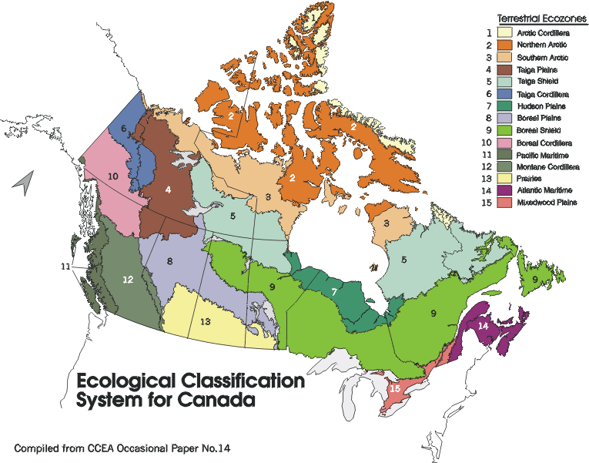

Use of the Venn diagram to do comparison between Era and between rock types for each Ecozone

Use Graphic Organizers to compare Table 1 and Table 2.

Classifying involves organizing elements into groups based on their similarities. One of the critical elements of classifying involves the rules that govern class or category membership.

This exercise is a Teacher-Directed Classification Task. In such a task, students are given the elements to classify and the categories into which the elements should be classified. The focus is on placing items into their appropriate categories and understanding why they belong in those categories.

The Venn diagram provides you with a visual display of the similarities and differences between items. The similarities between elements are listed in the intersections between the circles. The differences are listed in the parts of each circle that do not intersect.

Looking at Table 1, use this Venn diagram to classify the different Ecozones in their most appropriate Era. Look at the highest percentage to make your decision.

Cenozoic Mesozoic Paleozoic Precambrian

Summarize below your findings:

Landforms Era

Now look at Table 2 and use this Venn diagram to classify the different Ecozones by their most appropriate Rock types. Look at the highest percentage to make your decision.

Sedimentary Rocks Igneous Rocks

Metamorphic Rocks

Summarize your findings:

Landforms Era Rock Types

Geological Diversity and Geological History Internet Resources

Minerals and Metals – A World to Discover
A tour of some of Canada’s most important natural resources: minerals and metals. This site contains information about how these natural resources are used in our daily activities.
http://www.nrcan.gc.ca/mms/school/e_mine.htm

Earthnet
A virtual resource center for Earth Science Educators brought to you by Natural Resources Canada
http://agcwww.bio.ns.ca/schools/EarthNet/

Earth Sciences Sector – Educational Material
Natural Resources Canada
http://www.nrcan.gc.ca/ess/education_e.html

If the Earth could talk
A general introduction to the earth sciences. Here, you will find a series of fascinating topics, like the Geologist, the Earth, Volcanoes, Rocks, Minerals, Dating, Glaciers, Soil & Waters, etc. all explained in clear, simple terms.
http://www.cgq-qgc.ca/tous/terre/

PALEOMAP
The goal of the PALEOMAP site is to illustrate the plate tectonic development of the ocean basins and continents, as well as the changing distribution of land and sea during the past 1100 million years.
http://www.scotese.com/

Exploring the Environment
NASA Classroom of the Future
The ETE (Exploring the Environment™) online series, which features an integrated approach to environmental earth science through modules and activities, is developed at the NASA Classroom of the Future™: at Wheeling Jesuit University. Through a cooperative agreement with the NASA Goddard Space Flight Center, the ETE online series is supported by NASA's Information Infrastructure Technology and Applications (IITA) Program, which facilitates public use of Earth and Space Science remote sensing databases over the Internet. The vision of the ETE online series is to promote science-literate and reflective students who are knowledgeable of the earth's processes and their responsibilities for stewardship. The problems in the ETE modules and activities ask students to address human activities and their impacts upon the environment. The modules and activities incorporate environmental issues such as water quality, deforestation, biodiversity, volcanoes, ozone depletion, and global climate change.

Champlain Sea
PowerPoint presentation on Glacial Geology and Physiography of Southern Ontario
http://www.uoguelph.ca/~gparkin/01230/slides/lect10/sld020.htm

Geoscape Vancouver – Living with our Geological Landscape
http://sts.gsc.nrcan.gc.ca/page1/urban/geoscape/geoscape.htm

Geologic Survey of Canada, Terrain Sciences Division
This site permits you to find out about Terrain Sciences Division, browse online documents, query databases, access educational products and scientific material, view online maps using GeoServ, explore collections of images, investigate climate change issues, read about mineral exploration or geohazards and discover related linked sites.
http://sts.gsc.nrcan.gc.ca/

Welcome to the geology wing
Exploring this series of exhibits will take you on a journey through the history of the Earth, with stops at particular points in time to examine the fossil records
http://www.ucmp.berkeley.edu/exhibit/geology.html

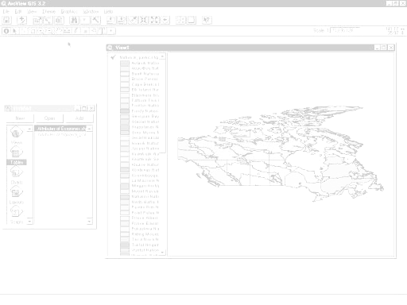
JOINING TABL ES
DISPLAYING A MAP
CLASSIFYING A MAP

DISPLAYING POINT DATA

BUILDING A QUERY

CHANGING DISPLAY FEATURES

Geological Diversity and Geological History of Canada

Arc View Lesson

GIS Information

Here's a list and explanation of important features in ArcView:

Project : In ArcView, a file for organizing your work. Projects use five types of
documents to organize information: views, tables, charts, layouts, and scripts.

View : A component of an ArcView project used for displaying, querying, and
analyzing geographic themes.

Table of Contents: All themes in a View are listed to the left of the map. The Table of
Contents shows the symbols used to draw features in each theme. The check box next to each theme indicates whether or not it is turned on or off in the map (whether it is currently drawn on the map).

Theme: A set of related geographic features, such as streets, parcels, or rivers, and the
characteristics (attributes) of those features.

Tables : Information formatted in rows and columns. A component of an ArcView
project used for displaying Tabular data.

Layout : The design or arrangement of elements in a digital map display or printed
map. A component of an ArcView project used for creating presentation-quality maps.

Hotlink: In ArcView, a way to display data (for example, a file, image, ArcView
document, or project) directly from a view, by clicking on a feature.

ArcView Buttons Reference Guide

View - Buttons
 | Save Project |  | Add Theme |  | Theme Properties | Edit Legend | Open Theme Table |  | Find | Locate Address | Query Builder |  | Zoom to Full Extent | Zoom to Active Theme | Zoom to Selected | Zoom In | Zoom Out | Zoom to Previous Extent |  | Select Features using Graphics | Clear Selected Features |  | Help

View – Tools
 | Identify | Pointer | Vertex Edit | Select Feature | Zoom In | Zoom Out | Pan | Measure | Hot Link | Area of Interest | Label | Text |  | Drawing and Editing Tools |  |  | Scale |  |  | Coordinates

Push and hold to select tool
Point
Line
Polyline
Rectangle
Circle
Polygon
Line Split
Polygon Split
Auto Complete

Table - Buttons
 | Save Project |  | Cut | Copy | Paste |  | Select All | Select None | Switch Selection |  | Create Chart |  | Find | Query Builder | Promote | Join |  | Summarize | Calculate |  | Sort Ascending | Sort Descending | Help

Table - Tools
Record Counter | Select Tool | Edit Tool | Identify Tool

Chart - Buttons
Save Project |  | Undo Erase |  | Area Chart Gallery | Bar Chart Gallery | Column Chart Gallery | Line Chart Gallery | Pie Chart Gallery | Scatter Chart Gallery | Chart Properties | Series From Records/Fields | Find | Help

Chart - Tools
Identify Tool | Erase Tool | Erase Within Polygon Tool | Chart Element Properties Tool | Chart Colour Tool

Layout - Buttons
Save Project | Cut | Copy | Paste | Layout Properties | Group | Ungroup | Bring to Front | Send to Back | Undo | Zoom to Page | Zoom to Actual Size | Zoom to Selected | Zoom In | Zoom Out | Print | Help

Layout - Tools
 |  | Pointer Tool | Vertex Tool | Zoom In Tool | Zoom Out Tool | Pan Tool | Text Tool | Drawing Tools |  | Frame Tools

Push and hold to select tool
View Frame
Legend Frame
Scale Frame
North Arrow Frame
Chart Frame
Table Frame
Picture Frame

For more Information: http://www.esricanada.com
Getting Started

Before you begin, the lesson data folder must be copied into a drive in which the student has writing and editing capabilities. This will probably be the drive containing your own personal account on the school’s system or it may be the C: drive of the machine you are currently working on. If the latter is the case you will have to work on the same machine each day until this assignment is complete. Each school set-up is different so work with your teacher to prepare your data folder.

! (The data for the lesson must first be downloaded from this Web site and placed on the school computer or network. Ask your teacher where to find the data folder that has been downloaded).

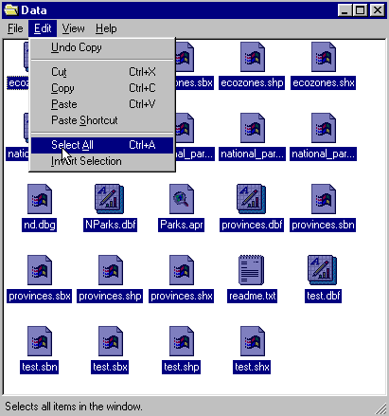 To do this, use the file manager program on your computer. For windows based systems this will be My Computer / Windows Explorer /.

Once the data folder has been copied to the required destination the files must be made usable by removing the read only attribute. For windows based systems follow these instructions:

! (The data downloaded from the Web Site is set as read only so that it cannot be changed or altered by accident.)

1. Open your new data folder
2. Choose Edit > Select all (they will all appear Blue)

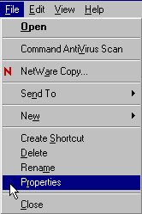3. From the menu choose:
File > Properties

4. Remove the check mark in the
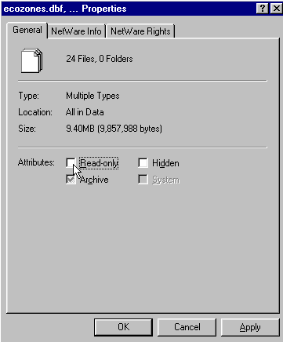
box beside the label read only.

5. Click apply, then OK

The data in your new data folder can now be opened, edited and saved using ArcView or other GIS software that can use SHAPE files to carry out the following project.
! Denotes an observation.
? Denotes a question to be answered on the Student Activity Sheet.

STARTING THE PROJECT

The purpose of this lesson is to include new data to a table by joining, display various themes by recoding polygons, displaying point data, building queries. We will look at geological age, rock type and mineral locations.

STARTING ArcView

Begin by starting up the ArcView program. If you are not sure how to do this, ask your teacher.

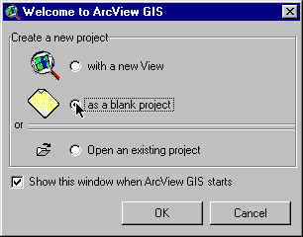
1. Choose as a blank project
2. Click O.K.

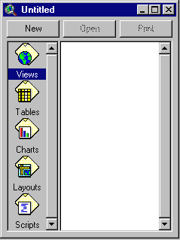When the program starts, it automatically opens a project window titled "Untitled."

If you like, you can maximize the ArcView window to fill the screen.

! In ArcView, you work within a project. A project is a collection of documents (map views, tables, charts, layouts, etc), document user interfaces, (called DocGUIs) and scripts. Only one project is open at a time.

3. Now you are ready to add documents to your new project.

4. With the “Views” icon selected, click on New and
maximize the View1 window.

5. Click the Add theme button and Navigate to the data folder where your data is stored. Hold down your SHIFT key and select the following files:

Admin.shp
Ecozones.shp
mines.shp

6. Click O.K.

This will add these three themes to the table of contents of the new view. They are now available for display and editing.

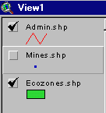
7. Click and drag to move the themes up or down in the table of content to change the order of display if necessary.

! Note the themes are displayed from the bottom to the top so line themes should be on top of polygon files to be visible.

8. Click on the square next to the themes you want to display. The theme that appears raised in the table of contents is the current active theme. This can be change by Clicking on other themes.

9. Remember to Save your project as you go along. Go to the File menu and select Save Project. Save your work to the appropriate directory (ask your teacher if you are not sure). Give your project a name that will identify your work. (The suffix apr. means that you are saving your work as a project that can be opened up in the future)

ArcView - Changing the Map Projection

! A Map Projection defines the relationship between the map coordinates and the geographic coordinates, (latitude and longitude). Our current display shows what a map of Canada looks like with only a geographic projection.

CHANGING PROJECTION

Now we will give our map “projection coordinates” to make it look more like the maps which are familiar to us.

1. From the View menu, choose Properties.
2. Select Properties.
3. Select Map Units list. Change the map units to decimal degrees.
4. Select Distance Units list. Change the distance units to kilometers
5.Click the Projection button.
6. Select Custom.
7. Select Lambert Conformal Conic from the projection list.
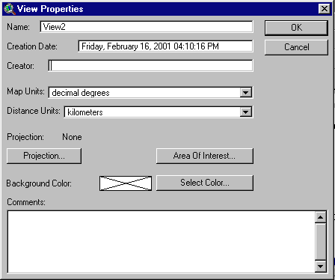
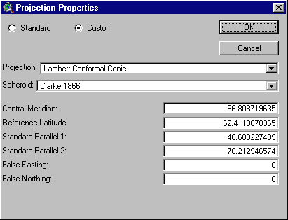

! Take a look at the parameters for this projection. Parameters are the descriptions of how the projection was made.
Note that a spheroid was used. (The earth is a slightly flattened sphere toward the poles).
Conformal implies that all angles are indicated correctly. All angles measured on the earth’s surface are given the same values on the map.
Conical means in the shape of a cone. In this projection, the relative positions on a globe are transferred to a plane in the shape of a cone around the globe. See how the longitudinal lines are closer together at the top of the image, that is, they are not parallel.

The central meridian, false easting and false northing are used to define the X (easting) and Y (northing) coordinates of the map. The reference latitude and standard parallel 1 and 2 are used to determine the origin of the projection (i.e. the point from which you are viewing the globe).

8. Click O.K.

The bottom of the View Properties window should look like this:

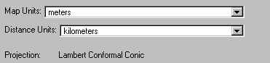

9. Click O.K.

! Note the difference in the map presentation.
? How is it different from the non-referenced map?

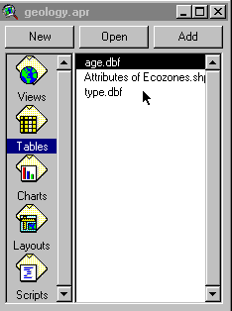

ArcView - JOINING TABLES

1. Close the View1 window.
2. From the untitled project window select tables.

3. Click the Add button and Navigate to the data folder where your data is stored. Hold down your SHIFT key and select the following files:
- age.dbf
- ecozones.dbf
- type.dbf

4. Select and Open each table.

? Examine each table and find a field common to all. What is it?

This is probably the field name containing the ecozones by name.

5. Select and activate the age.dbf table.
6. Click on the title of the field you identified as common to all tables.
7. From the window menu, select and activate the ecozones.dbf table.
8. Click on the title of the field you identified as common to all tables. It will appear darkened when selected.

! This common field will be used to join the two tables, with age.dbf being added to ecozones.dbf.

9. Click on the Join button .

? Examine the ecozones table.

What has been added at the end of the table?

Now Add rock type information.

10. Select and activate the type.dbf table using the window menu.
11. Click on the title of the field you identified as common to all tables.
12. From the window menu, Select and activate the ecozones.dbf table. Is the common field still selected? If not, click on it to make it active.
13. Click on the Join button.

? Examine the attributes of ecozones table.

What has changed?

14. Close all the tables.

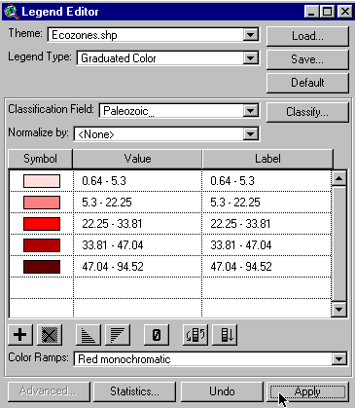
ArcView - DISPLAYING A MAP

Mapping Geological Age

1. From the Project window select the Views icon.
2. Select and open View1.
3. Double Click the ecozones.shp theme to edit it.
4. Open Legend Type list.

5. Select Graduated Colour.
6. Open Classification Field list.
7. Select Precambria (truncated to 10 characters from Precambrian)

8. Click Apply.

9. Close Legend Editor window.

! This will display the percent of Precambrian rock in each ecozone.

? Where are the oldest rocks located in Canada?
Describe the distribution of Precambrian rocks.
? Which ecozones have the greatest percent?
? How does this relate to the names of those ecozones?
Use the Identify Tool to query an ecozone to get its name and other details.

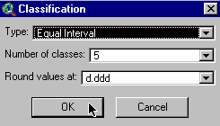
ArcView - CLASSIFYING A MAP

1. Double Click the ecozone theme.
2. Click Classify.
3. Select Type Equal Intervals.
4. Click O.K.
5. Click Apply.
6. Close Legend Editor window.

? How did the map and legend change?

Repeat this process to show the youngest rocks, (Cenozoic).

1. Double Click the ecozone theme.
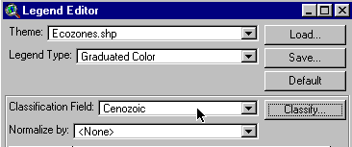2. Click Classify.

3. In the Classification Field list replace Precambria with Cenozoic.

4. Click Apply.

5. Close Legend Editor window.

? Where are the youngest rocks?

Describe the distribution of Cenozoic rocks.

Now, repeat this process again for both Mesozoic and Paleozoic rocks.

? Remember that the age of rock increases from the Cenozoic to the Mesozoic, to the Paleozoic and to Precambrian, the oldest.
Describe the distribution of geological rock age by ecozone.

Next, we'll map the ecozones by rock type.

1. Double Click the ecozones.shp theme to edit it.
2. Open Legend Type list.

3. Select Graduated Colour.
4. Open Classification Field list.
5. Select igneous.

8. Click Apply.

9. Close Legend Editor window.

? Describe the distribution of igneous rocks.

Explain why they occur in these areas.

Repeat this process for the other rock types: metamorphic and sedimentary.

? Where do the metamorphic and sedimentary rock types appear?

ArcView - DISPLAYING POINT DATA

Let's look at the mineral deposits in Canada and see how they are associated with certain rock ages.


1. Check the mines theme to view it.

? What can you say about the distribution of mines in Canada?

? Which ecozones do not contain mines?

Canada mines both metallic and non-metallic elements. We will look at each of these classes and see where they occur.

ArcView - BUILDING A QUERY

1. Double Click the ecozones.shp theme to edit it.
2. Open Legend Type list.

3. Select Unique Value.
4. Open Classification Field list.
5. Select % prim_age.

8. Click Apply.

9. Close Legend Editor window.

! This layer has the primary rock age for each ecozone.

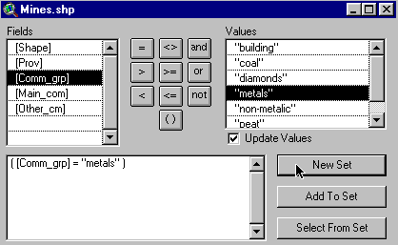

Now lets build a query to find all the mines that extract metals.

1. Select and activate mines theme.
2. Click Query Builder button.

3. Double Click Field comm_grp.

4. Click = button.

5. Double Click Values metals.
6. Click New Set button.
7. Close query window.

? With which age of rock is the majority of metal deposits associated?

8. Click Clear Selected Features button.

Using the same process as used for metals, choose building (for building materials).

9. Click Query Builder button.

10. Double Click Field comm_grp.

11. Click =.

12. Double Click Values building.
13. Click New Set button.
14. Close query window.

? From what rock age do most building materials come?
? What else does this map tell us about the location of mines and quarries for building materials?

Let's build a query to find where gold is most common.

Using the same process as for metals and building, substitute Au (Chemical symbol for gold) in the values field. Note that the query builder / field is now main_com.

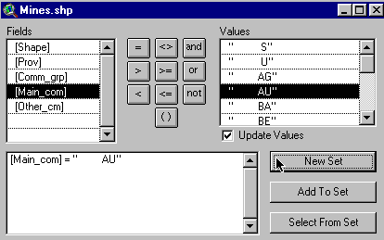

1. Click Query Builder button.

2. Double Click Field main_com.

3. Click = button.

4. Double Click Values Au.
5. Click New Set button.
6. Close query window.

? Where do most gold mines appear?

? How many different groups of gold mines do you see?

Explore other types of minerals like Talc, Clay, Asbestos, Iron, Zinc and Salt.

? Are these minerals metallic or non-metallic?

1. Keep your mine theme active.

2. From the main menu, select Theme and than Table.

3. You will find this information in the table you just open.

ArcView - CHANGING DISPLAY FEATURES

Now that we know how to display point data, let's try different symbols and colours for the points to make our map more meaningful.

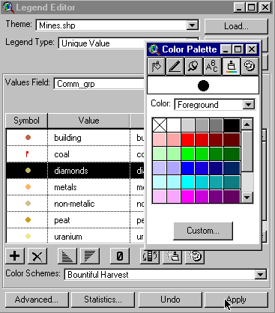

1. Double Click the mines theme.
2. Open Legend Type list.
3. Select Unique Value.
4. Open Values Field list. Select comm_grp.
5. Double Click symbol next to coal.
6. Select a new symbol by clicking on it.
7. Click Colour Brush button.
8. Select a New Colour for the symbol representing coal.

! Note that the size of the symbol can be changed to suit your map scale.

? Prepare a layout for "Mines of Canada" by using the elements in comm_grp.
and displaying the various metals with different colours and symbols.

Or,

Prepare a map of Canada showing the relationship of selected types of mines and geological age or rock type by changing the map display.

Try various combinations. Be creative!

ArcView - Map Layout for printing

Once you have a map classified and displayed to your satisfaction, you should prepare a map layout that can be used for printing. The purpose of this lesson is to set up your map on a page and annotate it for presentation.

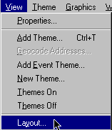
Set up map

1. Click Menu view.
2. Click Layout.

3. Select the layout template you want to use
(one of the landscape templates is suggested) .
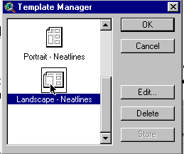

4. Click O.K.
5. Maximize the Layout screen.

EDIT TITLE

1. Double Click on the title View1.
2. Edit the title to reflect the purpose of the map, e.g., forestry, population.
3. Click O.K.
4. Resize the title using the corner handles and move it into a position that is visually balanced.
5. Click and Drag to reposition the legend if necessary.

EDIT NORTH ARROW

1. Double Click on the north arrow and select a different presentation. Ensure that that the arrow is pointing in the representative north direction of the map.
2. Click and Drag to reposition or rotate (using rotation function) as needed.

EDIT SCALE BAR

1. Double Click the scale bar.
2. Choose a new style of scale bar. The scale bar has default properties so you will not be able to change everything to the way you want.
3. Change the units to kms.
4. Find a combination of style, scale and divisions that is visually pleasing
5. Click and Drag to position to an appropriate location.

ADD LABELS, TEXT, OTHER INFORMATION

1. Click on the Text tool.
2. Click at the position on your layout where you want the text to appear.
3. In the Text Properties box, enter your text, e.g., “produced by (your name, date)”.
4. Select desired formatting information such as alignment, spacing and rotation.
5. Click O.K. when it appears, as you want it.
6. Click on Pointer tool.
7. Select the new text
8. Click once to change location or size, Click twice to change content.

! Experiment with all of the components of the layout until you have the look you want.

CHANGE THE NAME OF THE LAYOUT

You only have to do this if you want to save your project on the computer or on a disk.

1. Click menu Layout.
2. Select Properties.
3. Change the “name”. Click O.K.

ARRANGING YOUR LAYOUT

! Experiment with the layout buttons (use the tools page provided at the beginning of this lesson)
- to group (tie pieces together so they move as one)
- to ungroup (break apart the ties so that individual pieces move)
- bring to front (change order that pieces were laid down, e.g., lines on top of polygons)
- send to back (change order that pieces were laid down, e.g., polygons behind lines)
- zoom (make image bigger or smaller)
- neat line (border around layout)

PRINT MAP LAYOUT

1. Click Print button.
2. Click Setup.
3. Select your printer properties as outlined by your teacher.
4. Click O.K. to print.

! Note that the map can also be saved to a printer file.

ArcView Geological Diversity and Geological History

ArcView Lesson Student Activity Sheets

Name:

*Answers to the following questions can be obtained while completing the ArcView Canada’s Population Trends Activity.

- How is it different from the non-referenced map?

Joining Tables
- Examine each table and find a field common to all. What is it?

- Examine the ecozones table. What has been added at the end of the table?

- Examine the attributes of ecozones table. What has changed?

Examining the Distribution of Canada’s rock types

- Where are the oldest rocks located in Canada? Describe the distribution of Precambrian rocks.

- Which ecozones have the greatest percent?

- How does this relate to the names of those ecozones? Use the Identify tool to query an ecozone to get its name and other details.

- How did the map and legend change?

- Where are the youngest rocks? Describe the distribution of Cenozoic rocks.

- Remember that the age of rock increases from the Cenozoic to the Mesozoic, to the Paleozoic and to Precambrian, the oldest. Describe the distribution of geological rock age by ecozone.

- Describe the distribution of igneous rocks. Explain why they occur in these areas.

- Where do metamorphic and sedimentary rock types appear?

- What can you say about the distribution of mines in Canada?

- Which ecozones do not contain mines?

- With which age of rock is the majority of metal deposits associated? ___________________

- From what rock age do most building materials come? _____________________

- What else does this map tell us about the location of mines and quarries for building materials?

- Where do most gold mines appear?

- How many different groups of gold mines do you see?

- Are these minerals metallic or non-metallic? _________________

21. Prepare a layout for "Mines of Canada" by using the elements in comm_grp.
and displaying the various metals with different colours and symbols.

Or,

Prepare a map of Canada showing the relationship of selected types of mines and geological age or rock type by changing the map display.

Try various combinations. Be creative!

