Landforms of Canada

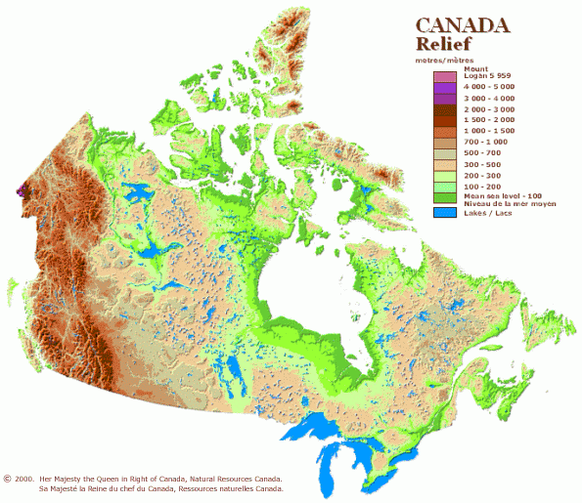



Table of Contents

Section Page

Lesson Objectives 3

Curriculum Expectations 3

Teacher Package (Academic Lesson) 4

Teacher Package (Applied Lesson) 5

Academic Performance Task, Expectations and Rubric 6

Applied Performance Task, Expectations and Rubric 8

Landforms of Canada 10

Landforms of Canada Student Activity Sheets 16

Ecozone Map 28

Landforms of Canada Internet Resources 29

Landforms of Canada – ArcView Lesson 30

Landforms of Canada – ArcView Lesson Activity Sheets 44

LANDFORMS OF CANADA

Lesson Objectives

- Explore the diverse landforms and morphology of Canada.
- Focus on the landform, surface form and topological make-up of the Ecozones of Canada.
- Learn about the range of landform types and surface form types in Canada.
- Study the relationships between elevation and landform.
- Learn about “Land Form Profiles” and surface structure.
- Produce vector maps showing the landform make-up of Ecozones.
- Produce vector maps showing the primary surface form make-up of Ecozones.
- Produce vector maps showing the elevation and topographic make-up of Ecozones.
- Modify map projections.
- Data charting.
- “Hot linking” images to maps
- Map classification.
- Map preparation and layout.

Curriculum Expectations

The Ontario grade 9 curriculum expectations were used as a basis for preparing the lessons in this series. Although there is no direct correlation between Ontario expectations and other provinces, in general, the issues covered in the lessons do relate to many of the curriculum requirements in other jurisdictions. The full curriculum expectations can be found at the Ontario Ministry of Education Web site

English http://www.edu.gov.on.ca/eng/document/curricul/secondary/canadian/canaful.html
French http://www.edu.gov.on.ca/fre/document/curricul/secondary/canadian/canaful.html

The performance tasks for Grade 9 Academic were based directly on curriculum expectations selected from the policy document for Canadian and World Studies. The tasks encompassed the four categories of knowledge and skills (i.e., Knowledge/Understanding, Thinking/Inquiry, Communication, and Application), requiring students to integrate their knowledge and skills in meaningful learning experiences.

The rubric for a specific performance task is intended to provide teachers and students with an overview of the expected final product with regard to the knowledge and skills being assessed as a whole. The rubric identifies key criteria by which the students’ work is to be assessed, and it provides descriptions that indicate the degree to which the key criteria have been met. The teacher can use the descriptions of the different levels of achievement given in the rubric to assess student achievement on a particular task.

Teacher Package

Academic Lesson

Title: Landforms of Canada – Building an ArcView Project

Time requirement: Prior learning and skill development:
1 period of 70 minutes each
ArcView lesson:
1 to 2 periods of 70 minutes each
Student research and proposal writing:
1 to 2 periods of 70 minutes each
Teacher Instructions:
- Description of the Task
(see Academic Performance Task, Expectations and Rubric).

- Final Product
Each student will submit their ArcView Map showing hot linked pictures with informative text file that demonstrate the various human activities occurring within distinct landforms in each of Canada’s ecozones.

- Assessment and Evaluation
The final product will be assessed using the Expectations and the Performance Task Rubric. Formal and informal assessment of the students based on prior knowledge, lesson objectives, production of their ArcView Map, research process done using the Background Information, the students’ activity sheets (on the Background and on the ArcView lesson), and the Rubric for assessing Maps. We suggest also that the students investigate the following website to help them find landform pictures:
http://sts.gsc.nrcan.gc.ca/tsdweb/landf_new.asp.
Internet research is needed to find human activities associated with the landforms in each ecozone. Self- or peer assessments and collaboration may be useful to the teacher and students.

- Accommodations
Accommodations that are normally provided in the regular classroom for students with special needs should be provided in the administration of this performance task.

- Rubric
Introduce the task-specific rubric to the students before giving the administrative task. Review the rubric with the students and ensure that each student understands the criteria and descriptions for achievement at each level.
Some students may perform below level 1. It will be important to note the characteristics of their work in relation to the criteria in the assessment rubric and to provide feedback to help them improve.

Teacher Package

Applied Lesson

Title: Landforms of Canada – Building an ArcView Project

Time requirement: Prior learning and skill development:
1 period of 70 minutes each
ArcView lesson:
1 to 2 periods of 70 minutes each
Computer Presentation
1 to 2 periods of 70 minutes each
Teacher Instructions:
- Description of the Task
(see Applied Performance Task, Expectations and Rubric)

- Final Product
Each student will submit their ArcView Map showing hot linked pictures that demonstrate the various human activities occurring within distinct landforms in each of Canada’s ecozones.

- Assessment and Evaluation
The final product will be assessed using the Expectations and the Performance Task Rubric. Formal and informal assessment of the students based on prior knowledge, lesson objectives, production of their ArcView Map; research process done using the Background Information, the students’ activity sheets (on the Background and on the ArcView lesson), and the Rubric for assessing Maps. We suggest also that the students investigate the following website to help them find landform pictures:
http://sts.gsc.nrcan.gc.ca/tsdweb/landf_new.asp.
Internet research is needed to find human activities associated with the landforms in each ecozone. Self- or peer assessments and collaboration may be useful to the teacher and students.

- Accommodations
Accommodations that are normally provided in the regular classroom for students with special needs should be provided in the administration of this performance task.

- Rubric
Introduce the task-specific rubric to the students before giving the administrative task. Review the rubric with the students and ensure that each student understands the criteria and descriptions for achievement at each level.
Some students may perform below level 1. It will be important to note the characteristics of their work in relation to the criteria in the assessment rubric and to provide feedback to help them improve.

Academic Performance Task, Expectations and Rubric

The Task
Students are to acquire various images from a variety of sources, including the Internet. The collected images should depict humans interacting within the various landscapes of Canada’s distinct ecozones. The completed Arcview project is to demonstrate the student’s understanding of how human activities are largely determined by the landforms in which we live. This is to be demonstrated by linking informative text files and pictures of the various human activities occurring within the distinct landforms in each of Canada’s ecozones.

Expectations
This task gives students the opportunity to demonstrate achievement of the following selected expectations from three strands: Geographic Foundations: Space and Systems; Human Environment Interactions; and Methods of Geographic Inquiry.

Students will:

- demonstrate an understanding of the characteristics of natural systems
- produce a set of criteria for identifying regions, including ecozones;
- demonstrate an understanding of how natural systems (e.g., climate, soils, landforms, natural vegetation, wildlife) influence cultural and economic activities (e.g., recreation, transportation, employment opportunities);
- select and use appropriate methods for displaying geographic data;
- create and use effectively photographs, charts, graphs, models, and diagrams.

Prior Knowledge and Skills
To complete this task, students are expected to be able to demonstrate the following:

- knowledge of the definition of an ecozone
- identify and describe Canada’s landforms and regions
- use maps and photos to interpret landforms and regional relationships
- Understanding of the physical processes that have shaped Canada’s ecozones (e.g. rock cycle; tectonic forces such as volcanism, folding, and faulting; glaciation)
- understanding of research methods using a variety of source materials
- ability to use a variety of tools and technologies for research.

Task Rubric – Landforms of Canada (Building an Arcview Project)

Expectations |  |  | Criteria |  |  | Level 1 (50 – 59) |  |  | Level 2 (60 –69) |  |  | Level 3 (70 – 79) |  |  | Level 4 (80 -100)

Knowledge / understanding
1,3 |  | - Demonstrates an understanding of the characteristics of natural systems  - Demonstrates an understanding of how natural systems influence cultural and economic activities |  |  | - Demonstrates little understanding of the characteristics of natural systems  - Demonstrates little understanding of how natural systems influence cultural and economic activities |  |  | - Demonstrates some understanding of the characteristics of natural systems  - Demonstrates some understanding of how natural systems influence cultural and economic activities |  |  | - Demonstrates considerable understanding of the characteristics of natural systems  - Demonstrates considerable understanding of how natural systems influence cultural and economic activities |  |  | - Demonstrates a high degree of understanding of the characteristics of natural systems  - Demonstrates a high degree of understanding of how natural systems influence cultural and economic activities

Thinking / Inquiry
2 |  | - Demonstrates understanding of human activities within ecozones |  |  | - Demonstrates little understanding of human activities within ecozones |  |  | - Demonstrates some understanding of human activities within ecozones |  |  | - Demonstrates considerable understanding of human activities within ecozones |  |  | - Demonstrates a high degree of understanding of human activities within ecozones

Communication
4 |  | - Selects and uses appropriate methods for displaying geographic data |  |  | - Uses few methods for displaying geographic data |  |  | - Uses some methods for displaying geographic data |  |  | - Uses many methods for displaying geographic data |  |  | - Uses many appropriate methods for displaying geographic data

Application
5 |  | - Creates and uses effectively photographs, charts, graphs, models, and diagrams |  |  | - Uses few photographs, charts, graphs, models, and diagrams |  |  | - Uses some photographs, charts, graphs, models, and diagrams |  |  | - Uses effectively photographs, charts, graphs, models, and diagrams |  |  | - Uses photographs, charts, graphs, models, and diagrams with purpose

Applied Performance Task, Expectations and Rubric

The Task
Students are to acquire various images from a variety of sources, including the Internet. The collected images should depict humans interacting within the various landscapes of Canada’s distinct ecozones. The completed Arcview project is to demonstrate the student’s understanding of how human activities are largely determined by the landforms in which we live. This is to be demonstrated by linking pictures of the various human activities occurring within the distinct landforms in each of Canada’s ecozones.

Expectations
This task gives students the opportunity to demonstrate achievement of the following selected expectations from three strands: Geographic Foundations: Space and Systems; Human Environment Interactions; and Methods of Geographic Inquiry.

Students will:

- demonstrate an understanding of how natural and human systems interact within ecozones
- analyse the natural and human factors that create regions
- use appropriate technology (e.g., computer maps, graphs, air photos) to present geographic information
- demonstrate an understanding of how natural systems (e.g., climate, soils, landforms, natural vegetation, wildlife) influence cultural and economic activities (e.g., recreation, transportation, employment opportunities);
- select and use appropriate methods for displaying geographic data;
- create and use effectively photographs, charts, graphs, models, and diagrams.

Prior Knowledge and Skills
To complete this task, students are expected to be able to demonstrate the following:

- knowledge of the definition of an ecozone
- identify and describe Canada’s landforms and regions
- use maps and photos to interpret landform and regional relationships
- understanding of the physical processes that have shaped Canada’s ecozones (e.g. rock cycle; tectonic forces such as volcanism, folding, and faulting; glaciation)
- understanding of research methods using a variety of source materials
- ability to use a variety of tools and technologies for research.

Task Rubric – Landforms of Canada (Building an Arcview Project)

Expectations |  |  | Criteria |  |  | Level 1 (50 – 59) |  |  | Level 2 (60 –69) |  |  | Level 3 (70 – 79) |  |  | Level 4 (80 -100)

Knowledge / understanding
1,4 |  | - Demonstrates an understanding of how natural and human systems interact within ecozones  - Demonstrates an understanding of how natural systems influence cultural and economic activities |  |  | - Demonstrates little understanding of how natural and human systems interact within ecozones  - Demonstrates little understanding of how natural systems influence cultural and economic activities |  |  | - Demonstrates some understanding of how natural and human systems interact within ecozones  - Demonstrates some understanding of how natural systems influence cultural and economic activities |  |  | - Demonstrates considerable understanding of how natural and human systems interact within ecozones  - Demonstrates considerable understanding of how natural systems influence cultural and economic activities |  |  | - Demonstrates a high degree of understanding of how natural and human systems interact within ecozones  - Demonstrates a high degree of understanding of how natural systems influence cultural and economic activities

Thinking / Inquiry
2 |  | - Analyses the natural and human factors that create regions |  |  | - Gathers data on the natural and human factors that create regions |  |  | - Identifies variables of the natural and human factors that create regions |  |  | - Draws conclusions of the natural and human factors that create regions |  |  | - Analyses the natural and human factors that create regions

Communication
5 |  | - Selects and uses appropriate methods for displaying geographic data |  |  | - Uses few methods for displaying geographic data |  |  | - Uses some methods for displaying geographic data |  |  | - Uses many methods for displaying geographic data |  |  | - Uses many appropriate methods for displaying geographic data

Application
6 |  | - Creates and uses effectively photographs, charts, graphs, models, and diagrams |  |  | - Uses few photographs, charts, graphs, models, and diagrams |  |  | - Uses some photographs, charts, graphs, models, and diagrams |  |  | - Uses effectively photographs, charts, graphs, models, and diagrams |  |  | - Uses photographs, charts, graphs, models, and diagrams with purpose

Landforms of Canada

Landform is the term given to the physical features of the earth's crust. The three distinct landforms of Canada are the Canadian Shield, the Highlands (mountains) and the Lowlands (plains). The Canadian Shield consists of the oldest, Precambrian rock. Much of its original mountainous surface has been worn away by glaciations and weathering to smooth, rounded hills. The mountain ranges of the Western Cordillera (Coastal, Columbia and Rocky Mountains), the Appalachian Mountains of the east coast and the Innuitian Mountains of the far north constitute the highlands in Canada. The Lowlands of Canada are formed by the Interior Plains (prairies and Manitoba lowlands), the Great Lakes - St. Lawrence Lowlands (St. Lawrence valley) and the Hudson Bay lowlands.

However, when we look at Canada's profile, we see that within mountainous highland regions there are plateaus and valleys. Using the information we learned from Canada's geological history, we can see how Canada's landforms came to be. Let's extend our classification of landforms into five categories for Canada:

B - Plateau – a relatively flat elevated area of land
H - Hills – natural rises in the landscape, not as high as a mountain
M - Mountains – large natural elevations rising abruptly from the surrounding area
P - Plains – flat, level areas of land
V - Valley – depression between hills or mountains

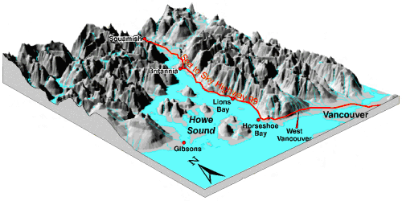
Mountains
Valley
Plains
Plateau
Hills

Adapted 3D model taken from the Natural Resources Canada, Geological Survey of Canada web site, Geoscape Vancouver Living with our Geological Landscape http://sts.gsc.nrcan.gc.ca/page1/urban/geoscape/geoscape.htm

Ecozones are rarely composed of one particular landform but are usually covered by several landforms in various combinations. To help visualize this combination, the following table gives you the percentage of any one landform in the ecozone by the percentage of land surface that it covers. Some landforms occur in only very small percentages, therefore only the top five percentages are given at this time, which may not account for a full 100% of the area.

Table 1: Percentage of each landform in an ecozone
Ecozone Names | Landform 1 |  | Landform  2 |  | Landform  3 |  | Landform  4 |  | Landform  5
Arctic Cordillera | 82 M |  | 9 H |  | 5 B |  | 2 P |  | 2 V
Northern Arctic | 30 M |  | 26 B |  | 26 P |  | 14 H |  | 4 V
Southern Arctic | 92 P |  | 7 H |  | 1 V
Taiga Plains | 55 P |  | 21 B |  | 10 V |  | 9 H |  | 5 M
Taiga Shield | 37 P |  | 27 H |  | 21 B |  | 12 M |  | 3 V
Boreal Shield | 49 P |  | 30 H |  | 16 M |  | 4 B |  | 1 V
Atlantic Maritime | 40 P |  | 28 H |  | 26 B |  | 5 M |  | 1 V
Mixedwood Plains | 87 P |  | 12 H |  | 1 B
Boreal Plains | 62 P |  | 21 H |  | 12 B |  | 5 V
Prairies | 73 P |  | 18 H |  | 6 B |  | 3 V
Taiga Cordillera | 63 M |  | 18 V |  | 10 P |  | 8 B |  | 1 H
Boreal Cordillera | 47 M |  | 17 B |  | 17 H |  | 15 V |  | 4 P
Pacific Maritime | 83 M |  | 7 H |  | 5 P |  | 4 V |  | 1 B
Montane Cordillera | 51 M |  | 35 B |  | 6 H |  | 6 V |  | 2 P
Hudson Plains | 100 P

Legend: M- Mountains, P- Plains, V- Valley, H- Hills, and B- Plateau

How data is presented is extremely important. Although the information in the table above tells us the relative amount of each landform in an ecozone, the data is difficult to interpret. Now, let’s put the data into another format. Rearrange the data so that all the values for mountains are in one column, those for plains in another, etc.

Table 2: Rearrange table into categories of landforms (percentages)
Ecozone | Mountains | Plains | Hills | Plateau | Valley
Arctic Cordillera | 82 | 2 | 9 | 5 | 2
Northern Arctic | 30 | 26 | 14 | 26 | 4
Southern Arctic |  | 92 | 7 |  | 1
Taiga Plains | 5 | 55 | 9 | 21 | 10
Taiga Shield | 12 | 37 | 27 | 21 | 3
Boreal Shield | 16 | 49 | 30 | 4 | 1
Atlantic Maritime | 5 | 40 | 28 | 26 | 1
Mixedwood Plains |  | 87 | 12 | 1
Boreal Plains |  | 62 | 21 | 12 | 5
Prairies |  | 73 | 18 | 6 | 3
Taiga Cordillera | 63 | 10 | 1 | 8 | 18
Boreal Cordillera | 47 | 4 | 17 | 17 | 15
Pacific Maritime | 83 | 5 | 7 | 1 | 4
Montane Cordillera | 51 | 2 | 6 | 35 | 6
Hudson Plains |  | 100

Elevation tables also tell us a great deal about our landscape. Elevations are measured from sea level. Consequently, the higher is the elevation, the higher the mountain or plateau. For example, a flat area of land that occurs at relatively low elevations is referred to as a plain while a large flat area of land occurring among mountains is referred to as a plateau.

It is also possible to have elevations below sea level. This land is often the most agriculturally productive since it contains high amounts of nutrient rich material washed into it from the surrounding areas and decomposed there. Dikes are often built to hold back the water and the land is drained for farming. Examples of this are found in Holland.

An indicator of the relative vertical position of one ecozone to another is the mean elevation. Mean elevation is the average elevation from a series of statistically distributed elevation measurements within an ecozone. A low mean elevation indicates that the ecozone is relatively flat and close to sea level while a high mean elevation indicates the ecozone is mountainous. Another indicator is elevation difference. Elevation difference is the mathematical value reached when the lowest elevation within an ecozone is subtracted from the highest. High elevation differences mean that the terrain is rugged with mountains and valleys while a low elevation difference indicates that the terrain is relatively flat.

Table 3: Elevation tables for each ecozone
ECOZONE NAMES | MEAN ELEVATION  (From Sea Level) | ELEVATION DIFFERENCE
Arctic Cordillera | 549 | 2416
Northern Arctic | 115 | 1778
Southern Arctic | 104 | 864
Taiga Plains | 364 | 2231
Taiga Shield | 328 | 1164
Boreal Shield | 305 | 1122
Atlantic Maritime | 138 | 1264
Mixedwood Plains | 174 | 541
Boreal Plains | 557 | 2141
Prairies | 675 | 1598
Taiga Cordillera | 1100 | 2892
Boreal Cordillera | 1177 | 5089
Pacific Maritime | 706 | 5800
Montane Cordillera | 1346 | 3792
Hudson Plains | 76 | 377

BAR GRAPH SHOWING MEAN ELEVATION AND ELEVATION DIFFERENCE FOR EACH ECOZONE
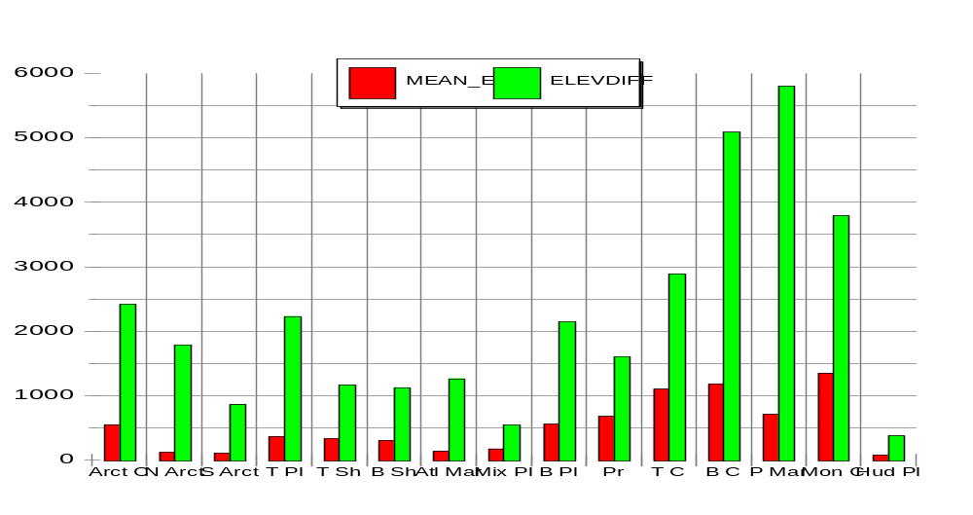

Landform tells us the general overall lay of the land, that is, whether it is mountainous or flat. However, if we chose to traverse the ecozone it would be important for us to know what the surface form, or the ground we are to walk across is like. To help us, the surface characteristics of Canada’s landscape have been given 14 classes. They are:

Table 4: Surface characteristics of Canada’s landscape
B - BOG | Wet, spongy swamp composed chiefly of decaying vegetation or peat
D - DISSECTED | Cut by erosion into hills and valleys or flat upland areas separated by valleys
F - FEN | Low land covered by water but producing reeds, sedges or coarse grasses
H - HUMMOCKY | Lumpy or in small uneven mounds
I - INCLINED | The dip of a bed, fault, vein or other tabular body measured from the horizontal
L - LEVEL | Flat alluvial plain
M - MARSH | Very shallow lakes with little or no drainage producing rushes, reeds and sedge often bordered by trees. Salt marshes are located along the coastline.
R - RIDGED | The narrow, elongated crests of hills or mountains
O - ROLLING | A succession of low hills giving a wave effect to the surface
S - STEEP | Sloping sharply as to be almost perpendicular to the horizon
W - SWAMP | Low, spongy land that may contain trees and shrubs
T - TERRACED | A level topped surface with step-like features where one side is bordered by a steeply ascending slope and the other by a steeply descending slope
U - UNDULATING | Rising and falling like waves
# - NOT APPLICABLE | Cannot be described by the definitions of surface form in this table

Table 5: Canada's Surface Forms

Ecozone Names |  | Percent |  | Primary surface |  | Percent |  | Secondary surface |  | Percent |  | Tertiary surface |  | Percent |  | Quaternary surface
 | Arctic Cordillera |  | 44 |  | # |  | 21 |  | I |  | 18 |  | S |  | 8 |  | H
 | Northern Arctic |  | 34 |  | U |  | 14 |  | D |  | 14 |  | S |  | 13 |  | I
 | Southern Arctic |  | 49 |  | U |  | 26 |  | L |  | 8 |  | I |  | 7 |  | S
 | Taiga Plains |  | 33 |  | B |  | 27 |  | U |  | 10 |  | F |  | 8 |  | I
 | Taiga Shield |  | 31 |  | U |  | 26 |  | H |  | 13 |  | O |  | 9 |  | R
 | Boreal Shield |  | 54 |  | H |  | 15 |  | B |  | 10 |  | U |  | 8 |  | O
 | Atlantic Maritime |  | 39 |  | O |  | 31 |  | U |  | 6 |  | H |  | 6 |  | L
 | Mixedwood Plains |  | 48 |  | U |  | 20 |  | L |  | 12 |  | H |  | 12 |  | O
 | Boreal Plains |  | 26 |  | U |  | 21 |  | H |  | 18 |  | B |  | 18 |  | O
 | Prairies |  | 41 |  | U |  | 31 |  | H |  | 15 |  | D |  | 8 |  | O
 | Taiga Cordillera |  | 47 |  | S |  | 35 |  | I |  | 3 |  | D |  | 3 |  | L
 | Boreal Cordillera |  | 22 |  | O |  | 20 |  | S |  | 17 |  | I |  | 11 |  | U
 | Pacific Maritime |  | 52 |  | S |  | 14 |  | H |  | 9 |  | # |  | 7 |  | R
 | Montane Cordillera |  | 31 |  | S |  | 27 |  | O |  | 15 |  | I |  | 11 |  | R
 | Hudson Plains |  | 46 |  | B |  | 36 |  | F |  | 6 |  | H |  | 5 |  | R

Landforms of Canada
Student Activity Sheets
Name:
*Most of the answers to these questions can be found in the Landforms of Canada background sections.

- Draw a landform profile for each of the ecozones. Use your own representation of the landforms (ex, broken lines for mountains, etc.) by adding each landform percentage for a total of 100%. Note that these profiles are not accurate since we are not giving you the height of the relief. Compare the similarities and the differences among the profiles and explain how each profile relates to the name of the associated ecozone?
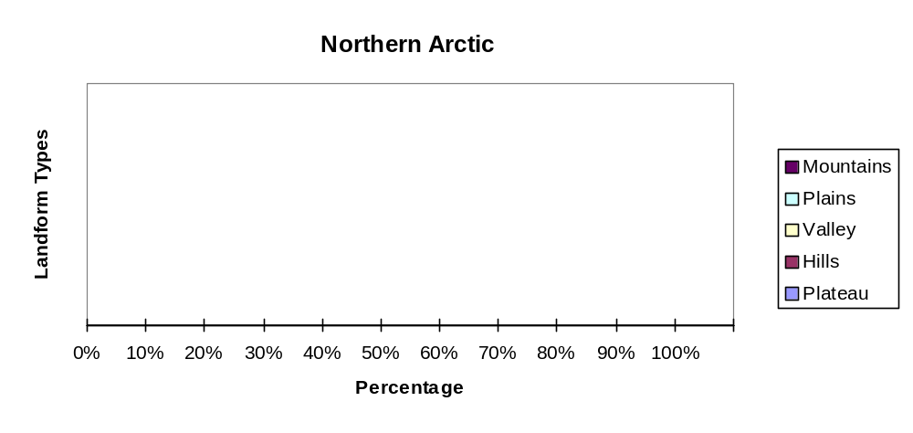
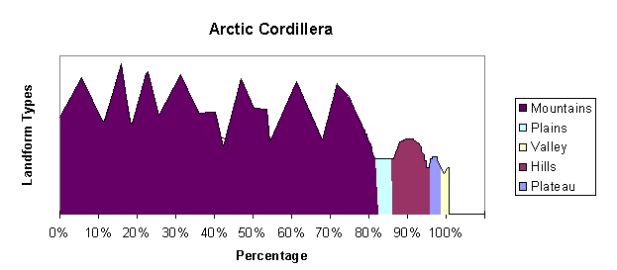

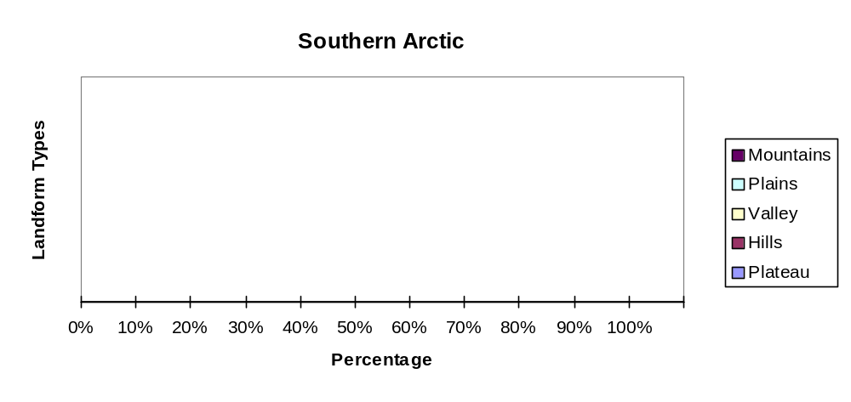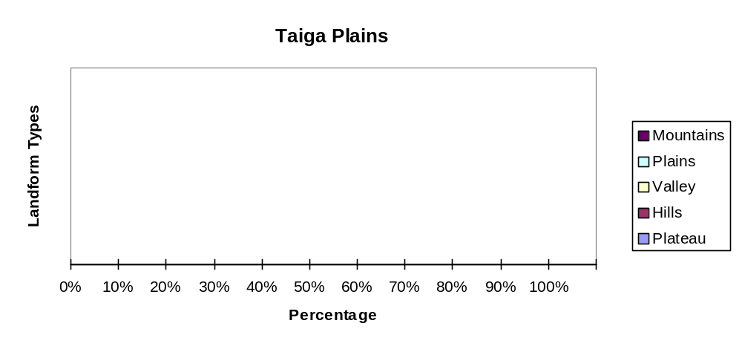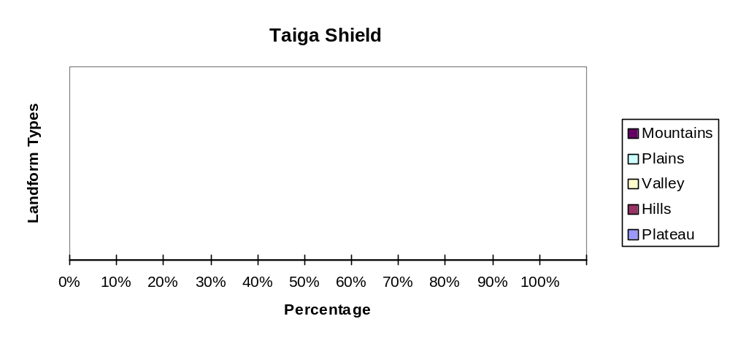

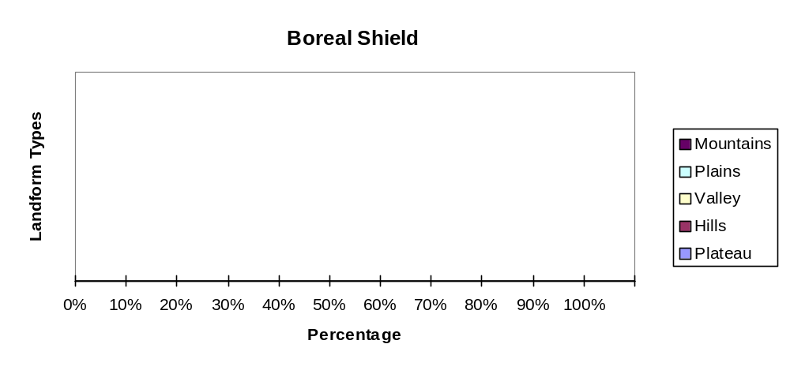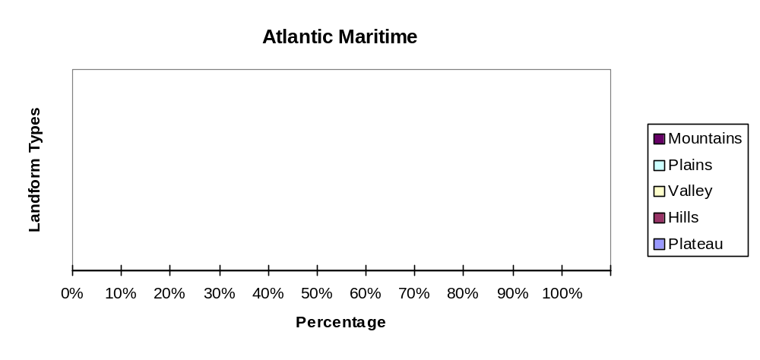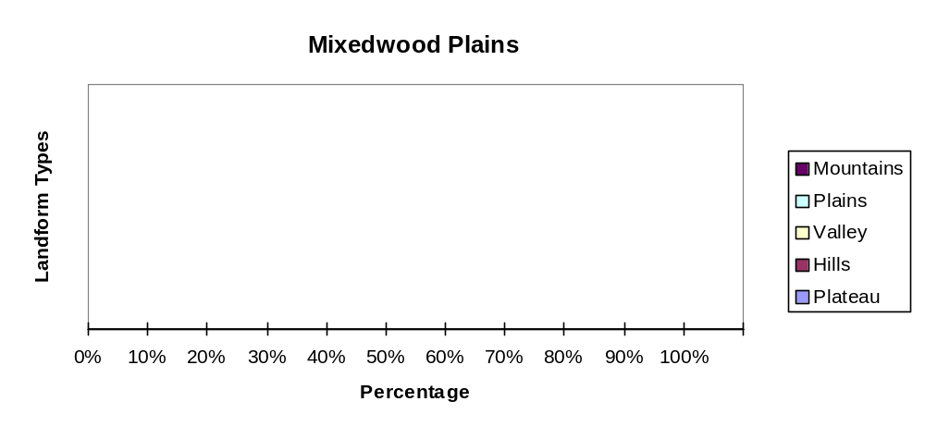

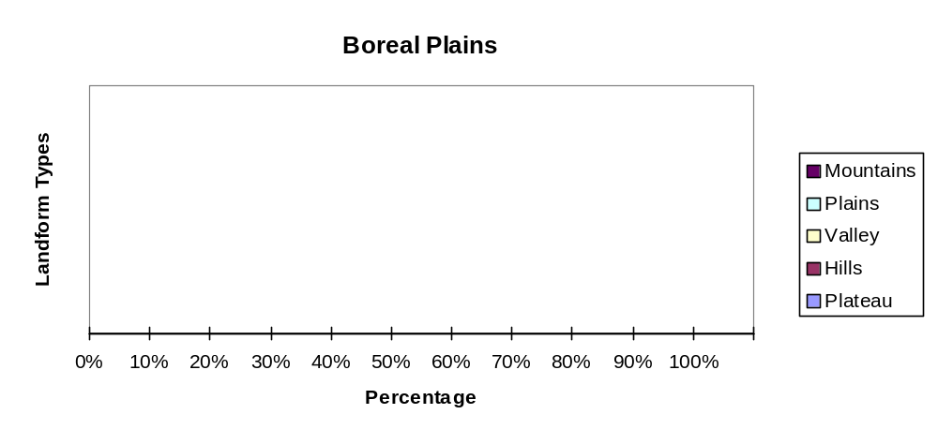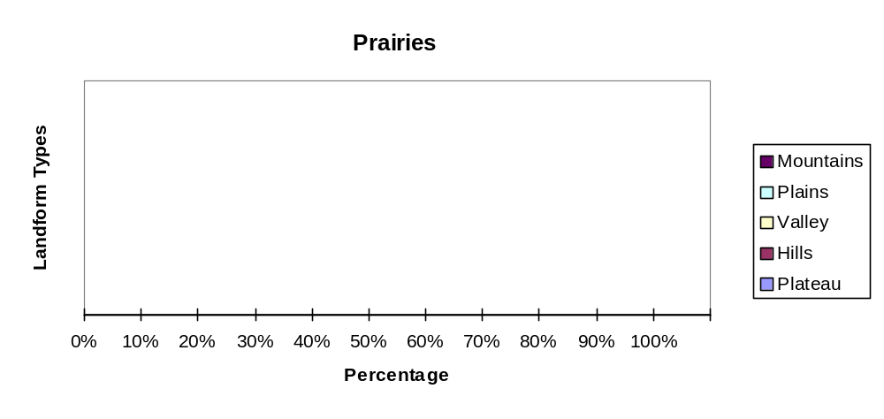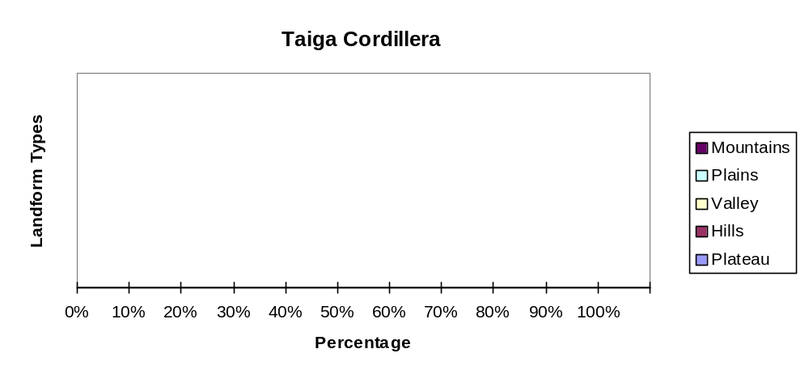

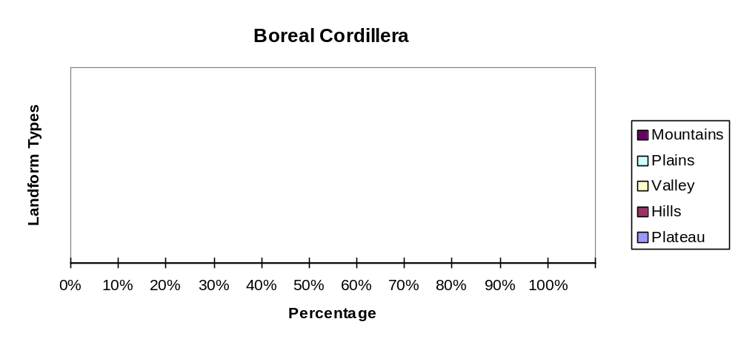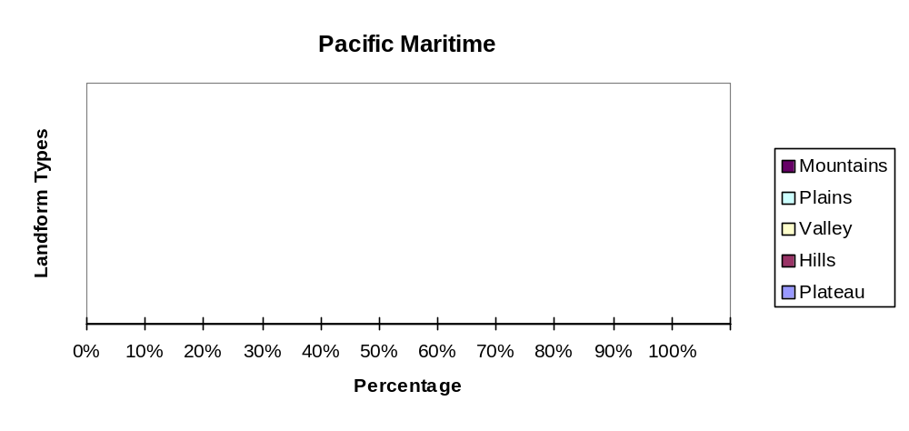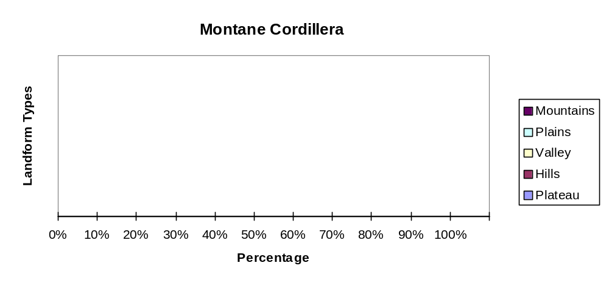

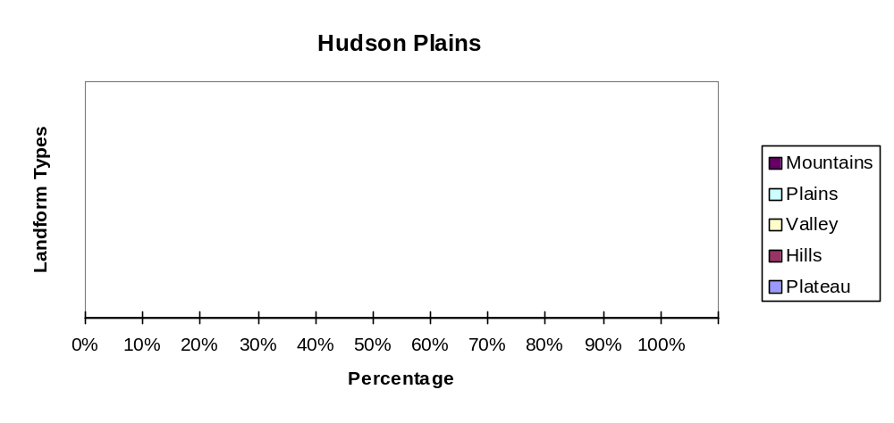Profiles Comments

- Arctic Cordillera: ________________________________________________________________________________________________________________________________________________________________________________________________________________________________________________________________________________________________________
- Northern Arctic: ________________________________________________________________________________________________________________________________________________________________________________________________________________________________________________________________________________________________________
- Southern Arctic: ________________________________________________________________________________________________________________________________________________________________________________________________________________________________________________________________________________________________________
- Taiga Plains: ________________________________________________________________________________________________________________________________________________________________________________________________________________________________________________________________________________________________________
- Taiga Shield: ________________________________________________________________________________________________________________________________________________________________________________________________________________________________________________________________________________________________________
- Boreal Shield: ________________________________________________________________________________________________________________________________________________________________________________________________________________________________________________________________________________________________________

- Atlantic Maritime: ________________________________________________________________________________________________________________________________________________________________________________________________________________________________________________________________________________________________________
- Mixedwood Plains: ________________________________________________________________________________________________________________________________________________________________________________________________________________________________________________________________________________________________________
- Boreal Plains: ________________________________________________________________________________________________________________________________________________________________________________________________________________________________________________________________________________________________________
- Prairies: ________________________________________________________________________________________________________________________________________________________________________________________________________________________________________________________________________________________________________
- Taiga Cordillera: ________________________________________________________________________________________________________________________________________________________________________________________________________________________________________________________________________________________________________
- Boreal Cordillera: ________________________________________________________________________________________________________________________________________________________________________________________________________________________________________________________________________________________________________
- Pacific Maritime: ________________________________________________________________________________________________________________________________________________________________________________________________________________________________________________________________________________________________________
- Montane Cordillera: ________________________________________________________________________________________________________________________________________________________________________________________________________________________________________________________________________________________________________
- Hudson Plains: ________________________________________________________________________________________________________________________________________________________________________________________________________________________________________________________________________________________________________

- Which ecozone has only one landform? __________________________

- Now considering the changes made from Table1 to Table 2, how does this rearrangement change the way we see the landscape?
________________________________________________________________________________________________________________________________________________________________________________________________________________________________________________________________________________________________________

- Now looking again at Table 2, what does this rearranged table automatically tell us about the ecozones? ________________________________________________________________________________________________________________________________________________________________________________________________________________________________________________________________________________________________________

- Which ecozones are the most mountainous? __________________________________________________________________________

- Which ecozones are the flattest? __________________________________________________________________________

- Do you see a relationship between mountains and plateaus? __________________________________________________________________________

- How about hills and plains? __________________________________________________________________________

- Where do you find the greatest amount of valleys? Why? _________________________________________________________________________

- Looking now at Table 3 (Elevation Tables for each ecozone), determine which ecozones have the least elevation difference? __________________________________________________________________________

- Which ecozones have the greatest? __________________________________________________________________________

- Which ecozones are closest to sea level? __________________________________________________________________________

- Using the ecozone map found at the end of this section, draw a line across Canada from west to east just above Canada’s border with the USA. Using the mean elevation values from Table 3, draw a graph profile of Canada along this line. As well, graph the mean elevation and the elevation difference as bar graphs on your map.

- What pattern do you see? Where are the highlands? Where are the lowlands? ______________________________________________________________________________________________________________________________________________________________________________________________________________________________
__________________________________________________________________________________________________________________________________________________________________________________________________________________________________________________________________________________________________________________________________________________________________________________

- Explain what geological forces caused these highlands to form? ________________________________________________________________________________________________________________________________________________________________________________________________________________________________________________________________________________________________________

- Now, looking at Table 5, which surface is most common in Canada? __________________________________________________________________________

- Which ecozone has the most diverse landscape, that is, which has the most evenly divided percentage among the top four surface forms? __________________________________________________________________________

- Create a chart by grouping all the wetland surface forms (bog, fen, marsh, swamp) into one class. Call it “W”. Group the rough terrain surface forms together (dissected, inclined, ridged, steep, terraced) called “R” and the flatter terrain surface forms (hummocky, level, rolling, undulating) called “G” together. At this point we will leave “not applicable” as a single group called “P”. Graph each ecozone by these four types.

W | B - BOG | F - FEN | M - MARSH | W - SWAMP
R | D - DISSECTED | I - INCLINED | R - RIDGED | S - STEEP | T - TERRACED
G | H - HUMMOCKY | L - LEVEL | O - ROLLING | U - UNDULATING
P | # - NOT APPLICABLE

- Which ecozone would have the most wetland surface?
__________________________________________________________________________

- Which ecozone would be the easiest to traverse?
__________________________________________________________________________

- Which would have the steepest inclines?
__________________________________________________________________________

- From the following pictures identify the different main surface forms used in this lesson.
Source: Canadian Landscapes and Landforms, Landform images and postcards
http://sts.gsc.nrcan.gc.ca/tsdweb/landf_new.asp

BOG FEN MARSH SWAMP DISSECTED
INCLINED RIDGED STEEP TERRACED HUMMOCKY
LEVEL ROLLING UNDULATING

1)____________________________ 2) _____________________________
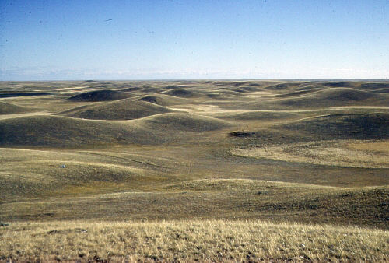
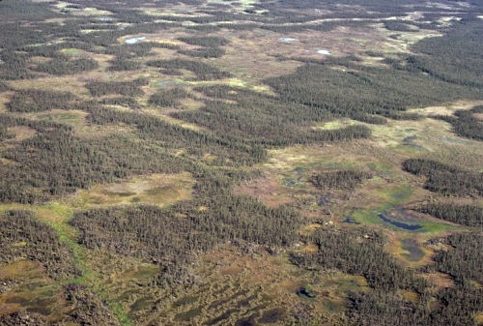

3)____________________________ 4) _____________________________
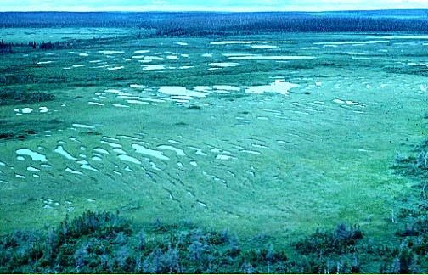
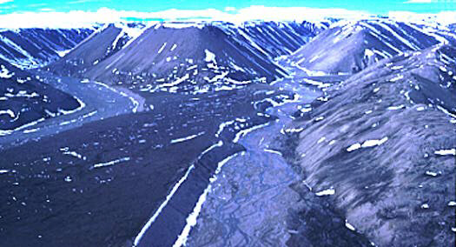

5)____________________________ 6) _____________________________
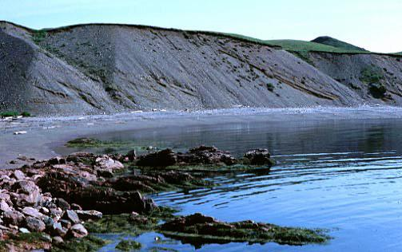
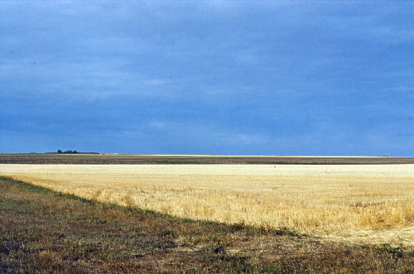

7)____________________________ 8) _____________________________
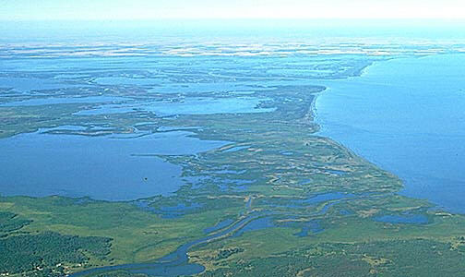
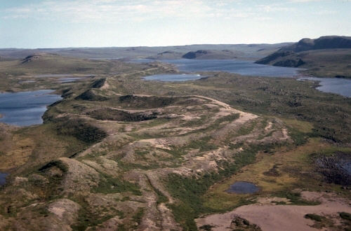

9)____________________________ 10) _____________________________

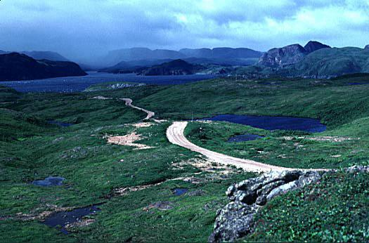
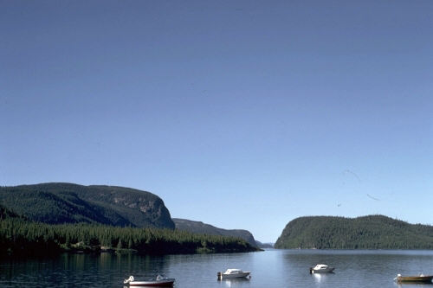

11)____________________________ 12) _____________________________

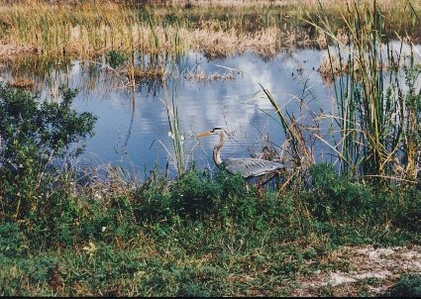
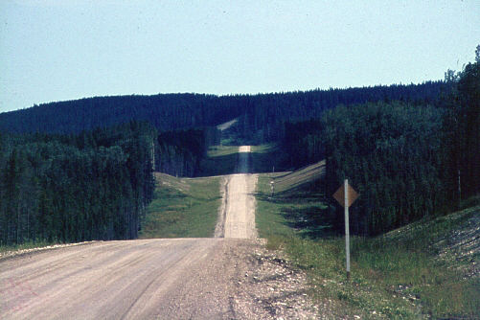

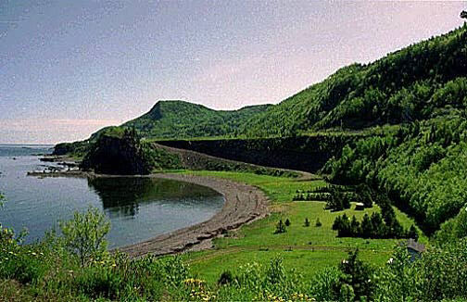13)____________________________

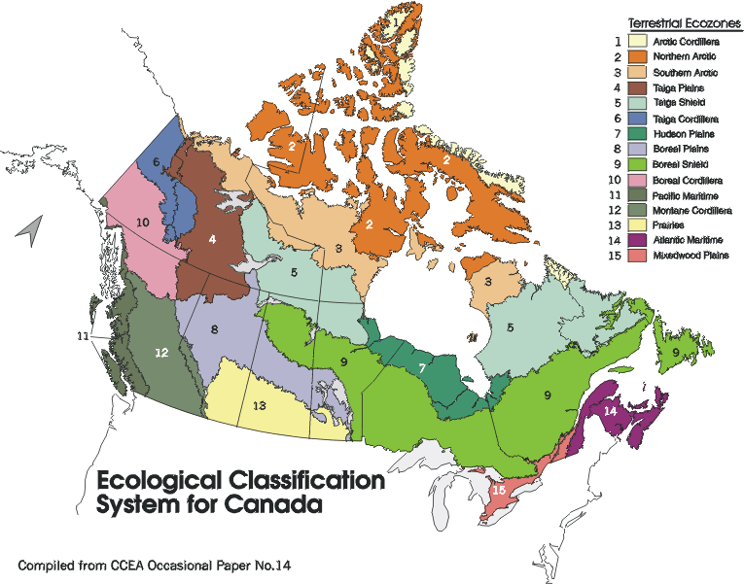

Landforms of Canada Internet Resources

References
Attribute Data for the National Ecological Framework for Canada
by I.B.Marshall, P.Schut and M.Ballard

Glossary of Geology and Related Sciences
American Geological Institute, 1966

Internet Resources
Canadian Landscapes and Landforms
Landform images and postcards
http://sts.gsc.nrcan.gc.ca/tsdweb/landf_new.asp

Relief Map of Canada
National Atlas of Canada
http://atlas.gc.ca/
choose Canada Relief Map
http://atlas.gc.ca/english/quick_maps/index_quickmaps.htm

Geological Survey of Canada
http://www.nrcan.gc.ca/gsc/

Canada’s Polar Life (Website from the University of Guelph)
http://www.polarlife.ca/ and also available mid December 2001 www.polarenvironments.ca

On line educational sites
Discover Canada's Geoscience Heritage
http://collections.ic.gc.ca/geoscience/

If the Earth could talk: General introduction to the Earth Sciences
http://www.cgq-qgc.ca/tous/terre/index.html

- Structure of the earth
- Plate tectonics
- Volcanoes
- Rocks
- Minerals
- Dating
- Glaciers
- Soil & water
- Mining
- Future
- Quizzes

Landforms of Canada
Displaying Map Theme
Displaying Data as Charts
Display Percentage Distribution
Hot linking Pictures to Maps
Creating a Map Layout

ArcView Lesson
GIS Information

Here's a list and explanation of important features in ArcView:

Project : In ArcView, a file for organizing your work. Projects use five types of
documents to organize information: views, tables, charts, layouts, and scripts.

View : A component of an ArcView project used for displaying, querying, and
analyzing geographic themes.

Table of Contents: All themes in a View are listed to the left of the map. The Table of
Contents show the symbols used to draw features in each theme. The check box next to each theme indicates whether or not it is turned on or off in the map (whether it is currently drawn on the map).

Theme: A set of related geographic features, such as streets, parcels, or rivers, and the
characteristics (attributes) of those features.

Tables : Information formatted in rows and columns. A component of an ArcView
project used for displaying Tabular data.

Layout : The design or arrangement of elements in a digital map display or printed
map. A component of an ArcView project used for creating presentation-quality maps.

Hotlink: In ArcView, a way to display data (for example, a file, image, ArcView
document, or project) directly from a view, by clicking on a feature.

ArcView Buttons Reference Guide

View - Buttons
 | Save Project |  | Add Theme |  | Theme Properties | Edit Legend | Open Theme Table |  | Find | Locate Address | Query Builder |  | Zoom to Full Extent | Zoom to Active Theme | Zoom to Selected | Zoom In | Zoom Out | Zoom to Previous Extent |  | Select Features using Graphics | Clear Selected Features |  | Help

View – Tools
 | Identify | Pointer | Vertex Edit | Select Feature | Zoom In | Zoom Out | Pan | Measure | Hot Link | Area of Interest | Label | Text |  | Drawing and Editing Tools |  |  | Scale |  |  | Coordinates

Push and hold to select tool
Point
Line
Polyline
Rectangle
Circle
Polygon
Line Split
Polygon Split
Auto Complete

Table - Buttons
 | Save Project |  | Cut | Copy | Paste |  | Select All | Select None | Switch Selection |  | Create Chart |  | Find | Query Builder | Promote | Join |  | Summarize | Calculate |  | Sort Ascending | Sort Descending | Help

Table - Tools
Record Counter | Select Tool | Edit Tool | Identify Tool

Chart - Buttons
Save Project |  | Undo Erase |  | Area Chart Gallery | Bar Chart Gallery | Column Chart Gallery | Line Chart Gallery | Pie Chart Gallery | Scatter Chart Gallery | Chart Properties | Series From Records/Fields | Find | Help

Chart - Tools
Identify Tool | Erase Tool | Erase Within Polygon Tool | Chart Element Properties Tool | Chart Colour Tool

Layout - Buttons
Save Project | Cut | Copy | Paste | Layout Properties | Group | Ungroup | Bring to Front | Send to Back | Undo | Zoom to Page | Zoom to Actual Size | Zoom to Selected | Zoom In | Zoom Out | Print | Help

Layout - Tools
 |  | Pointer Tool | Vertex Tool | Zoom In Tool | Zoom Out Tool | Pan Tool | Text Tool | Drawing Tools |  | Frame Tools

Push and hold to select tool
View Frame
Legend Frame
Scale Frame
North Arrow Frame
Chart Frame
Table Frame
Picture Frame

For more Information: http://www.esricanada.com
Getting Started

Before you begin, the lesson data folder must be copied into a drive in which the student has writing and editing capabilities. This will probably be the drive containing your own personal account on the school’s system or it may be the C: drive of the machine you are currently working on. If the latter is the case you will have to work on the same machine each day until this assignment is complete. Each school set-up is different so work with your teacher to prepare your data folder.

! (The data for the lesson must first be downloaded from this Web site and placed on the school computer or network. Ask your teacher where to find the data folder that has been downloaded).

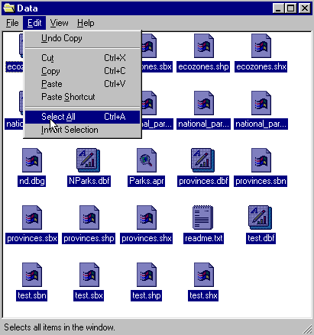 To do this, use the file manager program on your computer. For windows based systems this will be My Computer / Windows Explorer /.

Once the data folder has been copied to the required destination the files must be made usable by removing the read only attribute. For windows based systems follow these instructions:

! (The data downloaded from the Web Site is set as read only so that it cannot be changed or altered by accident.)

1. Open your new data folder
2. Choose Edit > Select all (they will all appear Blue)

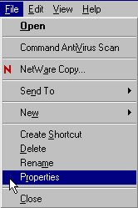3. From the menu choose:
File > Properties

4. Remove the check mark in the
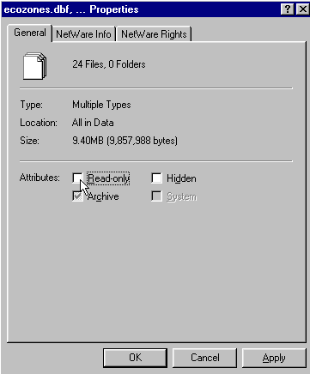
box beside the label read only.

5. Click apply, then OK.

The data in your new data folder can now be opened, edited and saved using ArcView or other GIS software that can use SHAPE files to carry out the following project.
! Denotes an observation.
? Denotes a question to be answered on the Student Activity Sheet.

STARTING THE PROJECT

The purpose of this exercise is to practice display functions using data tables, to display percentage distribution and data charts, compare distribution display techniques, to learn to hot link pictures to a map.

STARTING ArcView

Begin by starting up the ArcView program. If you are not sure how to do this, ask your teacher.

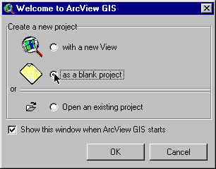
1. Choose as a blank project
2. Click OK.

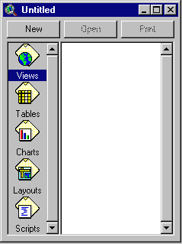When the program starts, it automatically opens a project window titled "Untitled."

If you like, you can maximize the ArcView window to fill the screen.

! In ArcView, you work within a project. A project is a collection of documents (map views, tables, charts, layouts, etc), document user interfaces, (called DocGUIs) and scripts. Only one project is open at a time.

3. Now you are ready to add documents to your new project.

4. With the “Views” icon selected, click on New and
maximize the View1 window.

5. Click the Add theme button and Navigate to the data folder where your data is stored. Hold down your SHIFT key and select the following files:

Admin.shp
Ecozones.shp

6. Click OK.

This will add these two themes to the table of contents of the new view. They are now available for display and editing.

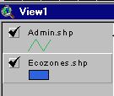
7. Click and drag to move the themes up or down in the table of content to change the order of display if necessary.

! Note the themes are displayed from the bottom to the top so line and point themes should be on top of polygon files to be visible.

8. Click on the square next to the themes you want to display. The theme that appears raised in the table of contents is the current active theme. This can be change by Clicking on other themes.

9. Remember to Save your project as you go along. Go to the File menu and select Save Project. Save your work to the appropriate directory (ask your teacher if you are not sure). Give your project a name that will identify your work. (The suffix apr. means that you are saving your work as a project that can be opened up in the future)

ArcView - Changing the Map Projection

! A Map Projection defines the relationship between the map coordinates and the geographic coordinates, (latitude and longitude). Our current display shows what a map of Canada looks like with only a geographic projection.

CHANGING PROJECTION

Now we will give our map “projection coordinates” to make it look more like the maps which are familiar to us.

1. From the View menu, choose Properties.
2. Select Properties.
3. Select Map Units list. Change the map units to decimal degrees.
4. Select Distance Units list. Change the distance units to kilometers
5.Click the Projection button.
6. Select Custom.
7. Select Lambert Conformal Conic from the projection list.
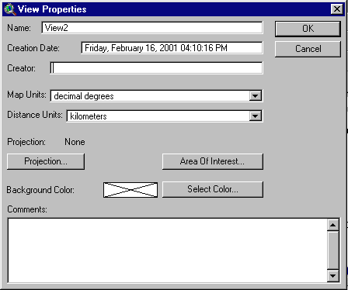
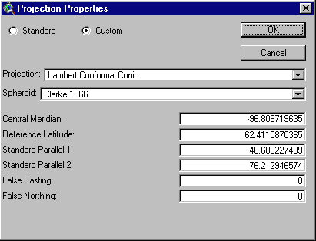

! Take a look at the parameters for this projection. Parameters are the descriptions of how the projection was made.
Note that a spheroid was used. (The earth is a slightly flattened sphere toward the poles).
Conformal implies that all angles are indicated correctly. All angles measured on the earth’s surface are given the same values on the map.
Conical means in the shape of a cone. In this projection, the relative positions on a globe are transferred to a plane in the shape of a cone around the globe. See how the longitudinal lines are closer together at the top of the image, that is, they are not parallel.

The central meridian, false easting and false northing are used to define the X (easting) and Y (northing) coordinates of the map. The reference latitude and standard parallel 1 and 2 are used to determine the origin of the projection (i.e. the point from which you are viewing the globe).

8. Click OK.

The bottom of the View Properties window should look like this:

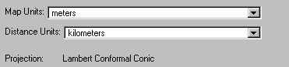

9. Click OK.

! Note the difference in the map presentation.
? How is it different from the non-referenced map?

ArcView - DISPLAYING MAP THEMES

We will be looking at the four main landforms of each ecozone in Canada.
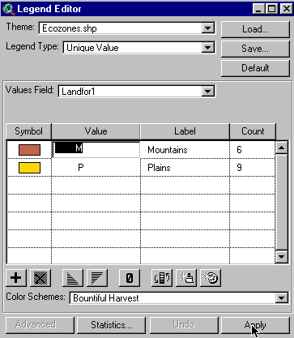

1. Double Click Ecozones theme.
2. Open Legend Type list, Select Unique Value.
3. Open Values Field list, Select Landfor1.
4. Edit the legend by clicking M in the Label Field, type mountains.
5. Repeat for P, type plains.
6. Click Apply.
7. Close Legend Editor window.

? What can you say about the distribution of the two primary landforms (Mountains and Plains) i.e. where they are located in Canada?

DISPLAY PERCENTAGE DISTRIBUTION

We will display the percentage distribution of the mountain landform.

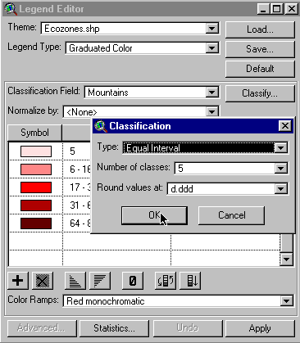
1. Double Click Ecozones theme.
2. Open Legend Type list.
3. Select Graduated Colour.
4. Open Classification Field list.
5. Select Mountains.
6. Click classify button.
7. Open Type list.
8. Select Equal Intervals.
9. Click OK.
10. Click Apply.
11. Close Legend Editor window.

? What can you say about the distribution of mountains?
? Are there any ecozones not represented?
? Why?

! To have a completed map, we will put a no data item in our legend for those ecozones that do not have a particular landform.

12. Double Click Ecozones theme.
13. In the Legend Editor window, Click on the Null Value button.

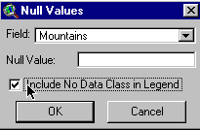
14. Check Include No Data Class In Legend box
15. Click OK.

16. Double Click no data legend item.

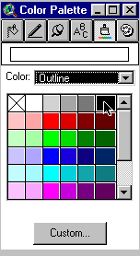
17. Click The Colour Palette button.
18. Select a new colour for the no data legend item.
19. Open The Colour list, Select Outline.
20. Select black for outline colour.
21. Close Colour Palette window.
22. Click Apply.
23. Close Legend Editor window.

! Using the same process that was used to display mountains, display the other landforms of plains, hills, plateau and valley one at a time. Explain the distribution patterns you see.
? Explain the distribution patterns you see for Plains, Hills, Plateau and Valleys.

Now that we know where the major landforms are located, let's explore to see what the surface forms are.

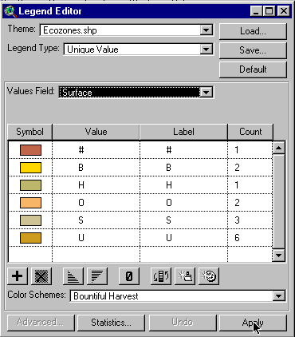
First we'll display the primary surface forms or those, which occur most frequently.

1. Double Click Ecozones theme.
2. Open Legend Type list, Select Unique Value.
3. Open Values Field list, Select Surface.
4. Edit the label values to represent the following.

B - BOG
O - ROLLING
H - HUMMOCKY
# - NOT APPLICABLE
S - STEEP
U - UNDULATING

5. Click Apply.
6. Close Legend Editor window.

7. Use the Identify button to identify a representative ecozone for each of the primary surface forms.

Now let's look at the minimum and maximum elevation characteristics of the Ecozones.

Elevation or height above mean sea level is an important measure of landform. Elevation for an Ecozone can be quite varied and therefore difficult to present on a map. Statistical values of elevation are often used to simplify presentations. Four common values that are used are;

- The Minimum Elevation found in the Ecozone. This actually may be Sea Level.
- The Maximum Elevation found in the Ecozone.
- The Mean or Average Elevation found in the Ecozone.
- The Elevation Difference, which is difference between the Minimum and Maximum Elevation.

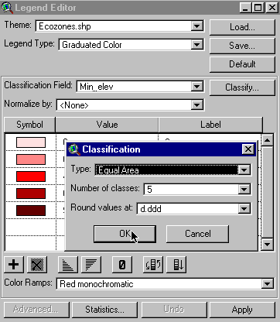
1. Double Click Ecozones theme.
2. Open Legend Type list.
3. Select Graduated Colour.
4. Open Classification Field list.
5. Select min_elev.
6. Click Classify button.
7. Open Type list.
8. Select Equal Intervals.
9. Click O.K.
10. Click Apply.
11. Close Legend Editor Window.

Repeat the process to display max_elev. Maximum elevation.
? Describe the different patterns displayed when illustrating the Minimum Elevations of Canada. Explain why.
? Now compare with the Maximum Elevations of Canada. Is this the same pattern as for Minimum Elevations? Explain.

Repeat the process for the mean_ele mean elevation and the elevdiff. Elevation difference.

? How do mean elevation and elevation difference compare to the previous patterns?

ArcView - DISPLAY DATA AS CHARTS

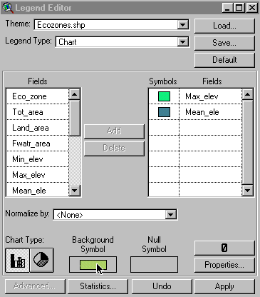
We will now display the maximum and mean elevations as charts for each ecozone.

1. Double Click Ecozone theme.
2. Open Legend Type list.
3. Select Chart.
4. In the Fields List, Select Max_elev.
5. Click Add.
6. Repeat for Mean_ele.
7. For Chart Type Click Bar Chart.
8. Double Click Background Symbol and Select a Background Symbol that does not conflict with your legend colours.

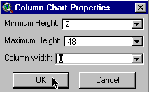

9. In the Legend Editor window, Click Properties to alter the look of the charts.
10. Click OK.
11. Click Apply.
12. Close Legend Editor window.
? By comparing the charts, which ecozones show the largest elevation difference?
? Which ecozones have very little elevation difference?
? By regrouping the surface forms, which ecozones
-have the most wetland?
-would be the easiest to traverse?
-would have the steepest inclines?

ArcView - HOT LINKING PICTURES TO A MAP

1. Double click ecozones theme.
2. Reset Legend type back to Single symbol.
3. Click Apply.
4. Close Legend Editor window.

- Click Open theme table button .

6. Scroll a cross the table to the Images 1 field. Note the values in this field all end as a .gif file. These are pictures representing the unique characteristics of the Ecozones of Canada. We are going to link these images to the Arc View project.

7. With the ecozones theme active, select Theme in the main menu.
Select Properties.

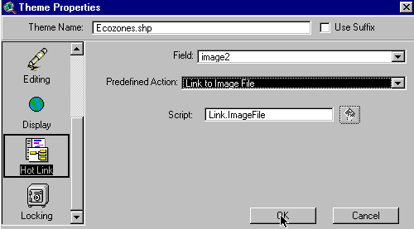
8. Scroll down the icon list on the left until you come to the Hotlinks.

9. Click on it.

10. Open Field list.
11. Select image 1.
12. Open Predefined action list
13. Select Link to Image File.
14. Click OK.

Now we'll test our hot links.

! Note that the hot link button is now active.

15. Click on it.
16. Move the cursor to an ecozone and click.

? What happens when you select an ecozone that you linked to an image?

Now create a layout for printing. Use examples from this exercise to show an aspect of Canada’s landforms.

ArcView - Map Layout for printing

Once you have a map classified and displayed to your satisfaction, you should prepare a map layout that can be used for printing. The purpose of this lesson is to set up your map on a page and annotate it for presentation.

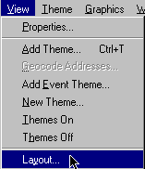
Set up map

1. Click Menu view.
2. Click Layout.

3. Select the layout template you want to use
(One of the landscape templates is suggested) .
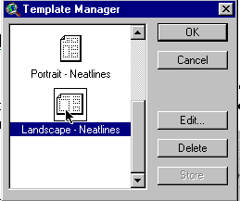

4. Click O.K.
5. Maximize the Layout screen.

EDIT TITLE

1. Double Click on the title View1.
2. Edit the title to reflect the purpose of the map, e.g., forestry, and population.
3. Click O.K.
4. Resize the title using the corner handles and move it into a position that is visually balanced.
5. Click and Drag to reposition the legend if necessary.

EDIT NORTH ARROW

1. Double Click on the north arrow and select a different presentation. Ensure that that the arrow is pointing in the representative north direction of the map.
2. Click and Drag to reposition or rotate (using rotation function) as needed.

EDIT SCALE BAR

1. Double Click the scale bar.
2. Choose a new style of scale bar. The scale bar has default properties so you will not be able to change everything to the way you want.
3. Change the units to kms.
4. Find a combination of style, scale and divisions that is visually pleasing
5. Click and Drag to position to an appropriate location.

ADD LABELS, TEXT, OTHER INFORMATION

1. Click on the Text tool.
2. Click at the position on your layout where you want the text to appear.
3. In the Text Properties box, enter your text, e.g., “produced by (your name, date)”.
4. Select desired formatting information such as alignment, spacing and rotation.
5. Click O.K. when it appears, as you want it.
6. Click on Pointer tool.
7. Select the new text
8. Click once to change location or size, Click twice to change content.

! Experiment with all of the components of the layout until you have the look you want.

CHANGE THE NAME OF THE LAYOUT

You only have to do this if you want to save your project on the computer or on a disk.

1. Click menu Layout.
2. Select Properties.
3. Change the “name”. Click O.K.

ARRANGING YOUR LAYOUT

! Experiment with the layout buttons (use the tools page provided at the beginning of this lesson)
- to group (tie pieces together so they move as one)
- to ungroup (break apart the ties so that individual pieces move)
- bring to front (change order that pieces were laid down, e.g., lines on top of polygons)
- send to back (change order that pieces were laid down, e.g., polygons behind lines)
- zoom (make image bigger or smaller)
- neat line (border around layout)

PRINT MAP LAYOUT

1. Click Print button.
2. Click Setup.
3. Select your printer properties as outlined by your teacher.
4. Click O.K. to print.

! Note that the map can also be saved to a printer file.
? Produce a layout for printing your map. Include your layout with this exercise sheet for evaluation. What is the purpose of your map?

ArcView Landforms of Canada
Student Activity Sheet

Name:

*Answers to the following questions can be obtained while completing the ArcView Landforms of Canada Activity.

- How is it different from the non-referenced map?

- What can you say about the distribution of the two primary landforms (Mountains and Plains) i.e. where they are located in Canada?

- What can you say about the distribution of mountains?

- Are there any ecozones not represented? Why?

- Explain the distribution patterns you see for:

Plains,

Hills,

Plateau,

Valleys

- Describe the different patterns displayed when illustrating the Minimum Elevations of Canada. Explain why.

- Now compare with the Maximum Elevations of Canada. Is this the same pattern as for Minimum Elevations? Explain.

- How do mean elevation and elevation difference compare to the previous patterns

- By comparing the charts, which ecozones show the largest elevation difference?

- Which ecozones have very little elevation difference?

- By regrouping the surface forms, which ecozones
-have the most wetland surface? ______________________
-would be the easiest to traverse? _____________________
-would have the steepest inclines? _____________________

- What happens when you select an ecozone that you hot linked to an image?

- Produce a layout for printing your map. Include your layout with this exercise sheet for evaluation. What is the purpose of your map?

