
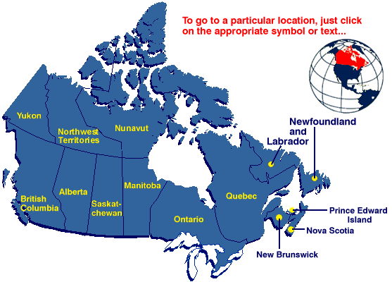
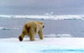
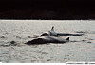
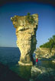
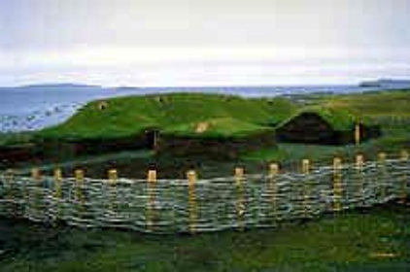
Conservation & Protected Areas of Canada
The pictures and map on this page are taken from the Parks Canada (Photo Gallery) Web site: http://www.parkscanada.pch.gc.ca/

Table of Contents

Section Page

Lesson Objectives 3

Curriculum Expectations 3

Teacher Package (Academic Lesson) 4

Teacher Package (Applied Lesson) 5

Academic Performance Task, Expectations and Rubric 6

Applied Performance Task, Expectations and Rubric 8

Parks and Conservation Areas 11

National Park Administration - Regulations 12

National Parks Administration - Offences, Punishment and Procedure 14

National Parks and National Park Reserves of Canada 16

Provincial Parks 18

Links to Information on Provincial Parks 20

Other Protected Areas 21

Ecological Integrity 22

Canada’s Parks and Conservation areas Students Activity Sheets 23
(On background information)

Protected Areas of Canada over 1000ha. 25

PowerPoint Cheat Sheet 26

PowerPoint Quick Reference 28

PowerPoint Planning Sheet 30

Conservation and Protected areas of Canada – ArcView Lesson 33

Conservation and Protected areas of Canada – ArcView Lesson Activity sheet 46

Lesson Objectives

- Explore parks and conservation characteristics of Canada’s Ecozones.
- Prepare maps of Canada’s National Parks.
- Analyze National Parks based on size and year of establishment.
- Use and query data tables linked and associated with maps.
- Calculate and use Quantile values.
- Compute and use new data tables.
- Display computed data using charts.
- Prepare a map layout for printing.

Curriculum Expectations

The Ontario grade 9 curriculum expectations were used as a basis for preparing the lessons in this series. Although there is no direct correlation between Ontario expectations and other provinces, in general, the issues covered in the lessons do relate to many of the curriculum requirements in other jurisdictions. The full curriculum expectations can be found at the Ontario Ministry of Education Web site

English http://www.edu.gov.on.ca/eng/document/curricul/secondary/canadian/canaful.html
French http://www.edu.gov.on.ca/fre/document/curricul/secondary/canadian/canaful.html

The performance tasks for Grade 9 Academic were based directly on curriculum expectations selected from the policy document for Canadian and World Studies. The tasks encompassed the four categories of knowledge and skills (i.e., Knowledge/Understanding, Thinking/Inquiry, Communication, and Application), requiring students to integrate their knowledge and skills in meaningful learning experiences.
The rubric for a specific performance task is intended to provide teachers and students with an overview of the expected final product with regard to the knowledge and skills being assessed as a whole. The rubric identifies key criteria by which the students’ work is to be assessed, and it provides descriptions that indicate the degree to which the key criteria have been met. The teacher can use the descriptions of the different levels of achievement given in the rubric to assess student achievement on a particular task.

Teacher Package

Academic Lesson

Title: Proposal for a New National Park

Time requirement: Prior learning and skill development:
3 periods of 70 minutes each
ArcView lesson
2 to 3 periods of 70 minutes each
Student research and proposal writing:
4 periods of 70 minutes each
Teacher Instructions:
- Description of the Task
(see Academic Performance Task, Expectations and Rubric).

- Final Product
Each student will submit a written, illustrated, and supported proposal for a new national park in Canada

- Assessment and Evaluation
The final product will be assessed using the Expectations and the Performance Task Rubric.
Formal and informal assessment of the students based on prior knowledge, lesson objectives, production of their ArcView Map, research process can be done using the Background Information, the students’ activity sheets (on the Background and on the ArcView lesson), the Ecozone Quiz and the Rubric for assessing Maps. Self- or peer assessments and collaboration may be useful to the teacher and students.

- Accommodations
Accommodations that are normally provided in the regular classroom for students with special needs should be provided in the administration of this performance task.

- Rubric
Introduce the task-specific rubric to the students before giving the administrative task. Review the rubric with the students and ensure that each student understands the criteria and descriptions for achievement at each level.
Some students may perform below level 1. It will be important to note the characteristics of their work in relation to the criteria in the assessment rubric and to provide feedback to help them improve.

Teacher Package

Applied Lesson

Title: Computer Presentation of a chosen Canadian Park or Conservation Area

Time requirement: Prior learning and skill development:
3 periods of 70 minutes each
ArcView lesson
2 to 3 periods of 70 minutes each
Computer Presentation
4 periods of 70 minutes each
Teacher Instructions:
- Description of the Task
(see Applied Performance Task, Expectations and Rubric)

- Final Product
In groups of three, students will choose a Canadian park or a Conservation Area and its ecozone for study by choosing one of administrative roles. Each student will create 5 PowerPoint or Corel Presentation slides of the different characteristics of human and natural system in their park and they will have to present to the class.

- Assessment and Evaluation
The final product will be assessed using the Expectations and the Performance Task Rubric.
Formal and informal assessment of the students based on prior knowledge, lesson objectives, production of their ArcView Map, research process could be done using the Background Information, the students’ activity sheets (on the Background and on the ArcView lesson), the Ecozone Quiz and the Rubric for assessing Maps. In this collaborative activity, self- and peer assessment should be done to ensure that students are collecting appropriate information, and are working well as a team. To facilitate your assessment please see “Record of Individual Participation in a Group and Self-Evaluation Form”.

- Accommodations
Accommodations that are normally provided in the regular classroom for students with special needs should be provided in the administration of this performance task.

- Rubric
Introduce the task-specific rubric to the students before giving the administrative task. Review the rubric with the students and ensure that each student understands the criteria and descriptions for achievement at each level.
Some students may perform below level 1. It will be important to note the characteristics of their work in relation to the criteria in the assessment rubric and to provide feedback to help them improve.

Academic Performance Task, Expectations and Rubric

The Task
Students begin by examining the amount of protected land in Canada. Each student is to select an ecozone, choose a park site in that ecozone, and develop a proposal for a new national park. In their proposal, students are to justify their site selection and the type of park they are proposing, and are to present collected research on the park’s location, natural and human characteristics and other distinguishing features. Student are instructed to include supporting visuals, such as maps, graphs, charts, diagrams, or pictures, in their proposals.

Expectations
This task gives students the opportunity to demonstrate achievement of the following selected expectations from three strands: Geographic Foundations: Space and Systems; Understanding and Managing Change; and Methods of Geographic Inquiry.

Students will:

- identify and analyse patterns of spatial organization, including land use, population distribution, and ecozones;
- predict the consequences of human activities (e.g., agriculture, recreation) on natural systems;
- demonstrate an understanding of how natural and human systems interact within ecozones;
- describe biases in information and identify what types of information are relevant to particular inquiries;
- demonstrate an understanding of the methods used to collect, organize, manipulate, and interpret geographic data;
- locate and use effectively geographic material from primary sources (e.g., field research, surveys, interviews) and secondary sources (e.g., mainstream and alternative media, CD-ROMs, Internet) to research a geographic issue;
- select and use appropriate methods for displaying geographic data;
- create and use effectively photographs, charts, graphs, models, and diagrams;
- use geographic data to support conclusions and opinions.

Prior Knowledge and Skills
To complete this task, students are expected to be able to demonstrate the following:

- knowledge of the definition of an ecozone
- knowledge of some of Canada’s ecozones and their physical characteristics (e.g. landforms, climate, vegetation, and soils)
- understanding of the physical processes that have shaped Canada’s ecozones (e.g. rock cycle; tectonic forces such as volcanism, folding, and faulting; glaciations)
- knowledge of purpose and types of national parks (e.g. for recreation, conservation, or preservation) and the characteristics of each type
- understanding of research methods using a variety of source materials
- ability to read, analyze, and interpret graphs and maps
- ability to use a variety of tools and technologies for research.

Task Rubric – Proposal for a New National Park

Expectations |  |  | Criteria |  |  | Level 1 (50–59) |  |  | Level 2 (60–69) |  |  | Level 3 (70–79) |  |  | Level 4 (80–100)

Knowledge / understanding
1, 2 |  | - Demonstrates knowledge of the selected ecozone  - Demonstrates understanding of the relationship between natural and human systems |  |  | - Demonstrates limited knowledge of the selected ecozone  - Demonstrates limited understanding of the relationship between natural and human systems |  |  | - Demonstrates some knowledge of the selected ecozone  - Demonstrates some understanding of the relationship between natural and human systems |  |  | - Demonstrates considerable knowledge of the selected ecozone  - Demonstrates considerable understanding of the relationship between natural and human systems |  |  | - Demonstrates thorough knowledge of the selected ecozone  - Demonstrates thorough understanding of the relationship between natural and human systems

Thinking / Inquiry
4, 9 |  | - Uses a variety of relevant supporting facts and details  - Explains the significance of the information selected |  |  | - Uses a limited variety of relevant supporting facts and details  - Explains the significance to a limited degree |  |  | - Uses some variety of relevant supporting facts and details  - Explains the significance to some degree |  |  | - Uses a considerable variety of relevant supporting facts and details  - Explains the significance to a considerable degree |  |  | - Uses a wide variety of relevant supporting facts and details  - Explains the significance to a high degree

Communication
6, 8 |  | - Uses visuals to illustrate the importance of the park site  - Writes a clear and convincing proposal |  |  | - Uses visuals that illustrate the importance to a limited degree  - Writes a proposal that is not very clear or convincing |  |  | - Uses visuals that illustrate the importance to some degree  - Writes a proposal that is somewhat clear and convincing |  |  | - Uses visuals to illustrate the importance to a considerable degree  - Writes a proposal that is generally clear and convincing |  |  | - Uses visuals that illustrate the importance to a high degree  - Writes a proposal that is very clear and convincing

Application
3 |  | - Explains environmental and social implications of park development in the selected ecozones |  |  | - Shows limited understanding of the implications |  |  | - Shows some understanding of the implications |  |  | - Shows considerable understanding of the implications |  |  | - Shows thorough understanding of the implications

Applied Performance Task, Expectations and Rubric

The Task
Students begin by examining the amount of protected land in Canada. In group of three, they are to create a PowerPoint or Corel presentation of one of the national park of their choice. In order to do their presentation, they have to research the specific national park and ecozone and they have to present collected information on the parks’ location and history, on the natural and human characteristics, and on other distinguishing features. Each student in the group has to choose one of the administrative roles listed below, create and present 5 slides for a minimum of 15 slides and a maximum of 25. Student are instructed to include supporting visuals, such as maps, graphs, charts, diagrams, pictures, and animation in their presentation.

Administrative Roles

- Park warden
-Human use
-Location of major cities close by
-Park History
-Major attractions/recreation/facilities in the Park

- Ecologist
-Ecozone information of your Park
-Wildlife and Endangered species present in the Park
-Vegetation in the Park

- Earth Scientist
-Major Landforms of the Park
-Climate in the Park
-Soils of the Park
-Drainage system in the Park

- For the presentation we recommend to book a computer room with an infocus projector.

Expectations
This task gives students the opportunity to demonstrate achievement of the following selected expectations from four strands: Geographic Foundations: Space and Systems; Human-Environment Interactions, Understanding and Managing Change; and Methods of Geographic Inquiry.

Students will:

- identify and evaluate patterns of spatial organization, including land use, population distribution, and ecozones;
- demonstrate a knowledge of the characteristics of natural systems (e.g., climate, landforms, water, soils, natural vegetation, wildlife);
- demonstrate a knowledge of the characteristics of human systems (e.g. transportation, population, communication, energy networks, industry);
- demonstrate an understanding of the ways in which natural and human system function as part of a whole;
- describe selected Canadian ecozones;
- demonstrate an understanding of how human activities (e.g., rural and urban development, waste management, parks development, forest harvesting, land reclamation) affect the environment;
- demonstrate an understanding of how natural systems (e.g., climate, soils, landforms, wildlife) influence cultural and economic activities (e.g., recreation, transportation, employment opportunities);
- communicate the results of geographic inquiries using appropriate methods and technologies, and present viewpoints on issues affecting Canadians.
- use geographic material from primary sources (e.g., field research, surveys, interviews) and secondary sources (e.g., mainstream and alternative media, CD-ROMs, Internet) effectively and appropriately when researching a geographic issue;
- select and use appropriate methods for displaying geographic data;

Prior Knowledge and Skills
To complete this task, students are expected to be able to demonstrate the following:

- knowledge of the definition of an ecozone
- knowledge of some of Canada’s ecozones and their physical characteristics (e.g. landforms, climate, vegetation, and soils)
- understanding of the physical processes that have shaped Canada’s ecozones (e.g. rock cycle; tectonic forces such as volcanism, folding, and faulting; glaciations)
- knowledge of purpose and types of national parks (e.g. for recreation, conservation, or preservation) and the characteristics of each type
- understanding of research methods using a variety of source materials
- ability to read, analyse, and interpret graphs and maps
- ability to use a variety of tools and technologies for research

Task Rubric – Computer Presentation (PowerPoint or Corel) of a chosen Park or Conservation Area

Expectations |  |  | Criteria |  |  | Level 1 (50–59) |  |  | Level 2 (60–69) |  |  | Level 3 (70–79) |  |  | Level 4 (80–100)

Knowledge / understanding
1, 2, 3, 5 |  | - Demonstrates knowledge of the selected ecozone of their chosen park  - Demonstrate a knowledge of the characteristics of natural and human systems |  |  | - Demonstrates limited knowledge of the selected ecozone  - Demonstrates limited knowledge of the characteristics of natural and human systems |  |  | - Demonstrates some knowledge of the selected ecozone  - Demonstrates some knowledge of the characteristics of natural and human systems |  |  | - Demonstrates considerable knowledge of the selected ecozone  - Demonstrates considerable knowledge of the characteristics of natural and human systems |  |  | - Demonstrates thorough knowledge of the selected ecozone  - Demonstrates thorough knowledge of the characteristics of natural and human systems

Thinking / Inquiry
6, 7 |  | - Uses a variety of relevant supporting facts, details and information about their parks’ ecozone  - Explains the significance of the information selected |  |  | - Uses a limited variety of relevant supporting facts, details and information about their parks’ ecozone  - Explains the significance to a limited degree |  |  | - Uses some variety of relevant supporting facts, details and information about their parks’ ecozone  - Explains the significance to some degree |  |  | - Uses a considerable variety of relevant supporting facts, details and information about their parks’ ecozone  - Explains the significance to a considerable degree |  |  | - Uses a wide variety of relevant supporting facts, details and information about their parks’ ecozone  - Explains the significance to a high degree

Communication
8, 9, 10 |  | - Uses visuals to illustrate the importance of the human and natural systems  - Communicate using appropriate methods and technologies through logical organization for different audiences |  |  | - Uses visuals to illustrate the importance to a limited degree  - Minimal logic in plan and sequence where organization interferes with comprehension  - Oral skills shows limited effectiveness to deliver presentation |  |  | - Uses visuals to illustrate the importance to some degree  - Some logic in plan and sequence where lapses of organization interfere with comprehension  - Oral skills shows effectiveness to deliver presentation |  |  | - Uses visuals to illustrate the importance to a considerable degree  - Logic in plan and sequence where organization is effective and do not interfere with comprehension  - Oral skills shows effectiveness and confidence to deliver presentation |  |  | - Uses visuals to illustrate the importance to a high degree  - Thoughtful and logic in plan and sequence where organization enhance comprehension  - Oral skills creatively and effectively deliver presentation

Application
4 |  | - Explain how natural and human systems function as part of a whole in their chosen park |  |  | - Shows limited explanations |  |  | - Shows some explanations |  |  | - Shows considerable explanations |  |  | - Shows thorough explanations

Parks and Conservation Areas

Canada is a vast land of extensive natural resources, bountiful flora and fauna, numerous fresh water lakes and coastal riches. To save these gifts for our future generations, Canadian governments have legislated a broad range of regulative measures to protect our lands. This protection comes in many forms: federal (national parks, game sanctuaries, wildlife management areas), provincial (parks, wildlife preserves, conservation areas), municipal (local parks) and at various levels (strictly protected to minimal protection).

Most protected areas are assigned an IUCN, World Conservation Unit, which designates the level of protection given to the area. There are 6 levels. Level 1 is reserved for strictly protected Nature Reserves. Level 2 contains areas of National Park status and equivalent reserves while Level 3 has areas of rare, representative, esthetic or important cultural elements. Activity within these areas is restricted. Level 4 protects Habitat/Species Management Areas but is less strictly regulated and would include restrictions to human activity. Level 5 is Protected Landscape/Seascape and protects areas of human activity from overuse and destruction. Level 6 is the least regulated but provides protection for Managed Resource Protected Areas, which would encompass lands set aside for the preservation of biological diversity.

The federal government has designated 39 national parks and park reserves in Canada. For the national parks system to be complete there should be at least one national park located in each of Canada's 39 natural regions. To achieve this, 14 additional national parks are needed. Work is underway to create these new parks, in co-operation with provinces, territories, Aboriginal Peoples, other federal departments, interest groups, and the public. Currently, the national parks system encompasses about 224 466 km² or about 2% of Canada's land mass. When the system is complete it will cover just over 3% of Canada.

The said tract of land is hereby reserved and set apart as a public park and pleasure ground for the benefit, advantage and enjoyment of the people of Canada, subject to the provisions of this Act and of the regulations hereinafter mentioned, and shall be known as the Rocky Mountains Park of Canada.
Statues of Canada, 50-51 Victoria, chapter 32

With these words the very first national park was legislated under Sir John A. Macdonald’s government in 1887. It is now known as Banff National Park. The main purpose of this first park was to preserve the resort at the Town of Banff, which was established when the Canadian Pacific Railway was built across the Rocky Mountains. Since then, the purpose of legislating national parks has expanded to protecting our natural heritage.

However, national parks are not our only protected lands. Many migratory bird sanctuaries have been designated to preserve the nesting habitat of breeding birds, waterfowl and seabirds. National wildlife preservation areas have also been established to protect the calving grounds of caribou, buffalo and musk ox as well as deer, moose and other large mammals. Recently several marine parks have been designated as protected areas to preserve underwater historic sites of shipwrecks as well as marine biological diversity.

Conservation area protection rights have also been granted to provincial governments. These are mostly in the form of provincial parks (nature reserve zones), wildlife management areas, wildlife preservation areas, conservation area authority, ecological reserves and historic areas.

Some legislative rights extend down to the municipal level in the form of local parks and heritage sites. However, these are minimally protected.

National Park Administration

The birth of a national park is a complex and difficult process. Parks Canada, the federal department within the Ministry of Heritage Canada that is responsible for federal lands, designates land as potential national park sites and oversees the administration, management and control of the parks.

Within five years after the proclamation of a park, Parks Canada must submit a management plan for that park in respect of resource protection, zoning, visitor use, and any other matter that is considered appropriate to Parliament for approval.

The first priority when considering park zoning and visitor use in a management plan is the maintenance of ecological integrity through the protection of natural resources. The plan is reviewed every five years and, where the ministry deems it appropriate, provides opportunities for public participation at the national, regional and local levels in the development of parks policy and management plans. The Minister of Heritage Canada reports to Parliament every two years on the state of the parks and progress towards establishing new parks.

Park wardens are charged with the duty of maintaining the parks. No activity may be carried on in a wilderness area that is likely to impair the wilderness character of the area. They are responsible for park administration, public safety, and the provision of basic user facilities including trails and rudimentary campsites, regulating traditional renewable resource harvesting and permitting access by air to remote parts of the parks under the jurisdiction of the Minister.

Regulations
Regulations are a form of law that state rules that apply generally rather than specifically to a person or thing. Parks mainly consist of public land and park regulations tell us what can and cannot be done with or on these lands. For example, public lands within the parks cannot be used or built upon by individuals for personal use or be sold except by permission of the ministry.

Regulations are made by persons given authority to do so by Parliament. In the case of parks, they may make regulations for
- the preservation, control and management of the parks;
- the protection of the flora, soil, waters, fossils, natural features, air quality and cultural, historical and archaeological resources;
- the protection of the fauna, the taking of specimens thereof for scientific or propagation purposes and the destruction or removal of dangerous or superabundant fauna;
- the management and regulation of fishing, and the protection of fish, including the prevention and remedying of any obstruction or pollution of waterways;
- the prevention and extinguishing of fire on or threatening park lands, and requiring persons residing or being in the vicinity to report any such fire or to assist in its extinguishment;
- the granting, amending and surrender of leases and licences of occupation of public lands in towns and visitor centres for the purposes of residence, trade, tourism, schools, churches, hospitals and places of recreation or entertainment, and of public lands in resort subdivisions for the purpose of residence;
- the granting, amending and surrender of leases and licences of occupation of public lands outside towns, visitor centres and resort subdivisions for the purposes of tourism, schools, churches, hospitals, service stations and places for the accommodation, recreation or entertainment of visitors to the parks;
- the granting of permits and licences for activities carried on in parks, in particular,
- the grazing of horses, mules and donkeys used for recreational purposes in parks,
- the removal of sand, stone and gravel for construction purposes within a park,
- the cutting and removal of dead or diseased timber and such green timber as may be necessary for the protection and management of forests in a park,
- the use in the parks of water for domestic, business and railway purposes, and
- the use of public camp grounds by persons visiting the parks;
- the administration and use of roads, streets, highways, sidewalks, trails, wharves, docks, bridges, and other ways within the parks,
- the control of traffic on roads, streets and highways and elsewhere within the parks, including the regulation of the speed, operation and parking of vehicles;
- prescribing the conditions under which any building, sign, placard, advertisement or other structure may be erected
- controlling trades, business, amusements, sports, occupations and other activities or undertakings and prescribing the places where any such activities or undertakings may be carried on, and the levying of licence fees in respect thereof;
- the summary removal from a park and the preventing of the return to a park of any person guilty of a contravention of such provisions of the Park Regulations or the Criminal Code as the Governor in Council may specify;
- the preservation of public health and prevention of disease;
- the abatement and prevention of nuisances;
- the survey of public lands in parks, the making of plans of surveyed lands, the delimitation in such plans of the boundaries of towns, resort subdivisions, visitor centres and cemeteries, the designation of surveyed lands as towns, resort subdivisions or visitor centres and the subdividing of lands so designated;
- the control of traditional renewable resource harvesting activities
- the acquisition or disposition of prehistoric and historic objects and of reproductions thereof, and the sale of publications, souvenirs and consumer articles;
- the control of domestic animals brought into parks, including the impounding or destruction of such animals found at large;
- public safety and the control of firearms within parks;
- the control of aircraft access to national parks.

Offences, Punishment and Procedure

In order to enforce regulations within our parks, wardens are given the authority to charge offenders. If found guilty, offenders can be fined or imprisoned as follows:

Every person who is guilty of an offence against regulations can be liable to a fine not exceeding two thousand dollars.

Subject to the regulations, every person who, in a park, hunts, disturbs, confines or is in possession of wildlife of any species included in List 1 (below) or who is in possession either in or outside a park of such wildlife killed or captured in a park, is guilty of an offence and liable to a fine not exceeding one hundred and fifty thousand dollars; or to imprisonment for a term not exceeding six months or to both.

List 1 THREATENED SPECIES

Bighorn Sheep
Dall's Sheep
Grizzly Bear
Gyrfalcon
Mountain Goat
Peregrine Falcon
Piping Plover
Polar Bear
Whooping Crane

Subject to the regulations, every person who, in a park, hunts, disturbs, confines or is in possession of wildlife of any species included in List 2 (below), or who is in possession either in or outside a park of such wildlife killed or captured in a park, is guilty of an offence and liable to a fine not exceeding ten thousand dollars; or to imprisonment for a term not exceeding six months or to both.

List 2 PROTECTED SPECIES

American Bison
American Elk (Wapiti)
Atlantic Salmon
Black Bear
Caribou
Cougar (Mountain Lion)
Moose
Whooping Crane
White – Tailed Deer
Wolf

Definitions
"hunt" means to kill, injure, trap or capture, to attempt any of the foregoing or to stalk with a weapon;
"wildlife", in relation to a species, includes any part of an individual of the species or an egg thereof.
Where any substance capable of degrading the natural environment, injuring the flora or fauna or endangering human health is discharged or deposited within a park, any person who has charge or control of the substance shall take reasonable measures to prevent any degradation of the environment and any danger to the flora or fauna or to persons resulting there from. That person shall be deemed responsible for complete restitution.

(The preceding text is adapted from the National Parks Act- Part I)

NATIONAL PARKS AND NATIONAL PARK RESERVES OF CANADA

Following are the national parks and national park reserves scheduled in the National Parks Act, its amendments or other Acts of Parliament.

For additional information, current bills (especially Bill C–27) or park boundaries refer to WWW.parkscanada.pch.gc.ca/Library/acts/acts_e.htm

ALBERTA
(1) Banff National Park
(2) Jasper National Park
(3) Waterton Lakes National Park
(4) Elk Island National Park
(5) Wood Buffalo National Park

BRITISH COLUMBIA
- Yoho National Park
- Kootenay National Park
- Glacier National Park
- Mount Revelstoke National Park
- Gwaii Haanas National Park Reserve
- Pacific Rim National Park Reserve.

SASKATCHEWAN
- Prince Albert National Park
- Grasslands National Park

MANITOBA
- Riding Mountain National Park
- Wapusk National Park

ONTARIO
- Point Pelee National Park
- St. Lawrence Islands National Park
- Georgian Bay Islands National Park
- Bruce Peninsula National Park
- Pukaskwa National Park

NEW BRUNSWICK
(1) Fundy National Park
(2) Kouchibouguac National Park

PRINCE EDWARD ISLAND
(1) Prince Edward Island National Park

NOVA SCOTIA
(1) Cape Breton Highlands National Park
(2) Kejimkujik National Park

NEWFOUNDLAND
- Terra Nova National Park
- Gros Morne National Park

QUEBEC
(1) Forillon National Park
(2) La Mauricie National Park
(3) Mingan Archipelago National Park Reserve

YUKON TERRITORY
(1) Northern Yukon (Ivvavik) National Park
(2) Kluane National Park and National Park Reserve
(3) Vuntut National Park

NORTHWEST TERRITORIES
- Nahanni National Park Reserve
- Aulavik National Park
- Tuktut Nogait National Park

NUNAVUT

Auyuittuq National Park Reserve

Quttinirpaaq (Ellesmere Island) National Park
- Sirmilik (North Baffin Island) National Park

Provincial Parks

Another level of protection afforded our conservation areas is Provincial Parks. All provinces and territories in Canada have legislation to assess statutory needs for provincial parks and ecological reserves. For expediency, we will refer only to Ontario’s legislation. Ontario currently has 107 provincial parks open to the public and another 165 parks that have been set aside to protect significant heritage values and to ensure outdoor recreational opportunities for future generations.

The Planning and Research Sections of Ontario Parks and the Nature Conservancy of Canada designate conservation areas in an innovative partnership called Ontario Parks Legacy 2000. Their job is:
- completing Ontario's system of parks and protected areas;
- recognizing the land use planning needs of the resource-based tourism industry;
- providing the forest, mining, and other resource industries with greater land and resource use certainty; and
- enhancing angling, hunting and other Crown land recreation opportunities.

Ontario’s Provincial Park Planning and Management Policies establish size and distribution criteria for wilderness, natural environment and waterway classes of parks. They also establish specific targets for representing the earth science, life science, and cultural and recreational features of the province. Collectively the parks are established to protect a representative system of Ontario’s diverse natural, cultural and recreational landscape.

Ontario’s Provincial parks fall within the following classes:

Wilderness Class Parks
The target for wilderness class parks is to establish one wilderness park, or equivalent sized national park, and one complementary wilderness zone in each of Ontario's 13 site regions. Wilderness parks should exceed 100,000 hectares, while zones should be greater than 2000 hectares in size. Due to extensive incompatible use, true wilderness can no longer be found in the province's two southernmost site regions.
An assessment shows that nine of 11 wilderness park targets and five wilderness zone targets have been met. Recent actions taken to complete Ontario’s system of wilderness parks include: the creation of new wilderness zones in Algonquin (25,000 hectares), The Massasauga (3,178 hectares) and Missinaibi (21,375 hectares) provincial parks. Public discussions on expanding Wabakimi and Polar Bear Provincial Parks have also been initiated.

Natural Environment Class Parks
The target for natural environment class parks is to establish one 2000 hectare park, or an equivalent size wilderness zone, in each of Ontario's 65 site districts. A preliminary assessment shows that 56 of 65 natural environment class park targets have been achieved. Parks in 16 of 56 site districts, however, fall short of the minimum 2000 hectare size criteria for natural environment parks.
Recent actions taken to complete this component of the park system include the regulation of Nakina Moraine and Kenny Forest Provincial Parks. New regulations also have been proposed to establish Blue Jay Creek Provincial Park and to expand Charleston Lake and Wakami Lake Provincial Park.

Waterway Class Parks
The target for waterway class parks is to establish one waterway park, or an equivalent waterway corridor, traversing each of Ontario's 65 site districts. Assessment shows that 37 of 65 waterway class park targets have been achieved. Waterway park target achievement is high in the north and low in the southern regions of the province.
Recent actions taken to complete this component of the park system include the expansions of Missinaibi, La Verendrye and Brightsands provincial parks and the nomination of the Grand River as a Canadian Heritage River.

Nature Reserve Class Parks
Targets for nature reserve class parks are defined by scientific based earth science and life science classifications. Nature reserves are selected to represent natural features and ecosystems not found in the other park classes. Currently, 88 provincial nature reserves and 263 nature reserve zones in other park classes incorporate 381,039 hectares of lands and waters.
Inventories show that about one half of all desired earth science and life science features and ecosystems have been secured by provincial parks. Recent action taken includes putting forward regulations for 10 new provincial nature reserves incorporating more than 58,000 hectares of lands and waters.

Historical Class Parks
Targets for historical class parks are defined by an archeologic- and historic-based classification. Historical parks are selected to represent cultural features and themes not found in other park classes. Inventories show that less than one half of all desired cultural resources have been secured by provincial parks. Considerable research and inventory is now needed to determine the future needs for this component of the provincial park system.

Recreation Class Parks
The target for recreation class parks is to provide residents and out of province visitors with appropriate levels of day use and facility-based camping opportunities. The selection (and operation) of recreation parks and the provision of outdoor recreation opportunities are related to regional population distribution and demands.
Today, there are 71 recreation class parks incorporating 39,570 hectares of lands and waters. These parks are being re-evaluated to determine whether they adequately satisfy current outdoor recreation
To provide visitors with appropriate levels of day use and facility-based camping opportunities, land is reserved for recreational class parks. These are generally found in the more populous areas of the province relatively close to cities and good transportation routes. They typically have good beaches, campgrounds and outdoor recreation opportunities. These parks have high human impact facilities such as showers, toilets, boat launch facilities, hiking trails and interpretive programs as well as playgrounds and picnic tables.

Links to Information on Provincial parks

British Columbia www.elp.gov.bc.ca/bcparks
be sure to check out the facts & figures

www.swparks.com/canada/british_columbia.html
parks in British Columbia

www.elp.gov.bc.ca/bcparks/explore/regions.htm
good description of what constitutes an ecological reserve and their purpose

Alberta www.gov.ab.ca/aboutalberta/
for facts & figures

www.seealberta.com/_map/mapmain.htm
in Alberta excellent description of national parks and includes maps of Alberta

www.gov.ab.ca/env/fw/threatsp/index.html
to learn about threatened species in Alberta

www.gov.ab.ca/env/fw/view/
areas where threatened species are located (includes maps)

Saskatchewan www.serm.gov.sk.ca/parks/
explore this excellent site including ecoregion information.

Ontario www.ontarioparks.com
Go to EXPLORE to find info on provincial parks, lots of supporting info at this site

Quebec http://www.fapaq.gouv.qc.ca/
information on Wildlife and Quebec’s provincial parks
www.tourisme.gouv.qc.ca/anglais/tourisme_a/profils_a/nature_a.html
natural areas in Quebec

New Brunswick www.tourismnbcanada.com/web/english/outdoor_network/default.htm
describes parks and natural sites of New Brunswick

PEI www.gov.pe.ca/visitorsguide/explore/parks/index.php3
good location map of PEI parks

Nova Scotia www.explore.gov.ns.ca/great_outdoors/parks.htm
lots to explore on this site

Yukon www.touryukon.com
info on wildlife and natural geography, excellent photos,

www.renres.gov.yk.ca
excellent source of info on protected areas and special places, facts and figures

Yukon, Nunavut, NWT www.newparksnorth.org/index.htm
great map of these territories with info on protected areas, parks, reserves, historical sites

NWT www.gov.nt.ca/research/facts/visiting.html
general info on national parks in NWT

Other Protected Areas

Migratory Bird Sanctuaries

Areas specific to nesting sites for migratory birds and waterfowl are designated as Migratory Bird Sanctuaries. Regulations prohibit all disturbance, hunting and collection of migratory birds and their eggs within these sanctuaries. Protection is only provided to the birds actually present in the sanctuary and not to their habitat. About a third of these migratory bird sanctuaries are located on federal land. They are also located on private or provincial land or any combination of land ownership.

Wildlife Management Areas

These are tracts of Crown land set aside to provide an abundance and diversity of wildlife habitat. There are three types of wildlife land: refuges where trapping or hunting of certain wildlife species is prohibited; public shooting grounds are areas set aside for recreational hunting; and wildlife management areas which are used as both refuge and hunting ground as required to manage wildlife use and productivity.

National Wildlife Areas

National wildlife areas are established on land either owned or leased for long periods of time by the federal government. It provides protection to preserve essential habitat for migratory bird species. In some cases, this protection is extended to endangered wildlife species.

World Heritage Sites

The World Heritage Convention, adopted by the 1972 Unesco General Assembly, provides for the designation of natural and man-made sites of “outstanding universal value” as World Heritage Sites. International sites include the Great Barrier Reef in Australia, the Grand Canyon in the USA, the Pyramids of Giza in Egypt and the Taj Mahal in India. In Canada, seven natural sites have been designated. They are

- Gros Morne National Park
- Kluane National Park Reserve
- Wood Buffalo National Park
- Nahanni National Park Reserve
- Dinosaur Provincial Park
- Canadian Rocky Mountains (including Banff, Jasper, Waterton, and Glacier National Parks, the Burgess Shale deposits in Yoho National Park and adjacent provincial parks in B.C.)

RAMSAR Sites

The Ramsar Convention, the Convention on the Conservation of Wetlands of International Importance, was drafted in 1971 in the city of Ramsar, Iran, and is administered by a secretariat located at the headquarters of the World Conservation Union (IUCN). The convention provides international recognition to a designated site. There are currently 30 Ramsar sites in Canada and 450 worldwide. Most of these sites are afforded some form of legal protection under federal or provincial legislation. Examples include Point Pelee National Park and two sites in Wood Buffalo National Park.

Ecological Integrity

The Panel on the Ecological Integrity of Canada’s National Parks states that “we measure the state of ecological integrity by examining three key aspects: biodiversity, ecosystem functions and stressors.”

Biological diversity or biodiversity refers to the variety of life within any system. This can relate to the landscape, the species of plants and animals, and to the genetic diversity. Landscape is important because different habitat supports different types of life form species. A variety of plants and animals are important to sustain the food chain. However, within any given species the genetic diversity is what allows the species to adapt to changing conditions and resist diseases or infestations.

Ecosystem functions are those factors that maintain an ecosystem and permit it to evolve. These include both natural and man-made succession (order of growth) and retrogression (destruction). Disturbances caused in nature such as insect epidemics, flooding, fire, grazing and windstorms cause destruction to an ecosystem. However, this forced change in the ecosystem often brings adaptation and regeneration of a new life cycle. For example both natural regrowth after a fire or replantation by human forces.

Ecological stressors are those forces that effect both biodiversity and ecosystem functions. Stressors can come in the form of habitat fragmentation, human land use patterns, invasion of exotic vegetation or pollution and impact according to their intensity. For example, a stressor is only significant if it has a definite ecological impact, it affects a significant area or it is constant or increasing in intensity.

The following table is taken from the “Assessing Ecological Integrity” Report mentioned above.

Indicators for Assessing Ecological Integrity

Biodiversity⁽¹⁾ | Ecosystem Functions⁽²⁾ | Stressors⁽³⁾
Species richness  - change in species richness  - numbers and extent of exotics  Population Dynamics  - mortality/natality rates of indicator species  - immigration/emigration of indicator species  - population viability of indicator species  Trophic structure  - size class distribution of all taxa  - predation levels | Succession/retrogression  - disturbance frequencies and size (fire, insects, flooding)  - vegetation age class distributions  Productivity  - landscape or by site  Decomposition  - by site  Nutrient retentions  - Ca, N by site | Human land-use patterns  - land use maps, roads, densities, population densities  Habitat fragmentation  - patch size inter-patch distance for interior  Pollutants  - sewage, petrochemicals, etc.  - long-range transportation of toxics  Climate  - weather data  - frequency of extreme events  Other  - park specific issues

Assessing Ecological Integrity, Panel on the Ecological Integrity of Canada’s National Parks, Parks Canada Web site: www.ecolog.org/toward_ei_e/indicateur_e.htm

Canada’s Parks and Conservation Areas
Student Activity Sheets
Name:
*Most of the answers to these questions can be found in the Parks and Conservation Areas background sections.

1) What are the forms of regulative measures legislated by the different levels of Canadian governments that protect our land? Explain briefly the purpose of each one.

2) What is an IUCN and what is its mandate?

3) Which National Park was created first, and why was it established?

4) When creating a new National Park, what is the first priority?

5) Who maintains the National Parks? _____________________________

6) What do we mean by Park’s regulations? Explore the Parks Canada Web site: http://www.parkscanada.pch.gc.ca/. Choose a park and provide a list of the specific regulations of that park. The background information on Parks and Conservation Areas will help you do this task.

7) What are some of the offences a person could be guilty of and liable for a fine or imprisonment in a Canadian National Park?

8) Research why there is such a difference in fines from the Threatened species from list 1 and the Protected species from list 2. What do we mean by Threatened and Protected?

9) What are the different classes of Provincial Parks? Explain in your own words how they are different.

10) Why are protecting Migratory Bird Sanctuaries and National Wildlife Areas important?

11) Give the three types of Wildlife Management Areas and explain their functions?

12) Knowing that International Protected Sites are design to protect natural and man-made sites of “outstanding universal value” as World Heritage Sites, choose one of our seven Canadian International Protected Sites and explain what is it’s “outstanding universal value”.

13) Name five Canadian RAMSAR sites and explains what each site protects.

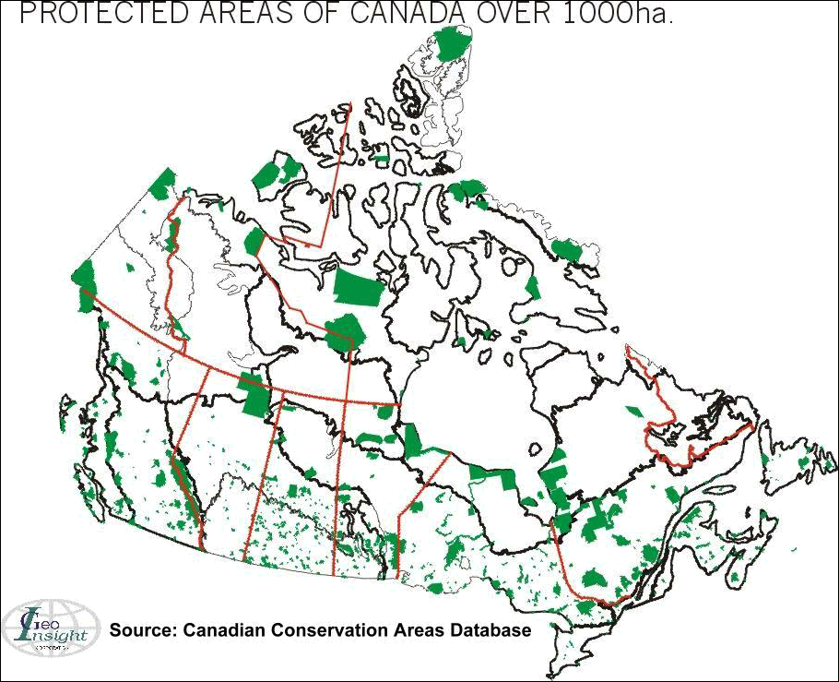

File Menu
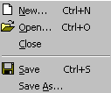


New – Starts a new presentation
Open – Opens a pre-existing presentation
Save – Saves your current (open window)
Presentation
Save As – Allows you to save your current
presentation with a new file name.

Edit Menu

Select All – Allows you to select all the items on the screen
Cut – Allows you to cut an item from your presentation and places that item on the clipboard
Paste – Allows you to paste a previously cut or copied item into you presentation
Delete Slide – Allows you to delete the current slide



View Menu

Slide – Views the current slide
Slide Sorter – Views all slides in a
negative sheet format
Master – Allows you to make changes
that affect the entire presentation (Slide Master)


Insert Menu
New Slide – Inserts a new slide into your presentation
Picture – Inserts a picture into your presentation


Format Menu

Font – Change your font size, colour, and style
Apply Design – Allows you to apply a design style to your presentation (use with Slide Master)



Slide Show Menu

View Show – Allows you to view you Slide Show
Action Buttons – Allows you to add video, sound, and link buttons to your presentation
Custom Animation – Allows you to animate the objects in a slide
Slide Transition – Allows you to affect slide transition

*(All are thanks to Mr. Jon Greer, Educational Technology Integrator, OCDSB, for giving us the permission to use this PowerPoint Cheat Sheet)

PowerPoint

Action Buttons – Action buttons allow you to create a button that links your slide show to sounds, movies, the web, and other files.

Slide Show | Action Buttons | Select appropriate button and set Action Settings for that button

Action Settings – Action settings are the settings used to assign an action to a button.

Click on object that requires action settings change | Slide Show | Action settings

Applying a design – Applying a design to your presentation creates a theme that encompasses all slides in the presentation

View | Master | Slide Master | Format | Apply Design | Select a Design and click OK. To return to your slide editing screen (View | Slide).

Changing Text – Click on the Text Box and use keyboard to edit

Custom Animation – Allows you to animate objects on the screen. Using this option allows you to make pictures and words fly onto the screen in a number of ways.

- Slide Show | Custom Animation | Click on Objects without Animation in the timing tab, and select animate button. The object gets moved into the animation order. Repeat for all objects requiring animation.
- To switch animation order, select the item in the animation order and use the turquoise arrows to move the object up or down in the order.
- To change the animation effect, select the desired item, and click on the Effects tab. You can now change the Entry animation
- To preview animations, click the preview button.

Editing your picture – Click on the picture | Format | Object or Picture

Inserting a New Slide – Insert | New Slide

Inserting a Picture – Insert | Picture | From Clip Art (use Clip Art Library) or From File (to use your own saved images)

Inserting Text Box – Insert | Text Box

Moving Text – Click on the text. Position the mouse pointer over the gray selection box to make the pointer change to a 4-way arrow. Hold down mouse button and drag text to desired location. Release mouse button to place text in new location.

Saving – File | Save As… | Save your File in the desired location
Starting a New Presentation – File | New

Slide Transition – Changes the way that slides switch from slide-to-slide

- Slide Show | Slide Transition | Choose your effect
- Apply to All affects every slide in your presentation. Apply only affects the way the current slide moves to the next slide.

Views

- Slide – View used to edit your slides
- Sorter – Provides a contact sheet of all slides in the presentation
- Notes – Allows you to enter and edit presentation notes
- Master | Slide Master – Allows you to make global changes to your presentation. This slide acts as a template for your entire presentation

Viewing your show – Slide Show | View Show

*(All are thanks to Mr. Jon Greer, Educational Technology Integrator, OCDSB, for giving us the permission to use this PowerPoint and Planning Sheets)

1
2
3
4
5
6
7
8

9
10
11
12
13
14
15
16

17
18
19
20
21
22
23
24

Conservation & Protected Areas of Canada

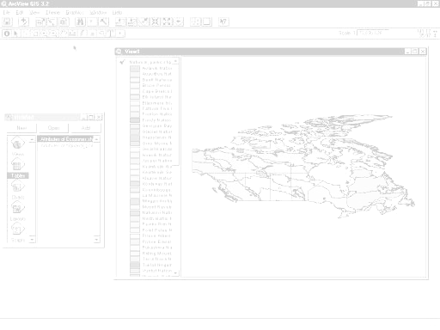
Using Data Tables
Using Data for Quantile Calculations
Querying Linked Data on a Map
Computing New Data
Displaying Data with Charts

ArcView Lesson

GIS Background Information

Here's a list and explanation of important features in ArcView:

Project: In ArcView, a file for organizing your work. Projects use five types of
documents to organize information: views, tables, charts, layouts, and scripts.

View : A component of an ArcView project used for displaying, querying, and
analyzing geographic themes.

Table of Contents: All themes in a View are listed to the left of the map. The Table of
Contents shows the symbols used to draw features in each theme. The check box next to each theme indicates whether or not it is turned on or off in the map (whether it is currently drawn on the map).

Theme: A set of related geographic features, such as streets, parcels, or rivers, and the
characteristics (attributes) of those features.

Tables : Information formatted in rows and columns. A component of an ArcView
project used for displaying tabular data.

Layout : The design or arrangement of elements in a digital map display or printed
map. A component of an ArcView project used for creating presentation-quality maps.

Hotlink: In ArcView, a way to display data (for example, a file, image, ArcView
document, or project) directly from a view, by clicking on a feature.

ArcView Buttons Reference Guide

View - Buttons
 | Save Project |  | Add Theme |  | Theme Properties | Edit Legend | Open Theme Table |  | Find | Locate Address | Query Builder |  | Zoom to Full Extent | Zoom to Active Theme | Zoom to Selected | Zoom In | Zoom Out | Zoom to Previous Extent |  | Select Features using Graphics | Clear Selected Features |  | Help

View – Tools
 | Identify | Pointer | Vertex Edit | Select Feature | Zoom In | Zoom Out | Pan | Measure | Hot Link | Area of Interest | Label | Text |  | Drawing and Editing Tools |  |  | Scale |  |  | Coordinates

Push and hold to select tool
Point
Line
Polyline
Rectangle
Circle
Polygon
Line Split
Polygon Split
Auto Complete

Table - Buttons
 | Save Project |  | Cut | Copy | Paste |  | Select All | Select None | Switch Selection |  | Create Chart |  | Find | Query Builder | Promote | Join |  | Summarize | Calculate |  | Sort Ascending | Sort Descending | Help

Table - Tools
Record Counter | Select Tool | Edit Tool | Identify Tool

Chart - Buttons
 | Save Project |  | Undo Erase |  | Area Chart Gallery | Bar Chart Gallery | Column Chart Gallery | Line Chart Gallery | Pie Chart Gallery | Scatter Chart Gallery | Chart Properties | Series From Records/Fields | Find | Help

Chart - Tools
Identify Tool | Erase Tool | Erase Within Polygon Tool | Chart Element Properties Tool | Chart Colour Tool

Layout - Buttons
Save Project | Cut | Copy | Paste | Layout Properties | Group | Ungroup | Bring to Front | Send to Back | Undo | Zoom to Page | Zoom to Actual Size | Zoom to Selected | Zoom In | Zoom Out | Print | Help

Layout - Tools
 |  | Pointer Tool | Vertex Tool | Zoom In Tool | Zoom Out Tool | Pan Tool | Text Tool | Drawing Tools |  | Frame Tools

Push and hold to select tool
View Frame
Legend Frame
Scale Frame
North Arrow Frame
Chart Frame
Table Frame
Picture Frame

For more information: www.esricanada.com
Getting Started

Before you begin, the Parks lesson data folder must be copied into a drive in which you the student has writing and editing capabilities. To do this use My Computer / Windows Explorer / or a file manager program. This will probably be the drive containing your own personal account on the school’s system or the C: drive of the machine you are currently working on. If the latter is the case you will have to work on the same machine each day until this assignment is complete.

Once the Park’s data folder has been copied to the required destination you will have to 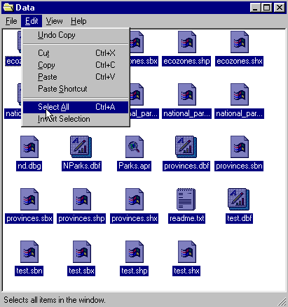follow the following instructions closely to prepare the data for use:

1. Open your new Park’s data folder
2. Choose edit > select all (they will all appear Blue)

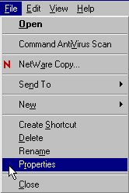
3. From the menu choose:
File > Properties

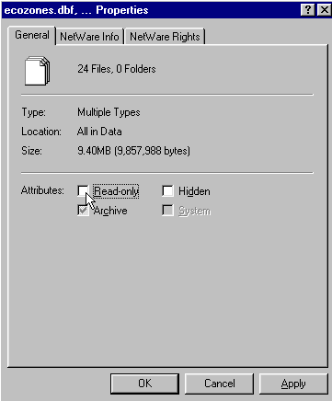
4. Remove the check mark in the
box beside the label read only.
- Click apply, then OK

The data in your parks data folder can now be opened edited and saved using ArcView to carry out the following project.

! Denotes an observation.
? Denotes a question to be answered on the Student Activity Sheet.
Starting the Project

The purpose of this lesson is to learn how to use data tables to display information in a meaningful way as map and chart presentations.

STARTING Arc View

Begin by starting up the Arc View program.

1. Open Arc View.
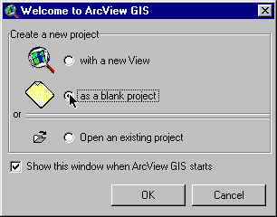
2. Click as a blank project.
3. Click O.K.

The Arc View program will launch. If necessary, click the window maximize button so that the Arc View window fills the screen.

When the program starts, it automatically opens a project window titled "Untitled."
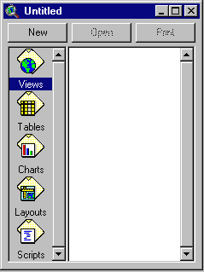

Arc View uses projects to group together and organize maps that are used together. A project has now been created for you to use with this activity.

4. Click the window maximize button on the project window.

5. Start a new view by clicking New while “Views” is highlighted.
If necessary, click the window maximize button to maximize the view window.

6. Click Add theme button and use the shift key to select from the data folder just created:

National_Parks.shp
Ecozones.shp
Provinces.shp

7. Click O.K.

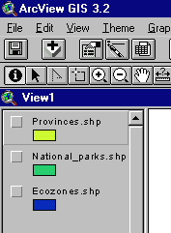
This will add these three themes to the table of contents of the new view. They are now available for display and editing.

8. Click and drag the Province.shp theme down to the bottom of the table of content.

9. Check mark the Provinces theme to make it visible.


10. Check mark the National Parks theme to make it visible.

ARCVIEW - DISPLAYING MAP LEGENDS

1. Double click National Parks theme.

By changing the colour ramp on a legend from shades of a single colour to a full spectrum, we can better distinguish the classes.

2. From legend editor box, click legend type list, select graduated colour.
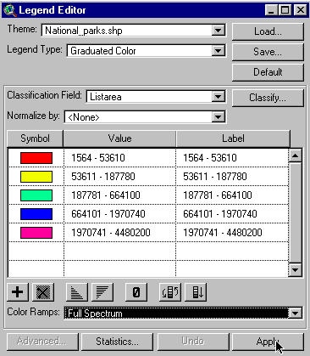
3. Click classification field list, select listarea.
4. Click colour ramp list, select full spectrum.
5. Click apply and close the legend editor window.

The National Parks are now grouped into classes based on area.

? Does this make it easier to see the classes?


6. Un-check province theme.

? Can you see the parks better?
What can you say about size distribution of the parks?
What is the reason for this pattern?

ARCVIEW - USING DATA TABLES ATTACHED TO A MAP

Using data tables, we will use the link between the tables and the map to identify national parks.

1. Check mark the provinces theme again.
2. Click the zoom in tool.
3. Click and hold down the left mouse button and draw a box around the Atlantic Provinces
4. Click on National Park theme in the table of contents to make it active (the theme will now appear raised).
5. Click the identify tool.
6. Place the cursor over one of the parks and click the left mouse button.

! Note the information table for the selected park.

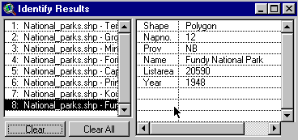
7. Check each park in Nova Scotia, New Brunswick, Prince Edward Island and Newfoundland to build an identify results table. You should find 8.
8. Turn off the province theme to find the two small ones (1 PEI, 1 NS).
9. Click each park listed in the left-hand table.
- Record the name and listarea for each park.

? Fill in Table 1 for the Atlantic Provinces. List the name and the area of the Parks in the table provided. Start with the largest park and list in descending order to the smallest park.
Use the listarea to compare sizes.

? Perform the same test on a different area of Canada. Record these results in table 2.

ARCVIEW - USING DATA FOR QUANTILE CALCULATIONS

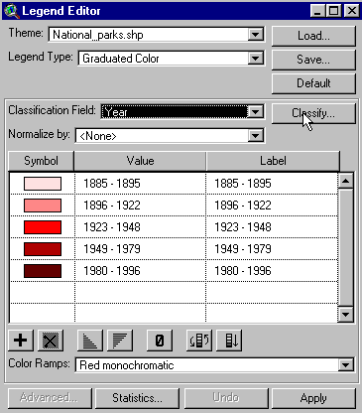By looking at year of establishment data, we will conclude where parks were first established and the pattern of new park designations.

1. Close the identify results window.
2. Click zoom to full extent button.
Double click National Parks theme.

3. Open classification field list, select year.
4. Click classify button.

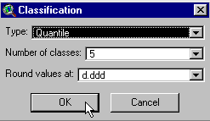
5. Open type list, select quantile.

6. Click O.K.
7. Open colour ramp list, select full spectrum.
8. Choose Apply and close the legend editor window.

9. Turn off provinces theme

? Where are most of the new parks? Why?

10. Turn the province theme on to identify the province into which they fall.

11. Make the National_Parks.shp theme your active theme by clicking on it once. You should now see it raised.

12. Click open theme/ table button

13. Click the title of the year field to select it

14. Click sort ascending button to arrange the records in ascending order by year of establishment.

? Which is the oldest national park and when was it established?
Which are the newest national parks and when were they established?

! Note that those parks that are reserves do not have establishment dates. Also note that park names are listed several times, once for each polygon within the park. (Park areas are sometimes cut by lakes or rivers or contain islands, creating several polygons to depict a single park).

15. Close table window.
16. Turn off the National Parks theme and province theme

ARCVIEW - QUERYING LINKED DATA ON A MAP


Now that we can display data through colours on a map, we will learn to query additional data linked to a map.
1. Open Ecozone theme alone by clicking to make it visible.
2. Double click Ecozone theme to edit.

3. Open legend type list, select graduated colour.
4. Open classification field list.
5. Select %conservat field (this is the percent of ecozone area covered by all conservation area types).
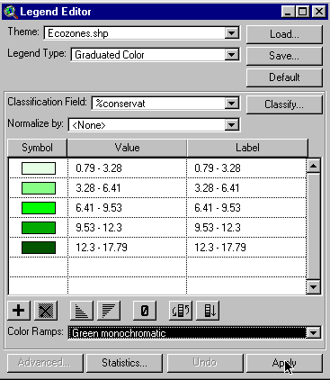6. Open colour ramp list, select green monochromatic.
7. Click apply.

8. Close edit legend window.
9. Click identify button and build an identify results table for selected ecozones. To select more than one Ecozone hold down the shift button as you select ecozones. Note that each Ecozone that you click on the left side of the table has a table of its own that shows on the right side with data about it. Look here to answer the questions below.

? Which three ecozones have the highest percent total conservation area?
Which two have the lowest?

ARCVIEW - COMPUTING NEW DATA

We will take data we have on national parks and total protection to calculate the amount of conservation area in each ecozone that is not a national park.

1. Make the ecozones.shp theme your active theme (it will appear raised).
2. Click open theme/ table button.
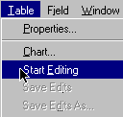
3. From the menu select table.
4. Select start editing.

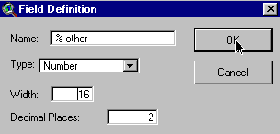
5. Click menu edit.
6. Select add field.
7. Change name to %other.
8. Change decimal place to 2.
9. Click O.K.

10. Click calculate button.
11. Build expression to create the mathematical equation to calculate the % conservation area minus the % national park area by selecting field, double click %conservat, then choose requests, double click - double click field %National . See the expression created.
12. Click O.K.
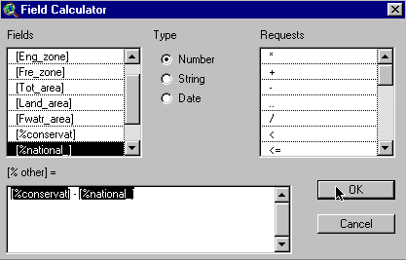

13. Click menu table.
- Select stop editing.
15. Click yes to save edits.
- Close table window.

ARCVIEW - DISPLAYING DATA WITH CHARTS

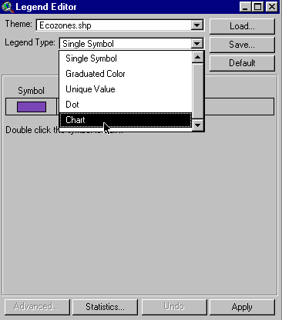
1. Double click ecozone theme.
2. Open legend type list.
3. Select chart.

4. Click %National field.
5. Click add.
6. Repeat for %other field.
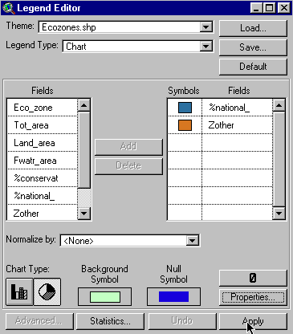
7. Click pie chart type.
8. Double click background symbol and change colour to a light shade by clicking on paintbrush and selecting a new colour.
9. Click properties button.
10. Change maximum size to 16.
11. Click O.K.
12. Click apply.
13. Close legend edit window and colour palette window.

14. Click on identify button.

! Note that only one chart is applied to each ecozone, therefore ecozones with more than one polygon, such as Taiga Shield, have non-assigned areas.

? Find the name of the ecozone with all of its conservation area represented by national parks.
? Find the name of the ecozone with has very little national park representation. Based on this analysis, which ecozone should be considered for new national parks?

! You have completed your examination of National Parks and Conservation Areas. Now create a layout for printing from any section of this analysis or create your own analysis for printing.

ArcView - Map Layout for printing

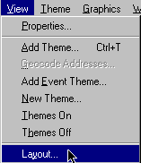
Once you have a map classified and displayed to your satisfaction, you should prepare a map layout that can be used for printing. The purpose of this lesson is to set up your map on a page and annotate it for presentation.

Set up map

1. Click menu view,
2. Click layout

3. Select the layout template you want to use (one of the landscape templates is suggested)
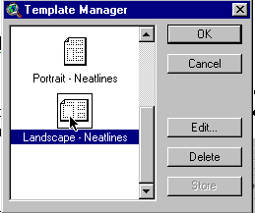

4. Click O.K.
5. Maximize layout screen

EDIT TITLE

1. Double click on the title View1
2. Edit the title to reflect the purpose of the map, e.g., forestry, and population
3. Click O.K.
4. Resize the title using the corner handles and move it into a position that is visually balanced
5. Reposition legend if necessary.

EDIT NORTH ARROW

1. Double click on the north arrow and select a different presentation. Ensure that that the arrow is pointing in the representative north direction of the map
2. Reposition or rotate (using rotation function) as needed

EDIT SCALE BAR

1. Double click scale bar
2. Choose a new style of scale bar
3. Change the units to be used
4. Change the number of scale units to be used
5. Change the number of unit divisions on the left of the scale to be used.
6. Find a combination of style, scale and divisions that is visually pleasing
7. Position to an appropriate location.

ADD LABELS, TEXT, OTHER INFORMATION

1. Click on the text tool
2. Click at the position on your layout where you want the text to appear
3. In the text properties box, enter your text, e.g., “produced by (your name, date)”
4. Select desired formatting information such as alignment, spacing and rotation
5. Click O.K. when it appears, as you want it
6. Click on pointer tool
7. Point to new text
8. Click once to change location or size, Click twice to change content

! Experiment with all of the components of the layout until you have the look you want.

CHANGE THE NAME OF THE LAYOUT

1. Click menu layout
2. Select properties
3. Change the “name”, Click O.K.

ARRANGING YOUR LAYOUT

! Experiment with the layout buttons (use the tools page provided at the beginning of this lesson)
- to group (tie pieces together so they move as one)
- to ungroup (break apart the ties so that individual pieces move)
- bring to front (change order that pieces were laid down, e.g. lines on top of polygons)
- send to back (change order that pieces were laid down, e.g., polygons behind lines)
- zoom (make image bigger or smaller)
- neat line (border around layout)

PRINT MAP LAYOUT

1. Click print button
2. Click setup
3. Select your printer properties as outlined by your teacher
4. Click O.K. to print

! Note that the map can also be saved to a printer file.

Canada’s Parks and Conservation Areas
Arc View Parks Student Activity Sheet

Name:

*Answers to the following questions can be obtained while completing the ArcView Canada’s Parks and Conservation Areas.

- Does this make it easier to see the classes?

- Can you see the parks better?

- What can you say about size distribution of the parks? What is the reason for this pattern?

- Fill in table 1 for the Atlantic Provinces. List the name and the area of the Parks in the table provided. Start with the largest park and list in descending order to the smallest park.

Table 1
National Park Name | National Park Area / Km sq.

- Perform the same test on a different area of Canada. Record these results in table 2.

Table 2
National Park Name | National Park Area / Km sq.

- Where are most of the new parks located? Why?

- Which is the oldest national park and when was it established?

- Which are the newest national parks and when were they established?

- Which three ecozones have the highest percentage total conservation area?

- Which two have the lowest?

- Find the name of the ecozone with all of its conservation area represented by national parks.

- Find the name of the ecozone, which has very little national park representation?

- Based on this analysis, which ecozone should be considered for new national parks and why?

