Canada's Population Trends

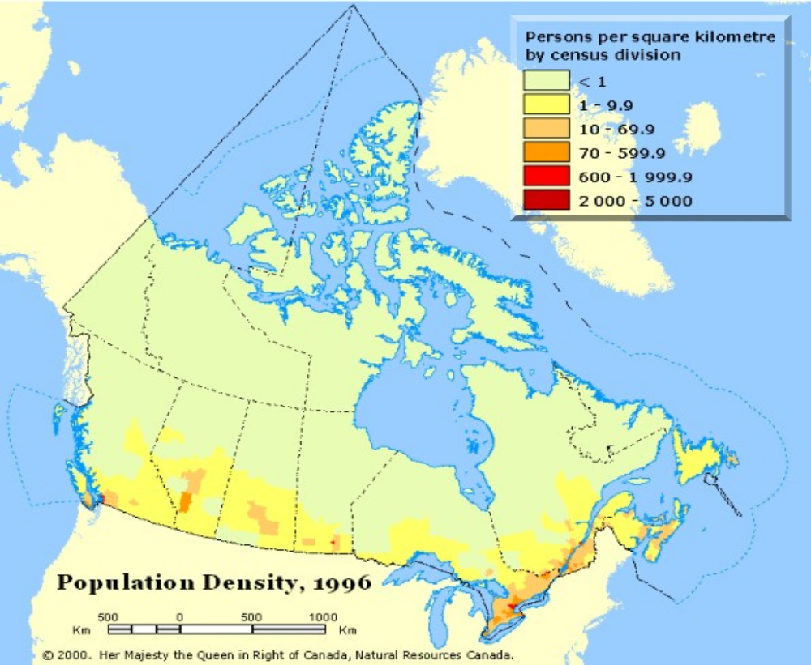



Table of Contents

Section Page

Lesson Objectives 3

Curriculum Expectations 3

Teacher Package (Academic Lesson) 4

Teacher Package (Applied Lesson) 5

Academic Performance Task, Expectations and Rubric 6

Applied Performance Task, Expectations and Rubric 8

Canada’s Population Trends 10

Ecozone map of Canada 13

Canada’s Population Trends Student Activity Sheets 14

Canada’s Population Trends Internet Resources 18

Canada’s Population Trends – ArcView Lesson 19

Canada’s Population Trends – ArcView Lesson Student Activity Sheets 36

Canada’s Population Trends

Lesson Objectives

- Explore the population distribution and trends in Canada.
- Focus on the population make-up of the Ecozones of Canada.
- Study the population characteristics of major population centers in Canada.
- Explore the Internet for population data.
- Download georeferenced population data from E-STAT (Statistics Canada)
- Produce vector maps showing the population characteristics of Ecozones.
- Download and join data tables and use new data to map Census Divisions.
- Map projections.
- Map classification.
- Map preparation and layout.

Curriculum Expectations

The Ontario grade 9 curriculum expectations were used as a basis for preparing the lessons in this series. Although there is no direct correlation between Ontario expectations and other provinces, in general, the issues covered in the lessons do relate to many of the curriculum requirements in other jurisdictions. The full curriculum expectations can be found at the Ontario Ministry of Education Web site

English http://www.edu.gov.on.ca/eng/document/curricul/secondary/canadian/canaful.html
French http://www.edu.gov.on.ca/fre/document/curricul/secondary/canadian/canaful.html

The performance tasks for Grade 9 Academic were based directly on curriculum expectations selected from the policy document for Canadian and World Studies. The tasks encompassed the four categories of knowledge and skills (i.e., Knowledge/Understanding, Thinking/Inquiry, Communication, and Application), requiring students to integrate their knowledge and skills in meaningful learning experiences.

The rubric for a specific performance task is intended to provide teachers and students with an overview of the expected final product with regard to the knowledge and skills being assessed as a whole. The rubric identifies key criteria by which the students’ work is to be assessed, and it provides descriptions that indicate the degree to which the key criteria have been met. The teacher can use the descriptions of the different levels of achievement given in the rubric to assess student achievement on a particular task.

Teacher Package

Academic Lesson

Title: Canada’s Population Trends Newspaper Article

Time requirement: Prior learning and skill development:
1 period of 70 minutes each
ArcView lesson:
1 to 2 periods of 70 minutes each
Student research and proposal writing:
1 to 2 periods of 70 minutes each

Teacher Instructions:
- Description of the Task
(see Academic Performance Task, Expectations and Rubric).

- Final Product
Each student is asked to produce a newspaper article to explain one of the patterns they encountered during their inquiry on population trends. The article should attempt to explain and predict the changing nature of Canada’s demographics. Their article should conclude by suggesting ways to prepare for the future. It should also include supporting visuals, such as maps, graphs, charts, diagrams or pictures.

- Assessment and Evaluation
The final product will be assessed using the Expectations and the Performance Task Rubric. Formal and informal assessment of the students based on prior knowledge, lesson objectives, production of their ArcView Map; research process using the Background Information, the students’ activity sheets (on the Background and on the ArcView lesson), and the Rubric for assessing Maps. In this lesson, students are going to investigate thoroughly E-STAT via Statistics Canada's web site at www.statcan.ca. Self- or peer assessments and collaboration may be useful to the teacher and students.

- Accommodations
Accommodations that are normally provided in the regular classroom for students with special needs should be provided in the administration of this performance task.

- Rubric
Introduce the task-specific rubric to the students before giving the administrative task. Review the rubric with the students and ensure that each student understands the criteria and descriptions for achievement at each level.
Some students may perform below level 1. It will be important to note the characteristics of their work in relation to the criteria in the assessment rubric and to provide feedback to help them improve.

Teacher Package

Applied Lesson

Title: Canada’s Population Trends Headlines

Time requirement: Prior learning and skill development:
1 period of 70 minutes each
ArcView lesson:
1 to 2 periods of 70 minutes each
Computer Presentation
1 to 2 periods of 70 minutes each

Teacher Instructions:
- Description of the Task
(see Applied Performance Task, Expectations and Rubric)

- Final Product
Students are asked to produce article headlines to explain patterns they encountered during their inquiry on population trends. Their headlines should attempt to explain and predict the changing nature of Canada’s demographics. A description should accompany their headlines and should suggest future population trends. Students are instructed to include supporting visuals, such as maps, graphs, charts, diagrams or pictures to support their headlines.

- Assessment and Evaluation
The final product will be assessed using the Expectations and the Performance Task Rubric. Formal and informal assessment of the students based on prior knowledge, lesson objectives, production of their ArcView Map; research process using the Background Information, the students’ activity sheets (on the Background and on the ArcView lesson), and the Rubric for assessing Maps. In this lesson, students are going to investigate thoroughly E-STAT via Statistics Canada's web site at www.statcan.ca. Self- or peer assessments and collaboration may be useful to the teacher and students.

- Accommodations
Accommodations that are normally provided in the regular classroom for students with special needs should be provided in the administration of this performance task.

- Rubric
Introduce the task-specific rubric to the students before giving the administrative task. Review the rubric with the students and ensure that each student understands the criteria and descriptions for achievement at each level.
Some students may perform below level 1. It will be important to note the characteristics of their work in relation to the criteria in the assessment rubric and to provide feedback to help them improve.

Academic Performance Task, Expectations and Rubric

The Task
Students begin by examining various aspects of Canada’s population. The initial inquiry explores population distribution, density, migration, and immigration patterns and explores urban versus rural areas. Following the initial exploration students are to access the data available on the Statistics Canada web site. From this site a vast variety of data can be accessed. These data are to be used to formulate a geographical inquiry into Canada’s demographics. Students are asked to produce a newspaper article to explain one of the patterns they encountered during their inquiry. The article should attempt to explain and predict the changing nature of Canada’s demographics. The report should conclude by suggesting ways to prepare for the future. Students are instructed to include supporting visuals, such as maps, graphs, charts, diagrams, or pictures, in the article.

Expectations
This task gives students the opportunity to demonstrate achievement of the following selected expectations from three strands: Geographic Foundations: Space and Systems; Understanding and Managing Change; and Methods of Geographic Inquiry.

Students will:

- identify and analyse patterns of spatial organization, including land use, population distribution, and ecozones;
- identify patterns of migration within Canada, and between Canada and other countries;
- analyse statistical data on population density to identify trends and variations;
- identify and explain the regional distribution patterns of various peoples across Canada (e.g., Aboriginal peoples, francophones, immigrant groups);
- demonstrate an understanding of the factors influencing demographics and migration in Canada;
- demonstrate an understanding of the methods used to collect, organize, manipulate, and interpret geographic data;
- locate and use effectively geographic material from primary sources (e.g., field research, surveys, interviews) and secondary sources (e.g., mainstream and alternative media, CD-ROMs, Internet) to research a geographic issue;
- select and use appropriate methods for displaying geographic data;
- create and use effectively photographs, charts, graphs, models, and diagrams;
- use geographic data to support conclusions and opinions.

Prior Knowledge and Skills
To complete this task, students are expected to be able to demonstrate the following:

- knowledge of the definition of an ecozone
- knowledge of some of Canada’s ecozones and their physical characteristics (e.g. landforms, climate, vegetation, and soils)
- interpret and use population pyramids
- identify the causes of immigration and emigration
- understanding of research methods using a variety of source materials
- ability to read, analyse, and interpret graphs and maps
- ability to use a variety of tools and technologies for research

Task Rubric – Canada’s Population Trends Newspaper Article

Expectations |  |  | Criteria |  |  | Level 1 (50 – 59) |  |  | Level 2 (60 –69) |  |  | Level 3 (70 – 79) |  |  | Level 4 (80-100)

Knowledge / understanding
5,6 |  | - Demonstrate an understanding of the factors influencing demographics and migration in Canada  - Demonstrate an under-standing of the method used to collect, organize, manipulate, and interpret geographic data |  |  | - Demonstrates little understanding of the factors influencing demographics and migration in Canada  - Demonstrates little understanding of the methods used with geographic data |  |  | - Demonstrates some understanding of the factors influencing demographics and migration in Canada  - Demonstrates some understanding of the methods used with geographic data |  |  | - Demonstrates considerable understanding of the factors influencing demographics and migration in Canada  - Demonstrates considerable understanding of the methods used with geographic data |  |  | - Demonstrates a high degree of understanding of the factors influencing demographics and migration in Canada  - Demonstrates a high degree of understanding of the methods used with geographic data

Thinking / Inquiry
1,2,3,10 |  | - Identify and analyse patterns of population distribution and migration  - Analyse statistical data on population density to identify trends and variations  - Use geographic data to support conclusions and opinions |  |  | - Shows little analyses of population distribution and migration patterns  - Shows little analyses on population density to identify trends and variations  - Few uses of geographic data to support conclusions and opinions |  |  | - Shows some analyses of population distribution and migration patterns  - Shows some analyses on population density to identify trends and variations  - Some uses of geographic data to support conclusions and opinions |  |  | - Shows considerable analyses of population distribution and migration patterns  - Shows considerable analyses on population density to identify trends and variations  - Considerable uses of geographic data to support conclusions and opinions |  |  | - Shows a high degree of analyses of population distribution and migration patterns  - Shows a high degree of analyses on population density to identify trends and variations  - Uses geographic data to support conclusions and opinions at a higher degree of inquiry

Communication
8,9 |  | - Select and use  appropriate methods for displaying geographic data  - Create and use effectively photographs, charts and graphs |  |  | - Uses few methods for displaying geographic data  - Uses few visuals |  |  | - Uses some methods for displaying geographic data  - Uses some visuals |  |  | - Uses many methods for displaying geographic data  - Uses many visuals |  |  | - Uses many appropriate methods for displaying geographic data  - Uses many visuals with purpose

Application
4 |  | - Identify and explain the regional distribution patterns of various peoples across Canada |  |  | - Identifies and explains little regional distribution patterns |  |  | - Identifies and explains some regional distribution patterns |  |  | - Identifies and explains effectively regional distribution patterns |  |  | - Identifies and explains at a high degree regional distribution patterns

Applied Performance Task, Expectations and Rubric

The Task
Students begin by examining various aspects of Canada’s population. The initial inquiry explores population distribution, density, migration, and immigration patterns and explores urban versus rural areas. Following the initial exploration students are to access the data available on the Statistics Canada web site. From this site a vast variety of data can be accessed. These data are to be used to formulate a geographical inquiry into Canada’s demographics. Students are asked to produce article headlines to explain patterns they encountered during their inquiry. Their headlines should attempt to explain and predict the changing nature of Canada’s demographics. A description should accompany their headlines and should suggest future population trends. Students are instructed to include supporting visuals, such as maps, graphs, charts, diagrams, or pictures to support their headlines.

Expectations
This task gives students the opportunity to demonstrate achievement of the following selected expectations from three strands: Geographic Foundations: Space and Systems; Understanding and Managing Change; and Methods of Geographic Inquiry.

Students will:

- identify and evaluate patterns of spatial organization, including land use, population distribution, and ecozones;
- explain how population patterns reflect cultural diversity;
- analyse statistical data on migration within Canada and between Canada and other nations, to identify migration patterns;
- explain variations in population density and relate overall population patterns to those variations within the local region;
- describe the factors (e.g., regional economic disparities) influencing demographics and migration in Canada;
- demonstrate an understanding of the methods used to collect, organize, manipulate, and interpret geographic data;
- use effectively geographic material from primary sources (e.g., field research, surveys, interviews) and secondary sources (e.g., mainstream and alternative media, CD-ROMs, Internet) effectively and appropriately when researching a geographic issue;
- select and use appropriate methods for displaying geographic data;
- create and use effectively photographs, charts, graphs, models, and diagrams.

Prior Knowledge and Skills
To complete this task, students are expected to be able to demonstrate the following:

- knowledge of the definition of an ecozone
- knowledge of some of Canada’s ecozones and their physical characteristics (e.g. landforms, climate, vegetation, and soils)
- interpret and use population pyramids
- identify the causes of immigration and emigration
- understanding of research methods using a variety of source materials
- ability to read, analyse, and interpret graphs and maps
- ability to use a variety of tools and technologies for research

Task Rubric – Canada’s Population Trends Headlines

Expectations |  |  | Criteria |  |  | Level 1 (50 – 59) |  |  | Level 2 (60 –69) |  |  | Level 3 (70 – 79) |  |  | Level 4 (80–100)

Knowledge / understanding
1,6 |  | - Identify and evaluate patterns of population distribution  - Demonstrate an understanding of the methods used to collect, organize, manipulate, and interpret geographic data |  |  | - Identifies and evaluates few patterns of population distribution  - Demonstrates little understanding of the methods used with geographic data |  |  | - Identifies and evaluates some patterns of population distribution  - Demonstrates some understanding of the methods used with geographic data |  |  | - Identifies and evaluates several patterns of population distribution  - Demonstrates considerable understanding of the methods used with geographic data |  |  | - Identifies and evaluates at a high degree patterns of population distribution  - Demonstrates a high degree of understanding of the methods used with geographic data

Thinking / Inquiry
2,3,4 |  | - Explain cultural diversity through population patterns  - Analyse statistical data on migration within Canada  - Explain variations in population density and relate to overall population patterns |  |  | - Explains poorly cultural diversity through population patterns  - Analyses poorly statistical data on migration within Canada  - Explains poorly variations in population density and relates to overall population patterns |  |  | - Explains adequately cultural diversity through population patterns  - Analyses adequately statistical data on migration within Canada  - Explains adequately variations in population density and relates to overall population patterns |  |  | - Explains well cultural diversity through population patterns  - Analyses well statistical data on migration within Canada  - Explains well variations in population density and relates to overall population patterns |  |  | - Explains accurately cultural diversity through population patterns  - Analyses accurately statistical data on migration within Canada  - Explains accurately variations in population density and relates to overall population patterns

Communication
8,9 |  | - Select and use appropriate methods for displaying geographic data  - Create and use effectively photographs, charts and graphs |  |  | - Uses few methods for displaying geographic data  - Uses few visuals |  |  | - Uses some methods for displaying geographic data  - Uses some visuals |  |  | - Uses many methods for displaying geographic data  - Uses many visuals |  |  | - Uses many appropriate methods for displaying geographic data  - Uses many visuals with purpose

Application
5 |  | - Describe the factors influencing demographics and migration in Canada |  |  | - Describes poorly the factors influencing demographics and migration in Canada |  |  | - Describes adequately the factors influencing demographics and migration in Canada |  |  | - Describes well the factors influencing demographics and migration in Canada |  |  | - Describes accurately the factors influencing demographics and migration in Canada

Canada’s Population Trends

Population is defined as the number of people occupying a given area. Population statistics are collected every five years in Canada by a national Census. Census takers used to go door-to-door and ask each household a variety of questions related to the number of persons in a household, age, occupation, family income, ethnic background and so forth. In more recent years, census questionnaires are sent out by mail in most areas that are accessible by postal service. Statistics questions have increased to include counts on possessions such as number of appliances, cars, electronic equipment and more. Other data collected are statistics on commercial trade import and export and transportation. Farm statistics collect information from the number of animals raised to the amount spent on fertilizer.

Although it may seem invasive for the government to question you on your personal information, census information is legislated by government to protect your personal privacy. Not even Revenue Canada or the RCMP can access individual information. Names and addresses are collected only to insure that all persons and households are included and not entered more than once. This specific information is not included in the database. Data that is collected is grouped and averaged for a census plot of many individuals so that information becomes representative and not specific.

The collected data is important to the government for: planning social programs such as Old Age Security and Child Tax Benefits; municipal services to establish schools and day-care centres; determining the extent of social and physical disabilities within the population; determining migration patterns; planning post-secondary and adult education programs; developing job creation programs; identifying specific geographic areas that need social assistance; determining areas that require housing programs.

Once the data is amalgamated to a minimal census plot, some of the information is made available to the public. Population is one of the databases that is accessible by all Canadians. We shall focus on the personal aspect of the population of Canada, i.e., number of people, dwellings, income, education, and so forth.

Population numbers tell us how many people are in a given area, but not all areas are equal in size. To make figures comparable, a population density is calculated which tells us the average number of people in a square kilometer. This allows us to compare population data at different levels by grouping the information collected in the census plots within the area of a municipality, province or ecozone respectively. If we look at Table 1, we see that densities vary greatly across the ecozones and show variations between Census years 1971 through 1991. Let's look at these five Census years and find a population trend, that is, the direction in which an ecozone population is going: increasing, decreasing or remaining relatively constant.

Table 1: Density Table for five Census years for each Ecozone

Ecozone names | Census 1971 | Census 1976 | Census 1981 | Census 1986 | Census 1991
Arctic Cordillera | 0.00654 | 0.00852 | 0.00636 | 0.00717 | 0.00812
Northern Arctic | 0.00830 | 0.00928 | 0.01036 | 0.01237 | 0.01425
Southern Arctic | 0.00598 | 0.00847 | 0.01142 | 0.01312 | 0.01447
Taiga Plains | 0.02725 | 0.03163 | 0.03247 | 0.03608 | 0.03790
Taiga Shield | 0.02122 | 0.02228 | 0.02463 | 0.02179 | 0.02724
Boreal Shield | 1.45452 | 1.53008 | 1.56236 | 1.36554 | 1.61978
Atlantic Maritime | 11.39533 | 11.82850 | 12.17778 | 12.40204 | 12.60761
Mixedwood Plains | 99.19291 | 105.30327 | 109.51450 | 114.93109 | 126.05242
Boreal Plains | 0.83814 | 0.91238 | 0.98912 | 1.01917 | 1.04216
Prairies | 6.40050 | 6.02559 | 7.68121 | 8.07801 | 8.44914
Taiga Cordillera | 0.00086 | 0.00089 | 0.00224 | 0.00212 | 0.00123
Boreal Cordillera | 0.04454 | 0.05329 | 0.05728 | 0.05723 | 0.06664
Pacific Maritime | 8.30110 | 9.16502 | 10.11289 | 10.83429 | 12.57036
Montane Cordillera | 1.06337 | 1.29732 | 1.46408 | 1.45934 | 1.31850
Hudson Plains | 0.02719 | 0.02528 | 0.02425 | 0.01721 | 0.02689

Population data can be assessed in different ways. Population density was compared above. From Table 2 below, we will learn how density values are calculated and how ratios can be used to show us information we might have missed.

Table 2:How do we calculate densities and ratios?

Ecozone Names | Land Area (km2) | Population  1996 | No. of dwellings  1996 | Density  (pop./area) | No. persons/ dwelling
Arctic Cordillera | 236309 | 1196 | 266 | ? | ?
Northern Arctic | 1338353 | 18881 | 4825 | ? | ?
Southern Arctic | 645355 | 11729 | 2892 | ? | ?
Taiga Plains | 549116 | 23986 | 7632 | ? | ?
Taiga Shield | 1077604 | 36560 | 10565 | ? | ?
Boreal Shield | 1620871 | 2894961 | 1082951 | ? | ?
Atlantic Maritime | 196691 | 2549061 | 963871 | ? | ?
Mixedwood Plains | 109779 | 14840411 | 5626811 | ? | ?
Boreal Plains | 664274 | 745172 | 259095 | ? | ?
Prairies | 454046 | 3979522 | 1499905 | ? | ?
Taiga Cordillera | 260373 | 358 | 128 | ? | ?
Boreal Cordillera | 450921 | 30324 | 11386 | ? | ?
Pacific Maritime | 201670 | 2848289 | 1098179 | ? | ?
Montane Cordillera | 471117 | 851656 | 326977 | ? | ?
Hudson Plains | 346016 | 11811 | 2902 | ? | ?

To find the population density, for example in 1996, we will look at the number of people per square kilometer in each ecozone. The population density is calculated by dividing the population of each ecozone by its area in square kilometers.

Now, let's use a ratio to find the average number of people in each dwelling. To do this we will divide the population by the number of dwellings. (Dwelling is used to indicate a person's home, be it a single house, an apartment or any other accommodation).

Table 3: CENSUS Data for Populations of Provincial and Territorial Capitals in Canada

City |  | Population 1996 |  | Area km² 1996 |  | Density per km²
Vancouver, BC | 1 831 665 |  | 2820.66 |  | 649.3746
Edmonton, AB | 862 597 |  | 9536.63 |  | 90.4509
Regina, SK | 193 652 |  | 3421.58 |  | 56.5972
Winnipeg, MB | 667 209 |  | 4077.64 |  | 163.6263
Toronto, ON | 4 263 757 |  | 5867.73 |  | 726.6451
Quebec City, QC | 671 889 |  | 3149.65 |  | 213.3218
Moncton, NB | 59 313 |  | 142.37 |  | 416.6116
Halifax, NS | 332 518 |  | 2503.10 |  | 132.8425
Charlottetown, PE | 32 531 |  | 42.64 |  | 762.9221
St.John's, NF | 174 051 |  | 789.66 |  | 220.4126
Iqaluit, NU | 4 220 |  | 45.06 |  | 93.6529
Yellowknife, NT | 17 275 |  | 102.38 |  | 168.7341
Whitehorse, YK | 19 157 |  | 413.48 |  | 46.3311

Note: populations are for the CENSUS metropolitan areas (e.g.Toronto is the greater area only)
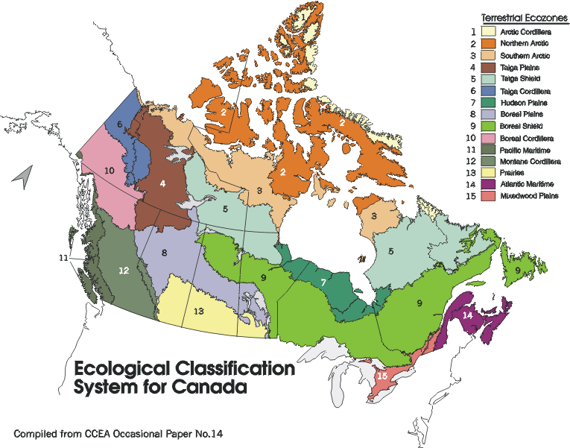
Canada’s Population Trends
Student Activity Sheets
Name:
*Most of the answers to these questions can be found in the Canada’s Population Trends background section.

- Table 1 in Canada’s Population Trends Background Information shows the wide spectrum of population densities across the ecozones for CENSUS years 1971, 1976, 1981, 1986, and 1991. From this Table, answer the following questions:

- Which ecozone has the highest density? ____________________
- Which have the lowest? __________________________________________
- Can you explain why there is a great difference between the ecozone, which has the highest density, and the one with the lowest? ______________________________________________________________________________________________________________________________________________
- Find an ecozone where the population trend is to increase. ________________________
- Find one, which is decreasing. ______________________
- Find one, which is relatively constant. ________________________
- Can you think of reasons why? _____________________________________________________________________________________________________________________________________________________________________________________________________________________________________________

- Calculate the population density, i.e. the number of people per square kilometer, for 1996. This is calculated by dividing the population of each ecozone by its area in square kilometers.

Table 2: Population density for 1996
Ecozone Names | Land Area (km2) | Population  1996 | No. of dwellings  1996 | Density  (pop./area) | No. persons/ dwelling
Arctic Cordillera | 236309 | 1196 | 266
Northern Arctic | 1338353 | 18881 | 4825
Southern Arctic | 645355 | 11729 | 2892
Taiga Plains | 549116 | 23986 | 7632
Taiga Shield | 1077604 | 36560 | 10565
Boreal Shield | 1620871 | 2894961 | 1082951
Atlantic Maritime | 196691 | 2549061 | 963871
Mixedwood Plains | 109779 | 14840411 | 5626811
Boreal Plains | 664274 | 745172 | 259095
Prairies | 454046 | 3979522 | 1499905
Taiga Cordillera | 260373 | 358 | 128
Boreal Cordillera | 450921 | 30324 | 11386
Pacific Maritime | 201670 | 2848289 | 1098179
Montane Cordillera | 471117 | 851656 | 326977
Hudson Plains | 346016 | 11811 | 2902

- Are the ecozones with the highest population also the ones with the highest density? Why?
____________________________________________________________________________________________________________________________________________________________________________________________________________________________________________________________________________________________________________________

- Let's use a ratio to find the average number of people in each dwelling. This will be calculated by dividing the population by the number of dwellings to give us the number of persons/dwelling in each ecozone.
- Which ecozones do you think have the highest number of persons in a single dwelling? Do the calculation and see if you are right.
_____________________________________________________________________________
- Is this what you expected? Can you think of reasons why?
__________________________________________________________________________________________________________________________________________________________________________________________________________________________________________________________________

- Compare the population density for 1996 you have obtain in Table 2 above to the Density Table in the Background Information (Table 1) for CENSUS years 1971 – 1991.

Are the trends you found in years 1971 through 1991 continuing into 1996?
__________________________________________________________________________________________________________________________________________________________________________________________________________________________________________________________________
- Are there any changes in the population trend of the ecozones between 1991 and 1996?
_______________________________________________________________________________________________________________________________________________________________________________________________________________________________________
- Why would the population densities for the ecozones be much lower than that of a city?
See Table 3 in the Background Information to obtain examples of city densities.
_______________________________________________________________________________________________________________________________________________________________________________________________________________________________________

Now let’s examine Table 3: CENSUS for Major Metropolitan Areas and Populations for Canada from the Background Information more closely.

Which city has the greatest population? _______________________
- Which city has the greatest area? ____________________________
- Which city has the highest density? __________________________
- Which city has the smallest population? _______________________
- Which city has the smallest area? ____________________________
- Which city has the lowest density? ___________________________
- Are there some surprises as to what you would expect?
_____________________________________________________________________________
__________________________________________________________________________________________________________________________________________________________
- Can you explain why Charlottetown would have approximately the same density as
Toronto?
_______________________________________________________________________________________________________________________________________________________________________________________________________________________________________

- Do the ArcView lesson or use an atlas to find five communities in ecozones different from your own. Try using a theme such as; communities farthest from your own, or in ecozones adjacent to yours.

- Find the Statistics Canada web site at www.statcan.ca. Look up CENSUS / The Structural Profile of Canadian Communities. Fill in the chart below with the information for your community or city as well as a community or city from each of four ecozones different from your own. How do they compare? Give a name to your table.

Table 4:
Item | Your location | Location 2 | Location 3 | Location 4 | Location 5
ecozone
community
land area
population
population 1996
population 1991
pop. change
avg. age
# aboriginals
Education
% males with greater than high school education
% females with greater than high school education
Income and work
avg. male income
avg. female income
male unemploy-ment rate
female unemployment rate
Family and income
avg. value owned occupied dwelling
Births & deaths
# of Births
# of Deaths

- Now, let's use some of these figures to produce our own statistics in the table below.
- Calculate the population density for these five communities.
- Calculate the percentage of aboriginals in each community in 1996.
- Determine the ratio of males to females with high school education (Divide the number of males by number of females).
- Determine the natural increase rate by subtracting the number of deaths from the number of births.
- Give a name to your table.

Table 5:
Item | Your location | Location 2 | Location 3 | Location 4 | Location 5
Ecozone

Community

population density
1996
% of population that are aboriginal
ratio M/F with high school diploma
natural increase rate

- How does your community compare with the others?
____________________________________________________________________________________________________________________________________________________________________________________________________________________________________________________________________________________________________________________

Canada’s Population Trends Internet Resources

References

Statistics Canada
http://statcan.ca

Statistical Profile of Canadian Communities to search out your own community

http://www.statcan.ca/english/census2001/reasons.htm
Source for reasons why the CENSUS questions are asked

E-Stat - data table for multiple topics
From CD disk or link to http://statcan.ca

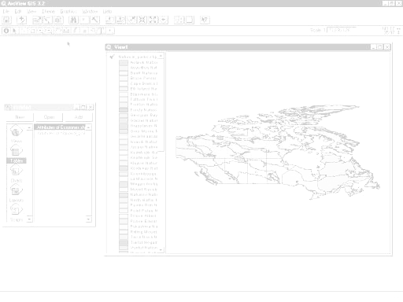

Canada’s Population Trends

GRAPHING CHANGE IN POPULATION

DISPLAY DATA BY ECOZONE FRAMEWORK

COLLECTING AND USING POPULATION DATA FROM THE INTERNET
PLOT POPULATION BY CENTERS

DISPLAY DATA BY POPULATION CENTERS

DOWNLOAD POPULATION DATA FROM THE INTERNET
EXTRACTING INFORMATION FROM YOUR MAP

ArcView Lesson
LINK INTERNET DATA TO ARCVIEW FILES
CREATE POPULATION MAPS

GIS Information

Here's a list and explanation of important features in ArcView:

Project : In ArcView, a file for organizing your work. Projects use five types of
documents to organize information: views, tables, charts, layouts, and scripts.

View : A component of an ArcView project used for displaying, querying, and
analyzing geographic themes.

Table of Contents: All themes in a View are listed to the left of the map. The Table of
Contents shows the symbols used to draw features in each theme. The check box next to each theme indicates whether or not it is turned on or off in the map (whether it is currently drawn on the map).

Theme: A set of related geographic features, such as streets, parcels, or rivers, and the
characteristics (attributes) of those features.

Tables : Information formatted in rows and columns. A component of an ArcView
project used for displaying Tabular data.

Layout : The design or arrangement of elements in a digital map display or printed
map. A component of an ArcView project used for creating presentation-quality maps.

Hotlink: In ArcView, a way to display data (for example, a file, image, ArcView
document, or project) directly from a view, by clicking on a feature.

ArcView Buttons Reference Guide

View - Buttons
 | Save Project |  | Add Theme |  | Theme Properties | Edit Legend | Open Theme Table |  | Find | Locate Address | Query Builder |  | Zoom to Full Extent | Zoom to Active Theme | Zoom to Selected | Zoom In | Zoom Out | Zoom to Previous Extent |  | Select Features using Graphics | Clear Selected Features |  | Help

View – Tools
 | Identify | Pointer | Vertex Edit | Select Feature | Zoom In | Zoom Out | Pan | Measure | Hot Link | Area of Interest | Label | Text |  | Drawing and Editing Tools |  |  | Scale |  |  | Coordinates

Push and hold to select tool
Point
Line
Polyline
Rectangle
Circle
Polygon
Line Split
Polygon Split
Auto Complete

Table - Buttons
 | Save Project |  | Cut | Copy | Paste |  | Select All | Select None | Switch Selection |  | Create Chart |  | Find | Query Builder | Promote | Join |  | Summarize | Calculate |  | Sort Ascending | Sort Descending | Help

Table - Tools
Record Counter | Select Tool | Edit Tool | Identify Tool

Chart - Buttons
Save Project |  | Undo Erase |  | Area Chart Gallery | Bar Chart Gallery | Column Chart Gallery | Line Chart Gallery | Pie Chart Gallery | Scatter Chart Gallery | Chart Properties | Series From Records/Fields | Find | Help

Chart - Tools
Identify Tool | Erase Tool | Erase Within Polygon Tool | Chart Element Properties Tool | Chart Colour Tool

Layout - Buttons
Save Project | Cut | Copy | Paste | Layout Properties | Group | Ungroup | Bring to Front | Send to Back | Undo | Zoom to Page | Zoom to Actual Size | Zoom to Selected | Zoom In | Zoom Out | Print | Help

Layout - Tools
 |  | Pointer Tool | Vertex Tool | Zoom In Tool | Zoom Out Tool | Pan Tool | Text Tool | Drawing Tools |  | Frame Tools

Push and hold to select tool
View Frame
Legend Frame
Scale Frame
North Arrow Frame
Chart Frame
Table Frame
Picture Frame

For more Information: http://www.esricanada.com

Getting Started

Before you begin, the lesson data folder must be copied into a drive in which the student has writing and editing capabilities. This will probably be the drive containing your own personal account on the school’s system or it may be the C: drive of the machine you are currently working on. If the latter is the case you will have to work on the same machine each day until this assignment is complete. Each school set-up is different so work with your teacher to prepare your data folder.

! (The data for the lesson must first be downloaded from this Web site and placed on the school computer or network. Ask your teacher where to find the data folder that has been downloaded).

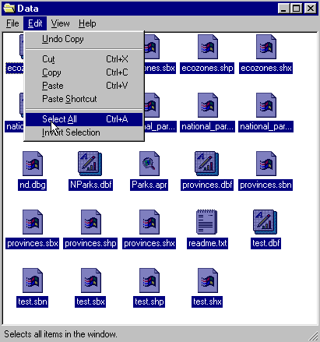 To do this, use the file manager program on your computer. For windows based systems this will be My Computer / Windows Explorer /.

Once the data folder has been copied to the required destination the files must be made usable by removing the read only attribute. For windows based systems follow these instructions:

! (The data downloaded from the Web Site is set as read only so that it cannot be changed or altered by accident.)

1. Open your new data folder
2. Choose Edit > Select all (they will all appear Blue)

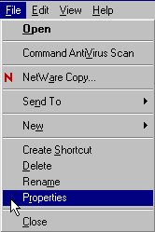3. From the menu choose:
File > Properties

4. Remove the check mark in the
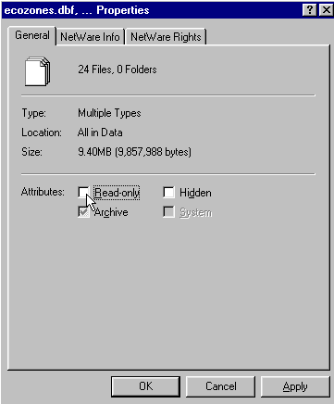
box beside the label read only.

5. Click apply, then OK

The data in your new data folder can now be opened, edited and saved using ArcView or other GIS software that can use SHAPE files to carry out the following project.

! Denotes an observation.
? Denotes a question to be answered on the Student Activity Sheet.

STARTING THE PROJECT

The purpose of this lesson is to use population data in various ways to show how it relates to different frameworks. A framework is the structure that is used to group data for information purposes. Examples of frameworks are by province, by ecozone, by city. In this lesson we will display attributes of population by using variable symbols to denote size classification.

STARTING ArcView

Begin by starting up the ArcView program. If you are not sure how to do this, ask your teacher.

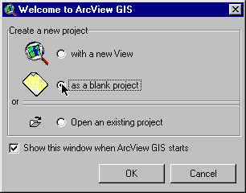
1. Choose as a blank project
2. Click O.K.

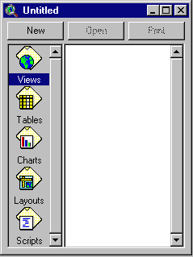When the program starts, it automatically opens a project window titled "Untitled."

If you like, you can maximize the ArcView window to fill the screen.

! In ArcView, you work within a project. A project is a collection of documents (map views, tables, charts, layouts, etc), document user interfaces, (called DocGUIs) and scripts. Only one project is open at a time.

3. Now you are ready to add documents to your new project.

4. With the “Views” icon selected, click on New and
maximize the View1 window.

5. Click the Add theme button and Navigate to the data folder where your data is stored. Hold down your SHIFT key and select the following files:

Admin.shp
Pop_centers.shp
Zone_population.shp

6. Click O.K.

This will add these three themes to the table of contents of the new view. They are now available for display and editing.

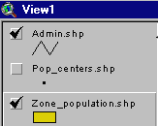
7. Click and drag to move the themes up or down in the table of content to change the order of display if necessary.

! Note the themes are displayed from the bottom to the top so line and point themes should be on top of polygon files to be visible.

8. Click on the square next to the themes you want to display. The theme that appears raised in the table of contents is the current active theme. This can be change by Clicking on other themes.

9. Remember to Save your project as you go along. Go to the File menu and select Save Project. Save your work to the appropriate directory (ask your teacher if you are not sure). Give your project a name that will identify your work. (The suffix apr. means that you are saving your work as a project that can be opened up in the future)

ArcView - Changing the Map Projection

! A Map Projection defines the relationship between the map coordinates and the geographic coordinates, (latitude and longitude). Our current display shows what a map of Canada looks like with only a geographic projection.

CHANGING PROJECTION

Now we will give our map “projection coordinates” to make it look more like the maps which are familiar to us.

1. From the View menu, choose Properties.
2. Select Properties.
3. Select Map Units list. Change the map units to decimal degrees.
4. Select Distance Units list. Change the distance units to kilometers
5.Click the Projection button.
6. Select Custom.
7. Select Lambert Conformal Conic from the projection list.
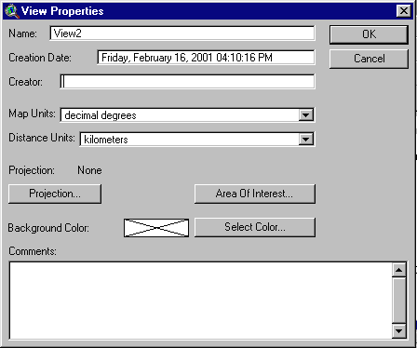
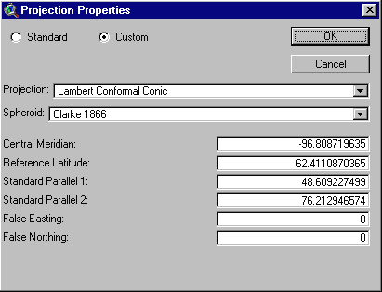

! Take a look at the parameters for this projection. Parameters are the descriptions of how the projection was made.
Note that a spheroid was used. (The earth is a slightly flattened sphere toward the poles).
Conformal implies that all angles are indicated correctly. All angles measured on the earth’s surface are given the same values on the map.
Conical means in the shape of a cone. In this projection, the relative positions on a globe are transferred to a plane in the shape of a cone around the globe. See how the longitudinal lines are closer together at the top of the image, that is, they are not parallel.

The central meridian, false easting and false northing are used to define the X (easting) and Y (northing) coordinates of the map. The reference latitude and standard parallel 1 and 2 are used to determine the origin of the projection (i.e. the point from which you are viewing the globe).

8. Click O.K.

The bottom of the View Properties window should look like this:

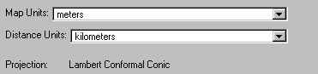

9. Click O.K.

! Note the difference in the map presentation.
? How is it different from the non-referenced map?

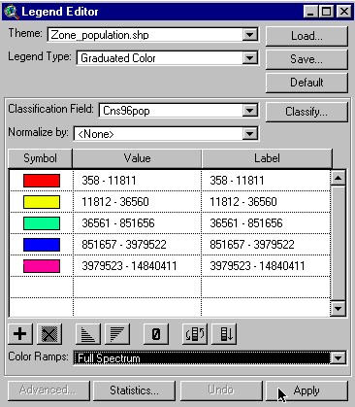
ArcView - DISPLAY POPULATION DATA BY ECOZONE FRAMEWORK

LETS LOOK 1996 POPULATION DATA.

1. Double Click Zone_Population theme.
2. Open Legend Type list, select Graduated Colour.
3. Open Classification field, Select Cns96pop.
4. Open Colour Ramps list, Select Full Spectrum.
5. Click Apply.
6. Close Legend Editor window.

? What is the general pattern of population by ecozones?
? Does the area of the ecozone have an effect on its population?

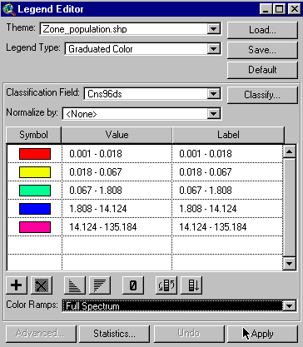
NOW LET’S DISPLAY POPULATION DENSITY

Population density is the number of people per square kilometer.

1. Double Click Zone_Population theme.
2. Classification Field list, Select Cns96ds.
3. Open Colour Ramp list, Select full spectrum.
4. Click Apply.
5. Close Legend Editor window.

? What is the general pattern of population density by ecozone?
? How is it different than 1996 population done above?
? Why?

NOW LET’S DISPLAY POPULATION CHANGE

Populations change and move over the years. Let's look at the change between 1971 and 1991.

1. Double Click Zone_Population theme.
2. Open Classification Field list, Select Pc71-91
3. Open colour ramp list, Select Full Spectrum
4. Click Apply.
5. Close Legend Editor window.

? Why is it important to map changes in population?
? Which ecozone has had the greatest change in population? Consider both increases and decreases.
? What implications does this have for the social, economic and environmental structure of the ecozone?
? Which ecozones have the next greatest population change?

ArcView - GRAPHING CHANGE IN POPULATION

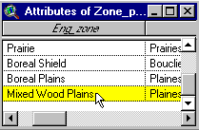
1. Click Open Theme Table for the zone_population
theme.

2. Click mixedwood plains ecozone record to select it.

3. Click Create Chart button

4. From Fields list, select Pd71, Pd76, Pd81, Pd86, Pd91, Cns96ds and Add To Group List.
5. Open Label Series Using list
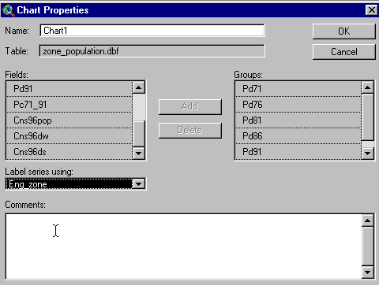
6. Select Eng_zone.
7. Click O.K.

? What does the chart tell you about the population growth in the Mixedwood Plains ecozone between 1971 and 1996?

8. Close Chart 1 window.

9. Click Select None button. to clear all selected records.
10. Now Select The Pacific Maritime and Atlantic Maritime ecozones. (Hold shift key while selecting)
11.Click Create Chart button.

12. From the Fields list, select Pd71, Pd76, Pd81, Pd86, Pd91, Cns96ds and Add To Group List.
13. Open Label Series Using list, Select Eng_zone.
14. Click O.K.

? What can you say about the population change in the two maritime ecozones?

15. Close Chart 2 window.
? Select another ecozone or group of ecozones.
Write down what you expect to see in the charts for change in population density.
Produce the chart and compare it with what you expected.

? Are there differences in what you expected to see and the graph for the selected ecozone(s)?
? Why?

16. Close The Table window.

ArcView - PLOT POPULATION BY CENTERS OF POPULATION

1. Double Click Zone_Population theme.
2. Open Legend Type list.
3. Select Single Symbol.
4. Click Apply.
5. Close Legend Editor window.
6. Check Pop_centers theme to make it visible.

? What can you say about the distribution of population centres?
You may have to edit legend colour to optimize the visibility of the points.
You can zoom in to get a better look.

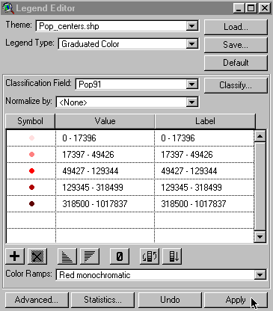
1. Double click Pop_centers theme.
2. Open legend type list.
3. Select graduated symbols.
4. Open classification field list.
5. Select pop91.
6. Click Apply.
7. Close Legend Editor window.

? What can you say about the distribution of population centres based on population size?

Zoom in to get a good look.
? How does this compare with what we discovered using ecozone data?

? Give pros and cons for using the two methods.

ArcView - EXTRACTING INFORMATION FROM YOUR MAP

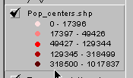
Now that you have added data to your map, let's find the names of some of the population centers you mapped.

1. Click Pop_centers theme to make it active (it should appear raised).

2. Click The Identify button.

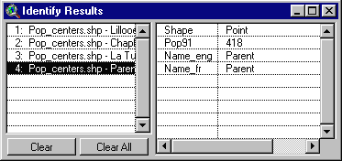
? Using your cursor, find a large population centre near where you live
3. Click. This will give you an Identify Results table, which will give the name of the population center and the 1991 population.

? Using the cursor, find four other large population centres in Canada that are in ecozones different from your own.
Record the name of each city and the ecozone in which it is found.
Zoom in to locate population centers more easily.

? How does the 1991 population data for the five centres compare? Can you draw a graph with this data?

COLLECTING AND USING POPULATION DATA FROM THE INTERNET
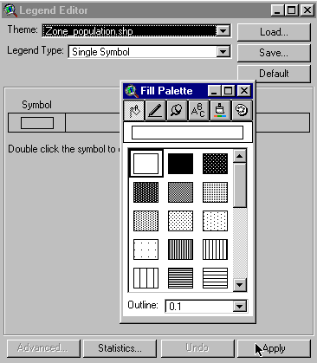

1. Double click zone_population theme.
2. Open Legend type list.
3. Select Single symbol.
4. Open the Fill Palette by double clicking symbol.
5. Select the clear palette to view only the outline.
6. Click Apply.
7. Close Legend Editor window.

8. Un-Check Admin.Shp. to turn it off .
9. Click the Add theme button and Navigate to the data folder where your data is stored.
10. Select Cd96.shp file.
11. Drag And Drop the Zone.Population.Shp to the top layer of the view.

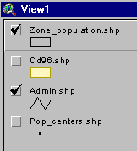
12. The layers of your view should now look like this.

Accessing E-STAT on-line

1. Access the Internet version of E-STAT via Statistics Canada's web site at www.statcan.ca

2. Click on the language of choice - English or French.


3. Select Education Resources.

4. Choose the link called E-STAT.

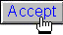
5. There are several resources available here. To access the data, select Accept (at the bottom of the page). You may need a password to connect.

This part of the exercise will explain how to obtain the census data from E-STAT Online and how to set it up so that you can bring it into ArcView later on. This portion of the exercise also assumes that you are using the Internet version of E-STAT 1999.

! Note: We are only going to use the Census Data portion of E-STAT since this is the only data that can be joined to existing data in ArcView.

6. Select 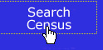 from the left bar menu.

7. At the Available Databases screen, Select The 1996 Census and then click on the Go! Button. (For this exercise we are going to use 1996 census information. However, the same concepts apply to the 1986 and 1991 censuses).

8. At the 1996 Census screen, from the drop down list, select 1996 Census Of Population (Provinces, Census Divisions, Municipalities) and click on the Go! Button. (Note: Municipalities are also called Census Subdivisions, and counties or regional districts are also called Census Divisions).

9. At the Profile Selection screen, from the drop down list select The Table Immigration And Citizenship then click on the Go! Button. (At this point you can select any profile from the list below that you are interested in, we are just using this profile as an example)

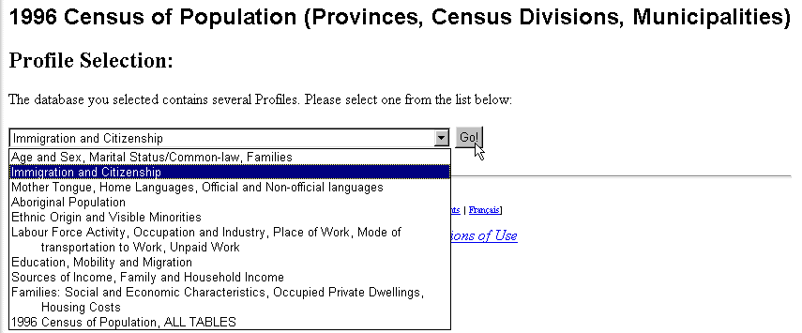

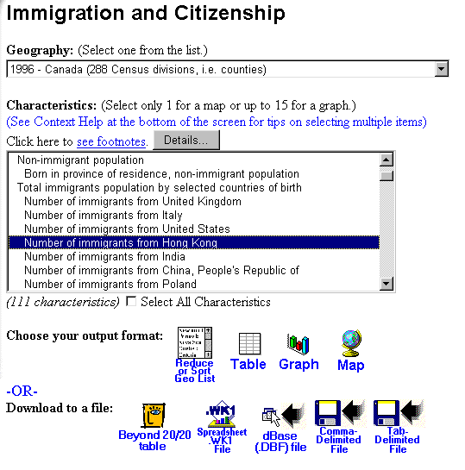

10. You are now at the Geography and Characteristics screen. From the Geography, click on the grouping of areas for which you want to extract data; e.g. Census subdivisions in Ontario - 1996 - Ottawa (92 areas). We are using (1996 – Canada (288 Census division, i.e. counties)

11. From the Characteristics drop down list, select the characteristics you would like to examine. Scroll through the list and decide what you want to look at, and then select your choices. To select a characteristic, Simply Click On The Characteristic of your choice, it will be highlighted. Continue to select the characteristics that you would like to examine. (Note: For a Windows-based browser, you can select multiple non-adjacent characteristics by holding the 'Ctrl' key while clicking on your selection.) (For a MAC-based browser, you would hold the 'Command" key while clicking on your selections.)

12. The next step is to Choose Your Output Format. For use in ArcView GIS, you will need to Select The Table icon to output the selected data in Table format. Your computer will think for a while and then the table will appear in your browser window.

13. Before you continue, it is very important that you: Make Note Of The Characteristics (column headings) and Countries (rows headings) that you chose and the order that they are listed in the table. It would be helpful to get a record of this information, especially the characteristics you have selected by printing the table. When you save your table, it will not save the field headings so you need to either print the table or write each one of them down so that you can change them later. Furthermore, the names of the municipalities/counties that appear in the row (record) headings will not appear in the table either, only their unique code.

14. Once you have written everything down or printed the page, you are now ready to export your table. At the bottom of the page you will notice that there are several options. Next to the heading "Download to a file:" click on the dBase (DBF) file icon. You will be asked to SAVE the file somewhere and give it a name (make sure you remember where you saved it!).

15. When you are done exporting your table(s), you can close your E-STAT application. You are now ready to bring your data into ArcView and map it!

Using E-STAT data in ArcView.

We will now add the E-STAT data to our ArcView project.

1. Click and Check the Cd96.shp theme. You will make a map of Ontario's census subdivisions for 1996 appear.

2. Click Once on Cd96.shp theme to active it (it will appear raised).
3. Click on the Open Theme Table button. You will see the attribute table for the census subdivisions appear.

4. From the Window Menu, Choose Population.Apr to go back to your Project Window.
5. Click on the Tables Icon and then click on the Add button. You are now going to add the table that you created in E-STAT.

6. In the Add Table Dialog Box navigate to the directory where you saved your E-STAT table.
7. Select the E-Stat table and then click on OK. That table will now appear in ArcView. Rearrange your windows so that they do not overlap.

8. Notice that in your table now, the field headings are not displayed, all that is listed is "Field_1", "Field_2" etc. You now need to set up what is called an "alias" for your table so that the proper field headings can be listed. Make sure that your E-STAT data table is the active one (if you are not sure, click on the title bar at the top of the window).
9. From the Table Menu, Choose Properties. In the dialog box that appears you will see the field headings listed. Under "Alias", type in the fields’ headings for your E-STAT table (Use the data you recorded when you were at the E-STAT web site).
10. When you are done, click on OK.

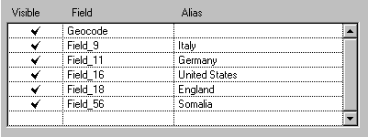

11. You will notice that your field headings are as they should be. You now need to join your E-STAT table to the table showing the census subdivision table so that your map has the data from E-STAT. In your E-STAT table, click on the field heading called Geocode (it will appear dark gray and pushed in).

12. From the Window Menu, choose Attributes Of Csd96.Shp. Scroll along until you find the field called E-STAT and click on the field heading (it will also appear pushed in).
13. Click on the Join button.

! Your E-STAT table will disappear and attach itself to the end of the Attributes of Csd96.Shp table. You are now ready to map your new data!

14. From the Window Menu, choose View1.
15. Double click on the Csd96.Shp theme to bring up the Legend Editor. You can now choose which kind of thematic map you would like to make and what classification field you would like to use!

ArcView - Map Layout for printing

Once you have a map classified and displayed to your satisfaction, you should prepare a map layout that can be used for printing. The purpose of this lesson is to set up your map on a page and annotate it for presentation.

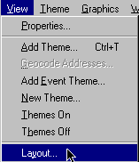
Set up map

1. Click Menu view.
2. Click Layout.

3. Select the Layout template you want to use
(one of the Landscape templates is suggested) .
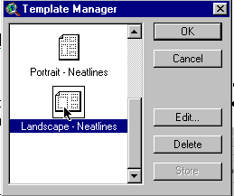

4. Click O.K.
5. Maximize the Layout screen.

EDIT TITLE

1. Double Click on the title View1.
2. Edit the title to reflect the purpose of the map, e.g., forestry, and population.
3. Click O.K.
4. Resize the title using the corner handles and move it into a position that is visually balanced.
5. Click and Drag to reposition the legend if necessary.

EDIT NORTH ARROW

1. Double Click on the north arrow and select a different presentation. Ensure that that the arrow is pointing in the representative north direction of the map.
2. Click and Drag to reposition or rotate (using rotation function) as needed.

EDIT SCALE BAR

1. Double Click the scale bar.
2. Choose a new style of scale bar. The scale bar has default properties so you will not be able to change everything to the way you want.
3. Change the units to kms.
4. Find a combination of style, scale and divisions that is visually pleasing
5. Click and Drag to position to an appropriate location.

ADD LABELS, TEXT, OTHER INFORMATION

1. Click on the Text tool.
2. Click at the position on your layout where you want the text to appear.
3. In the Text Properties box, enter your text, e.g., “produced by (your name, date)”.
4. Select desired formatting information such as alignment, spacing and rotation.
5. Click O.K. when it appears, as you want it.
6. Click on Pointer tool.
7. Select the new text.
8. Click once to change location or size, Click twice to change content.

! Experiment with all of the components of the layout until you have the look you want.

CHANGE THE NAME OF THE LAYOUT

You only have to do this if you want to save your project on the computer or on a disk.

1. Click menu Layout.
2. Select Properties.
3. Change the “name”. Click O.K.

ARRANGING YOUR LAYOUT

! Experiment with the layout buttons (use the tools page provided at the beginning of this lesson)
- to group (tie pieces together so they move as one)
- to ungroup (break apart the ties so that individual pieces move)
- bring to front ( change order that pieces were laid down, e.g., lines on top of polygons)
- send to back ( change order that pieces were laid down, e.g., polygons behind lines)
- zoom ( make image bigger or smaller)
- neat line (border around layout)

PRINT MAP LAYOUT

1. Click Print button.
2. Click Setup.
3. Select your printer properties as outlined by your teacher.
4. Click O.K. to print.

! Note that the map can also be saved to a printer file.

Canada’s Population Trends
ArcView Lesson Student Activity Sheets

Name:

*Answers to the following questions can be obtained while completing the ArcView Canada’s Population Trends Activity.

- How is it different from the non-referenced map?

- What is the general pattern of population by ecozones?

- Does the area of the ecozone have an effect on its population?

- Population density is the number of people per square kilometre.
- What is the general pattern of population density by ecozone?

- How is it different than 1996 population done above? Why?

- Why is it important to map changes in population?

- Which ecozone has had the greatest change in population? Consider both increases and decreases. __________________________

- What implications does this have for the social, economic and environmental structure of the ecozone?

- Which ecozones have the next greatest population change? __________________________

- What does the chart tell you about the population growth in the Mixedwood Plains ecozone between 1971 and 1996?

- What can you say about the population change in the two maritime ecozones?

- Select another ecozone or group of ecozones.
- Write down what you expect to see in the charts for change in population density
- Produce the chart and compare with what you expected.

Expected results:

Actual Results:

- Are there differences in what you expected to see and the graph for the selected ecozone(s)? Why?

- What can you say about the distribution of population centres? You may have to edit legend colour to optimize the visibility of the points. You can zoom in to get a better look.

- What can you say about distribution of population centres based on size? Zoom in to get a good look.

- How does this compare with what we discovered using ecozone data?

- Give pros and cons for using the two methods.

- Using your cursor, find a large population centre near where you live.

Population Centres Ecozone
_________________ ____________________

Using the cursor, find four other large population centres in Canada that are in ecozones different from your own.
Record the name of each city and the ecozone in which it is found.
Zoom in to locate population centres more easily.

Population Centres Ecozone
_________________ ____________________
_________________ ____________________
_________________ ____________________
_________________ ____________________

- How does the 1991 population data for the five centres compare? Can you draw a graph with this data?

