Transportation
Trends in
Canada

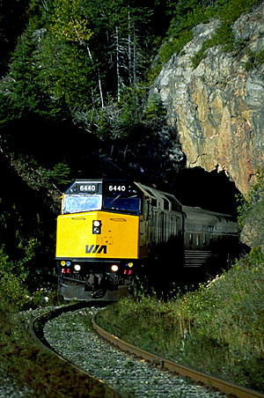

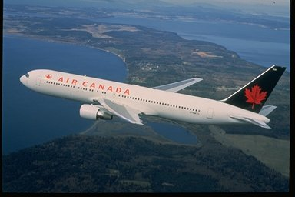

Pictures were taken form:
www.aircanada.ca
www.viarail.ca



Table of Contents

Section Page

Lesson Objectives 3

Curriculum Expectations 3

Teacher Package (Academic Lesson) 4

Teacher Package (Applied Lesson) 5

Academic Performance Task, Expectations and Rubric 6

Applied Performance Task, Expectations and Rubric 8

Transportation Trends in Canada 10

Transportation Trends in Canada Student Activity Sheets 12

Transportation Trends in Canada Internet Resources 18

Transportation Trends in Canada – ArcView Lesson 19

Transportation Trends in Canada– ArcView Lesson Activity Sheets 34

Transportation Patterns in Canada

Lesson Objectives

- Explore the theme of transportation in Canada.
- Study the relationships between road, rail and airport systems.
- Learn about the transportation characteristics of the ecozones of Canada.
- Investigate the pipeline network of Canada.
- Map development and querying.
- Networks and database queries.
- Buffer development and query.
- Build a map layout.

Curriculum Expectations

The Ontario grade 9 curriculum expectations were used as a basis for preparing the lessons in this series. Although there is no direct correlation between Ontario expectations and other provinces, in general, the issues covered in the lessons do relate to many of the curriculum requirements in other jurisdictions. The full curriculum expectations can be found at the Ontario Ministry of Education Web site

English http://www.edu.gov.on.ca/eng/document/curricul/secondary/canadian/canaful.html
French http://www.edu.gov.on.ca/fre/document/curricul/secondary/canadian/canaful.html

The performance tasks for Grade 9 Academic were based directly on curriculum expectations selected from the policy document for Canadian and World Studies. The tasks encompassed the four categories of knowledge and skills (i.e., Knowledge/Understanding, Thinking/Inquiry, Communication, and Application), requiring students to integrate their knowledge and skills in meaningful learning experiences.

The rubric for a specific performance task is intended to provide teachers and students with an overview of the expected final product with regard to the knowledge and skills being assessed as a whole. The rubric identifies key criteria by which the students’ work is to be assessed, and it provides descriptions that indicate the degree to which the key criteria have been met. The teacher can use the descriptions of the different levels of achievement given in the rubric to assess student achievement on a particular task.

Teacher Package

Academic Lesson

Title: Proposal for the Location of a New Business

Time requirement: Prior learning and skill development:
1 period of 70 minutes each
ArcView lesson:
1 to 2 periods of 70 minutes each
Student research and proposal writing:
1 to 2 periods of 70 minutes each
Teacher Instructions:
- Description of the Task
(see Academic Performance Task, Expectations and Rubric).

- Final Product
Students are asked to use these skills to determine the location for a new business. The type of enterprise being proposed is to be researched to determine the ideal location based on closeness to: population centers and various transportation networks. Students are instructed to include supporting visuals, such as maps, graphs, charts, diagrams, or pictures, in the proposal.

- Assessment and Evaluation
The final product will be assessed using the Expectations and the Performance Task Rubric.
Formal and informal assessment of the students based on prior knowledge, lesson objectives, production of their ArcView Map, research process done using the Background Information, the students’ activity sheets (on the Background and on the ArcView lesson), and the Rubric for assessing Maps. Self- or peer assessments and collaboration may be useful to the teacher and students.

- Accommodations
Accommodations that are normally provided in the regular classroom for students with special needs should be provided in the administration of this performance task.

- Rubric
Introduce the task-specific rubric to the students before giving the administrative task. Review the rubric with the students and ensure that each student understands the criteria and descriptions for achievement at each level.
Some students may perform below level 1. It will be important to note the characteristics of their work in relation to the criteria in the assessment rubric and to provide feedback to help them improve.

Teacher Package

Applied Lesson

Title: Proposal for the Location of a New Business

Time requirement: Prior learning and skill development:
1period of 70 minutes each
ArcView lesson:
1 to 2 periods of 70 minutes each
Computer Presentation
1 to 2 periods of 70 minutes each
Teacher Instructions:
- Description of the Task
(see Applied Performance Task, Expectations and Rubric)

- Final Product
Students are asked to use these skills to determine the location for a new business. The type of enterprise being proposed is to be researched to determine the ideal location based on closeness to: population centers and various transportation networks. Students are instructed to include supporting visuals, such as maps, graphs, charts, diagrams, or pictures, in the proposal.

- Assessment and Evaluation
The final product will be assessed using the Expectations and the Performance Task Rubric.
Formal and informal assessment of the students based on prior knowledge, lesson objectives, production of their ArcView Map, research process done using the Background Information, the students’ activity sheets (on the Background and on the ArcView lesson), and the Rubric for assessing Maps. Self- or peer assessments and collaboration may be useful to the teacher and students.

- Accommodations
Accommodations that are normally provided in the regular classroom for students with special needs should be provided in the administration of this performance task.

- Rubric
Introduce the task-specific rubric to the students before giving the administrative task. Review the rubric with the students and ensure that each student understands the criteria and descriptions for achievement at each level.
Some students may perform below level 1. It will be important to note the characteristics of their work in relation to the criteria in the assessment rubric and to provide feedback to help them improve.

Academic Performance Task, Expectations and Rubric

The Task
Students begin by examining distribution patterns of transportation systems. Road, rail, and air travel patterns are examined. Through the analysis students will determine the relationships between population centers and various transportation networks. Software functions of query, statistics, buffer creation and length measurement will be used in the exploration of the various transportation networks. Students are asked to use these skills to determine the location for a new business. The type of enterprise being proposed is to be researched to determine the ideal location based on closeness to: population centers and various transportation networks. Students are instructed to include supporting visuals, such as maps, graphs, charts, diagrams, or pictures, in the proposal.

Expectations
This task gives students the opportunity to demonstrate achievement of the following selected expectations from three strands: Geographic Foundations: Space and Systems; Understanding and Managing Change; and Methods of Geographic Inquiry.

Students will:

- demonstrate an understanding of the characteristics of human systems (e.g., transportation, population, communication, energy networks, industry);
- explain the geographical requirements that determine the location of businesses, industries, and transportation systems, and make predictions about future locations of these enterprises and systems;
- identify and analyse the positive and negative impacts on people and the environment of the manufacture, transportation to market, and consumption of selected products (e.g., cars, clothing, tropical food products);
- select and use appropriate methods for displaying geographic data;
- create and use effectively photographs, charts, graphs, models, and diagrams;
- use geographic data to support conclusions and opinions.

Prior Knowledge and Skills
To complete this task, students are expected to be able to demonstrate the following:

- knowledge of the definition of an ecozone;
- ability to read, analyse, and interpret graphs and maps;
- ability to use a variety of tools and technologies for research;
- use GIS to study the location of a new industry and the reasons for their location;
- identify and describe location factors that influence manufacturers;
- examine future trends for tertiary industries.

Task Rubric – Proposal for the Location of a New Business
Expectations |  |  | Criteria |  |  | Level 1 (50 – 59) |  |  | Level 2 (60 –69) |  |  | Level 3 (70 – 79) |  |  | Level 4 (80 -100)

Knowledge / understanding
1 |  | - Demonstrate an understanding of the characteristics of human systems |  |  | - Demonstrates little understanding of the characteristics of human systems |  |  | - Demonstrates some understanding of the characteristics of human systems |  |  | - Demonstrates considerable understanding of the characteristics of human systems |  |  | - Demonstrates a high degree of understanding of the characteristics of human systems

Thinking / Inquiry
2 |  | - Explain the geographical requirements that determine the location of businesses, industries, and transportation systems, and make predictions about future locations of these enterprises and systems |  |  | - Few explanations of the geographical requirements that determine the location of businesses |  |  | - Some explanations of the geographical requirements that determine the location of businesses |  |  | - Considerable explanations of the geographical requirements that determine the location of businesses |  |  | - A high degree of explanations of the geographical requirements that determine the location of businesses

Communication
4,5,6 |  | - Use visuals to illustrate the location of the industry  - Write a clear and convincing proposal |  |  | - Uses visuals to illustrate the location of the industry to a limited degree  - Writes a proposal that is not very clear or convincing |  |  | - Uses visuals to illustrate the location of the industry to some degree  - Writes a proposal that is somewhat clear and convincing |  |  | - Uses visuals to illustrate the location of the industry to a considerable degree  - Writes a proposal that is generally clear and convincing |  |  | - Uses visuals to illustrate the location of the industry to a high degree  - Writes a proposal that is very clear and convincing

Application
3 |  | - Identify and analyse the positive and negative impacts on people and the environment of the manufacture, transportation to market, and consumption of selected products (e.g., cars, clothing, tropical food products) |  |  | - Shows limited understanding of the implications |  |  | - Shows some understanding of the implications |  |  | - Shows considerable understanding of the implications |  |  | - Shows thorough understanding of the implications

Applied Performance Task, Expectations and Rubric

The Task
Students begin by examining distribution patterns of transportation systems. Road, rail, and air travel patterns are examined. Through the analysis students will determine the relationships between population centers and various transportation networks. Software functions of query, statistics, buffer creation and length measurement will be used in the exploration of the various transportation networks. Students are asked to use these skills to determine the location for a new business. The type of enterprise being proposed is to be researched to determine the ideal location based on closeness to: population centers and various transportation networks. Students are instructed to include supporting visuals, such as maps, graphs, charts, diagrams, or pictures, in the proposal.

Expectations
This task gives students the opportunity to demonstrate achievement of the following selected expectations from three strands: Geographic Foundations: Space and Systems; Understanding and Managing Change; and Methods of Geographic Inquiry.

Students will:

- demonstrate an understanding of the characteristics of human systems (e.g., transportation, population, communication, energy networks, industry);
- identify and explain the geographical requirements that determine the location of businesses, industries, or transportation systems;
- explain the positive and negative impacts on people and the environment of the manufacture, transportation to market, and consumption of selected products (e.g., cars, clothing, tropical food products);
- select and use appropriate methods for displaying geographic data;
- use appropriate technology (e.g., computer maps, graphs, air photos) effectively to present geographic information;
- provide evidence to support conclusions and opinions.

Prior Knowledge and Skills
To complete this task, students are expected to be able to demonstrate the following:

- knowledge of the definition of an ecozone
- ability to read, analyse, and interpret graphs and maps
- ability to use a variety of tools and technologies for research
- use GIS to study the location of a new industry and the reasons for their location
- identify and describe location factors that influence manufacturers
- examine future trends for tertiary industries.

Task Rubric – Proposal for the Location of a New Business
Expectations |  |  | Criteria |  |  | Level 1 (50 – 59) |  |  | Level 2 (60 –69) |  |  | Level 3 (70 – 79) |  |  | Level 4 (80 –100)

Knowledge / understanding
1 |  | - Demonstrate an understanding of the characteristics of human systems |  |  | - Demonstrates little understanding of the characteristics of human systems |  |  | - Demonstrates some understanding of the characteristics of human systems |  |  | - Demonstrates considerable understanding of the characteristics of human systems |  |  | - Demonstrates a high degree of understanding of the characteristics of human systems

Thinking / Inquiry
2 |  | - Identify and explain the geographical requirements that determine the location of businesses, industries, and transportation systems, and make predictions about future locations of these enterprises and systems |  |  | - Few identifications and explanations of the geographical requirements that determine the location of businesses |  |  | - Some identifications and explanations of the geographical requirements that determine the location of businesses |  |  | - Considerable identifications and explanations of the geographical requirements that determine the location of businesses |  |  | - A high degree of identifications and explanations of the geographical requirements that determine the location of businesses

Communication
4,5,6 |  | - Use visuals to illustrate the location of the industry  - Write a clear and convincing proposal |  |  | - Uses visuals to illustrate the location of the industry to a limited degree  - Writes a proposal that is not very clear or convincing |  |  | - Uses visuals to illustrate the location of the industry to some degree  - Writes a proposal that is somewhat clear and convincing |  |  | - Uses visuals to illustrate the location of the industry to a considerable degree  - Writes a proposal that is generally clear and convincing |  |  | - Uses visuals to illustrate the location of the industry to a high degree  - Writes a proposal that is very clear and convincing
Application
3 |  | - Explain the positive and negative impacts on people and the environment of the manufacture, transportation to market, and consumption of selected products (e.g., cars, clothing, tropical food products) |  |  | - Shows limited understanding of the implications |  |  | - Shows some understanding of the implications |  |  | - Shows considerable understanding of the implications |  |  | - Shows thorough understanding of the implications

Transportation Trends in Canada

By definition, transport means to convey (persons, goods, troops, baggage, etc) from one place to another. In a country as large as Canada, this is accomplished by a variety of means. The first explorers and native Indians moved by canoe on nature's own highways, that is, by waterways of rivers and lakes. Eventually, trails were cleared and became roads and people could move further inland by horse and carriage. It wasn't until the middle of the 1800's that one could cross this country by train with the building of the first Trans-Canada rail line and the use of steam engines. Cars, trolleys and trucks were not common until the early nineteenth century and air travel wasn't used on any regular basis until the mid-1900. It wasn't until after the Second World War ended in 1945 that Canadians had the technology and manpower for mass production of cars, airplanes, diesel-engine trains and buses. But moving machines are not the only means of transporting goods. Pipelines are becoming increasingly important, as Canada becomes an important producer of oil, gas and liquid petroleum.

Table 1: Ecozone statistics
Ecozone names | Coastal Length | Population  1996 | Road Length (km) | Road Density
Arctic Cordillera | 15460 | 1196 | 44 | 0.0002
Northern Arctic | 93816 | 18881 | 726 | 0.0005
Southern Arctic | 25863 | 11729 | 98 | 0.0002
Taiga Plains | 95 | 23986 | 6360 | 0.0116
Taiga Shield | 13370 | 36560 | 4663 | 0.0043
Boreal Shield | 17664 | 2894961 | 236615 | 0.1460
Atlantic Maritime | 10748 | 2549061 | 154724 | 0.7866
Mixedwood Plains | 227 | 14840411 | 133591 | 1.2169
Boreal Plains |  | 745172 | 164242 | 0.2472
Prairies |  | 3979522 | 296304 | 0.6526
Taiga Cordillera |  | 358 | 1718 | 0.0066
Boreal Cordillera |  | 30324 | 8323 | 0.0185
Pacific Maritime | 23138 | 2848289 | 38530 | 0.1911
Montane Cordillera |  | 851656 | 103223 | 0.2191
Hudson Plains | 3190 | 11811 | 1684 | 0.0049

Information on different means of transportation

Railways:
total: 36,114 km; note - there are two major transcontinental freight railway systems: Canadian National (privatized November 1995) and Canadian Pacific Railway; passenger service provided by government-operated firm VIA, which has no trackage of its own
standard gauge: 36,114 km 1.435-m gauge (156 km electrified) (1998)

Highways:
total: 901,902 km
paved: 318,371 km (including 16,571 km of expressways)
unpaved: 583,531 km (1999 est.)

Waterways:
3,000 km, including Saint Lawrence Seaway

Pipelines:
crude and refined oil 23,564 km; natural gas 74,980 km

Ports:
Becancour (Qc), Churchill (MN), Halifax (NS), Hamilton (ON), Montreal (QC), New Westminster (BC), Prince Rupert (BC), Quebec (QC), Saint John (NB), St. John's (NF), Sept Isles (QC), Sydney (NS), Trois-Rivieres (QC), Thunder Bay (ON), Toronto (ON), Vancouver (BC), Windsor (ON).

Merchant marine:
total: 114 ships (1,000 GRT or over) totaling 1,602,275 GRT/2,371,146 DWT
ships by type: barge carrier 1, bulk 61, cargo 11, chemical tanker 5, combination bulk 2, passenger 3, passenger/cargo 1, petroleum tanker 16, rail car carrier 2, roll-on/roll-off 8, short-sea passenger 3, specialized tanker 1 (1999 est.)
note: does not include ships used exclusively in the Great Lakes (1998 est.)

Airports:
1,411 (1999 est.)
Airports - with paved runways:
total: 515
over 3,047 m: 16
2,438 to 3,047 m: 17
1,524 to 2,437 m: 152
914 to 1,523 m: 240
under 914 m: 90 (1999 est.)
Airports - with unpaved runways:
total: 896
1,524 to 2,437 m: 73
914 to 1,523 m: 362
under 914 m: 461 (1999 est.)

Heliports:
15 (1999 est.)

Transportation Trends of Canada
Student Activity Sheets
Name:
*Most of the answers to these questions can be found in the Transportation Trends of Canada background section.

- From Table 1, which ecozones do you think use ships as an important transportation method?
__________________________

- What limitations are there in the most northerly ecozones?
_______________________________________________________________________________________________________________________________________________________________________________________________________________________________________

- Find communities that lie on coasts. What goods would they ship?
_______________________________________________________________________________________________________________________________________________________________________________________________________________________________________

- Which ecozones are limited to using road, rail or air transportation as their only means of possible transportation?
__________________________

- Which ecozone has the greatest density of roads?
__________________________

- Does this coincide with the one with the greatest population?
_______________________________________________________________________________________________________________________________________________________________________________________________________________________________________

- Look at the density for the Boreal Shield and that of the Mixedwood Plains. Can you explain why one is about 1/10th of the size of the other yet it has almost twice as many kilometers of road?
_______________________________________________________________________________________________________________________________________________________________________________________________________________________________________

- Can you find other similar situations?
_______________________________________________________________________________________________________________________________________________________________________________________________________________________________________

From the attached map, of the major roads in Canada (source GeoGratis).

- Where are the major hubs?
_______________________________________________________________________________________________________________________________________________________________________________________________________________________________________

- Do most roads run east / west or north / south?
_____________________________________________________________________________

From the attached maps, of the major pipelines in Canada (source National Energy Board).

- Canada has several major pipelines. Which direction do they run? ______________ Why?
_______________________________________________________________________________________________________________________________________________________________________________________________________________________________________

- Where are the major oil and gas producing fields?
_______________________________________________________________________________________________________________________________________________________________________________________________________________________________________

- Where are the refineries?
_______________________________________________________________________________________________________________________________________________________________________________________________________________________________________

- Most of the proposed pipelines run to the northern regions of Canada and Alaska. Why are they needed?
_______________________________________________________________________________________________________________________________________________________________________________________________________________________________________

From the attached map, of the major railroads in Canada (source GeoGratis).

- Where are the major hubs?
_______________________________________________________________________________________________________________________________________________________________________________________________________________________________________

- Do they correspond to the road network?
_______________________________________________________________________________________________________________________________________________________________________________________________________________________________________

- What cargo would most likely be transported by train?
_______________________________________________________________________________________________________________________________________________________________________________________________________________________________________

- A train in the major corridor from Windsor to Montréal and Québec City would carry what goods west?
_______________________________________________________________________________________________________________________________________________________________________________________________________________________________________

- Would carry what goods east?
_______________________________________________________________________________________________________________________________________________________________________________________________________________________________________

- Why have trucks become more popular than trains for shipping many goods?
_______________________________________________________________________________________________________________________________________________________________________________________________________________________________________

- What advantages do trucks and trains have over air transport?
_______________________________________________________________________________________________________________________________________________________________________________________________________________________________________

- What advantage does air transport have over train or truck?
_______________________________________________________________________________________________________________________________________________________________________________________________________________________________________

- When goods are shipped to market, several factors have to be considered. Shipping charges are based on distance, weight and volume. You also have to consider a distribution network. For example, a supplier of coats in Winnipeg may be able to ship across country by train to a major city such as Vancouver or Montréal, but must then get the goods to local stores in those cities. Each transfer of goods involves labour and chance of loss. Which shipping method would be most efficient and least expensive?
_______________________________________________________________________________________________________________________________________________________________________________________________________________________________________

- In another example, iron ore could be loaded in Montréal or Québec City onto trains or freight ships to be transported to the smelters in Hamilton. Consider the route for each mode of transport. Which would be faster?
__________________________

- Which would probably be cheaper?
__________________________

- Why?
_______________________________________________________________________________________________________________________________________________________________________________________________________________________________________

- Complete the chart below deciding which mode of transport (air, rail, truck, pipeline, ship) would be used to transport the cargo from its source to market. Create a distribution network for the goods. Choose the most efficient method considering time, cost and distance. Sometimes more than one mode of transport is appropriate.

Cargo | Mode of transport
Grain
Computer parts
Household goods
Mining machinery
Crude Oil
Cattle
Cars and trucks
Canned goods
Fresh fruit and vegetables
Coal
Lumber
Paper
Natural Gas
Clothing
Appliances

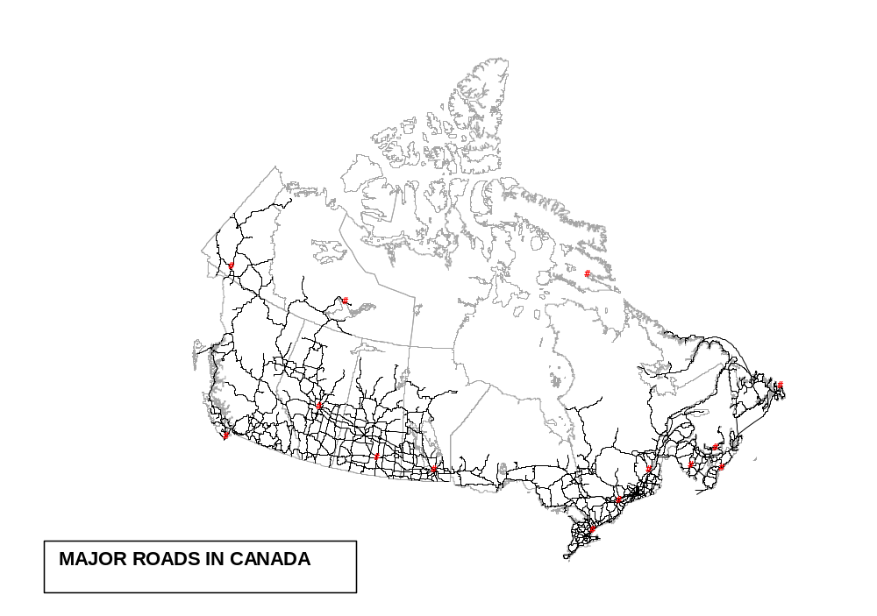
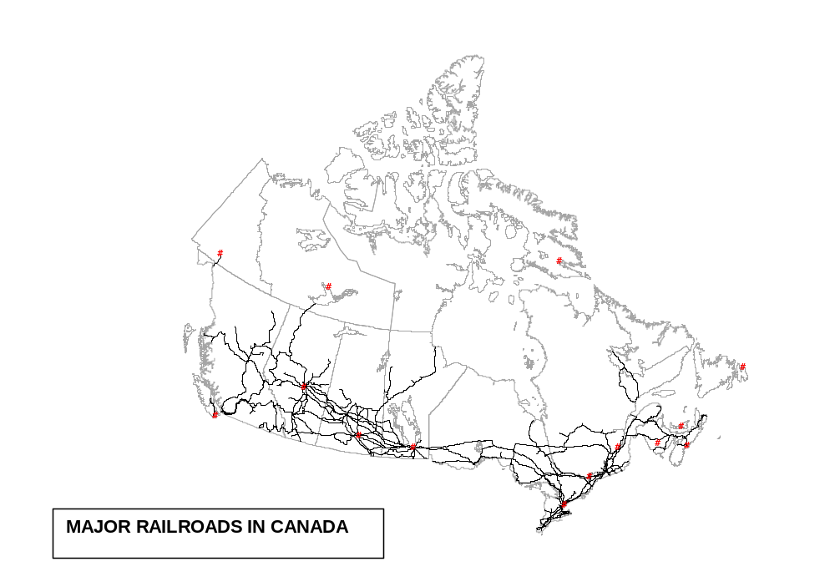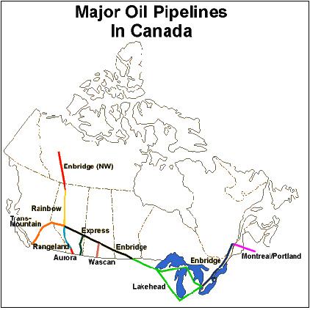

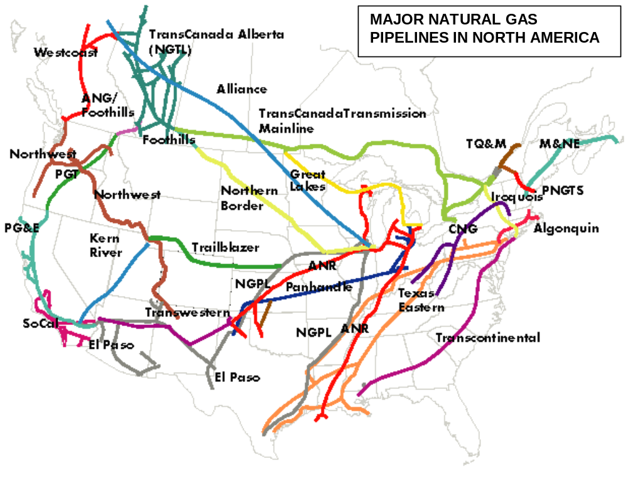

Transportation Trends in Canada Internet Resources

Web links:

Check out the Canadian Transportation Agency web page to learn more about the rules and regulations that govern Canadian transportation. Learn about marine, rail and air transportation. www.cta-otc.gc.ca

EcoMAP: database
http://geogratis.cgdi.gc.ca/frames.html Maps and description

Resources

Victoria, British Columbia - Transit
Find out how to get around on this transit system in Canada. Includes route maps, fares and news.
http://www.transitbc.com/victoria/index.stm

Calgary, Alberta Transit
Calgary's mass transportation system provides schedules, route maps, details of special events and fares.
http://www.calgarytransit.com/

Innovative Transportation Technologies main index page
http://faculty.washington.edu/~jbs/itrans/

Ontario Ministry of Transportation Home Page
http://www.mto.gov.on.ca/english/

Transportation Sector in Canada
Information on the transportation industry in Canada - air, marine, rail and road.
http://canadaonline.about.com/aboutcanada/canadaonline/msub21trans.htm?iam=dpile&terms=canada%27s+transportation+systems

Transport 2000 Canada is a national association interested in public transportation, safety, energy, the environment and consumer advocacy. Regular updates
http://www.transport2000.ca/

GO Transit is Canada's first, and Ontario's only, interregional transit system, established to link Toronto with the surrounding regions of the Greater Toronto Area (GTA). It carries 36 million passengers every year in a network of train and bus services that is one of North America’s premier transportation systems.
http://www.gotransit.com/

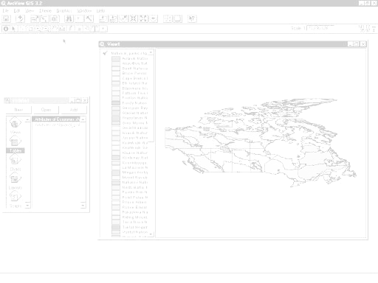
QUERYING A MAP
LOOKING AT NETWORKS
TRACING A NETWORK
QUERYING A DATABASE
CREATING BUFFERS FOR COMPLEX QUERIES
DRAWING A BUFFER

Transportation Trends in Canada

ArcView Lesson

GIS Information

Here's a list and explanation of important features in ArcView:

Project : In ArcView, a file for organizing your work. Projects use five types of
documents to organize information: views, tables, charts, layouts, and scripts.

View : A component of an ArcView project used for displaying, querying, and
analyzing geographic themes.

Table of Contents: All themes in a View are listed to the left of the map. The Table of
Contents shows the symbols used to draw features in each theme. The check box next to each theme indicates whether or not it is turned on or off in the map (whether it is currently drawn on the map).

Theme: A set of related geographic features, such as streets, parcels, or rivers, and the
characteristics (attributes) of those features.

Tables : Information formatted in rows and columns. A component of an ArcView
project used for displaying Tabular data.

Layout : The design or arrangement of elements in a digital map display or printed
map. A component of an ArcView project used for creating presentation-quality maps.

Hotlink: In ArcView, a way to display data (for example, a file, image, ArcView
document, or project) directly from a view, by clicking on a feature.

ArcView Buttons Reference Guide

View - Buttons
 | Save Project |  | Add Theme |  | Theme Properties | Edit Legend | Open Theme Table |  | Find | Locate Address | Query Builder |  | Zoom to Full Extent | Zoom to Active Theme | Zoom to Selected | Zoom In | Zoom Out | Zoom to Previous Extent |  | Select Features using Graphics | Clear Selected Features |  | Help

View – Tools
 | Identify | Pointer | Vertex Edit | Select Feature | Zoom In | Zoom Out | Pan | Measure | Hot Link | Area of Interest | Label | Text |  | Drawing and Editing Tools |  |  | Scale |  |  | Coordinates

Push and hold to select tool
Point
Line
Polyline
Rectangle
Circle
Polygon
Line Split
Polygon Split
Auto Complete

Table - Buttons
 | Save Project |  | Cut | Copy | Paste |  | Select All | Select None | Switch Selection |  | Create Chart |  | Find | Query Builder | Promote | Join |  | Summarize | Calculate |  | Sort Ascending | Sort Descending | Help

Table - Tools
Record Counter | Select Tool | Edit Tool | Identify Tool

Chart - Buttons
Save Project |  | Undo Erase |  | Area Chart Gallery | Bar Chart Gallery | Column Chart Gallery | Line Chart Gallery | Pie Chart Gallery | Scatter Chart Gallery | Chart Properties | Series From Records/Fields | Find | Help

Chart - Tools
Identify Tool | Erase Tool | Erase Within Polygon Tool | Chart Element Properties Tool | Chart Colour Tool

Layout - Buttons
Save Project | Cut | Copy | Paste | Layout Properties | Group | Ungroup | Bring to Front | Send to Back | Undo | Zoom to Page | Zoom to Actual Size | Zoom to Selected | Zoom In | Zoom Out | Print | Help

Layout - Tools
 |  | Pointer Tool | Vertex Tool | Zoom In Tool | Zoom Out Tool | Pan Tool | Text Tool | Drawing Tools |  | Frame Tools

Push and hold to select tool
View Frame
Legend Frame
Scale Frame
North Arrow Frame
Chart Frame
Table Frame
Picture Frame

For more Information: http://www.esricanada.com

STARTING THE PROJECT

In this lesson we will examine the distribution patterns of transportation systems. Software functions of query, statistics, buffer creation and length measurement will be used.

STARTING ArcView

Begin by starting up the ArcView program. If you are not sure how to do this, ask your teacher.

1. Choose as a blank project.

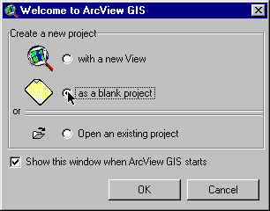
2. Click O.K.

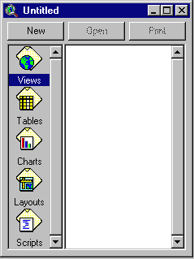When the program starts, it automatically opens a project window titled "Untitled."

If you like, you can maximize the ArcView window to fill the screen.

! In ArcView, you work within a project. A project is a collection of documents (map views, tables, charts, layouts, etc), document user interfaces, (called DocGUIs) and scripts. Only one project is open at a time.

3. Now you are ready to add documents to your new project.

4. With the “Views” icon selected, click on New and
maximize the View1 window.

5. Click the Add Theme button and navigate to the data folder where your data is stored. Hold down your SHIFT key and select the following files:
Admin.shp
Ecozone_trans.shp
Roa.shp
Rla.shp
Airpt.shp
Pop_centers.shp

6. Click O.K.

This will add these six themes to the table of contents of the new view. They are now available for display and editing.

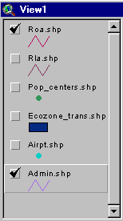
7. Click and drag to move the themes up or down in the table of content to change the order of display if necessary.

! Note the themes are displayed from the bottom to the top so line and point themes should be on top of polygon files to be visible.

8. Click on the square next to the themes you want to display. The theme that appears raised in the table of contents is the current active theme. This can be changed by clicking on other themes.

9. Remember to Save your project as you go along. Go to the File menu and select Save Project. Save your work to the appropriate directory (ask your teacher if you are not sure). Give your project a name that will identify your work. (the suffix .apr means that you are saving your work as a project that can be opened up in the future).

ArcView - Changing the Map Projection

! A Map Projection defines the relationship between the map coordinates and the geographic coordinates, (latitude and longitude). Our current display shows what a map of Canada looks like with only a geographic projection.

Now we will give our map “projection coordinates” to make it look more like the maps which are familiar to us.
1. From the View menu, choose Properties.
2. Select Properties.
3. Select Map Units list. Change the map units to decimal degrees.
4. Select Distance Units list. Change the distance units to kilometers
5.Click the Projection button.
6. Select Custom.
7. Select Lambert Conformal Conic from the projection list.
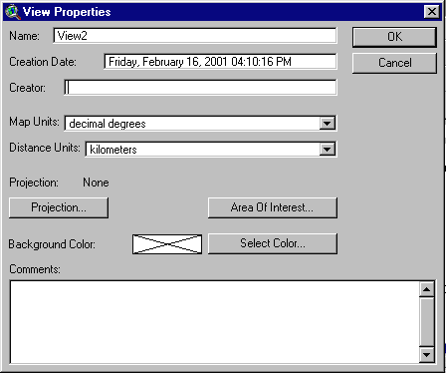
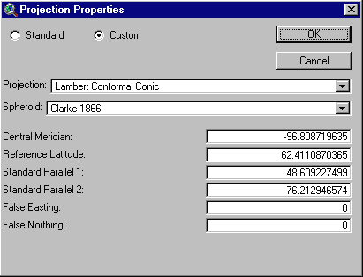

! Take a look at the parameters for this projection. Parameters are the descriptions of how the projection was made.
Note that a spheroid was used. (The earth is a slightly flattened sphere toward the poles).
Conformal implies that all angles are indicated correctly. All angles measured on the earth’s surface are given the same values on the map.
Conical means in the shape of a cone. In this projection, the relative positions on a globe are transferred to a plane in the shape of a cone around the globe. See how
the longitudinal lines are closer together at the top of the image, that is, they are not parallel.

The central meridian, false easting and false northing are used to define the X (easting) and Y (northing) coordinates of the map. The reference latitude and standard parallel 1 and 2 are used to determine the origin of the projection (i.e. the point from which you are viewing the globe).

- Click O.K.
The bottom of the View Properties window should look like this:

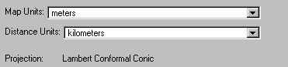
9. Click O.K.
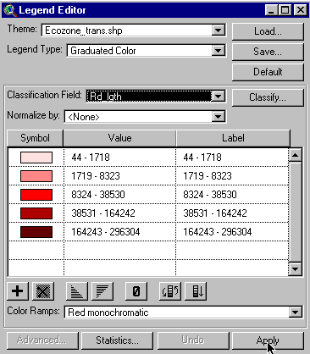
! Note the difference in the map presentation.
? How is it different from the non-referenced map?

ArcView - QUERYING THE MAP

1. Double click ecozone_trans theme.
2. Open Legend Type list.
3. Select Graduated Colour.
4. Open Classification Field list.
5. Select Rd_lgth. (road length).
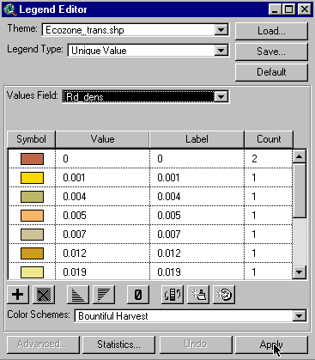
6. Click Apply.
7. Close Legend Editor window.

8. Select the Identify Tool. Move the cursor over each ecozone and click to get information on that ecozone.

? Which ecozone has the greatest length of roads?
? Which ecozone has the second greatest length of roads?
? Is this what you would expect? Explain.

9. Double click ecozone_trans theme.
10. Open Classification Field list.
11. Select Rd_dens (road density).
12. Click Apply.
13. Close Legend Editor window.
14. Click the Identify Tool. Move the cursor over each ecozone and click to get information on that ecozone.

? Find the ecozone with the highest road density?
? Which ecozones have the second and third highest densities?
List two pros and cons related to high road density.

ArcView - LOOKING AT NETWORKS

One definition of a network is an arrangement of intersecting lines and nodes. Transportation networks can be made up of roads and rail lines that intersect at many locations which are often points of commerce such as cities and ports.

1. Click on the square next to the roads theme to make it active.
2. Use the Zoom In button to look closely at the high density areas.

? Do you see a relationship between the road network and the road density?
? Do you think that all the roads of Canada are shown on this map?

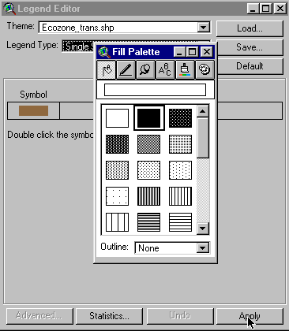

3. Double click ecozone_trans theme.
4. Open Legend Type list.
5. Select Single Symbol.
6. Double click Symbol box.
7. Open Outline list.
8. Select None.
9. Click Apply.
10. Close Legend Editor window.

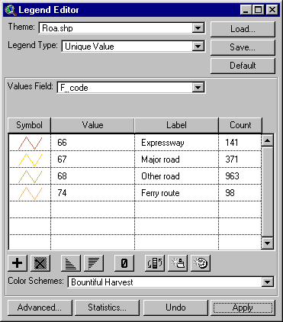
11. Double click Roa. (roads) theme.
12. Open Legend Type list.
13. Select Unique Value.
14. Open Values Field list.
15. Select F_code.

16. Edit the Label list by changing the number code to the corresponding text listed below.
- Expressway
- Major road
- Other road
- Ferry route
16. Click Apply.
17. Close Legend Editor window.
18. Use the Zoom In button to explore the road network.

? Explore the road network. Where are most of the expressways?
? Where are the road hubs?
? Which coast has more ferry routes?

ArcView - TRACING A NETWORK

Let's try and follow the Trans-Canada Highway across the country.

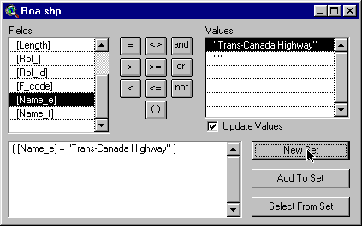
1. Double click Roa. (roads) theme.
2. Open Legend Type list.
3. Select Single Symbol.
4. Click Apply.
5. Close Legend Editor window.
6. Click Query Builder . button.
7. In the Fields list, double click name_e.
8. Click = button.
9. Double click Trans-Canada Highway.
10. Click New Set.
11. Close the Query Builder window.

? Is there more than one route for the Trans-Canada Highway?

12. Click Clear Selected Features button.
13. Uncheck Roa. (roads) theme to turn it off.

Now, let's look at the railroad network.
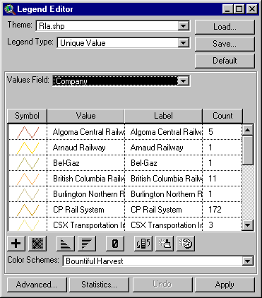
14. Click Rla (railroads) theme to activate it and check it to make it visible.
15. Use the Zoom In tool to explore the railroad network.

? Where do you find the largest number of railroad lines?
? Why?
? Where are the rail hubs?

16. Double click Rla (railroads) theme.
17. Open Legend Type list.
18. Select Unique Value.
19. Open Value Field list.
20. Select company.
21. Click Apply.

? How many railroad companies are there in Canada?

Click the Edit legend button to get a count for the number of companies.
? Which are the two largest?

22. Close Legend Editor window.

ArcView - QUERYING THE DATABASE

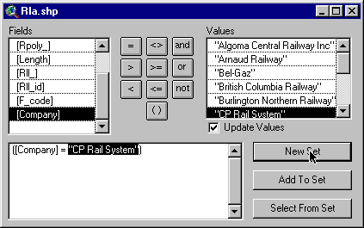
We have found that CP Rail System has a vast network of rail lines. Let's find all the rail lines that belong to Canadian Pacific.
1. Click the Query Builder button.

2. Double click company in Fields list.
3. Click = button.
4. Double click CP Rail System in Values list.
5. Click New Set.
6. Close the Query Builder window.

? Does CP Rail System operate in the Atlantic Provinces?

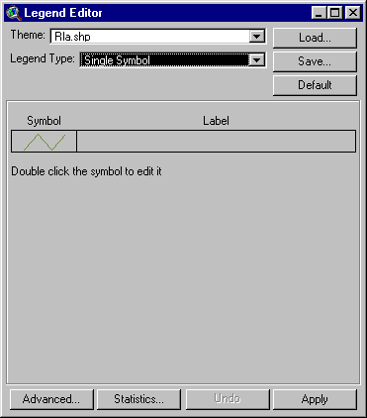

7. Double click Rla (railroads) theme.
8. Open Legend Type list.
9. Select Single Symbol.
10. Click Apply.
11. Close Legend Editor window.
12. Click Clear Selected Features button.

13. Uncheck Rla (railroads) theme to turn it off.

We've looked at roads and railroads, now let's see where our airports are located. 

1. Click on Airpt (Airports) theme to make it active.
2. Check Airpt (Airports) theme to make it visible.

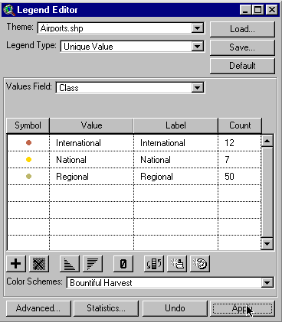
? Can you describe the distribution of airports in Canada? Explain.

3. Double click Airpt (Airports) theme.
4. Open Legend Type list.
5. Select Unique Value.
6. Select Class.
7. Click Apply.
8. Close Legend Editor window.

? Which provinces do not have international airports?

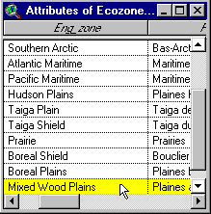
From our map, we can see that the majority of airports are located in the Mixedwood Plains ecozone. Let's find out how many.

1. Activate ecozone_trans theme by clicking on it.
2. Click Open Theme Table button .

3. Click Mixedwood Plains in the table.
4. Close the table.

The Mixedwood Plains ecozone should be highlighted.

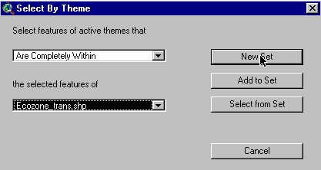

5. Click Airpt (Airports) theme to activate it.
6. Click MENU item Theme.
7. Click Select By Theme.
8. Open Select features of active theme that list.
9. Select Are Completely Within.
10. Open the selected features of list.
11. Select ecozone_trans.
12. Click New Set.

Airports within the Mixedwood Plains should be highlighted.

13. Click Open Theme Table button.

? How many airports have been selected?
? What are their names?
? What class of airport are they?

ArcView - CREATING BUFFERS FOR COMPLEX QUERIES

Buffers are used to measure an area of a given distance surrounding a selected feature.

Examples would be the area of a circle surrounding a point

or a worm shaped area surrounding a line feature.


Let's try a complex query. We want to find:
a) how many population centres were within a 100 km radius of a selected airport b) how many people lived within that same radius in 1991.

1. Activate the Airpt (Airports) theme.

2. Click the Select Features button.

3. Move the cursor over an airport you want to study and click. This will select that airport.
4. Zoom In if there are a number of airports close together.
5. Click Open Theme Table and check that you have selected only one airport and record its name.
6. Close table.

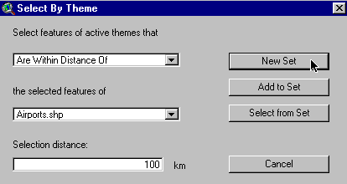
ArcView - FINDING STATISTICS

1. Click pop_centers theme to activate.
2. Click MENU item Theme.
3. Click Select By Theme.
4. Open Select features of active theme that list.
5. Select Are Within Distance Of.
6. Open the selected features of list.
7. Select Airpt (Airports).
8. Enter 100 in the Selection distance.
9. Click New Set.
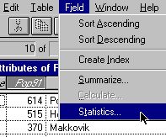

10. Click Open Theme Table button.

11. Click the Field title Pop91 to select the 1991 population field.
12. Click MENU item Field.
13. Click Statistics.

? How many population centres are within 100 km of your airport?
? How many people live within the 100 km radius of that airport?

Search the table to find the airport you selected and make a list of all the population centres that fall within 100 km.

14. Close the table.
15. Check pop_centers theme.

? Looking at your map, can you see the distribution of population centres around your airport? Explain.

Let's use a buffer to determine how many people live within a 20 km area of the Trans-Canada Highway.

1. Activate the Roa (roads) theme. Click Query Builder and select the Trans-Canada Highway as you did in the earlier part of this lesson.
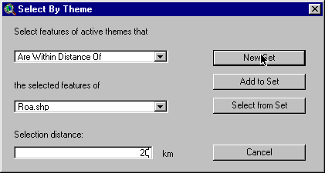
2. Click pop_centers theme to activate.
3. Click MENU item Theme and Select By Theme.
4. In the Selected features of active theme that list, select Are Within Distance Of
5. In the Selected feature of list, select Roa.shp.
6. Enter 20 in Selection distance
7. Click New Set.
8. Close the window.
9. Click Open Theme Table button.
10. Click field title Pop91 in the table.
11. Click MENU item Field.
12. Click Statistics.

? How many population centres are located within 20 km of the Trans-Canada Highway? ? How many people are within this buffer?

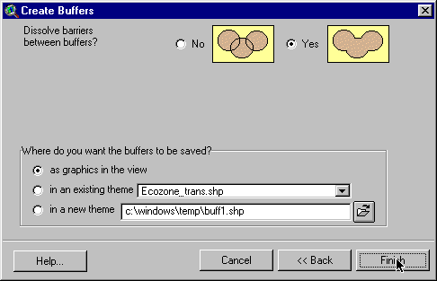
ArcView - DRAW A BUFFER

1. Click Roa (roads) theme.
2. With the Trans-Canada Highway still
selected, Click MENU item Theme.
3. Click Create Buffers.
4. Open Theme list.
5. Select Roa (roads).
6. Click Next.
7. Click button at a specific distance.
8. Enter 20.
9. Select Distance units, Km.
10. Click Next.
11. Next to Dissolve Barriers check Yes.
12. Save as Graphics In View.
13. Click Finish. This process may take a while. Be patient.

14. Zoom In on the Trans-Canada Highway to see a buffer.
15. Click on Measure button.
16. Measure the distance from the highway to the edge of the buffer.

? Does zooming in give better readings?
It should read 20 km.

ArcView - Map Layout for printing

Once you have a map classified and displayed to your satisfaction, you should prepare a map layout that can be used for printing. The purpose of this lesson is to set up your map on a page and annotate it for presentation.

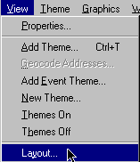
Set up map

1. Click Menu View.
2. Click Layout.

3. Select the Layout Template you want to use.
(One of the landscape templates is suggested).

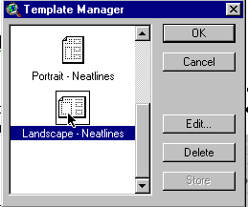
4. Click O.K.
5. Maximize the Layout screen.

EDIT TITLE

1. Double click on the title View1.
2. Edit the title to reflect the purpose of the map, e.g., forestry, population.
3. Click O.K.
4. Resize the title using the corner handles and move it into a position that is visually balanced.
5. Click and drag to reposition the legend if necessary.

EDIT NORTH ARROW

1. Double Click on the north arrow and select a different presentation. Ensure that the arrow is pointing in the representative north direction of the map.
2. Click and drag to reposition or rotate (using rotation function) as needed.

EDIT SCALE BAR

1. Double click the scale bar.
2. Choose a new style of scale bar. The scale bar has default properties so you will not be able to change everything to the way you want.
3. Change the units to kms.
4. Find a combination of style, scale and divisions that is visually pleasing.
5. Click and drag the scale bar to an appropriate location.

ADD LABELS, TEXT, OTHER INFORMATION

1. Click on the Text tool.
2. Click at the position on your layout where you want the text to appear.
3. In the Text Properties box, enter your text, e.g., “Produced by (your name, date)”.
4. Select desired formatting information such as alignment, spacing and rotation.
5. Click O.K. when it appears, as you want it.
6. Click on Pointer tool.
7. Select the new text.
8. Click once to change location or size, click twice to change content.

! Experiment with all of the components of the layout until you have the look you want.

CHANGE THE NAME OF THE LAYOUT

You only have to do this if you want to save your project on the computer or on a disk.

1. Click menu Layout.
2. Select Properties.
3. Change the “name”. Click O.K.

ARRANGING YOUR LAYOUT

! Experiment with the layout buttons (use the tools page provided at the beginning of this lesson if you are unsure of their function).
- to group (tie pieces together so they move as one)
- to ungroup (break apart the ties so that individual pieces move)
- bring to front ( change order that pieces were laid down, e,g, lines on top of polygons)
- send to back ( change order that pieces were laid down, e,g, polygons behind lines)
- zoom ( make image bigger or smaller)
- neat line (border around layout)

PRINT MAP LAYOUT

1. Click Print button.
2. Click Setup.
3. Select your printer properties as outlined by your teacher.
4. Click O.K. to print.

! Note that the map can also be saved to a printer file.

Transportation Trends in Canada

ArcView Lesson Activity Sheets

Name:________________________

- Note the answers for the following questions can be obtained while completing the Transportation Patterns ArcView lesson.

- How is it different from the non-referenced map?
____________________________________________________________________________________________________________________________________________________

- Which ecozone has the greatest length of roads? ______________________________

- Which ecozone has the second greatest length of roads? _______________________

- Is this what you would expect? Explain. ____________________________________________________________________________________________________________________________________________________

- Find the ecozone with the highest road density.
_________________________

- Which ecozones have the second and third highest densities?
_________________________

- List two pros and cons related to high road density.
__________________________________________________________________________________________________________________________________________________________

- Do you see a relationship between the road network and the road density? Explain.
__________________________________________________________________________________________________________________________________________________________

- Do you think that all the roads of Canada are shown on this map? _____________________

- Explore the road network. Where are most of the expressways located in Canada? _________________________________________________________________________

- Where are the road hubs? ____________________________________________________

- Which coast has more ferry routes? ____________________________________________

- Is there more than one route for the Trans-Canada Highway? _______________________

- Where do you find the largest number of railroad lines? Why? _______________________
________________________________________________________________________

- Where are the rail hubs located? _________________________________________________________________________

- How many railroad companies are there in Canada? __________________________

- Which are the two largest? ______________________________________________

- Does CP Rail System operate in the Atlantic Provinces? ______________________

- Can you describe the distribution of airports in Canada? Explain.
______________________________
____________________________________________________________________
____________________________________________________________________

- Which provinces do not have international airports? ___________________________

- Find the airports in the Mixedwood Plains. What are their names and class?
_______________________________________________________________

- How many population centres are within 100 km of your airport? _________________

- How many people live within the 100 km radius of that airport? __________________

- Looking at your map, can you see the distribution of population centres around your airport? Explain.
____________________________________________________________________
____________________________________________________________________

- How many population centres are located within 20 km of the Trans-Canada Highway? __________________

- How many people are within this buffer? ____________________________________

