
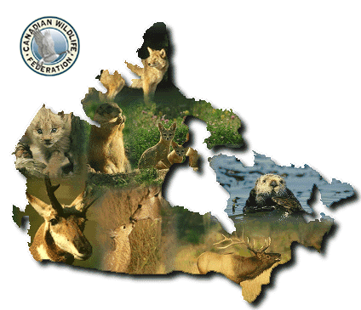
Wildlife and
Species Richness
of Canada
Picture taken from:
http://cwf-fcf.org/pages/indexe.htm

Table of Contents

Section Page

Lesson Objectives 3

Curriculum Expectations 3

Teacher Package (Academic Lesson) 4

Teacher Package (Applied Lesson) 5

Academic Performance Task, Expectations and Rubric 6

Applied Performance Task, Expectations and Rubric 8

Wildlife and Species Richness of Canada 10

Wildlife and Species Richness of Canada – Part of Bill C – 33 12

Ecozone Map of Canada 14

Wildlife and Species Richness of Canada – Glossary COSEWIC 15

Wildlife and Species Richness of Canada Student Activity Sheets 17

Wildlife and Species Richness of Canada Internet Resources 22

Wildlife and Species Richness of Canada – ArcView Lesson 24

Wildlife and Species Richness of Canada – ArcView Lesson Activity Sheets 37

Wildlife and Species Richness of Canada

Lesson Objectives

- Explore the biological diversity of Canada.
- Study the relationships between species at risk and human activity.
- Learn about the biodiversity of the ecozones of Canada.
- Investigate the topic of species at risk.
- Model risk to biodiversity.
- Relating land cover to wildlife habitat.
- Build maps to display the wildlife diversity of the Canadian ecozones.
- Table calculations.
- Use the Internet to research selected species at risk.
- Build a map layout.

Curriculum Expectations

The Ontario grade 9 curriculum expectations were used as a basis for preparing the lessons in this series. Although there is no direct correlation between Ontario expectations and other provinces, in general, the issues covered in the lessons do relate to many of the curriculum requirements in other jurisdictions. The full curriculum expectations can be found at the Ontario Ministry of Education Web site

English http://www.edu.gov.on.ca/eng/document/curricul/secondary/canadian/canaful.html
French http://www.edu.gov.on.ca/fre/document/curricul/secondary/canadian/canaful.html

The performance tasks for Grade 9 Academic were based directly on curriculum expectations selected from the policy document for Canadian and World Studies. The tasks encompassed the four categories of knowledge and skills (i.e., Knowledge/Understanding, Thinking/Inquiry, Communication, and Application), requiring students to integrate their knowledge and skills in meaningful learning experiences.

The rubric for a specific performance task is intended to provide teachers and students with an overview of the expected final product with regard to the knowledge and skills being assessed as a whole. The rubric identifies key criteria by which the students’ work is to be assessed, and it provides descriptions that indicate the degree to which the key criteria have been met. The teacher can use the descriptions of the different levels of achievement given in the rubric to assess student achievement on a particular task.

Teacher Package

Academic Lesson

Title: Species at Risk

Time requirement: Prior learning and skill development:
1 period of 70 minutes each
ArcView lesson:
1 to 2 periods of 70 minutes each
Student research and proposal writing:
1 to 2 periods of 70 minutes each
Teacher Instructions:
- Description of the Task
(see Academic Performance Task, Expectations and Rubric).

- Final Product
Students are to determine if there is a correlation between species at risk and certain ecozones, and what might be contributing to the species being at risk. Finally students will use existing hot linked text files within ArcView and the Internet, access the http:/www.speciesatrisk.gc.ca/Species/English/SearchRequest.cfm web site, to select a species at risk. A brief report is to be prepared which provides information as to why the species is currently at risk and what is / can be done to improve the habitat for that species.
The report should conclude by suggesting ways to prepare for the future. Students are instructed to include supporting visuals, such as species distribution maps, graphs, charts, diagrams, or pictures, in the article.

- Assessment and Evaluation
The final product will be assessed using the Expectations and the Performance Task Rubric.
Formal and informal assessment of the students based on prior knowledge, lesson objectives, production of their ArcView Map, research process done using the Background Information, the students’ activity sheets (on the Background and on the ArcView lesson), the Internet (particularly at the following web site:
http:/www.speciesatrisk.gc.ca/Species/English/SearchRequest.cfm) and the Rubric for assessing maps. Self- or peer assessments and collaboration may be useful to the teacher and students.

- Accommodations
Accommodations that are normally provided in the regular classroom for students with special needs should be provided in the administration of this performance task.

- Rubric
Introduce the task-specific rubric to the students before giving the administrative task. Review the rubric with the students and ensure that each student understands the criteria and descriptions for achievement at each level.
Some students may perform below level 1. It will be important to note the characteristics of their work in relation to the criteria in the assessment rubric and to provide feedback to help them improve.

Teacher Package

Applied Lesson

Title: Species at Risk

Time requirement: Prior learning and skill development:
1period of 70 minutes each
ArcView lesson:
1 to 2 periods of 70 minutes each
Computer Presentation
1 to 2 periods of 70 minutes each
Teacher Instructions:
- Description of the Task
(see Applied Performance Task, Expectations and Rubric)

- Final Product
Students are to determine if there is a correlation between species at risk and certain ecozones, and what might be contributing to the species being at risk. Finally students will use existing hot linked text files within ArcView and the Internet, access the http:/www.speciesatrisk.gc.ca/Species/English/SearchRequest.cfm web site, to select a species at risk. A brief report is to be prepared which provides information as to why the species is currently at risk and what is / can be done to improve the habitat for that species.
The report should conclude by suggesting ways to prepare for the future. Students are instructed to include supporting visuals, such as species distribution maps, graphs, charts, diagrams, or pictures, in the article.

- Assessment and Evaluation
The final product will be assessed using the Expectations and the Performance Task Rubric.
Formal and informal assessment of the students based on prior knowledge, lesson objectives, production of their ArcView Map, research process done using the Background Information, the students’ activity sheets (on the Background and on the ArcView lesson), the Internet (particularly at the following web site:
http:/www.speciesatrisk.gc.ca/Species/English/SearchRequest.cfm) and the Rubric for assessing maps. Self- or peer assessments and collaboration may be useful to the teacher and students.

- Accommodations
Accommodations that are normally provided in the regular classroom for students with special needs should be provided in the administration of this performance task.

- Rubric
Introduce the task-specific rubric to the students before giving the administrative task. Review the rubric with the students and ensure that each student understands the criteria and descriptions for achievement at each level.
Some students may perform below level 1. It will be important to note the characteristics of their work in relation to the criteria in the assessment rubric and to provide feedback to help them improve.

Academic Performance Task, Expectations and Rubric

The Task
Students begin by displaying the dominant land cover in each ecozone and interpret its value as wildlife habitat. The initial inquiry will focus on the distribution of bird, mammal, plant, and reptile species across Canada. Students will be expected to examine potential reasons for the various species distributions they encountered. Students will then sum the reptile & amphibian, tree, rare plants, endemic plants, bird and mammal species numbers for each ecozone to get a total number of species in each ecozone. This will allow students to determine if there is a correlation between species at risk and certain ecozones, and what might be contributing to the species being at risk. Finally students will use existing hot linked text files within ArcView and the Internet, access the http:/www.speciesatrisk.gc.ca/Species/English/SearchRequest.cfm web site, to select a species at risk. A brief report is to be prepared which provides information as to why the species is currently at risk and what is / can be done to improve the habitat for that species.
The report should conclude by suggesting ways to prepare for the future. Students are instructed to include supporting visuals, such as species distribution maps, graphs, charts, diagrams, or pictures, in the article.

Expectations
This task gives students the opportunity to demonstrate achievement of the following selected expectations from three strands: Geographic Foundations: Space and Systems; Human – Environment Interactions; and Methods of Geographic Inquiry.

Students will:

- demonstrate an understanding of the characteristics of natural systems (e.g., climate, landforms, soils, natural vegetation, wildlife);
- demonstrate an understanding of how natural and human systems interact within ecozones;
- analyse the ways in which natural systems interact with human systems, then make predictions about the outcomes of these interactions;
- explain how the effects of urban growth (e.g., development on former farmlands, destruction of wildlife habitats, draining of marshes) alter the natural environment;
- select and use appropriate methods for displaying geographic data;
- create and use effectively photographs, charts, graphs, models, and diagrams;
- use geographic data to support conclusions and opinions.

Prior Knowledge and Skills
To complete this task, students are expected to be able to demonstrate the following:

- knowledge of the definition of an ecozone;
- knowledge of some of Canada’s ecozones and their physical characteristics (e.g. landforms, climate, vegetation, and soils);
- of what value are wild animals to Canadians?;
- knowledge of wilderness areas of Canada and human and animal needs for wilderness;
- understand the differences between extinct species, extirpated species, endangered species, threatened species, at-risk species, and vulnerable species;
- understanding of research methods using a variety of source materials;
- ability to read, analyse, and interpret graphs and maps.

Task Rubric – Species at Risk
Expectations |  |  | Criteria |  |  | Level 1 (50 – 59) |  |  | Level 2 (60 –69) |  |  | Level 3 (70 – 79) |  |  | Level 4 (80 -100)

Knowledge / understanding
1, 2 |  | - Demonstrate an understanding of the characteristics of natural systems (e.g., climate, landforms, soils, natural vegetation, wildlife);  - Demonstrate an understanding of how natural and human systems interact within ecozones |  |  | - Demonstrates little understanding of how natural and human systems interact within ecozones |  |  | - Demonstrates some understanding of how natural and human systems interact within ecozones |  |  | - Demonstrates considerable understanding of how natural and human systems interact within ecozones |  |  | - Demonstrates a high degree of understanding of how natural and human systems interact within ecozones

Thinking / Inquiry
3 |  | - Analyse the ways in which natural systems interact with human systems, then make predictions about the outcomes of these interactions |  |  | - Uses a limited variety of relevant supporting facts and details  - Explains the significance to a limited degree |  |  | - Uses some variety of relevant supporting facts and details  - Explains the significance to some degree |  |  | - Uses a considerable variety of relevant supporting facts and details  - Explains the significance to a considerable degree |  |  | - Uses a wide variety of relevant supporting facts and details  - Explains the significance to a high degree

Communication
5,6,7 |  | - Use visuals to help illustrate the importance of the issue  - Write a clear and convincing report |  |  | - Uses visuals to illustrate the importance to a limited degree  - Writes a report that is not very clear or convincing |  |  | - Uses visuals to illustrate the importance to some degree  - Writes a report that is somewhat clear and convincing |  |  | - Uses visuals to illustrate the importance to a considerable degree  - Writes a report that is generally clear and convincing |  |  | - Uses visuals to illustrate the importance to a high degree  - Writes a report that is very clear and convincing
Application
4 |  | - Explain how the effects of urban growth alter the natural environment |  |  | - Shows limited understanding of the implications |  |  | - Shows some understanding of the implications |  |  | - Shows considerable understanding of the implications |  |  | - Shows thorough understanding of the implications

Applied Performance Task, Expectations and Rubric

The Task
Students begin by displaying the dominant land cover in each ecozone and interpret its value as wildlife habitat. The initial inquiry will focus on the distribution of bird, mammal, plant, and reptile species across Canada. Students will be expected to examine potential reasons for the various species distributions they encountered. Students will then sum the reptile & amphibian, tree, rare plants, endemic plants, bird and mammal species numbers for each ecozone to get a total number of species in each ecozone. This will allow students to determine if there is a correlation between species at risk and certain ecozones, and what might be contributing to the species being at risk. Finally students will use existing hot linked text files within ArcView and the Internet, access the http:/www.speciesatrisk.gc.ca/Species/English/SearchRequest.cfm web site, to select a species at risk. A brief report is to be prepared which provides information as to why the species is currently at risk and what is / can be done to improve the habitat for that species.
The report should conclude by suggesting ways to prepare for the future. Students are instructed to include supporting visuals, such as species distribution maps, graphs, charts, diagrams, or pictures, in the article.

Expectations
This task gives students the opportunity to demonstrate achievement of the following selected expectations from three strands: Geographic Foundations: Space and Systems; Human – Environment Interactions; and Methods of Geographic Inquiry.

Students will:

- demonstrate an understanding of the characteristics of natural systems (e.g., climate, landforms, soils, natural vegetation, wildlife);
- demonstrate an understanding of how natural and human systems interact within ecozones;
- research and report on ways to improve the balance between human needs and natural systems (e.g., recycling, river clean-ups, ecological restoration of local woodlots or schoolyards, industrial initiatives to reduce pollution);
- demonstrate an understanding of how human activities (e.g., rural and urban development, waste management, parks development, forest harvesting, land reclamation) affect the environment;
- select and use appropriate methods for displaying geographic data;
- use geographic material from primary sources (e.g., field research, surveys, interviews) and secondary sources (e.g., mainstream and alternative media, CD-ROMs, Internet) effectively and appropriately when researching a geographic issue;
- provide evidence to support conclusions and opinions;

Prior Knowledge and Skills
To complete this task, students are expected to be able to demonstrate the following:

- knowledge of the definition of an ecozone;
- knowledge of some of Canada’s ecozones and their physical characteristics (e.g. landforms, climate, vegetation, and soils);
- understand the value of wild animals to Canadians;
- knowledge of wilderness areas of Canada and human and animal needs for wilderness;
- understand the differences between extinct species, extirpated species, endangered species, threatened species, at-risk species, and vulnerable species;
- understanding of research methods using a variety of source materials;
- ability to read, analyse, and interpret graphs and maps.

Task Rubric – Species at Risk
Expectations |  |  | Criteria |  |  | Level 1 (50 – 59) |  |  | Level 2 (60 –69) |  |  | Level 3 (70 – 79) |  |  | Level 4 (80 -100)

Knowledge / understanding
1, 2 |  | - Demonstrate an understanding of the characteristics of natural systems (e.g., climate, landforms, soils, natural vegetation, wildlife);  - Demonstrate an understanding of how natural and human systems interact within ecozones |  |  | - Demonstrates little understanding of how natural and human systems interact within ecozones |  |  | - Demonstrates some understanding of how natural and human systems interact within ecozones |  |  | - Demonstrates considerable understanding of how natural and human systems interact within ecozones |  |  | - Demonstrates a high degree of understanding of how natural and human systems interact within ecozones

Thinking / Inquiry
3 |  | - Research and report on ways to improve the balance between human needs and natural systems |  |  | - Uses a limited variety of relevant supporting facts and details  - Explains the significance to a limited degree |  |  | - Uses some variety of relevant supporting facts and details  - Explains the significance to some degree |  |  | - Uses a considerable variety of relevant supporting facts and details  - Explains the significance to a considerable degree |  |  | - Uses a wide variety of relevant supporting facts and details  - Explains the significance to a high degree

Communication
5,6,7 |  | - Use visuals to help illustrate the importance of the issue  - Write a clear and convincing report |  |  | - Uses visuals to illustrate the importance to a limited degree  - Writes a report that is not very clear or convincing |  |  | - Uses visuals to illustrate the importance to some degree  - Writes a report that is somewhat clear and convincing |  |  | - Uses visuals to illustrate the importance to a considerable degree  - Writes a report that is generally clear and convincing |  |  | - Uses visuals to illustrate the importance to a high degree  - Writes a report that is very clear and convincing
Application
4 |  | - Demonstrate an understanding of how human activities (e.g., rural and urban development, forest harvesting, etc.) affect the environment |  |  | - Shows limited understanding of the implications |  |  | - Shows some understanding of the implications |  |  | - Shows considerable understanding of the implications |  |  | - Shows through understanding of the implications

Wildlife and Species Richness of Canada

Canada's legacy to future generations will be the protection of Canada's native wildlife and its species richness. What does this mean? A legacy is something, material or immaterial, that is preserved by one generation for another. The Canadian government has established COSEWIC (The Committee on the Status of Endangered Wildlife in Canada) as a legal entity to assess the level of risk of extinction for wildlife species. It is based on the best available, scientific, Aboriginal traditional, and community knowledge on the status of the species of birds, mammals, amphibians, plants, fish and others that are native to Canadian land and waters. COSEWIC is an independent committee made up of wildlife experts from several universities and museums, provinces and territories, three national conservation organizations (Canadian Nature Federation, Canadian Wildlife Federation, World Wildlife Fund Canada) and four federal agencies (Canadian Wildlife Service, Parks Canada, Fisheries and Oceans Canada, Canadian Museum of Nature). It is their responsibility to ensure that native species and their natural environment are protected so that they can be sustained and produce future generations. The task of this committee is to determine whether any particular species is at risk and if so, to what extent. Whenever any of these species become endangered, threatened or vulnerable they are placed on a COSEWIC list. In 1999 there were 339 species on the COSEWIC list. This list is constantly changing; new species are added, some species are moved to different levels of risk when their situation either improves or deteriorates, some are removed all together if they are no longer at risk. They are assessed at seven levels of risk from greatest to lowest:
- extinct - a species that no longer exists
- extirpated - a species that no longer exists in the wild in Canada, but occurs elsewhere, (for example, in captivity or in the wild in the United States).
- endangered - a species facing imminent extirpation or extinction
- threatened - a species likely to become endangered if limiting factors are not reversed
- special concern (formerly called vulnerable) -a species of special concern because of characteristics that make it particularly sensitive to human activities or natural events
- species not at risk - a species that is not in danger of extinction

- data deficient - insufficient data on population size and distribution, on geographic range or regarding sensitivity to human activities and threats.

There are four main questions asked to determine whether a species is at risk.
- Is it a taxonomically valid species, subspecies/ variety or population according to taxonomical experts?
- Is it a species native to Canada (either naturally occurring or having persisted here for at least 50 years)?
- Is it a species of regular occurrence in Canada, not an accidental visitor?
- If it is a non-resident or migratory species, does it require Canadian lands or waters for a key part of its life cycle?

The importance of protecting our wildlife is emphasized by the number of species appearing on the COSEWIC list. Canada is fortunate to be rich in flora and fauna. There are more than 150 tree species in Canada and the most recent list of birds found in Canada has 417 different species on it. There are 186 native mammals across the 15 terrestrial and 5 marine ecozones, and 88 reptiles and amphibians.

The occurrence of any one of these species within an ecozone is determined by its range. A range is the geographical limits of the area of land or water in which the species has been found and which supports its habitat requirements. Some vertebrate species have very small ranges and remain there year-round. An example might be a particular species of fish that is limited to a few lakes. Others are migratory and have different ranges at specific times of the year. For example, geese have a breeding range in the northern ecozones, a summer range across much of Canada and a winter range mostly south of the border in a climate warmer than that found in Canada. Other mammals, such as big horn sheep, occupy relatively small areas and have summer ranges at higher altitudes and move down into sheltered valleys in the winter where food is more abundant.

The number of species found within any ecozone is largely dependent on the climate and the availability of food sources. This not only applies to the vertebrate species but to plant species as well. In the southern ecozones where the soil is rich, plant life flourishes and consequently so do herbivores (plant-eaters: e.g. deer, bear, rabbit), insectivores (insect-eaters: e.g. birds, skunks) and grainivores (grain-eaters: birds, rodents). In the progression of the food chain, the carnivores are also abundant in those regions. However, in the farthest northern ecozones where the surface is mostly bare rock, very few species of plant or animal can survive. Most mammals which can survive in these regions depend on fish or smaller fish-eating mammals. It is to these northern regions that the migratory species, mostly birds, go to breed their young in spring and raise them during the short summer. Most of Canada's wetlands are found in a broad band around Hudson Bay and these areas produce abundant insect populations on which the birds feed. The table below shows the number of terrestrial species found within each of the ecozones.

Table 1: Terrestrial Species within each of the Ecozones
Ecozone names | Bird | Mammal | Reptile/  Amphibian | Tree | Total Species | Total minus COSEWIC
Arctic Cordillera | 69 | 29 | 1 | 6 | 105 | 96
Northern Arctic | 72 | 23 | 0 | 0 | 95 | 83
Southern Arctic | 141 | 44 | 1 | 12 | 198 | 184
Taiga Plains | 212 | 57 | 7 | 20 | 296 | 284
Taiga Shield | 193 | 53 | 9 | 23 | 278 | 264
Boreal Shield | 267 | 71 | 43 | 80 | 461 | 398
Atlantic Maritime | 195 | 54 | 38 | 64 | 351 | 309
Mixedwood Plains | 238 | 58 | 51 | 106 | 453 | 325
Boreal Plains | 278 | 81 | 21 | 49 | 429 | 404
Prairies | 280 | 84 | 26 | 44 | 434 | 388
Taiga Cordillera | 174 | 47 | 1 | 13 | 235 | 229
Boreal Cordillera | 194 | 52 | 6 | 28 | 280 | 270
Pacific Maritime | 250 | 85 | 31 | 47 | 413 | 358
Montane Cordillera | 265 | 92 | 33 | 52 | 442 | 400
Hudson Plains | 185 | 50 | 9 | 26 | 270 | 262

Species biodiversity refers to the variety and number of species found within an ecozone. It is affected by a variety of factors. We must consider the number of species there are in an ecozone to begin with. Then we will consider the number of species within that ecozone that are on the COSEWIC list. Other factors which might affect the survival of the species within an ecozone are the population density and the density of roads. In reality, there are many more factors involved and to a much more complex level, but for our purpose of learning how modeling works, we will keep it simple. Modeling uses mathematical equations to rank the importance of various factors. In our case, total number of species, number of COSEWIC species, population density and road density will be considered as to the effect they have on the diversity of the species.

In order to protect our natural environment, the Canadian government has legislated several laws to protect native Canadian species from ending as endangered species. Below, you will find part of the legislation that has gone before Parliament. These regulations protect not only the species as individual organisms but also their natural habitat. They ensure that each protected species is given the best chance at survival.

Part of Bill C-5

MEASURES TO PROTECT LISTED WIDLIFE SPECIES
 | General Prohibitions
Killing, harming, etc., listed wildlife species | 32. (1) No person shall kill, harm, harass, capture or take an individual of a wildlife species that is listed as an extirpated species, an endangered species or a threatened species.
Possession, collection, etc. | (2) No person shall possess, collect, buy, sell or trade an individual of a wildlife species that is listed as an extirpated species, an endangered species or a threatened species, or any part or derivative of such an individual.
Deeming | (3) For the purposes of subsection (2), any animal, plant or thing that is represented to be an individual, or a part or derivative of an individual, of a wildlife species that is listed as an extirpated species, an endangered species or a threatened species is deemed, in the absence of evidence to the contrary, to be such an individual or a part or derivative of such an individual.
Damage or destruction of residence | 33. No person shall damage or destroy the residence of one or more individuals of a wildlife species that is listed as an endangered species or a threatened species, or that is listed as an extirpated species if a recovery strategy has recommended the reintroduction of the species into the wild in Canada.
Applica-  tion - certain species in provinces | 34. (1) With respect to individuals of a listed wildlife species that is not an aquatic species or a species of birds that are migratory birds protected by the Migratory Birds Convention Act, 1994, sections 32 and 33 do not apply in lands in a province that are not federal lands unless an order is made under subsection (2) to provide that they apply.
Order | (2) The Governor in Council may, on the recommendation of the Minister, by order, provide that sections 32 and 33 apply in lands in a province that are not federal lands with respect to individuals of a listed wildlife species that is not an aquatic species or a species of birds that are migratory birds protected by the Migratory Birds Convention Act, 1994.
Obligation to make recommenda-  tion | (3) The Minister must recommend that the order be made if the Minister is of the opinion that the laws of the province do not protect the species.
Consultation | (4) Before recommending that the Governor in Council make an order under subsection (2), the Minister must consult
 | (a) the appropriate provincial minister; and
 | (b) if the species is found in an area in respect of which a wildlife management board is authorized by a land claims agreement to perform functions in respect of wildlife species, the wildlife management board.

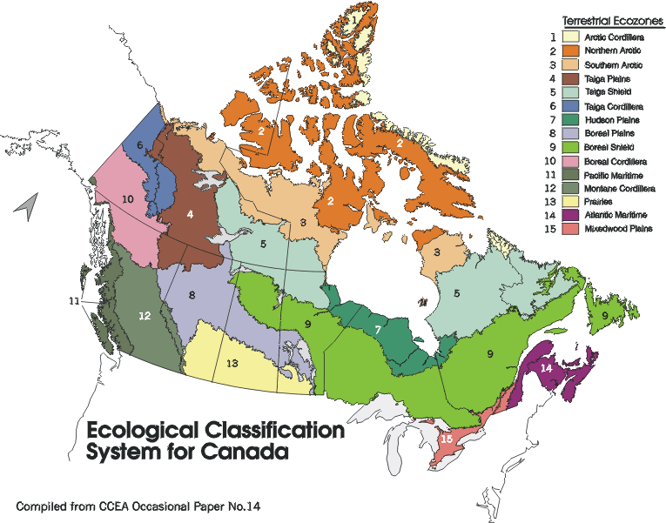
Glossary COSEWIC

amphibian | Any cold-blooded vertebrate of the class Amphibia, typically living on land but breeding in water.
biodiversity | The variety of life (species and genetic stocks) in different ecosystems; "biodiversity" is short for biological diversity.
ecosystem | All organisms in a community, plus the associated environmental factors with which they interact.
environment | The components of the Earth, including: land, water and air; all organic and inorganic matter and living organisms; and the interacting natural systems of which these components are a part.
endangered | A species facing imminent extirpation or extinction.
extinct | A species that no longer exists.
extirpated | A species that no longer exists in the wild in Canada, but occurs elsewhere (e.g., in captivity or in the wild in the United States).
genus | A category of biological classification comprised of a group of closely related or structurally similar species, or a single species exhibiting unusual features; appears as the first half of the scientific name of a species (e.g., in the scientific name Grus americana, Grus is the genus).
habitat | The particular type of local environment occupied by an individual or a population.
hibernation | A state of inactivity or dormancy assumed by certain animals during periods of unfavourable climatic conditions; while hibernating, an animal's metabolic processes are greatly slowed.
indeterminate | A species for which there is insufficient scientific information to support status designation.
lichen | Any of various small plants which are formed by the symbiotic association of a fungus and an alga and occur as crusty patches or bushy growths on trees or rocks.
mammal | Any animal of the Mammalia, a large class of warm-blooded vertebrates having mammary glands.
migration | The periodical movement of an individual from one locality or climate to another for feeding, breeding or hibernating (e.g., some bat species).
mollusc | Any of various invertebrates having a soft unsegmented body, and often a shell secreted by a fold of skin (called the mantle). The group includes the gastropods (snails, slugs, etc.), bivalves (clams, mussels, etc.), and cephalopods (cuttlefish, octopuses, etc.).
moss | Any of a class of plants, typically growing in dense mats on trees, rocks, moist ground, etc.
organism | Any individual living creature, either unicellular (of one cell) or multicellular.
pesticide | A general term for a chemical agent used to kill pests (organisms unwanted by humans at a specific time and place); compare with insecticide, a chemical agent used to kill insects and invertebrate pests; and herbicide, a chemical agent used to kill weeds or herbage.
population | A group of individuals of one species, found within a prescribed area and usually somewhat isolated from other groups of the same species.
range | The geographical limits of a species or group; a migratory species usually has both a breeding range and a wintering range.
recovery | Conservation actions undertaken to benefit an endangered or threatened species until a sustainable population level of fit individuals has been reached and threats to the population have been controlled.
reptile | Any of the cold-blooded vertebrates, of the class Reptilia, characterized by lungs, an outer covering of horny scales or plates, and young produced in eggs.
restoration | Conservation actions undertaken to increase the population size and distribution of an endangered or threatened species to what existed before human activities caused the population to decline.
special concern | A species of special concern because of characteristics that make it particularly sensitive to human activities or natural events.
species | A group of closely related organisms which are potentially capable of interbreeding, and which are reproductively isolated from other groups of organisms; the basic unit of biological classification. Each species is designated by an italicized, binomial Latin name that consists of the genus (capitalized) followed by a noun or adjective (uncapitalized) (e.g., in the scientific name Grus americana, americana is the species).
subspecies | A geographically limited subdivision of a species that is taxonomically different from other such subdivisions of the same species.
sustainable use | Human use of an organism or ecosystem at a rate within its capacity for renewal or regeneration.
taxonomy | The science of classification, esp. of living and extinct organisms
threatened | A species likely to become endangered if limiting factors are not reversed.
vertebrate | Any animal of a subphylum characterized by a bony skeleton and a well developed brain: the group contains fishes, amphibians, reptiles, birds and mammals.
wetland | Land that is saturated with water long enough to promote wetland or aquatic processes; examples are bogs, fens, marshes, swamps, and shallow waters.
wildlife | Any wild organism, including: wild mammals, birds, reptiles, amphibians, fishes, invertebrates, plants, fungi, algae, and bacteria.

Wildlife and Species Richness of Canada
Student Activity Sheets
Name:
*Most of the answers to these questions can be found in the Wildlife and Species Richness of Canada background section.

- Now that we have determined how a species is put on a COSEWIC list and the seven levels of risk, let's look at that list and learn more about those species. Access the Canadian Wildlife Service Web site www.speciesatrisk.gc.ca and fill in the table below with at least one species that falls within each of the seven levels of risk.

Table 1: Species at Risk
Level of risk | species name | category of species
extinct

extirpated

endangered

threatened

special concern

not at risk

data deficient

- Using the following table, make a classified map of Species-at-Risk for Canada by giving each ecozone a classification number (Classification 1) using equal intervals for the number of species at risk within that ecozone.
The method to do this is as follows: if you decide to use 5 classes, divide the range (lowest to highest values) into 5 equal intervals.
For example, if the range was from 1 to 100, the highest value(100) divided by 5 is the size of each interval. The example intervals would therefore be: 1. less than 20, 2. less than 40, 3. less than 60, 4. less than 80, 5. less than or equal to 100.
What problems do you see with this example in classifying your map?
________________________________________________________________________________________________________________________________________________________________________________________________________________________________________________

Table 2: Species at Risk by Ecozone Classification Number
Ecozone names | COSEWIC99 | Classification 1 | Classification 2
 | # Species at Risk
Arctic Cordillera | 9
Northern Arctic | 12
Southern Arctic | 14
Taiga Plains | 12
Taiga Shield | 14
Boreal Shield | 63
Atlantic Maritime | 42
Mixedwood Plains | 128
Boreal Plains | 25
Prairies | 46
Taiga Cordillera | 6
Boreal Cordillera | 10
Pacific Maritime | 55
Montane Cordillera | 42
Hudson Plains | 8

- Now, reclassify the ecozones using different classification intervals (Classification 2). Try using a different range (e.g. 6 to 128) or change your intervals to better differentiate the ecozone classifications by using uneven intervals. This can be done by limiting your range. An example would be to use intervals of <10, <20, <40, <60, >=60. How does this change the appearance of your map?
________________________________________________________________________________________________________________________________________________________________________________________________________________________________________________

- From Table 3 make a line graph of each bird, mammal, amphibian/reptile and tree category across the ecozones. Determine which ecozone has the largest number of species for birds, mammals, reptile/amphibians, trees. (Ask your teacher to provide you with graph paper).
Use four colours of lines (one for each class) on the same graph.

Birds Colour: Highest count in: Ecozone
Mammals Colour: Highest count in: Ecozone Amphibian/reptiles Colour: Highest count in: Ecozone Trees Colour: Highest count in: Ecozone

- Can you think of a reason why that particular ecozone is highest for a category?
________________________________________________________________________________________________________________________________________________________________________________________________________________________________________________

- Can you give a reason why one ecozone is not the highest for all categories?
________________________________________________________________________________________________________________________________________________________________________________________________________________________________________________

Table 3: Terrestrial Species within each of the Ecozones
Ecozone names | # of Bird Species | # of Mammal  Species | # of Reptile/  Amphibian  Species | # of Tree  Species | Total # of Wildlife Species | Total  minus COSEWIC  Species
Arctic Cordillera | 69 | 29 | 1 | 6 |  | 96
Northern Arctic | 72 | 23 | 0 | 0 |  | 83
Southern Arctic | 141 | 44 | 1 | 12 |  | 184
Taiga Plains | 212 | 57 | 7 | 20 |  | 284
Taiga Shield | 193 | 53 | 9 | 23 |  | 264
Boreal Shield | 267 | 71 | 43 | 80 |  | 398
Atlantic Maritime | 195 | 54 | 38 | 64 |  | 309
Mixedwood Plains | 238 | 58 | 51 | 106 |  | 325
Boreal Plains | 278 | 81 | 21 | 49 |  | 404
Prairies | 280 | 84 | 26 | 44 |  | 388
Taiga Cordillera | 174 | 47 | 1 | 13 |  | 229
Boreal Cordillera | 194 | 52 | 6 | 28 |  | 270
Pacific Maritime | 250 | 85 | 31 | 47 |  | 358
Montane Cordillera | 265 | 92 | 33 | 52 |  | 400
Hudson Plains | 185 | 50 | 9 | 26 |  | 262

- Do you see a relationship between climate and number of species? (Explain)
________________________________________________________________________________________________________________________________________________________________________________________________________________________________________________

- Which category does climate affect the most?
________________________________________________________________________________

- Using the data from Table 3, complete the table by supplying the total number of species to determine the Wildlife Species Richness. (Calculate this by adding the bird, mammal, amphibian/reptile number of species. Leave out the tree species for now). Enter your values for each ecozone on a graph. Which ecozone has the highest?
_________________________

- Which has the lowest?
_________________________

- How does that profile compare with the number of trees in each ecozone?
________________________________________________________________________________________________________________________________________________________________________________________________________________________________________________

- Now map the total number of species (available from Table 3). Remember to add in the tree species. Note that this chart does not include all species in Canada, i.e. we have only used four categories and do not include fish, plants, etc. This chart is therefore only to be used as an approximation for example purposes.

- Using the attribute table (Table 3) for the maps, create a new layer by using the number of species at risk subtracted from the total number of species. How do these two maps compare?
________________________________________________________________________________________________________________________________________________________________________________________________________________________________________________

- Locate the species richness map on the GeoGratis Web page by exploring the site at:
http://geogratis.cgdi.gc.ca/Ecosystem/ecosystem.html. Compare your map to it.

- Let's try some modeling to predict the effect of various factors on an ecozone's risk to species biodiversity. To simplify the calculations, we have classified our table in the same way you did above for Species at Risk.
Now, consider the relationship between population densities, road densities and the number of total species and COSEWIC species on biodiversity, that is, which factor would have the greatest impact on the risk to biodiversity if it were to change. Rank each of these factors from 1(least) to 4 (most) as you think they affect the risk to biodiversity. Use this number to calculate the value in the appropriate columns below. The same factor is applied to each ecozone for a given category, e.g. if species factor is 3, then each ecozone value for total species is multiplied by 3.
Now, complete the mathematical equation for weighted factor below for each of the ecozones.
total species X species factor = species value
cosewic species X cosewic factor = cosewic value
pop.density X pop.factor = pop. value
road density X road factor = road value.
species value + cosewic value + pop. value + road value = weighted value

Table 4: Classified values for weighting factor calculation
Ecozone names | Total | Species | COSEWIC | COSEWIC | Population | Pop. | Road | Road | Weighted
 | Species | Value | Species | Value | Density | Value | Density | Value | Value
Arctic Cordillera | 2 |  | 1 |  | 1 |  | 1
Northern Arctic | 1 |  | 2 |  | 2 |  | 1
Southern Arctic | 2 |  | 2 |  | 2 |  | 1
Taiga Plains | 3 |  | 2 |  | 2 |  | 2
Taiga Shield | 3 |  | 2 |  | 2 |  | 1
Boreal Shield | 5 |  | 4 |  | 3 |  | 2
Atlantic Maritime | 4 |  | 3 |  | 4 |  | 3
Mixedwood Plains | 5 |  | 5 |  | 5 |  | 4
Boreal Plains | 4 |  | 3 |  | 3 |  | 3
Prairies | 4 |  | 3 |  | 4 |  | 3
Taiga Cordillera | 3 |  | 1 |  | 1 |  | 1
Boreal Cordillera | 3 |  | 1 |  | 2 |  | 2
Pacific Maritime | 4 |  | 4 |  | 4 |  | 2
Montane Cordillera | 4 |  | 3 |  | 3 |  | 2
Hudson Plains | 3 |  | 1 |  | 2 |  | 1

- Which ecozone is the greatest at risk by your calculation? _______________________

- Is it what you would expect, and why?
________________________________________________________________________________________________________________________________________________________________________________________________________________________________________________

- Re-assess your factors and try again. How has this changed the risk to biodiversity of the ecozones?
________________________________________________________________________________________________________________________________________________________________________________________________________________________________________________

- What factor has the greatest effect on your model?
________________________________________________________________________________________________________________________________________________________________________________________________________________________________________________

Wildlife and Species Richness Internet Resources

References
EcoMAP: http://geogratis.cgdi.gc.ca/frames.html Maps and description

COSEWIC : http://www.cosewic.gc.ca/ English
http://www.cosewic.gc.ca/ French
http://www.cws-scf.ec.gc.ca/sara/media/policy3_e.htm background

Canadian Wildlife Service
English http://www.cws-scf.ec.gc.ca/cwshom_e.html
French http://www.cws-scf.ec.gc.ca/cwshom_f.html

Species at Risk Search:
English http:/www.speciesatrisk.gc.ca/Species/English/SearchRequest.cfm
French http:/www.speciesatrisk.gc.ca/Species/Francais/SearchRequest.cfm

Other Internet Resources

Search for Species at Risk in Canada
http://www.speciesatrisk.gc.ca/Species/English/

Parks Canada
This web site has a lot of great information on ecozones in Canada. Each description has been edited for this document, but please refer to this site for more information on plants and animals for each ecozone.
http://parkscanada.pch.gc.ca/natress/inf_pa1/ECO_DES/ECOZONES/zone_00e.htm

Canadian Wildlife Federation
This site has lost of activities for students and teachers
http://www.cwf-fcf.org/

Space for Species
http://www.spaceforspecies.ca/
Space for Species is a unique educational program that enables students to monitor migratory species and their habitats from beyond the Earth's atmosphere. Developed by the Canadian Space Agency, the Canadian Wildlife Federation and the Canadian Wildlife Service, with assistance from corporate sponsors, Space for Species is a web-based learning experience that brings science and technology to life in your classroom.

The World Wildlife Fund
The Living Planet Campaign: lots of conservation information.
http://www.panda.org/livingplanet/

Threatened Animals of the World
Statistical information regarding threatened species.
http://www.unep-wcmc.org/index.html?http://www.unep-wcmc.org/species/animals/animal_redlist.html~main

E Link Endangered Species
Activities and Lesson Plans based on specific animals and areas of the world.
http://www.nceet.snre.umich.edu/EndSpp/Endangered.html

The Raptor Center
Lots of educational projects about different species of birds, including satellite tracking information.
http://www.raptor.cvm.umn.edu/

Endangered Species - The Rarest Information Around
Includes endangered species lesson plans.
http://www.endangeredspecie.com/

Online Zoologists
Research and Information about protected marine species.
http://www.rtis.com/nat/user/elsberry/marspec.html

Greenpeace
Endangered Species and their Habitat in Canada
http://www.greenpeace.org/search.shtml type in Endangered Species and their Habitat in Canada, visit Climate Changed and Arctic Wildlife, Caribou and Climate Change, British Columbia and Oceans campaign global overfishing.

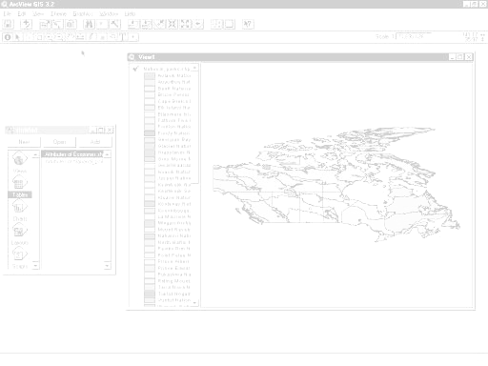

Wildlife and Species Richness of Canada
Displaying Data
Displaying Distribution of Bird Species
Dis
Displaying Distribution of Mammal Species Species \\\\
Table Calculations
Creating a Chart

ArcView Lesson
Using existing Hotlinks to Query Text Tied to a Map
GIS Information

Here's a list and explanation of important features in ArcView:

Project : In ArcView, a file for organizing your work. Projects use five types of
documents to organize information: views, tables, charts, layouts, and scripts.

View : A component of an ArcView project used for displaying, querying, and
analyzing geographic themes.

Table of Contents: All themes in a View are listed to the left of the map. The Table of
Contents shows the symbols used to draw features in each theme. The check box next to each theme indicates whether or not it is turned on or off in the map (whether it is currently drawn on the map).

Theme: A set of related geographic features, such as streets, parcels, or rivers, and the
characteristics (attributes) of those features.

Tables : Information formatted in rows and columns. A component of an ArcView
project used for displaying Tabular data.

Layout : The design or arrangement of elements in a digital map display or printed
map. A component of an ArcView project used for creating presentation-quality maps.

Hotlink: In ArcView, a way to display data (for example, a file, image, ArcView
document, or project) directly from a view, by clicking on a feature.

ArcView Buttons Reference Guide

View - Buttons
 | Save Project |  | Add Theme |  | Theme Properties | Edit Legend | Open Theme Table |  | Find | Locate Address | Query Builder |  | Zoom to Full Extent | Zoom to Active Theme | Zoom to Selected | Zoom In | Zoom Out | Zoom to Previous Extent |  | Select Features using Graphics | Clear Selected Features |  | Help

View – Tools
 | Identify | Pointer | Vertex Edit | Select Feature | Zoom In | Zoom Out | Pan | Measure | Hot Link | Area of Interest | Label | Text |  | Drawing and Editing Tools |  |  | Scale |  |  | Coordinates

Push and hold to select tool
Point
Line
Polyline
Rectangle
Circle
Polygon
Line Split
Polygon Split
Auto Complete

Table - Buttons
 | Save Project |  | Cut | Copy | Paste |  | Select All | Select None | Switch Selection |  | Create Chart |  | Find | Query Builder | Promote | Join |  | Summarize | Calculate |  | Sort Ascending | Sort Descending | Help

Table - Tools
Record Counter | Select Tool | Edit Tool | Identify Tool

Chart - Buttons
Save Project |  | Undo Erase |  | Area Chart Gallery | Bar Chart Gallery | Column Chart Gallery | Line Chart Gallery | Pie Chart Gallery | Scatter Chart Gallery | Chart Properties | Series From Records/Fields | Find | Help

Chart - Tools
Identify Tool | Erase Tool | Erase Within Polygon Tool | Chart Element Properties Tool | Chart Colour Tool

Layout - Buttons
Save Project | Cut | Copy | Paste | Layout Properties | Group | Ungroup | Bring to Front | Send to Back | Undo | Zoom to Page | Zoom to Actual Size | Zoom to Selected | Zoom In | Zoom Out | Print | Help

Layout - Tools
 |  | Pointer Tool | Vertex Tool | Zoom In Tool | Zoom Out Tool | Pan Tool | Text Tool | Drawing Tools |  | Frame Tools

Push and hold to select tool
View Frame
Legend Frame
Scale Frame
North Arrow Frame
Chart Frame
Table Frame
Picture Frame

For more Information: http://www.esricanada.com

Getting Started

Before you begin, the lesson data folder must be copied into a drive in which the student has writing and editing capabilities. This will probably be the drive containing your own personal account on the school’s system or it may be the C: drive of the machine you are currently working on. If the latter is the case you will have to work on the same machine each day until this assignment is complete. Each school set-up is different so work with your teacher to prepare your data folder.

! (the data for the lesson must first be downloaded from this Web site and placed on the school computer or network. Ask your teacher where to find the data folder that has been downloaded).

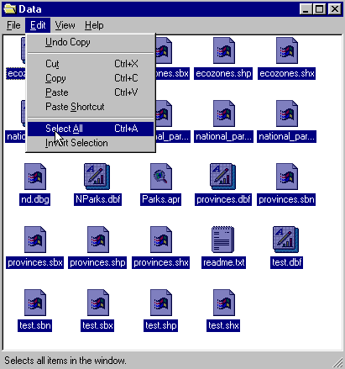To do this, use the file manager program on your computer. For Windows-based systems this will be My Computer / Windows Explorer /.

Once the data folder has been copied to the required destination the files must be made usable by removing the read only attribute. For Windows-based systems follow these instructions:

!(The data downloaded from the Web Site is set as read only so that it can not be changed or altered by accident.)

1. Open your new data folder.
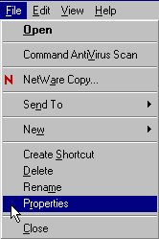2. Choose Edit > Select all (they will all appear Blue)

3. From the menu choose:
File > Properties

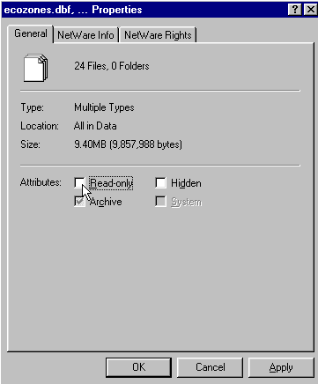

4. Remove the check mark in the
box beside the label read only.

5. Click Apply, then OK.

The data in your new data folder can now be opened, edited and saved using ArcView or other GIS software that can use SHAPE files to carry out the following project.

! Denotes an observation.
? Denotes a question to be answered on the Student Activity Sheet.

STARTING THE PROJECT

This lesson will deal with displaying data, graphing, table calculations and hot links to text files.

STARTING ArcView

Begin by starting up the ArcView program. If you are not sure how to do this, ask your teacher.

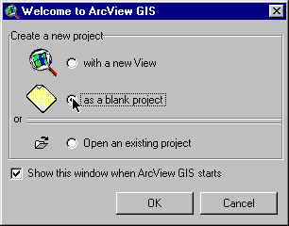
1. Choose as a blank project.
2. Click O.K.

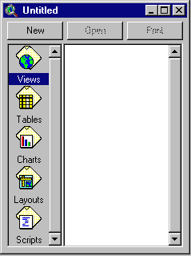When the program starts, it automatically opens a project window titled "Untitled."

If you like, you can maximize the ArcView window to fill the screen.

! In ArcView, you work within a project. A project is a collection of documents (map views, tables, charts, layouts, etc), document user interfaces, (called DocGUIs) and scripts. Only one project is open at a time.

3. Now you are ready to add documents to your new project.

4. With the “Views” icon selected, click on New and
maximize the View1 window.

5. Click the Add Theme button and navigate to the data folder where your data is stored. Hold down your SHIFT key and select the following files:

Admin.shp
Pop_centers.shp
Zones_wildlife.shp

6. Click O.K.

This will add these three themes to the table of contents of the new view. They are now available for display and editing.

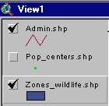
7. Click and drag to move the themes up or down in the table of content to change the order of display if necessary.

! Note the themes are displayed from the bottom to the top so line and point themes should be on top of polygon files to be visible.

8. Click on the square next to the themes you want to display. The theme that appears raised in the table of contents is the current active theme. This can be change by clicking on other themes.

9. Remember to Save your project as you go along. Go to the File menu and select Save Project. Save your work to the appropriate directory (ask your teacher if you are not sure). Give your project a name that will identify your work. (the suffix .apr means that you are saving your work as a project that can be opened up in the future).

ArcView - Changing the Map Projection

! A Map Projection defines the relationship between the map coordinates and the geographic coordinates, (latitude and longitude). Our current display shows what a map of Canada looks like with only a geographic projection.

Now we will give our map “projection coordinates” to make it look more like the maps which are familiar to us.
1. From the View menu, choose Properties.
2. Select Properties.
3. Select Map Units list. Change the map units to decimal degrees.
4. Select Distance Units list. Change the distance units to kilometers.
5.Click the Projection button.
6. Select Custom.
7. Select Lambert Conformal Conic from the projection list.
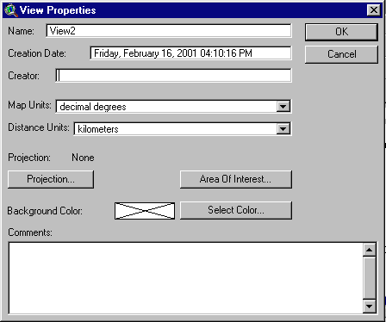
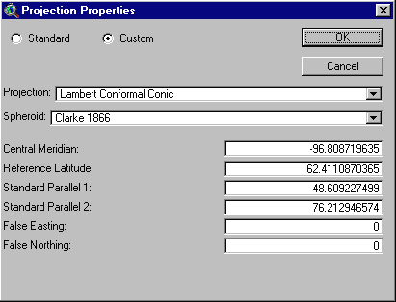

! Take a look at the parameters for this projection. Parameters are the descriptions of how the projection was made.
Note that a spheroid was used. (The earth is a slightly flattened sphere toward the poles).
Conformal implies that all angles are indicated correctly. All angles measured on the earth’s surface are given the same values on the map.
Conical means in the shape of a cone. In this projection, the relative positions on a globe are transferred to a plane in the shape of a cone around the globe. See how
the longitudinal lines are closer together at the top of the image, that is, they are not parallel.

The central meridian, false easting and false northing are used to define the X (easting) and Y (northing) coordinates of the map. The reference latitude and standard parallel 1 and 2 are used to determine the origin of the projection (i.e. the point from which you are viewing the globe).

- Click O.K.
The bottom of the View Properties window should look like this:

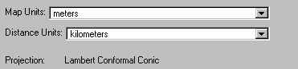
9. Click O.K.

! Note the difference in the map presentation.
? How is it different from the non-referenced map?
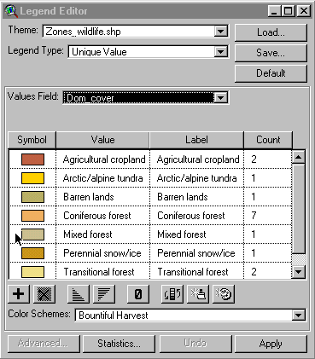

ArcView - DISPLAYING DATA

Let's begin by displaying the dominant land cover and interpret its value as wildlife habitat.

1. Double click zones_wildlife theme.
2. Open Legend Type list.
3. Select Unique Value.
4. Open Values Field list.
5. Select Dom_cover.
6. Click Apply.
7. Close Legend Editor window.

8. Click Identify Tool and use the cursor to find an ecozone, which might have good habitat for each of the following:

- forest dependent birds
- small mammals that live in open agricultural fields
- caribou that calf on open tundra
- seabirds that nest on barren rocky cliffs

ArcView - DISPLAYING DISTRIBUTION OF BIRD SPECIES

Now let’s make a map that shows the distribution of bird species by ecozone.
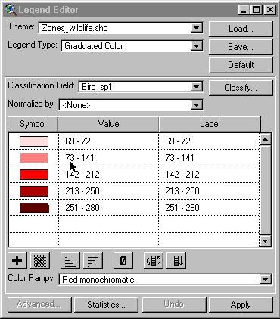
1. Double click zones_wildlife theme.
2. Open Legend Type list.
3. Select Graduated Colour.
4. Open Classification Field list.
5. Select Bird_spl (number of bird species).

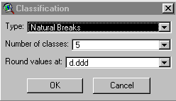

6. Click Classify.
7. Open Type list.
8. Select Natural Breaks. Click O.K.
9. Click Apply.
10. Close Legend Editor window.

? What can you say about the distribution of bird species across Canada?

11. Using the Identify Tool , find the ecozone with the greatest number of bird species.

? Find the ecozone with the greatest number of bird species. Give some possible reasons why this ecozone has the greatest number of bird species?

ArcView - DISPLAY DISTRIBUTION OF MAMMAL SPECIES

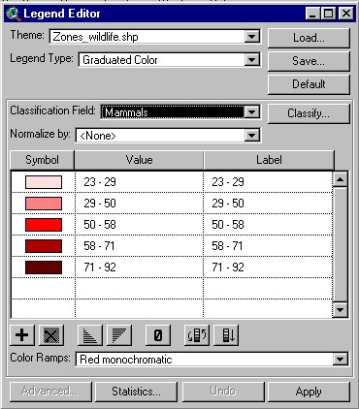
1. Double click zones_wildlife theme.
2. Open Classification Field list.
3. Select mammals.
4. Click Apply.
5. Close Legend Editor window.
6. Using the Identify Tool , find the ecozone with the greatest number of mammal species.

? Find the ecozone with the greatest number of mammal species. Give some possible reasons why this ecozone has the greatest number of mammal species?

Repeat this process to determine the ecozone with the greatest number of trees (tree_sp) and the greatest number of reptiles & amphibians (reptile_).

? Determine the ecozone with the greatest number of tree species (tree_sp).
? Determine the ecozone with the greatest number of reptiles & amphibians (reptile_).
? Which ecozone has no tree species? Why?
? Which ecozones have no reptiles or amphibians? Why?

ArcView - TABLE CALCULATIONS

We are going to calculate the species richness of each ecozone. We will sum the reptile & amphibian, tree, rare plants, endemic plants, bird and mammal species values for each ecozone to get a total number of species in each ecozone.

1. Click zones_wildlife theme to activate it.

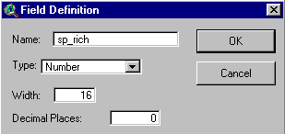2. Click Open Theme Table button.
3. From the MENU, click Table.
4. Click Start Editing.
5. From the MENU, click Edit.
6. Click Add Field.
7. Enter field name sp_rich.
8. Click O.K.

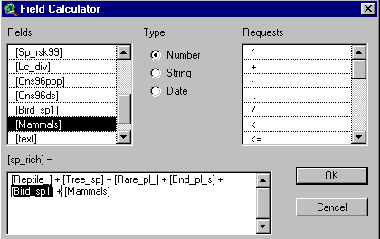

9. Click Calculate button.

We will build an expression that will compute the species richness. To do this, double click on each component to be added to the expression. This will sum the selected columns. The expression should look like [reptile] + [tree_sp] + [rare_pl] + [end_pl_s] + [bird_spl] +[mammals].

10. Click O.K.

The calculated values should appear in the sp_rich field.

11. Click MENU item Table.
12. Click Stop Editing.
13. To save edits, click Yes.

ArcView - CREATING A CHART
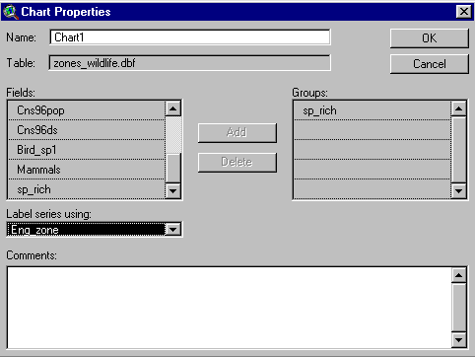
1. Click Create Chart button.
2. From Field list, select sp_rich.
3. Click Add.
4. Open Label Series Using list.
5. Select eng_zone.
6. Click O.K.

? From the graph you created in ArcView, which ecozone has the highest species richness? Why?

7. Close the graph window.
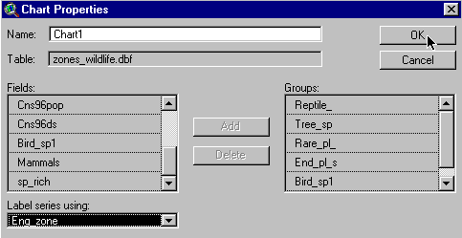
8. From the Table, select Mixedwood Plains record.

9. Click Create Graph button.

10. From Fields list, add reptiles, trees, rare plants, endemic plants, birds and mammals to groups.
11. Open Label Series Using list.
12. Select eng_zone.
13. Click O.K.

? Which species group makes up the largest percentage of the species richness in the Mixedwood Plains ecozone?

14. Close the graph window.
15. Activate the table and click the Select None button.
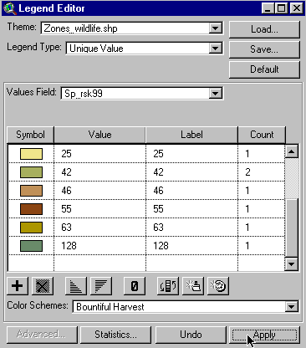
16. Close the table.

Now, we'll look at the species at risk in each ecozone.

1. Double click zones_wildlife theme.
2. Open Legend Type. Select Unique Value.
3. In the Values Field select Sp_rsk99.
4. Click Apply.
5. Close Legend Editor window.

? Which ecozone has the largest number of species at risk?
Why?

6. Check pop_centers theme to make it visible.

? Is there a correlation between species at risk and centers of high population?

ArcView - USING EXISTING HOT LINKS TO QUERY TEXT TIED
TO A MAP
1. Click Hot Link button.

2. Move the cursor to the ecozone you want to study. Click on it.
3. From the list of forest dependent species at risk that appears, select two.
4. Using the Internet, access the http:/www.speciesatrisk.gc.ca/Species/English/SearchRequest.cfm Web site.
5. Research these two species and compile a fact sheet.

ArcView - MAP LAYOUT FOR PRINTING

Once you have a map classified and displayed to your satisfaction, you should prepare a map layout that can be used for printing. The purpose of this lesson is to set up your map on a page and annotate it for presentation.

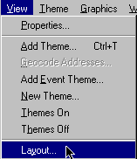
Set up map

1. Click Menu View.
2. Click Layout.

3. Select the Layout Template you want to use
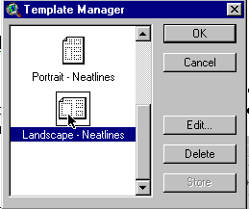
(one of the landscape templates is suggested) .

4. Click O.K.
5. Maximize the Layout screen.

EDIT TITLE

1. Double click on the title View1.
2. Edit the title to reflect the purpose of the map, e.g., forestry, population.
3. Click O.K.
4. Resize the title using the corner handles and move it into a position that is visually balanced.
5. Click and drag to reposition the legend if necessary.

EDIT NORTH ARROW

1. Double click on the north arrow and select a different presentation. Ensure that the arrow is pointing in the representative north direction of the map.
2. Click and drag to reposition or rotate (using rotation function) as needed.

EDIT SCALE BAR

1. Double click the scale bar.
2. Choose a new style of scale bar. The scale bar has default properties so you will not be able to change everything to the way you want.
3. Change the units to kms.
4. Find a combination of style, scale and divisions that is visually pleasing.
5. Click and drag to position to an appropriate location.

ADD LABELS, TEXT, OTHER INFORMATION

1. Click on the Text tool.
2. Click at the position on your layout where you want the text to appear.
3. In the Text Properties box, enter your text, e.g., “produced by (your name, date)”.
4. Select desired formatting information such as alignment, spacing and rotation.
5. Click O.K. when it appears as you want it.
6. Click on Pointer tool.
7. Select the new text
8. Click once to change location or size. Click twice to change content.

! Experiment with all of the components of the layout until you have the look you want.

CHANGE THE NAME OF THE LAYOUT

You only have to do this if you want to save your project on the computer or on a disk.

1. Click menu Layout.
2. Select Properties.
3. Change the “name”. Click O.K.

ARRANGING YOUR LAYOUT

! Experiment with the layout buttons (use the tools page provided at the beginning of this lesson if you are unsure of their function).
- to group (tie pieces together so they move as one)
- to ungroup (break apart the ties so that individual pieces move)
- bring to front ( change order that pieces were laid down, e,g, lines on top of polygons)
- send to back ( change order that pieces were laid down, e,g, polygons behind lines)
- zoom ( make image bigger or smaller)
- neat line (border around layout)

PRINT MAP LAYOUT

1. Click Print button.
2. Click Setup.
3. Select your printer properties as outlined by your teacher.
4. Click O.K. to print.

! Note that the map can also be saved to a printer file.

Wildlife and Species Richness of Canada

ArcView Student Activity Sheet

Name:

*Answers to the following questions can be obtained while completing the Wildlife and Species Richness of Canada ArcView Lesson.

- How is it different from the non-referenced map?
.

- What can you say about the distribution of bird species across Canada?
.

- Find the ecozone with the greatest number of bird species. Give some possible reasons why this ecozone has the greatest number of bird species.
.

- Find the ecozone with the greatest number of mammal species. Give some possible reasons why this ecozone has the greatest number of mammal species.
.

- Determine the ecozone with the greatest number of tree species (tree_sp).

.

- Determine the ecozone with the greatest number of reptiles & amphibians (reptile_).

.

6) Which ecozone has no tree species?

Why? .

7) Which ecozones have no reptiles or amphibians?

Why?

8) From the graph you created in Arc View, which ecozone has the highest species richness?

Why?

9) Which species group makes up the largest percentage of the species richness in the Mixedwood Plains ecozone? .

10) Which ecozone has the largest number of species at risk?

Why?

11) Is there a correlation between species at risk and centers of high population?

