Water Resources
and Pollution
in Canada

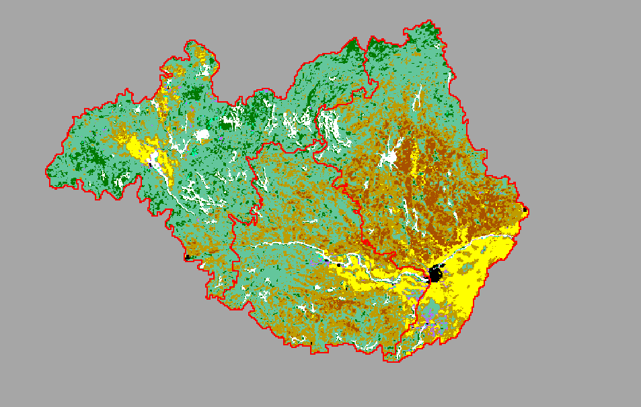



Table of Contents

Section Page

Lesson Objectives 3

Curriculum Expectations 3

Teacher Package (Academic Lesson) 4

Teacher Package (Applied Lesson) 5

Academic Performance Task, Expectations and Rubric 6

Applied Performance Task, Expectations and Rubric 8

Water Resources and Pollution in Canada 10

What is a DEM (Digital Elevation Model)? 12

Water Resources and Pollution in Canada Student Activity Sheets 13

Water Resources and Pollution in Canada Internet Resources 17

Water Resources and Pollution in Canada - MFworks Lesson 18

Water Resources and Pollution in Canada - MFworks Lesson Activity sheet 30

Lesson Objectives

- Explore the major drainage and water bodies of Canada.
- Study the relationships between drainage and watersheds.
- Learn about the hydrological make-up of the ecozones of Canada.
- Investigate sources of water pollution.
- Learn about the structure of Digital Elevation Models (DEM).
- Learn how to build a watershed mask in a GIS setting.
- Build multi-layer maps.
- Create a coloured relief map.
- Learn how to build a slope map from a DEM.
- Model changes in sea level due to climate change.
- Build a map layout.

Curriculum Expectations

The Ontario grade 9 curriculum expectations were used as a basis for preparing the lessons in this series. Although there is no direct correlation between Ontario expectations and other provinces, in general, the issues covered in the lessons do relate to many of the curriculum requirements in other jurisdictions. The full curriculum expectations can be found at the Ontario Ministry of Education Web site

English http://www.edu.gov.on.ca/eng/document/curricul/secondary/canadian/canaful.html
French http://www.edu.gov.on.ca/fre/document/curricul/secondary/canadian/canaful.html

The performance tasks for Grade 9 Academic were based directly on curriculum expectations selected from the policy document for Canadian and World Studies. The tasks encompassed the four categories of knowledge and skills (i.e., Knowledge/Understanding, Thinking/Inquiry, Communication, and Application), requiring students to integrate their knowledge and skills in meaningful learning experiences.
The rubric for a specific performance task is intended to provide teachers and students with an overview of the expected final product with regard to the knowledge and skills being assessed as a whole. The rubric identifies key criteria by which the students’ work is to be assessed, and it provides descriptions that indicate the degree to which the key criteria have been met. The teacher can use the descriptions of the different levels of achievement given in the rubric to assess student achievement on a particular task.

Teacher Package

Academic Lesson

Title: Ottawa River Watershed, Potential Sources of Pollution

Time requirement: Prior learning and skill development:
1 period of 70 minutes each
MFworks lesson
1 to 2 periods of 70 minutes each
Student research and proposal writing:
1 period of 70 minutes each
Teacher Instructions:
- Description of the Task
(see Academic Performance Task, Expectations and Rubric).

- Final Product
Each student will show research on how different land use patterns affects water quality and write a report outlining various procedures, which could be imposed to improve water quality. The report should conclude by suggesting ways to prepare for the future, to insure that high water quality is available for future generations. Students are instructed to include supporting visuals, such as maps, graphs, charts, diagrams, or pictures, in the report.

- Assessment and Evaluation
The final product will be assessed using the Expectations and the Performance Task Rubric.
Formal and informal assessment of the students based on prior knowledge, lesson objectives, production of their MFworks Map, research process can be done using the Background Information, the students’ activity sheets (on the Background and on the MFworks lesson), and the Rubric for assessing Maps. Self- or peer assessments and collaboration may be useful to the teacher and students. Students will be exposed to a Digital Elevation Model in the Background Information and in the MFworks lesson. This lesson looks at the Ottawa River Watershed using MFworks. It deals with building masks, created slope and shaded relief maps from DEM, composite overlays and data analysis.

- Accommodations
Accommodations that are normally provided in the regular classroom for students with special needs should be provided in the administration of this performance task.

- Rubric
Introduce the task-specific rubric to the students before giving the administrative task. Review the rubric with the students and ensure that each student understands the criteria and descriptions for achievement at each level.
Some students may perform below level 1. It will be important to note the characteristics of their work in relation to the criteria in the assessment rubric and to provide feedback to help them improve.

Teacher Package

Applied Lesson

Title: Future Water Quality Debate

Time requirement: Prior learning and skill development:
1 period of 70 minutes each
MFworks lesson
1 to 2 periods of 70 minutes each
Computer Presentation
1 period of 70 minutes each
Teacher Instructions:
- Description of the Task
(see Applied Performance Task, Expectations and Rubric)

- Final Product
Students will research how different land use patterns affects water quality and in groups prepare for a debate focused on the improvement of water quality. The debate should focus on suggesting ways to prepare for the future, to insure a high water quality for future generations. Students are instructed to include supporting visuals, such as maps, graphs, charts, diagrams, or pictures, in the debate.

- Assessment and Evaluation
The final product will be assessed using the Expectations and the Performance Task Rubric.
Formal and informal assessment of the students based on prior knowledge, lesson objectives, production of their MFworks Map; research process can be done using the Background Information, the students’ activity sheets (on the Background and on the MFworks lesson), and the Rubric for assessing Maps. Self- or peer assessments and collaboration may be useful to the teacher and students. Students will be exposed to a Digital Elevation Model in the Background Information and in the MFworks lesson. This lesson looks at the Ottawa River Watershed using MFworks. It deals with building masks, created slope and shaded relief maps from DEM, composite overlays and data analysis.

- Accommodations
Accommodations that are normally provided in the regular classroom for students with special needs should be provided in the administration of this performance task.

- Rubric
Introduce the task-specific rubric to the students before giving the administrative task. Review the rubric with the students and ensure that each student understands the criteria and descriptions for achievement at each level.
Some students may perform below level 1. It will be important to note the characteristics of their work in relation to the criteria in the assessment rubric and to provide feedback to help them improve.

Academic Performance Task, Expectations and Rubric

The Task

This lesson looks at the Ottawa River Watershed in particular, using MFworks. It deals with building masks, created slope and shaded relief maps from DEM (Digital Elevation Model), composite overlays and data analysis. Students begin by examining various land use patterns, as they exist in the Ottawa River Watershed. Land use patterns include agriculture, urbanization, soils, and vegetation patterns as they relate to water quality. Students will research how different land use patterns affects water quality and write a report outlining various procedures, which could be imposed to improve water quality. The report should conclude by suggesting ways to prepare for the future, to insure that high water quality is available for future generations. Students are instructed to include supporting visuals, such as maps, graphs, charts, diagrams, or pictures, in the report.

Expectations
This task gives students the opportunity to demonstrate achievement of the following selected expectations from three strands: Geographic Foundations: Space and Systems; Understanding and Managing Change; and Methods of Geographic Inquiry.

Students will:
- analyse factors that affect natural and human systems in Canada;
- demonstrate an understanding of the challenges associated with achieving resource sustainability, and explain the implications of meeting or not meeting those challenges for future resource use in Canada;
- explain the role of government in managing resources and protecting the environment.
- synthesize information on changes in the geography of Canada, such as changes in land use and urban patterns, as well as resource depletion, in order to plan for the future;
- identify and analyse patterns of spatial organization, including land use, population distribution, and ecozones;
- create and use effectively photographs, charts, graphs, models, and diagrams
- demonstrate an understanding of the methods used to collect, organize, manipulate, and interpret geographic data.

Prior Knowledge and Skills
To complete this task, students are expected to be able to demonstrate the following:

- know ways in which rivers are important to our lives and our culture;
- know about runoff, drainage basins, drainage divide, river flow, etc.;
- know about major Canadian water bodies;
- know about the hydrologic cycle;
- have an idea of water as a resource, Canada’s supply of fresh water and the demands for water resources;
- have an idea of how rivers and water basins get contaminated;
- ability to read, analyse, and interpret satellite imagery and graphs;
- ability to use a variety of tools and technologies for research;
- select and use appropriate methods for displaying geographic data;
- use geographic data to support conclusions and opinions.

Task Rubric – Ottawa River Watershed, potential sources of pollution

Expectations |  |  | Criteria |  |  | Level 1 (50 – 59) |  |  | Level 2 (60 –69) |  |  | Level 3 (70 – 79) |  |  | Level 4 (80-100)

Knowledge / understanding
1, 2 |  | - Analyse factors that affect natural and human systems in Canada;  - Demonstrate an understanding of the challenges associated with achieving resource sustainability, and explain the implications of meeting or not meeting those challenges for future resource use in Canada |  |  | - Shows little analyses of factors that affect natural and human systems  - Demonstrates little understanding of the challenges associated with achieving resource sustainability |  |  | - Shows some analyses of factors that affect natural and human systems  - Demonstrates some understanding of the challenges associated with achieving resource sustainability |  |  | - Shows considerable analyses of factors that affect natural and human systems  - Demonstrates considerable understanding of the challenges associated with achieving resource sustainability |  |  | - Shows a high degree of analyses of factors that affect natural and human systems  - Demonstrates a high degree of understanding of the challenges associated with achieving resource sustainability

Thinking / Inquiry
4, 7 |  | - Use a variety of relevant supporting facts and details  - Explain the significance of the information selected |  |  | - Uses a limited variety of relevant supporting facts and details  - Explains the significance to a limited degree |  |  | - Uses some variety of relevant supporting facts and details  - Explains the significance to some degree |  |  | - Uses a considerable variety of relevant supporting facts and details  - Explains the significance to a considerable degree |  |  | - Uses a wide variety of relevant supporting facts and details  - Explains the significance to a high degree

Communication
6 |  | - Use visuals to illustrate the importance of report |  |  | - Uses visuals to illustrate the importance to a limited degree |  |  | - Uses visuals to illustrate the importance to some degree |  |  | - Uses visuals to illustrate the importance to a considerable degree |  |  | - Uses visuals to illustrate the importance to a high degree

Application
3 |  | - Explain the role of government in managing resources and protecting the environment. |  |  | - Demonstrates little understanding |  |  | - Demonstrates some understanding |  |  | - Demonstrates considerable understanding |  |  | - Demonstrates a high degree of understanding

Applied Performance Task, Expectations and Rubric

The Task
This lesson looks at the Ottawa River Watershed in particular, using MFworks. It deals with building masks, created slope and shaded relief maps from DEM (Digital Elevation Model), composite overlays and data analysis. Students begin by examining various land use patterns, as they exist in the Ottawa River Watershed. Land use patterns include agriculture, urbanization, soils, and vegetation patterns as they relate to water quality. Students will research how different land use patterns affects water quality and in groups prepare for a debate focused on the improvement of water quality. The debate should focus on suggesting ways to prepare for the future, to insure a high water quality for future generations. Students are instructed to include supporting visuals, such as maps, graphs, charts, diagrams, or pictures, in the debate.

Expectations
This task gives students the opportunity to demonstrate achievement of the following selected expectations from three strands: Geographic Foundations: Space and Systems; Understanding and Managing Change; and Methods of Geographic Inquiry.

- demonstrate an understanding of the challenges associated with achieving resource sustainability and explain the implications of meeting or not meeting those challenges for future resource use in Canada;
- create and implement a plan to address a local environmental concern;
- synthesize information on changes in the geography of Canada, such as changes in land use and urban patterns, as well as resource depletion, in order to plan for the future;
- predict the consequences of human activities (e.g., agriculture, recreation) on natural systems (e.g., soil depletion, climate change);
- use communication skills (e.g., letter writing, debating, consensus building) effectively to promote environmental awareness;
- provide evidence to support conclusions and opinions;
- create and use effectively photographs, charts, graphs, models, and diagrams.

Prior Knowledge and Skills
To complete this task, students are expected to be able to demonstrate the following:

- know ways in which rivers are important to our lives and our culture;
- know about runoff, drainage basins, drainage divide, river flow, etc.;
- know about major Canadian water bodies;
- know about the hydrologic cycle;
- have an idea of water as a resource, Canada’s supply of fresh water and the demands for water resources;
- have an idea of how rivers and water basins get contaminated;
- ability to read, analyse, and interpret satellite imagery and graphs;
- ability to use a variety of tools and technologies for research;
- select and use appropriate methods for displaying geographic data;
- use geographic data to support conclusions and opinions;
- communicate the results of geographic inquiries using appropriate methods and technologies, and present viewpoints on issues affecting Canadians;
- use cartographic conventions correctly when constructing maps (e.g., scale, legend, direction).

Task Rubric – Future Water Quality Debate

Expectations |  |  | Criteria |  |  | Level 1 (50 – 59) |  |  | Level 2 (60 –69) |  |  | Level 3 (70 – 79) |  |  | Level 4 (80–100)

Knowledge / understanding
1 |  | - Demonstrate an understanding of the challenges associated with achieving resource sustainability, and explain the implications of meeting or not meeting those challenges for future resource use in Canada |  |  | - Demonstrates little understanding of the challenges associated with achieving resource sustainability |  |  | - Demonstrates some understanding of the challenges associated with achieving resource sustainability |  |  | - Demonstrates considerable understanding of the challenges associated with achieving resource sustainability |  |  | - Demonstrates a high degree of understanding of the challenges associated with achieving resource sustainability

Thinking / Inquiry
3, 4 |  | - Predict the consequences of human activities on natural systems to plan for the future |  |  | - Fails to predict the consequences of human activities on natural systems to plan for the future |  |  | - Shows some consequences of human activities on natural systems to plan for the future |  |  | - Shows considerable consequences of human activities on natural systems to plan for the future |  |  | - Shows a high degree of consequences of human activities on natural systems to plan for the future

Communication
5, 6, 7 |  | - Use visuals and collected research to support conclusions and opinions in debate |  |  | - Uses visuals and collected research to support conclusions and opinions in debate to a limited degree |  |  | - Uses visuals and collected research to support conclusions and opinions in debate to some degree |  |  | - Uses visuals and collected research to support conclusions and opinions in debate to a considerable degree |  |  | - Uses visuals and collected research to support conclusions and opinions in debate to a high degree

Application
2 |  | - Create and implement a plan to address a local environmental concern; |  |  | - Fails to create and implement a plan |  |  | - Creates and implements of a plan to some degree |  |  | - Creates and implements a good plan |  |  | - Creates and implements a good and very efficient plan

Water Resources and Pollution in Canada

Although water covers 75% of the earth’s surface, much of it is in oceans and seas, which contain high mineral salt content. Humans and many other life forms cannot use this salt water to hydrate their living cells. It is therefore essential for us to have fresh water, that is, water with very low mineral salt concentrations. Of all the water on the earth, only 2.7% is fresh water thus making it a precious commodity. Of that, Canada has almost 10% of the world supply. This water is held in the Great Lakes and the numerous inland lakes and rivers that constitute our landscape.

Within Canada, the St. Lawrence River, which drains the Great Lakes, has the largest discharge of fresh water and the Mackenzie River in British Columbia is the longest. Many of Canada’s largest lakes are found on the edge of the Canadian Shield. These lakes were gouged into the landscape as the glaciers moved off the bedrock and pushed into the sedimentary rock surrounding the Shield. Great Bear Lake, Great Slave Lake, Lake Winnipeg and four of the five Great Lakes (Huron, Superior, Ontario and Erie) are found on the edge of the Canadian Shield.

Amazing facts and figures about fresh water in Canada.

- In Canada there are 755,180 km² of freshwater lakes, ponds and rivers (>100 m. wide).
- The Mackenzie River has the largest drainage area at 1, 805, 200 km^{2.}
- The Mackenzie River is the longest river in Canada at 4241 km.
- The St. Lawrence River has the greatest annual discharge at 9 850 m³
- Wollaston Lake, Saskatchewan, at 2681 km², is the largest lake in the world that drains in two directions, north to the Mackenzie River basin and east to Hudson Bay.

Not all-fresh water comes from rain. Glaciers and ice fields produce the largest portion of fresh water, followed by underground aquifers, lakes and rivers and lastly, precipitation. Most fresh water that comes from meltwater or precipitation is collected in the major watersheds. Acting as large catchments, water drains off the highland surfaces into a network of increasingly larger streams and rivers, which eventually empty into the oceans. Canada has four major drainage basins or watersheds; three that flow directly into oceans, one that flows into Hudson Bay which eventually also empties into the Atlantic Ocean. One smaller, yet very important watershed within Canada flows through the United States into the Gulf of Mexico from central Canada.

The five major watersheds of Canada are fed by major Canadian rivers.

Yukon River
Columbia River Pacific watershed
Fraser River

Mackenzie River Arctic watershed

Nelson River
South Saskatchewan River Hudson Bay watershed

St. Lawrence River Atlantic watershed

Portions of
Milk River
Frenchman River Gulf of Mexico watershed

Water that is caught in depressions and lowlands produces swamps, bogs and marshes known as wetlands. These, as well as other large flat areas, which do not drain off quickly, serve as recharge areas for groundwater. Because this water cannot run off into lakes and rivers, it is strained through the surficial material into underground aquifers. These aquifers extend from the bedrock upward. The level to which the water rises from the bedrock in the ground is called a water table. This water source is reached by means of wells drilled into the ground and the water is pumped to the surface. Wells are the only source of water for many areas that are at a distance from rivers or lakes.

Because water is such an important resource, man has endeavored to control it. Not only can it be used for human and animal consumption, but also for irrigation, mining, manufacturing and electrical power generation. Man has constructed reservoirs and dams to contain the water. Benefits are numerous in the form of a constant water supply, electricity production, control of flood conditions and recreational uses. However, the construction of a dam or reservoir is destructive as well. Land up river is flooded with respective damage done to vegetation, forests and the need to relocate humans and animals. Changes in water levels and in water flows destroy natural habit for many fish as well as impacting their spawning grounds. In Canada, every major river has some form of water control in effect.

As a study example, let's look at the Ottawa River drainage system. The Ottawa River is 1271 km. long. It collects water from many lakes and streams in its headwaters in the upper Ottawa valley and has a total drainage area of 146 300 km². At Ottawa it is fed by the Rideau River (drainage area of 3800 km²) and the Gatineau River (drainage area of 23 700 km²). It is later joined by the Rivière du Lièvre and the South Nation River (drainage area of 3830 km²). The Ottawa River empties into the St. Lawrence River at the Lake of Two Mountains just west of the island of Montréal.

Pollution

Water in Canada is often taken for granted and the necessary precautions to protect it are not always followed. Conflicts between man and nature are inevitable. Most of Canada’s population lives on the edge of major rivers or lakeshores. Our water supply is often drawn from these same lakes and rivers. Those who live away from rivers, such as sections of the prairie region, draw their water from aquifers. However, we cannot take clean, potable water for granted. Where there is human habitation there is often accompanying waste products in the form of garbage, sewage, industrial discharge and smog. This contamination of our clean environment is called pollution. Some pollution is very visible such as a waste disposal site. But other sources of pollution are not as obvious. Runoff from these same garbage disposal sites, seepage from waste treatment plants and illegal dumping all contribute to polluted lakes, rivers and groundwater. Precipitation causes agricultural waste, fertilizers and pesticides to run off farmland into water sources. Industrial gases such as carbon monoxide and sulfur dioxide from manufacturing and milling plants form smog, which in combination with precipitation forms acid rain. When this rain falls it contaminates not only our water resources but our land as well. It is evident in stunted tree growth, deteriorating masonry on buildings and clear lakes with no fish or lush vegetation. Industrial discharge from factories and production plants also contains such toxic elements as PCBs, dioxin, mercury, iron, lead, nickel, zinc, cadmium and arsenic. These contaminants pollute not only the location at which they are released but influence, in varying degrees, the ecosystem of the drainage basin all the way to the ocean.

What is a DEM (Digital Elevation Model)?

A DEM or Digital Elevation Model is a digital representation of elevation. Most imagery, at least in Remote Sensing applications, is taken from high altitudes looking straight down. It is often useful to simulate the view an observer would have if standing on the ground looking out over the image.
This is known as perspective scene. Those of you who play Nintendo or Play Station games have seen several of those perspective scenes. In order to create such a scene we need a DEM.

DEMs have many uses. Among the most important are the following:
- Storage of elevation data for digital topographic maps in national databases;
- Cut-and-fill problems in road design and other civil engineering projects;
- Three-dimensional display of land forms for military purposes (weapon guidance systems, pilot training) and for landscape design planning (landscape architecture);
- Planning routes for roads, locations of dams, etc.;
- Computing slope and aspect maps, and slope profiles that can be used to assist applications such predicting erosion hazards;
- As a background for displaying thematic information or for combining relief data with thematic data such as soils, land use or vegetation.

A Digital Elevation Model (DEM) as represented in the raster system, is simply an image layer where the values of each grid square represent the mean height, or elevation of land above some base plane. Sea level is commonly used as the base elevation. DEMs are commonly represented as the highest points being a bright colour or white, and the lowest points as dark colours or black. Each pixel will have a DEM value. The higher the value the higher is the elevation.

25 | 30 | 31 | 36
22 | 40 | 42 | 38
25 | 33 | 39 | 36
20 | 23 | 38 | 37

- This information is taken from the Student Manual “Digital Image Processing Using EOScape” from PCI Enterprises

- In the Teacher Tools Section of this lesson we are providing you with a Fly Demo of a DEM.

Water Resources and Pollution in Canada
Student Activity Sheets
Name:
*Most of the answers to these questions can be found in the Water Resources and Pollution Sources in Canada background sections.

- Match the numbers on the map to the names of the water bodies, rivers and lakes in the Table on the next page.

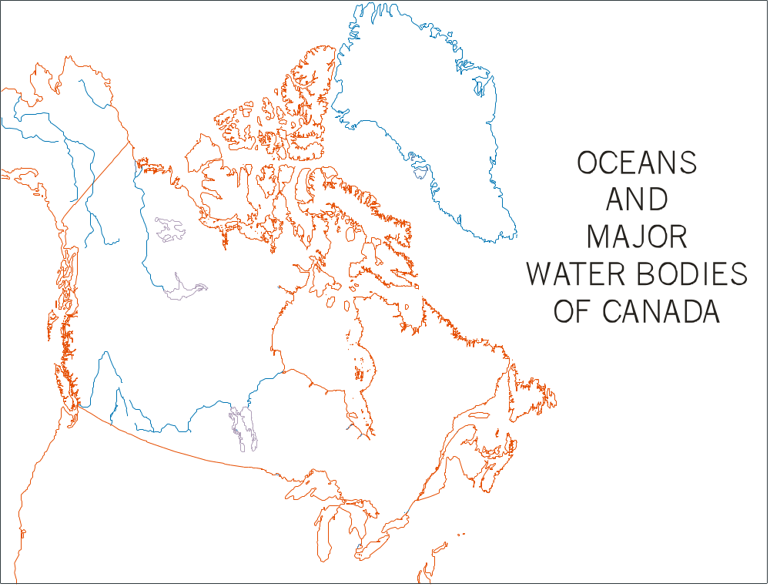
Match the numbers on the map to the names of the water bodies, rivers and lakes in the Table on the next page.

Major Water Bodies |  | Major Rivers
 | Arctic Ocean |  | Mackenzie River
 | Atlantic Ocean |  | St. Lawrence River
 | Pacific Ocean |  | Columbia River
 | Belle Isle Strait |  | Fraser River
 | Bay of Fundy |  | Yukon River
 | Admunsen Gulf |  | Nelson River
 | Hudson Bay |  | South Saskatchewan River
 | James Bay
 | Queen Charlotte Str. | Major Freshwater Lakes
 | Foxe Basin |  | Great Slave Lake
 | Juan de Fuca Strait |  | Lake Superior
 | Hudson Strait |  | Lake Winnipeg
 | Queen Maude Gulf |  | Lake Erie
 | Gulf of St. Lawrence |  | Great Bear Lake
 | Coronation Gulf |  | Lake Huron
 | Hecate Strait |  | Lake Michigan
 | Ungava Bay |  | Lake Ontario

- Can you draw the major drainage divides between the drainage systems? The dividing line follows the high ground from which the water flows downward into the valleys. Remembering where the mountain ranges are will give you a start. Show the four largest watersheds and indicate to which ocean they flow. Overlay the drainage basin map and see how close you came to predicting the watersheds.

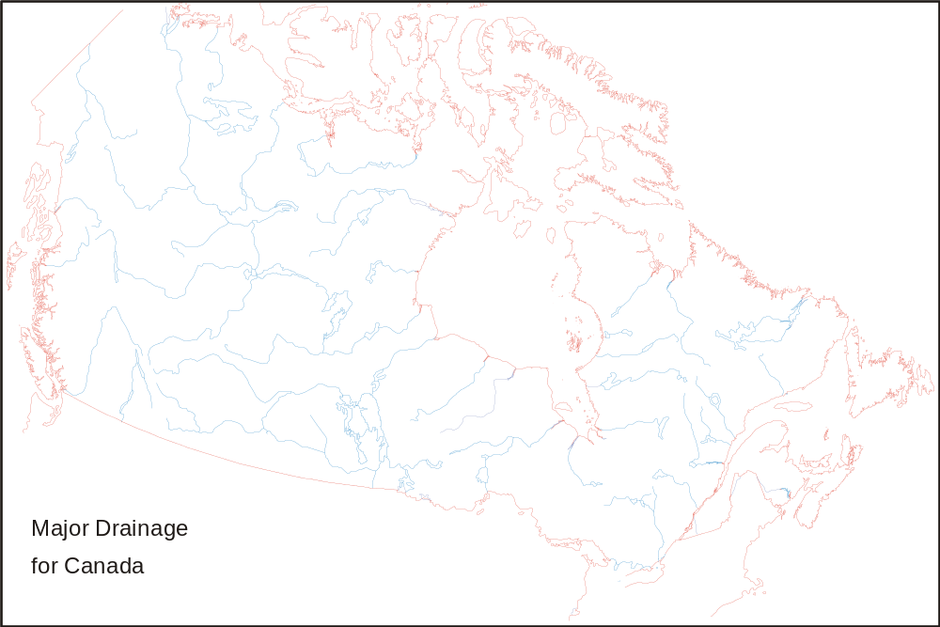

Ecozone names | Total Area (ha) | Water Area (ha) | Water as %of area | Discharge sites | No. of mines | No. of mills
Arctic Cordillera | 24218992 | 588129 | 0.02 | 0 | 0 | 0
Northern Arctic | 150787239 | 16951955 | 0.11 | 1 | 4 | 0
Southern Arctic | 83976042 | 19440507 | 0.23 | 0 | 1 | 0
Taiga Plains | 65212536 | 10300907 | 0.16 | 18 | 0 | 1
Taiga Shield | 138182116 | 30421678 | 0.22 | 4 | 2 | 0
Boreal Shield | 193751675 | 31664613 | 0.16 | 181 | 32 | 49
Atlantic Maritime | 21386312 | 1717260 | 0.08 | 140 | 16 | 26
Mixedwood Plains | 16820378 | 5842462 | 0.35 | 513 | 10 | 22
Boreal Plains | 73728656 | 7301227 | 0.10 | 157 | 4 | 12
Prairies | 46509379 | 1104775 | 0.02 | 234 | 9 | 1
Taiga Cordillera | 26537469 | 500145 | 0.02 | 0 | 0 | 0
Boreal Cordillera | 46786981 | 1694849 | 0.04 | 15 | 8 | 0
Pacific Maritime | 20792528 | 625532 | 0.03 | 315 | 3 | 14
Montane Cordillera | 48789560 | 1677879 | 0.03 | 434 | 9 | 6
Hudson Plains | 37371829 | 2770218 | 0.07 | 2 | 0 | 0

- From the table above, which ecozone has the proportionally largest amount of water?
_____________________________________________________________________________

- From the number of pollution producing factors listed in the Background Information, which ecozone would you estimate to be most polluted?
_____________________________________________________________________________

- What are the industries within your region that contribute to pollution?
_____________________________________________________________________________
_____________________________________________________________________________
_____________________________________________________________________________
_____________________________________________________________________________

3D map of Ottawa Valley
- Determine the water drainage basin for the headwaters of the Ottawa River.
_____________________________________________________________________________

- What water control features are built on this river system?
_____________________________________________________________________________
_____________________________________________________________________________
_____________________________________________________________________________
_____________________________________________________________________________

- How is water managed and why?
_____________________________________________________________________________
_____________________________________________________________________________
_____________________________________________________________________________
_____________________________________________________________________________

- What pollution contributors can you identify in the region?
_____________________________________________________________________________
_____________________________________________________________________________
_____________________________________________________________________________

- What are the potential pollution sources?
_____________________________________________________________________________
_____________________________________________________________________________
_____________________________________________________________________________
_____________________________________________________________________________

- How is the water for human consumption protected? (Water treatment- intake, sewage treatment –outflow)
_____________________________________________________________________________
_____________________________________________________________________________
_____________________________________________________________________________
_____________________________________________________________________________

- Why are the Ottawa beaches sometimes closed after heavy rains?
_____________________________________________________________________________
_____________________________________________________________________________
_____________________________________________________________________________
_____________________________________________________________________________

Water resources and Pollution in Canada
Internet Resources

References

Facts about Canada
http://atlas.gc.ca/english/facts

Drainage basins
Rivers
Waterfalls
Glaciers
Mountains

Water is the lifeblood of the Earth
Excellent site from Environment Canada on water
http://www.ec.gc.ca/water/accueil.htm

Freshwater Series
Available at: Enquiry Centre
Environment Canada
Ottawa, Ontario
K1A 0H3
Tel: (819) 997-2800
Toll free: 1-800668-6767
Fax: (819) 953-2225

Building a Mask
Stacking Layers
Producing a Layout Presentation
Digital Elevation Model Study
Using a Model
Creating a Relief Map

MFworks Lesson

Water Resources and Pollution in Canada

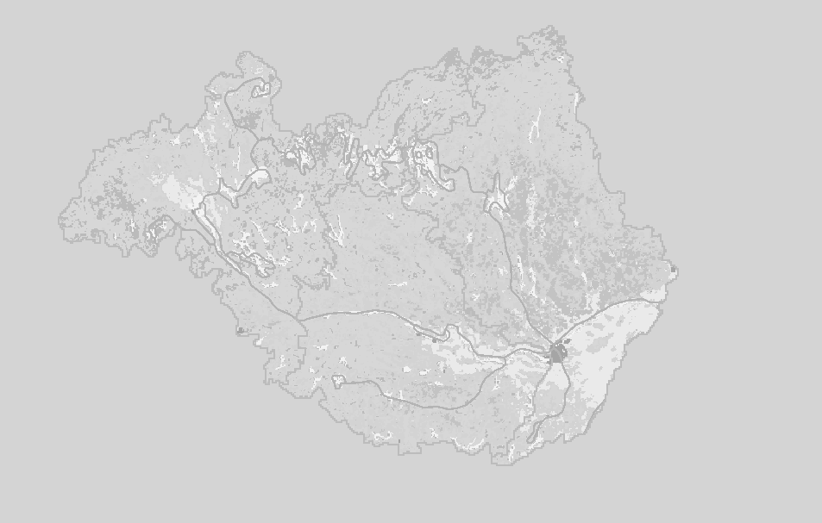

MFworks Icons and Tool Bars

Create new map | Open map | Save Map | Print Map |  | Cut | Copy | Paste |  | Font | Bold | Italic | Underline |  | View Legend | Select Legend | Display Information | Display Comment | Display Layout |  | New Script |  | Help | About

Tool Bar
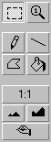

Select Tools

Numeric Magnifying Glass

Freehand Drawing Tool

Draw Line Tool

Draw Polygon Tool

Fill Tool

Zoom To

Zoom Out

Zoom In

Redraw Map

For more information check: http://www.thinkspace.com

STARTING MFworks

Before you begin, the lesson data folder must be copied into a drive in which the student has writing and editing capabilities. This will probably be the drive containing your own personal account on the school’s system or it may be the C: drive of the machine you are currently working on. If the latter is the case you will have to work on the same machine each day until this assignment is complete. Each school set-up is different so work with your teacher to prepare your data folder.

! (The data for the lesson must first be downloaded from this Web site and placed on the school computer or network. Ask your teacher where to find the data folder that has been downloaded).

To do this, use the file manager program on your computer. For windows based systems this will be My Computer / Windows Explorer /.

Once the data folder has been copied to the required destination the files must be made usable by removing the read only attribute. For windows based systems follow these instructions:

! (The data downloaded from the Web Site is set as read only so that it cannot be changed or altered by accident.)

1. Open your new data folder.
2. Choose Edit > Select All (they will all appear Blue).
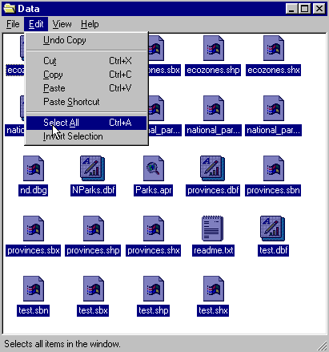

3. From the menu choose:
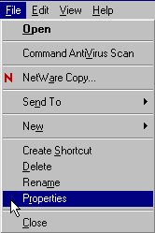 File > Properties

4. Remove the check mark in the box beside the label read only.

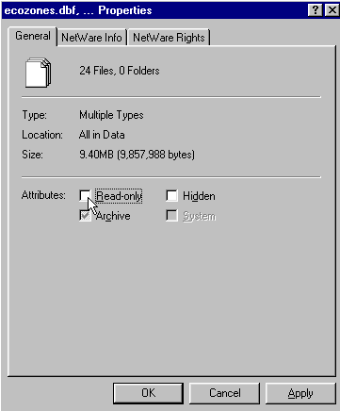

5. Click Apply, then OK.

The data in your new data folder can now be opened, edited and saved using MF Works to carry out the following project.

! Denotes an observation.
? Denotes a question that may be answered on the Student Activity Sheet.

Begin the lesson by starting up the MFworks program.

- From your system Start menu, choose Programs > MFworks > MFworks.

The MFworks program will launch. If necessary, click the window maximize button so that the MFworks window fills the screen.

! When the program starts, it automatically opens a window titled "Untitled Project." MFworks uses projects to group together and organize maps that are used together. A project has been created for you to use with this activity, so you do not need the default project.

- Choose File > Close to close the Untitled Project window.
- Choose File > Open Project to bring up the Open dialog box.
- Make sure that the folder named in the "Look in" field is the data folder just created.
- Select the file name Water_Basin.mfp and click the Open button to open that project.

! The Water_Basin.mfp project lists nine maps that you will use in this activity. You will also create several others using MFworks operations. As they are created, these new maps will automatically be listed in the Project window. In order to keep the workspace usable it is important to close or minimize any maps not in use leaving only one map open on the screen to work on. If you close a map ignore the “Save Changes” message where appropriate.
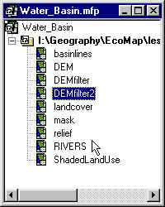
This lesson looks at the Ottawa River Watershed using MFworks. It deals with building masks, created slope and shaded relief maps from DEM, composite overlays and data analysis.

BUILDING A MASK

We will begin by building a watershed mask for the Ottawa River drainage area.
A mask limits the viewing area of a map by covering all cells that are not related to the defined feature area such as a drainage basin.

- Double Click basinlines. In the project window. This will open the basinlines map and legend windows.
- Click and Drag the edge or corner of the “basinlines” map window to enlarge the Map window to fill your screen.
- Click on Edit > Select All.
- Click on Edit > Copy.
- Click on Edit > Paste To New Map. This will create a new Map “MapLayer1” which is a copy of the basinlines map.
- Close the original basinlines map window.
- With the New Map MapLayer1 open and maximized.

- Click the Numeric Magnifying Glass button. Move the cursor over the map.

! Check the map to see that all cells are void except the boundary lines
that are 1. The Ottawa River drainage area is found on the inside of this boundary line.

Now we want to class the area surrounding the Ottawa River drainage area to 2.

- Click on the Fill Area button.
- In the Paint Value window at the bottom left of the map enter 2. This will assign the value 2 to the Fill Area button.

- Open the Paint Colour list to the left of the window.
- Select a medium grey shade.
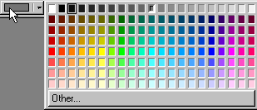

- Move the Fill Area cursor to an area outside the watershed.
- Hold down the Shift Key and click the left mouse button.
- When the area is filled, use the scroll bars to move the map in the map window. You will see new areas of the map that have not been filled yet. Repeat the fill procedure until all the area outside the Ottawa River drainage area is coded 2.

STACKING LAYERS

Now we will add the Ottawa River watershed mask that we just created to the AVHRR land cover map.

! AVHRR stands for Advanced Very High Resolution Radiometer. This is an instrument on a satellite that takes the images of the earth's surface. From these images, the data recorded by the instrument is classified into groups that represent land cover categories.

- Open the Water_Basin.mfp project window.
- Double click landcover. To open the landcover map.
- Click and Drag the edge or corner of the “landcover” map window to enlarge the Map.
- On the landcover map note that built-up areas are black and water is white.

? Can you find the cities of Montreal and Ottawa? Describe where they are.
? Can you find the Ottawa River and the St. Lawrence River? Describe these shapes and the visual appearance of these two features?

- Click the Legend button. Note the colours and values for agriculture (Yellow) and forest (Greens & Browns).
- Click the Map button.

? Can you describe the distribution of agriculture in the image?

- Click on Operation > Cover.
- Open the Map List at the bottom of the stacking order.
- Select landcover.
- Open the second Map List from the bottom.
- Select map layer1, which you created earlier.
12. Click O.K.
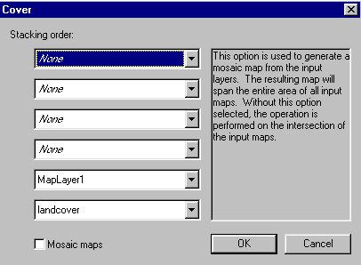
! Describe the new map MapLayer2.
? What can you say about the landcover within the Ottawa River watershed?
! Noting that the red line separates sub-basins, find the Lower (containing Ottawa) basin, Central basin, and Upper basin.
! Describe the landcover in each.
? If agricultural runoff is a major source of pollution, which sub-basin is at greatest risk? Why?
! If acidic soils have low buffering capability, that is to say, they cannot neutralize acidic rain as easily as basic soils, then they are more susceptible to the effect of acid rain. We know that coniferous forests prefer acidic rock and soil conditions. Looking at the landcover map, find the areas of acidic rock and soil by their association with coniferous forests.
? Which sub-basin is most affected by acid rain?

PRODUCE A LAYOUT PRESENTATION

We will now prepare a layout presentation of the Landcover map that can be printed.
- Click Layout button.
- Centre the map on the page.
Edit the legend as follows:

- Click Legend button.
- Click Legend > Format.

- Click and drag Value and Area from the top row down to the bottom row.
- Click and drag Text over next to Symbol Colour box.
- Apply.

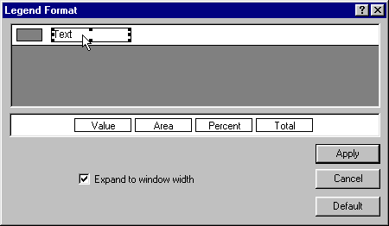

- Click Layout button.
- Click Legend Style tool button.
- Add legend.
- Click add text tool button.
- Add title.

DIGITAL ELEVATION MODEL STUDY

Let's study the digital elevation model of the Ottawa River watershed. This map will show us the relative elevations of the land surrounding the Ottawa River watershed cell by cell. We will see how the water basin collects the precipitation and funnels the water down to the river.

- Click MENU item window > Water_Basin.
- Double click DEM. (Digital Elevation Model).
- Use the Numeric Magnifying Glass to investigate the values in the DEM (digital elevation model). The values measure the mean elevation for each cell in meters above mean sea level.

? Can you identify some of the major topographic features?
? Where is the highest point?
? Where is the lowest?
? Can you trace some of the runoff patterns? Describe them here.

CREATING A SLOPE MAP

A slope map shows us the relative angle or slope between the high points and the low points on the map. The greater the angle of the slope the lighter is the image.

- Click MENU item operation > Grade.
- Open Surface Map list.
- Select DEM.
- Click Maximum Slope button.
- Click O.K.
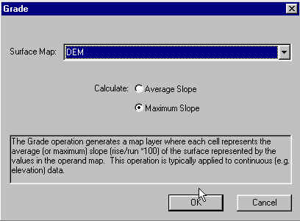

? Can you see a pattern between the runoff and the slope?
? If steeper slopes are good for ski hills, where would you expect to find the ski hills in this watershed?

CREATING A SHADED RELIEF MAP

A shaded relief map shows the relief or elevation pattern of an area by means of creating shadows. It simulates the shadows that would be observed on the ground if the sun were shining. The higher a hill or mountain, the longer is the shadow.

- Click Window > Water_Basin.
- Double click DEM filter.
3. Use the Numeric Magnifying Glass to study the values in this map to be used as a kernel in a filtering routine.

? What is the maximum value?
? What is the minimum value?
? What is the pattern of values?
? What is the size of the kernel?

- Click Operation > Filter.
- Open Surface Map list.
- Select DEM.
- Open Kernel list.
- Select DEM filter.
- Click O.K.
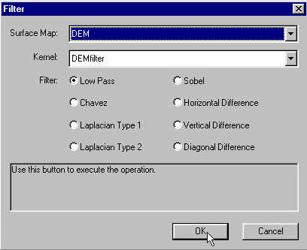

Study the shaded relief map.
? What direction is the illumination coming from?
? What happens if we rotate the filter by 180 degrees?

Repeat the process above but try using the DEMfilter2 as the kernel.
? What changes do you see?

PRODUCE A SHADED RELIEF MAP USING A LANDCOVER MAP

- Click New Script button.
- Enter the following:

shadedlandcover = relief + landcover;

- Click MENU item Script. > Check Script.
- If there are no errors, click O.K.
- Click MENU item Script > Execute Script.

? Can you see a relationship between topography and agriculture?

- Click MENU item Operation > Cover.
- Select Shadedlandcover for bottom of stack.
- Select MapLayer1 for next layer in the stack.
- Click O.K.

? What can you see in the shaded landcover map of the Ottawa River watershed?

USING A MODEL

If global warming caused a 150 metres rise in sea level due to ice cap melting, what part of the Ottawa River watershed would be flooded by seawater? Let's find out.

- Click MENU item Operation > Recode.
- Open Input Mask list.
- Select DEM.
- Enter 150 in the Assigned field.
- Enter 0…150 in the To field.
We now have recoded all the cells with values of 150 metres or less to a single value of 150 metres.

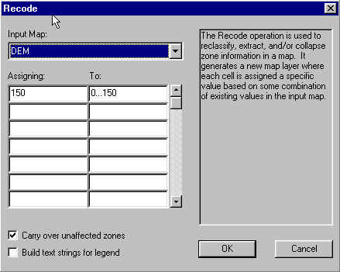

- Check Carry Over Unaffected Zones. O.K.
- Click Legend button for the new map layer.
- Click Symbol Colour box for 150.

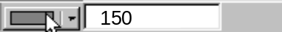

- Select a blue colour.
- Click Map button.
- Click MENU item Operations > Cover.
- Select the New Map Layer for the bottom of the stack.
- Select Mask for the next layer in the stack.

! Describe the area that would be covered with seawater.

Water Resources and Pollution in Canada
MFworks Student Activity Sheets
Name:
*Answers to the following questions can be obtained while completing the MFworks Water Resources and Pollution in Canada.

- Can you find the cities of Montreal and Ottawa? Describe where they are?
__________________________________________________________________________________________________________________________________________________________

- Can you find the Ottawa River and the St. Lawrence River? Describe these shapes and the visual appearance of these two features?
__________________________________________________________________________________________________________________________________________________________

- Can you describe the distribution of agriculture in the image?
__________________________________________________________________________________________________________________________________________________________
- What can you say about the landcover within the Ottawa River watershed?
__________________________________________________________________________________________________________________________________________________________
- If agricultural runoff is a major source of pollution, which sub-basin is at greatest risk? Why?
__________________________________________________________________________________________________________________________________________________________
- Which sub-basin is most affected by acid rain? ____________________________________

- Can you identify some of the major topographic features?
__________________________________________________________________________________________________________________________________________________________
- Where is the highest point? ____________________________________________________

- Where is the lowest? _________________________________________________________

- Can you trace some of the runoff patterns? Describe them here.
_____________________________________________________________________________
- Can you see a pattern between the runoff and the slope? ____________________________

- If steeper slopes are good for ski hills, where would you expect to find the ski hills in this watershed?
__________________________________________________________________________________________________________________________________________________________
- What is the maximum value? ____________________________
- What is the minimum value? ____________________________
- What is the pattern of values? ____________________________
- What is the size of the kernel? ____________________________
- What direction is the illumination coming from? ____________________________
- What happens if we rotate the filter by 180 degrees? ____________________________
- What changes do you see?
__________________________________________________________________________________________________________________________________________________________
- Can you see a relationship between topography and agriculture?
_____________________________________________________________________________
- What can you see in the shaded landcover map of the Ottawa River watershed?
__________________________________________________________________________________________________________________________________________________________

