学号：202021090107 姓名：熊静 作业名：第一次作业

作业要求：

客户端：

从命令行读入服务器的IP地址；并连接到服务器；

服务器端：

接收客户的连接请求，并显示客户的IP地址和端口号；

客户端程序为client1.c文件，

服务器程序为server1.c文件。

client1.c代码:

#include <stdio.h>

#include <stdlib.h>

#include <sys/socket.h>

#include <netinet/in.h>

#include <unistd.h>

#include <string.h>

#include <arpa/inet.h>

int main(int argc, char **argv){

if(argc<2)

printf("usage: %s <server address>", argv[0]);

int sockfd;

struct sockaddr_in server_addr;

sockfd = socket(AF_INET, SOCK_STREAM, 0);

memset(&server_addr, 0, sizeof(server_addr));

server_addr.sin_family = AF_INET;

server_addr.sin_port = htons(9999);

if((inet_pton(AF_INET, argv[1], &server_addr.sin_addr)) < 0)

perror("invalid IP address");

if(connect(sockfd, (struct sockaddr*)&server_addr, sizeof(server_addr)) < 0)

perror("can't connect to server");

close(sockfd);

return 0;

}

server1.c代码:

#include <stdio.h>

#include <stdlib.h>

#include <netinet/in.h>

#include <sys/socket.h>

#include <arpa/inet.h>

#include <unistd.h>

#include <string.h>

int main(int argc, char **argv){

int listenfd, connfd;

socklen_t clilen;

struct sockaddr_in server_addr, client_addr;

listenfd = socket(AF_INET, SOCK_STREAM, 0);

int opt = SO_REUSEADDR;

setsockopt(listenfd, SOL_SOCKET, SO_REUSEADDR, &opt, sizeof(opt));

memset(&server_addr, 0, sizeof(server_addr));

server_addr.sin_family = AF_INET;

server_addr.sin_addr.s_addr = htonl(INADDR_ANY);

server_addr.sin_port = htons(9999);

if(bind(listenfd, (struct sockaddr*)& server_addr,sizeof(server_addr)))

perror("bind error");

if(listen(listenfd, 10) < 0)

perror("listen error");

char buff[1024];

while(1){

clilen = sizeof(client_addr);

if(connfd = accept(listenfd, (struct sockaddr*) &client_addr, &clilen) < 0)

perror("accept error");

printf("client address: %s, client port: %d\n", inet_ntoa(client_addr.sin_addr), client_addr.sin_port);

close(connfd);

}

close(listenfd);

return 0;

}

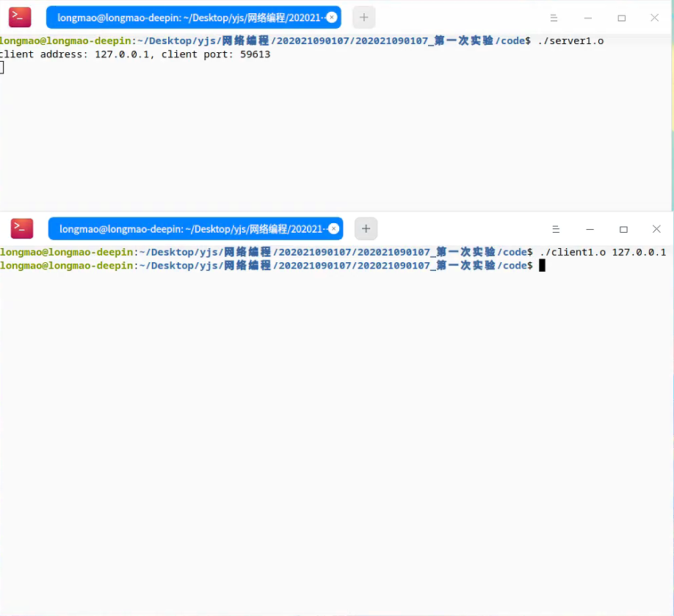运行截图: