1. Design

Concept
For this project I made Tax Evasion Surfers, a game in the same genre as Subway Surfers. I wanted the idea to be funny, so the main character owes 1 million dollars in taxes. An IRS agent knocks on his apartment door, and he jumps out the window onto a city street. From there he runs forward forever. The player has to dodge cars coming toward them, cars coming from behind, and people on the sidewalk, while picking up dollar bills. The IRS agent chases right behind and every so often jumps into a lane to try to grab you. The dollars you collect can be spent on bribes, which get people on the street to hold the agent back for five seconds.

Why this idea fits the assignment
I picked a runner game because it fits the rules of the assignment really well. A runner only moves forward and side to side, so a camera that moves in x and z without ever turning feels natural in this game. Everything in my game, like roads, buildings, cars, people and dollars, is made out of boxes and flat shapes, so it looks clear both as a wireframe and filled in. The street is built from just a few models that are copied, moved and resized hundreds of times. There are also lots of objects in front of and behind each other, like people in front of buildings, which made it a good test for my depth buffer in Level 3.

Sketch
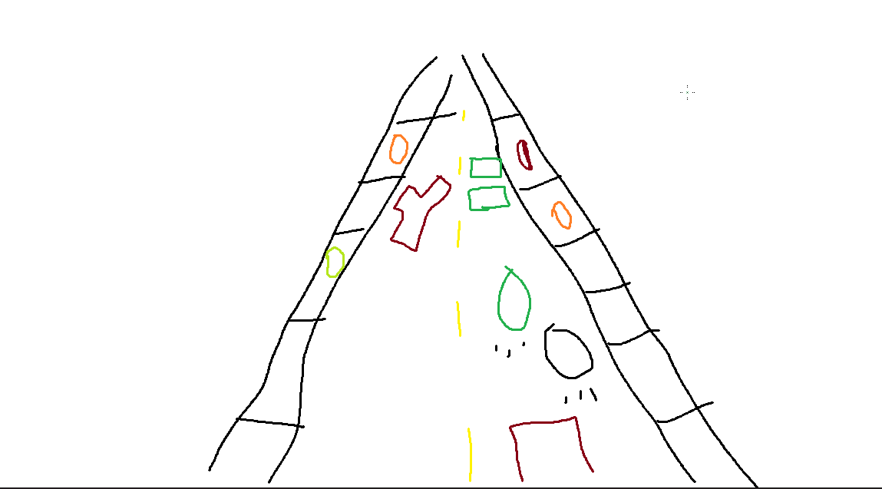
My first sketch of the street and lanes.
I split the street into four lanes, and each lane has its own danger. The player runs forward, which is the +z direction. The far left lane is a sidewalk with people walking away from you. The next lane has cars driving straight at you. The next lane has cars coming up from behind, and the game always warns you 3 seconds before one arrives. The far right lane is a sidewalk with people walking toward you. This is where the run starts, because the runner's apartment is on that side of the street.

Planned behavior
The game starts on a home screen inside the runner's apartment. He stands next to the cube required for Level 0, and the arrow keys move the camera around the room. Pressing Enter starts a short scene. Someone knocks, the door slides open, the IRS agent walks in and says you are being audited, and the runner escapes out the window.
On the street, new road and buildings keep appearing ahead of you and get removed once they are behind the camera. The IRS agent chases you the whole time. Every few seconds he picks the lane you are in, gives you a 2 second warning, and then jumps into it. If you are still in that lane, you get caught. Every 10 dollars you pick up gives you one bribe, and you can hold up to 3. I also made the game get harder the longer you last. You run faster, going from a speed of 12 up to 22, and obstacles show up closer together.

2. Features and Controls
The controls work a little differently on the home screen and during the run. On the home screen, Enter or Space starts the game, and pressing Enter again skips the cutscene. The left and right arrow keys, or A and D, move the camera left and right. The up and down arrow keys, or W and S, move the camera forward and back. This covers the Level 0 camera requirement.
During the run, the left and right arrow keys switch lanes. Holding up makes you sprint, and holding down slows you down, but slowing down lets the IRS agent catch you. Space uses a bribe, and Enter starts a new run after you lose.
Some keys work everywhere. R resets the current screen so the camera and objects go back to where they started. The 1, 2 and 3 keys switch between the three drawing levels, and M cycles through them. The buttons in the page header do the same thing. G shows the pixel grid in Levels 2 and 3, P pauses, T goes back to the home screen, and X opens the test screen.
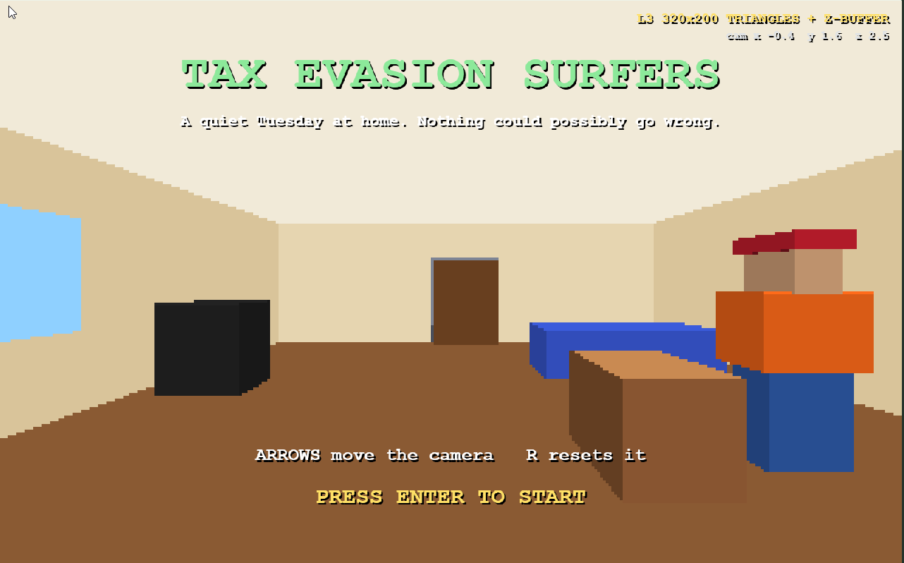
The home screen. The runner stands in his apartment next to the coffee table.
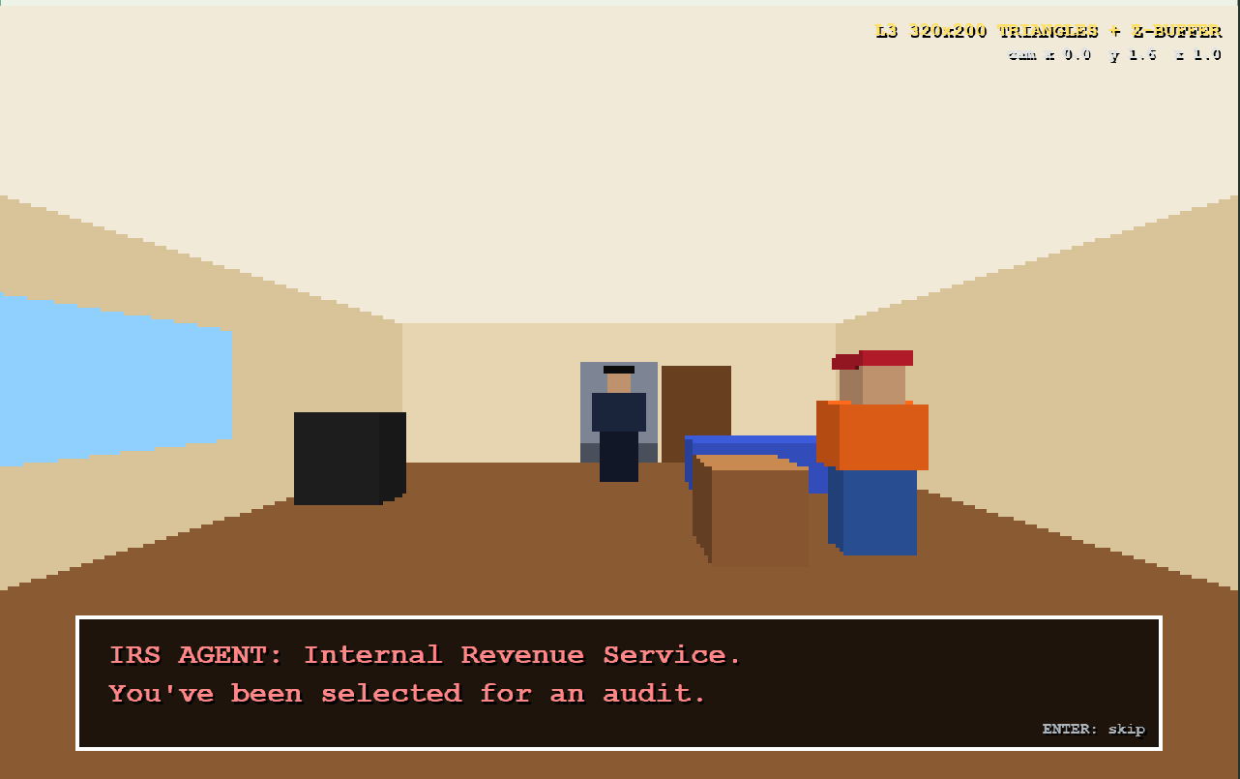
The cutscene. The IRS agent walks in and announces the audit.
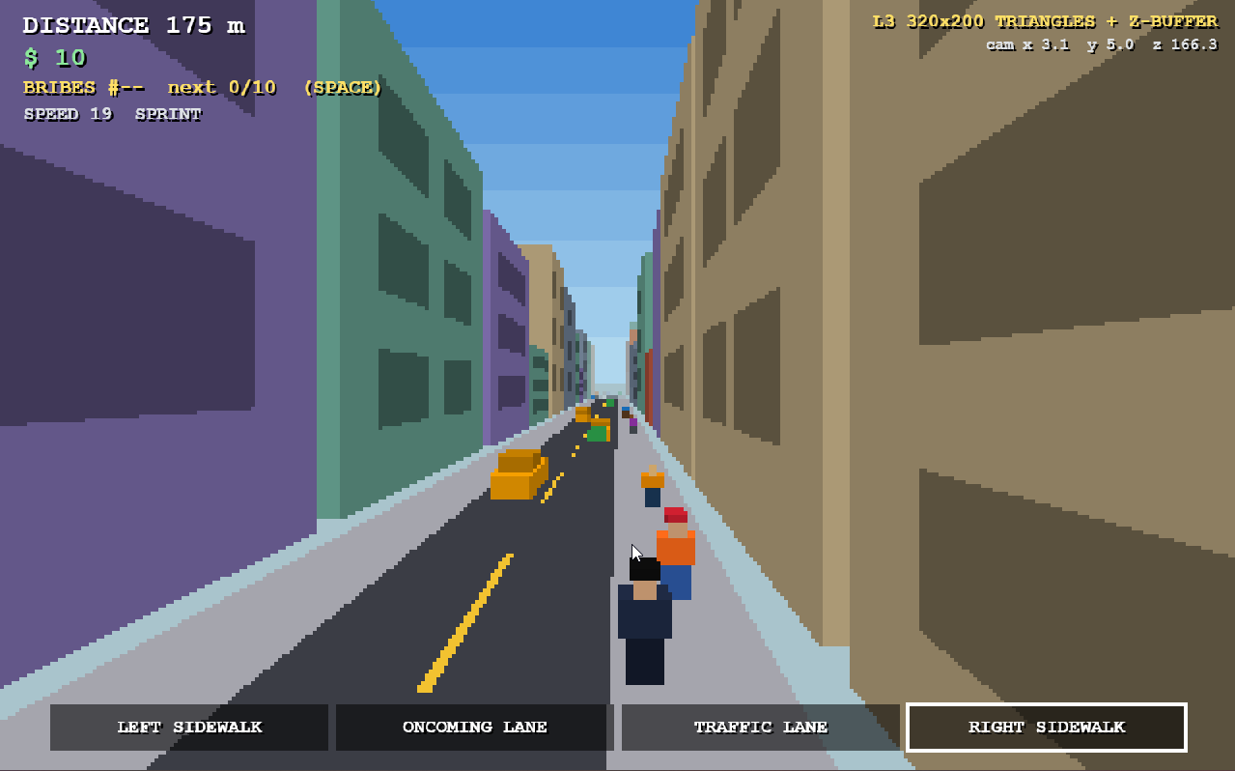
The run. Distance, dollars, bribes and speed are shown in the top left, and the four lanes are shown at the bottom.
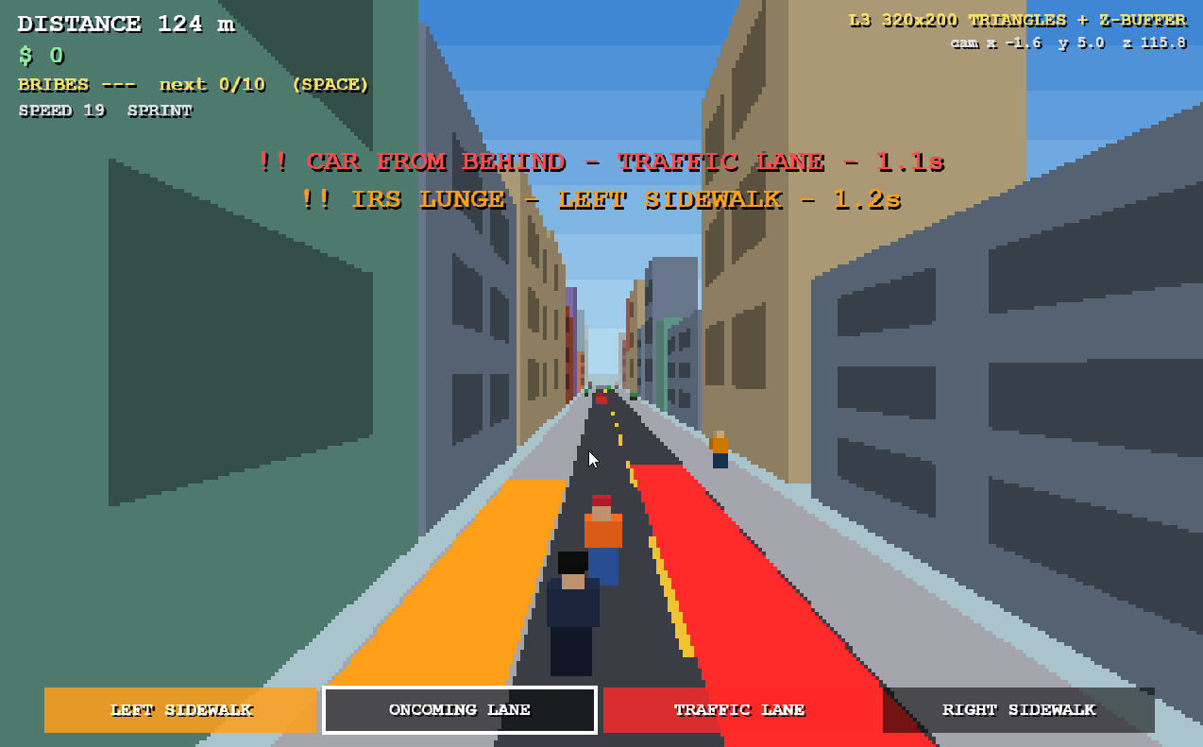
Warnings. The lane turns red when a car is coming from behind and orange when the IRS agent is about to jump.
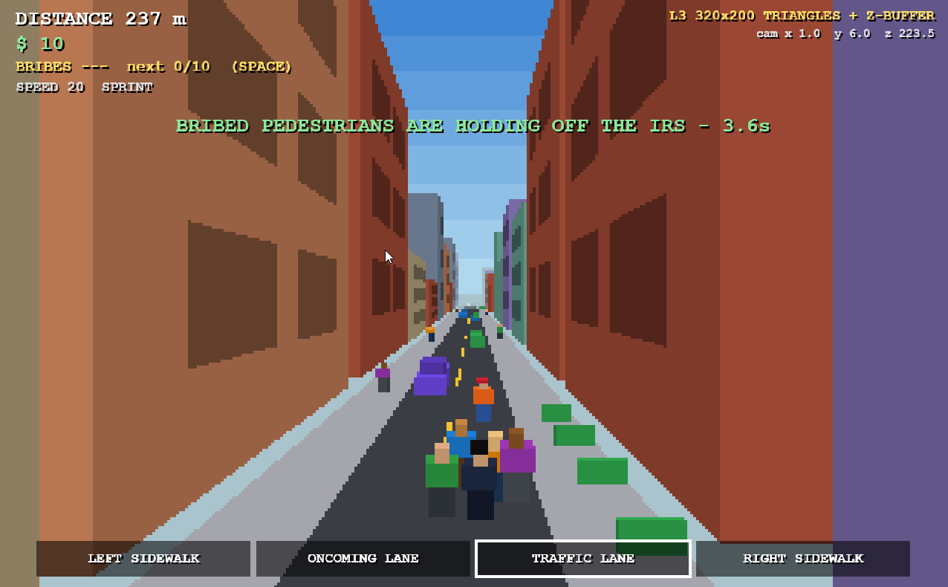
A bribe. People on the street crowd around the IRS agent and hold him back.
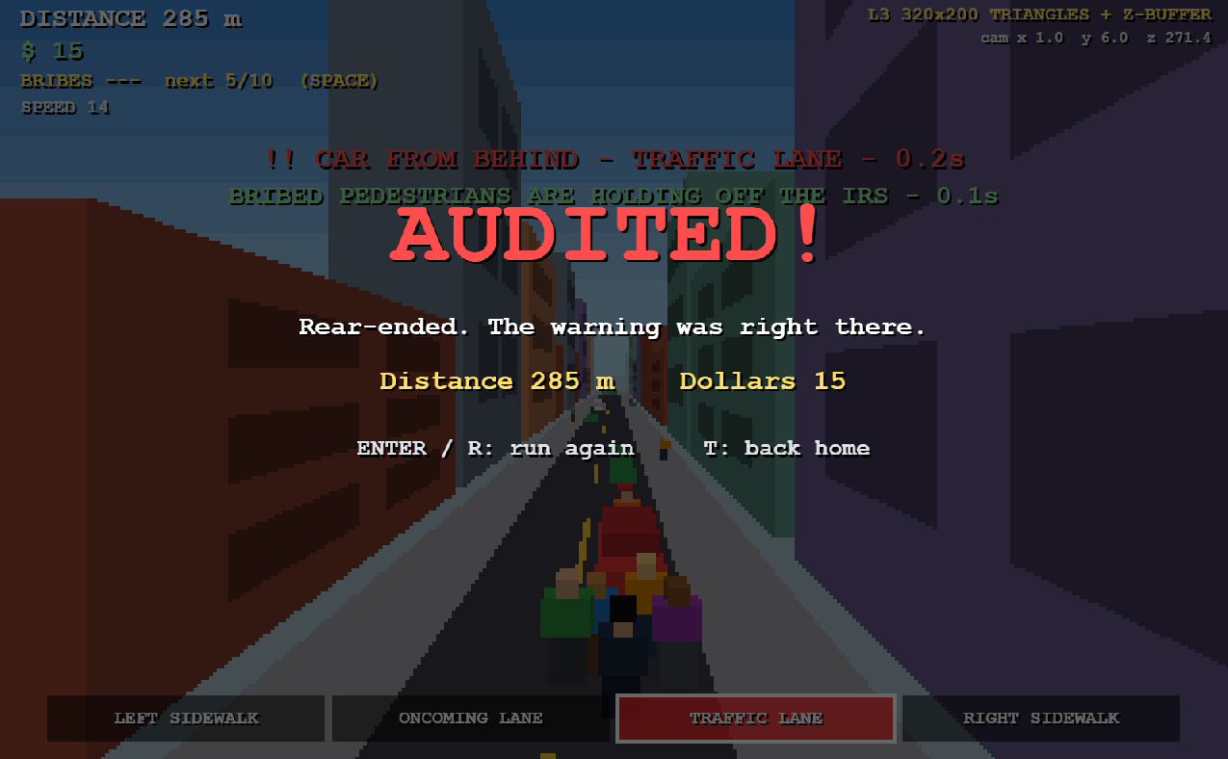
Game over. The screen says AUDITED and tells you how you got caught.

3. How the Drawing Works
All three levels start the same way and only change at the very end, when the shapes are drawn on the screen. First, every model is made of points around its own center, at (0, 0, 0). Next, each point is resized, moved to where the object is in the world, and then shifted so that the camera is at the center. After that, anything behind the camera is cut off. Then each point is projected, which means dividing x and y by z to find where it lands on the screen. Finally, the shapes are drawn. Level 1 uses the canvas's own line drawing on a 1600×1000 screen. Level 2 uses my own line function on a 320×200 screen. Level 3 uses my own triangle filling with a depth buffer on the 320×200 screen.

How the code is organized
I split my code into six files. The file inclass.js has everything from class: moving points relative to the camera, the pinhole projection, the line function, the triangle function, the 320×200 screen, and the three drawing levels. The file helpers.js has the settings, the functions used to build models, the function that makes copies of models, the code that cuts off things behind the camera, and the fog and sky colors.
The file models.js builds all the models, like the cube, road, buildings, cars, people and dollars. The file cutscenes.js has the home screen and the IRS cutscene. The file game.js runs the actual game, including building the street, checking for crashes, the IRS agent, and bribes. The file main.js handles the keyboard, the text on the screen, the test screen, and the loop that runs the game about 60 times a second.

4. Level 0: Page, Cube and Camera
I made the page with plain HTML, CSS and JavaScript. I designed the header at the top to look like a tax form to match the theme of the game. It has the title, names for an audit, and a numbered list of all the controls. The game canvas below it is 1600×1000 pixels.
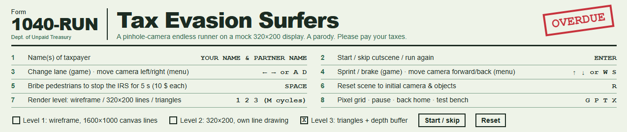
The page header, designed to look like a tax form.
The cube is a 2×2×2 box centered at (0, 0, 0). It has 8 corners, 12 edges, and 12 triangles for the filled-in version. I made it in models.js like this:
M.cube = (() => { const m = makeModel();
addBox(m, -1, -1, -1, 1, 1, 1, 0xd9a066, [...face colors]);
return finish(m); })();
Instead of leaving the cube floating in empty space, I shrunk it down to 0.45 of its size and used it as the table in the runner's apartment. On the home screen, the left and right arrows change the camera's x position, and the up and down arrows change its z position. Pressing R puts the camera back where it started.
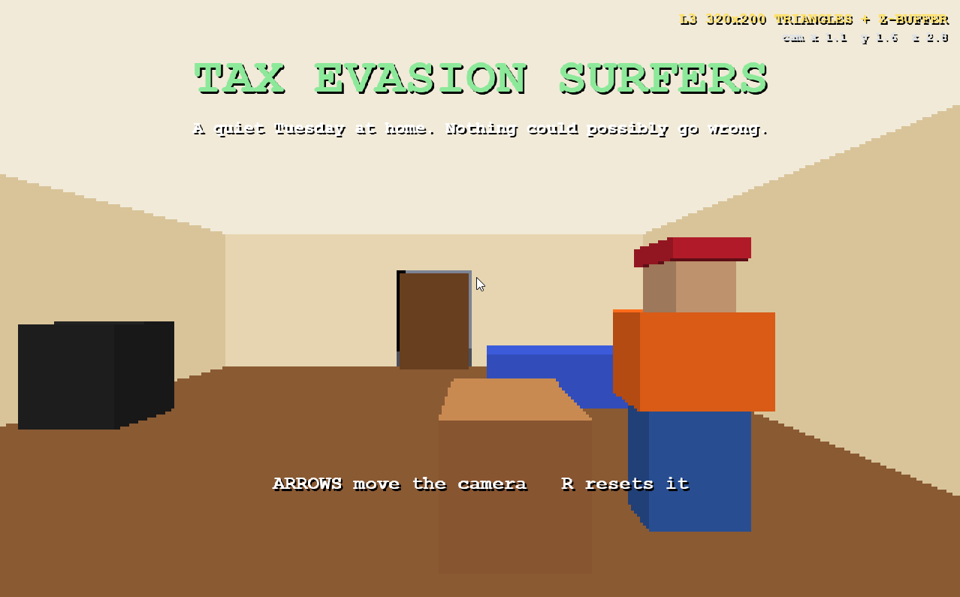
The home screen after moving the camera, looking at the coffee table cube from a different spot.

5. Level 1: Wireframe with a Pinhole Camera

The models
Every model is a list of points, a list of lines that connect those points, and a list of triangles for Level 3. I built each model around its own center, and y = 0 is the ground.
My game has five main types of objects. The first is the road, which is a piece 10 units long with the road, two sidewalks and a yellow line in the middle. In wireframe mode I only draw the lines that go down the street, so the ground doesn't look messy.
The second is the building. It is just a box that is 1 unit on each side, with six darker windows on the side that faces the street. There are six colors, and a left-side and right-side version so the windows always face the road.
The third is the car, which is a box for the body with a smaller box on top. There are six colors of cars. The fourth is the person, which is made of boxes for the legs, body, head and sometimes a hat. I used the same person model for people on the street, for the runner in the orange hoodie and red hat, and for the IRS agent in the dark suit and black hat. The fifth is the dollar bill, which is a thin green box.
I also made a few extra models for the cutscene and warnings, like the apartment room, the door, and the colored stripes that flash on a lane when something dangerous is coming.

Copies of models: moving and resizing
Each object in the game is a copy of a model with its own position and size. The inst function makes these copies. The size can be one number, which makes the whole thing bigger or smaller evenly, or three numbers, which stretch it differently in each direction. Nothing is ever rotated.
The buildings show this best. There is only one building model, a small 1×1×1 box, and each copy gets stretched to a random width, height and depth. That is how I turned one tiny model into a whole row of different buildings. People on the street also get a slightly random size so they are not all the same height.
The camVerts function takes every point of a model and puts it where it belongs compared to the camera. It multiplies the point by the size, adds the position, and then subtracts the camera's position. After this, the camera is at (0, 0, 0) looking forward along z.
x = point.x * size.x + position.x - camera.x
y = point.y * size.y + position.y - camera.y
z = point.z * size.z + position.z - camera.z

The pinhole camera
A pinhole camera makes things that are farther away look smaller. My project function does this by dividing x and y by z, which is how far away the point is. If something is twice as far away, it ends up half as far from the center of the screen. Then the function moves the result so that the center of the screen is straight ahead, and scales it up to fit the screen.
u = x / z
v = y / z
screen x = width/2 + u * (height/2)
screen y = height/2 - v * (height/2)
I multiply both x and y by half the screen height, so the pixels stay square and boxes don't get stretched. The y part is subtracted because on a screen, y goes down instead of up. The same function works for both the big 1600×1000 screen and the small 320×200 screen, since only the width and height change. It also gives back 1 divided by z, which Level 3 uses to know how far away each pixel is.

Color
Everything has its own color. In Level 1, I made the line colors a little lighter so they show up on the dark background. To draw faster, all the lines of the same color are grouped together and drawn at once.

Moving the camera and objects behind it
During the run, the camera follows the player. It moves forward every frame, slides left and right to follow your lane, and pulls back a little during a bribe so you can see what is happening.
Since you are always running forward, objects keep ending up behind the camera. I handled this in three ways. First, the inView function skips any object that is completely behind the camera or too far ahead to see. Second, if a line or triangle is only partly behind the camera, I cut it off right in front of the camera. Third, the game deletes objects once they are behind the camera and keeps building new street 170 units ahead of you.

Actions and reset
Besides moving the camera, the player can switch lanes, sprint, slow down, pick up dollars and use bribes. Pressing R resets whatever screen you are on back to where the camera and objects started.
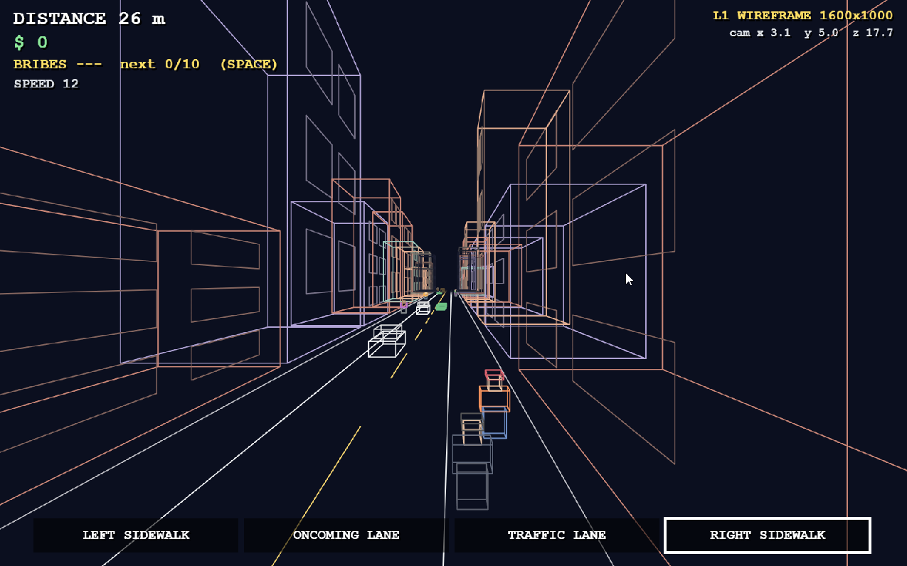
Level 1, drawn with the canvas's own lines on the 1600×1000 screen.

6. Level 2: My Own Line Drawing at 320×200

The fake low-resolution screen
For Level 2 I made a fake screen that is only 320 pixels wide and 200 pixels tall. It is stored in a 2D array called frame, where each spot holds the color of one pixel. At the start of every frame, the whole array is filled with the background color. Then lines are drawn into the array one pixel at a time using setPixel.
At the end, the presentFrame function draws every spot in the array as a 5×5 square on the real canvas. Since 320 times 5 is 1600 and 200 times 5 is 1000, it fills the canvas exactly. To make this faster, pixels next to each other that are the same color get drawn as one wider rectangle, which looks exactly the same. Pressing G turns on grid mode, which puts a small gap between every pixel so you can see each one.

My line drawing function
My drawLine function replaces the canvas's own line drawing. It uses a method called DDA. First it checks whether the line goes farther left and right or farther up and down, and it takes that many steps. On each step, it moves exactly one pixel in the longer direction and a small part of a pixel in the shorter direction, then rounds to the nearest pixel and colors it in.
steps = the bigger of |dx| and |dy|
xStep = dx / steps
yStep = dy / steps
repeat for every step: color the pixel at (round(x), round(y)), then add xStep to x and yStep to y
Because it always steps along the longer direction, the line never has gaps, whether it is steep, flat, straight or going backwards. Before a line is drawn, I also trim it to the edges of the screen, so I don't waste time on parts that are off screen.
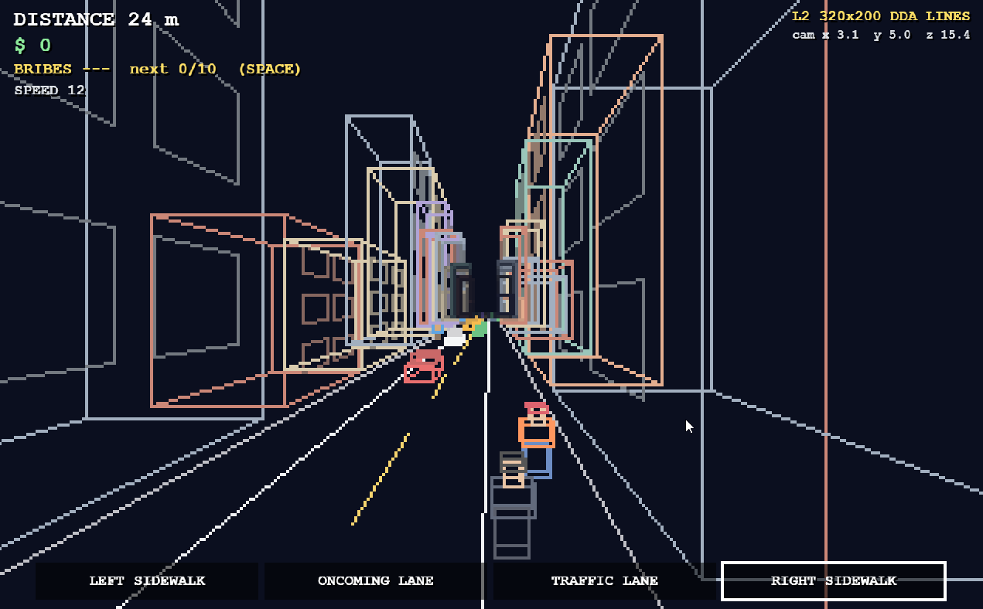
Level 2, drawn with my own line function on the 320×200 screen.
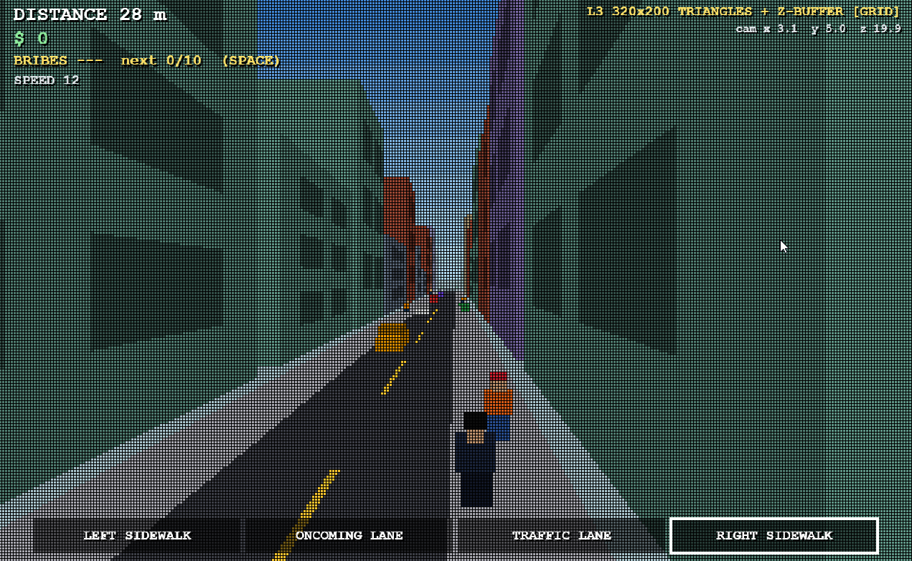
Grid mode, where you can see each 5×5 pixel.

7. Level 3: Filled Triangles with a Depth Buffer

Models as triangles
The same functions that make the lines for each model also make triangles. A flat four-sided shape becomes 2 triangles, and a box becomes 12 triangles, 2 for each side. I gave each side of a box a slightly different brightness, with the top the brightest and the bottom the darkest, so you can tell the sides apart.

Figuring out which pixels a triangle covers
My fillTriangle function colors in a triangle on the fake screen. First, it finds the smallest rectangle that fits around the triangle, so it only has to check pixels that could be inside. Then, for each pixel in that rectangle, it looks at the center of the pixel.
To tell if the center is inside the triangle, I use a function called area2. It finds the area of a triangle made from three points, and the answer is positive or negative depending on which way the points go around. For each pixel, I find the area of the three small triangles the pixel makes with each side of the big triangle, and divide each one by the area of the big triangle. This gives three numbers, called weights, that always add up to 1. If all three weights are zero or more, the pixel is inside the triangle and gets colored in. Dividing by the big triangle's area means it works no matter which order the corners are in.

The depth buffer
To make sure closer objects cover farther ones, I keep a second 320×200 array called depth. It remembers how close the thing already drawn at each pixel is. I store 1 divided by z instead of z, so a bigger number means closer, and at the start of each frame everything is set to 0, which means really far away.
For each pixel inside a triangle, I use the same three weights to figure out how close that exact spot is. The pixel only gets colored if it is closer than what is already there. Because of this, triangles can be drawn in any order and the closest one always ends up in front. I use 1 divided by z because it changes evenly across the screen after projection, while z does not, so it gives the right answer even when two triangles pass through each other.

Cutting off triangles behind the camera
If a triangle is partly behind the camera, it gets cut off right in front of the camera. The piece that is left can have 3 or 4 corners. If it has 4, it is split into two triangles before being filled in.
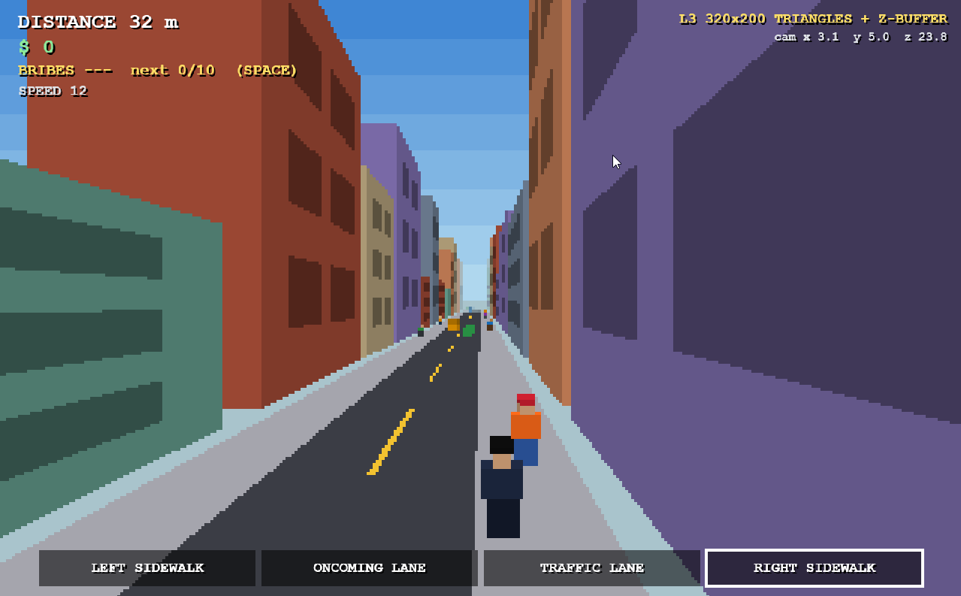Level 3, with filled triangles, the depth buffer, the sky and fog.

The test screen
I made a test screen, opened with X, to check my drawing functions on their own. It shows 24 lines in a star shape to prove my line function works at every angle. It also draws a red triangle first and a farther blue triangle second, and the red one still ends up in front because of the depth buffer. Last, it has a green and a purple triangle that pass through each other, and the depth buffer splits them cleanly along a slanted line.
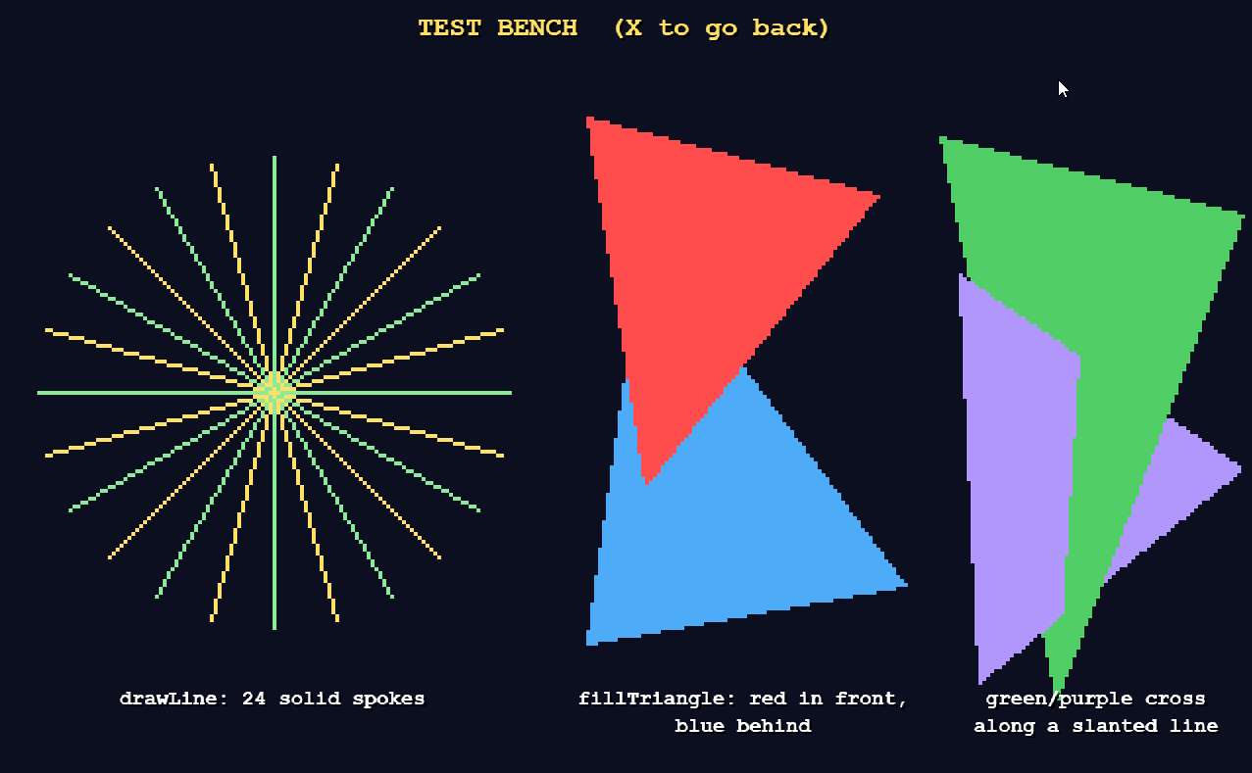The test screen for my line and triangle functions.

8. Things Added Beyond Class
A few parts of my project go past what we learned in class. The most important is cutting off lines and triangles that go behind the camera, done by clipSegNear and clipPolyNear. In a running game, objects pass behind the camera all the time, and without this they would show up in strange places on the screen.
I also trim every line to the edges of the 320×200 screen before drawing it, using a function called clip2D. This way I never waste time drawing pixels that are off the screen.
To make it look better, I added fog. Things more than 110 units away slowly fade into the background color, so objects don't suddenly pop into view in the distance. I also added a sky that fades from dark blue to light blue in 8 steps, which gives it an old-school look.
The street is built automatically as you run by the generate and spawnRow functions, so it goes on forever using just a few models. I also made the game fair on purpose. Cars from behind start 36 units back and move 12 units per second faster than you, so they reach you in exactly 3 seconds, the same amount of time the warning shows. The IRS agent switches between chasing, warning, jumping and recovering, and crashes are checked by seeing how close you are to each object.

9. Future Work
If I kept working on this, I would first skip drawing the sides of objects that face away from the camera to improve efficiently. Some other ideas I had was other cool uses for money and maybe adding turns like there are in Temple Run. My take on the game was to find fun ways to out run the IRS agent, maybe if you get enough cash you can audit the IRS agent and chase him for a period. I have a lot of silly ideas for this game and honesty play to continue developing it.

10. AI Use
I used Claude Sonnet during this project. For most of the project I used it as a helper, but a few parts were made mostly by AI. The cutscene was created completely by AI. The idea for it was mine: I was inspired by Subway Surfers and wanted a reason for why the character is running. The header with the controls was also AI. Other functions were developed by me with the help of AI. Processes such as removing objects when they appear off screen and the process to put them in was AI. Other than that, a lot of the functions AI were used as a helper, because I really wanted to understand the code rather than just create it. I really enjoyed this project and am likely to do something like this in the future.
The functions in inclass.js were all written by me. These are the camera projection, line drawing, triangle filling and depth buffer. I wanted to apply the class concepts myself first before relying on AI. The AI framework did not actually work until I finished my line drawing, projection and triangle filling functions. After that, I made edits based on my own creative decisions and my knowledge of JavaScript, and I used Claude for bigger design changes. I checked the AI's work by running the game, testing each render level, and fixing anything that didn't behave the way I wanted.

