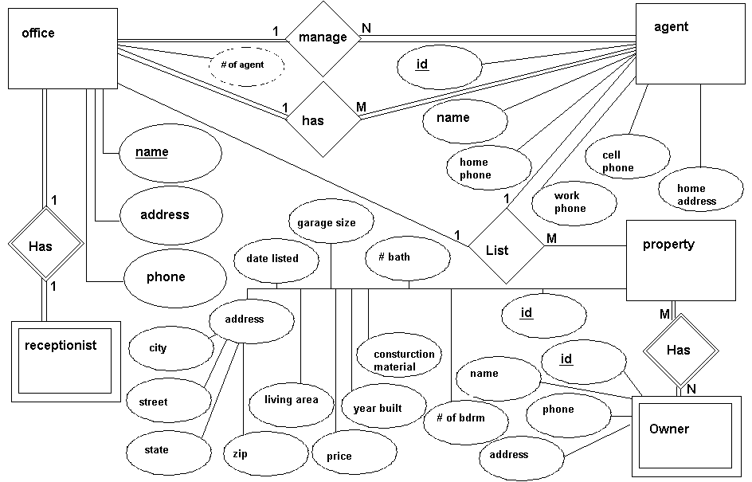

Name: Timothy Beckett
Assignment: 2 – ER Diagram
Instructor: Dr. Cripps

