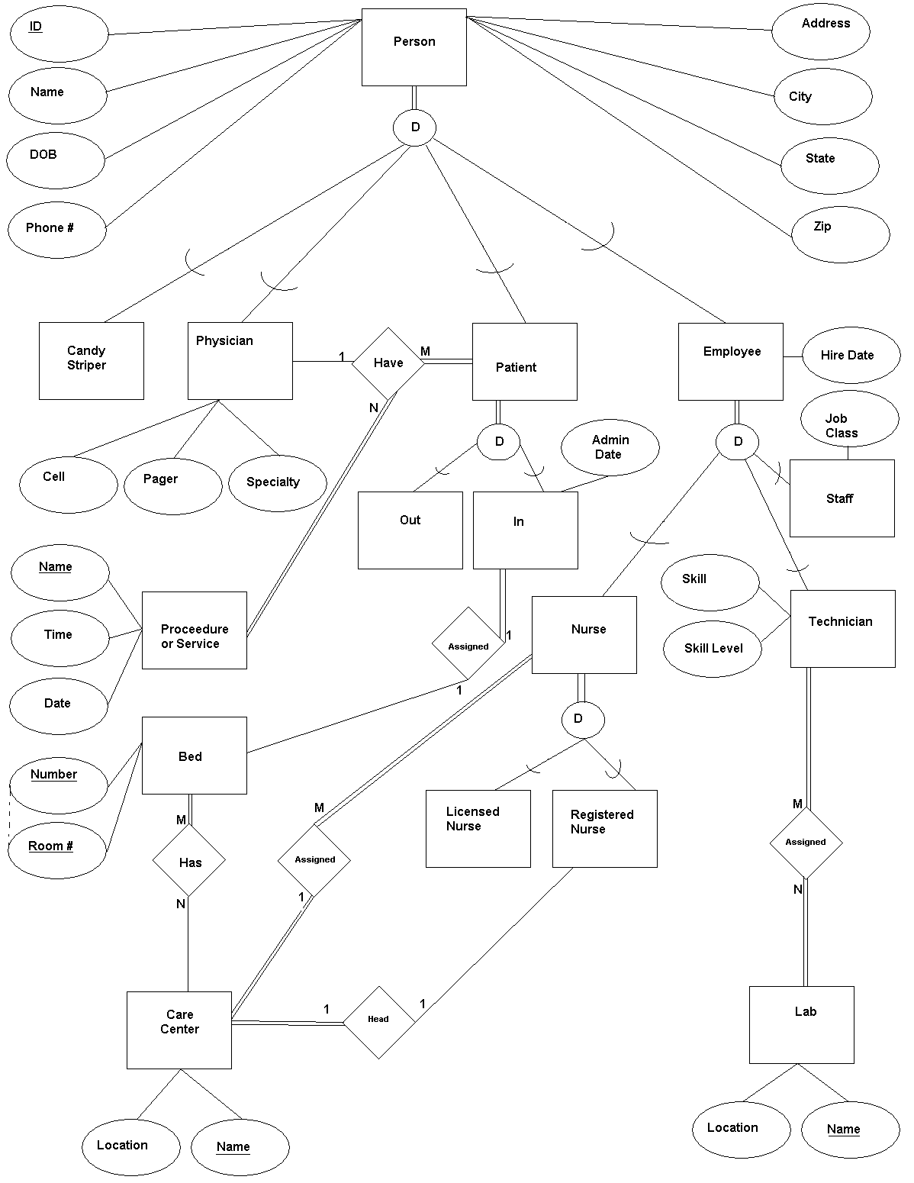

Name Timothy Beckett
Class CSCI 4560
Instructor Dr. Cripps
Assignment 2 EER Design of database

