The People’s Software



Library Management System

Timothy Beckett
Chris Eadie
Scott Fulton
Diana King
David Rivenbark

Estimation Worksheet for Group Assignment 1
Name of Team Member: Timothy Beckett

Estimation of individual time
to complete this assignment: ______________

Estimation of time in group
meetings to complete this assignment: ______________
__________________________________________________

Name of Team Member: Chris Eadie____

Estimation of individual time
to complete this assignment: ______________

Estimation of time in group
meetings to complete this assignment: ______________
__________________________________________________

Name of Team Member: Scott Fulton____

Estimation of individual time
to complete this assignment: ______________

Estimation of time in group
meetings to complete this assignment: ______________
__________________________________________________

Name of Team Member: Diana King_____

Estimation of individual time
to complete this assignment: ______________

Estimation of time in group
meetings to complete this assignment: ______________
__________________________________________________

Name of Team Member: David Rivenbark

Estimation of individual time
to complete this assignment: ______________

Estimation of time in group
meetings to complete this assignment: ______________
Actual Time Log for Group Assignment 1
Name of Team Member: Timothy Beckett

Time Log of individual time
spent in completing this assignment: ______________

Time Log of group meetings for
this assignment: ______________
__________________________________________________

Name of Team Member: Chris Eadie____

Time Log of individual time
spent in completing this assignment: ______________

Time Log of group meetings for
this assignment: ______________
__________________________________________________

Name of Team Member: Scott Fulton____

Time Log of individual time
spent in completing this assignment: ______________

Time Log of group meetings for
this assignment: ______________
__________________________________________________

Name of Team Member: Diana King_____

Time Log of individual time
spent in completing this assignment: ______________

Time Log of group meetings for
this assignment: ______________
__________________________________________________

Name of Team Member: David Rivenbark

Time Log of individual time
spent in completing this assignment: ______________

Time Log of group meetings for
this assignment: ______________
Minutes
January 18, 2007
The first order of business was to select a group name and logo. One member submitted a name and logo, and the group agreed that the name and logo was acceptable. The second order of business was to start brainstorming about the group assignment. We decided to use a database in SQL for the implementation of the data storage. The current design includes four tables: one for the books and media, one for the library staff, one for the members of the library, one for book/media that are reserved and can’t leave the library (this table will use the ids from the staff and book/media tables as the key, and the date the medium will be returned to the general collection), and one for tacking who has checked out the media (this one will include the ids from the members, staff, and book/media tables, and finally the date that the medium was checked out). The Final order of business was to consider languages that we will be writing the interfaces that the users will be using to access the data base; we are considering C++, Java, and C# (we are primarily considering Java at this time).

January 23, 2007
The first order of business today was to discuss what language will be used for the project. It was decided to make Java the programming language for the project. The second order of business was to critique the design. We discussed proposed changes to the layout of the database and to the data to be stored. We also discussed what features the system should or shouldn’t have. The next item on the agenda was the team name and logo. Chris put forth his team name of The People’s Software. He also showed his preliminary ideas for the logo. We decided to think about his suggestions and to vote on them at a further meeting. The final order of business was to divide up tasks. We had each member take a section to think about and present at the next meeting.

January 25, 2007
Today we focused mostly on the database. It was decided that Tim would take the lead on that part since he had the most experience. We discussed how the tables should be laid out and what information they should contain. Next the group discussed the outline that was handed out on the SSS. We went through each item and discussed our thoughts on the issues.

January 30, 2007
The first order of business on today’s agenda was to discuss the preliminary System Statements of Scopes that each team member came up with. The need for user passwords and logging in was discussed. It was decided that all users to the system would need a password to login. It was decided that preliminary interface designs to the system should be created. The group elected Dave to consolidate the information that had been gathered and to put together the System Statement of Scope. The next issue on the agenda was the team logo and name. It was confirmed that the logo and name submitted by Chris would be the team choice. The team decided to individually create a sample logo based on Chris’s design and vote on them during the next meeting.

February 1, 2007
The first thing on the agenda today was to talk about the logo. Scott had a sample design that he had come up with. The group evaluated it and it was decide that the team name should appear on the logo. Next, we discussed how the reports should be presented in the paper. It was decided to put the basic template designs in the appendix. The next item was security and quality assurance. Tim discussed SQL and its live update. Diana presented her ideas about the constraints on the system.

System Statement of Scope
- Functionality
The major goal for this project is to construct a library management system to manage the library’s users and resources. The system should track all resources and which users have these resources. The system will be web based and allows users to access it resources from any where with a secure login. When expressing the functionality of the system, three areas must be considered. These areas are the library users, the library resources, and the structure of the system itself.
The first aspect of the system is the users. The library software will be comprised of two types of users: staff and patrons. The patrons will have the ability to checkout and return books, search the media and book collections, and put his/her name on a queue for books that are on the reserved list. All patrons will be required to provide the following information: first name, last name, phone number, email address, mailing address; furthermore, the patrons will be issued an identification number and password. The staff will be able to perform all actions for patrons; additionally, a staff member is required to handle the check out of any book or media to a patron. The staff will be required to provide the same information as the patrons, and they too will be issued identification numbers as well as a password word for validation of his/her identity. Staff members will be required to check in all return books and media promptly; additionally, they will responsible for reversing books and media for university faculty.
The next aspect of the system is the library resources. The library software will also be required to keep track of all books and media a with an identification number that complies with the library of congress standards. Information that will be stored in the system about the books will be the author(s), title, copyright(s), publisher, topic, category, and a synopsis; for media it will need to store any applicable stars, performers, or narrators, and the title, topic, category, a synopsis, copyright, producers, publishers, or distributors, and the type of media: videos & movies on VHS or DVD, or music & audio file on audio cassette or compact disk. The system will also be required to track what books and media are checked out, who has it, and whether or not is it over due. The system will be required to keep track of what books and media are on reserve and when the item goes back to the general curriculum. As well as who reversed it, has it checked out for use in the library, and is in the waiting queue to get it next? The waiting queue is only good till the end of the current business day, and patrons may be removed from the queue if they do not answer pages with in ten minutes of being paged for his/her turn to get the item. The system will also be required to check for any over due books or media and notify the patron, via email, of his/her overdue status.
The final aspect of the system is the structure. All data will be stored using a SQL database system. Interfaces and underlying code will be implemented utilizing Java and the Java Development Kit. The system network will be web based and accessible from any internet connection. An authentication system will be in place requiring all users of the system to be registered in order to access the system information. The only exception is the search engine. Users will be able to search for available resources without having to log in. However, a user account in good standing is required to check out any books. The basic interfaces for this system will include a search engine, an account access, an administrator access, and a check in/out resource page. The search engine will allow all users to search for available resources in the system. The account access page gives users access to their personal accounts. The administrator access page gives the administrator access to such features as adding new users, removing old users, adding new resources, removing old resources, and updating the permissions of the users of the system. The check in/out resource page allows library staff to check in and/or check out library resources.

- Data
Input data will consist of user and resource information. All patrons will be required to provide the following information: first name, last name, phone number, email address, mailing address; furthermore, the patrons will be issued an identification number and password. Information that will be stored in the system about the books will be the author(s), title, copyright(s), publisher, topic, category, and a synopsis. For media the system will need to store any applicable stars, performers, narrators, the title, topic, category, a synopsis, copyright, producers, publishers, distributors, and the type of media. The different types of media include: videos & movies on VHS or DVD, or music and audio files on audio cassette or compact disk.
Output data falls into two categories; output to the monitor and reports. Any output due to search results or inquiries to the database will result in output to the monitor. For search results on users, this data can include names, addresses, phone numbers, and id numbers. When users search for resources, the data for those resources will be output to the monitor. The second type of output from the system is reports. Reports can be electronic or paper. Electronic reports include overdue notices that are sent to library patrons with the fine information, dates checked out, and the titles of the resources that are overdue. Paper reports include search results, receipts for overdue transactions, and notices of termination. Search result reports are report information obtained from a search for available resources. Receipts are given to patrons who have paid for overdue fines. Notices of termination are sent out to patrons who have not responded to any of the overdue email notifications to alert them of the termination of their account. See Appendix A, B, and C for example layouts of all the report types.

- Environment
The system environment is divided into the physical environment, hardware environment, and the software environment. The physical environment will be the library in which the system is located. The physical environment will also include the off site servers and data storage used for backup purposes. The hardware environment will include computers with monitors, keyboards, mouse, and speakers. The software environment for the system will be Java utilizing the Java Development Kit. The database used in storing the data will me managed using SQL.

- Users
There are three types of users for the system; the administrator, library staff, and library patrons. Library patrons can be divided into the subcategories of faculty and students. Faculty patrons have more permissions than student patrons. Faculty is allowed to check out books for longer periods and place resources on reserve. All users are allowed to check out resources. However, only the administrator and library staff may check materials out and in. Furthermore, the administrator is the only one who can add and remove people and resources from the database. Library staff are expected to have passed a basic training class on how to use the system.

- Interfaces
The two types of interfaces available are human interfaces and hardware/software interfaces. Human interfaces include a monitor, keyboard, mouse, and speakers. The hardware/software interfaces include the database and the GUI interfaces used for accessing the system information. There are two types of GUI interfaces used on this system. There is the administrator and library staff interface and the library user interface which includes the search engine.

- Documentation
Documentation for the system will consist of a user’s manual. A printed copy of this manual will accompany the software being purchased. An electronic copy may be attained my emailing the company at the_peoples_software@yahoo.com. The manual will describe the basic steps for installing the software onto the library system, how to set up the system, the basic operations of the system, and troubleshooting. Below is an example of what the table of contents might look like:
- Introduction
- Getting Started
  - Installing the software
  - Setting Prefrences
  - Adding Users
  - Adding Books and Media
- Basic Operations
  - How to check out books and media
  - How to check in books and media
  - How to place resources on reserves
  - Removing books and resources
  - Add/Remove users
  - Setting permissions
  - Maintenance
- Trouble Shooting
  - Database issues
  - Trouble logging in to the system
  - System failure
  - Browser issues
  - Miscellaneous problems
- Index
- Acknowledgements

- Security and Performance Requirements
This system will require a secure login to access most of the resources. The only exception will be the search engine. By having a secure login, the system will prevent unauthorized users from being able to change important settings and permissions. This system will allow multiple users to access the search engine at one time and to check resources in and out.

- Quality Assurance
As a quality assurance, all maintenance will be performed at off hours. As insurance against mishaps, only the administrator has rights to give users staff privileges. Also the administrator is the only user with the ability to remove other users and resources from the system.

- Constraints
The system has several constraints. First, the system requires the use of the internet for networking purposes. Next, user permissions may only be changed by the top administrator and no one else. Third, patrons are not allowed to check books and media out on their own. They must have the library staff perform this action.

- Maintenance
If during the first service year, a bug is found in the system, free patches will be made available by us. However after the first year or at the end of the service agreement, patches will only be provided at service fee. A yearly service plan will be made available after the first year for a fee. This service plan will include software patches and customer service.
Appendix A: Enhanced ER diagram of Database (to be implemented in SQL) 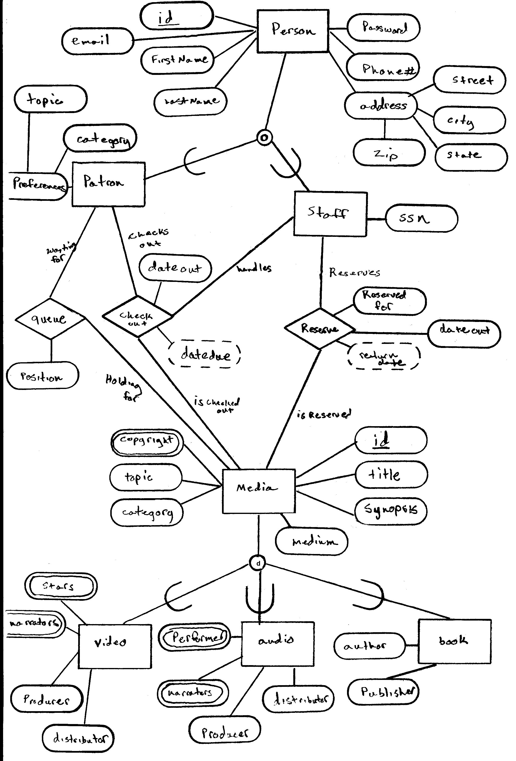
Appendix B: Receipt

Library Patron: John B. Doe
User ID: mt123jbd
Resources Fine $
How to Survive College, by A. Smith 1.20
Software Engineering for Dummies, by J. Jones 1.20
___________________________________________________________
TOTAL: $ 2.40
----------------------------------------------------------------------------------------
AMOUNT PAID: $ 3.00
CHANGE: $ 0.60
__________________________________________________________
Confirmation number: mt123jbd232

Appendix C

