Assembling the No Phone Contact Tracer (NPCT)

Summary: NPCT is a totally anonymous contact tracer hardware token. It costs about $20 to make and could enable participants to engage in "self-motivated" contact tracing. It does not involve mobile phones, an App or the Internet at all.

Supplies needed: 1 ESP32, 1 micro-USB cable, 1 5000mAh battery. Sample sources: ESP32 (check eBay too), cable (short one; 1 ft max.), battery. Note: The battery may come with a suitable cable.

Part I: Turn the EPS32 into a contact tracer
1. Get the ESP32 and plug it into your computer using the USB cable.  2. Download this file: npct.bin.  3. Download this ESP32 "flashing" program": Windows or macOS. | 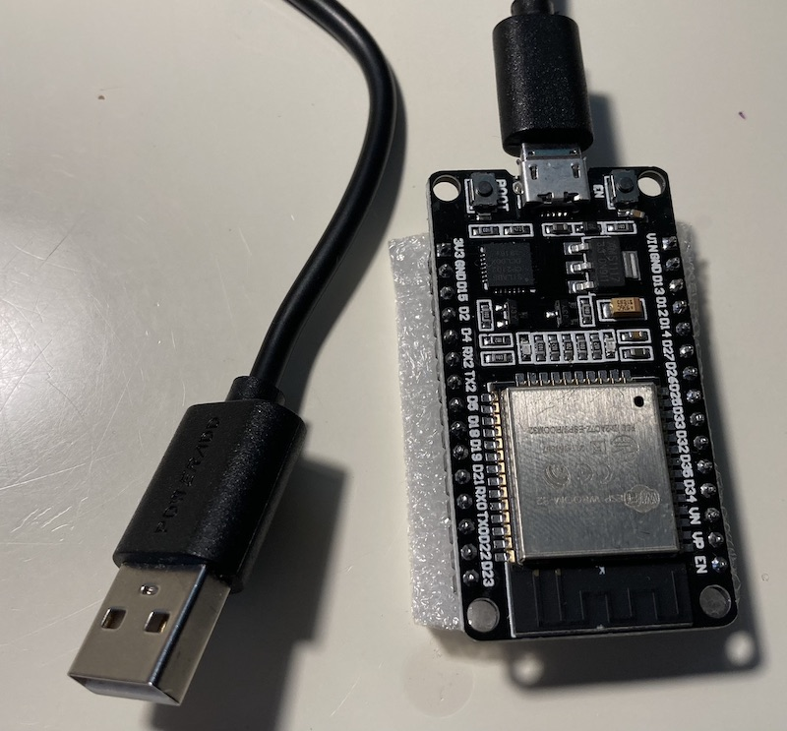

4. Run the flashing program. Click the top right "Browse..." button (same line as the "Flash App..." description).  5. Tell it about the npct.bin file you downloaded in Step 2.  6. Click the big "Flash" button. If nothing happens, try a different Serial Port.  7. It's working when you see a Connecting........_____....." message in the text box at the bottom. When this happens, press and hold the "BOOT" button as shown to the right (red arrow) until "Writing..." message appears, then release the button.  8. When writing reaches 100%, you are done, and do not have to repeat this again. You can delete the npct.bin file and the flashing software. | 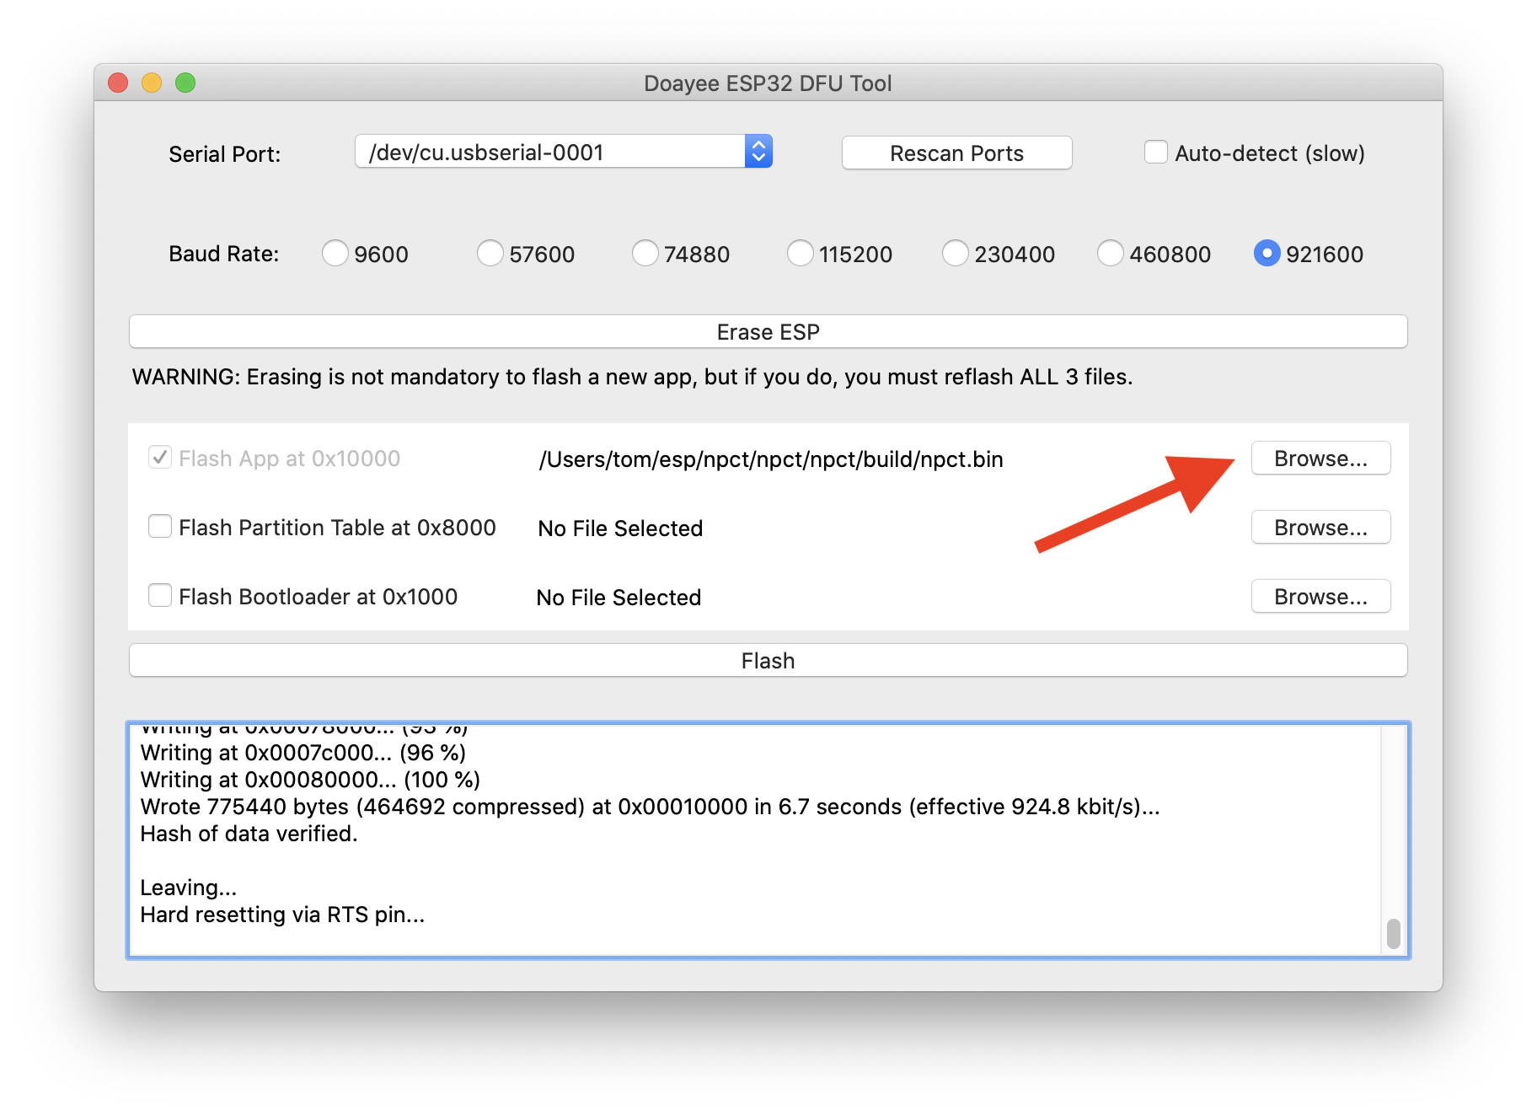  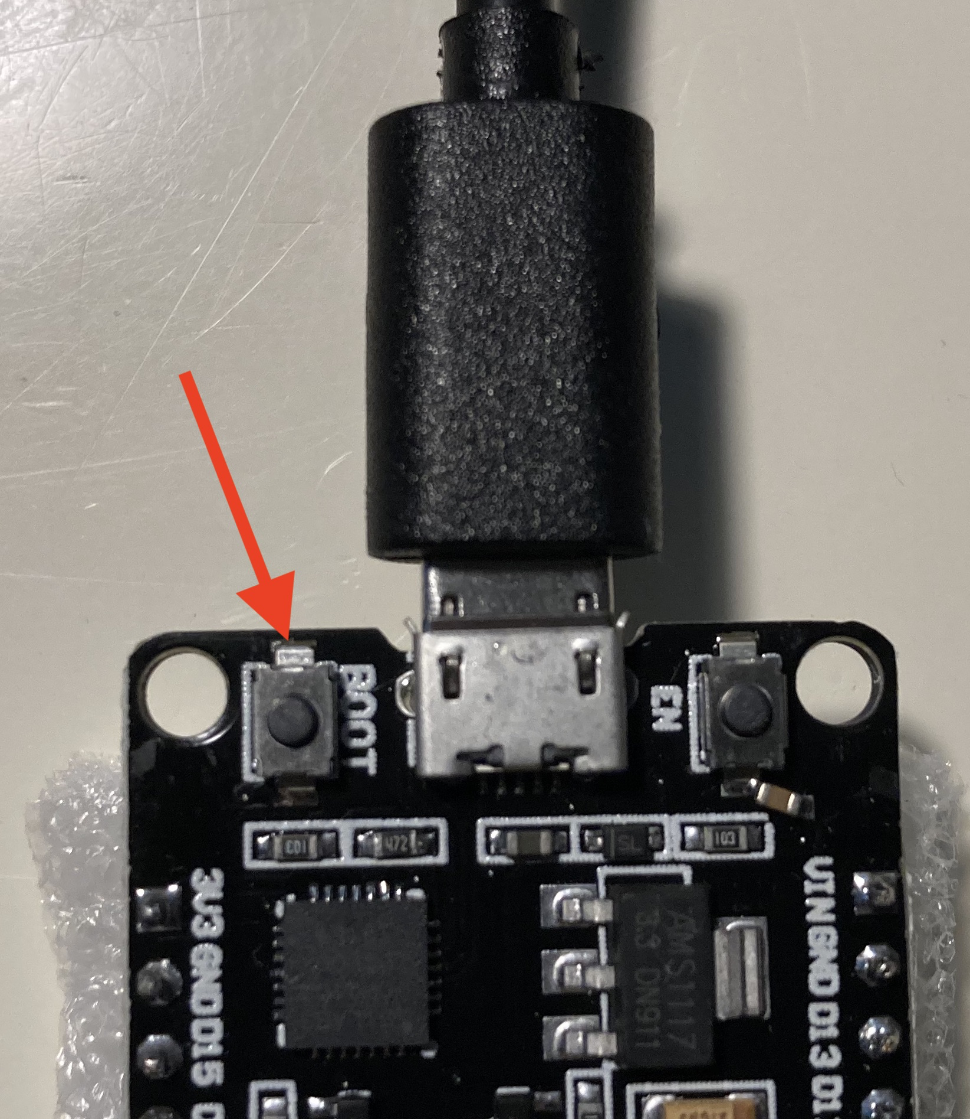

Part II: Personalize the ESP32
1. Make a folder on your computer, say on the Desktop. Download all five of these files into this folder.

2. With the ESP32 "on" (either still connected to your computer or powered using the battery), use the Chrome web browser (you must use Chrome), version 83+, to open the file (Use File→Open File) in your new folder called config.html.

3. Follow the on-screen instructions you'll find. You'll be issued an ID and can tick off any health related symptoms for broadcasting. Your final step will be to click the green "Update hardware" button to personalize the ESP32.

You are done. Power up the ESP32 with the battery and take it with you. Maybe make a case for it (but do not use any metal, or a metallic case). Use the same config.html in Chrome to download any encounters you had when you were out and about and to (regularly) update the ESP32 on your health conditions.

