Summary of UROP
Ben Thompson
During last summer and this last semester, I did some image analysis and pattern recognition with Alejandra as part of her graduate thesis. The main purpose of her project is to analyze the microscale deformation of rocks and minerals. This is achieved by tracking the motion of points in a micron scale grid imprinted on the rock. The grid is imprinted using microfabrication technology. In order to relate this strain data with the crystal structure, EBSD data was collected for the same piece of calcite. Unfortunately, obtaining the EBSD data is a difficult, time-consuming, and expensive process.
In examining images of the microscale grid, Alejandra noticed that the shape imprinted on the rock seemed to be consistent within a crystal but vary across crystal boundaries. I investigated this relationship with the hopes that it could provide a very rough sense of the crystal structure.
In order to do this, I first needed to write code to automatically identify the locations of the imprinted shapes. Because they could be approximated as circular, I was able to use a circular Hough Transform algorithm to find them. The circular Hough Transform algorithm allows each pixel a vote for where a circle center is. The pixels “vote” for locations that lie in a circle around themselves – the center of a circle with radius R containing a point A lies on a circle centered at point A with radius R. The Hough Transform was run on the gradient of the image and tested multiple different radii of circles. Before using the Hough Transform, the image was smoothed with a Gaussian filter. After the Hough Transform was calculated, a Laplacian of the Gaussians filtering was applied to emphasize the peaks and another Gaussian smoothing was applied to make sure random peaks were ignored. This result was then filtered for the highest responses (most “votes”). An example of the results can be seen below in Figure 1. These were declared the circle centers. I performed various perturbation tests on the original image to make sure the algorithm was consistent
Then, with the centers identified, I used a k-means clustering algorithm to group the centers into sets with, hopefully, different crystallographic properties. An example of the result can be seen in Figure 2. At this point, Alejandra and I realized that, even without a correlation between the different microfabricated shapes, the different shape categories could provide an automated technique to determine crystal grain boundaries. Automatically identifying grain boundaries should prove useful to her research directions – perhaps relating strains within grains and between grains.
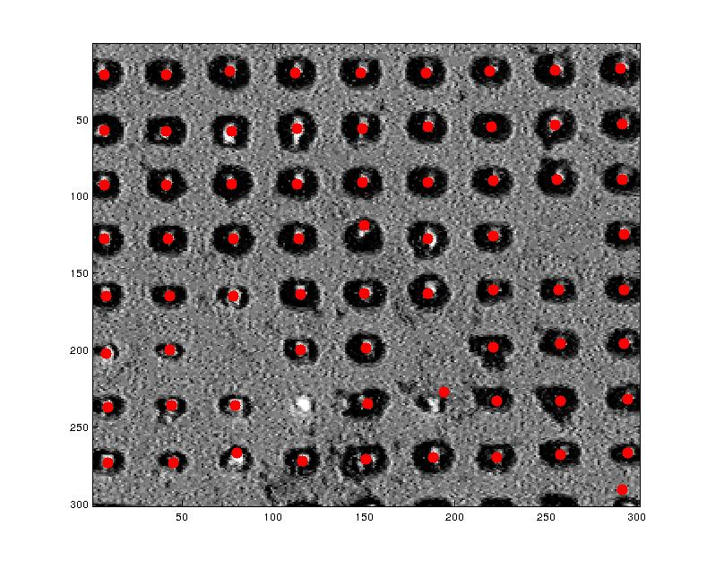Figure 1: Example of centering algorithm's results. Red dots are centers.
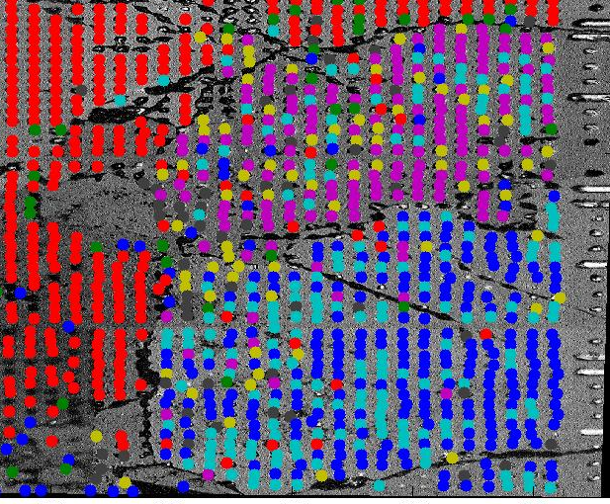Figure 2: Example of shape categorization. Each color is a different shape category. Observe the variation across grain boundaries.

