Managing the unmanageable: Understanding the competing effects of salinity and nutrient loading on estuarine water quality
Marcus W Beck^{1,✉}, Kerry Flaherty-Walia¹, Blake A Simmons¹, Maya C Burke¹, and Edward T Sherwood¹
¹ Tampa Bay Estuary Program, 263 13th Ave S., Suite 350, St. Petersburg, Florida 33701 USA
✉ Correspondence: Marcus W Beck <mbeck@tbep.org>

Abstract
Changing climatic conditions that can alter physical characteristics of surface waters may limit the effectiveness of conventional approaches to nutrient management. This study evaluated the competing effects of nutrient loads and changing salinity on chlorophyll-a dynamics in Tampa Bay (Florida, USA). This estuary has demonstrated long-term recovery of water quality primarily through wastewater infrastructure improvements, whereas a gradual freshening of the Bay over the last few decades may compromise future management efforts to protect water quality. The relative effects of loading and salinity over a forty-year time period were evaluated using normalized predictions from Generalized Additive Models (GAMs). All bay segments showed a gradually increasing influence of reduced salinity on chlorophyll-a. Old Tampa Bay in the northwest also showed an increasing influence of nutrient loading. Simulation scenarios using the GAMs assessed the relative likelihood of exceeding regulatory chlorophyll-a standards under future salinity conditions. All bay segments showed an increased likelihood of exceeding regulatory standards, particularly in Old Tampa Bay where likelihood increased by ~20% over a fifty-year simulation. The results suggested that current nutrient loads should be reduced by approximately half of the federally-recognized TMDL to maintain a likelihood in the future that is similar to present. By understanding the effects of largely unmanageable characteristics of the Bay, water quality managers can reassess efforts on limiting factors they can control to account for those they cannot.
Key words: chlorophyll-a; Generalized Additive Models; nutrients; salinity; Tampa Bay

1 Introduction
Water quality management has been guided for decades in the United States by frameworks established under the 1972 amendments to the Federal Water Pollution Control Act (Clean Water Act). Similar mandates under the European Water Framework Directive define processes for identifying and remediating unacceptable water quality conditions. While these legislative frameworks have provided the foundation for thousands of efforts to protect and improve water quality, few examples exist that demonstrate the effectiveness of these approaches at large scales given the challenges of collaborative management across broad regions (Adler and Landman 1993; Moss and Newig 2010). Successful management paradigms require intentional efforts that bridge multiple entities and also consider the unique setting of each waterbody to create a nuanced and iterative approach to adaptively manage water quality (Cloern 2001; Testa et al. 2025). In locations where past efforts have been successful to remediate environmental degradation, understanding what has been effective in the past, and if it will continue to be effective in the future, is critical for long-term protection of the resource (Paerl et al. 2006).
Case studies to assess questions on long-term management effectiveness are only possible when sufficient data exist and ecosystem response to management actions has been demonstrated (Greening et al. 2014; Schiff et al. 2016). Tampa Bay (Florida, USA) provides an exceptional opportunity to evaluate these questions. First, Tampa Bay has one of the longest surface water quality monitoring programs in the United States. These data have been used for many research applications (Gerold Morrison et al. 2006; Beck and Hagy 2015; Karlen et al. 2023) and have also contributed to the development of regulatory standards for different parts of the Bay (Janicki and Wade 1996; Janicki et al. 2000) Similarly, monthly long-term estimates of external nutrient inputs are also available and have been used to monitor the effectiveness of management interventions to reduce excess loads to the Bay (Greening and Janicki 2006; Janicki et al. 2023). Second, Tampa Bay represents a known success story where large-scale ecosystem recovery has been documented from concerted efforts to reduce external nutrient loads, which was highly dependent on a robust management paradigm and the cooperative efforts of multiple entities (Sherwood et al. 2016). Recent changes in the Bay’s ecology has brought into question the continuing effectiveness of this paradigm, in part due to changing load sources over time as the human presence in the watershed continues to grow. Additionally, long-term effects of climate change have also altered the Bay’s ecology, with documented changes in water temperature and salinity (Beck et al. 2024). Large-scale effects of physical drivers can alter the Bay’s assimilative capacity for external nutrients, bringing into question the effectiveness of existing management paradigms and protective thresholds that were developed decades ago when the Bay’s ecology was much different. This study is an explicit follow-up to Beck et al. (2024) by providing a quantitative assessment of the relative risk of exceeding regulatory standards under future climate change.
This work evaluates the competing associations of nutrient loading and salinity with Tampa Bay’s water quality over four decades. The association between water quality and external nutrient inputs is well-understood and comparatively straightforward (i.e., Nixon 1995). Nitrogen, in particular, is a well-documented limiting nutrient for phytoplankton growth in Tampa Bay because of the underlying geology of central Florida that influences the chemical characteristics of dissolved content in surficial waters via groundwater flow (P. F. Wang et al. 1999; Yates et al. 2011). Salinity gradients and mixing dynamics in estuaries have also received substantial attention in coastal research given the fundamental influence on biogeochemical processes in estuaries (Bowden 1963; Kuo and Neilson 1987; Damme et al. 2005). However, the role of salinity in eutrophication is not as straightforward as nutrients, since it reflects characteristics of the physical environment that do not directly control primary production in the same manner as macro-nutrients (McCorquodale et al. 2009; Lui and Chen 2012). Salinity is used herein as a proxy for physical factors that may affect phytoplankton community dynamics, such as through tidal mixing, residence time, freshwater inputs, or other factors related to circulation. Thus, we are not concerned with the direct effect of salinity on algal dynamics, rather we seek an understanding of how changing physical conditions could change the ecology of the Bay through the lens of changing salinity. Such changes potentially alter the Bay’s response to external nutrients, which can be managed through substantial efforts, whereas salinity at large scales cannot be as effectively managed by similar means (Paerl et al. 2006).
Models using mechanistic and spatially-explicit representations of estuarine processes have been leveraged extensively for regulatory assessments and to evaluate the potential effectiveness of management interventions (Borsuk et al. 2002; Borah et al. 2006; Sherwood et al. 2015). While these tools will continue to serve this valuable role, empirical models can provide rapid and more light-weight approaches to test similar scenarios or to develop an alternative understanding of system dynamics. In fluvial environments, the Weighted Regressions on Time, Discharge, and Season (WRTDS) method has been used extensively to model long-term trends in nutrient concentration and flux (Hirsch et al. 2010). Central to this approach is the inclusion of the confounding effects of discharge on trend analysis. In estuarine settings, salinity can be used as a conservative tracer in WRTDS to account for the effects of freshwater inputs or circulation (Beck and Hagy 2015). These approaches allow an estimate of flow- or salinity-normalized trends in water quality parameters by removing their effects on the predictions. Generalized Additive Models (GAMs) have also been used in this capacity, while allowing flexibility to include additional parameters and more accessible measures of uncertainty (Wood 2017; Murphy et al. 2019; Schramm 2023). We adopt GAMs for this analysis based on these advantages, while also recognizing that the WRTDS approach has been foundational in these approaches. In particular, we use model predictions and differences with the normalized results to evaluate the relative effects of different drivers on chlorophyll-a dynamics.
The objectives of this study were to (1) develop Generalized Additive Models (GAMs) for chlorophyll-a trends for the four major bay segments of Tampa Bay as a function of time, salinity, and total nitrogen loading, (2) quantify the relative influence of salinity changes and nitrogen loading on chlorophyll-a trends, and (3) assess the potential likelihoods of exceeding regulatory criteria under future salinity changes and different loading scenarios. We hypothesize that water quality drivers have changed over time, warranting a shift in thinking about management strategies to account for the effects of factors that are difficult to control (salinity) under conventional management paradigms. This shift may be particularly important in upper bay segments where long-term nitrogen loads have changed, residence time is affected by freshwater inflows and barriers to circulation, and current loading thresholds may be insufficient to protect water quality under future expected changes in salinity. Overall, this work provides an in-depth assessment of chlorophyll-a trends for informing the management of water quality under past and contemporary conditions, with a generalized framework that could be applied in other locations with long-term data.

2 Methods
Tampa Bay on the west coast of Florida is a sub-tropical shallow estuary covering 400 m$​^{2}$ (1036 km$​^{2}$) of open water that includes native habitats of seagrasses, macroalgae, oysters, tidal flats, and hard bottom (Figure 1). Average depth of the Bay is 11 ft with a maximum depth of 43 feet in the dredged shipping channels that primarily traverse the longitudinal axis. The water column is well-mixed and typically does not exhibit strong stratification. The Bay is divided into four major segments defined by physical and natural boundaries; Old Tampa Bay (OTB) in the northwest, Hillsborough Bay (HB) in the northeast, Middle Tampa Bay (MTB), and Lower Tampa Bay (LTB) at the southernmost extent that exchanges with the Gulf of Mexico (Figure 1). The watershed is 2,200 mi$2$ (5872 km$​^{2}$) and includes an extensive human presence, with 42% of the land as urban or suburban (Southwest Florida Water Management District 2025). Agricultural and mining activities cover about 25% of the watershed, whereas the remainder includes native habitats of hardwood or scrub uplands and freshwater wetlands.
Residence time varies with inflow, wind, and spatial scale. Baywide estimates range from 75 (Eulerian) to 159 (Lagrangian) days (Burwell et al. 2000; G. Morrison and Yates 2011), with substantial variation by location. Major inflows enter HB via the Hillsborough and Alafia Rivers, MTB via the Little Manatee river, and LTB via the Manatee River. LTB that exchanges with the Gulf has the shortest residence time of a few days, whereas OTB and HB have the longest. However, HB flushes relatively rapidly compared to OTB due to major freshwater inflows and enhanced baroclinic circulation via the main dredge channel that extends from the mouth of the Bay to upper HB (G. Morrison and Yates 2011). More importantly, OTB has three major bridges with substantial causeways that are known impediments to circulation (Luther and Meyers 2022). Residence times in OTB can last as long as three months (Janicki Environmental, Inc. 2015).
Long-term external nutrient loading from multiple sources has decreased overall in Tampa Bay over the last fifty years (Janicki et al. 2023). Point sources have been substantially reduced following upgrades of wastewater plants to advanced tertiery treatment, resulting in an overall reduction of approximately two thirds from the 1970s to present for the entire bay. Conversely, nonpoint sources primarily from stormwater runoff remain the dominant source of nutrients to the Bay, particularly in OTB and HB. Loading from nonpoint sources varies substantially between years with changes in rainfall and with more long-term climatic drivers (i.e., El Niño vs La Niña years). However, a weak but long-term inrease in rainfall over the past fifty years has lead to gradual increases in stormwater loads and, consequently, a freshening of Tampa Bay, particularly in the upper bay segments (Beck et al. 2024). Overall, HB receives the largest external nitrogen loads on an annual basis, followed by MTB, OTB, and LTB, respectively.
Reporting and management of external nutrient loads to Tampa Bay have been the responsibility of the Tampa Bay Nitrogen Management Consortium (TBNMC) since the early 2000s. These efforts are guided by a Reasonable Assurance Plan whereby compliance assessments and water quality improvement efforts are reported to the Florida Department of Environmental Protection. Regulatory criteria for chlorophyll-a apply to each bay segment, such that exceedances for more than two consecutive years require an assessment of a bay segment’s assimilative capacity. The assimilative capacity for each bay segment is currently defined by a maximum annual nitrogen loading beyond which water quality outcomes detrimental to seagraasses are expected. Similarly, chlorophyll-a thresholds for each bay segment were established to maintain a light environment supportive of seagrass growth. Efforts of the TBNMC to manage external nutrient loads have contributed to the long-term recovery of Tampa Bay. However, current ecology and physical conditions of the Bay compared to past conditions from which regulatory thresholds were developed have been the focus of recent discussions by the TBNMC and have also motivated this current work. Chlorophyll-a and total load thresholds for each bay segment are evaluated for objective three using the GAMs for scenario assessments under expected future changes and management actions.

2.1 Data processing
Long-term monitoring data for Tampa Bay were obtained from the Environmental Protection Commission of Hillsborough County. This monitoring program has been ongoing since the mid-1970s, with monthly sampling at 45 fixed stations across the major bay segments (Figure 1). Surface chlorophyll-a and salinity observations at each station were averaged by month for each bay segment, with salinity averaged across bottom, mid, and surface depth measurements at each station (annual averages by bay segment are shown in Figure 2a, b). Salinity and chlorophyll-a gaps were filled using linear interpolation between observed values, where the maximum gap filled was three months. Salinity and chlorophyll-a gaps accounted for less than 5% and 2%, respectively, of the observations for each bay segment. Monthly data from 1985 to present by bay segment were used for analysis to coincide with the period of record for the nutrient loading data ($n$ = 480 for each bay segment).
Monthly total nitrogen loading for each bay segment from 1985 to present were estimated following methods in Zarbock et al. (1994; additional details in Janicki Environmental, Inc. 2023). In brief, loading data were estimated as tons per month by external source, including domestic point-sources (wastewater treatment effluent, reclaimed water), industrial point sources, non-point sources, atmospheric deposition, groundwater/springs, and material losses from nutrients entering the Bay through port/shipping activities (annual totals by bay segment are shown in Figure 2c). Point source loads were estimated from reported flow and concentration data for every permitted entity in the Tampa Bay watershed. Conversely, non-point source loads were estimated from gauged and ungauged portions of the watershed by combining rainfall and flow estimates with event mean concentration data by land use and soil type. Atmospheric deposition was estimated using rainfall and airshed chemical constituent data obtained from the Verna well-field long-term air quality monitoring site. Groundwater loading was estimated from aquifer concentration data combined with potentiometric sub-surface flow data, whereas springs loadings were calculated directly from discharge and concentration data measured at each spring. Finally, material losses were based on a loss factor per unit shipped at each port location. For the purpose of this analysis, no distinction was made between load sources, such that the total load as the sum across sources was used for modelling. However, we note that trends by sources have varied by location, e.g., non-point source loads have increased in OTB, whereas point sources have decreased (Janicki et al. 2023).

2.2 GAMs
Four separate GAMs were created for each bay segment using the combined water quality and loading data for the monthly observations from 1985 to present. The primary goal was to develop models with sufficient explained variance for chlorophyll-a by including the effects of salinity, nitrogen loading, and time. Time was expressed as two separate variables for each time step, first as continuous decimal time (e.g., July 1st 2017 is 2017.5) and as day of year to capture a seasonal component. Loading was evaluated during the same month of the chlorophyll-a sample. Previous work has suggested cumulative monthly sums of preceding loading may better explain variation in chlorophyll-a (Janicki and Wade 1996), although initial analyses did not indicate improved model fit. Each predictor was evaluated as an additive smooth to quantify an individual association with chlorophyll-a, whereas interaction smoothers were also included for every pairwise combination of the predictors. No efforts were made for variable selection since the same model structure for describing drivers and scenario testing between bay segments was desired (objectives 2 and 3). This also allowed direct comparability between models regarding explained variance, either as a whole or for individual predictors.
The model notation was:
$$\begin{matrix}{\text{chla}}_{i} & ∼\text{Gamma}\left(μ_{i},ϕ\right) \\ log\left(μ_{i}\right) & =β_{0}+f_{1}\left({\text{dec_time}}_{i}\right)+f_{2}\left({\text{doy}}_{i}\right)+f_{3}\left({\text{sal}}_{i}\right)+f_{4}\left({\text{load}}_{i}\right)+ \\ & +f_{12}\left({\text{dec_time}}_{i},{\text{doy}}_{i}\right) \\ & +f_{13}\left({\text{dec_time}}_{i},{\text{sal}}_{i}\right) \\ & +f_{14}\left({\text{dec_time}}_{i},{\text{load}}_{i}\right) \\ & +f_{23}\left({\text{doy}}_{i},{\text{sal}}_{i}\right) \\ & +f_{24}\left({\text{doy}}_{i},{\text{load}}_{i}\right) \\ & +f_{34}\left({\text{sal}}_{i},{\text{load}}_{i}\right)\end{matrix}$$
where chlorophyll-a was modelled as a Gamma-distributed response variable with mean $μ_{i}$ and dispersion parameter ϕ for observation $i$ (year-month). A Gamma distribution was used to account for an increase in variance with the mean, which is a reasonable expectation for chlorophyll-a data. The log-transformed mean chlorophyll-a was modelled as an intercept ($β_{0}$) plus smooth functions of decimal time (dec_time), day of year (doy), salinity (sal), and loading (load), along with tensor product smooth interactions between each pair of the four predictors. Specifically, $f_{1}$​() is a thin plate regression spline with k = 40 basis functions, $f_{2}$() is a cyclic cubic regression spline with k = 10 basis functions, $f_{3}$() and $f_{4}$() are thin plate regression splines with k = 10 basis functions, and $f_{12}$(), $f_{13}$(), $f_{14}$(), $f_{23}$(), $f_{24}$(), and $f_{34}$() are tensor product smooths (excluding main effects) with k = (5, 5) basis functions (25 total). Smoothing parameters were estimated using restricted maximum likelihood (Wood 2011) using the gam() function from the mgcv R package (Wood 2017). Collinearity among model predictors was evaluated with variance inflation factors (VIFs), all of which were sufficiently low for inclusion (all VIF < 2, Fox and Weisberg 2018).
The K values (number of basis functions) for each smoother were chosen to allow sufficient degrees of freedom to describe the association of each predictor with chlorophyll. Once models were fit, the gam.check() function was used to compare the estimated degrees of freedom for each smoother to the maximum degrees of freedom allowed by the K value. None of the smoothers were within 80% of the maximum degrees of freedom allowed, suggesting sufficient flexibility to describe the association. ACF plots (Venables and Ripley 2002) also showed minimal autocorrelation of model residuals at lag 1 (all < 0.20 $ρ$), indicating a time-correlated variance structure was not needed for the models.
In addition to predicted chlorophyll-a, the GAMs were used to create two additional types of predictions. First, salinity-normalized predictions were made by predicting chlorophyll-a across a range of salinity values (minimum to maximum observed) at each time step, then taking the mean of those predictions as the salinity-normalized value. This produces a time series that can be considered the chlorophyll-a trend independent of changes in salinity (i.e., just time and loading). The approach is consistent with other studies examining the effects of salinity on chlorophyll-a concentrations (Beck and Murphy 2017; Murphy et al. 2019).
Salinity-normalized predictions at mean loading were also estimated. These predictions can be considered the chlorophyll-a trend independent of changes in both salinity and loading. This is accomplished by predicting chlorophyll-a at each time step using the mean loading with the salinity-normalized predictions for each bay segment across the entire time series. Mean loading is used in this case as opposed to the more involved grid based approach for salinity normalization. This was preferred for ease of interpretation and absence of a typical seasonal cycle that would be expected for a variable like salinity.
Finally, the models for each bay segment were evaluated for fit using conventional GAM summary statistics, which included Generalized Cross-Validation scores, explained deviance, estimated and reference degrees of freedom, F, and p-values for each smoother. Simple correlations between observed and predicted chlorophyll-a were also evaluated for different year groupings (1985-1999, 2000-2014, 2015-2024) and seasonal periods (annual, JFM, AMJ, JAS, OND) to assess when model fit may differ relative to the entire time series.

2.3 Partitioning Drivers of Chlorophyll-a Change
The second objective was to assess the relative effects of salinity and loading on chlorophyll-a trends from the GAMs for each bay segment. This was accomplished by comparing the predicted values from the GAMs with those from the salinity-normalized predictions and the salinity-normalized predictions at mean loading. Specifically, the difference between the predictions and salinity-normalized values as a simple subtraction was used as an expression of salinity effects on chlorophyll. Likewise, the difference between the salinity-normalized values and the salinity-normalized values at mean loading was used an expression of the loading effects on chlorophyll.
The differences among the predictions by bay segment were assessed as simple visualizations of the annual results over time and using a state-space diagram plotting the differences for each time series over time on separate axes. For the latter, the x-axis showed the salinity effects (positive being more oligohaline effect, negative being more euhaline effect) and the y-axis showed the loading effects (positive being higher loading effect, negative being lower loading effect). Individual years were plotted on the diagram to assess the relative effects of salinity changes and/or loading on the relative chlorophyll-a changes each year. Depending on where a year is located on the plot, conclusions can be made on which factor (or both) may or may not have influenced chlorophyll-a each year. Additionally, these differences were further evaluated for different year groupings (1985-1999, 2000-2014, 2015-2024) and seasonal periods (annual, JFM, AMJ, JAS, OND) to further evaluate periods of time when salinity and/or loading had differing effects on chlorophyll-a.

2.4 Likelihood of Exceeding Regulatory Criteria
The third objective was to use the GAMs to assess the likelihood of exceeding regulatory criteria under projected (future) salinity changes and loading scenarios. This was accomplished using the simulate() function from the gratia R package (Simpson 2025), which predicts randomized GAM outputs within the prediction interval of the model based on user inputs. For each scenario, 10,000 simulations were used to estimate chlorophyll for different salinity and loading scenarios, where the mean (and standard deviation) of the percent of years exceeding the thresholds were used to identify the likelihood of exceeding regulatory criteria over time. Herein, “over time” is defined as a hypothetical period from present to fifty years in the future at one year time steps based on potential salinity changes over this period and constant loading for different scenarios (current, at the TMDL, half the TMDL, and double the TMDL). Chlorophyll-a thresholds for each bay segment are 9.3, 15.0, 8.5, and 5.1 $μ$g/L and external loading thresholds for the federally-recognized TMDL are 486, 1451, 799, 349 tons per year for OTB, HB, MTB, and LTB, respectively (Janicki and Wade 1996; Janicki et al. 2000; Tampa Bay Nitrogen Management Consortium 2010).
Salinity changes from present to fifty years in the future were estimated using the slopes from linear regressions from 1975 to present for the annual average salinities in each bay segment, i.e., to obtain estimated change in ppth per year. Loading scenarios were assessed under four different conditions - current load, loading at the TMDL threshold, half the threshold, and twice the threshold. The simulations and scenarios were applied to the 2015-2024 period of record for each bay segment. Changes in salinity were implemented for the chosen time period at one year time steps up to “50 years” using the expected change per year, where the observed salinity time series was multiplied by the slope and the numbers of years in the “future” (one to 50). Similarly, loading scenarios were evaluated for the four different conditions described above using the observed loading or scaled accordingly within each year, such that the sum of monthly loadings each year was equal to the annual sum for each relative scenario (i.e., half the TDML, equal to TMDL, or double the TMDL). Practically, the results can be interpreted as the relative effects of potential salinity and loading changes if all other conditions within the chosen year period persisted for fifty years into the future.

3 Results

3.1 Model Performance
All bay segments had overall explained deviance near 70% (OTB 74%, HB 69%, MTB 76%), except LTB which had the lowest at 61% (Figure 3, Table 1). Model predictions over time captured the seasonality of chlorophyll-a and substantial inter-annual variability in the seasonality. The long-term decreases in chlorophyll-a were notable in the upper bay segments, i.e., purple lines earlier in the time series had higher chlorophyll-a predictions than the green and yellow lines later in the time series for OTB and HB (Figure 3b). All bay segments had significant ($p$ < 0.05) individual smoothers for decimal time, day of year, and salinity, whereas none of the bay segments had a significant smoother for nitrogen loading Table 1. However, every bay segment except MTB had at least one significant interaction smoother for nitrogen loading suggesting an effect of loading on chlorophyll-a that was dependent on values of other predictors (loading and decimal time for OTB; loading and decimal time for HB; and loading and salinity for LTB). MTB had a nearly significant interaction smoother for loading and salinity ($p$ = 0.053)
Differences in correlations between observed and predicted chlorophyll-a were also shown by annual groupings and seasonal periods (Table 2), suggesting fit varied by time in each bay segment. Annual groupings by bay segment had correlations greater than 0.7, although LTB had slightly lower correlations than the other bay segments. The highest annual grouping correlation was observed for 2015 to 2024 for OTB ($ρ$ = 0.90), whereas the lowest was observed for 2000 to 2014 for LTB ($ρ$ = 0.72). By season, the October, November, December (OND) period generally had higher correlations across annual groupings and bay segments (mean $ρ$ = 0.74), with the exception of OND for the 2000 - 2014 and 2015 - 2024 annual groupings for LTB ($ρ$ = 0.42, 0.44, respectively). Mean correlations were similar between bay segments and annual groupings for all other seasons (mean $ρ$ = 0.61, 0.62, 0.63 for JFM, AMJ, and JAS, respectively). The lowest seasonal correlation was observed for the JFM period for OTB in 2000-2014 ($ρ$ = 0.24). The highest seasonal correlation was observed for the OND period for OTB in 2015-2024 ($ρ$ = 0.92).

3.2 Drivers of Chlorophyll-a Change
Annually-averaged model predictions showing the salinity-normalized and salinity-normalized results at mean loading provided a general description of the differing effects of salinity and loading on chlorophyll-a over time Figure 4. For each bay segment, the plots were evaluated based on differences between the predictions (black points), salinity-normalized results (solid red lines), and salinity-normalized results at mean loading (dashed blue lines). All bay segments except LTB had normalized results (salinity and salinity at mean loading) that differed largely from model predictions, suggesting that salinity and/or loading were key drivers of chlorophyll-a that varied over time. For LTB, the normalized results generally followed the predictions, suggesting a relatively lower influence of salinity and loading on chlorophll-a in this bay segment. Further, OTB and HB had salinity-normalized results that differed from the results at mean loading, whereas the results for MTB and LTB had salinity-normalized results that were similar to those at mean loading. This suggested that loading had more unique effects on chlorophyll-a in OTB and HB, whereas loading was less important for MTB and LTB. The unique effects of loading in OTB were most notable later in the time series, as indicated by larger deviations of the solid red lines from the dashed blue lines. Comparing MTB ad LTB suggests that salinity had a larger influence on chlorophyll-a in the former, whereas loading was not a key driver in both.
The results in Figure 4 are shown differently in Figure 5 by taking the differences between the predictions and the salinity-normalized results (salinity effects, Figure 5a) and the differences between the salinity-normalized results and the salinity-normalized results at mean loading (loading effects, Figure 5b). The differences in scale between the salinity and loading effects suggest that the former explained more in the variation of chlorophyll-a. Linear trends by bay segment across the period of record also demonstrated that salinity effects through gradual freshening over time have contributed to higher chlorophyll-a concentrations in all bay segments, with the effect decreasing toward the mouth of the Bay. However, loading effects differed by bay segment, where the effects of lower loading over time have contributed to lower chlorophyll-a in all bay segments, except OTB, where the opposite trend was observed.
The relative differences in the predictions, salinity-normalized results, and salinity-normalized results at mean loading were further evaluated by annual groupings and seasons (Table 3). The results are expressed as mean differences in chlorophyll-a for the predictions in Figure 4 to describe the magnitude and direction of the effects of salinity (predictions minus salinity-normalized results) and loading (salinity-normalized results minus salinity-normalized results at mean loading) in the left and right side of Table 3, respectively. As described above, salinity showed more of a positive effect (freshening) on chlorophyll through time, particularly in the JJA seasonal period for all bay segments. Similarly, loading effects increased over time, although the effects varied by season. The largest seasonal effects, particularly in OTB and HB, were observed for the JJA period where the effect incrased across year groupings, whereas other seasonal groupings showed the opposite trend (e.g., AMJ). Overall, these results provide greater insight into the annual changes by exploring times of year when the changes may be most dramatic (or even counter to one another).
The state-space representation provided a complementary interpretation of the effects of salinity and loading on chlorophyll-a over time (Figure 6, these are the same results as in Figure 5 but plotted in both dimensions). Overall by annual grouping (1985-1999, 2000-2014, and 2015-2024), OTB suggested a shift towards more load-dominated and lower salinity influence on chlorophyll-a in 2015-2024 as shown by a shift in the mean effects towards the upper right of the plot (Figure 6b). A shift towards the right on the x-axis for the 2015-2024 grouping for all bay segments suggested chlorophyll-a was also influenced by more oligohaline conditions. Although general trends by annual groupings were shown by the mean effects in Figure 6b, substantial inter-annual variability was shown for some years (Figure 6a). For example, exceptionally wet years that had a disproportionate effect on chlorophyll-a were seen as outliers in 1998 on the x-axis for OTB, HB, and MTB. Similarly, years with higher than normal loading effects were seen as outliers in 2024 on the y-axis for OTB and HB.

3.3 Likelihood of Exceeding Regulatory Criteria
Scenario assessments for recent years (2015-2024) suggested future reductions in salinity will contribute to increased likelihoods of exceeding the respective chlorophyll-a thresholds for each bay segment (Table 4). However, these effects were trivial for all bay segments except OTB (describd below) because thresholds have not been exceeded in recent years. That is, reductions in salinity in HB, MTB, and LTB suggested an increased likelihood although overall likelihoods were minimal (< 10% likelihood over 50 years). One exception is HB when the loading was doubled, such that the likelihood of exceeding the regulatory threshold rose from ~1% at the current load to 12% at present and 16% in fifty years with reduced salinity. These increased likelihoods are still marginal compared to OTB.
The remainder of this section focuses on the likelihood that OTB will exceed regulatory criteria under projected salinity changes and different loading scenarios. Because actual regulatory exceedences were observed from 2015-2024 (five years in this period), the likelihood at present under observed salinity and loading was approximately 42% (Table 4). Any changes in salinity and loading had non-trivial effects on the overall likelihood. As an example, a subset of 100 simulations showed the effects of changing salinity for each loading scenario on predicted annual chlorophyll-a relative the regulatory criteria of 9.8 $μ$g/L (Figure 7a). The left column in Figure 7a shows the results for present salinity and the right column shows the results for salinity fifty years from present (at a decrease of 0.04 ppth per year), where the rows (from top to bottom) show results for the actual load, half the TMDL loading, TMDL loading, and twice the TMDL loading. The solid black lines show the average chlorophyll-a across the simulations, relative to the actual chlorophyll-a (solid blue lines) for each scenario. The decrease in salinity resulted in higher predicted chlorophyll-a for all loading scenarios. As expected, higher loading conditions also resulted in higher chlorophyll.
Results across all years (1 year to 50) for the full 10,000 simulations show the overall likelihood of exceeding the regulatory threshold in OTB under the different scenarios (Figure 7b). If current loadings are maintained, the likelihood of exceeding the regulatory thresholds increases 18% by year 50 to ~60% (Table 4). Relative increases in the likelihood are similar for each loading scenario, although the curves shift up or down proportionally depending on the loading. Understandably, reducing the load by half shifted the likelihood curves down, whereas doubling the load shifted the curves higher. Importantly, maintaining loading at the TMDL (slightly lower than the observed average loading from 2015-2024) showed that the likelihood of exceeding the regulatory criteria increases from 36% to 56% by year 50 with expected changes in salinity.

4 Discussion
The underlying management paradigm for Tampa Bay emphasizes the control of external nutrients to create a light environment that is supportive of seagrass. This paradigm has effectively supported the long-term recovery of seagrass in Tampa Bay, whereas shifting baselines, both present and in the future, may diminish the effectiveness of this approach (Sherwood et al. 2017; Beck et al. 2024). The management paradigm for Tampa Bay was conceived over thirty years prior based on conditions of the Bay in the 1990s (Janicki and Wade 1996; Janicki et al. 2000). It is understood that conditions have changed and the primary objective of this work was to assess the time-varying effects of loading and salinity on water quality in Tampa Bay. Our results demonstrated that chlorophyll-a conditions are affected by both, particularly in the upper bay, and that the dominant drivers have shifted over time. This information has ecological importance by demonstrating how shifting baselines will continue to alter key drivers of water quality that can influence the ecosystem as a whole. This information also has regulatory and management implications. Mitigating external nutrient loads has been a fundamental approach for estuarine restoration, whereas salinity controls typically are not. In anticipation of future salinity conditions, additional load reductions may be needed.
The simulation results suggested an increased likelihood of exceeding regulatory thresholds with future reductions in salinity. These analyses also underscored the continuing role that nutrient loads have for affecting water quality. In OTB, where regulatory exceedances have occurred in several past years, changing salinity conditions may require further load reductions beyond the federally-established TMDL to maintain water quality in the future. Even if the nutrient TMDL is maintained (it is currently exceeded by 6 tons for the last assessment period based on a five year average), the likelihood that the chlorophyll-a threshold will be exceeded increases by 9% in 25 years and by 18% in fifty years to an overall likelihood of 60%. These increases must also be considered relative to potential future loading trends if no actions are taken to mitigate sources. Although total loads across all sources in OTB have been relatively stable since 1985 (with subsantial inter-annual variability, Figure 2c), contributions from non-point sources (stormwater primarily) have increased at a rate of 2.6 tons per year. These load increases, if not addressed, will further increase the likelihood of exceeding regulatory criteria in the future. The simulation models suggest that current total loading should be reduced by at least 50% to achieve a similar likelihood at present of exceeding the regulatory criteria in fifty years to account for the largely unmanageable effects of reduced salinity on chorophyll-a.
Model predictions compared to salinity-normalized and salinity-normalized results at mean loading suggested that chlorophyll-a in 1) OTB and HB were influenced by both salinity and loading, 2) MTB was influenced primarily by salinity, and 3) LTB was influenced by neither. These relationships were also variable over time, particularly in OTB, where pure loading effects appear to have recently increased in importance. This result has management implications where exceedances of the chlorophyll-a threshold have been observed in recent years. Compliance assessment for the nutrient loadings in each bay segment was established as a loading ratio, where loads are scaled based on hydrologic inputs (Tampa Bay Nitrogen Management Consortium 2010). This allows flexibility during wet years when loading is higher than normal so that stormwater managers are not unnecessarily penalized. For all bay segments except OTB, there has been agreement between meeting the chlorophyll-a threshold and the nutrient load ratios. Recent exceedances of the chlorophyll-a threshold in OTB and non-attainment of the loading ratio presents a mismatch in compliance assessment. Because the nutrient loading ratios are based on hydrologic conditions from a 1992-1994 reference period, changing hydrology and rainfall patterns suggest this approach no longer describes a meaningful ecological relationship (Beck et al. 2024; H. Wang et al. 2026). Attainment based on absolute loadings would be a more meaningful assessment, at least for OTB.
The model results were interpreted as the unique effects of both nutrient loading and salinity, one or the other, or neither on chlorophyll-a. Although loading was suggested as having less of an influence on chlorophyll-a in MTB and LTB, the results do not imply loading is unimportant in these bay segments. Rather, the results must be interpreted relatively between bay segments such that a general conclusion can be made that loading is more important for driving chlorophyll-a in the upper segments, not that is it wholly unimportant for the lower bay segments. The GAM structure was selected specifically to isolate the effects of key drivers and is a relatively simplistic interpretation compared to a more mechanistic descriptions of factors driving chlorophyll-a. Controlling external nitrogen loads to each bay segment will continue to be a key focus for managements efforts to maintain or improve water quality in Tampa Bay.
Recognizing what salinity represents as a proxy of causal mechanisms of chlorophyll-a dynamics in each bay segment is critical for the interpretation of the results. Salinity is not independent from loading such that nutrient inputs to the Bay are largely dependent on annual rainfall. Extreme wet or dry years have coincided with high and low nutrient loading years, which are prominent as the annual outliers in Figures 5 and 6. From a statistical perspective, loading and salinity are correlated but not so excessive as to prevent both from being used as unique predictors in the models (VIFs were sufficiently low). Given the varying importance of either in the models for each bay segment, salinity can be interpreted as having a unique effect on chlorophyll-a independent of loading. The most likely interpretation is that salinity is a proxy for flushing, residence time, and tidal exchange (e.g., Hagy et al. 2000; Meyers et al. 2015). Although lower salinity likely reflects greater freshwater inputs, the association with residence time may be more complicated. In many estuaries, higher freshwater inputs may increase flushing, reduce residence time, and export more nutrients and phytoplankton biomass seaward (e.g., Sin et al. 1999; Lu and Gan 2015). This may not be the case in Tampa Bay, particularly for OTB, given the association of higher chlorophyll-a with more oligohaline conditions. Rather, periods of low salinity generally create conditions where the combination of loads from stormwater inputs and lack of exchange with the Gulf promotes an environment conducive for phytoplankton growth. Such periods of time could be visually interpreted from Figure 4 when the model predictions are much higher than the solid red lines showing the salinity-normalized values. The opposite could be true during periods of high salinity when tidal exchange is high (i.e., predictions well below the solid red lines).
Our approach offers a relatively novel application of GAMs to describe long-term trends in chlorophyll-a and how drivers have changed. We build off similar past models used for these purposes (Richards et al. 2013; Murphy et al. 2019; Beck et al. 2022), although most of the existing applications have focused on trend description (e.g., how has chlorophyll-a changed?) and not describing changing causal mechanisms (e.g., why has chlorophyll-a changed?). GAMs have had far less applications in the latter context for long-term monitoring data in estuaries (but see, Murphy et al. 2021; Schramm 2023). The use of GAMs to simulate chlorophyll-a trends under different scenarios is also novel and highlights a strength of these models for evaluating future conditions or management interventions. Other similar but functionally different methods (e.g., WRTDS models) cannot be readily used for these purposes. Mechanistic models have also traditionally filled these roles, particularly for developing TMDLS in impaired waters (Borsuk et al. 2002; Wool et al. 2003; Borah et al. 2006). While mechanistic models will continue to support TMDL development, GAMs are more easily adapted to support management, either through modification of the core model structure or for scenario assessment.
Finally, the scenario assessments using simulated results from the GAMs also assumed that current chloropyll standards are and will continue to support a light environment for seagrasses. These chloropyll thresholds, much like the loading thresholds, were developed with data from the 1990s and current conditions suggest analysis is needed to determine if they are still appropriate. Optical models, in situ light measurements, and current seagrass coverage maps cross-referenced with bathymetry need to be leveraged to determine if these thresholds are still sufficient to maintain light environments at the deep edge of seagrass for each bay segment (Johansson 2022). Evaluating other water quality factors that attenuate light may also be important, such as color and turbidity (Chen, Hu, and Muller-Karger 2007; Le et al. 2013). Although there are no standards to support the light environment other than chlorophyll, evaluating the roles of alternative drivers of light attenuation can help development expectations of times when seagrasses may be vulnerable. For example, high rainfall events, such as during tropical storms, can elevate dissolved organic carbon that alters water color but not chlorophyll-a (Avery Jr et al. 2004; Chen, Hu, Conmy, et al. 2007). The effects of these events on light attenuation and seagrass growth are not well understood in Tampa Bay.

4.1 Conclusions
This study evaluated the competing effects of nutrient loading and salinity on chlorophyll-a dynamics in the four major bay segments of Tampa Bay. Dominant drivers have changed over time, particularly for the upper bay segments (OTB, HB), which has relevance when considering that current management paradigms for the Bay were conceived over thirty years ago when conditions were much different than those at present. We further demonstrated how future salinity changes, which are difficult if not impossible to manage, will lead to higher likelihoods of exceeding regulatory criteria in the future, such that current loading thresholds may be insufficient to protect water quality. Specifically, nutrient loads in Old Tampa Bay may need to be reduced by half of the current TMDL to maintain a sufficiently low likelihood of exceeding regulatory standards. These models were developed only in the context of nutrient loading and salinity, and it is recognized that additional system-wide changes may further stress conditions in the Bay. In particular, increased temperatures from climate change will not only physically stress the Bay’s resources (e.g., seagrass growth and mortality, Beck et al. 2024), but will also alter physiological response of phytoplankton and nutrient cycling rates (Lassen et al. 2010; Statham 2012). Future work should evaluate the role of additional stressors, like temperature, to better guide how Bay management should proceed to protect critical resources. Our approach can also be leveraged in other estuarine systems where the effectiveness of conventional management paradigms should be assessed relative to changing baselines.

Figures
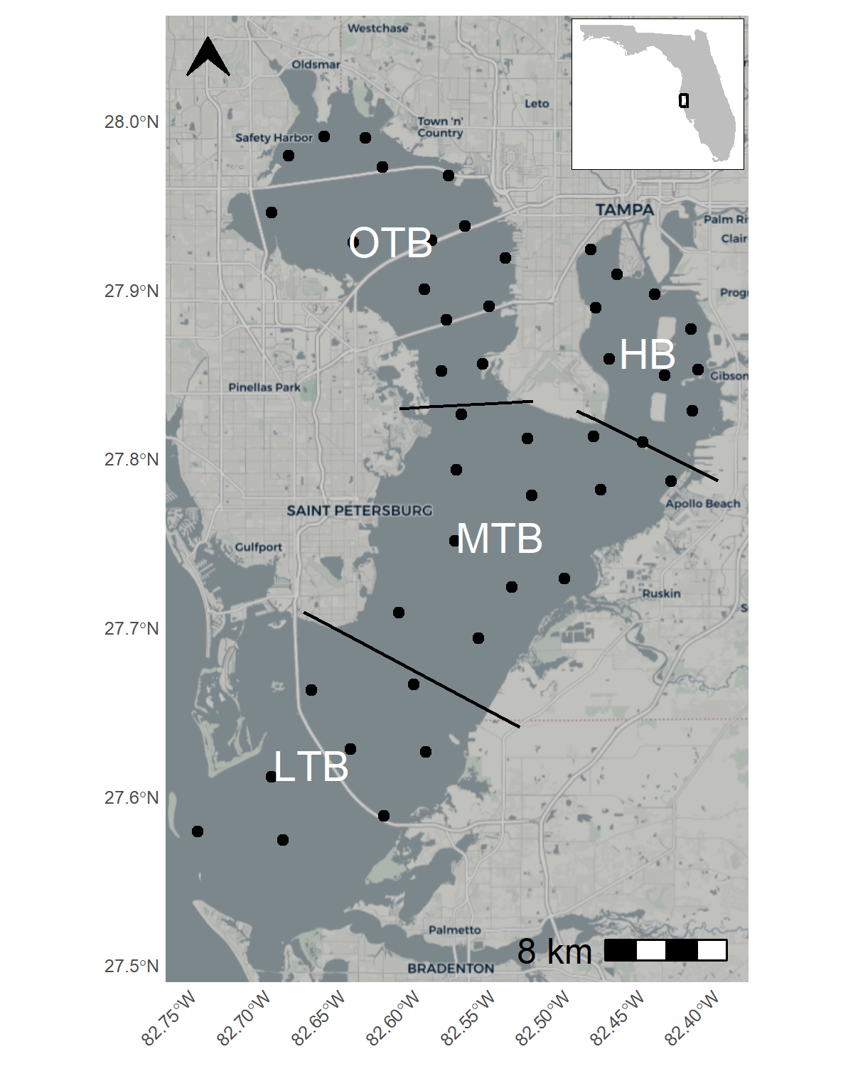
Fig. 1: Tampa Bay on the west coast of Florida, USA. Bay segments are denoted with the labels and their boundaries. Points show long-term monitoring stations from the Environmental Protection Commission of Hillsborough County where chlorophyll-a and salinity data were used for modeling. OTB: Old Tampa Bay; HB: Hillsborough Bay; MTB: Middle Tampa Bay; LTB: Lower Tampa Bay.

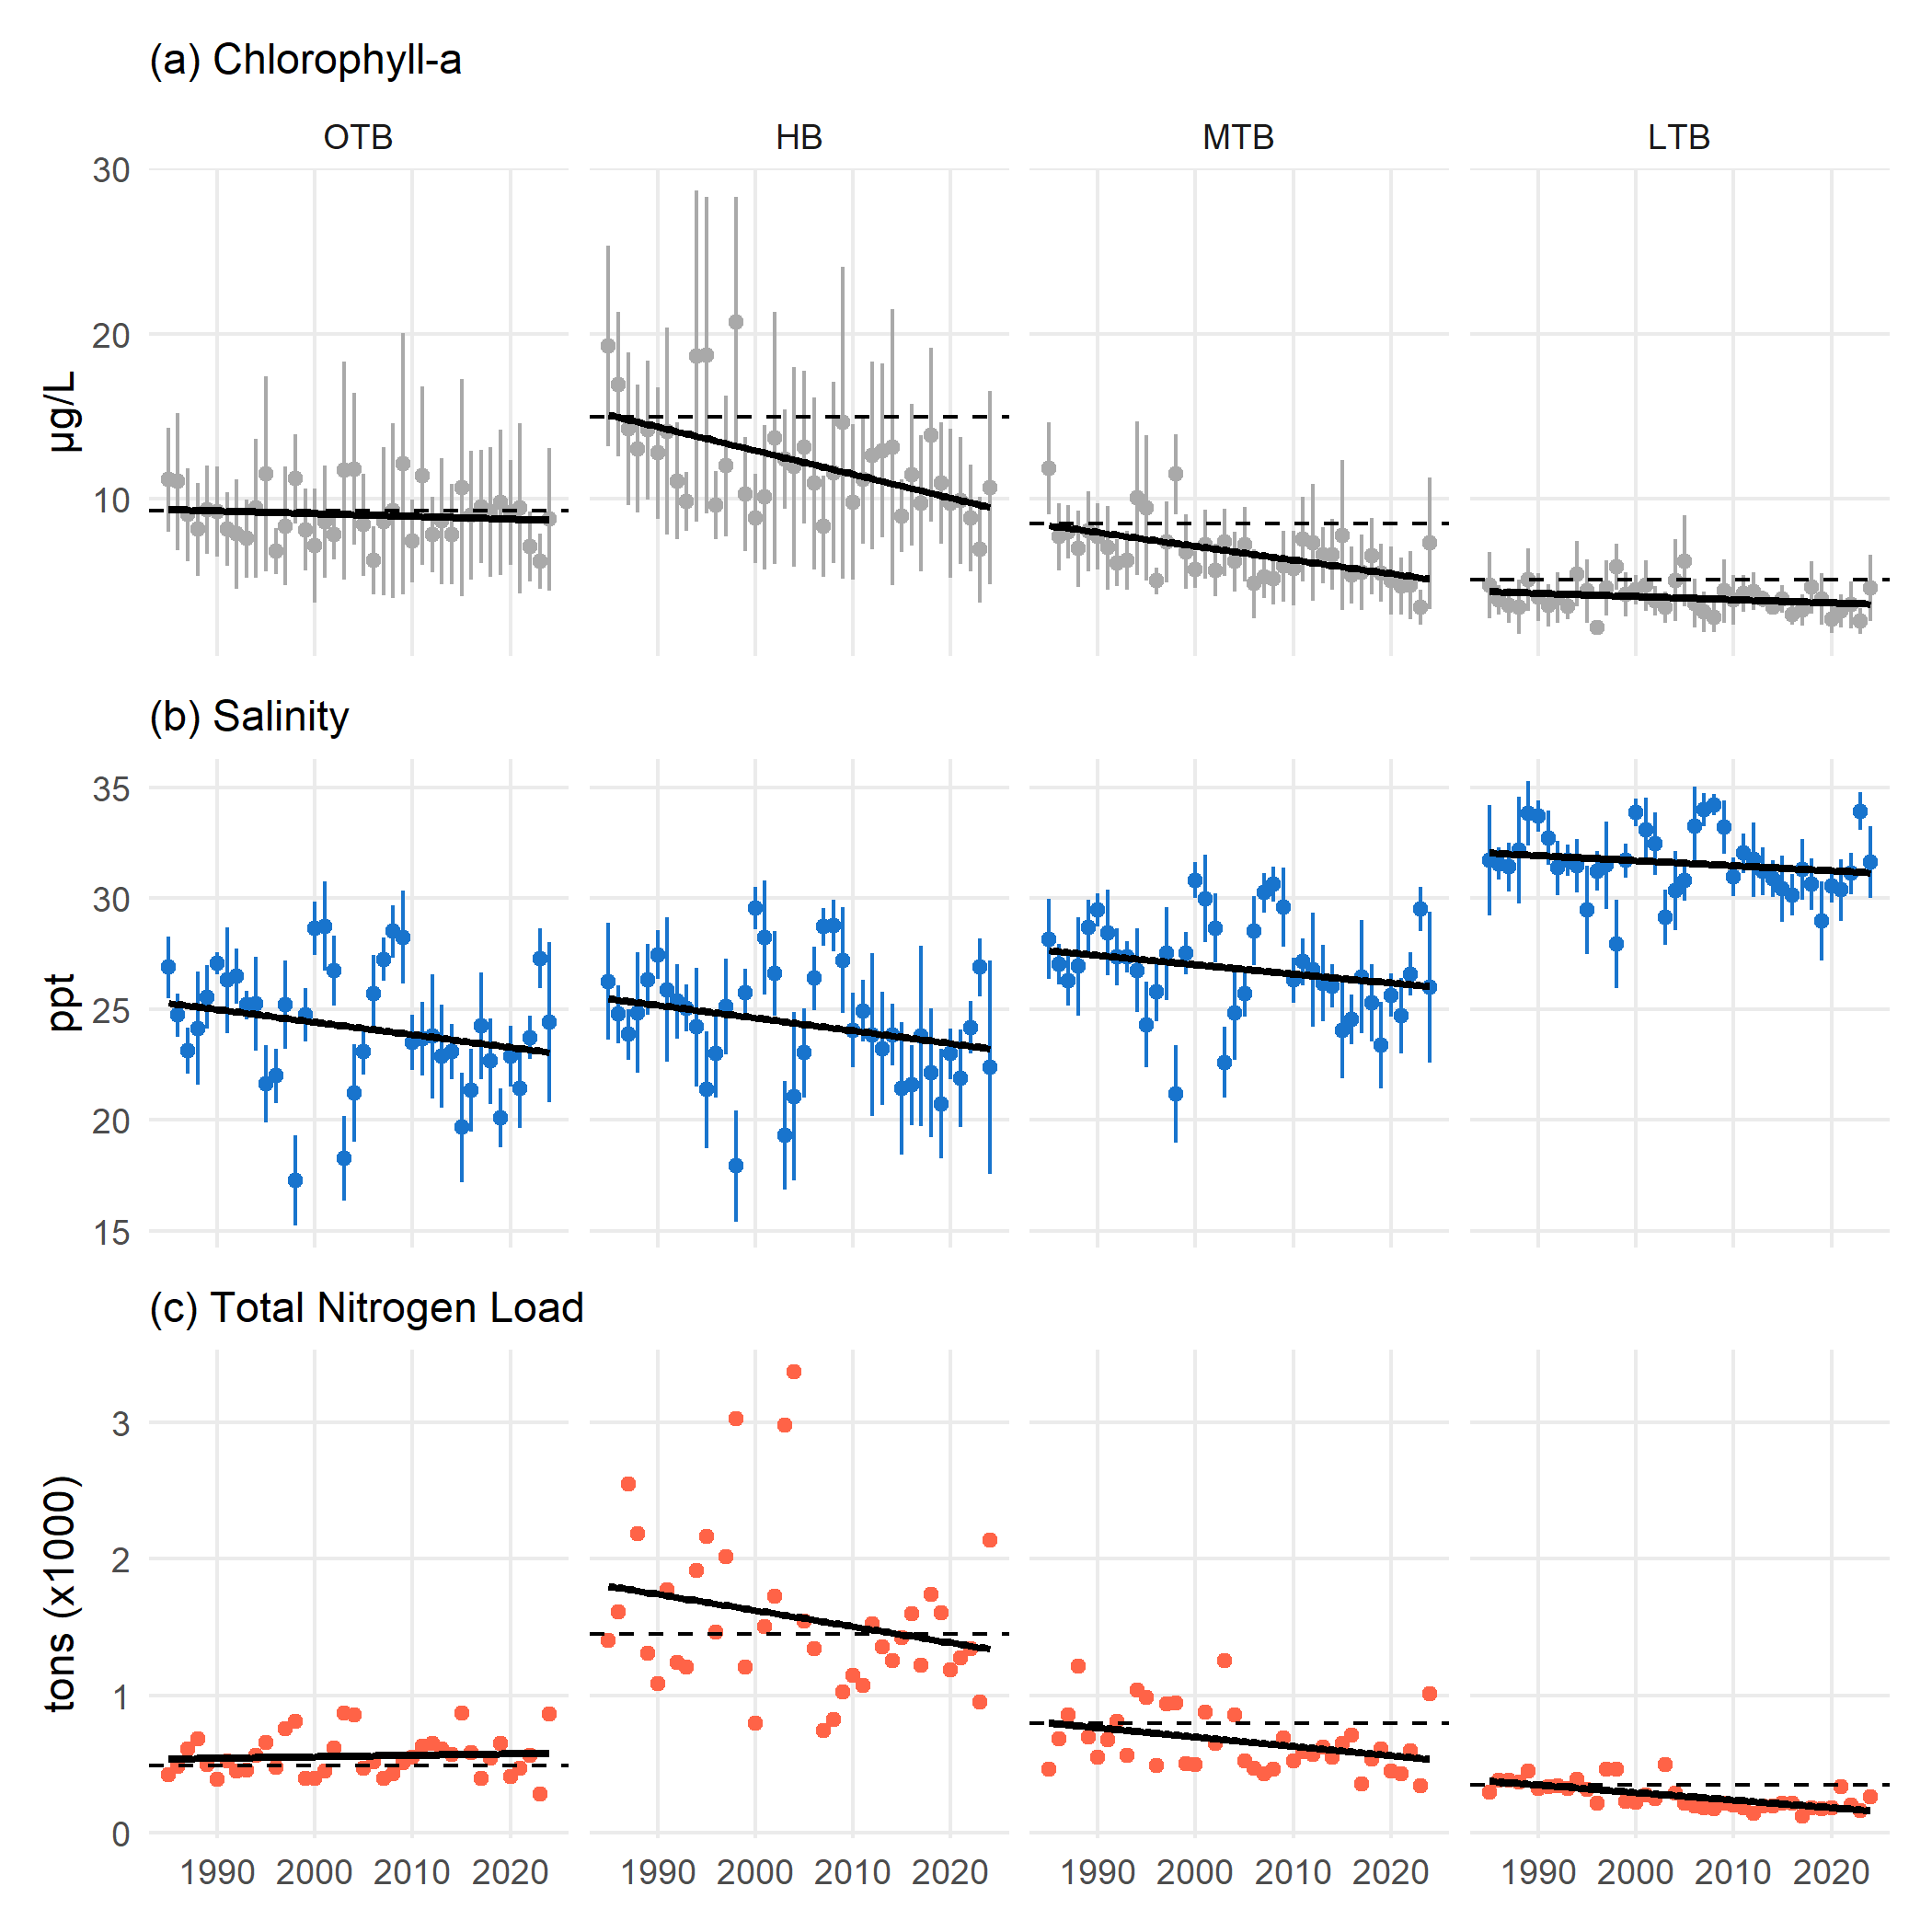
Fig. 2: Annual chlorophyll-a (a), salinity (b), and total nitrogen load (c) for each bay segment from 1985 to present. Chlorophyll-a and salinity are shown as annual averages with 95% confidence intervals and the total nitrogen loads are the annual sums across each month. Relevant regulatory standards are shown as dashed lines for chlorophyll-a and total nitrogen load. Linear trends are also shown with the solid black lines. OTB: Old Tampa Bay; HB: Hillsborough Bay; MTB: Middle Tampa Bay; LTB: Lower Tampa Bay.

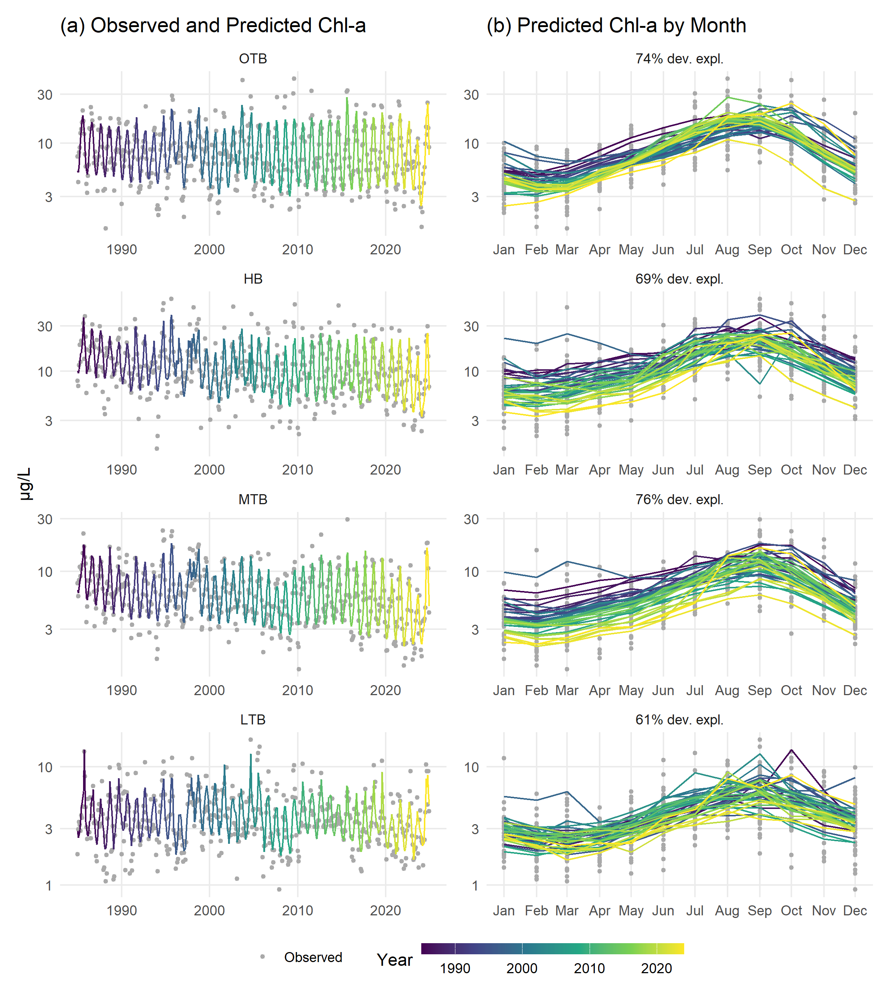
Fig. 3: Observed and predicted chlorophll-a ($μ$g/L) for the four major bay segments of Tampa Bay. Observed and predicted are shown continuously over time (a) and by month (b). Color shading indicates year. Rows are arranged by bay segment with the top labels in the left column showing the bay segment and the right column showing deviance explained.

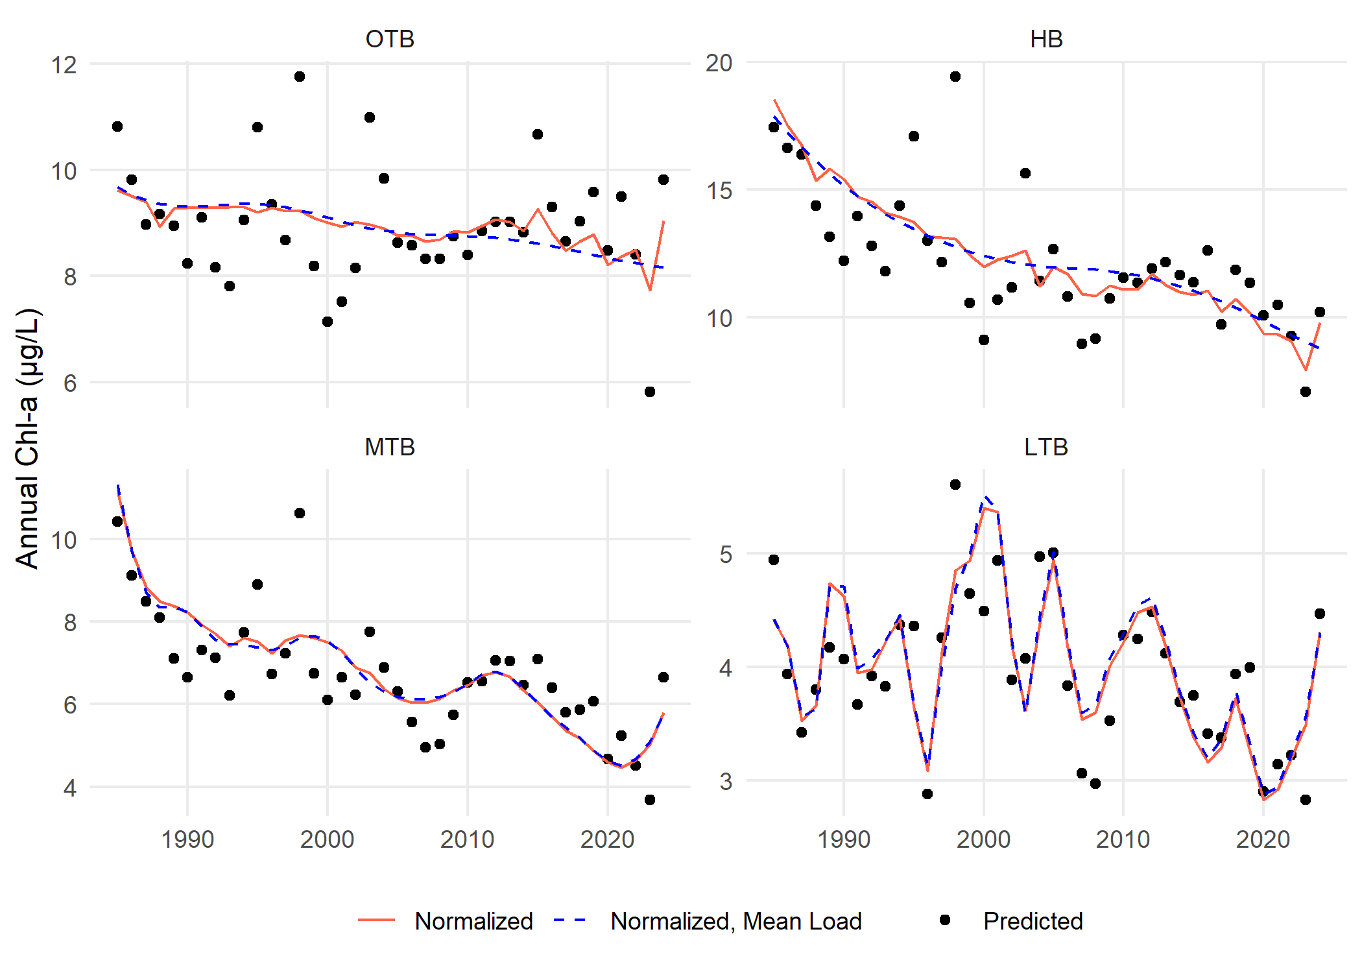
Fig. 4: Annual predictions, normalized estimates, and normalized estimates at mean loading for chlorophyll-a by major bay segment from the separate GAMs. Normalized values (solid lines) are those that remove the salinity influence using the mean result of predictions across a range of salinity values at each time step, whereas the normalized, mean load values (dashed lines) are salinity-normalized values at a constant mean load for each bay segment. OTB: Old Tampa Bay; HB: Hillsborough Bay; MTB: Middle Tampa Bay; LTB: Lower Tampa Bay.

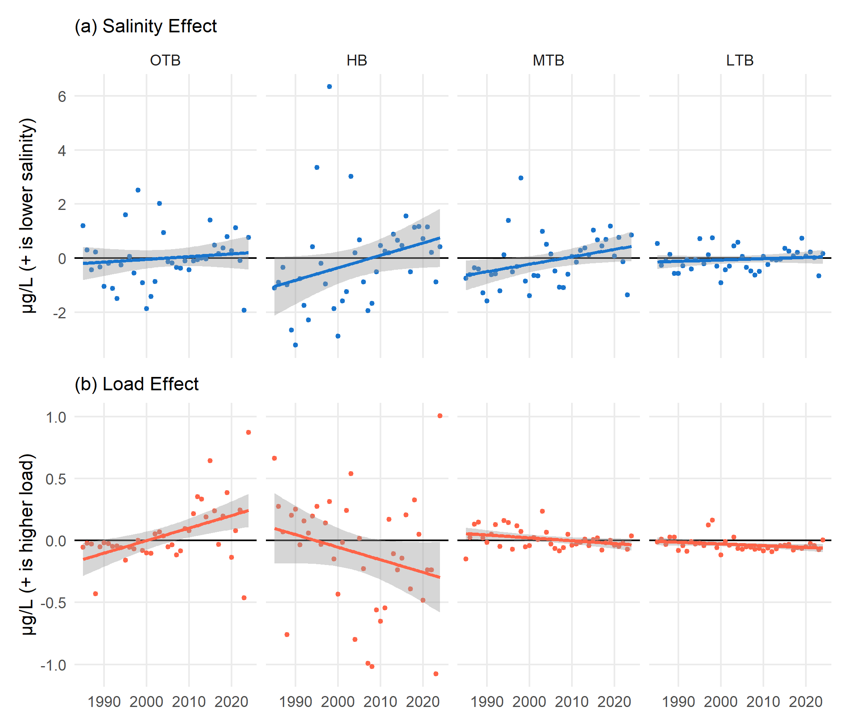
Fig. 5: Unique effects of salinity (a) and loading (b) on chlorophyll-a concentrations over time by bay segment. Points represent values for a given year where the model predictions minus the salinity-normalized results show the effect of salinity (a) and the salinity-normalized results minus the normalized results at mean loading show the effect of loading (b). Linear trends and standard error across years are also shown. OTB: Old Tampa Bay; HB: Hillsborough Bay; MTB: Middle Tampa Bay; LTB: Lower Tampa Bay.

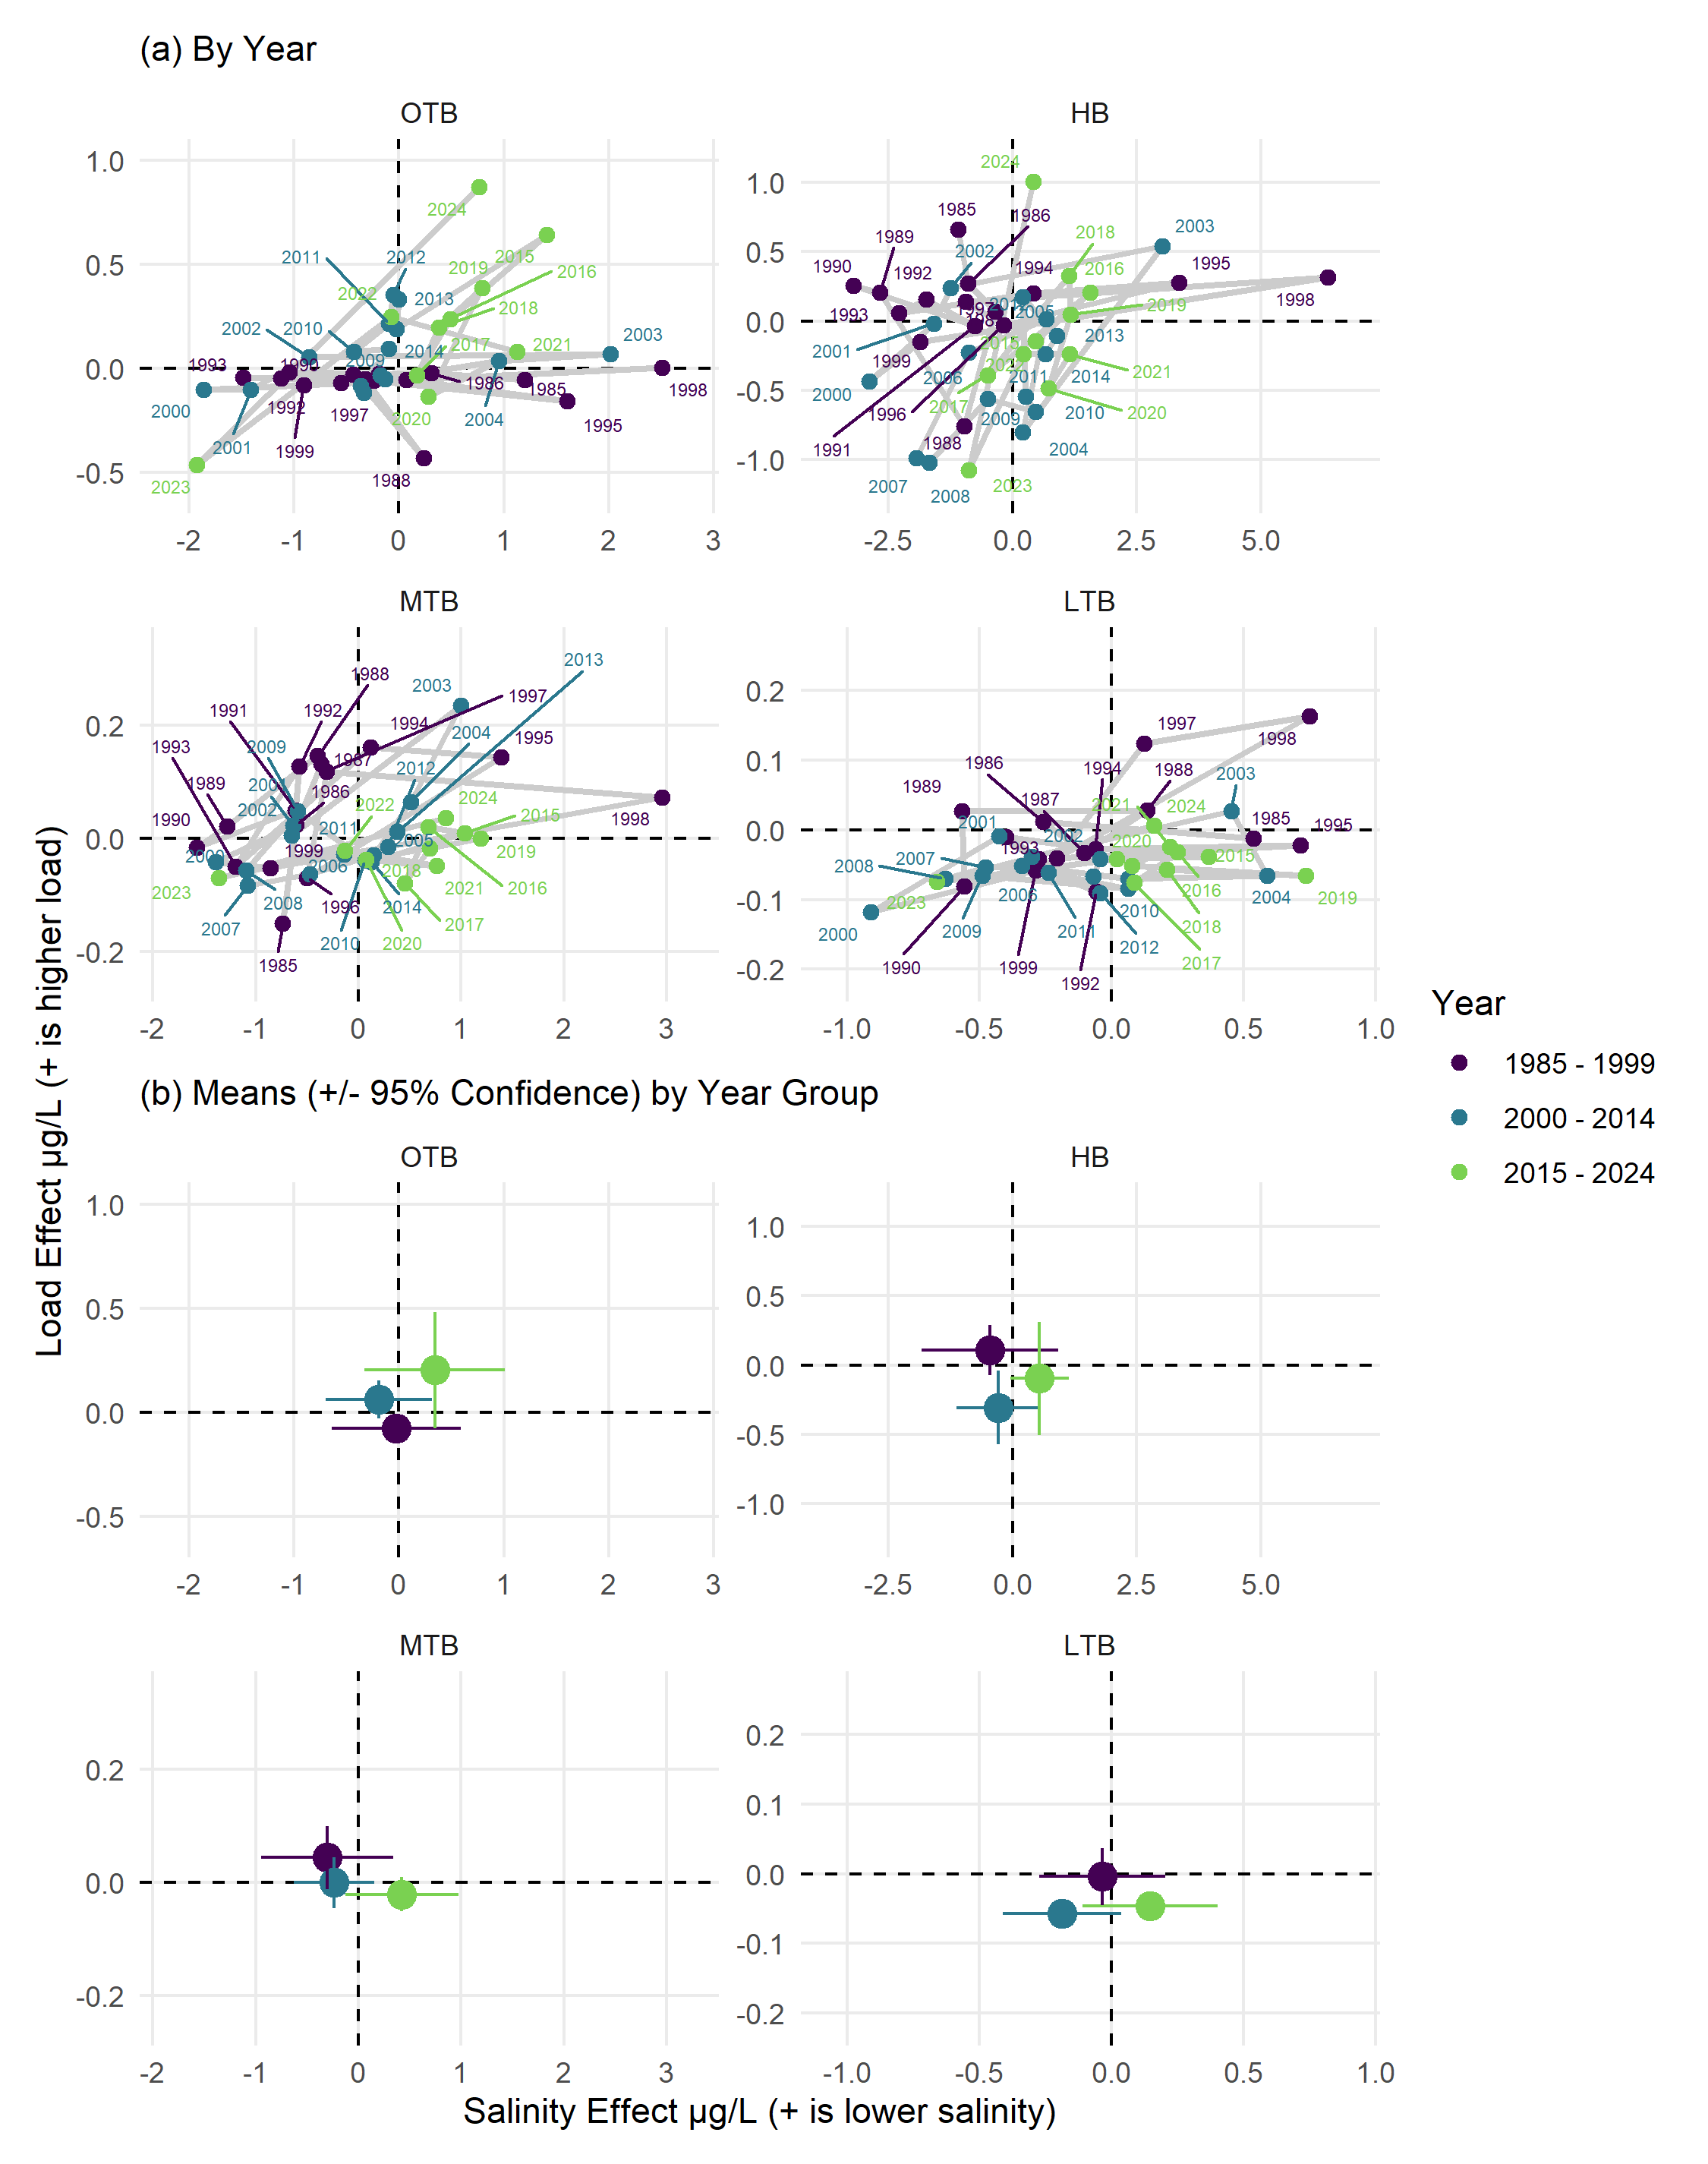
Fig. 6: State space representations of modelled annual chlorophyll-a response to salinity (x-axis) or nitrogen load (y-axis). Points represent values for a given year in (a), joined sequentially through time by the grey lines. Means and 95% confidence for the year groups are shown in (b). OTB: Old Tampa Bay; HB: Hillsborough Bay; MTB: Middle Tampa Bay; LTB: Lower Tampa Bay.

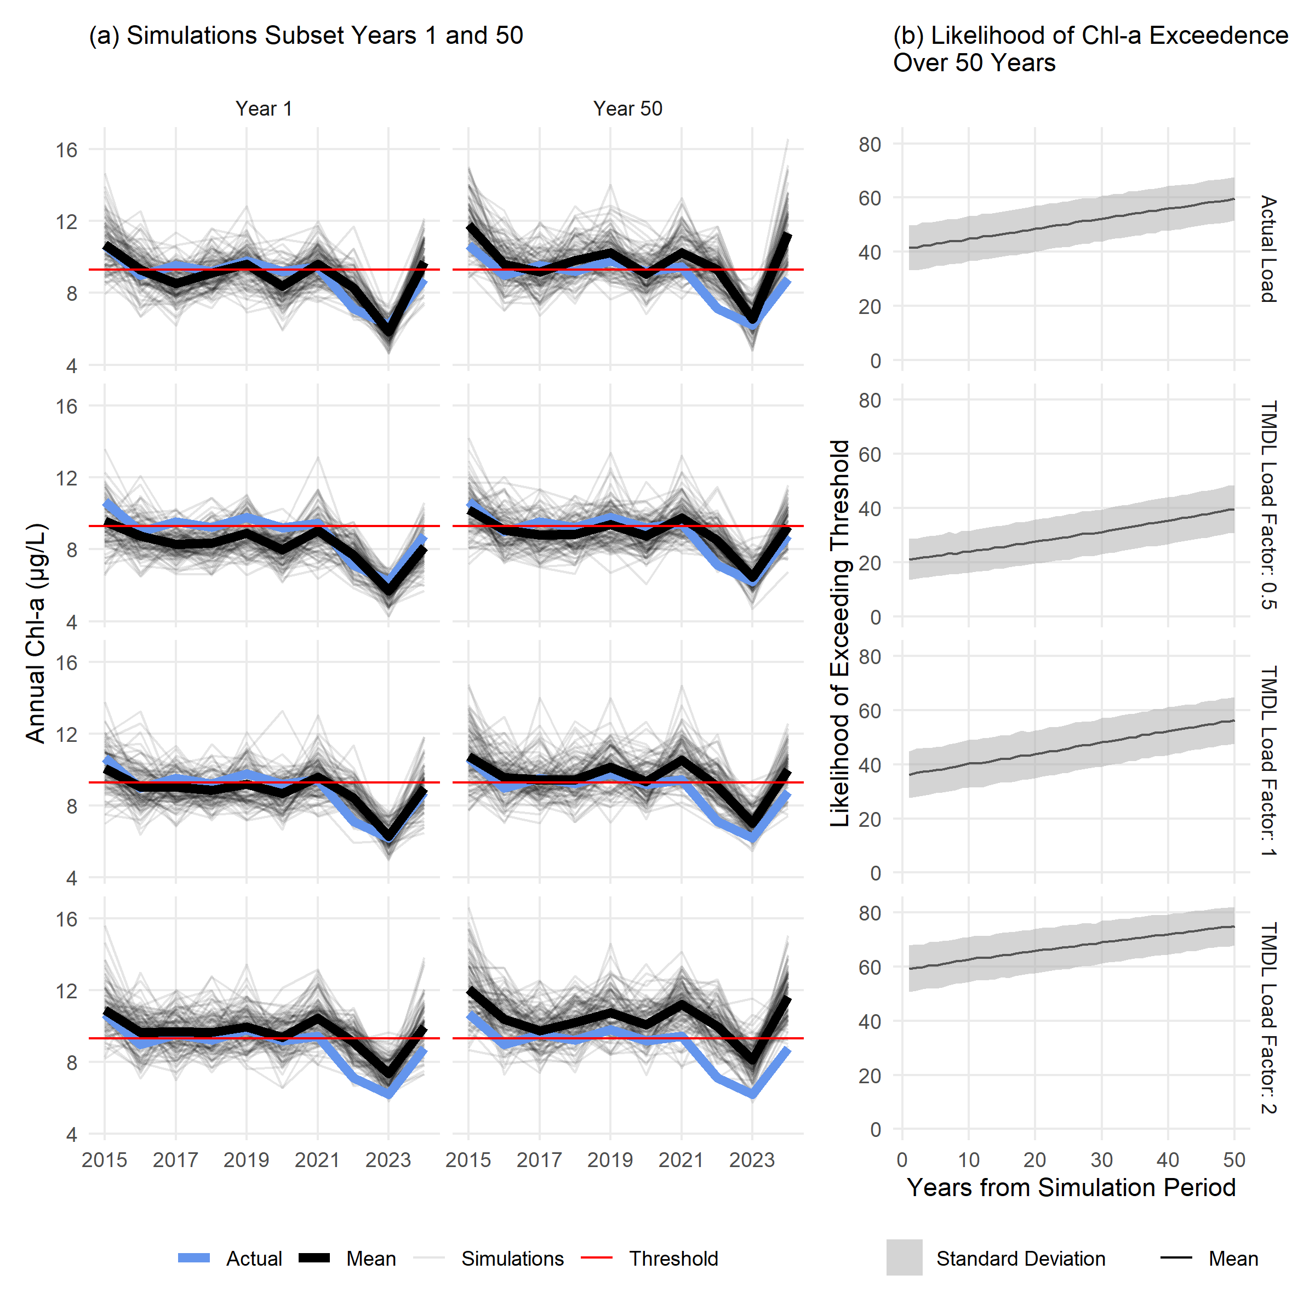
Fig. 7: Estimated chlorophyll-a for a subset of 100 simulations (a) and likelihood of exceeding regulatory thresholds with 10,000 simulations (b) in OTB under different loading conditions and salinity changes. The left column in (a) shows simulated chl-a for the first year where salinity is set at observed and the right column shows results for expected salinity fifty years from present for the time period from 2015-2024. Nitrogen load values were set to the actual observed load (top row), half the TMDL (second row), the TMDL (third row), and double the TMDL (bottom row). Lines in (b) show the average and standard deviations of likelihoods of exceeding the thresholds over time for 10,000 simulations using the OTB model.

Tables
Table 1: Generalized Additive Model (GAM) summary statistics for chlorophyll-a predictions by bay segment in Tampa Bay (n = 480 for each). Results for the overall model fit are shown with the Generalized Cross Validation (GCV) score and deviance explained (Dev. Expl.). Summary statistics for the smoothers used in each model are also shown with the estimated degrees of freedom (edf), reference degrees of freedom (Ref.df), F-statistic (F), and p-value (p, bold < $α$ = 0.05). $s$() indicates a single spline smooth for the predictor and $ti$() indicates a tensor product smoother interaction between two predictors. dec_time: decimal time; doy: day of year; sal: salinity (ppth); tn_load: total nitrogen load (tons/month). OTB: Old Tampa Bay; HB: Hillsborough Bay; MTB: Middle Tampa Bay; LTB: Lower Tampa Bay.
Bay Segment | GCV | Dev. Expl. | Smoother | edf | Ref.df | F | p
OTB | 1159 | 0.74 | s(dec_time) | 1 | 1 | 10.01 | 0.002
 |  |  | s(doy) | 5.96 | 8 | 50.08 | < 0.001
 |  |  | s(sal) | 1 | 1 | 13.03 | < 0.001
 |  |  | s(tn_load) | 1.91 | 2.45 | 1.49 | 0.251
 |  |  | ti(dec_time,doy) | 7.11 | 12 | 2.05 | < 0.001
 |  |  | ti(dec_time,sal) | 8.89 | 10.96 | 2.91 | < 0.001
 |  |  | ti(sal,doy) | 3.57 | 12 | 1.8 | < 0.001
 |  |  | ti(dec_time,tn_load) | 1 | 1.01 | 4.55 | 0.033
 |  |  | ti(tn_load,doy) | 0 | 12 | 0 | 0.501
 |  |  | ti(tn_load,sal) | 1.84 | 2.24 | 0.89 | 0.460
HB | 1347 | 0.69 | s(dec_time) | 3.87 | 4.8 | 21.02 | < 0.001
 |  |  | s(doy) | 5.24 | 8 | 28.07 | < 0.001
 |  |  | s(sal) | 1 | 1 | 41.25 | < 0.001
 |  |  | s(tn_load) | 2.69 | 3.45 | 2.2 | 0.079
 |  |  | ti(dec_time,doy) | 0.78 | 12 | 0.08 | 0.264
 |  |  | ti(dec_time,sal) | 7.23 | 9 | 1.81 | 0.064
 |  |  | ti(sal,doy) | 3.35 | 12 | 0.69 | 0.019
 |  |  | ti(dec_time,tn_load) | 2.47 | 2.89 | 2.93 | 0.041
 |  |  | ti(tn_load,doy) | 0 | 12 | 0 | 0.439
 |  |  | ti(tn_load,sal) | 2.23 | 2.67 | 2.49 | 0.114
MTB | 970 | 0.76 | s(dec_time) | 11.09 | 13.76 | 15.17 | < 0.001
 |  |  | s(doy) | 5.76 | 8 | 47.51 | < 0.001
 |  |  | s(sal) | 2.75 | 3.48 | 24.21 | < 0.001
 |  |  | s(tn_load) | 1.26 | 1.47 | 1.59 | 0.136
 |  |  | ti(dec_time,doy) | 1.58 | 12 | 0.42 | 0.028
 |  |  | ti(dec_time,sal) | 6.51 | 8.3 | 1.52 | 0.144
 |  |  | ti(sal,doy) | 1.88 | 12 | 0.45 | 0.031
 |  |  | ti(dec_time,tn_load) | 1 | 1 | 0.03 | 0.858
 |  |  | ti(tn_load,doy) | 0 | 12 | 0 | 0.403
 |  |  | ti(tn_load,sal) | 1 | 1 | 3.75 | 0.053
LTB | 836 | 0.61 | s(dec_time) | 23.05 | 27.88 | 3.72 | < 0.001
 |  |  | s(doy) | 4.73 | 8 | 23.71 | < 0.001
 |  |  | s(sal) | 2.52 | 3.22 | 13.36 | < 0.001
 |  |  | s(tn_load) | 1 | 1 | 3.24 | 0.073
 |  |  | ti(dec_time,doy) | 4.42 | 12 | 0.68 | 0.050
 |  |  | ti(dec_time,sal) | 1.83 | 2.28 | 0.41 | 0.623
 |  |  | ti(sal,doy) | 0 | 12 | 0 | 0.883
 |  |  | ti(dec_time,tn_load) | 1 | 1 | 0.15 | 0.702
 |  |  | ti(tn_load,doy) | 1.51 | 12 | 0.29 | 0.063
 |  |  | ti(tn_load,sal) | 4.6 | 5.99 | 2.26 | 0.038

Table 2: Correlations between monthly observed and predicted chlorophyll-a for different annual and seasonal periods for each bay segment. The Annual column shows the correlation for the entire year grouping (1985-1999, 2000-2014, or 2015-2024) and the remaining columns show the seasonal correlations within the year group. Font shading and size is proportional to the strength of the correlations. See Table 1 for individual model summary statistics. JFM: January, February, March; AMJ: April, May, June; JAS: July, August, September; OND: October, November, December. OTB: Old Tampa Bay; HB: Hillsborough Bay; MTB: Middle Tampa Bay; LTB: Lower Tampa Bay.
Bay Segment | Year Group | Annual | JFM | AMJ | JAS | OND
OTB | 1985 - 1999 | 0.82 | 0.62 | 0.65 | 0.56 | 0.83
 | 2000 - 2014 | 0.77 | 0.24 | 0.55 | 0.34 | 0.84
 | 2015 - 2024 | 0.90 | 0.54 | 0.70 | 0.72 | 0.92
HB | 1985 - 1999 | 0.78 | 0.73 | 0.51 | 0.67 | 0.77
 | 2000 - 2014 | 0.79 | 0.59 | 0.37 | 0.53 | 0.70
 | 2015 - 2024 | 0.80 | 0.71 | 0.87 | 0.58 | 0.69
MTB | 1985 - 1999 | 0.85 | 0.74 | 0.65 | 0.72 | 0.84
 | 2000 - 2014 | 0.84 | 0.54 | 0.55 | 0.65 | 0.80
 | 2015 - 2024 | 0.83 | 0.80 | 0.76 | 0.67 | 0.83
LTB | 1985 - 1999 | 0.79 | 0.72 | 0.55 | 0.70 | 0.78
 | 2000 - 2014 | 0.72 | 0.55 | 0.72 | 0.60 | 0.42
 | 2015 - 2024 | 0.79 | 0.52 | 0.51 | 0.86 | 0.44

Table 3: Mean differences ($μ$g/L) for monthly predictions minus salinity-normalized results (Salinity) and salinity-normalized results minus salinity-normalized results at mean loadings (Load). The values in the salinity columns can be considered the relative effects of changes in salinity on chlorophyll-a, whereas those in the load columns are relative effects of loading on chlorophyll-a independent of salinity. The Annual columns show the differences for the entire year grouping (1985-1999, 2000-2014, or 2015-2024) and the remaining columns show the seasonal differences within the year group. Font size is proportional to the magnitude of the effects, whereas colors show negative (blue) or positive (red) effects on chlorophyll-a. JFM: January, February, March; AMJ: April, May, June; JAS: July, August, September; OND: October, November, December. OTB: Old Tampa Bay; HB: Hillsborough Bay; MTB: Middle Tampa Bay; LTB: Lower Tampa Bay.
 |  | Salinity |  |  |  |  | Load
Bay Segment | Year Group | Annual | JFM | AMJ | JJA | OND | Annual | JFM | AMJ | JJA | OND
OTB | 1985 - 1999 | -0.03 | 0.23 | 0.09 | -0.22 | -0.21 | -0.08 | -0.05 | -0.05 | -0.15 | -0.05
 | 2000 - 2014 | -0.19 | -0.08 | -0.01 | -0.33 | -0.35 | 0.06 | -0.16 | -0.11 | 0.85 | -0.33
 | 2015 - 2024 | 0.34 | 0.13 | -0.07 | 0.44 | 0.87 | 0.20 | -0.30 | -0.25 | 1.61 | -0.25
HB | 1985 - 1999 | -0.46 | 0.47 | 0.11 | -2.41 | 0.00 | 0.11 | 0.09 | 0.15 | 0.05 | 0.15
 | 2000 - 2014 | -0.29 | -0.35 | -0.07 | -0.40 | -0.34 | -0.31 | -0.65 | -0.69 | 0.92 | -0.80
 | 2015 - 2024 | 0.55 | 0.42 | 0.48 | 0.55 | 0.73 | -0.10 | -0.96 | -1.17 | 2.11 | -0.38
MTB | 1985 - 1999 | -0.30 | 0.12 | 0.10 | -1.30 | -0.14 | 0.04 | -0.08 | 0.02 | 0.35 | -0.11
 | 2000 - 2014 | -0.24 | -0.19 | -0.13 | -0.37 | -0.26 | 0.00 | -0.09 | -0.03 | 0.25 | -0.13
 | 2015 - 2024 | 0.42 | 0.09 | 0.12 | 1.07 | 0.42 | -0.02 | -0.07 | -0.06 | 0.12 | -0.07
LTB | 1985 - 1999 | -0.03 | 0.03 | -0.05 | -0.36 | 0.24 | 0.00 | 0.00 | -0.09 | 0.11 | -0.04
 | 2000 - 2014 | -0.19 | -0.24 | -0.08 | -0.13 | -0.29 | -0.06 | -0.06 | -0.10 | 0.06 | -0.13
 | 2015 - 2024 | 0.15 | 0.12 | 0.01 | 0.34 | 0.12 | -0.05 | -0.08 | -0.02 | 0.04 | -0.13

Table 4: Likelihoods of exceeding regulatory chlorophyll-a thresholds for each bay segment for different loading scenarios under projected future salinity changes. Results shown are likelihoods of exceeding the threshold from 10,000 simulations from each model and future year (1 to 50) for the 2015-2024 time period. Standard deviations and the relative changes from present for years 25 and 50 are shown in parentheses. OTB: Old Tampa Bay; HB: Hillsborough Bay; MTB: Middle Tampa Bay; LTB: Lower Tampa Bay.
 |  |  |  | TMDL Load Factor
Bay  Segment | Time | Salinity  Change (ppth) | Actual Load | 0.5 | 1 | 2
OTB | Present | — | 41.5  (8.3) | 21.1  (7.6) | 36.2  (8.7) | 59.3  (8.6)
 | Year 25 | -0.95 | 50.1  (8.5, ↑8.6) | 29.4  (8.5, ↑8.3) | 45.9  (8.9, ↑9.7) | 67.2  (8.1, ↑8)
 | Year 50 | -1.89 | 59.6  (8, ↑18.1) | 39.7  (8.9, ↑18.6) | 56.3  (8.7, ↑20.1) | 74.9  (7, ↑15.7)
HB | Present | — | 1  (2) | 0  (0.2) | 0.7  (1.6) | 12.3  (6.2)
 | Year 25 | -0.66 | 1.2  (2.1, ↑0.2) | 0  (0.3, ≈0) | 0.9  (1.8, ↑0.2) | 13.9  (6.3, ↑1.6)
 | Year 50 | -1.33 | 1.3  (2.2, ↑0.3) | 0  (0.3, ≈0) | 0.9  (1.9, ↑0.3) | 15.9  (6.7, ↑3.6)
MTB | Present | — | 0.4  (1.2) | 0.7  (1.6) | 0.4  (1.2) | 0.1  (0.7)
 | Year 25 | -0.58 | 0.8  (1.7, ↑0.4) | 1.4  (2.2, ↑0.7) | 0.9  (1.8, ↑0.5) | 0.3  (1.1, ↑0.2)
 | Year 50 | -1.17 | 1.5  (2.4, ↑1.2) | 3.1  (3.2, ↑2.4) | 1.8  (2.6, ↑1.5) | 0.6  (1.5, ↑0.4)
LTB | Present | — | 1.4  (2.2) | 0.9  (1.8) | 1.6  (2.4) | 2.4  (2.8)
 | Year 25 | -0.76 | 3  (3, ↑1.6) | 2.3  (2.8, ↑1.4) | 3.5  (3.3, ↑1.9) | 3.9  (3.4, ↑1.5)
 | Year 50 | -1.51 | 6  (4.2, ↑4.6) | 5.3  (4.1, ↑4.5) | 6.1  (4.1, ↑4.5) | 6.5  (4.2, ↑4.2)

Data Availability
All data and analysis code for this manuscript is available on GitHub at https://github.com/tbep-tech/chlhydro-manu.

Acknowledgments
This work benefited from constructive discussions with the Technical Advisory Committee of the Tampa Bay Estuary Program (TBEP). We are thankful for constructive comments provided by xxx anonymous reviewers. We are indebted to the community of field and technical staff that have routinely collected and maintained the valuable long-term monitoring data used in this study. We also thank Dr. Ray Pribble for extensive support with the loading estimates.

Statements and Declarations

Author Contributions
Conceptualization: all authors; Data Curation: Marcus W Beck; Methodology: Marcus W Beck, Edward T Sherwood; Formal analysis and investigation: Marcus W Beck; Writing - original draft preparation: Marcus W Beck; Writing - review and editing: all authors; Funding acquisition: Edward T Sherwood.

Ethics Declaration
The authors have no competing interests to declare that are relevant to the content of this article.

Funding
This study was funded by EPA Section 320 Grant Funds, and the TBEP’s local government partners (Hillsborough, Manatee, Pasco, and Pinellas Counties; the Cities of Clearwater, St. Petersburg, and Tampa; Tampa Bay Water; and the Southwest Florida Water Management District) through contributions to the operating budget.

References
Adler, R. W., and J. C. Landman. 1993. Clean water act 20 years later. Washington, DC: Island Press.
Avery Jr, G. B., R. J. Kieber, J. D. Willey, G. C. Shank, and R. F. Whitehead. 2004. Impact of hurricanes on the flux of rainwater and Cape Fear River water dissolved organic carbon to Long Bay, southeastern United States. Global Biogeochemical Cycles 18. Wiley Online Library. https://doi.org/10.1029/2004GB002229.
Beck, M. W., P. deValpine, R. Murphy, I. Wren, A. Chelsky, M. Foley, and D. B. Senn. 2022. Multi-scale trend analysis of water quality using error propagation of generalized additive models. Science of The Total Environment 802: 149927. https://doi.org/10.1016/j.scitotenv.2021.149927.
Beck, M. W., K. Flaherty-Walia, S. Scolaro, M. C. Burke, B. T. Furman, D. J. Karlen, C. Pratt, C. J. Anastasiou, and E. T. Sherwood. 2024. Hot and fresh: Evidence of climate-related suboptimal water conditions for seagrass in a large Gulf coast estuary. Estuaries and Coasts 47. Springer: 1475–1497. https://doi.org/10.1007/s12237-024-01385-0.
Beck, M. W., and J. D. Hagy. 2015. Adaptation of a weighted regression approach to evaluate water quality trends in an estuary. Environmental Modeling & Assessment 20. Springer: 637–655. https://doi.org/10.1007/s10666-015-9452-8.
Beck, M. W., and R. R. Murphy. 2017. Numerical and qualitative contrasts of two statistical models for water quality change in tidal waters. JAWRA Journal of the American Water Resources Association 53. Wiley Online Library: 197–219. https://doi.org/10.1111/1752-1688.12489.
Borah, D. K., G. Yagow, A. Saleh, P. L. Barnes, W. Rosenthal, E. C. Krug, and L. M. Hauck. 2006. Sediment and nutrient modeling for TMDL development and implementation. Transactions of the ASABE 49. American Society of Agricultural; Biological Engineers: 967–986. https://doi.org/10.13031/2013.21742.
Borsuk, M. E., C. A. Stow, and K. H. Reckhow. 2002. Predicting the frequency of water quality standard violations: a probabilistic approach for TMDL development. Environmental Science & Technology 36: 2109–2115. https://doi.org/10.1021/es011246m.
Bowden, K. F. 1963. The mixing processes in a tidal estuary. International Journal of Air and Water Pollution 7: 343–356.
Burwell, D., M. Vincent, M. Luther, and B. Galperin. 2000. Modeling residence times: Eulerian vs Lagrangian. In Estuarine and coastal modeling, ed. M. L. Spaulding and H. L. Butler, 995–1009. Reston, VA: American Society of Civil Engineers.
Chen, Z., C. Hu, R. N. Conmy, F. Muller-Karger, and P. Swarzenski. 2007. Colored dissolved organic matter in Tampa Bay, Florida. Marine Chemistry 104. Elsevier: 98–109. https://doi.org/10.1016/j.marchem.2006.12.007.
Chen, Z., C. Hu, and F. Muller-Karger. 2007. Monitoring turbidity in Tampa Bay using MODIS/Aqua 250-m imagery. Remote sensing of Environment 109. Elsevier: 207–220. https://doi.org/10.1016/j.rse.2006.12.019.
Cloern, J. E. 2001. Our evolving conceptual model of the coastal eutrophication problem. Marine Ecology Progress Series 210: 223–253. https://doi.org/10.3354/meps210223.
Damme, S. V., E. Struyf, T. Maris, T. Ysebaert, F. Dehairs, M. Tackx, C. Heip, and P. Meire. 2005. Spatial and temporal patterns of water quality along the estuarine salinity gradient of the Scheldt estuary (Belgium and The Netherlands): Results of an integrated monitoring approach. Hydrobiologia 540. Springer: 29–45. https://doi.org/10.1007/s10750-004-7102-2.
Fox, J., and S. Weisberg. 2018. An R companion to applied regression. Sage publications.
Greening, H. S., and A. J. Janicki. 2006. Toward reversal of eutrophic conditions in a subtropical estuary: Water quality and seagrass response to nitrogen loading reductions in Tampa Bay, Florida, USA. Environmental Management 38: 163–178. https://doi.org/10.1007/s00267-005-0079-4.
Greening, H. S., A. J. Janicki, E. T. Sherwood, R. Pribble, and J. O. R. Johansson. 2014. Ecosystem responses to long-term nutrient management in an urban estuary: Tampa Bay, Florida, USA. Estuarine, Coastal and Shelf Science 151: A1–A16. https://doi.org/10.1016/j.ecss.2014.10.003.
Hagy, J. D., W. R. Boynton, and L. P. Sanford. 2000. Estimation of net physical transport and hydraulic residence times for a coastal plain estuary using box models. Estuaries 23. Springer: 328–340. https://doi.org/10.2307/1353325.
Hirsch, R. M., D. L. Moyer, and S. A. Archfield. 2010. Weighted regressions on time, discharge, and season (WRTDS), with an application to Chesapeake Bay river inputs 1. JAWRA Journal of the American Water Resources Association 46. Wiley Online Library: 857–880. https://doi.org/10.1111/j.1752-1688.2010.00482.x.
Janicki, A. J., J. R. Pribble, H. Zarbock, and D. Wade. 2023. A look back at long-term trends in nitrogen loading to Tampa Bay. Florida Scientist 86: 255–263.
Janicki, A. J., and D. L. Wade. 1996. Estimating critical nitrogen loads for the Tampa Bay estuary: An empirically based approach to setting management targets. Technical report 06-96. St. Petersburg, Florida: Tampa Bay Estuary Program.
Janicki, A. J., D. L. Wade, and J. R. Pribble. 2000. Developing and establishing a process to track the status of chlorophyll-a concentrations and light attenuation to support seagrass restoration goals in Tampa Bay. Technical report 04-00. St. Petersburg, Florida: Tampa Bay Estuary Program.
Janicki Environmental, Inc. 2015. Old Tampa Bay Integrated Ecosystem Model development project: Task deliverables. Technical report 11-15. St. Petersburg, Florida: Tampa Bay Estuary Program.
Janicki Environmental, Inc. 2023. Estimates of total nitrogen, total phosphorus, total suspended solids, and biological oxygen demand loadings to Tampa Bay, Florida: 2017-2021. 06-23. St. Petersburg, Florida: Tampa Bay Estuary Program.
Johansson, J. O. R. 2022. Optical model evaluation of the recent underwater light climate in the northern segments of Tampa Bay and its potential influence on seagrass abundance and growth. Technical report 06-22. St. Petersburg, Florida: Tampa Bay Estuary Program.
Karlen, D. J., K. Campbell, T. Ash, B. Goetting, C. Pratt, E. Mathiak, and M. Schuman. 2023. Long-term water quality trends in Tampa Bay (1974-2020). Florida Scientist 86. JSTOR: 400–408.
Kuo, A. Y., and B. J. Neilson. 1987. Hypoxia and salinity in Virginia estuaries. Estuaries 10. Springer: 277–283. https://doi.org/10.2307/1351884.
Lassen, M. K., K. D. Nielsen, K. Richardson, K. Garde, and L. Schlüter. 2010. The effects of temperature increases on a temperate phytoplankton community—a mesocosm climate change scenario. Journal of Experimental Marine Biology and Ecology 383. Elsevier: 79–88. https://doi.org/10.1016/j.jembe.2009.10.014.
Le, C., C. Hu, D. English, J. Cannizzaro, Z. Chen, C. Kovach, C. J. Anastasiou, J. Zhao, and K. L. Carder. 2013. Inherent and apparent optical properties of the complex estuarine waters of Tampa Bay: What controls light? Estuarine, Coastal and Shelf Science 117. Elsevier: 54–69. https://doi.org/10.1016/j.ecss.2012.09.017.
Lu, Z., and J. Gan. 2015. Controls of seasonal variability of phytoplankton blooms in the Pearl River Estuary. Deep Sea Research Part II: Topical Studies in Oceanography 117. Elsevier: 86–96. https://doi.org/10.1016/j.dsr2.2013.12.011.
Lui, H. K., and C. T. A. Chen. 2012. The nonlinear relationship between nutrient ratios and salinity in estuarine ecosystems: Implications for management. Current Opinion in Environmental Sustainability 4. Elsevier: 227–232. https://doi.org/10.1016/j.cosust.2012.03.002.
Luther, M. E., and S. D. Meyers. 2022. Designing a genetic algorithm for the selection of causeway cut-throughs in Old Tampa Bay: Planning and prototyping. 08-22. St. Petersburg, Florida: Tampa Bay Estuary Program.
McCorquodale, J. A., R. J. Roblin, I. Y. Georgiou, and K. A. Haralampides. 2009. Salinity, nutrient, and sediment dynamics in the Pontchartrain Estuary. Journal of Coastal Research: 71–87. https://doi.org/10.2112/SI54-000.1.
Meyers, S. D., M. Wilson, and M. E. Luther. 2015. Observations of hysteresis in the annual exchange circulation of a large microtidal estuary. Journal of Geophysical Research: Oceans 120. Wiley Online Library: 2904–2919. https://doi.org/10.1002/2014JC010342.
Morrison, Gerold, E. T. Sherwood, R. Boler, and J. Barron. 2006. Variations in water clarity and chlorophylla in Tampa Bay, Florida, in response to annual rainfall, 19852004. Estuaries and Coasts 29: 926–931. https://doi.org/10.1007/bf02798652.
Morrison, G., and K. K. Yates. 2011. Environmental setting. In Integrating science and resource management in Tampa Bay, Florida, ed. K. K. Yates, H. Greening, and G. Morrison, 17–36. St. Petersburg, FL: US Geological Survey, Tampa Bay Estuary Program.
Moss, T., and J. Newig. 2010. Multilevel water governance and problems of scale: Setting the stage for a broader debate. Environmental management 46. Springer: 1–6. https://doi.org/10.1007/s00267-010-9531-1.
Murphy, R. R., J. Keisman, J. Harcum, R. R. Karrh, M. Lane, E. S. Perry, and Q. Zhang. 2021. Nutrient improvements in Chesapeake Bay: Direct effect of load reductions and implications for coastal management. Environmental Science & Technology 56. ACS Publications: 260–270. https://doi.org/10.1021/acs.est.1c05388.
Murphy, R. R., E. Perry, J. Harcum, and J. Keisman. 2019. A generalized additive model approach to evaluating water quality: Chesapeake Bay case study. Environmental modelling & software 118. Elsevier: 1–13. https://doi.org/10.1016/j.envsoft.2019.03.027.
Nixon, S. W. 1995. Coastal marine eutrophication: A definition, social causes, and future concerns. Ophelia 41. Taylor & Francis: 199–219. https://doi.org/10.1080/00785236.1995.10422044.
Paerl, H. W., L. M. Valdes, M. F. Piehler, and C. A. Stow. 2006. Assessing the effects of nutrient management in an estuary experiencing climatic change: The Neuse River Estuary, North Carolina. Environmental Management 37. Springer: 422–436. https://doi.org/10.1007/s00267-004-0034-9.
Richards, R., L. Hughes, D. Gee, and R. Tomlinson. 2013. Using generalized additive models for water quality assessments: A case study example from Australia. Journal of Coastal Research. Coastal Education; Research Foundation: 111–116.
Schiff, K., P. R. Trowbridge, E. T. Sherwood, P. Tango, and R. A. Batiuk. 2016. Regional monitoring programs in the United States: Synthesis of four case studies from Pacific, Atlantic, and Gulf coasts. Regional Studies in Marine Science 4. Elsevier: A1–A7. https://doi.org/10.1016/j.rsma.2015.11.007.
Schramm, M. P. 2023. Linking watershed nutrient loading to estuary water quality with generalized additive models. PeerJ 11. PeerJ Inc.: e16073. https://doi.org/10.7717/peerj.16073.
Sherwood, E. T., H. S. Greening, L. Garcia, K. Kaufman, A. J. Janicki, R. Pribble, B. Cunningham, et al. 2015. Development of an integrated ecosystem model to determine effectiveness of potential watershed management projects on improving Old Tampa Bay. 10-15. St. Petersburg, Florida: Tampa Bay Estuary Program.
Sherwood, E. T., H. S. Greening, A. J. Janicki, and D. J. Karlen. 2016. Tampa Bay estuary: Monitoring long-term recovery through regional partnerships. Regional Studies in Marine Science 4: 1–11. https://doi.org/10.1016/j.rsma.2015.05.005.
Sherwood, E. T., H. S. Greening, J. O. R. Johansson, K. Kaufman, and G. E. Raulerson. 2017. Tampa Bay (Florida, USA): Documenting seagrass recovery since the 1980’s and reviewing the benefits. Southeastern Geographer 57: 294–319. https://doi.org/10.1353/sgo.2017.0026.
Simpson, G. L. 2025. gratia: Graceful ggplot-based graphics and other functions for GAMs fitted using mgcv. https://doi.org/10.32614/CRAN.package.gratia.
Sin, Y., R. L. Wetzel, and I. C. Anderson. 1999. Spatial and temporal characteristics of nutrient and phytoplankton dynamics in the York River estuary, Virginia: Analyses of long-term data. Estuaries 22. Springer: 260–275. https://doi.org/10.2307/1352982.
Southwest Florida Water Management District. 2025. 2023 land use land cover shapefile for SWFWMD.
Statham, P. J. 2012. Nutrients in estuaries - An overview and the potential impacts of climate change. Science of The Total Environment 434: 213–227. https://doi.org/10.1016/j.scitotenv.2011.09.088.
Tampa Bay Nitrogen Management Consortium. 2010. 2009 reasonable assurance addendum: Allocation and assessment report. Technical report 03-10. St. Petersburg, Florida: Tampa Bay Estuary Program.
Testa, J. M., P. Bukaveckas, W. Boynton, L. Harris, R. Murphy, M. Lane, and V. Lyubchich. 2025. Coupled and de-coupled watershed nutrient loading and estuarine nutrient concentrations: A case study of the Chesapeake Bay. JAWRA Journal of the American Water Resources Association 61: e70070. https://doi.org/10.1111/1752-1688.70070.
Venables, W. N., and B. D. Ripley. 2002. Modern applied statistics with S. New York: Springer. https://doi.org/10.1007/978-0-387-21706-2.
Wang, H., T. Asefa, F. Getachew, and Y. Zhou. 2026. Multi-scale shifts in rainfall patterns in a subtropical region (1981–2024): Challenges and implications for water management. Journal of Hydrology. Elsevier: 134851. https://doi.org/10.1016/j.jhydrol.2025.134851.
Wang, P. F., J. Martin, and G. Morrison. 1999. Water quality and eutrophication in Tampa Bay, Florida. Estuarine, Coastal and Shelf Science 49. Elsevier: 1–20. https://doi.org/10.1006/ecss.1999.0490.
Wood, S. N. 2011. Fast stable restricted maximum likelihood and marginal likelihood estimation of semiparametric generalized linear models. Journal of the Royal Statistical Society (B) 73: 3–36. https://doi.org/10.1111/j.1467-9868.2010.00749.x.
Wood, S. N. 2017. Generalized Additive Models: An introduction with R. 2nd ed. Chapman; Hall/CRC.
Wool, T. A., S. R. Davie, and H. N. Rodriguez. 2003. Development of three-dimensional hydrodynamic and water quality models to support total maximum daily load decision process for the Neuse River Estuary, North Carolina. Journal of Water Resources Planning and Management 129. American Society of Civil Engineers: 295–306. https://doi.org/10.1061/(ASCE)0733-9496(2003)129:4(295).
Yates, K., H. Greening, and G. Morrison. 2011. Integrating science and resource management in Tampa Bay, Florida, USGS circular 1348. Technical report 05-11. St. Petersburg, Florida: USGS Circular 1348.
Zarbock, H. W., A. J. Janicki, D. L. Wade, and D. G. Heimbuch. 1994. Estimates of total nitrogen, total phosphorus, and total suspended solids loadings to Tampa Bay, Florida. Technical report 04-94. St. Petersburg, Florida: Tampa Bay Estuary Program.

