March 17th, 2022

Dr. Michael Boufadel, Dr. Francois Galgani, Dr. Gui-Peng Yang

Co-Editors-in-Chief

Marine Pollution Bulletin

We are pleased to resubmit our manuscript, “Initial estuarine response to inorganic nutrient inputs from a legacy mining facility adjacent to Tampa Bay, Florida” to be considered as an original research article in Marine Pollution Bulletin. Once again, we thank the reviewers for providing helpful comments on the revised draft. Our response to these final comments is provided below. In short, we have revised the manuscript title, further simplified the graphical abstract, and provided additional clarification regarding the modelling components of this work. We are confident that these changes have further improved the draft, making it suitable for publication.

Sincerely,

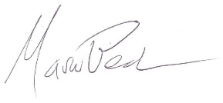

Dr. Marcus W. Beck

Program Scientist

Tampa Bay Estuary Program