Coordinated monitoring of the Piney Point wastewater discharage into Tampa Bay: Data synthesis and reporting

Marcus W. Beck, Tampa Bay Estuary Program, 263 13th Ave S, Saint Petersburg, FL, [mbeck@tbep.org](mailto:mbeck@tbep.org)

Maya C. Burke, Tampa Bay Estuary Program, 263 13th Ave S, Saint Petersburg, FL, [mburke@tbep.org](mailto:mburke@tbep.org)

Gary E. Raulerson, Tampa Bay Estuary Program, 263 13th Ave S, Saint Petersburg, FL, [graulerson@tbep.org](mailto:graulerson@tbep.org)

Sheila Scolaro, Tampa Bay Estuary Program, 263 13th Ave S, Saint Petersburg, FL, [sscolaro@tbep.org](mailto:sscolaro@tbep.org)

Edward T. Sherwood, Tampa Bay Estuary Program, 263 13th Ave S, Saint Petersburg, FL, [esherwood@tbep.org](mailto:esherwood@tbep.org)

Joe Whalen, Tampa Bay Estuary Program, 263 13th Ave S, Saint Petersburg, FL, [jwhalen@tbep.org](mailto:jwhalen@tbep.org)

From March 30th to April 9th, 2021, an estimated 215 million gallons of wastewater from the Piney Point phosphogypsum stacks were released into Tampa Bay to avoid catastrophic failure of the holding ponds. Ammonium concentrations in the wastewater were measured in excess of 200 mg/L and it was estimated that ~205 tons of total nitrogen were exported to Lower Tampa Bay, exceeding typical annual nitrogen load estimates in a matter of days. In response to these events, a coordinated environmental monitoring effort consisting of multiple government, university, and private sector partners began to assess conditions of surface waters around Piney Point to understand conditions prior to, during, and after the wastewater release. These efforts included sampling of surface water chemistry, surveys of algal community response, assessments of wastewater contaminants, and biological surveys of seagrass, macroalgae, benthic, and nekton communities. This resulted in many disparate data sets coming from multiple sources, which required the use of robust synthesis methods for assessment of current conditions, comparisons with the decades of baseline data available in Tampa Bay, and development of forward-facing reporting products to convey results of field sampling in near real time. This talk will discuss the open-source tools that were used to synthesize the environmental monitoring data, the online dashboard that was developed to report the data, and how these products were used to inform management response to rapidly changing environmental conditions. The specific challenges in combining data, both from a technical and philosophical perspective, will also be discussed as lessons learned from the Piney Point experience to inform future event-based monitoring responses, both in Tampa Bay and elsewhere.

Last manuscript build 2022-05-13 13:16:30

# Introduction

* Piney Point background
* Monitoring response
* Challenges with data synthesis and need for rapid assessment tools, TBEP commitment to OS
* Goals
  + Paper: describe data synthesis and communication using OS tools during 2021 Piney Point event
  + OS tools: organize/synthesize, contextualize, and communicate with specific focus on the dashboard

Test reference (Greening et al. 2016)

# Data collection and synthesis

* Monitoring details - effort, agencies, methods, TBEP coordination, refer to MPB paper for details, Figure 1
* Synthesis workflow Figure 2
  + Challenges - multiple streams, messy AF
  + Solutions - centralized data uploads, R tools for synthesis (import, testing, app integration)
  + Sorta unified data structure (but see metadata section)
* Repository setup - synthesis and app

# The Piney Point Dashboard

## Setup

* App creation and hosting, Figure 3
* App structure - backend
  + R/dat_proc.R to data folder, logs
  + Testing why and how (testthat, GitHub Actions)
  + Rmarkdown w/ flexdashboard: Dependencies/globals, reactives, UI setup with text descriptions and dynamic inputs
  + CSS styling
  + Google Analytics js
* App structure - frontend
  + Landing page
  + Current data
    - Water quality results
    - Algal surveys
    - Seagrass/macroalgae
    - Contaminants
    - Benthic
  + Baseline data
    - Water quality
    - Seagrasses

## Analytics

* Analytics and where it was linked (e.g., DEP, myfwc), not analytics did not start until May 13th, 2021
  + Average time spent on app, mobile vs desktop (go to analytics to get this)
  + Total users over time (from Google Analytics), Figure 4
  + Users by geographic location (country, state, city), Table 1

# Data Archive

* Rationale, maybe make relative to past PP events (no data) and highlight importance of metadata
* Workflow and GitHub repository
* EML, KNB location, download stats

# Discussion

* Added value of the app
  + analytics speak for themselves, but not the whole picture. How did users get to our dashboard (some of this info is in Analytics, but which of our comms products drove the bus)? How was it used (e.g., screenshots for pres, K. Hubbard pers. comm.)?
  + how can we better assess the value of these tools more holistically? What is the true measure of success in terms of behavior change or driving policy, if any?
* Relevant considerations
  + What worked - use of OS tools, but still very time-consuming (e.g., R/dat_proc.R is thousands of lines of code)
  + Need for unified datasets, use of tidy principles, etc. Also mention that this relied on partners sending us data/putting data on GDrive, not everyone did that (note issues with the latter, i.e., access from elsewhere can be unreliable, but we also didn’t have all the data). Highly value of partnerships - data collection and sharing.
  + Value of historical data and contextualized summaries
  + Exposure of additional data needs (e.g., macroalgae)
* Future of Piney Point, next steps, etc.

# Figures

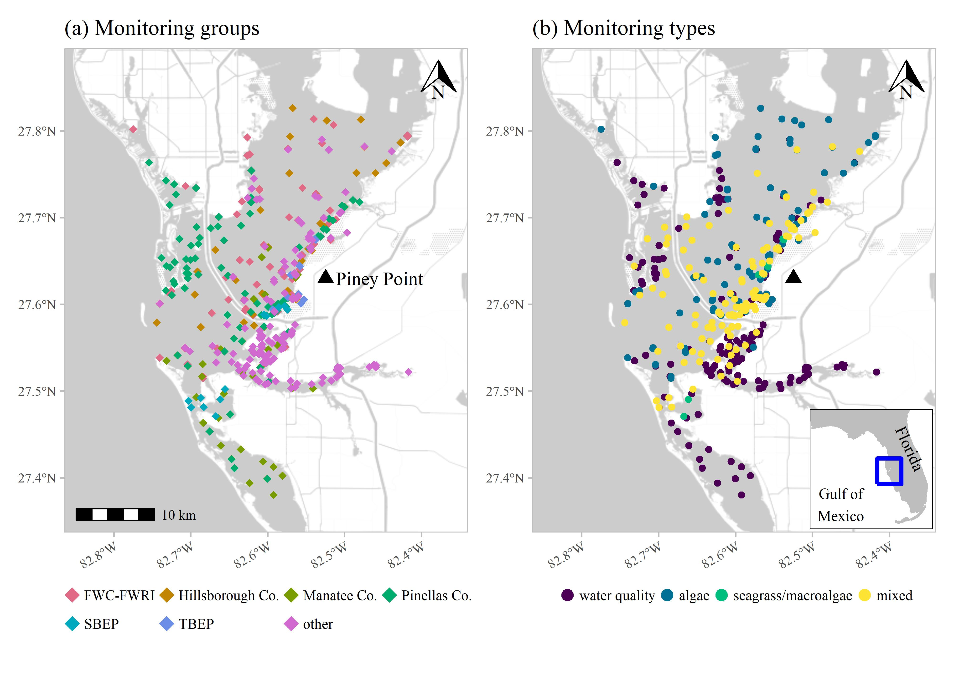

Figure 1: Response-based monitoring effort near Piney Point from March through September 2021 with (a) effort by monitoring group and (b) monitoring data type. Monitoring groups included City of St. Petersburg, Environmental Science Associates, Florida Department of Environmental Protection, Fish and Wildlife Commission, Fisheries and Wildlife Research Institute (FWC-FWRI), Hillsborough Co., Manatee Co., New College of Florida, Pinellas Co., Sarasota Bay Estuary Program (SBEP), Tampa Bay Estuary Program (TBEP), University of Florida, and University of South Florida. Monitoring data included algae sampling, seagrass and macroalgae, water quality (field-based and laboratory samples), and mixed monitoring (algae, seagrass and macroalgae, water quality). Inset shows location of Tampa Bay on the Gulf coast of Florida, USA.

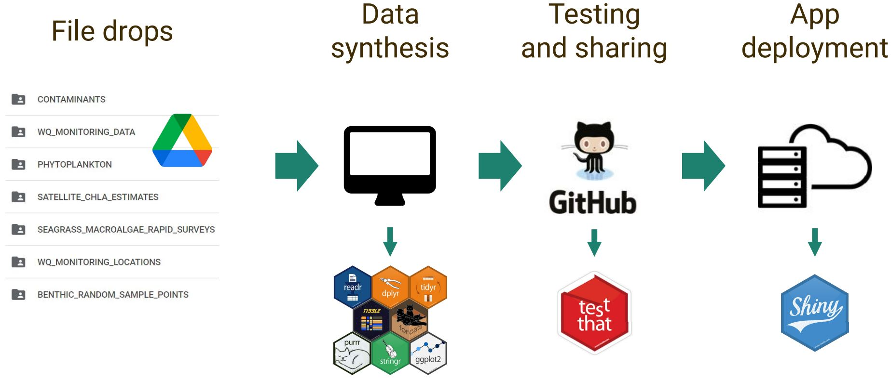

Figure 2: Data synthesis workflow for Piney Point data. Raw data were uploaded by partners to Google Drive, data were synthesized using R-based tools, data and dashboard code were uploaded in a unified format on GitHub that included automated testing, and then the app was deployed using Shiny Server.

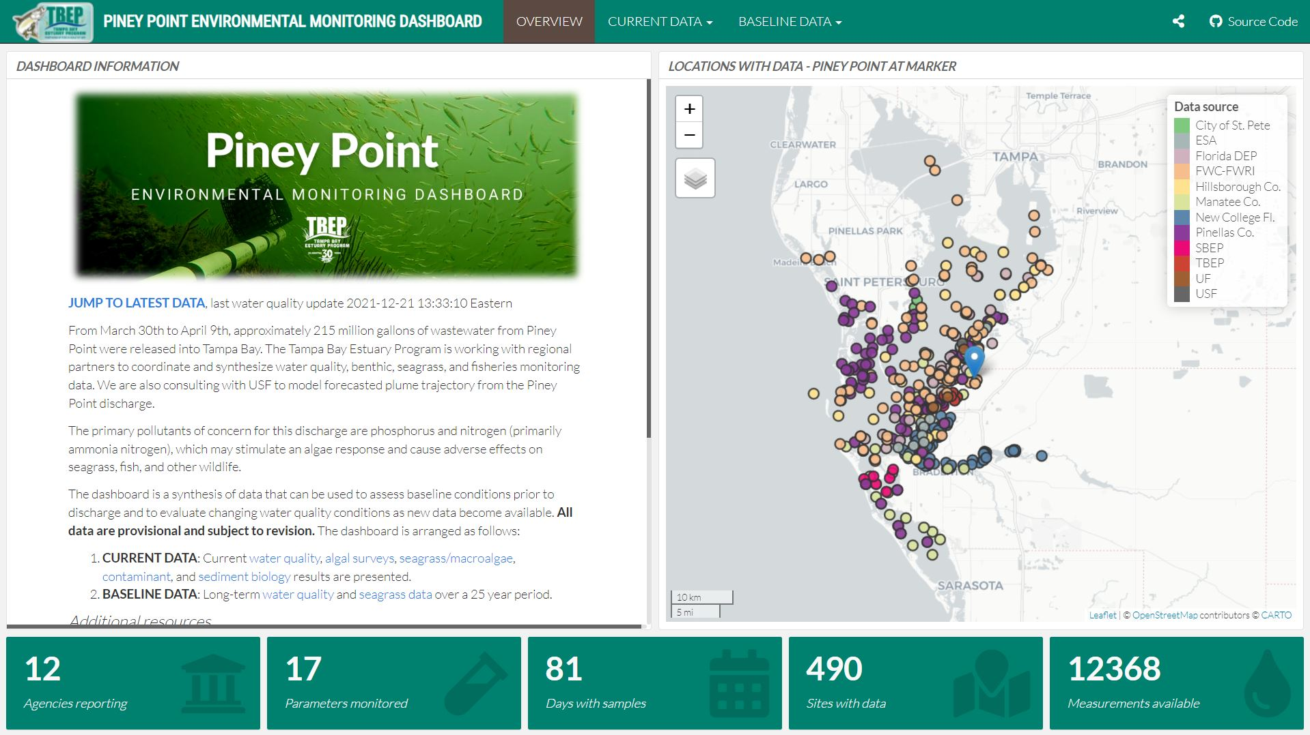

Figure 3: Landing page for the Piney Point dashboard. Users can view a summary of effort to date and access additional tabs to view specific datasets.

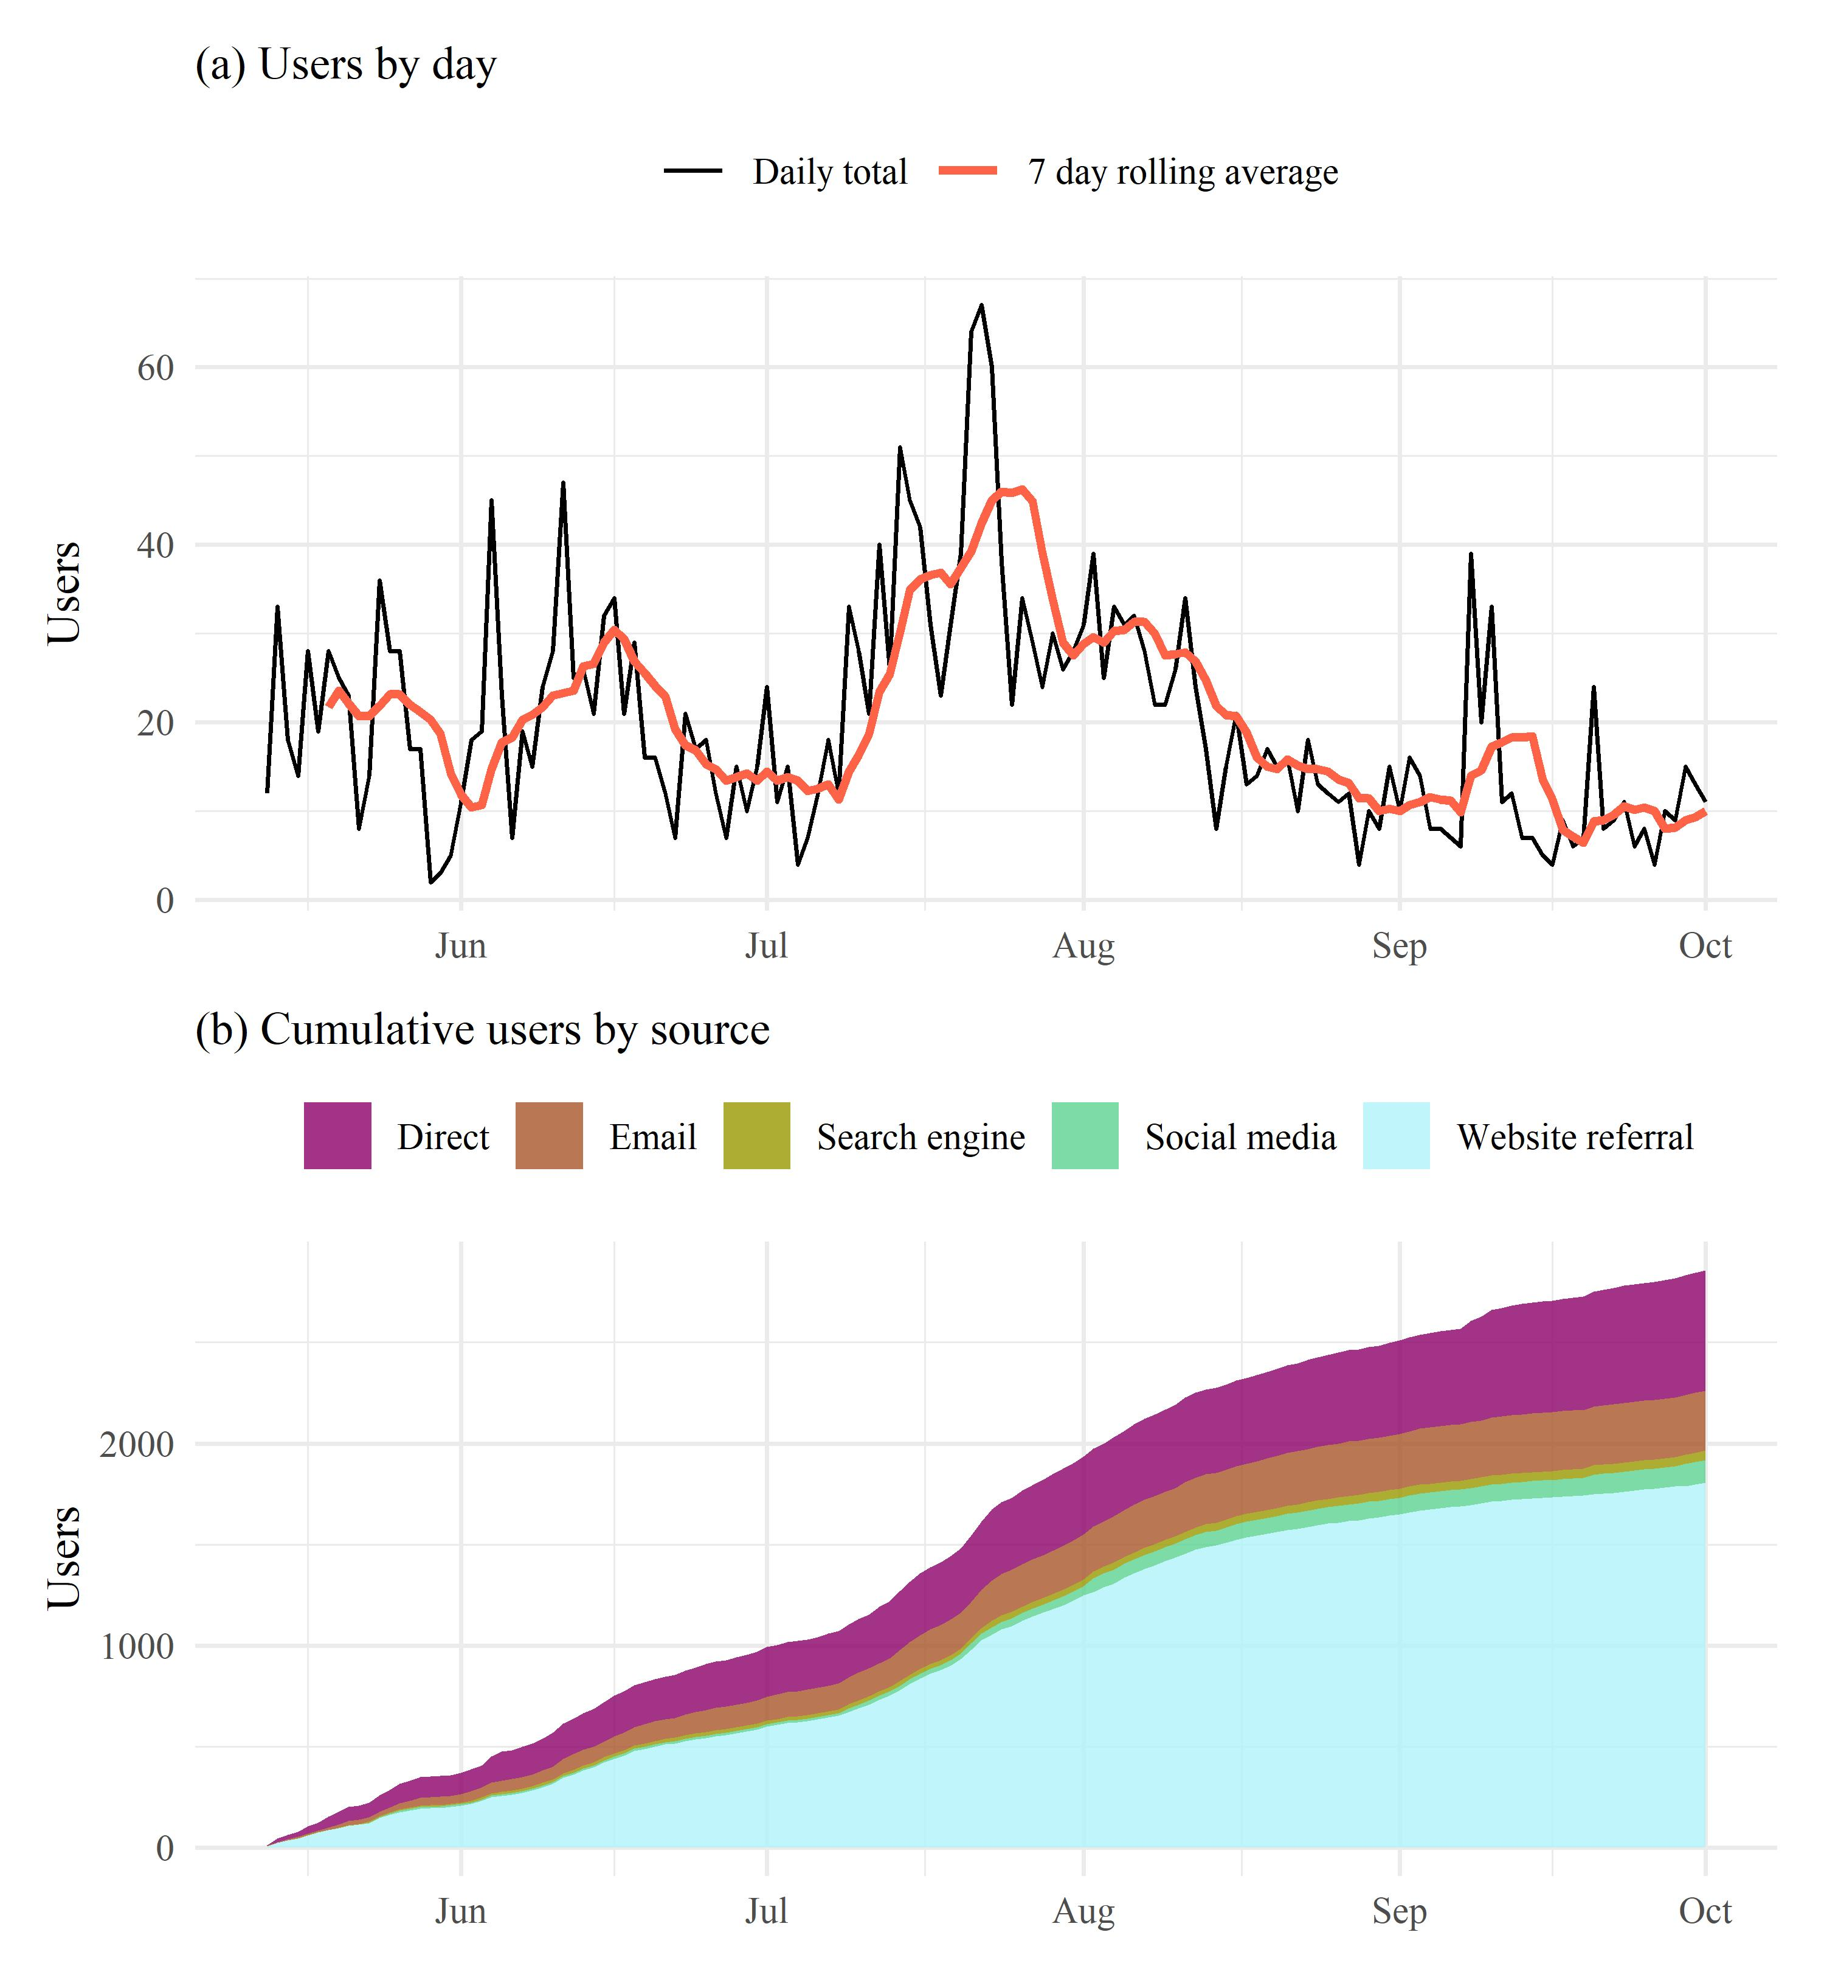

Figure 4: Piney Point dashboard (a) users by day and (b) cumulative users by source. Source refers to how users accessed the dashboard (e.g., direct URL to the dashboard, email links, etc.). Analytics were included in the dashboard beginning on May 13th, 2021.

# Tables

* Data effort over time

Table 1: Top ten locations of users by city, state, and country for the Piney Point dashboard. Numbers show the total users and percentages from the total for all locations. Total cities, states, and countries that accessed the dashboard are shown in the column headers in parentheses. Summaries are from May 13th, 2021 when analytics were included in the dashboard to October 1st, 2021.

| City (654) | Users | State (70) | Users | Country (19) | Users |
| --- | --- | --- | --- | --- | --- |
| St. Petersburg | 325 (11.4) | Florida | 2005 (69.9) | United States | 2812 (98.3) |
| Tampa | 282 (9.9) | California | 107 (3.7) | Canada | 11 (0.4) |
| Bradenton | 81 (2.8) | New York | 65 (2.3) | United Kingdom | 9 (0.3) |
| Largo | 68 (2.4) | Texas | 57 (2) | Germany | 8 (0.3) |
| Orlando | 66 (2.3) | Georgia | 56 (2) | Finland | 3 (0.1) |
| Clearwater | 52 (1.8) | Ohio | 44 (1.5) | India | 3 (0.1) |
| Roseville | 49 (1.7) | Illinois | 36 (1.3) | Ireland | 2 (0.1) |
| Pinellas Park | 46 (1.6) | Pennsylvania | 35 (1.2) | Netherlands | 2 (0.1) |
| Sarasota | 43 (1.5) | Indiana | 31 (1.1) | Spain | 2 (0.1) |
| Miami | 42 (1.5) | Virginia | 27 (0.9) | Australia | 1 (0) |

# References

Greening H, Janicki A, Sherwood E. 2016. [Seagrass recovery in Tampa Bay, Florida (USA)](https://10.1007/978-94-007-6173-5_269-1), pp. 1–12 *In* Finlayson CM, Milton GR, Prentice RC, Davidson NC [eds.], The wetland book. Springer, Berlin, Germany.