Coordinated monitoring of the Piney Point wastewater discharge into Tampa Bay: Data synthesis and reporting

Marcus W. Beck, Tampa Bay Estuary Program, 263 13th Ave S, Saint Petersburg, FL, [mbeck@tbep.org](mailto:mbeck@tbep.org)

Maya C. Burke, Tampa Bay Estuary Program, 263 13th Ave S, Saint Petersburg, FL, [mburke@tbep.org](mailto:mburke@tbep.org)

Gary E. Raulerson, Tampa Bay Estuary Program, 263 13th Ave S, Saint Petersburg, FL, [graulerson@tbep.org](mailto:graulerson@tbep.org)

Sheila Scolaro, Tampa Bay Estuary Program, 263 13th Ave S, Saint Petersburg, FL, [sscolaro@tbep.org](mailto:sscolaro@tbep.org)

Edward T. Sherwood, Tampa Bay Estuary Program, 263 13th Ave S, Saint Petersburg, FL, [esherwood@tbep.org](mailto:esherwood@tbep.org)

Joe Whalen, Tampa Bay Estuary Program, 263 13th Ave S, Saint Petersburg, FL, [jwhalen@tbep.org](mailto:jwhalen@tbep.org)

From March 30th to April 9th, 2021, an estimated 215 million gallons of wastewater from the Piney Point phosphogypsum stacks were released into Tampa Bay to avoid catastrophic failure of the holding ponds. Ammonium concentrations in the wastewater were measured in excess of 200 mg/L and it was estimated that ~205 tons of total nitrogen were exported to Lower Tampa Bay, exceeding typical annual nitrogen load estimates in a matter of days. In response to these events, a coordinated environmental monitoring effort consisting of multiple government, university, and private sector partners began to assess conditions of surface waters around Piney Point to understand conditions prior to, during, and after the wastewater release. These efforts included sampling of surface water chemistry, surveys of algal community response, assessments of wastewater contaminants, and biological surveys of seagrass, macroalgae, benthic, and nekton communities. This resulted in many disparate data sets coming from multiple sources, which required the use of robust synthesis methods for assessment of current conditions, comparisons with the decades of baseline data available in Tampa Bay, and development of forward-facing reporting products to convey results of field sampling in near real time. This paper describes the open-source tools that were used to synthesize the environmental monitoring data, the online dashboard that was developed to report the data, and how these products were used to inform management response to rapidly changing environmental conditions. The specific challenges in combining data, both from a technical and philosophical perspective, is also presented as lessons learned from the Piney Point experience to inform future event-based monitoring responses, both in Tampa Bay and elsewhere.

Last manuscript build 2022-11-14 17:12:38

# Introduction

The long-term recovery of Tampa Bay, Florida represents a collaborative, multi-stakeholder effort to quantify and limit external nitrogen loading as a key pollutant impacting ecosystem health. Nitrogen loading to the estuary has been reduced by approximately two thirds of historical conditions primarily through upgrades to wastewater treatment systems, stormwater controls, and habitat restoration projects (Johansson 1991; Lewis et al. 1998; Greening et al. 2014; Beck et al. 2019). As a result, chlorophyll-a concentrations (a proxy for phytoplankton production) have decreased, water clarity has improved, and seagrasses recovered to a historical 1950s baseline in 2016 (Greening et al. 2014; Sherwood et al. 2017). Despite these historical gains, ongoing management challenges for protecting and restoring the natural resources of Tampa Bay persist (e.g., continuing stressors associated with climate change and increasing watershed development). Recent seagrass losses over the 2018 to 2022 period and seasonally recurring harmful algal blooms since the mid-2000s in portions of Tampa Bay highlight contemporary challenges affecting the bay’s current ecology (Lopez et al. 2016; Tomasko et al. 2020).

Human health and environment impacts associated with extractive mining activities are well-documented worldwide (Tayibi et al. 2009; Sanders et al. 2013; Tepanosyan et al. 2018). In Florida, phosphate mining has generated a multi-billion dollar fertilizer industry that supports agricultural production on the global market (Henderson 2004). Seventeen phosphate mining facilities occur in the Tampa Bay watershed and wastewater releases into surface waters from these facilities has negatively impacted environmental resources in the past. The Piney Point facility on the southeast shore of Tampa Bay has been inactive for over twenty years with the State of Florida overseeing the management of the remaining onsite wastewater. Emergency discharges occurred in the early 2000s and in 2011 to Tampa Bay (Garrett et al. 2011; Switzer et al. 2011). In March 2021, a leak was identified in the southern holding pond containment wall and an emergency order by the Florida Department of Environmental Protection (FDEP) authorized wastewater releases to prevent a catastrophic failure of the facility. Approximately 215 million gallons of mixed legacy phosphate mining wastewater and seawater from port dredging operations were released over a ten day period, introducing ~205 tons of nitrogen directly into lower Tampa Bay (Beck et al. 2022).

In response to the 2021 release from Piney Point, local resource managers coordinated a rapid-response monitoring effort to assess any potential impacts to bay resources. The influx of data from multiple monitoring groups complicated, but also enabled, the quick dissemination of results to a concerned public, in addition to informing the ongoing management response to rapidly changing conditions. This paper describes the data synthesis tools that were used by the Tampa Bay Estuary Program (TBEP) beginning in April 2021 and continuing into the fall once conditions were relatively stable. We focus specifically on the open science methods and products that were created to organize, contextualize, and communicate these data, including the Piney Point environmental monitoring dashboard to rapidly deliver data and results in near real-time. A discussion of the technical and philosophical challenges of synthesizing data from multiple disparate sources, as well as the lessons learned, is also provided to inform future response-based monitoring efforts.

# Data collection

Additional monitoring of bay resources in response to the recent Piney Point event began in late March of 2021 and continued through the summer and early fall. Several partners from public, private, and academic institutions conducted monitoring of water quality, phytoplankton (including the red tide organism *Karenia brevis*), seagrasses, macroalgae, and benthic habitats (Figure 1). Monitoring partners included the FDEP, Environmental Protection Commission (EPC) of Hillsborough County, Parks and Natural Resources Department of Manatee County, Pinellas County Division of Environmental Management, Fish and Wildlife Research Institute (FWRI) of the Florida Fish and Wildlife Conservation Commission (FWC), City of St. Petersburg, TBEP, Sarasota Bay Estuary Program, Environmental Science Associates, University of South Florida, University of Florida, and New College of Florida (Figure 1a). Coordination among monitoring agencies was facilitated by the TBEP under guidance of a plume simulation model developed by the Ocean Circulation Lab at the University of South Florida (USF), College of Marine Science (Chen et al. 2018, 2019). Initial monitoring was focused near the release site at Port Manatee (Figure 1), but later expanded throughout middle and lower Tampa Bay, Boca Ciega Bay, Manatee River, and Sarasota Bay, as the simulation model predicted dispersal of the plume away from lower Tampa Bay (Liu et al. 2021). Sampling effort was most intense in April, with less frequent sampling from May through September, although seagrass and macroalgae sampling was consistent throughout the event (Table 1).

Water quality monitoring focused on parameters indicative of elevated nutrient loads from the Piney Point release. Because Tampa Bay is a nitrogen-limited estuary (Wang et al. 1999; Greening & Janicki 2006; Greening et al. 2014), water quality monitoring focused primarily on total nitrogen and inorganic forms (i.e., total ammonia nitrogen, nitrate/nitrite), chlorophyll-a as an indication of phytoplankton production, and additional parameters expected to respond to nutrient loading (e.g., secchi depth and dissolved oxygen). Phytoplankton monitoring included both qualitative (presence/absence) and quantitative (cells/L) summaries of taxa enumerated by microscopy from water samples taken at similar frequency and distribution as the water quality sites. Phytoplankton data also included event-based sampling for *Karenia brevis*. Finally, seagrass and macroalgae data were collected at transect locations covering the shoreline north of Piney Point and extending to the south into northern Sarasota Bay. Transect sampling included identification of seagrass species and macroalgae, typically to genus, and Braun-Blanquet cover-abundance estimates (Westhoff & Maarel 1978) at 10 m distances along each 50 m transect. Details on all sampling methods are provided in Beck et al. (2022).

# Data synthesis

The synthesis of data from multiple partners included several challenges that TBEP staff addressed by employing open science methods within the time and resource limitations of the event. First, a centralized location for sharing data on Google Drive was required for the synthesis effort (Figure 2, file drops). Partner agencies were requested to voluntarily upload their data to publicly accessible folders, or share via email with TBEP staff for upload if access issues were encountered. Datasets were also downloaded by TBEP staff if available online (e.g., FDEP, <https://floridadep.gov/dear/dear/content/tampa-bay-sampling-response-and-results>) and uploaded to the Google Drive. Using more formal data hosting services that included full metadata documentation was not possible while monitoring was ongoing given the volume and variety of data collected by partners. As such, Google Drive was a useful interim solution that provided 1) online sharing of data in different formats in a familiar file-based organization that was easy to navigate by partner agencies, and 2) an entry point for downstream data synthesis products created by TBEP. Changing user permissions also allowed read/write access to only those necessary (i.e., for data upload), while allowing a read only option for all files so that source data were publicly available for viewing, as needed.

A second synthesis challenge was unifying the multiple data types hosted on Google Drive into a usable format for the dashboard and additional analyses (Figure 2, data synthesis). Several folders on Google Drive were created that included relevant files for each type of monitoring data (water quality, phytoplankton, etc.). Each folder typically contained dozens of files saved as Google Sheets, often uploaded as a single sampling event by an individual monitoring agency. For example, the folder for the water quality sampling included 91 separate files. Extensive data “wrangling” was required to combine the files into a “tidy” format (Wickham 2014) and a custom processing script was created by TBEP using the open source R statistical programming language (R Core Team 2021). An RStudio project was created with full version control that included the synthesis script, dat_proc.R, that imported and processed all files from Google Drive into individual binary .RData files (individual file for water quality, phytoplankton, etc.). These discrete files were later used to develop a subsequent results dashboard . Several R packages were indispensable in the data synthesis effort and these included the 1) googlesheets4 (Bryan 2020) and googledrive (D’Agostino McGowan & Bryan 2020) R packages for connecting and downloading files from Google Drive, and 2) dplyr, tidyr, lubridate, and readxl packages included with the tidyverse suite of packages (Wickham et al. 2019) to assist with data processing. Importantly, all source files were kept on Google Drive and were unaltered from their original format to isolate the original data from any downstream analysis.

Combining the source files on Google Drive into a synthesized format in R also required a consistent set of variables and naming conventions that were applied to each file. For example, parameters included in each water quality file were converted to a common set of names and all units were standardized (total nitrogen as tn and mg/L, chlorophyll-a as chla and g/L, etc.). This required developing custom processing code for data files from each partner to address each unique use case. As a result, the final processing file included almost 3000 lines of code to create the synthesized data products. Each partner agency was also assigned a unique identifier in the synthesized files so effort could be tracked and reported in the dashboard (Pinellas County as pinco, Florida Department of Environmental Protection as fldep, etc.). All synthesized files were saved in a long and tidy format, where each observation was given its own row, each variable was in its own column, and only one value was assigned to a cell (Wickham 2014). This allowed easier filtering of observations of interest (as required with the dashboard) using the standardized naming conventions applied to each source file. More importantly, the developed workflow was used iteratively, often several times each week, as new data files were uploaded to the Drive folders. This required executing the synthesis code locally (i.e., on a personal computer) before pushing data to the dashboard and constantly revising the code to address new data formats or other issues encountered when new files were uploaded.

The local workflow created by TBEP was hosted online in a GitHub repository (<https://github.com/tbep-tech/piney-point>, Beck 2021) that allowed use of additional resources that were critical to the synthesis effort (Figure 2, testing and sharing). Hosting the RStudio project on GitHub served multiple purposes, including: 1) using version control to document and track changes using Git software, 2) making the code publicly accessible for transparency with the larger research and management community, 3) allowing automated testing of repository content, and 4) serving as an access point for deploying the dashboard on an internet-facing Shiny Server (see below). Cloud-based, automated testing was an important service to identify potential errors or mistakes in the synthesized datasets. The testthat R package (Wickham 2011) was used to write several checks for each dataset that were considered essential for maintaining integrity of the information. Each time local changes were made to the workflow and pushed to the GitHub repository, tests were run automatically with GitHub Actions to verify each dataset included appropriate and accurate results. For example, a test was used to verify that all water quality parameters were appropriately named and did not include any missing values. An automated notification was sent via email to TBEP staff if an error was encountered. This service reduced the amount of time required to manually check the data and provided additional quality assurance for data feeds into the dashboard.

# The Piney Point Dashboard

## Setup

The Piney Point environmental monitoring dashboard was created to communicate the results from the synthesized datasets (Figure 3, Beck et al. 2021). The dashboard was developed “on the fly” as data became available and the synthesis workflow described in the previous section was developed to update input datasets during the course of the 2021 monitoring effort. All code used to synthesize the datasets from Google Drive and the code used to create the dashboard were contained in the same GitHub repository, allowing the workflow in Figure 2 to be used iteratively to update the content. The dashboard was created using the shiny (Chang et al. 2021) and flexdashboard (Iannone et al. 2020) R packages to create the server and user interface (UI) components of the app. The dashboard was deployed using Shiny Server by pulling the GitHub repository to a remote server maintained by TBEP each time an update was made (Figure 2, app deployment). This enabled public access to the dashboard through a common url: <https://shiny.tbep.org/piney-point>.

Both the server and UI components of the dashboard were developed in a single R Markdown (Xie et al. 2020) file totaling 2346 lines of code, with 71% and 29% of the code dedicated to the server and UI, respectively. The server components of the dashboard included a setup component (346 lines, 15% of the total) and reactive component (1319, 56% of the total). The setup imported all R package dependencies to run the dashboard (15 total), the synthesized input data from Google Drive (20 .RData files), an R script with custom functions to summarize or plot the results, five log files, and various “static” objects used in other parts of the dashboard that did not depend on user inputs. The rest of the server included thirty-one reactive objects (1319 lines, 56% of the total) that received different user inputs and returned a shiny data object sent back to the user interface. The imported log files were created during the data synthesis steps external to the dashboard and were specific to each data type (water quality, phytoplankton, etc.). Each log file was used to display on the dashboard when a data type was last modified, to inform users when updates were made to the input datasets.

The remainder of the R Markdown file was used to create the dashboard UI (681 lines, 29% of total). The flexdashboard package rendered with R Markdown was used to place shiny content in specific CSS elements for easier content navigation, such as boxes or tabs that are scaled automatically to a user’s browser. Specifically, the UI code organized the dashboard content (Figure 3) into 1) a landing page when a user first accesses the website, 2) tabs for navigating to current results for data from a specific monitoring type, and 3) tabs for viewing historical baseline data for comparison with the response-based monitoring data. The landing page included a text overview of the dashboard, a map showing the monitoring locations, and several summary boxes at the bottom showing current effort to date (number of sites, total days sampled, etc., Figure 3). Each ‘current data’ tab was organized specifically for each monitoring data type. Although, common elements included maps and tabular summaries where the displayed data could be chosen by date ranges or selected parameters by the user. Finally, the baseline data tab displayed multi-decadal monitoring data for water quality and seagrasses to provide additional context and comparison with the response-based monitoring data.

This was an important service provided by the dashboard, allowing dashboard users to quickly assess if the 2021 conditions were abnormal relative to historical, seasonal patterns observed in the bay. In addition to the baseline data tabs, all water quality data from the response-based monitoring were compared to the long-term monthly averages for data at the nearest ambient monitoring station (Beck et al. 2022). Elements of the UI and summary plots allowed a user to quickly determine if the results were outside of an expected seasonal range in comparison to nearby, long-term ambient monitoring stations. Map points for a sampling event were displayed with a solid outline if results were out of range and without an outline if within the normal range. A user could also click on an individual map point to view a time series of the 2021 data for the selected location that included upper and lower limits for the long-term monthly averages. This functionality required additional modifications to the UI, in addition to developing custom code in the synthesis workflow that summarized the normal ranges prior to uploading data to the dashboard. Ultimately, these changes improved the quality of information provided by the response-based monitoring effort by leveraging and comparing results to the decades of long-term monitoring data available for Tampa Bay.

## Analytics

In addition to providing a centralized location for viewing results of the 2021 monitoring, the TBEP also had a need to understand how the broader community was engaging with the dashboard content. The Google Analytics service was used to track the number of users over time, their approximate location, how long a user engaged with the dashboard, and how the dashboard was accessed. From May 13th (when the analytics were added) to September, 2,856 users visited the dashboard, with about an even split of users accessing through a mobile device or a web browser on a personal computer. Users were documented from 654 cities, 70 states, and 19 countries (Table 2). Understandably, users from the state of Florida accounted for a majority of site visits. An average of one minute and 21 seconds was spent on the dashboard by each user, although this time varied throughout the summer. The number of users also varied over time (Figure 4a), with the highest number of visits in July, which corresponded to severe red tide conditions within Tampa Bay proper, peak cell counts for *K. brevis*, and observable fish kills in densely populated areas of the bay (Beck et al. 2022). Most users accessed the website through referrals from other websites (e.g., Figure 4b), although a substantial amount of visitors also accessed the dashboard directly (e.g., bookmarks or entering the URL in a web browser) or through email links. Accessing the dashboard through social media or organically through a search engine were less common. Trends in how users accessed the dashboard did not appear to change over time.

# Data Archive

Finally, the synthesized datasets used by the dashboard were documented with complete metadata and uploaded to a federated data repository in December 2021 (Beck 2021). The TBEP has a commitment to open science, as defined in a recent Strategic Plan (Burke & Amaral 2020). An essential part of this effort was to ensure that event response data are available and documented appropriately for reuse by others. Notably, full documentation, data archives and ecosystem monitoring results describing prior spill and release events in Tampa Bay are lacking. Making these data available from the 2021 event, in addition to publishing initial data syntheses in an open access journal article (i.e., Beck et al. 2022), ensured that the broader scientific and resource management community can learn from this event. Products developed under this effort will inform future research on estuarine responses to inorganic nutrient inputs from phosphate mining and other sources, as well as any future efforts towards response-based monitoring conducted by the Tampa Bay resource management community.

The synthesized datasets were uploaded to the Knowledge Network for Biocomplexity (KNB) data repository with metadata created using the Ecological Metadata Language (EML). The KNB repository is part of the broader DataOne network of federated data repositories that includes domain-, industry-, and regionally-specific datasets that are archived in perpetuity and easily findable through permanent Digital Object Identifiers (DOIs). This allows access by anyone to download the Piney Point datasets for additional analysis and research, which can also be tracked using the DOI to determine how others are engaging with the data. The metadata created with the EML standard allowed us to document both the narrative context of the data (e.g., who, what, when, where, why) and specific details about each dataset included in the repository (column names, units, coordinate reference systems, etc.). This necessary context ensures that future data assessments are responsibly conducted by allowing other analysts to determine if the data are appropriate for their needs and that analyses are performed within the limits of the data. An additional repository on GitHub (<https://github.com/tbep-tech/piney-point-metadata>) was created with a workflow for documenting the metadata with EML and pushing the content to KNB. This repository included additional R-based tools (Jones et al. 2020; Boettiger & Jones 2021) that will be further leveraged by the TBEP’s open science initiatives to archive other datasets in the future.

# Discussion

The release of wastewater from Piney Point in the spring of 2021 mobilized resource managers and stakeholders across a variety of institutions in an effort to track and document the potential impacts to Tampa Bay. The communication tools and workflows used to synthesize the data collected in this effort were useful for informing the proactive management response and the analytics of our dashboard suggested that the products created by TBEP were valuable resources that were actively consumed and disseminated in 2021. However, dashboard analytics are not the only metric of success and additional information can help assess the effectiveness of these tools to efficiently and transparently communicate science for decision-making. For example, area researchers and managers were able to use screenshots from the dashboard to communicate results in real time, although there was no formal metric for identifying and documenting these applications. More holistically assessing the value of open science tools is needed, such as how they may be used to inform policy or regulatory changes aimed at minimizing environmental impacts. For example, subsequent final closure plans for Piney Point were developed in 2022 following the response-monitoring and open data documentation stemming from this most recent event.

From a data science perspective, several lessons were learned from the need to rapidly synthesize multiple sources of information collected during the response-based monitoring. Broader use of tidy data principles would significantly decrease the processing time required to create data in a usable format for analysis. Data entry sheets or digital platforms for sharing data should be structured to more easily transform results into a tidy format (i.e., one observation per row, one variable in a column, one value per cell). However, this requires coordination among multiple entities as to which standards are acceptable for use in digital information storage and even additional training activities to bridge communication gaps between field staff and analysts. Data wrangling will always be a component of analysis, but the time spent doing so could be reduced through routine communication between institutions by adopting similar data standards. Finding uniform, acceptable solutions for sharing data was also problematic. Although Google Drive was useful, not every partner was able to access the information given IT limitations that were agency-specific. Moreover, hosting data on Google Drive was contingent on trust and willingness to share data with TBEP. The TBEP did not have access to all data collected in response to the 2021 Piney Point event, despite the dozens of partners that did share data with our organization. Building and sustaining partnerships is a fundamental mission of the National Estuary Programs. Past successes of TBEP have helped build this trust and the continued success of the organization is dependent on sustaining and growing similar partnerships in the future.

Permanent closure of Piney Point in an environmentally responsible manner remains the ultimate goal of regional resource managers and policy-makers. The open science tools created by the TBEP in 2021 were effective based on the limited means of assessing their impact, yet it is hoped that the tools developed can continue to facilitate conversations towards broader goals of effectively restoring and protecting Tampa Bay. In addition to Piney Point, ongoing mining and land development activities in Florida and elsewhere continue to impose external costs on human health and the environment. The role of science in documenting these impacts is important, but even more so, research priorities should focus on understanding societal and political mechanisms that enable these preventable impacts to occur. Combining traditional science with open science technologies is one path to effectively enable positive change through better science communication. Such approaches can facilitate broader public trust and engagement in management decisions by producing more robust, transparent analyses and facilitating inter-agency cooperation.

# Figures

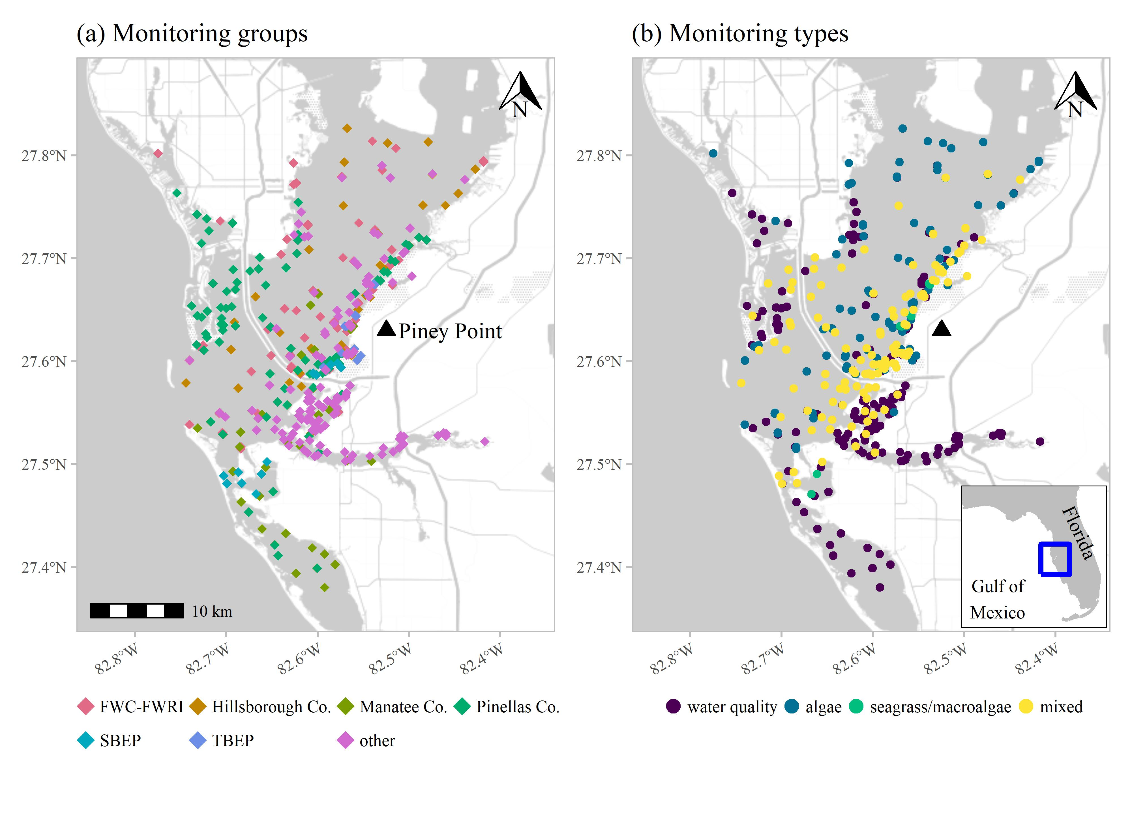

Figure 1: Response-based monitoring effort near Piney Point from April through September 2021 with (a) effort by monitoring group and (b) monitoring data type. Monitoring groups included City of St. Petersburg, Environmental Science Associates, Florida Department of Environmental Protection, Fish and Wildlife Commission, Fisheries and Wildlife Research Institute (FWC-FWRI), Hillsborough Co., Manatee Co., New College of Florida, Pinellas Co., Sarasota Bay Estuary Program (SBEP), Tampa Bay Estuary Program (TBEP), University of Florida, and University of South Florida. Monitoring data included water quality (field-based and laboratory samples), algae sampling, seagrass and macroalgae, and mixed monitoring (water quality, algae, seagrass and macroalgae). Inset shows location of Tampa Bay on the Gulf coast of Florida, USA.

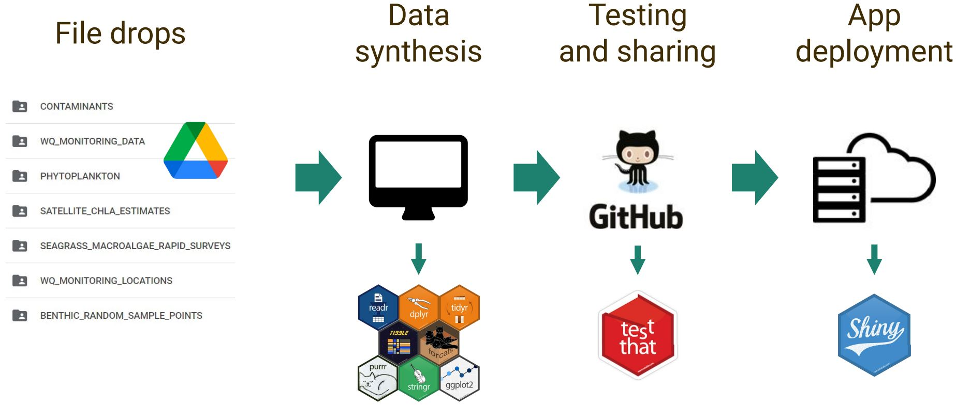

Figure 2: Data synthesis workflow for Piney Point data. Raw data were uploaded by partners to Google Drive; data were synthesized using R-based tools; data and dashboard code were uploaded in a unified format on GitHub that included automated testing; and the dashboard was deployed using Shiny Server.

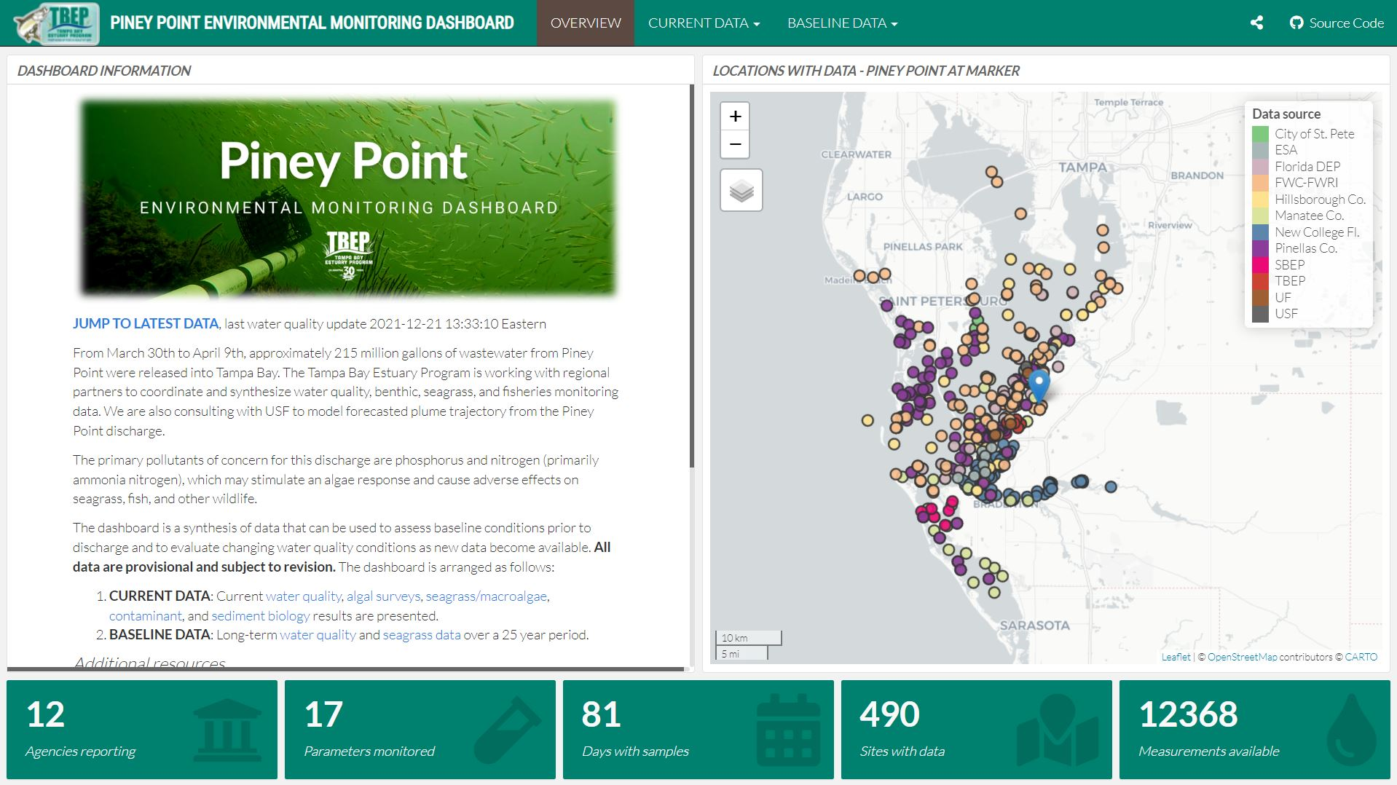

Figure 3: Landing page for the Piney Point dashboard. Users can view a summary of effort to date, when the data were last updated, and access additional tabs to view specific datasets.

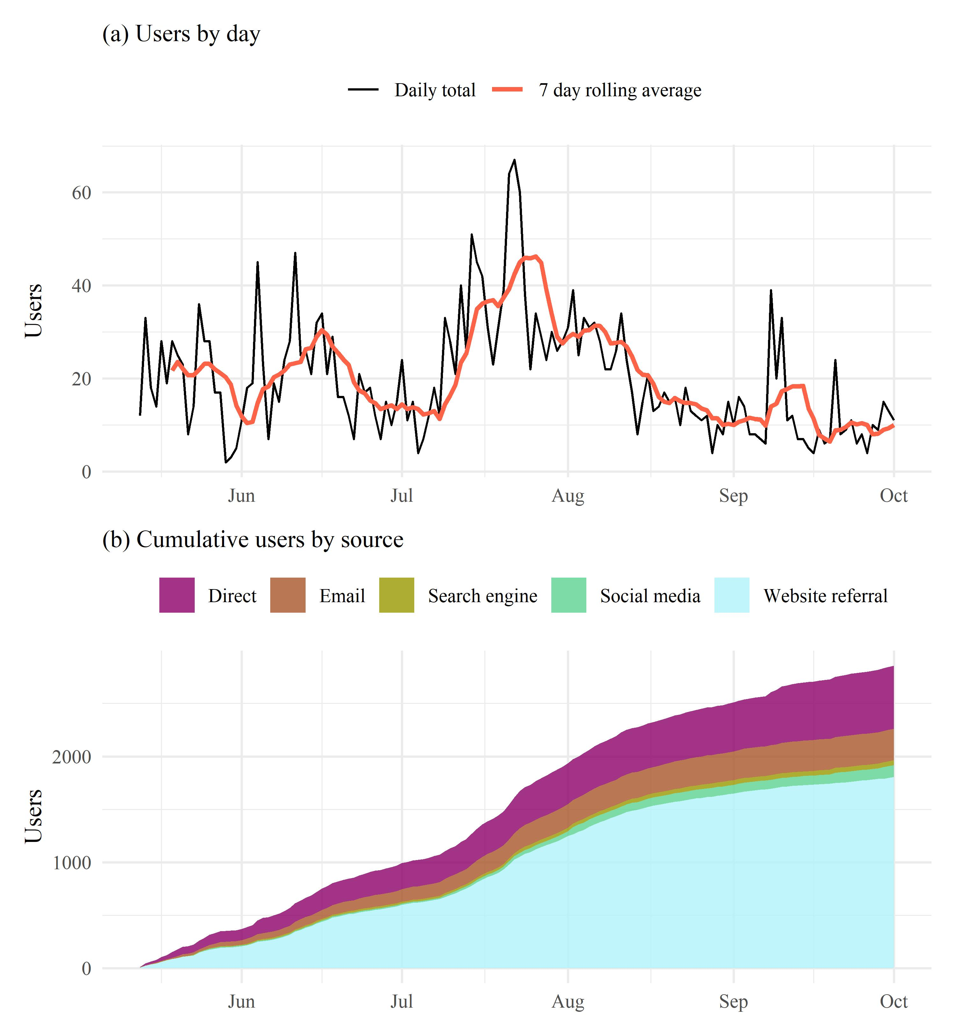

Figure 4: Piney Point dashboard (a) users by day and (b) cumulative users by source. Source refers to how users accessed the dashboard (direct URL to the dashboard, email links, etc.). Analytics were included in the dashboard beginning on May 13th, 2021.

# Tables

Table 1: Sampling effort for response-based monitoring by partners from April 1st, 2021 through September. Values show the total number of unique sites sampled for water quality, algae (phytoplankton), and seagrass/macroalgae in Tampa Bay. Values in parentheses show the percentage of the total sites for each monitoring type across months.

| Month | Water Quality | Algae | Seagrass/macroalgae |
| --- | --- | --- | --- |
| Apr | 223 (45.1) | 181 (41.8) | 30 (17.4) |
| May | 82 (16.6) | 62 (14.3) | 36 (20.9) |
| Jun | 55 (11.1) | 40 (9.2) | 35 (20.3) |
| Jul | 60 (12.1) | 54 (12.5) | 18 (10.5) |
| Aug | 43 (8.7) | 49 (11.3) | 28 (16.3) |
| Sep | 31 (6.3) | 47 (10.9) | 25 (14.5) |

Table 2: Top ten locations of users by city, state, and country for the Piney Point dashboard. Numbers show the total users and percentages from the total for each location type. Total cities, states, and countries that accessed the dashboard are shown in the column headers in parentheses. Summaries are from May 13th, 2021 when analytics were included in the dashboard through September.

| City (654) | Users | State (70) | Users | Country (19) | Users |
| --- | --- | --- | --- | --- | --- |
| St. Petersburg | 325 (11.4) | Florida | 2005 (69.9) | United States | 2812 (98.3) |
| Tampa | 282 (9.9) | California | 107 (3.7) | Canada | 11 (0.4) |
| Bradenton | 81 (2.8) | New York | 65 (2.3) | United Kingdom | 9 (0.3) |
| Largo | 68 (2.4) | Texas | 57 (2) | Germany | 8 (0.3) |
| Orlando | 66 (2.3) | Georgia | 56 (2) | Finland | 3 (0.1) |
| Clearwater | 52 (1.8) | Ohio | 44 (1.5) | India | 3 (0.1) |
| Roseville | 49 (1.7) | Illinois | 36 (1.3) | Ireland | 2 (0.1) |
| Pinellas Park | 46 (1.6) | Pennsylvania | 35 (1.2) | Netherlands | 2 (0.1) |
| Sarasota | 43 (1.5) | Indiana | 31 (1.1) | Spain | 2 (0.1) |
| Miami | 42 (1.5) | Virginia | 27 (0.9) | Australia | 1 (0) |

# References

Beck MW. 2021. [2021 Piney Point Sampling in Tampa Bay. Knowledge Network for Biocomplexity. urn:node:KNB.](https://doi.org/doi:10.5063/F1959G05)

Beck MW, Altieri A, Angelini C, Burke MC, Chen J, Chin DW, Gardiner J, Hu C, Hubbard KA, Liu Y, Lopez C, Medina M, Morrison E, Phlips EJ, Raulerson GE, Scolaro S, Sherwood ET, Tomasko D, Weisberg RH, Whalen J. 2022. [Initial estuarine response to inorganic nutrient inputs from a legacy mining facility adjacent to Tampa Bay, Florida](https://doi.org/10.1016/j.marpolbul.2022.113598). Marine Pollution Bulletin 178: 113598.

Beck MW, Burke MC, Raulerson GE, Scolaro SC, Sherwood ET, Whalen JD. 2021. [Piney Point environmental monitoring dashboard. tbep-tech/piney-point: v1.0.0](https://doi.org/10.5281/zenodo.4666494). Zenodo.

Beck MW, Sherwood ET, Henkel JR, Dorans K, Ireland K, Varela P. 2019. [Assessment of the cumulative effects of restoration activities on water quality in Tampa Bay, Florida](https://doi.org/10.1007/s12237-019-00619-w). Estuaries and Coasts 42: 1774–1791.

Boettiger C, Jones MB. 2021. [EML: Read and write Ecological Metadata Language files](https://CRAN.R-project.org/package=EML).

Bryan J. 2020. [googlesheets4: Access Google Sheets using the Sheets API V4. R package version 0.2.0. https://CRAN.R-project.org/package=googlesheets4](https://CRAN.R-project.org/package=googlesheets4).

Burke M, Amaral M. 2020. [2021-2025 Strategic Plan](https://drive.google.com/file/d/11xohuoaHDxNHRqgXoOHdI37FpWvac_rn/view?usp=sharing). Tampa Bay Estuary Program, St. Petersburg, Florida, 19pp.

Chang W, Cheng J, Allaire J, Sievert C, Schloerke B, Xie Y, Allen J, McPherson J, Dipert A, Borges B. 2021. [shiny: Web application framework for R](https://CRAN.R-project.org/package=shiny).

Chen J, Weisberg RH, Liu Y, Zheng L. 2018. [The Tampa Bay Coastal Ocean Model performance for Hurricane Irma](https://doi.org/10.4031/MTSJ.52.3.6). Marine Technology Society Journal 52: 33–42.

Chen J, Weisberg RH, Liu Y, Zheng L, Zhu J. 2019. [On the momentum balance of tampa bay](https://doi.org/10.1029/2018JC014890). Journal of Geophysical Research: Oceans 124: 4492–4510.

D’Agostino McGowan L, Bryan J. 2020. [googledrive: An interface to Google Drive. R package version 1.0.1. https://CRAN.R-project.org/package=googledrive](https://CRAN.R-project.org/package=googledrive).

Garrett M, Wolny J, Truby E, Heil C, Kovach C. 2011. [Harmful algal bloom species and phosphate-processing effluent: Field and laboratory studies](https://doi.org/10.1016/j.marpolbul.2010.11.017). Marine Pollution Bulletin 62: 596–601.

Greening H, Janicki A. 2006. [Toward reversal of eutrophic conditions in a subtropical estuary: Water quality and seagrass response to nitrogen loading reductions in Tampa Bay, Florida, USA](https://doi.org/10.1007/s00267-005-0079-4). Environmental Management 38: 163–178.

Greening H, Janicki A, Sherwood E, Pribble R, Johansson JOR. 2014. [Ecosystem responses to long-term nutrient management in an urban estuary: Tampa Bay, Florida, USA](https://doi.org/10.1016/j.ecss.2014.10.003). Estuarine, Coastal and Shelf Science 151: A1–A16.

Henderson CS. 2004. Piney Point phosphate plant: An environmental analysis. University of South Florida St. Petersburg, Florida.

Iannone R, Allaire J, Borges B. 2020. [flexdashboard: R Markdown format for flexible dashboards](https://CRAN.R-project.org/package=flexdashboard).

Johansson JOR. 1991. Long-term trends of nitrogen loading, water quality and biological indicators in Hillsborough Bay, Florida Treat SF, Clark PA [eds.]. : 157–176.

Jones MB, Slaughter P, Nahf R, Boettiger C, Jones C, Mecum B, Clark J, Read J, Walker L, Hart E, Chamberlain S. 2020. [dataone: R interface to the DataONE REST API](https://doi.org/10.5063/F1M61H5X).

Lewis RR, Clark PA, Fehring WK, Greening HS, Johansson RO, Paul RT. 1998. [The rehabilitation of Tampa Bay Estuary, Florida, USA, as an example of successful integrated coastal management](https://doi.org/10.1016/S0025-326X(99)00139-3). Marine Pollution Bulletin 37: 468–473.

Liu Y, Weisberg RH, Zheng L, Sun Y, Chen J. 2021. Nowcast/forecast of the Tampa Bay, Piney Point effluent plume: A rapid response, *In* Abstract (OS35B-1036) presented at AGU fall meeting, december, 2021. New Orleans, Lousiana.

Lopez CB, smith CG, Marot ME, Karlen DJ, Corcoran AA. 2016. The role of seedbeds of *Pyrodinium bahamense* bloom dynamics in Tampa Bay, pp. 78–83 *In* Burke MC [ed.], Proceedings of the sixth tampa bay area scientific information symposium, BASIS 6. Saint Petersburg, Florida, USA.

R Core Team. 2021. [R: A language and environment for statistical computing, v4.1.2](https://www.R-project.org/). R Foundation for Statistical Computing, Vienna, Austria.

Sanders L, Luiz-Silva W, Machado W, Sanders CJ, Marotta H, Enrich-Prast A, Bosco-Santos A, Boden A, Silva-Filho E, Santos IR, others. 2013. [Rare earth element and radionuclide distribution in surface sediments along an estuarine system affected by fertilizer industry contamination](https://doi.org/10.1007/s11270-013-1742-7). Water, Air, & Soil Pollution 224: 1–8.

Sherwood E, Greening H, Johansson JOR, Kaufman K, Raulerson G. 2017. [Tampa Bay (Florida, USA): Documenting seagrass recovery since the 1980’s and reviewing the benefits](https://doi.org/10.1353/sgo.2017.0026). Southeastern Geographer 57: 294–319.

Switzer TS, Tyler-Jedlund AJ, Rogers KR, Grier H, McMichael Jr RH, Fox S. 2011. Response of estuarine nekton to the regulated discharge of treated phosphate-production process water. Florida Fish; Wildlife Conservation Commission, Fish; Wildlife Research Institute, St. Petersburg, Florida, 24pp.

Tayibi H, Choura M, López FA, Alguacil FJ, López-Delgado A. 2009. [Environmental impact and management of phosphogypsum](https://doi.org/10.1016/j.jenvman.2009.03.007). Journal of Environmental Management 90: 2377–2386.

Tepanosyan G, Sahakyan L, Belyaeva O, Asmaryan S, Saghatelyan A. 2018. [Continuous impact of mining activities on soil heavy metals levels and human health](https://doi.org/10.1016/j.scitotenv.2018.05.211). Science of the Total Environment 639: 900–909.

Tomasko D, Alderson M, Burnes R, Hecker J, Iadevaia N, Leverone J, Raulerson G, Sherwood E. 2020. [The effects of Hurricane Irma on seagrass meadows in previously eutrophic estuaries in Southwest Florida (USA)](https://doi.org/10.1016/j.marpolbul.2020.111247). Marine Pollution Bulletin 156: 111247.

Wang P, Martin J, Morrison G. 1999. [Water quality and eutrophication in Tampa Bay, Florida](https://doi.org/10.1006/ecss.1999.0490). Estuarine, Coastal and Shelf Science 49: 1–20.

Westhoff V, Maarel E van der. 1978. The Braun-Blanquet Approach, pp. 287–399 *In* Classification of plant communities. Springer.

Wickham H. 2011. [testthat: Get started with testing](https://journal.r-project.org/archive/2011-1/RJournal_2011-1_Wickham.pdf). The R Journal 3: 5–10.

Wickham H. 2014. [Tidy data](https://doi.org/10.18637/jss.v059.i10). Journal of Statistical Software 59: 1–23.

Wickham H, Averick M, Bryan J, Chang W, McGowan LD, François R, Grolemund G, Hayes A, Henry L, Hester J, Kuhn M, Pedersen TL, Miller E, Bache SM, Müller K, Ooms J, Robinson D, Seidel DP, Spinu V, Takahashi K, Vaughan D, Wilke C, Woo K, Yutani H. 2019. [Welcome to the tidyverse](https://doi.org/10.21105/joss.01686). Journal of Open Source Software 4: 1686.

Xie Y, Dervieux C, Riederer E. 2020. [R markdown cookbook](https://bookdown.org/yihui/rmarkdown-cookbook). Chapman; Hall/CRC, Boca Raton, Florida.