**Robinson Preserve Sport Fish Tagging Project [Home Page]**

***Tracking juvenile sport fish movement from a habitat restoration site to fished populations of Tampa Bay***

Many commercially and recreationally important fishes use estuarine habitats as juvenile nursery grounds. However, many of these habitats are threatened by a number of stressors, including rising sea levels and increasing urbanization. Restoration and preservation of affected juvenile habitats can help support adult populations.

*The Robinson Preserve Sport Fish Tagging Project was initiated to determine the extent to which the habitat restoration at* [*Robinson Preserve*](https://www.mymanatee.org/departments/parks___natural_resources/parks__preserves___beaches/robinson_preserve)*, a 682-acre area with a variety of restored fisheries nursery habitat, contributes juvenile sport fish to adult populations in the greater Tampa Bay area. The contribution of juveniles is a major information gap that exists for many habitat restoration projects, despite being a realistic metric for evaluating restoration success. With the help of* [*Manatee County Department of Parks and Natural Resources*](https://www.mymanatee.org/departments/parks___natural_resources) *and the* [*National Oceanic and Atmospheric Administration Office of Habitat Conservation*](https://www.fisheries.noaa.gov/about/office-habitat-conservation)*, researchers at the* [*Florida Fish and Wildlife Research Institute*](https://myfwc.com/research/) *are seeking to fill this information gap by tagging and tracking the movement of juvenile sport fishes from and within Robinson Preserve.*

*Robinson Preserve Restoration for Fisheries Enhancement*

Robinson Preserve is a 682-acre restored area located on the southern shore of Tampa Bay. The preserve is positioned approximately five miles east of the Gulf of Mexico and is adjacent to the mouth of the Manatee River, Perico Bayou, and Palma Sola Bay. Historically, the area consisted of coastal wetlands, but these wetlands were drained in the 1920s to allow for agricultural and human use. Multi-agency restoration efforts began in 2003 with the goal to restore the historical hydrology of the area and provide nursery habitat for recreationally important sportfish in the Tampa Bay estuary.

Hydrological restoration reconnected the area with the surrounding estuary, allowing coastal wetland vegetation communities to become reestablished. Robinson Preserve now contains a variety of estuarine habitats, including mangrove-lined creeks and salt marshes, that are critical nursery habitats for many sportfish species. The structure of these vegetation communities protects young fish from predators and provides high prey availability. Young-of-the-year (recently hatched and recruited fish) and juvenile Common Snook (*Centropomus undecimalis*), Red Drum (*Sciaenops ocellatus*), Spotted Seatrout (*Cynoscion nebulosus*), and Atlantic Tarpon (*Megalops atlanticus*) have all been observed in Robinson Preserve.

The restoration efforts within Robinson Preserve remain ongoing. In 2021, an expansion of Robinson Preserve was reconnected with the Tampa Bay estuary. The waterbodies created in the expansion have unique characteristics, such as variation in depth and tidal connections, that may affect their performance as nursery habitat for sportfish. Additionally, for a nursery habitat to be truly successful, sub-adult fish must move away (or emigrate) from juvenile to sub-adult and adult habitats where reproduction can eventually occur. The main goal of this study is to determine if the restored habitats are providing sub-adult fish to the Tampa Bay fishery. If waterbodies within Robinson Preserve are acting as nursery habitats, we should eventually detect acoustically tagged fish with receivers located outside of the preserve boundary. We can also use telemetry data to examine how juvenile sportfish use different waterbodies in the preserve, determine which corridors are most effective for emigration, and look for differences in habitat use among species. The information obtained from this study will be useful for future restoration design and construction.

*Importance of Acoustic Tagging*

Animals move around their environment to fulfil a range of biological needs such as feeding, transitioning from nursery to adult habitats, or searching for mates. It is important to note that these movement behaviors are often drastically different, so movements for foraging and movements for migration often operate at vastly different spatial scales. Studying animal movement is important for researchers because it gives us insight into the habitats animals use for different purposes, which can help determine their biological requirements and the ecological factors that contribute to their persistence. Unfortunately, visual observation of animals in aquatic environments can be quite difficult, especially for extended periods of time. Acoustic telemetry is a tool used by researchers to monitor the movements of animals in aquatic environments, often over vast areas for several years. Acoustic telemetry gives researchers a window into an otherwise unknown world – it allows us to observe individual fish as they move through their environment and use habitats throughout their life cycle – which can help us make management decisions and implement science-based conservation initiatives.

*How Acoustic Tagging Works*

For studies focused on fish movement, acoustic tags (or transmitters) are typically surgically implanted into the abdomen of the fish. The size of the tag varies depending on the species of interest to avoid altering the animal’s behavior and ensure survivorship. Once implanted, the acoustic tags emit short pulses of sound that communicate a unique identifier at preset intervals. The ‘pings’ are detected by a nearby hydrophone, or acoustic receiver, that stores the detection data so it can be downloaded and analyzed by the researcher. When researchers design acoustic telemetry studies, careful consideration and planning must occur to ensure that receivers are strategically located to detect fish in all areas of interest. Acoustic tags continue to ping until no battery power remains, so there is potential for animals to move great distances from their initial tagging location before the tag dies. The acoustic tag will remain in the fish for its entire life, but we will no longer receive location information once the battery is too weak to transmit. Acoustic telemetry networks allow researchers to communicate “orphan” detections with collaborative scientists as they download their telemetry data. These telemetry networks, such as iTAG (Integrated Tracking of Animals in the Gulf of Mexico), essentially integrate the acoustic arrays of all users, which may allow for tag detections significant distances away from where the animal was first tagged further increasing our knowledgebase.

**Related Pictures:**

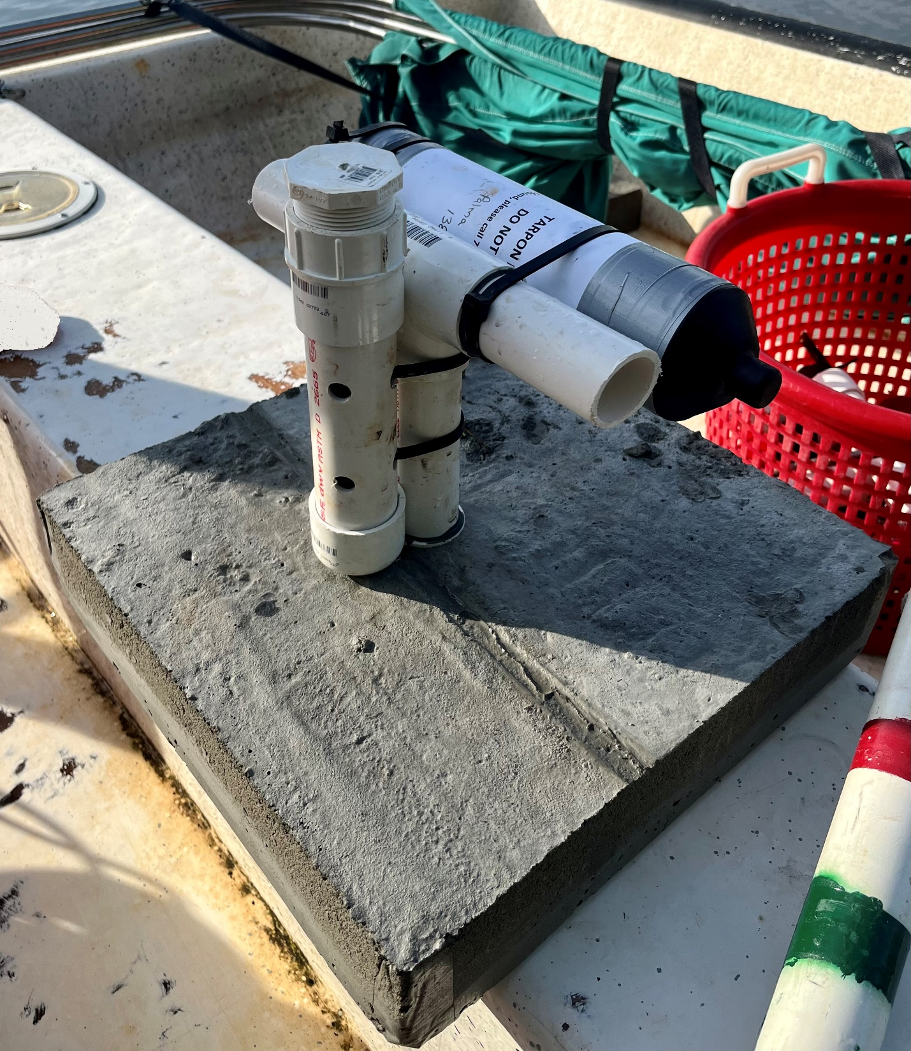

**Caption:** Acoustic receiver and water quality logger before being deployed in shallow water environment adjacent to Robinson Preserve.

**Caption:**  Acoustic receiver and water quality logger deployed in shallow seagrass bed adjacent to Robinson Preserve.

**Caption:** FWRI staff finishing acoustic tag implantation surgery on a juvenile Red Drum in Robinson Preserve.

**Caption:** FWRI staff releasing a juvenile Red Drum after acoustic tag implantation surgery in Robinson Preserve.

**Caption:** FWRI staff releasing juvenile Atlantic Tarpon after acoustic tag implantation surgery in Robinson Preserve.