Title
Marcus W Beck^{1,✉} (0000-0002-4996-0059), Kerry Flaherty-Walia¹ (0000-0002-6032-0570), and Sheila Scolaro-Moffatt¹ (0000-0003-3220-3737)
¹ Tampa Bay Estuary Program, 263 13th Ave S., Suite 350, St. Petersburg, Florida 33701 USA
✉ Correspondence: Marcus W Beck <mbeck@tbep.org>

Abstract
Text
Key words:

1 Introduction
importance of monitoring
local context
difficulty in precision/accuracy, examples with known biases
methods to assess precision/accuracy
goals: present a reproducible framework for assessing precision among disparate groups, evaluate its robustness (leave one out for ‘truth’, baseline sensitivity), and determine if training efforts have improved precision using the framework

2 Methods
Prior to the transect monitoring that occurs each year in Tampa Bay, a one-day training event is conducted mid-June to further develop skillsets of field technicians and to assess comparability among the groups. This training has been at the same location in Tampa Bay (in Lower Tampa Bay near the mouth, 27.649 N, 82.678 W) and has had consistent data reporting since 2020. Additionally, most of the partners that participate in the interagency seagrass monitoring program have consistently attended each year, although it is noted that individuals from each entity have changed over time.
The training each year typically includes six locations chosen by the TBEP staff to represent a range of conditions (e.g., multi-species with dense cover, solitary species with low cover, etc.). Each location is marked with a floating buoy attached to a 1 m$​^{2}$ quadrat staked to the bottom. Each group visits each location that is considered an independent unit for assessment. For all locations, seagrass and macroalgal species are recorded using the Braun-Blanquet abundance scale (0 = no cover, 0.1 = solitary, 0.5 = few shoots, 1 = 1–5% cover, 2 = 6–25% cover, 3 = 26–50% cover, 4 = 51–75% cover, 5 = 76–100% cover, Braun-Blanquet, 1965). At three of the locations, blade lengths (cm) and short shoot densities (shoots m$​^{−2}$) are also estimated for each seagrass species using three separate smaller quadrats (25 cm$​^{2}$) placed in or near the larger quadrat. Additional ancillary information is also collected (e.g., epiphyte load, leaf condition, sediment type, etc.), although it is not considered for the scoring. Throughout this paper the training locations are referred to as transects, whereas the transects in the actual monitoring that occurs after training are true transects often extending hundreds of meters from the shoreline into the bay.

2.1 Scoring
The scoring method was developed to compare consistency among groups that participated in the training each year, i.e., how closely a group’s results compared to the overall group mean in a given year. The method also allows an assessment of scores over time to determine if groups are becoming more or less consistent with additional training. No single external ground truth exists, so precision was used as the basis of scoring. Additionally, the species list for a given year was based on corraboration, not unanimity across groups, such that a species was considered present if at least two groups found it at a location. This allowed for the identification of both false positives and false negatives, both of which can penalize a group’s score as described below.
All scores were first calculated at the smallest scale of species/metric/location, then scaled up to a species/metric score, then finally summed to a metric score. Three scores are assigned to each group for the abundance, blade length, and short shoot density metrics. The total score is a simple average of the metric scores. The entire process to score an individual group in a given year includes ten steps, as shown in Figure 1 and described in detail below. All steps were developed using custom R functions (R Core Team, 2025), relying heavily on the tidyverse suite of packages (Wickham et al., 2019).

2.1.1 Step 1: Consensus Species List
The first step requires identifying the consensus species that are present at each location. As noted above, a species was considered present at a location if identified by at least two groups. The species list could include both submerged aquatic vegetation (SAV or seagrass, typically Halodule wrightii, Syringodium filiforme, or Thalassia testudinum) or macroalgae (drift or attached, typically identified to species). By using corroboration as the basis for the species lists, species identified by only one group could be used to penalize a score as a false positive, whereas a species identified by at least two other groups but not another group also penalized the score as false negative.

2.1.2 Step 2: True Values
The true values for the species metrics at each transect are then identified as the basis of comparison for each group in a given training year. In this step, the “true” values are simply the cross-group means of the metrics for each species at each location. Although the averages are nominally true, they were not considered an absolute external ground truth since we acknowledge that no single group is perfect in their assessments. The true values are calculated only for the consensus species at each location. True values for abundance were estimated for all SAV and macroalgae species, whereas true values for blade length and short shoot density were calculated only for SAV since these values are not recorded for macroalgae. The abundance averages were based on the Braun-Blanquet values (0, 0.1, 0.5, 1, 2, 3, 4, or 5), which were snapped to the nearest value after averaging. Blade length and short shoot density were averaged in their native units (cm and shoots m$​^{−2}$).

2.1.3 Steps 3-6: Group Differences and Species/Metric Scores
Steps 3-6 are repeated across species and metrics for a given group to combine results across each location. Specifically, results are first evaluated at each location to identify the species and metric differences from the true values, then the location values are combined using a weighted average to obtain species and metric scores. Weighting is used to discount or penalize scores based on variation in the true values. For example, differences from the true values are penalized more heavily for a group if all groups were more in agreement for a species and metric assessment, and vice versa. Similarly, false positives and missed species (false negatives) are also penalized in the abundance scores when combining scores across locations. The mechanics of these differences, their penalties, and species weighting is described in detail below.
For these steps, differences in a group’s reported values from the true values are calculated two ways. For abundance and blade length, the difference $d$ for species $s$ at transect $t$ is a simple subtraction:
$$d_{s,t}=\text{reported}−\text{true} \left(1\right)$$
For short shoot density, the difference is a symmetric percent difference:
$$d_{s,t}=\frac{\text{reported}−\text{true}}{\left(\text{reported}+\text{true}\right)/2} \left(2\right)$$
The symmetric percent difference was used for short shoot density because the magnitude of the difference varies with the magnitude of the raw measurements, which also varies by species (e.g., Halodule short shoot density is typically higher than Thalassia). The symmetric percent difference removes this correlation by providing a common scale for assessing the differences. Initial analyses also verified that blade length was not susceptible to this bias and Equation 1 was used for the differences.
For abundance, the differences are in ordinal category positions for the Braun-Blanquet estimates (e.g., integer values from zero to eight for the values 0, 0.1, 0.5, 1, 2, 3, 4, and 5). Using the ordinal category positions for the differences simply considers rank value differences since the actual abundance values differ between the categories, i.e., it was not desired to have different scales of comparison for low or high abundance estimates. For a given group, the $d_{s,t}$ values for abundance are estimates for each species and transect using the consensus species list at that location. If a group missed a species, it is assigned a zero, whereas a false positive is given a value of 1. As such, a missed species is penalized proportionally based on the true ordinal position that scales with group consensus. However, a false positive is only penalized by one ordinal category position since what category a group reports does not provide any information about whether the species was actually present. False positives or missed species only influenced the abundance metric and not blade length or short shoot density calculations since these metrics cannot be meaningfully penalized in the same manner as abundance.
After the species- and transect-level differences are determined, the differences for each metric are then summarized for each species across the transects. This summary used a weighted average where each species is assigned a weight based on the standard deviation of group estimates across the transects for each species. The intent of using the weights was to discount or penalize differences for each group by considering how similar or different the groups were in their assessments. Groups should not be penalized as heavily for large differences if all groups had variable estimates. Similarly, groups should be penalized more for large differences if all groups had more similar estimates. The species weights at each transect were determined as:
$$w_{s,t}=\frac{1}{1+σ_{s,t}} \left(3\right)$$
$$σ_{s,t}=\text{SD}\left(x_{s,t}\right) \left(4\right)$$
where the weight $w$ for species $s$ at transect $t$ is simply the standard deviation $\text{SD}$ of estimates across all groups for that species at that transect ($x_{s,t}$). One minor difference for the short shoot density metric is that the species, transect weights in Equation 4 are calculated using the coefficient of variation, following similar reasoning as using the symmetric difference in Equation 2 described above. The weighted average for the species and metric that combines the differences across transects is then:
$${\overset{‾}{d}}_{s}=\frac{\sum_{t=1}^{T}{w_{s,t}} d_{s,t}}{\sum_{t=1}^{T}{w_{s,t}}} \left(5\right)$$
where a group’s mean difference for a species $s$ across transects $t=1$ to $T$ is the summation of the weights $w_{s,t}$ multiplied by the differences $d_{s,t}$, then divided by the summation of the weights. This equation applies to each metric and species.

2.1.4 Step 7: Metric Scores
The next step is averaging the absolute differences across species to get the raw metric score:
metric scoreraw=1Ss​ds 6
where $S$ is the number of species each with ${\overset{‾}{d}}_{s}$. No further weighting is used since species weights are already included in ${\overset{‾}{d}}_{s}$. By the end of the process, there are three raw metric scores estimated for each group for abundance, blade length, and short shoot density.

2.1.5 Steps 8-10: Final scores
The last steps convert the raw metric scores to a conventional numeric grading scale and letter grades. At the simplest level, the distribution of the raw metric scores across the groups for a given metric score and year is rescaled from 50 to 100, with the group having the largest difference receiving 50 and the group having the smallest difference receiving 100. However, this simple rescaling does not account for variation in the scores among the groups across years. Using the same scale each year may overly penalize years when groups were more similar. To account for this, the minimum floor of the rescaling can be raised in years when groups were more similar, so that all groups receive an overall higher score. The floor for a metric in a given year is calculated as:
$${\text{floor}}_{\text{yr, met}}=max​\left(50, 50+\left(1−\frac{{\text{SD}}_{\text{yr, met}}}{\overline{{\text{SD}}_{\text{met}}}}\right)×50\right) \left(7\right)$$
where the floor is the maximum between 50 or a recalculated floor based on variation among groups for the metric scores in the focal year relative to baseline variation. The baseline variation was an estimation of “typical” score variation calculated as the mean of the standard deviation of raw scores across groups for the first five years of the training occurred ($\overset{‾}{\text{SD_}\text{met}}$). The number of years for the baseline period was subjective, although we demonstrate below how this choice influenced the floor behavior. The standard deviation of metric scores across groups for a focal year ($\text{SD_}\text{yr, met}$) was compared to the baseline variation as one minus the ratio of the two, multiplied by 50, then added to 50. For example, if all groups had the exact same scores in a given year, the floor would be 100. However, if the standard deviation of raw metric scores across groups in a focal year was greater than the baseline variation, the floor remained at 50, so that no extra penalty was applied. In other words, the floor is only raised if within-year variation is less than the baseline.
The three raw metric are assigned to a numeric score based on the ranges defined between the floor to 100 and then averaged to get a single total score for a group. For communication to training participants, the numeric scores were converted to letter grades following a typical grading scheme, i.e., A = 100 – 95, A- = <95 – 90, B+ = <90 – 85, $…$, D < 55.
Each group that participated in an annual training received an online report card to both motivate and provide additional resources if improvements were warranted Figure 2. These reports were parameterized as a Quarto dashboard that used a single template applied to each group and year. The first tab of the report showed the group’s scores for a year for each of the three metrics, the raw differences for the species used in each metric, the overall score, and a table showing individual transect outcomes relative to the group means. The second tab provided additional resources to consult if a group was deficient in any given area (i.e., species identification, large deviation for any of the metrics). Any letter grades less than A- for the scores or any false positives or missed species prompted a conditional display of resources, otherwise, a satisfactory note was provided. The resources included online documentation and video training resources curated by the TBEP.

2.2 Sensitivity analysis
The scoring methods were evaluated to assess robustness to site or group changes over time and sensitivity to a priori decisions. First, all scores were recalculated for each year after removing each location or group sequentially following a “leave-one-out” approach since the core of the method relies on averages across transects as group consensus. The intent was to demonstrate that overall scores did not vary considerably based on inclusion or exclusion of individual sites or groups. The recalculated scores were compared to those using all sites or groups in a year with the expectation that results should be similar.
Second, the choice for the number of years to use as the baseline comparison for the flooring method was also evaluated since this choice influences the range of scores that could be received each year. The score floors that were calculated each year for the three metrics were evaluated using the first two years to the first six years of training data (i.e., 2, 3, 4, 5, and 6 years of data were used to define the mean standard deviation of scores for each metric). The expectation was the that the floors for each year and metric were relatively insensitive to the number of years used to define the baseline.

2.3 Assessment of scores over time
A primary goal of the trainings is to ensure consistent methods are used by the different groups that collect seagrass transect data in Tampa Bay. A reasonable expectation is that groups would show less variation in their estimates over time as they participated in the trainings for successive years. To test this hypothesis, the change in the three metric scores and the change in the absolute values of the raw differences were evaluated over time using mixed-effects models. For the former, group was used as a random intercept, whereas the latter used group and species as random intercepts since species-level information was retained in the raw differences. An expectation is that scores would increase and raw differences would decrease over time. Trends were evaluated for the raw differences only for Halodule, Syringodium, and Thalassia since these were the most common species observed. Models were constructed with the lmer() function from the lme4 R package (Bates et al., 2015)

3 Results

3.1 Scoring
The methods described above were applied to every group that participated in the training from 2020 to 2026, producing 42 total assessments. An average of six groups participated each year. Only two groups participated all seven years, whereas three groups only missed one year of training. Although all groups were used for the scoring process, two groups that only participated in three or less years were removed from the assessment of scores over time.
use trndat to identify number of plots/transects across years - consensus species list - abundance changes, though note that transects were selected to cover a variation in seagrass abundance/diversity and were not randomly selected. Maybe have a table of species over time with x marks showing if they were part of the consensus list?
robustness of method - year period for calibration of score floor, leave one out
group scores
improving scores over time

4 Discussion
limitations * truth is not known * discounting abundance scores treats ordinal positions equally, although it’s shown that independent observers are more likely to agree on measurements of high abundance compared to lower values, i.e., precision is lower for low abundance (see Jan’s paper). Differences at higher abundnace categories could be weighted more.
what didn’t work:
- attempts at discounting group differences by how variable they were between species. this was done for a species across transects, small sample sizes (e.g., a species at two or three transects) made this measure noisy and not a meaningful assessment of group consistency. Alternatively, the getween-group variation is a more meaningful measure of certainty, but it describes an entirely different source of variation.

Figures
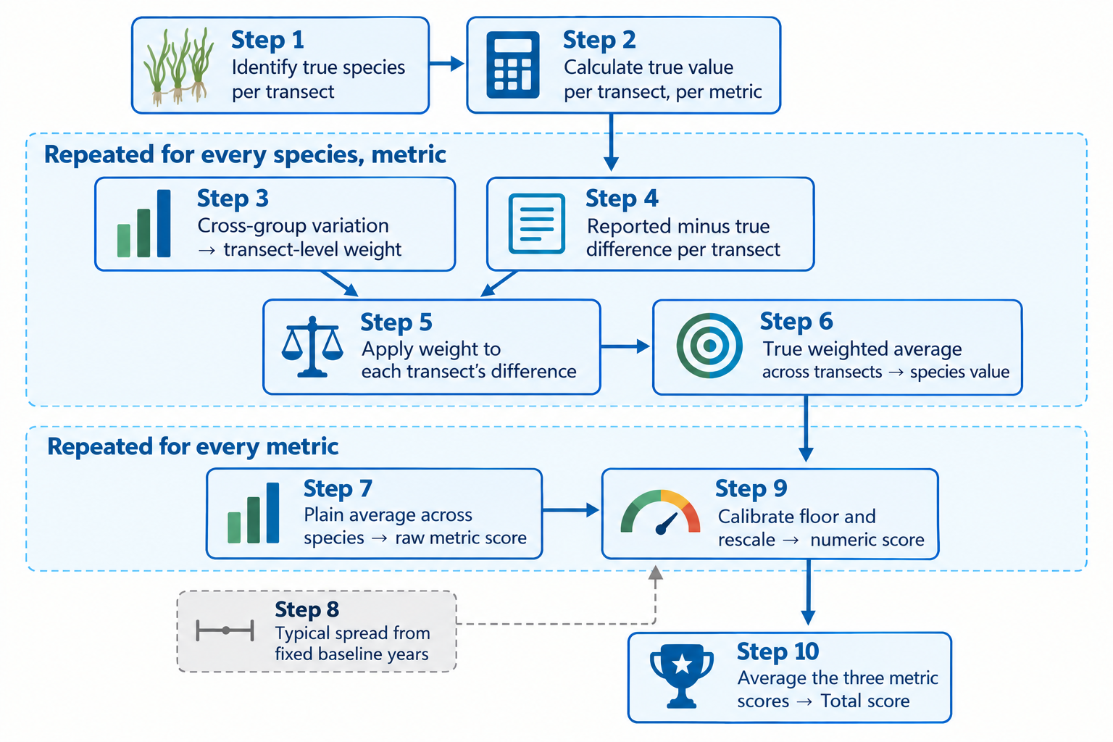
Fig. 1: Flowchart showing the scoring process from steps 1 to 10 for a single group in a given year. Step 3 involves all groups in the focal year and step 8 is a historical baseline from all groups for a set period of past trainings.

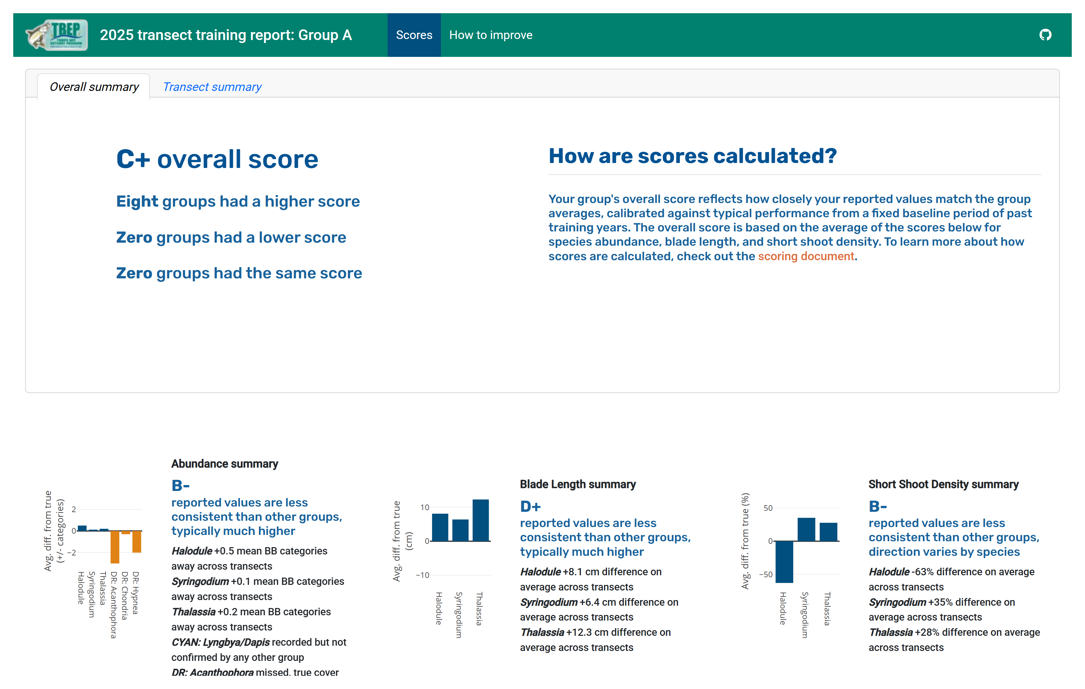
Fig. 2: Landing page for a group’s annual report card showing the overall score (top left), metric scores (bottom row), and barplots of deviations for each species used to calculate the metric scores. Also available is a summary of results for each species at each transect and an additional tab with resources on how to improve the scores.

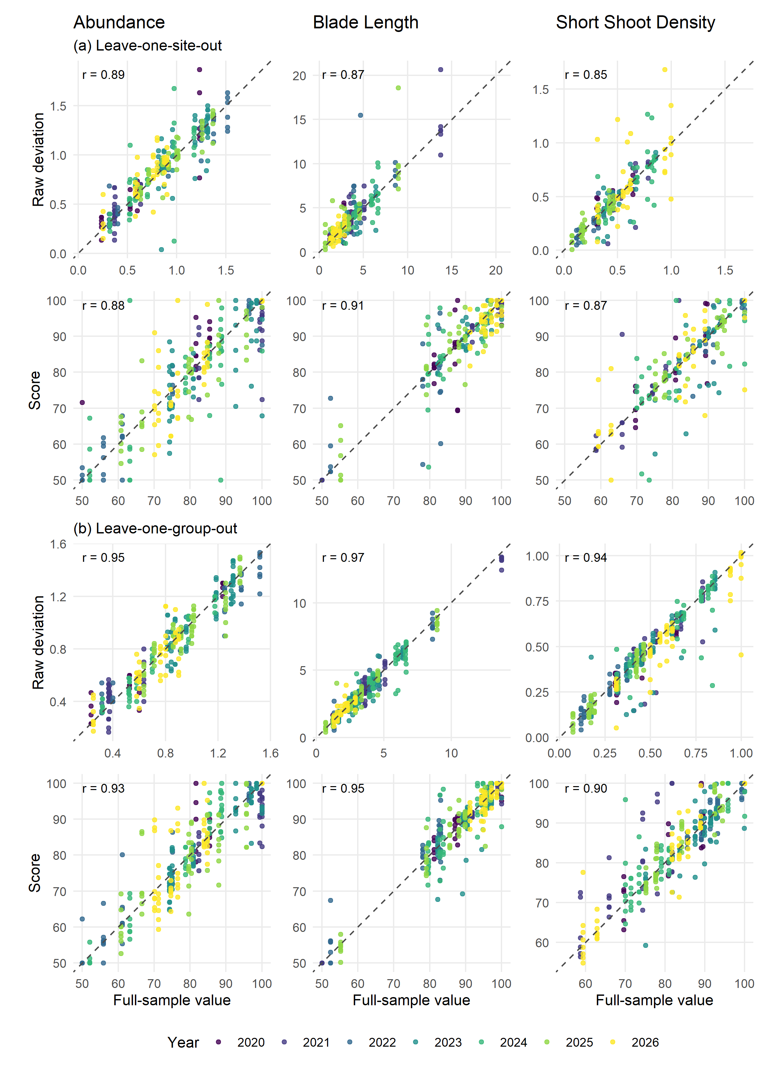
Fig. 3: Comparison of raw deviations (top row) and scores (bottom row) for each of three metrics following a leave-one-out analysis for (a) sites and (b) groups across all years. The values on the y-axis represent the newly calculated raw deviations or scores after removing one site or group for each of all sampling years, repeated until each site or group was removed once. The x-axis shows the original full-sample value for comparison. Points are colored by year. The $r$ values represent the correlations between the recalculated values after removing one site/group and the full values with all sites/groups. The dashed lines are 1:1 relationships.

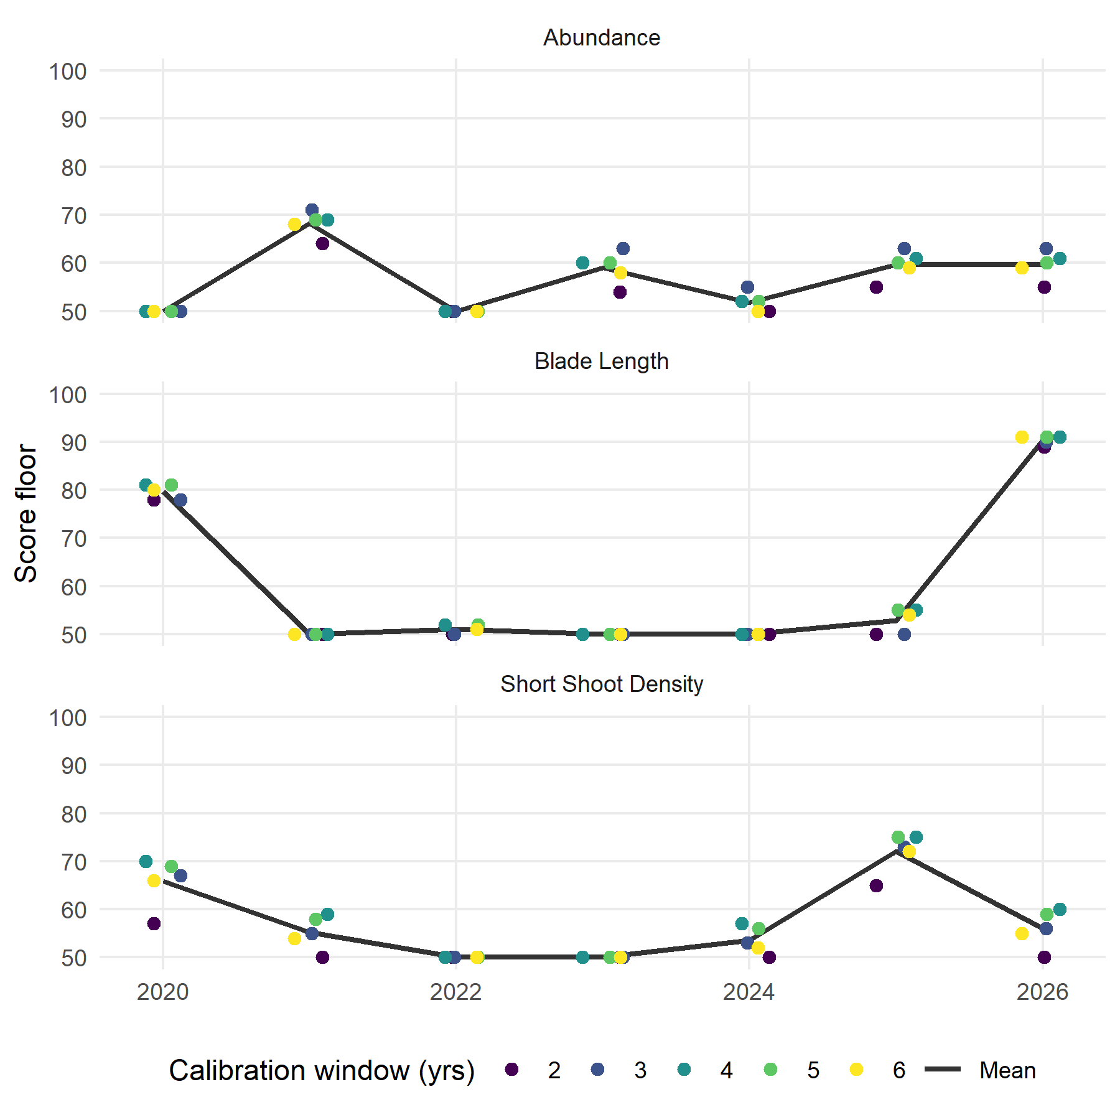
Fig. 4: Sensitivity of the calculated floor for the metric scores based on length of the calibration period. Different calibration periods of two to six years from the beginning of the period of record were evaluated and are shown by point color. The black line is the mean floor across calibration periods for each year and metric. Points are jittered on the x-axis within each year.

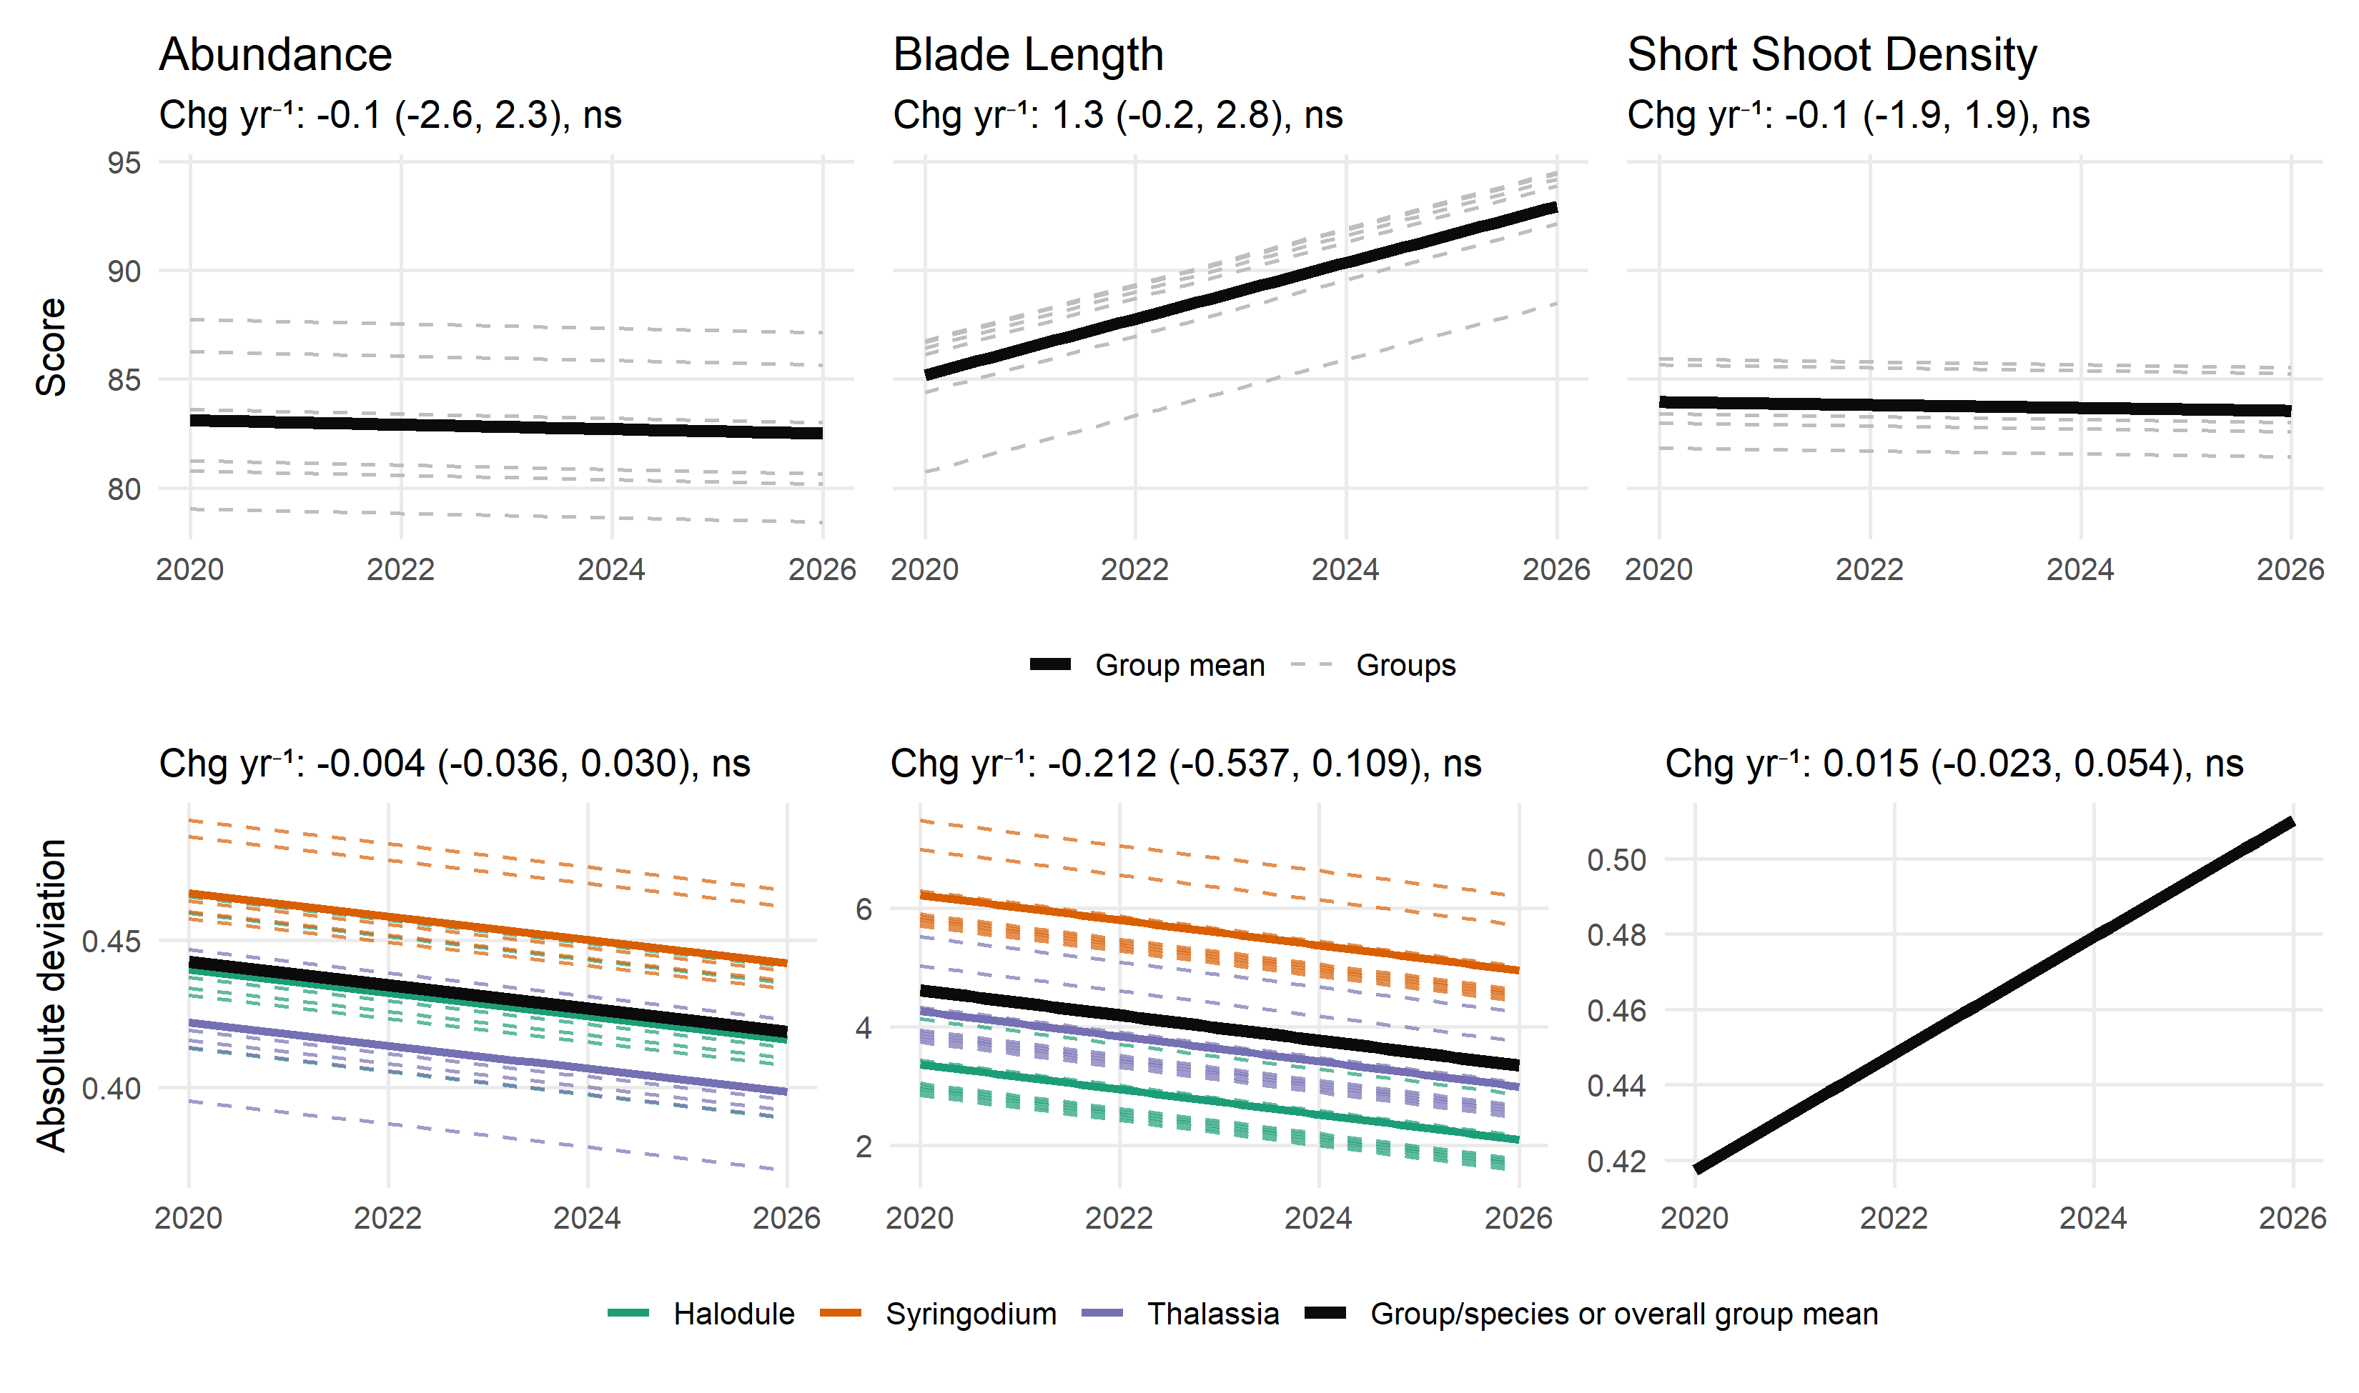
Fig. 5: Results of mixed-effects models comparing group scores (top row) and absolute deviations (bottom row) over time. The models in the top row evaluate scores as a function of time with a random group effect, whereas the models in the bottom row evaluate the absolute deviation of each group’s reported value from the cross-group consensus (true) value, with random effects for species and group. Solid lines show the overall group or group/species means and the dashed lines show individual effects for group or group by species combinations. The bottom right plot (Short Shoot Density) is a singular fit with both species and group random-intercept variances estimated as zero, so only the fixed-effect trend is shown. None of the relationships are significant (ns: not significant).

Tables
Table 1: Model summaries of metric score trends over time (year) by metric, with group as a random intercept. Group SD is the between group standard deviation. R² is shown for the marginal (fixed effects only) and conditional (fixed and random) effects. AIC: Akaike Information Criterion.
Metric | Change yr⁻¹ (95% CI) | Group SD | R² (marg/cond) | AIC
Abundance | -0.1 (-2.6, 2.3) | 5.1 | 0.00 / 0.11 | 304.9
Blade Length | 1.3 (-0.2, 2.8) | 3.4 | 0.07 / 0.18 | 272.8
Short Shoot Density | -0.1 (-1.9, 1.9) | 2.9 | 0.00 / 0.06 | 286.8
N = 37, Groups = 6 for all models.

Table 2: Model summaries of absolute deviation trends over time (year) by metric, with species and group as crossed random intercepts. Units are specific to the metric (Abundance: category positions, Blade Length: cm, Short Shoot Density: percent difference). Group SD is the between group standard deviation and species SD is the between species standard deviation. R² is shown for the marginal (fixed effects only) and conditional (fixed and random) effects. Short Shoot Density is a singular fit (both random-intercept variances estimated as zero), so its conditional R² is undefined. AIC: Akaike Information Criterion.
Metric | N | Change yr⁻¹ (95% CI) | Group SD | Species SD | R² (marg/cond) | AIC
Abundance | 135 | -0.004 (-0.036, 0.030) | 0.04 | 0.04 | 0.00 / 0.02 | 129.4
Blade Length | 130 | -0.212 (-0.537, 0.109) | 0.92 | 1.54 | 0.01 / 0.23 | 702.3
Short Shoot Density | 125 | 0.015 (-0.023, 0.054) | 0.00 | 0.00 | 0.01 / NA | 141.4
Groups = 8, Species = 3 for all models.

Table 3: Slopes of change over time (year) for raw absolute deviations of metrics, by species and training group (identities anonymized as A-F). Colors diverge at zero within each metric (red increasing, green decreasing), with the domain scaled separately per metric since the units differ (Abundance: category positions, Blade Length: cm, Short Shoot Density: percent difference).
 |  | Groups
Metric | Species | A | B | C | D | E | F
Abundance | Halodule | 0.11 | -0.00 | 0.07 | 0.00 | -0.07 | -0.04
Abundance | Syringodium | 0.10 | 0.25 | -0.05 | 0.03 | -0.15 | 0.04
Abundance | Thalassia | -0.16 | -0.09 | -0.01 | 0.02 | -0.10 | -0.02
Blade Length | Halodule | 0.26 | -0.83 | -0.44 | 0.39 | -0.26 | -0.31
Blade Length | Syringodium | -1.14 | 0.21 | 0.44 | -1.85 | 1.69 | -0.65
Blade Length | Thalassia | -0.45 | -0.84 | -0.28 | -0.68 | -0.11 | 0.36
Short Shoot Density | Halodule | -0.03 | -0.03 | -0.11 | 0.12 | 0.02 | -0.05
Short Shoot Density | Syringodium | -0.01 | 0.22 | 0.17 | 0.15 | 0.05 | 0.05
Short Shoot Density | Thalassia | -0.00 | 0.13 | -0.02 | 0.01 | -0.02 | 0.07

Data Availability
All data and analysis code for this manuscript is available on GitHub at https://github.com/tbep-tech/seagrasstraining-manu.

Acknowledgments

References
Bates, D., M. Mächler, B. Bolker, and S. Walker. 2015. Fitting linear mixed-effects models using lme4. Journal of Statistical Software 67: 1–48. https://doi.org/10.18637/jss.v067.i01.
Braun-Blanquet, J. 1965. Plant sociology: The study of plant communities. London: Hafner Publishing Company.
R Core Team. 2025. R: A language and environment for statistical computing. Vienna, Austria: R Foundation for Statistical Computing.
Wickham, H., M. Averick, J. Bryan, W. Chang, L. D. McGowan, R. François, G. Grolemund, et al. 2019. Welcome to the tidyverse. Journal of Open Source Software 4: 1686. https://doi.org/10.21105/joss.01686.

