Untitled
Your Name
July 3, 2015

R Markdown
This is an R Markdown document. Markdown is a simple formatting syntax for authoring HTML, PDF, and MS Word documents. For more details on using R Markdown see http://rmarkdown.rstudio.com.
When you click the Knit button a document will be generated that includes both content as well as the output of any embedded R code chunks within the document. You can embed an R code chunk like this:
summary(cars)
## speed dist
## Min. : 4.0 Min. : 2.00
## 1st Qu.:12.0 1st Qu.: 26.00
## Median :15.0 Median : 36.00
## Mean :15.4 Mean : 42.98
## 3rd Qu.:19.0 3rd Qu.: 56.00
## Max. :25.0 Max. :120.00

Including Plots
You can also embed plots, for example:
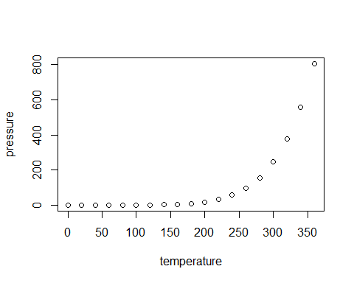
Note that the echo = FALSE parameter was added to the code chunk to prevent printing of the R code that generated the plot.

Heading 3

Bay Segment | Station | Lon | Lat | AIC | GCV | R$​^{2}$
OTB | 36 | -82.553 | 27.856 | 2115 | 3.76 | 0.92
 | 38 | -82.577 | 27.882 | 2167 | 4.19 | 0.91
 | 40 | -82.587 | 27.929 | 2140 | 3.87 | 0.92
 | 41 | -82.565 | 27.937 | 2242 | 4.72 | 0.90
 | 46 | -82.659 | 27.990 | 2261 | 5.97 | 0.87
 | 47 | -82.620 | 27.973 | 2203 | 4.31 | 0.91
 | 50 | -82.538 | 27.919 | 2209 | 4.58 | 0.90
 | 51 | -82.549 | 27.890 | 2034 | 3.90 | 0.91
 | 60 | -82.632 | 27.990 | 1937 | 5.51 | 0.88
 | 63 | -82.576 | 27.968 | 2190 | 5.34 | 0.89
 | 64 | -82.683 | 27.979 | 1085 | 5.53 | 0.90
 | 65 | -82.694 | 27.946 | 2078 | 5.03 | 0.88
 | 66 | -82.640 | 27.928 | 2166 | 4.19 | 0.91
 | 67 | -82.592 | 27.900 | 2234 | 4.54 | 0.90
 | 68 | -82.581 | 27.852 | 2142 | 3.98 | 0.92

