Title

Marcus W Beck1,✉

1 Tampa Bay Estuary Program, St. Petersburg, Florida 33701 USA 16802 USA

✉ Correspondence: [Marcus W Beck <mbeck@tbep.org>](mailto:mbeck@tbep.org)

## Abstract

## 1 Introduction

## 2 Methods

Salinity tolerance: Ruppia > Halodule> Thalassia > Syringodium

Halodule:

* Temp: 20-30 (range, Lewis III et al. (1985))
* Salinity: grows well in most salinity ranges (Lirman and Cropper 2003), like Syringodium but more tolerant (Lewis III et al. 1985), 10-35 (range) or < 10 (S. Scolaro)

Thalassia:

* Temp: 20-30 (range, Lewis III et al. (1985), (**zieman75?**)), 30-31 (upper, from SS)
* Salinity: 25 (lower, Lewis III et al. (1985)); 30, lowest at 5 (lower, Lirman and Cropper (2003)), 33-38 (range, Phillips (1960)); 24-35 (range, Zieman (1975) citing Phillips (1960))

Syringodium:

* Temp: 20-30 (range, Lewis III et al. (1985)), 29 (upper from SS)
* Salinity: 20 (lower, Lewis III et al. (1985)), 25 (lower, (**lirman?**)),

Lewis III et al. (1985) review of seagrass in Tampa Bay. Lirman and Cropper (2003) conducted exposure experiments to evaluate seagrass growth in response to a range of salinity conditions. McMillan and Moseley (1967) discusses growth of halodule, syringodium, thalassia, and ruppia in response to salinity increases (up to 75 psu), no info on lower limit. Cites Phillips (1960) for a salinity range of Thalassia in Florida of 33 - 38 psu. Zieman (1975) discusses seasonal variation of thalassia relative to temp and salinity

* Get FIM, Pinellas, Manatee data

The conceptual stressor diagram **?@fig-concept**.

## 3 Results

## 4 Discussion

## Acknowledgments

## Figures

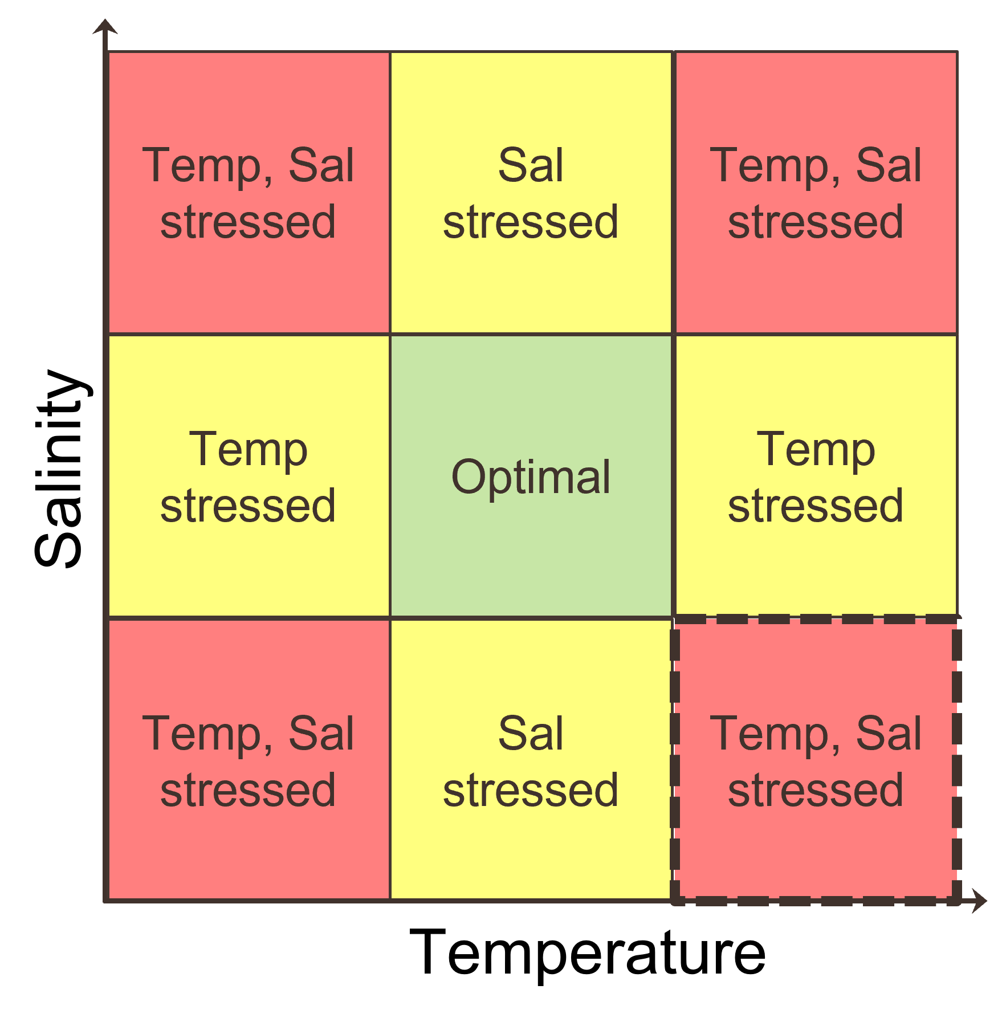

## Tables

## References

Lewis III, Roy R, MJ Durako, MD Moffler, and RC Phillips. 1985. “Seagrass Meadows of Tampa Bay - a Review.” In *Proceedings, Tampa Bay Area Scientific Information Symposium, May 1982*, edited by S. F. Treat, J. L. Simon, R. R. Lewis III, and R. L. Whitman Jr., 210–46. Tampa, Florida: Bellweather Press. <https://drive.google.com/file/d/1sNp3FpjdeOjATZ9nDRRAiXEOqQen9W_p/view?usp=sharing>.

Lirman, Diego, and Wendell P. Cropper. 2003. “The Influence of Salinity on Seagrass Growth, Survivorship, and Distribution Within Biscayne Bay, Florida: Field, Experimental, and Modeling Studies.” *Estuaries* 26 (1): 131–41. <https://doi.org/10.1007/bf02691700>.

McMillan, Calvin, and Frank N. Moseley. 1967. “Salinity Tolerances of Five Marine Spermatophytes of Redfish Bay, Texas.” *Ecology* 48 (3): 503–6. <https://doi.org/10.2307/1932688>.

Phillips, Ronald C. 1960. *Observations on the Ecology and Distribution of the Florida Seagrasses*. 44. Florida State Board of Conservation, Marine Laboratory.

Zieman, Joseph C. 1975. “Seasonal Variation of Turtle Grass, Thalassia Testudinum König, with Reference to Temperature and Salinity Effects.” *Aquatic Botany* 1 (January): 107–23. <https://doi.org/10.1016/0304-3770(75)90016-9>.