July 28th, 2021

Dr. Damià Barceló, Dr. Jay Gan, Dr. Philip Hopke

Co-Editors-in-Chief

Science of the Total Environment

We are pleased to resubmit our manuscript, “Multi-scale trend analysis of water quality using error propagation of generalized additive models” to be considered as an original research paper in Science of the Total Environment. We sincerely thank the two reviewers for providing thoughtful comments on the written text and proposed methods. Our response to reviewers is included with this resubmission as a point-by-point response to each comment provided. We are confident that these changes have improved our manuscript and are hopeful that is now appropriate for publication.

Sincerely,

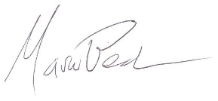

Dr. Marcus W. Beck

Program Scientist

Tampa Bay Estuary Program