Global Precipitation Mission (GPM)
Ground Validation System

STATISTICAL ANALYSIS AND DISPLAY
PROGRAM USER’S MANUAL
FOR
GPM VALIDATION NETWORK DATA

November, 2016

Goddard Space Flight Center
Greenbelt, Maryland 20771


Document History

Document Version | Date | Changes
Draft | November 24, 2009 | Initial draft
1.1 | July 15, 2010 | Updates for Version 1.1 of the program.
1.2 | January 26, 2012 | Updated URLs, standardized document fonts, minor editing.  Updates for Version 1.2 of the program, with new options for batch Postscript processing and white background option for graphs and PPI images.
2.0 | November, 2016 | Updates for GPM-era Version of the program:  - Renamed “parent” IDL procedure z_comparisons_driver to rr_or_z_comparisons.  - Renamed “child” procedure geo_match_z_pdf_profile_ppi_bb_prox_sca_ps to geo_match_3d_rr_or_z_comparisons.  - Added the ability to analyze GPM DPR data, to analyze either reflectivity or rain rate, to analyze a subset of data around a selected area.  - Improved appearance of scatter plots in Postscript/PDF output.  - Added HIDE_PPIS keyword parameter to suppress PPI plotting to screen.  - Added capability to process GRtoDPRGMI matchup data type.  - Changed INSTRUMENT keyword to MATCHUP_TYPE.  - Added DECLUTTER keyword option to filter out samples identified as ground-clutter-affected.  - Added documentation of MAX_BLOCKAGE and Z_BLOCKAGE_THRESH keyword options to filter out samples identified as GR beam blocked.  - Documented use of FORCEBB keyword option to force program to use the mean BB value provided by ALT_BB_HGT and override any mean BB value from data in the matchup file.  - Described color-coding by height of points in scatter plots in Postscript/PDF output mode.  - Added descriptions of options to apply site-specific GR reflectivity bias corrections and a global DPR Zcorr/Zmeas bias correction.
3.0 | TBD | SHOW/DESCRIBE RAIN RATE AND DSD ANALYSIS AND OPTIONS. Update the names of the driver and main analysis procedures to reflect the merger of the DSD analysis into the Z/RR analysis. Describe the function of the new keyword options added since the last update.

Contact Information
Additional information, including information on VN points-of-contact, can be obtained from the GPM Ground Validation web site:
http://pmm.nasa.gov/science/ground-validation

Table of Contents
1. INTRODUCTION 1
2. SYNOPSIS 2
2.1 Specification of Keyword Parameters 7
3. PRECONDITIONS AND LIMITATIONS 9
4. RUNNING THE PROGRAM 10
4.1 Prepare control file for the rr_or_z_comparisons procedure 10
4.2 Starting rr_or_z_comparisons (in the IDL Virtual Machine) 11
4.3 Starting rr_or_z_comparisons (in IDL command-line mode, or in IDLDE) 12
5. PROGRAM OUTPUTS 14
5.1 PPI Animation Display 15
5.1.1 STEP_MANUAL mode of PPI animation 16
5.2 Vertical Profiles and Categorized Histograms of Reflectivity 16
5.3 Scatter Plots of Reflectivity 21
5.4 Rain Rate Analyses 22
6. EFFECTS OF OPTIONAL KEYWORDS 22
6.1 File Selection Options 22
6.2 Storm Subset Analysis 23
6.2.1 Saving Storm Subset Data 24
6.3 PPI Animation Options 26
6.4 Histogram/Profile Options 27
6.5 Hide Raintype Option 28
6.6 Statistical/Computational Options 29
6.6.1 Apply Bias Adjustments to DPR and GR Reflectivity Data 33
6.7 PPI Displays for Matchup Files with GR Dual-Polarimetric Fields 34
6.8 Postscript/Adobe PDF Option 35
7. RUNNING THE “RAW” STATISTICAL ANALYSIS PROCEDURE 37
8. REFERENCES 38
9. APPENDIX - Sample Postscript/PDF file output 39

INTRODUCTION

The GPM Validation Network (VN) Statistical Analysis and Display Program consists of the IDL procedure rr_or_z_comparisons, which displays and computes comparison statistics between geometry-matched spaceborne Precipitation Radar (PR) and ground radar (GR or GV) reflectivity or rain rate data produced by the GPM Validation Network prototype. The spaceborne PR data are from either the TRMM Precipitation Radar (PR) or the GPM Dual-Frequency Precipitation Radar (DPR). The input data to the program consists of a previously computed netCDF file containing the geometry-matched PR and GR data, one file per “rainy” site overpass (a TRMM PR or GPM DPR overpass of a GR site, with precipitation echoes present, referred to below as an “event”). These data are described in detail in the GPM Validation Network Data User’s Guide, Vols. 1 and 2 (available at http://pmm.nasa.gov/science/ground-validation ). For purposes of this document, the PR designation refers to data from either the TRMM PR or GPM DPR, except where explicit differences between the two are indicated.

The VN Statistical Analysis computes and displays tables of mean differences (PR-GR) between the PR and GR reflectivity or rain rate from the geo-matched data for a selected event, with the data stratified into vertical layers in two manners: (1) by height above the surface, in 1.5-km-deep layers, for 15 levels centered from 1.5 to 19.5 km, and (2) into three layers defined by proximity to the bright band (freezing level): above, within, and below the bright band. For purposes of the latter, match-up samples are categorized as above (below) the bright band if their base (top) is 750 m or more above (750 m or more below) the mean bright band height of the points being analyzed. The remaining points are assigned as within the bright band. The bright band heights in the netCDF file originate from the bright band analysis contained in the level 2A PR product (TRMM 2A-25 product; GPM 2ADPR, 2Aka, or 2AKu product). Only the attenuation-corrected PR reflectivity from the level 2A products are used in the reflectivity comparisons, even though the “raw calibrated” PR reflectivity also is present in the netCDF data files. A future enhancement to the procedure will provide an option to compare the “raw” PR reflectivity to the GR.

The rr_or_z_comparisons statistical analysis graphical displays include: (1) an animation sequence of PR and GR Plan Position Indicator (PPI) images from the volume-matched data; (2) vertical profiles of mean PR and GR reflectivity or 3-D rain rate from match-up data averaged over the 15 constant height levels, (3) histograms of PR and GR reflectivity accumulated in 2 dBZ bins or histograms of rain rate accumulated in predefined ranges, for match-up data stratified by proximity to the bright band (below, within, and above); and (4) scatter plots of PR and GR reflectivity or rain rate stratified by rain type and proximity to the bright band. As an option, the S-band to Ku-band frequency adjustments of Liao and Meneghini (2009) may be applied to the GR reflectivity values prior to generation of statistical and graphical display results.

By default, the statistical analysis is performed over the entire domain of the PR-GR volume match, which is defined at the time of the volume matching. Optional parameters can either limit the matchup to samples within a maximum range of the ground radar, or samples for a storm area selected by the user.

Output options are: (a) to the screen (the default), and (b) to a Postscript or PDF file. The Postscript/PDF output option is functional only if running a licensed copy of IDL. This document assumes that the user already knows the basics of running programs in IDL. Beginners can become familiar with IDL by reviewing the online learning materials at http://www.exelisvis.com/docs/getting_started.html.

SYNOPSIS

The rr_or_z_comparisons procedure is a user-friendly “wrapper” program which encapsulates the IDL procedure geo_match_3d_rr_or_z_comparisons. The latter procedure, geo_match_3d_rr_or_z_comparisons, does the actual work of reading and analyzing the geometry-match data. The importance of this “wrapper” relationship is that the geo_match_3d_rr_or_z_comparisons procedure accepts a large number of optional and required IDL keyword parameters to control the functionality of the program and set up the local configuration of the host machine in terms of the data file paths, and the wrapper routine, rr_or_z_comparisons, greatly simplifies the mechanism used to specify these keyword parameters.

IDL keyword parameters are of the form KEYWORD=value, where KEYWORD indicates which parameter is being specified, and value is the value to be assigned to the keyword parameter. The complete geo_match_3d_rr_or_z_comparisons calling sequence in IDL, showing all of the allowable keyword parameters, is as follows:

geo_match_3d_rr_or_z_comparisons, RR_OR_Z=rr_or_z, $
MATCHUP_TYPE=matchup_type, SWATH_CMB=swath_cmb, $
KUKA_CMB=KuKa_cmb, SPEED=looprate, ELEVS2SHOW=elevs2show, $
NCPATH=ncpath, SITE=sitefilter, NO_PROMPT=no_prompt, $
PPI_VERTICAL=ppi_vertical, PPI_SIZE=ppi_size, $
PCT_ABV_THRESH=pctAbvThresh, DPR_Z_ADJUST=dpr_z_adjust, $
GR_Z_ADJUST=gr_z_adjust, MAX_RANGE=max_range_in, $
MAX_BLOCKAGE=max_blockage, Z_BLOCKAGE_THRESH=z_blockage_thresh, $
SHOW_THRESH_PPI=show_thresh_ppi, GV_CONVECTIVE=gv_convective, $
GV_STRATIFORM=gv_stratiform, ALT_BB_HGT=alt_bb_hgt, $
FORCEBB=forcebb, HIDE_TOTALS=hide_totals, $
HIDE_RNTYPE=hide_rntype, HIDE_PPIS=hide_ppis, $
PS_DIR=ps_dir, B_W=b_w, BATCH=batch, S2KU = s2ku, $
USE_ZR = use_zr, GR_RR_FIELD=gr_rr_field_in, $
RECALL_NCPATH=recall_ncpath, SUBSET_METHOD=subset_method, $
MIN_FOR_SUBSET=min_for_subset, SAVE_DIR=save_dir, $
STEP_MANUAL=step_manual, DECLUTTER=declutter

While it is possible to run geo_match_3d_rr_or_z_comparisons directly in IDL as shown above, the length of the calling sequence can make this quite cumbersome depending on the number of parameters that need to be specified. The same results can be achieved by running the wrapper procedure rr_or_z_comparisons to read the keyword parameters from a simple, user-editable text file, and pass them along internally to geo_match_3d_rr_or_z_comparisons to produce the requested comparison displays.

Detailed instructions for running geo_match_3d_rr_or_z_comparisons and/or rr_or_z_comparisons in IDL, and detailed examples of the affect of keyword parameters on the program output are given in the next sections. The remainder of this section briefly describes the keyword parameters accepted by the procedures. Note that each keyword parameter is optional, and has a default value and behavior if no value is specified.

The usage and functionality of each keyword parameter is as follows:

RR_OR_Z: specifies which field is to be analyzed. Value of “RR” indicates that rain rate is to be analyzed, where a value of “Z” indicates that reflectivity is to be analyzed. Defaults to “Z” (reflectivity) if not specified.

MATCHUP_TYPE: indicates which satellite radar is to be the source of the matchup data to be analyzed. Allowable values are 'PR' (TRMM data), 'DPR', and ‘DPRGMI’ or ‘CMB’ (GPM data). Default='DPR'. If a mismatch occurs between MATCHUP_TYPE and the type of matchup file selected for processing then an error occurs. In the case of DPR, the matchup to GR can be from the 2AKa, 2AKu, or 2ADPR product, for any scan (swath) type. The DPR product and scan type will be indicated in the GRtoDPR netCDF file name. ‘CMB’ is an alias for ‘DPRGMI’, and both indicate the matchup to the GPM 2B-DPRGMI “Combined” product.

SWATH_CMB: designates which swath (scan type) to analyze for the DPRGMI matchup type. Allowable values are 'MS' and 'NS' (default). Ignored if MATCHUP_TYPE is ‘PR’ or ‘DPR’.

KUKA_CMB: designates which DPR instrument's data to analyze for the DPRGMI matchup type. Allowable values are 'Ku' and 'Ka' If SWATH_CMB is 'NS' then KUKA_CMB must be 'Ku'. If unspecified or if in conflict with SWATH_CMB then the value will be assigned to 'Ku' by default.

SPEED: initial animation rate for the PPI animation loop on startup. Defaults to 3 if unspecified, or if the specified value is outside of the allowed range of 0-100.

ELEVS2SHOW: number of PPIs to display in the PPI image animation, starting at a specified elevation angle in the volume, in the form 'N.s', where N is the number of PPIs to show, and s is the starting sweep (1-based, where 1 = first). Disables PPI plot if
N <= 0, and displays a static plot if N = 1. Defaults to N=7.1 if unspecified. If s is zero or if only N is specified, then s = 1.

NCPATH: local directory path to the geo_match netCDF files' location. Defaults to /data/netcdf/geo_match if not specified. This parameter MUST be specified if the netCDF files are not located under /data/netcdf/geo_match on the local host.

SITE: file pattern, which acts as a filter limiting the set of input files shown in the File Selector (Fig. 3), or over which the program will iterate. Mode of selecting the (next) file depends on the NO_PROMPT parameter. Default=* (all files)

NO_PROMPT: method by which the next file in the set of files defined by NCPATH and SITE is selected. Binary parameter (e.g., /NO_PROMPT or NO_PROMPT=1 to set to On). If unset or set to 0 (Off), the program defaults to using DialogPickfile (IDL’s pop-up File Selector, shown in Figure 3). If set to On, then the program will automatically process each file in the set, in order of ascending site ID and date.

PPI_VERTICAL: controls orientation for PPI plot/animation subpanels. Binary parameter. If unset, or if SHOW_THRESH_PPI is On, then defaults to horizontal with PR PPI to left of GR PPI (Fig. 4). If set, then PR is plotted above GR (Fig. 7).

PPI_SIZE: size in pixels of each subpanel in PPI plot. Default=375. The scatter plot window size for plots to the screen is also controlled by this parameter, and is roughly equal to PPI_SIZE*2.

PCT_ABV_THRESH: Each geometry-matched PR and GR sample volume consists of a spatial average of data values from one or more full-resolution PR and GR radar bins. These geo-match data have metadata fields that can be used to compute the percent of bins included in each sample average that are above specific reflectivity thresholds (default = 18.0 dBZ for PR, 15.0 dBZ for GR). These “detection thresholds” are specified at the time the geo-match dataset is created. This percent above threshold is essentially a measure of "beam-filling goodness". The pctAbvThresh keyword value indicates the minimum percentage of above-threshold bins that must be present, in common, in each PR and GR volume average sample included in the statistics and displays. 100 means use only those matchup points where all the PR and GR bins in the volume averages were above threshold (the volumes are completely filled with above-threshold bin values). 0 means use all non-missing matchup points available, with no regard for thresholds (the default behavior, if no pctAbvThresh value is specified).

DPR_Z_ADJUST: Optional parameter. Bias offset to be applied (added to) the PR or DPR reflectivity values to account for the calibration offset between the PR/DPR and ground radars in a global sense (same for all GR sites). Positive (negative) value raises (lowers) the non-missing PR/DPR reflectivity values.

GR_Z_ADJUST: Optional parameter. Pathname to a "|"-delimited text file containing the bias offset to be applied (added to) each ground radar site's reflectivity to correct the calibration offset between the PR/DPR and ground radars in a site-specific sense. See Section 6.6.1 for details.

MAX_RANGE: Maximum range from the ground radar (in km) of samples to be included in the mean difference calculations. Defaults to 100 if not specified.

MAX_BLOCKAGE: Maximum fractional GR beam blockage to allow in samples to be included in the mean difference calculations. If value is between 0.0 and 1.0 it is treated as the fraction of blockage. If value is greater than 1 and <= 100, it is treated as percent blockage and is converted to a fractional amount. Disables beam blockage checking if not specified, if resulting fractional amount is 1.0 (100%), or if matchup file does not contain the GR_blockage variable.

Z_BLOCKAGE_THRESH: optional parameter to limit samples included in the comparisons by beam blockage, as implied by a Z dropoff between the second and first sweeps. Is ignored in the presence of valid MAX_BLOCKAGE value and presence of GR_blockage data.

SHOW_THRESH_PPI: Binary parameter, controls whether to create and display a 2nd set of PPIs plotting only those PR and GR points meeting the PCT_ABV_THRESH constraint. If set to On, then PPI_VERTICAL behavior defaults to horizontal orientation (PR left of GR).

gv_convective: GR reflectivity threshold at or above which GR data are considered to be of Convective Rain Type. If set to 0 (default), then GR reflectivity is ignored in evaluating whether a PR indication of Stratiform Rain Type is a mismatch to a GR indication of Convective rain type.

gv_stratiform: GR reflectivity threshold at or below which GR data are considered to be of Stratiform Rain Type. If set to 0 (default), then GR reflectivity is ignored in evaluating whether a PR indication of Convective Rain Type is a mismatch to a GR indication of Stratiform rain type.

ALT_BB_HGT: manually-specified bright band height (km) to be used if the bright band height cannot be determined from the PR or DPR data. If a numerical value is provided it is treated as the mean BB height. If a file pathname is provided, it is treated as the name of a file to be searched for the model-sounding-based freezing height for the given site and time.

FORCEBB: Binary parameter. If set, then override any mean BB height from the matchup file with the value provided by ALT_BB_HEIGHT.

hide_totals: Binary parameter, controls whether to show (default) or hide the histogram and vertical profile plots for rain type = "Any".

HIDE_RNTYPE: Binary parameter, indicates whether to use hatching in the PPI plots indicating the PR/DPR rain type identified for the given ray.

HIDE_PPIS: Binary parameter, controls whether to show (default) or hide the PPI plots and animations.

ps_dir: Directory to which optional postscript/PDF output will be written. If not specified or set to “Off” then output is directed only to the screen.

b_w: Binary parameter, controls whether to draw vertical profile and histogram plots in a Postscript file in color (default) or in black-and-white.

BATCH: Binary parameter, controls whether to produce multiple Postscript/PDF output files with no user interaction required for the full set of input files defined by NCPATH and SITE when NO_PROMPT is set. Default = no.

s2ku: Binary parameter, controls whether or not to apply the Liao/Meneghini S-band to Ku-band frequency adjustment GR reflectivity. Default = no.

USE_ZR: Binary parameter, controls whether or not to override the gvrr (GR rain rate) field in the geo-match netCDF file with a Z-R derived rain rate.

GR_RR_FIELD: UF field ID of the GR rain rate estimate source to be used: RC (Cifelli), RP (PolZR), or RR (DROPS, default).

RECALL_NCPATH: Binary parameter. If set, assigns the last file path used to select a file to a user-defined system variable that stays in effect for the IDL session. The resulting behavior is, if RECALL_NCPATH is set and if the user variable exists from a previous selection, then the directory path pointed to by user variable will override the NCPATH parameter value on program startup.

SUBSET_METHOD: Method to use to select subset areas from the matchup data: ‘D’ for distance, ‘V’ for value. If 'D', then select an area within a cutoff distance in km (defined by the 'MIN_FOR_SUBSET' parameter) from a user-selected point. If 'V', then select an area of contiguous data values around the user-selected start location that are at/above the 'MIN_FOR_SUBSET' value. The data value to be thresholded is defined by the 'RR_OR_Z' parameter, and the threshold applies to the highest data value in the vertical column along the PR/DPR ray (e.g., to the composite reflectivity). If either the PR/DPR or the matching ground radar value exceeds the threshold, then the data for that ray will be included in the subset area. If SUBSET_METHOD is unspecified then the analysis will be performed over the entire domain of the matchup dataset.

MIN_FOR_SUBSET: Threshold value to be used to define points to be included in a user-selected subset area. If SUBSET_METHOD is 'D', then MIN_FOR_SUBSET is a distance in km. If SUBSET_METHOD is 'V', then the parameter units are either dBZ or mm/h, as defined by the RR_OR_Z parameter value. This parameter is ignored if no value is specified for SUBSET_METHOD.

SAVE_DIR: Optional directory specification to which the subsetted variables in a structure will be saved in an IDL SAVE file if the user chooses to save them.

STEP_MANUAL: Flag and Rate value to toggle and control the alternative method of animation of PPI images. If unset, animation is automated in an interactive window (default, legacy behavior). If set to a non-zero value, then the PPI images will be stepped through under user control via a prompt on the command line: step either one at a time in forward or reverse, or in an automatic forward sequence where the pause, in seconds, between frames is defined by the STEP_MANUAL value. The automated forward sequence will only play through one time, starting from the currently-displayed frame.

DECLUTTER: Binary parameter, if set to ON, then read and use the clutterStatus variable to filter out clutter-flagged volume match samples, regardless of pctAbvThresh status.

Specification of Keyword Parameters

The mechanism and formats for specifying the keyword parameters differ between the rr_or_z_comparisons and geo_match_3d_rr_or_z_comparisons procedures. For rr_or_z_comparisons, the keyword parameters must be entered in a control file that will be read by the procedure when it starts. This process is described in detail in the RUNNING THE PROGRAM section. When directly running the procedure geo_match_3d_rr_or_z_comparisons in IDL or IDLDE, the keyword/value pairs must be listed on the command line following the name of the procedure, each separated by a comma. For example:

IDL> geo_match_3d_rr_or_z_comparisons, $
NCPATH=’/Users/Chuck/data/netcdf/geo_match’, $
PCT_ABV_THRESH=95, SHOW_THRESH_PPI=1

The $ is a continuation character in IDL and allows you to enter a single command over several lines, for readability.

Note that two types of IDL keyword parameters are used in the procedure. The regular keyword parameters take specific numerical or text string values as the parameter value, in the format KEYWORD=value. For those regular keywords whose values are strings, the string value must be enclosed in quotes when specified on the command line, e.g., NCPATH=’/data/netcdf/geo_match’. For those regular keywords whose values are numbers (or for any regular keyword specified in the control file only), the keyword values do not need to be in quotes, e.g., ELEVS2SHOW=6.3, or (control file only) SITE=KAMX.

Binary keywords are specified in the KEYWORD=value format, or (on the command line only) in the “slash” format: /KEYWORD. In the KEYWORD=value format, the option is turned “On” by specifying a numerical value of 1 (one) for the value (e.g., B_W=1), and “Off” by specifying a value of 0 (zero) for the value (e.g., B_W=0). Specifying the keyword name preceded by a slash (/) is equivalent to specifying a value of 1 to turn the option “On”. For example, B_W=1 and /B_W are equivalent. If a binary keyword is not specified on the command line or in the control file, it is “Off” by default.

Table 1 summarizes the format rules/options for specifying each type of keyword parameter, for the control file and for parameters specified on the command line.

Table 1. Keyword/value formatting rules and options for specification of parameters in the control file (for rr_or_z_comparisons) and on the command line (for geo_match_3d_rr_or_z_comparisons).

Keyword Type | Control File Format(s) | Command Line Format(s)
String (e.g., SITE) | SITE = KAMX  or  SITE = ’KAMX’  or  SITE = ”KAMX” | SITE = ’KAMX’  or  SITE = ”KAMX”
Numerical (e.g., SPEED, ELEVS2SHOW) | SPEED = 3  ELEVS2SHOW = 4.2 | SPEED = 3  ELEVS2SHOW = 4.2
Binary (e.g., B_W) | B_W = 1 (On)  B_W = 0 (Off) | B_W = 1 (On)  /B_W (On, slash form)  B_W = 0 (Off)

PRECONDITIONS AND LIMITATIONS

The statistical analysis procedure may be run in IDL using any of the following methods:

- via command-line IDL or the IDL Development Environment (IDLDE), with a licensed copy of IDL
- via command-line IDL or the IDLDE, in a time-limited evaluation mode with an unlicensed copy of IDL
- within the IDL “Virtual Machine”, with either a licensed or unlicensed copy of IDL.

The major limitations of each of these methods for the statistical analysis procedures are that:

- Postscript or other file output is not allowed is not allowed if running an unlicensed copy of IDL
- When running command-line IDL or IDLDE without an IDL license, the session automatically terminates after 7 minutes. This can be very inconvenient if analyzing a large number of cases in a session, or if a large number of options need to be specified on the command line and edited between runs. As an alternative to these IDL modes, the “wrapped” procedure rr_or_z_comparisons may be executed using the freely available IDL Virtual Machine, with or without an IDL license. The IDL Virtual Machine does not limit the length of a session.
- The IDL Virtual Machine does not provide a direct mechanism to specify mandatory and keyword parameters to a procedure. The rr_or_z_comparisons procedure gets around this limitation by reading the keyword parameters from a text file and handling them internally.

In any case, a working copy of IDL or the IDL Virtual Machine must be installed or available over the network on the host where the procedures will be run. The procedures cannot be run outside of IDL or the IDL Virtual Machine. In addition, the program files and (at a minimum) test data files for the statistical analysis program must be installed on the host where the procedures will be run. Installation procedures for the statistical analysis program are provided with the software bundle, and are not repeated in this document.

RUNNING THE PROGRAM

Most users will find it much easier and more convenient to run rr_or_z_comparisons, the wrapped version of the statistical analysis procedure. Therefore, directions for running this version of the program will be presented first. Instructions for running the “raw” version of the procedure, geo_match_3d_rr_or_z_comparisons, will be presented later.

Prepare control file for the rr_or_z_comparisons procedure

The rr_or_z_comparisons procedure reads a plain (ASCII) text control file with the desired keyword parameters entered on separate lines in a specific format. A valid control file must be prepared and saved before rr_or_z_comparisons can be run. By convention, the name of the control file should end with the file extension ‘.ctl’ (e.g., ‘StatsKMOB.ctl’). Any number of control files may be created and saved under different names. A sample file of the required format, which includes all allowable keyword parameters, is shown here.
RR_OR_Z=Z
MATCHUP_TYPE=DPR
SWATH_CMB = NS
KUKA_CMB = Ku
SPEED=3
ELEVS2SHOW=4.2
NCPATH = /Users/Chuck/data/netcdf/geo_match
SITE=KMOB
NO_PROMPT=0
PPI_VERTICAL=0
PPI_SIZE=350
PCT_ABV_THRESH=70
DPR_Z_ADJUST=0.0
GR_Z_ADJUST=''
MAX_RANGE=100
MAX_BLOCKAGE=0.1
Z_BLOCKAGE_THRESH=3.0
SHOW_THRESH_PPI=0
GV_CONVECTIVE=0
GV_STRATIFORM=0
ALT_BB_HGT=3.6
FORCEBB=1
HIDE_TOTALS=1
HIDE_RNTYPE=1
HIDE_PPIS=0
PS_DIR=''
B_W=0
BATCH=0
S2KU=1
USE_ZR=0
GR_RR_FIELD=RR
RECALL_NCPATH=1
SUBSET_METHOD=D
MIN_FOR_SUBSET=25
SAVE_DIR=''
STEP_MANUAL=0
DECLUTTER=0

Leading and trailing spaces, and spaces either side of the assignment operator (=) in the control file, are optional and ignored. Quote marks around the string-valued parameters, such as the value for NCPATH, are optional in the control file, except in the case where the empty string is being specified as the value (e.g., PS_DIR=''). This is in contrast to specifying these parameter values on the command line in IDL, where the keyword values for string-type variables must be placed within single or double quotes. The keyword parameters may be listed in any order in the control file. If a given keyword parameter is not present in the control file, or if the empty string is specified for the keyword value (as shown for PS_DIR), then the parameter will take on its default value (see SYNOPSIS section, above). The “slash” form of the binary keyword parameters (e.g., /S2KU) is not allowed in the control file. Assign a value of 0 to unset the binary keyword parameter (e.g., S2KU=0), or simply remove the line for binary keyword parameter from the control file. Assign a value of 1 to set the parameter to the “On” state (e.g., S2KU=1).

The PS_DIR, B_W, and BATCH parameters control Postscript/PDF output. Postscript and other file output is not supported when running with an unlicensed copy of IDL. Postscript output has been disabled in the example by specifying the null string for PS_DIR keyword value, so all output will be sent only to the screen. If running the procedure under IDL or the IDL Virtual Machine with a license, then keyword values activating PS_DIR, B_W and BATCH may be defined and included in the control file, and will take effect.

At a minimum, the NCPATH parameter should be specified in the control file so that the geo_match netCDF file path is correctly set. For instance, if the DPR netCDF files are located in the /Users/Chuck/data/netcdf/geo_match directory, then run the procedure with NCPATH set as follows in the control file (with optional quotes shown):
NCPATH=’/Users/Chuck/data/netcdf/geo_match’

Starting rr_or_z_comparisons (in the IDL Virtual Machine)

The wrapped version of the statistical analysis procedure is provided as the precompiled IDL ‘save’ file: rr_or_z_comparisons.sav. To run the wrapper file, place it and the control file in a directory of your choice (preferably the current working directory) and start IDL in the Virtual Machine mode, using the procedures that apply to the host machine operating system. When IDL starts in the Virtual Machine mode, a file selector (Fig. 1) will appear and the analyst will be prompted to select an IDL save file. If the wrapper file ‘rr_or_z_comparisons.sav’ does not appear, then edit either the Directory field or the Filter field as needed and click ‘Filter’, until the save file appears in the select list. Select the proper save file name and click OK to start the statistical analysis wrapper program. NOTE: The IDL Save File Selector only appears when running IDL in the Virtual Machine mode. Only previously compiled and saved IDL procedures can be run with the IDL Virtual Machine.

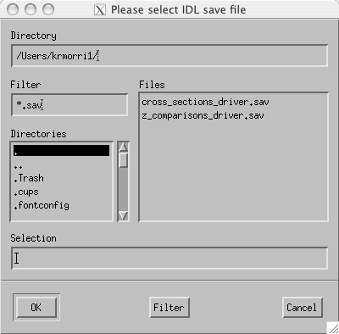
Figure 1. File selector for choosing as IDL 'save' file to be executed in IDL's Virtual Machine mode.

Starting rr_or_z_comparisons (in IDL command-line mode, or in IDLDE)

Start IDL (either command-line mode or Development Environment [IDLDE]), using the procedures specific to your operating system. At the IDL prompt (e.g., IDL> ), change the current directory to the one where the rr_or_z_comparisons.sav file is located (the quotes in the example commands are required). For example, if the .sav file is located in the /Users/Chuck/IDL_Save_Files directory, enter the following command at the IDL prompt and hit return:

IDL> cd, ‘/Users/Chuck/IDL_Save_Files’

Then ‘restore’ the saved binary procedure so that it can be run:

IDL> restore, ‘rr_or_z_comparisons.sav’

Note that the path and file name are enclosed in quotes in the preceding commands, and are case-sensitive. To run the procedure, enter its name at the IDL prompt and hit return:

IDL> rr_or_z_comparisons

If all is well the wrapper program should then start and the control file selector user interface should appear and the analyst will be prompted to select the control file, as shown in Fig. 2. Otherwise, edit the Directory and/or Filter fields in the file selector as needed and click ‘Filter’, until the control files appear in the select list. Select the desired control file and click OK to start the statistical analysis program.

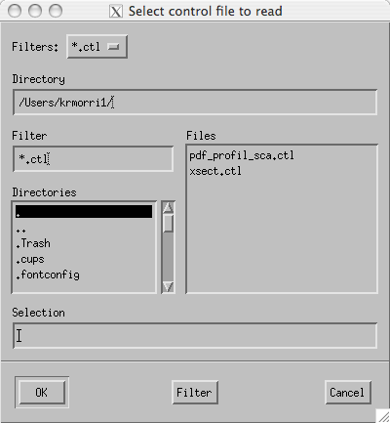
Figure 2. File selector to allow selection of the control file for a run of the statistical analysis wrapper program, rr_or_z_comparisons.

The analysis procedure itself should then start and the data file selector user interface should appear and be populated with the list of geo_match netCDF files, as shown in Fig. 3. By default, the geo-match netCDF file names are prefixed by “GRtoPR” (for TRMM PR) “GRtoDPR” (for GPM DPR, for all three 2A product types), or “GRtoDPRGMI” (for GPM 2B-DPRGMI combined product type). If the NCPATH and SITE keywords are correctly specified, then one or more data files should appear in the file select list. Otherwise, edit the Directory and/or Filter fields in the file selector as needed and click ‘Filter’, until the desired data files appear in the select list. Select the desired data file name and click OK to perform the statistical analysis of the selected data set. NOTE: The Data File Selector will not appear if the NO_PROMPT keyword is set to 1 (On). See NO_PROMPT descriptions in text.

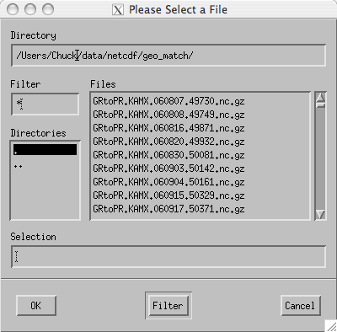
Figure 3. File selector for geometry-matched netCDF files.

PROGRAM OUTPUTS

Once a file has been selected from the list in the File Selector, and assuming that the SUBSET_METHOD, BATCH, and STEP_MANUAL parameters are not in effect, then diagnostic and statistical output from the procedure (Exhibit 1) will immediately be listed in the terminal window (IDL command-line mode or IDL Virtual Machine) or in the IDLDE Console:
- an animation loop of PPI images of the PR and GR volume-matched reflectivity and rain rate data in the netCDF file will be displayed in one new window (e.g., Fig. 4) – see Fig. 15, Section 6.7 for a description of the PPI images included for cases including dual-polarimetric GR fields;
- a four-panel plot with the vertical profile of reflectivity and histograms of reflectivity OR rain rate above, within, and below the bright band will be displayed in a second window (e.g., Fig. 5); and
- scatter plots of PR and GR reflectivity OR rain rate will be displayed in a third window (e.g., Fig. 6).

These plotted windows will remain displayed until the End Animation button is pushed on the PPI animation display (e.g., Fig. 4) or the PPI Animation Window is closed using the window management buttons provided by the operating system. The procedure will proceed to the selection of the next geo-matchup netCDF file using the current file selection mode (e.g., Fig. 3) after the PPI Animation Window is closed. If only one frame of PPI data is being shown (e.g., ELEVS2SHOW=1.1), then the Animation Window does not apply, and the user instead will be prompted on the command line whether to proceed to the next file selection or quit the program, as follows:
Hit Return to proceed to next case, Q to Quit:

PPI Animation Display

Figure 4a shows one frame of the PPI animation. If the ELEVS2SHOW parameter is unspecified, then the elevation angles to be plotted in the PPIs will be the first seven elevation sweeps in the list of elevations in the GR volume scan, or the number of sweeps in the volume scan, whichever is less. Otherwise, if ELEVS2SHOW=N.s is specified as a keyword parameter, then ‘N’ number of sweeps in the GR volume scan will be shown in the PPI animation, beginning from the elevation number ‘s’, where s=1,2,…nsweeps, and ‘nsweeps’ is the number of sweeps in the volume scan. See the description of the ELEVS2SHOW parameter for other rules governing the N.s value.

Note that areas indicated as Stratiform rain type are shown on the PPIs with a horizontally-oriented line pattern, and areas of Convective rain type are shown with a vertical line pattern. Samples where the rain type is Unknown or Other are plotted with solid fill. Samples where a pattern appears on the dark gray background indicate a PR ray position where no valid reflectivity value is present at the elevation being displayed.

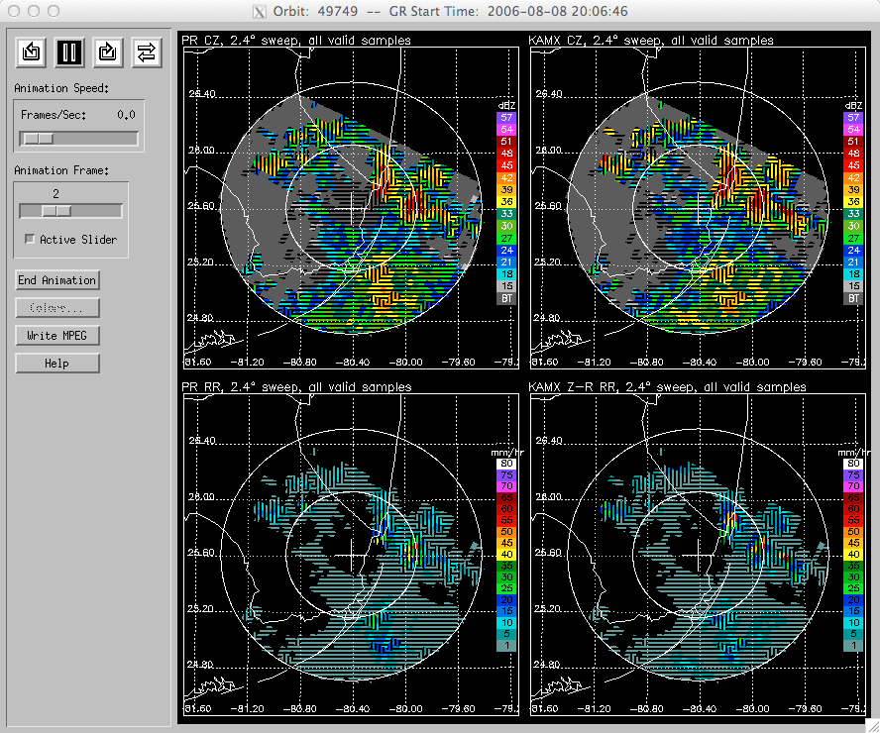
Figure 4a. The PPI animation window of the statistical analysis tool, showing one frame of the animation. Case shown is with all display parameters using their default values, except for MATCHUP_TYPE=”PR” to analyze TRMM PR matchup data. See Fig. 15, Section 6.7 for an example of the PPI display produced for matchup files that include GR dual-polarimetric data fields.

If run as above with no other keyword parameters specified, the keyword parameters will take on their default values as described in the SYNOPSIS section, above. The procedure will produce diagnostic and statistical output in the terminal window from which IDL is run, or in the console window of IDLDE. Shown below in Exhibit 1 is the IDL output for the default case where no parameters other than NCPATH and MATCHUP_TYPE are specified, for the case shown in Fig. 4a.

STEP_MANUAL mode of PPI animation
If the STEP_MANUAL keyword parameter is set to a non-zero integer value, then instead of the interactive animation window shown in Fig. 4, then a simple window with only the PPI panels (Fig. 4b) will be plotted, and the following interactive prompt will be displayed on the terminal:
Please wait while PPI image animation is being prepared...

Enter B to step Back one frame,
Hit Enter to show next frame,
Enter A to step through All frames without prompt,
or Enter Q to Quit:

In this mode, the user can enter values to manually step forward or backwards through the PPI sequence defined by the ELEVS2SHOW settings, or if the “A” (All) option is selected, the sequence will be automatically stepped through with a time delay in seconds equal to the value given for STEP_MANUAL. The main purpose of the manual options is to allow a user to do a screen capture of the PPI window(s) for uses outside of the statistical analysis program itself. Once the end of the PPI sequence is reached, or if the “Q” (Quit) option is selected, all the displayed windows will be closed and the program will proceed to selection of the next matchup file as described in Section 5, above.

Vertical Profiles and Categorized Histograms of Reflectivity

Figure 5 shows the on-screen output window containing the vertical profiles and histograms of PR and GR reflectivity. Separate profiles and histograms are shown for data points having rain types of convective, stratiform, and Any rain type (labeled All or Any/All), for both the PR and GR radars. By default, the Total rain type profiles and histograms are included in the plots. These may be excluded from the plots for clarity by setting the HIDE_TOTALS binary keyword parameter to “ON”. Also, the width of the bins in which the reflectivity histograms are totaled is set to 2 dBZ by default. This value may be adjusted by specifying a different value for the histo_Width keyword parameter. A value of 1 results in the most detail in the histogram plots, but can be very noisy and jagged. A smoother plot results from raising the value of HISTO_WIDTH. By default, and for all output to the screen, the PR profiles and histograms are shown in red and the GR in green. For Postscript output only, black-and-white vertical profile and histogram plots result if the B_W binary keyword parameter is set to “ON”.

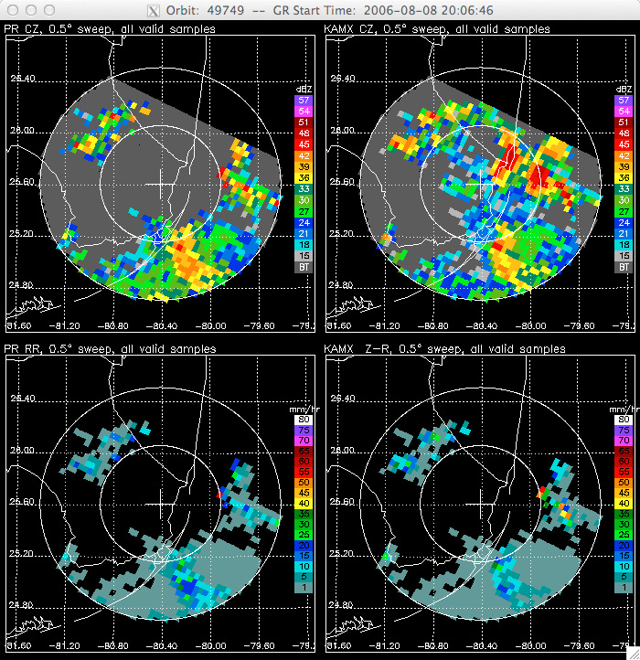 Figure 4b. As in Fig. 4a, but with the STEP_MANUAL mode in effect, and with the HIDE_RNTYPE option set to “On”. Note the absence of interactive animation control buttons attached to the PPI display window.

The PCT_ABV_THRESH keyword parameter permits the analyst to constrain the quality of volume-match data included in the displays and calculations. Each geometry-match data volume represents an average of the full-resolution radar bins within the 3-D volume defined by the geometric intersection of a PR ray and a GR elevation sweep. PR data are averaged in the vertical along the PR ray, between the top and bottom of its intersection with a GR sweep. GR data are averaged in the horizontal, over the area of a PR footprint. Each PR and GR geo-match sample carries a value indicating the number of full-resolution radar bins expected to be included in the volume average from a geometric standpoint (n_pr_expected for PR, n_gv_expected for GR), and another value that indicates the number of “below threshold” bins (n_2a25_rejected for PR, n_gv_rejected for GR) within the 3-D volume averages. Below-threshold bins are those with a reflectivity value below the fixed detection thresholds of 18.0 dBZ for the PR, and 15.0 dBZ for the GR. These fixed thresholds are set in the code that performs the geometry matching (POLAR2PR procedure). 18.0 dBZ is considered to be the minimum reflectivity detection threshold for the PR instrument, and any PR bins below this threshold are excluded from the PR volume averages. It is recognized that GR reflectivity for most ground radars is generally accurate to 0 dBZ or less, but to avoid biasing PR against GR at the lower reflectivity values, a 15.0 dBZ matching detection threshold is applied to the GR. This allows for a fair comparison of PR and GR for all cases where a ground radar calibration is no more than 3 dBZ too low. Only GR bins with values of 0 dBZ or less are excluded from the GR volume averages.

Then, for a given PCT_ABV_THRESH parameter value, only those points where the following two criteria are met will be included in the analysis:

100*( n_pr_expected - n_2a25_rejected) / n_pr_expected ≥ PCT_ABV_THRESH
100*( n_gv_expected - n_gv_rejected) / n_gv_expected ≥ PCT_ABV_THRESH

In other words, only those samples where the percent of “good” bins in the average meets or exceeds PCT_ABV_THRESH are considered. In the example output shown Exhibit 1, the PCT_ABV_THRESH parameter uses its default value of zero, indicating that all matchup points with non-missing reflectivity values are being included in the plots and statistics calculations. The default value of zero includes all points with a valid reflectivity value, regardless of the percentage of bins that are above the cutoff thresholds. A value of 100 means to include only points where every PR and GR bin included in their respective volume averages are above the cutoff thresholds (i.e., n_2a25_rejected and n_gv_rejected values are both zero for the point).

Each matchup point has an associated Rain Type value taken from the PR 2A-25 product, but no GR-derived rain type is present in the matchup data files. An implied, GR-based rain type value may be derived based on GR reflectivity thresholds specified by the parameters gv_convective and gv_stratiform. If non-zero parameter values enabling gv_convective and gv_stratiform are specified, the effect is to override the PR rain type value for any point where the GR-implied rain type (based on applying the GV_convective and/or gv_stratiform reflectivity thresholds) differs from the PR-indicated rain type. Points whose PR- and GR-indicated rain type values differ are moved from the Convective or Stratiform category to the Any/All rain type category, also called Other. A summary of the GR rain type reflectivity thresholds, and the resulting number and type of points whose PR-indicated rain type values have been overridden are included in the diagnostic output of the procedure, as shown in Exhibit 1. See the SYNOPSIS section for the rules describing how the GR reflectivity thresholds for implied GR rain types are applied or disabled.

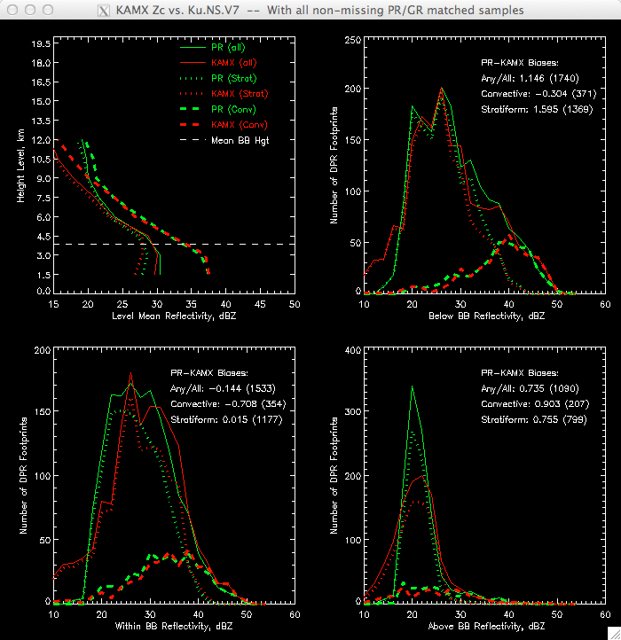
Figure 5. Vertical profiles and histograms of PR (in red) and GR (in green) reflectivity, for Convective (heavy dashed), Stratiform (dotted) and Any (solid) rain type, for the same case shown in Fig. 4, with all statistical parameters using default values.
IDL> geo_match_3d_rr_or_z_comparisons, ncp='~/data/netcdf/geo_match/',MATCHUP_TYPE=’PR’

#############################################################
# GEO_MATCH_3D_RR_OR_Z_COMPARISONS: Version 1.0 #
# (Statistical Analysis Program for Geometry-Match data) #
# NASA/GSFC/GPM Ground Validation, January 2015 #
#############################################################

Defaulting to Z for comparison element.
Defaulting to 7 for the number of PPI levels to plot, starting with the first.

Defaulting to 350 for PPI size.
Defaulting to 0 for PERCENT BINS ABOVE THRESHOLD.
Disabling GR Convective floor threshold.
Disabling GR Stratiform ceiling threshold.
Defaulting to screen output for scatter plot.
No value supplied for GR_RR_FIELD, and not using Z-R rainrate.
Setting GR_RR_FIELD value to RR (for DROPS).
pctAbvThresh = 0.00000
INSTRUMENT: PR

=============================================================================
Computing Percent Above Threshold for PR and GR Reflectivity and Rainrate.
=============================================================================
Leaving PR Convective Rain Type assignments unchanged.
Leaving PR Stratiform Rain Type assignments unchanged.
Mean BB (km MSL) by 2A23 BBstatus 'good': 3.86582
Mean BB (km AGL), bblo, bbhi = 3.86182 3.00000 4.50000

Leaving PR Convective Rain Type assignments unchanged.
Leaving PR Stratiform Rain Type assignments unchanged.

PR-GR Reflectivity difference statistics (dBZ) - GR Site: KAMX Orbit: 49749 Version: V7
PR time = 2006-08-08 20:04:36 GR start time = 2006-08-08 20:06:46
Required percent of above-threshold PR and GR bins in matched volumes >= 0%

Statistics grouped by fixed height levels (km):

Vert. | Any Rain Type | Stratiform | Convective | Dataset Statistics |
Layer | PR-GR NumPts | PR-GR NumPts | PR-GR NumPts | AvgDist PRMaxZ GRMaxZ |
----- | ------- ------ | ------- ------ | ------- ------ | ------- -------- -------- |
1.5 0.783 921 1.028 715 0.091 206 44.157 51.068 50.615
3.0 0.363 1100 0.663 857 -0.649 243 56.761 52.853 50.318 @ BB
4.5 -0.464 807 -0.568 610 -0.204 194 61.781 51.723 49.444 @ BB
6.0 0.319 552 0.204 416 0.785 106 67.075 45.282 49.320
7.5 0.648 336 0.980 252 -0.143 48 69.358 38.011 43.250
9.0 2.180 112 2.585 74 1.203 23 60.164 31.720 31.912
10.5 4.094 31 4.221 19 3.085 10 62.684 26.082 25.676
12.0 4.630 4 6.922 1 3.865 3 43.837 19.910 19.432
No above-threshold points at height 13.500
No above-threshold points at height 15.000
No points at height 16.500
No points at height 18.000
No points at height 19.500
% LOADCT: Loading table GRN-RED-BLU-WHT

Statistics grouped by proximity to Bright Band:

Surface| Any Rain Type | Stratiform | Convective | Dataset Statistics |
type | PR-GR NumPts | PR-GR NumPts | PR-GR NumPts | AvgDist PRMaxZ GRMaxZ |
----- | ------- ------ | ------- ------ | ------- ------ | ------- -------- -------- |
Below 1.146 1740 1.595 1369 -0.304 371 50.124 52.853 50.615
Within -0.144 1533 0.015 1177 -0.708 354 62.767 51.723 50.318 @ BB
Above 0.735 1090 0.755 799 0.903 207 65.127 45.282 49.320

Please wait while PPI image animation is being prepared...

Click END ANIMATION button or close Animation window to proceed to next case:

Exhibit 1. Output diagnostics and statistics from the statistical analysis and display procedure, sent to the terminal or IDLDE console. Statistics are for the case shown in Fig. 4, using default program parameters except for data location/type.

Scatter Plots of Reflectivity

Figure 6 shows scatter plots (on-screen appearance) of PR vs. GR reflectivity for all combinations of the three bright band proximity levels (above, within, below) and the two rain types (stratiform and convective), for same case as shown in Figs. 4 and 5, and using the parameter defaults.

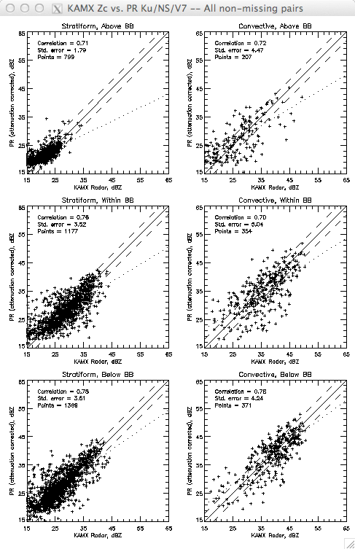
Figure 6. Scatter plots of PR vs. GR reflectivity using default parameters, for the same case as in Figs. 4 and 5. Solid line is PR=GR; dashed lines are for PR +/- 3 dBZ from GR; dotted line is the linear fit to the data. Figure represents data as they appear on-screen. Postscript/PDF output appearance differs, see Appendix.

Rain Rate Analyses

If the RR_OR_Z keyword option is set to ‘RR’ then the statistical analysis program will compute and display results of 3-D DPR and GR rain rate. The DPR rain rate is from the vertically-averaged ‘precipRate’ variable which gives a rain rate estimate at each DPR range bin. The rain rate from the ground radar may be from one of four sources, depending on the value of the GR_RR_FIELD and ZR_FORCE parameters:

GR_RR_FIELD=’RR’: Use the volume-matched GR rain rate based on GR estimates from the DROPS2 algorithm. This is the default GR rain rate used if the GR_RR_FIELD parameter is not specified and the DROPS2-based rain rate field is present in the matchup file.
GR_RR_FIELD=’RC’: Use the volume-matched GR rain rate based on GR estimates from the Cifelli algorithm.
GR_RR_FIELD=’RP’: Use the volume-matched GR rain rate based on GR estimates from the Polarimetric Z-R (Bringi) algorithm.

If the ZR_FORCE binary parameter is set, then the value of GR_RR_FIELD is ignored and the volume-matched GR rain rate is computed from applying the default WSR-88D Z-R relationship (Z=300R**1.4) to the volume-matched GR reflectivity at each sample. This is also the default GR rain rate used if both the GR_RR_FIELD and ZR_FORCE parameters are unspecified and the default DROPS2-based rain rate field is not present in the matchup file.

The first three GR rain rate sources provide rain rate estimates only for those samples in the liquid precipitation layer below the freezing level (bright band), while the Z-R rain rate is computed for all GR samples with a non-missing reflectivity value, regardless of proximity to the freezing level.

EFFECTS OF OPTIONAL KEYWORDS

File Selection Options

Selection of matchup netCDF files is controlled by the NCPATH, MATCHUP_TYPE, SITE, and NO_PROMPT keywords. NCPATH is used to specify a directory path to the matchup netCDF files to be processed. The MATCHUP_TYPE keyword defines whether PR (GRtoPR matchup files), DPR (GRtoDPR matchup files), or DPRGMI (GRtoDPRGMI) data is to be analyzed. The SITE keyword takes part of a regular expression specifying a full or partial file name as its value, with a leading and trailing ‘*’ being added to the value by default. All files in the NCPATH directory whose file names match the regular expression specified for SITE will be shown in the Data File Selector (Fig. 3). For example, if SITE=’KTLH.0809’ is specified as a parameter, then *KTLH.0809* will appear in the Filter field in the File Selector, and only/all those files for the KTLH radar in September, 2008 will be listed.

If the user wishes to process a large number of files at one time, then selecting files one at a time with the File Selector can be cumbersome. In this case, if the binary keyword NO_PROMPT is set, the File Selector will be bypassed and the set of files pointed to by NCPATH and SITE will be processed sequentially, in alphabetical order. As each new file is processed, the animation window will be displayed and the other graphical and textual output will be created for the file. The procedure will automatically open and process the next file when the user closes the animation window for the current file. In this automated mode, the program will ask the user after every 10th file whether to continue automatically processing the list, in case there are a very large number of files specified by SITE. The user can then either Quit, Continue with the next 10 files, or Continue processing all the remaining files without asking again.

Storm Subset Analysis

By default, the statistical analysis program considers all samples within 100 km of the ground radar. There are three methods by which the samples to be included in the analysis can be modified. The first and most direct method is to specify a value for the MAX_RANGE parameter that is smaller than the default value of 100 km. This will define a circle of radius max_range centered on the location of the ground radar, and only those samples whose centers are within this range limit will be included in the statistical analysis (tables, profiles, histograms, scatter plots). However, samples at all ranges will still be displayed in the PPI plots.

The second and third methods of selecting a data subset involve setting values for the SUBSET_METHOD and MIN_FOR_SUBSET parameters. If SUBSET_METHOD is set to “D” (distance), then the user will be given the option to select a center point of the analysis on a PPI plot of the geometry-matched PR and DPR reflectivity (Fig. 7). The program will then select the set of samples whose distance from the center point is within the range limit defined by the value specified by MIN_FOR_SUBSET. In the third method, if SUBSET_METHOD is set to “V” (value), then the user again will be given the option to select a center point of the analysis on a PPI plot of the geometry-matched PR and DPR reflectivity (Fig. 7). The program will then identify and select the set of contiguous samples (i.e., a “storm cell”) whose reflectivity or rain rate magnitude is at or above the threshold value defined by MIN_FOR_SUBSET. If the magnitude of the selected sample point is below the threshold value then the location will be rejected and the user will be prompted to select a different starting point for the identification of the contiguous above-threshold samples. The value of RR_OR_Z controls whether the identification of the “storm cell” is based on contiguous reflectivity or contiguous rain rate samples.

For purposes of evaluating contiguous above-threshold samples, the value at each point is the greater of the PR or GR data values occurring along each vertical column of data (each PR ray). That is, the value is the greater of the PR or GR Composite Reflectivity (or Composite Rain Rate) for each sample location.

If MIN_FOR_SUBSET is not defined, then it will take on a default value depending on the values of RR_OR_Z and SUBSET_METHOD, as defined in the following table:

RR_OR_Z | SUBSET_METHOD | Default MIN_FOR_SUBSET
Z | D | 20 (km)
Z | V | 30 (dBZ)
RR | D | 20 (km)
RR | V | 1.0 (mm/h)

Figure 8 shows an example of the results of defining a storm area by a reflectivity threshold. It displays a frame of the PPI animation that plots only the area of the storm selected by clicking on the point shown in Fig. 7 and applying a 35 dBZ reflectivity threshold (SUBSET_METHOD=”D”, MIN_FOR_SUBSET=35).

Saving Storm Subset Data

When analysis is performed for a user-defined subset of data, the statistical analysis program provides an optional capability to save the extracted subset of data in the form of a binary IDL “SAVE” file. If the parameter SAVE_DIR is set then, after a subset of data is analyzed and displayed and the animation window is closed, the user will be prompted with the question:
Save subset variables to file? Enter Y or N :

If the user responds with “Y”, then a file name based on a combination of fields from the matchup netCDF file basename, the latitude and longitude of the selected point, and the PCT_ABV_THRESH value will be defined. For example, for the case shown, with a value of “~/Desktop” for SAVE_DIR, the IDL SAVE file name would be:

~/Desktop/KAMX.060808.49749.V7.PR_Ku_NS.Pct0_25.88N_81.04W_Z.sav

where the ‘.sav’ extension identifies it as an IDL “SAVE” file, by convention. These files are only in a format appropriate for use within IDL. The SAVE file can be RESTORED in IDL to allow subsequent analysis within other programs. The contents and format of the SAVE file may be seen by examination of the source code file geo_match_3d_rr_or_z_comparisons.pro.

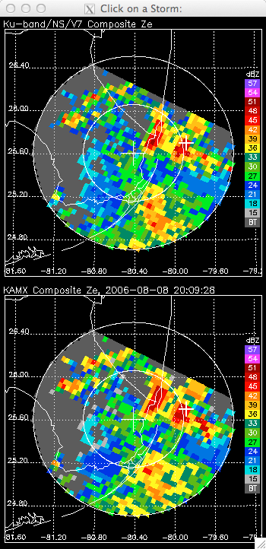

Figure 7. PPI plot window that is shown when SUBSET_METHOD keyword parameter is set to “D” or “V”. It allows the user to position the cursor on the center of a subset of samples to be identified by a range limit from the selected point (“D” option) or as a contiguous set of samples above a specified threshold value (“V” option). A white “+” sign indicates the user-selected “storm center”. User may click on a point in either of the two PPI images.
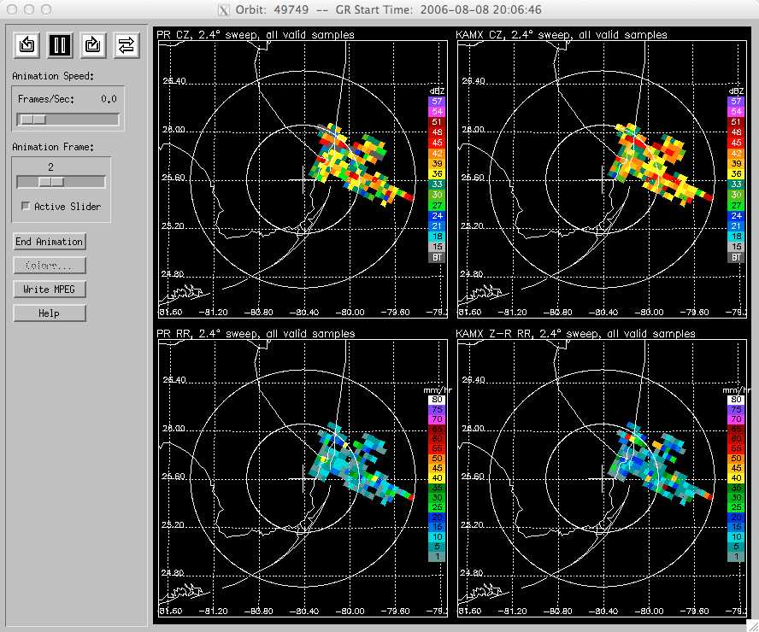Figure 8. As in Fig. 4, but for a storm area around the point selected in Fig. 7, defined by computing a contiguous area of reflectivity at or above a threshold of 35 dBZ. Statistics will be computed for the subset of sample locations defined by this storm area.

PPI Animation Options

The PPI animation loop is affected by the keywords SPEED, ELEVS2SHOW, PPI_SIZE, SHOW_THRESH_PPI, and PCT_ABV_THRESH. SPEED, ELEVS2SHOW, and PPI_SIZE are described in the SYNOPSIS section, and their effects cannot be shown here. By default, a second set of PR and GR PPIs showing 3-D rain rate are plotted below the reflectivity PPIs in the image frames in the animation window. The second set of PPIs, plotted below the original PPIs, will show only those matchup points where the criteria defined by the value of PCT_ABV_THRESH are met. Figure 9 shows the animation window contents if the example shown in Fig. 4 is re-run with the IDL options set as:
PCT_ABV_THRESH=95
SHOW_THRESH_PPI=1
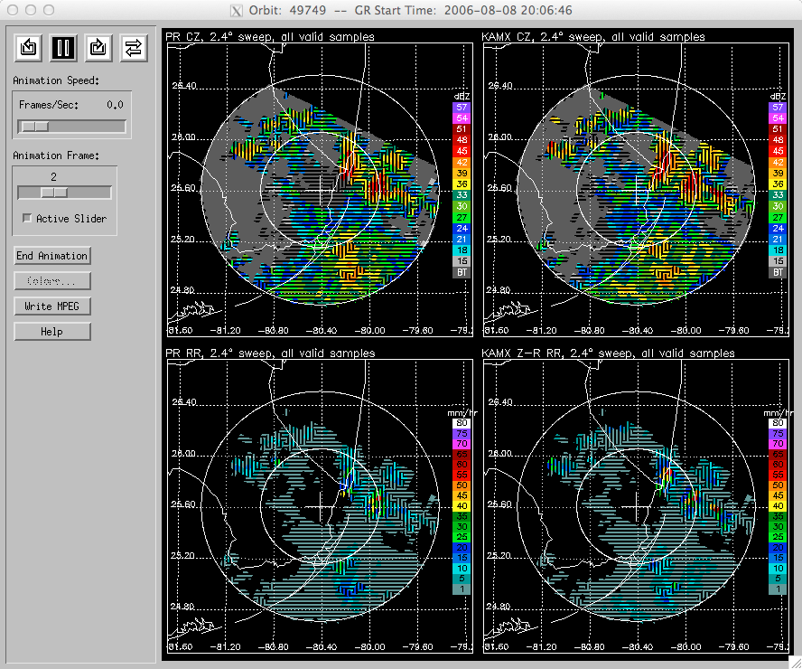
Figure 9. As in Fig. 4, but with the option PCT_ABV_THRESH=95 set. The upper reflectivity PPIs show all matchup points. The lower rain rate PPIs gray out those points not meeting the restriction of having at least 95% of the bins in the sample averages above fixed dBZ thresholds.

Histogram/Profile Options

The HIDE_TOTALS keyword parameter affects the plotting of the vertical profile and histogram graphics. Its effect on the plots has already been described above. Figure 10 shows an example of the vertical profile and histogram plots for the same case as Fig. 5, but with the HIDE_TOTALS binary keyword set. The parameter has no effect on computation of the statistics shown on the graphics or in the tabular output. Options for Fig. 10 are:
HIDE_TOTALS=1

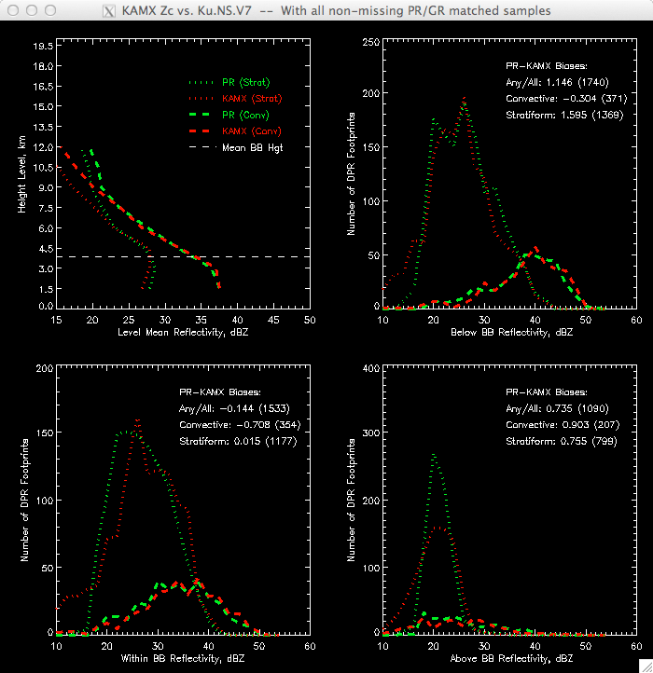
Figure 10. As in Figure 5, but with non-default option HIDE_TOTALS=1. Note the solid-line plots for Any/All rain type are hidden.

Hide Raintype Option

The HIDE_RNTYPE keyword parameter disables the hatching that encodes the PR rain type in the PPI plots and makes the individual sample outlines easier to see. Figure 11 shows a PPI plot for the same case as in Fig. 4, but with the HIDE_RNTYPE binary keyword set to 1. This parameter has no effect on computation of the statistics shown on the graphics or in the tabular output. Options for Figs. 11 are:
HIDE_RNTYPE=1

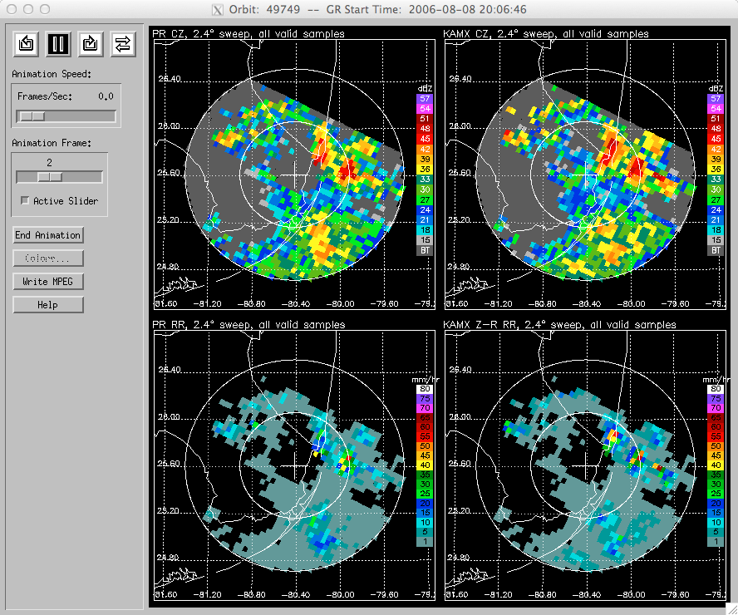
Figure 11. As in Fig. 4, but with non-default HIDE_RNTYPE=1 option.

Statistical/Computational Options

The PCT_ABV_THRESH, MAX_BLOCKAGE, Z_BLOCKAGE_THRESH, GV_CONVECTIVE, GV_STRATIFORM, ALT_BB_HEIGHT, FORCEBB, and S2KU keyword parameters affect the output statistics and displayed graphics. The effects of the PCT_ABV_THRESH, GV_CONVECTIVE, and GV_STRATIFORM parameters have already been described above. The first five of these parameters serve to filter the data points being included in the statistical computations and data displays, for the points as a whole (PCT_ABV_THRESH, and MAX_BLOCKAGE or Z_BLOCKAGE_THRESH) or for the points in each rain type category (GV_CONVECTIVE and GV_STRATIFORM). Figure 12 shows an example of the vertical profile and histogram plots for the same case as Fig. 5, but with PCT_ABV_THRESH=95. Figure 13 uses the same PCT_ABV_THRESH option as Fig. 12, but with GV_CONVECTIVE set to 35 dBZ and GV_STRATIFORM set to 25 dBZ (do rain type adjustments based on GR reflectivity thresholds).

Options for Fig. 12 are:
PCT_ABV_THRESH=95

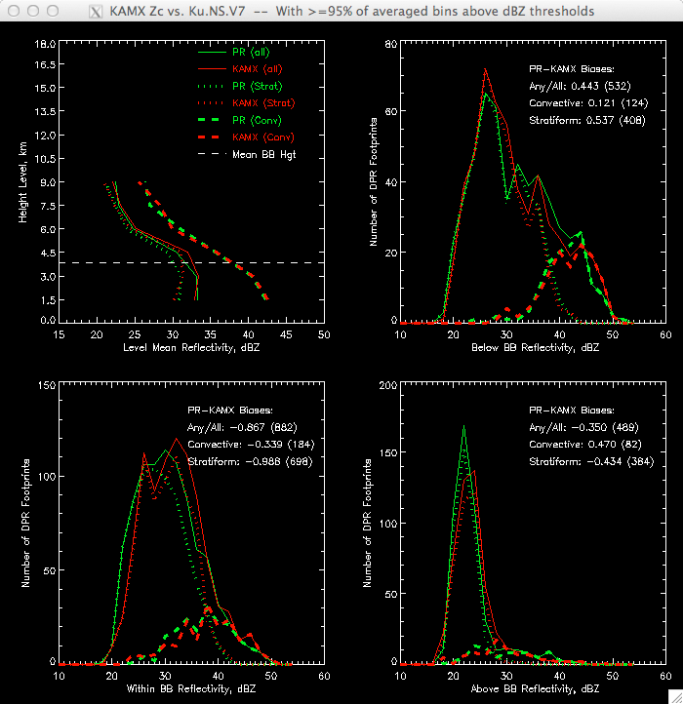
Figure 12. As in Fig. 5, but with non-default option PCT_ABV_THRESH=95 used. Note the fewer number of points in each category and general improvement in mean difference statistics above and below the bright band as compared to Fig. 5, due to the filtering of “incomplete volume average” points.

Options for Fig. 13 are:
PCT_ABV_THRESH=95
GV_CONVECTIVE=35
GV_STRATIFORM=25

Note that the computation of the mean bright band height in the current version of the statistical analysis program only considers PR profiles categorized as stratiform, so changes to the GV_STRATIFORM parameter can affect the analyzed mean bright band height through the inclusion or exclusion of PR profiles that meet the stratiform rain type criterion. In the case of Fig. 13, changing the GV_STRATIFORM parameter value to 25 results in exclusion of certain PR profiles from the bright band height calculation. This can also change the mean bright band height in some cases, which can affect the distribution of sample points characterized as above, within, and below the bright band.

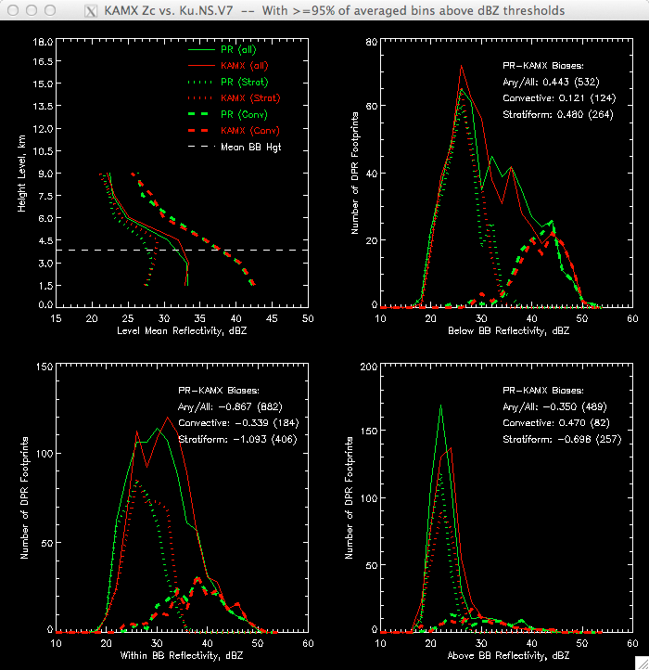
Figure 13. As in Fig. 12, but with GV_STRATIFORM=25 and GV_CONVECTIVE=35 resulting in PR rain type assignments being changed. Note that there are fewer points in the Stratiform rain type category when compared to Fig. 12.

In the case where a mean bright band height cannot be determined from the satellite radar data, ALT_BB_HEIGHT offers a way to supply a value for the mean BB height. ALT_BB_HEIGHT can take two forms: a numerical value giving the height, in km, of the bright band, or the name of a file to be searched to find the RUC model freezing height for the GR site and GPM orbit number. The model freezing height files are prepared by a separate program as part of the GPM Validation Network operations. If the FORCEBB parameter is set and a valid ALT_BB_HEIGHT parameter value is supplied, then the ALT_BB_HEIGHT value will be used for the BB height even if a valid mean BB height is present in the satellite radar data.

The MAX_BLOCKAGE and Z_BLOCKAGE_THRESH parameters offer two methods for excluding samples where the ground radar may be experiencing beam blockage that can bias the GR-DPR reflectivity differences. The MAX_BLOCKAGE parameter specifies the largest fraction of beam blockage allowed for included samples. It can only be applied to sites where beam blockage has been computed and included in the matchup files (Version 1.21 or later for GRtoDPR; Version 1.11 or later for GRtoDPRGMI matchup files). The range of MAX_BLOCKAGE ranges from 0.0 (no blockage allowed) to 1.0 (full blockage allowed). If a value greater than 1.0 and less than or equal to 100 is specified, then the value is treated as a percent blockage and is internally converted to the fractional blockage between 0.0 and 1.0.

If MAX_BLOCKAGE is unspecified, or where no blockage information is contained in the matchup file, then samples with possible ground radar beam blockage can be determined and filtered by locating data columns where a Z dropoff between the second and first sweeps that exceeds the value of the Z_BLOCKAGE_THRESH parameter. In practice, a dropoff of 3 dBZ in GR reflectivity at the lowest sweep indicates a beam blockage of 50%. If MAX_BLOCKAGE and Z_BLOCKAGE_THRESH are both left unspecified then no data samples are excluded based on GR beam blockage.

The S2KU binary keyword controls whether the Liao and Menghini (2009) S-band to Ku-band frequency adjustments are applied to the GR reflectivity prior to computation of the mean difference statistics and generation of the graphical plots. The adjustments account for the differences in reflectivity factor that occur when the same rain or snow targets are observed by S- and Ku-band radars. The snow correction is applied to data above the bright band, and the rain correction is applied to the data samples below the bright band. Figure 14 shows the same case as in Fig. 13, but with the S2KU keyword parameter set. Options for Fig. 14 are:
PCT_ABV_THRESH=95
GV_CONVECTIVE=0
GV_STRATIFORM=0
S2KU=1

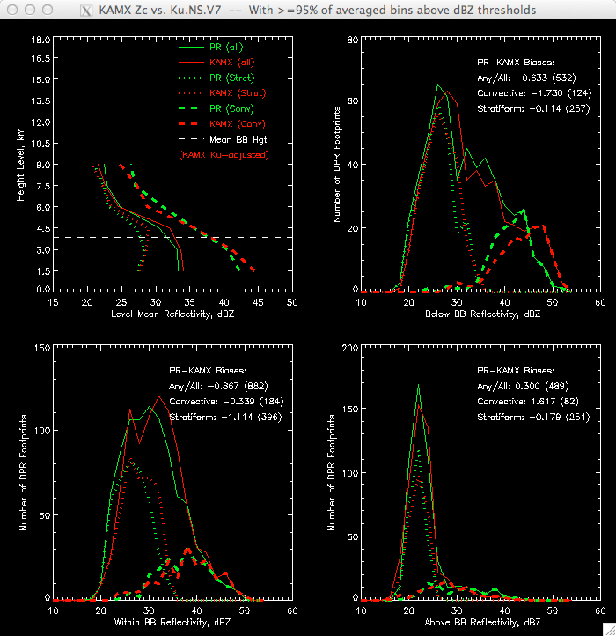
Figure 14. As in Fig. 13, but with the S2KU=1 keyword set to apply the S-to-Ku frequency adjustment to GR reflectivity above (snow) and below (rain) the bright band. No adjustments are made to points within the bright band.

Apply Bias Adjustments to DPR and GR Reflectivity Data

The optional keyword parameters DPR_Z_ADJUST and GR_Z_ADJUST allow offsets to reflectivity values to be applied additively to the PR/DPR and GR reflectivity values prior to their analysis and plotting on the displays. DPR_Z_ADJUST is specified as a single numerical value, e.g.:

DPR_Z_ADJUST=-1.4

In this case, the PR or DPR measured and corrected reflectivity would be reduced by 1.4 dBZ for all volume-match and original-resolution samples prior to analysis and display.

GR_Z_ADJUST specifies the full pathname to a delimited text file containing GR-site-specific bias corrections to be applied (added to) a ground radar site's reflectivity to account for the calibration difference between the PR/DPR and ground radar in a site-specific sense. Each line of the text file lists one site identifier and its bias offset value separated by the delimiter, e.g.:

KMLB|2.89
KWAJ|-0.3
PAIH|1.7

If no matching entry is found in the file for the radar site, then the GR reflectivity is not changed from the values read from the matchup netCDF file. The site-specific GR bias adjustment is applied AFTER the frequency adjustment if the S2KU parameter is set.

Only those PR/DPR and GR reflectivity values above 0.0 dBZ are affected by the bias adjustment. In no case is an above-zero reflectivity allowed to go below 0.0 by the bias adjustments. DPR_Z_ADJUST is constrained to be within the range from -3.0 to 3.0 dBZ. There is no limitation on bias adjustment values for the GR.

PPI Displays for Matchup Files with GR Dual-Polarimetric Fields

All PPI examples shown to this point represent what will be plotted from early matchup netCDF files prior to the availability, and inclusion of, dual-polarimetric data fields from the ground radars. Matchup files for events that follow the date of the dual-polarization upgrade of the WSR-88D radars contain several GR dual-polarimetric fields, and along with reflectivity and rain rate, selected of these GR fields will be plotted in additional panels in the default PPI displays of rr_or_z_comparisons, as shown in Fig. 15. These fields are not involved in the statistical analysis of reflectivity or rain rate in the program at this time, and the plotted fields to be included in the PPI display are not configurable except through modification of the code.

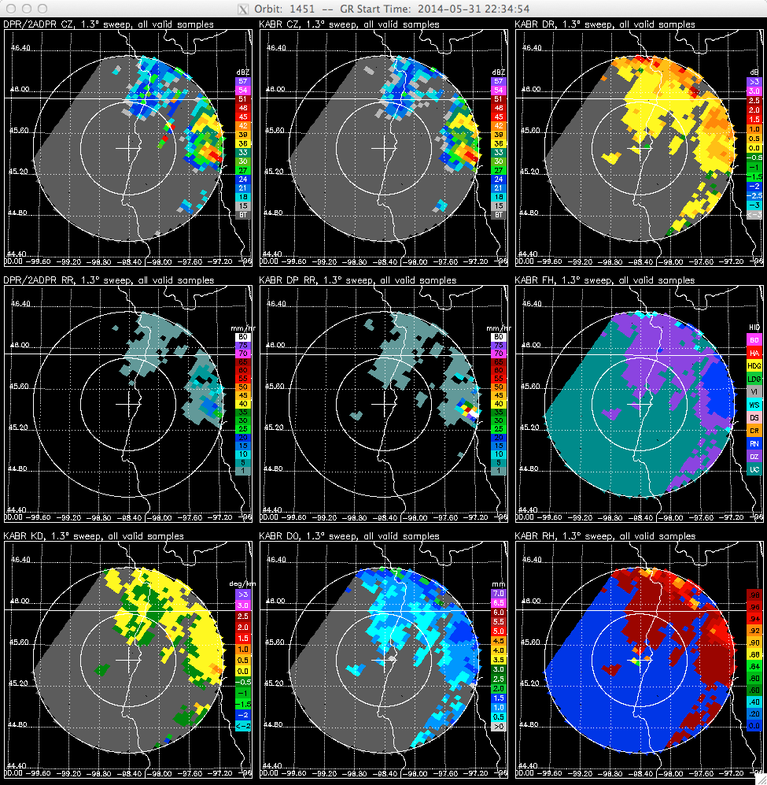
Figure 15. Additional ground radar PPI fields included in the PPI animation when dual-polarization data are available. Clockwise from top right: Differential Reflectivity (DR); Hydrometeor Type (FH); Co-Polar Correlation Coefficient, aka RHOhv (RH); Mean Drop Diameter (D0); Specific Differential Phase, aka Kdp (KD).

Postscript/Adobe PDF Option

If the PS_DIR keyword is specified, then output from the procedure will be sent to a Postscript or PDF file whose name is derived from the matchup netCDF file. All graphical and textual output from the procedure is written to a Postscript file when PS_DIR is set. If the utility ‘ps2pdf’ (unix/Linux) or ‘pstopdf’ (Mac OS X) is present on the host system, then the Postscript output file will be immediately converted to the Adobe Portable Document Format (PDF) file format.
NOTE: Output to a Postscript or PDF file is only available when running the procedure with a licensed copy of IDL.

The Postscript output option is activated by specification of a non-null value for the PS_DIR keyword parameter. The value of PS_DIR must point to an existing directory with write privileges.

For example, if the parameter specification PS_DIR=’/tmp’ is given as an option, e.g.:
PS_DIR=’/tmp’

and the file GRtoPR.KAMX.060808.49749.6.2_1.nc.gz is selected for display, then the Postscript file /tmp/GRtoPR.KAMX.060808.49749.V6.Pct0_PDF_SCATR.ps will be created. The ‘V6’ portion of the name reflects the version of TRMM data used in the matchups (6 or 7), as indicated in the GRtoPR netCDF matchup file. The ‘Pct0’ portion of the name reflects the value of the PCT_ABV_THRESH parameter used in the run of the procedure, and is always included in the file name. The status of the S2KU parameter value is also reflected in the output file name. If the S2KU parameter is set to On, then the GR reflectivity values will have the S-to-Ku frequency adjustment applied for the statistical calculations, and the output filename will indicate this by insertion of the string ‘S2Ku’ in the file name. Otherwise, if S2KU is unset, no indication will be present in the file name. For example, if the procedure is invoked with:
PS_DIR=’/tmp’
PCT_ABV_THRESH=95
S2KU=1

and the file GRtoPR.KAMX.060808.49749.6.2_1.nc.gz is selected for display, then the file /tmp/GRtoPR.KAMX.060808.49749.V6.Pct95_S2Ku_PDF_SCATR.ps will be created.

If the utility ‘ps2pdf’ or ‘pstopdf’ is present on the system, then the Postscript file will be converted to an Adobe Portable Document Format (PDF) file by default, and the ‘.ps’ file extension will be replaced by ‘.pdf’. In the preceding example, the output file name /tmp/GRtoPR.KAMX.060808.49749.V6.Pct95_S2Ku_PDF_SCATR.pdf instead would be created.

When running with the Postscript option activated and with the BATCH keyword parameter unset or set to 0, the PPI animation window (e.g., Fig. 4) will still be created, and a copy of the statistical and diagnostic output (Exhibit 1) will still be sent to the terminal or IDLDE Console. The Postscript/PDF file will contain all the graphical and statistical output from the procedure on multiple pages, in the following order:

Page 1: vertical profile and histogram plots, as in Fig. 5
Page 2: mean difference tables by height and by bright band proximity, as in Exhibit 1
Page 3: scatter plots, as shown in Fig. 6, but with addition features described below
Pages 4…n: images as within each individual frame of the PPI animation loop, one frame per page. The exact list of images to be included in the loop and output to the file are controlled by the ELEVS2SHOW parameter.

If the B_W binary keyword parameter is specified in the parameters and set to On (i.e., B_W=1), then the vertical profile and histograms plots will be drawn in black-and-white for Postscript/PDF output. The B_W parameter does not affect the on-screen display of the vertical profiles and histograms, nor does it affect the PPI images, which are always output in color. By default, the PPI images in the postscript/PDF output file will have white backgrounds instead of black.

The scatter plots for Postscript/PDF output have two additional features supported by the higher display resolution of the file output compared to the on-screen display. First, the individual data points are plotted as filled circles whose size is inversely dependent on the number of points to be shown. The more points there are to plot, the smaller the circles are, to help eliminate overlap between points. Secondly, the fill color of the points represents the height above the surface of the midpoints of the data samples, and a legend on the right side of the plot defines the colors for each height range. The B_W parameter does not affect the Postscript/PDF output of the scatter plots, which are always output with color-coding of the sample heights. See the appendix for an example of the Postscript/PDF appearance of the scatter plots.

If the BATCH keyword is set to 1 and PS_DIR is set to an existing directory, then all graphical output will be sent only to the Postscript/PDF file. Diagnostics and tabular results will still be sent to the terminal. When BATCH, PS_DIR, and NO_PROMPT are all set, then a large number of cases can automatically be processed and output to a series of Postscript/PDF files with no user interaction needed.

An example of the procedure’s complete set of output to a Postscript/PDF file is included as an appendix.

RUNNING THE “RAW” STATISTICAL ANALYSIS PROCEDURE

The geo_match_3d_rr_or_z_comparisons procedure is the underlying procedure that provides all of the functional capabilities of the Statistical Analysis and Display Program. This “raw” procedure is provided as a precompiled and saved IDL binary file: geo_match_3d_rr_or_z_comparisons.sav. To run the file, place it in a directory of your choice, and start IDL (either command-line mode or Development Environment [IDLDE]). At the IDL prompt (e.g., IDL> ), change the current directory to where the geo_match_3d_rr_or_z_comparisons.sav file is located (the quotes in the example commands are required):

IDL> cd, ‘/Users/Chuck/IDL_Save_Files’

Then ‘restore’ the saved binary procedure so that it can be run:

IDL> restore, ‘geo_match_3d_rr_or_z_comparisons.sav’

The procedure can then be run. At a minimum, the NCPATH parameter will need to be specified on the command line so that the local path to the geo_match netCDF files is set. For instance, if the netCDF files are located on the local machine under the directory /Users/Chuck/data/netcdf/geo_match, then run the procedure with NCPATH set as follows:

IDL> geo_match_3d_rr_or_z_comparisons, $
NCPATH=’/Users/Chuck/data/netcdf/geo_match’

The $ is a continuation character in IDL and allows you to enter a single command over several lines, for readability. Any other keyword parameters desired should be included on the command line, separated by commas and (optionally) continuation characters, as shown above.

If all is well the procedure should then start and the file selector user interface should appear and be populated with the list of geo_match netCDF files, as previously shown in Fig. 3. Once a data file is selected, program output will be produced as directed by the keyword options specified on the command line at startup.

It is not feasible to run the geo_match_3d_rr_or_z_comparisons procedure under the IDL Virtual Machine, as there is no mechanism to specify the control parameters on the command line.

REFERENCES

Liao, L., and R. Meneghini, 2009: Changes in the TRMM Version-5 and Version-6 Precipitation Radar Products due to Orbit Boost. Journal of the Meteorological Society of Japan 87A, No. 0, 93-107.

NASA/GSFC, 2015: GPM Validation Network Data User’s Guide, Vols. 1 and 2. Available for download at http://pmm.nasa.gov/science/ground-validation.

APPENDIX - Sample Postscript/PDF file output

The following pages show a complete example of the procedure’s multi-page output to a Postscript or PDF file. Each page below is a separate page in the Postscript or PDF file, appearing in file in the order shown. For brevity, only the first four elevation sweeps in the scan volume were specified for output in the PPI animation loop and Postscript/PDF file. Other options affecting the statistical results and appearance of this output include:

ELEVS2SHOW=4.1
PCT_ABV_THRESH=95
GV_CONVECTIVE=0
GV_STRATIFORM=0
HIDE_RNTYPE=1
HIDE_TOTALS=1
B_W=1
S2KU=1

See the document text for a description of these options and their effects on the output results. Outputs for this example are from the same case as presented in the sample figures in the prior sections of this document:

GR Site: KAMX (Miami, FL)
Date: 2006-08-08
TRMM Orbit No.: 49749
TRMM Product Version: 6
Matchup Product Version: 2.1
Statistical Analysis Program Version: 1.0

