Published September 2015

Creating a Portable Windows 10 Environment with Windows To Go

IT Showcase Productivity Guide

Summary: You can use Windows To Go, a feature in Windows 10 Enterprise (and previous versions), to provision a USB drive with a complete and managed Windows 10 system image. You can insert the USB drive (known as a Windows To Go workspace) into a managed or unmanaged Windows 10 host computer to boot and run a managed Windows 10 system. You don’t have to install any software on the host computer to use the Windows To Go workspace.

This guide shows you how to create a Windows To Go workspace. (Additionally, you can use the same methods to create a Windows To Go workspace to boot a portable and managed Windows 8.x system or a managed or unmanaged Windows 7 system.)

# Topics in this guide include:

Overview

Creating a Windows To Go workspace

Suspending BitLocker on the host computer

Updating the configuration

Getting apps from the Windows Store

For more information

# Overview

You can create a Windows To Go workspace to boot a portable and managed Windows 10 system. For example, you might want to provide a company-owned Windows To Go workspace to staff members who use their own non-domain-joined computer at work. The Windows To Go workspace provides a domain-joined computer experience for these users without modifying their personal consumer devices. As another example, you could create a Windows To Go workspace for yourself to use on a home computer that might still be running Windows 7.

You can use a Windows To Go workspace as you would any desktop, laptop, or tablet computer. For example, you can:

* Join a corporate domain.
* Connect to the corporate network from a remote site using VPN.
* Install applications.
* Access USB devices (such as a smart card reader) attached to the host.

A Windows To Go workspace works with any host computer (desktop, laptop, or tablet PC) that supports the **Boot To USB Hard Disk Drive** startup option. When you connect a Windows To Go workspace to a USB port on a host computer, the workspace is isolated from the host system’s hard drive so the hard drive can’t be compromised or infected. The user can switch between the Windows To Go workspace and the host hard drive at any time by inserting or removing the Windows To Go workspace during a system restart.

# Creating a Windows To Go workspace

1. Download a copy of a Windows 10 Enterprise installation image (.iso file) to the host computer, as provided by your local help desk or IT administrator, or from the [TechNet Evaluation Center](http://www.microsoft.com/en-us/evalcenter/).
2. When the download is complete, open your Downloads folder on the host computer, press and hold (or right-click with the mouse) the Windows installation image .iso file, and then select **MOUNT ISO**.

The .iso file appears as a disk drive on the host computer.

1. Display the charms, select the **Settings** charm, and then select **Control Panel**.
2. In Control Panel, select **Windows To Go**.
3. Insert a USB drive into a USB port on the host computer.

NOTES:

*The USB drive must have at least 25* *gigabytes (GB) of space available. To see a list of certified USB drives for Windows To Go, review the “Hardware Considerations” section of the TechNet article* [Windows To Go: Feature Overview](https://technet.microsoft.com/en-us/library/f82d1a0a-d8f7-4e8a-86a6-704166969a42#wtg_hardware).

*Make sure to remove any files on the USB drive that you want to save. The USB drive will be reformatted, and all data will be deleted when you provision it.*

The Create a Windows To Go workspace wizard opens.

1. On the **Choose the drive you want to use** page, all attached USB drives appear. Choose the USB drive you want to use, and then select **Next**.

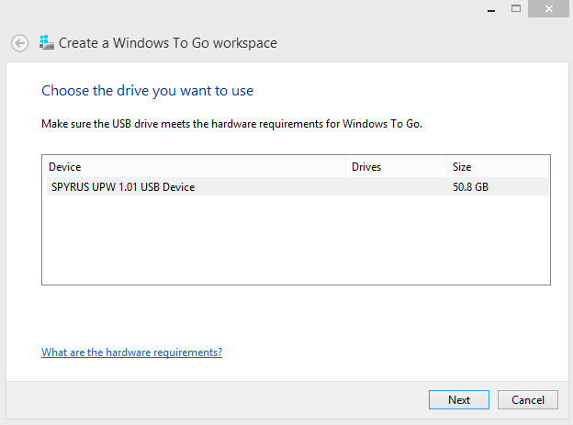

1. On the **Choose a Windows 10 image** page, the mounted .iso file appears. If you don’t see the .iso file, select **Add search location** to choose the mounted .iso file. Select the file, and then select **Next**.

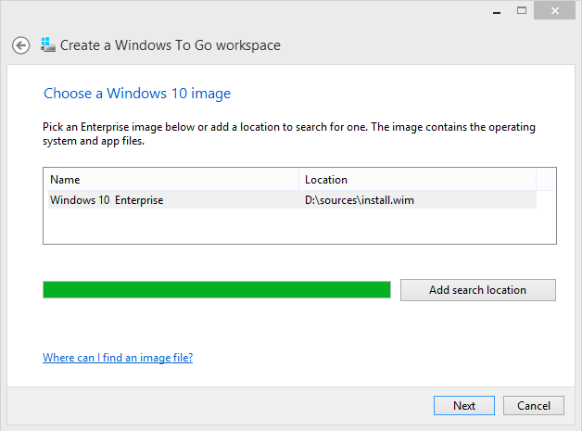

1. On the **Set a BitLocker password (optional)** page, select the **Use BitLocker with my Windows To Go workspace** check box to protect the drive with BitLocker Drive Encryption.
2. Enter a BitLocker password, confirm it, and then select **Next**.

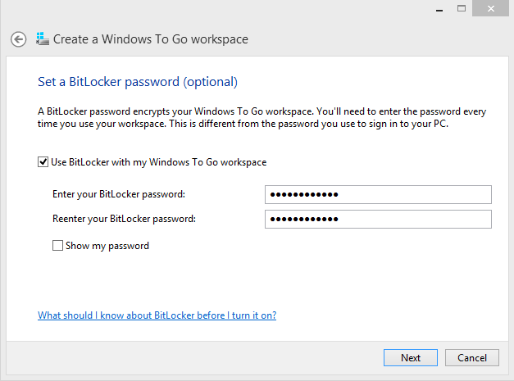

1. On the **Ready to create your Windows to Go workspace** page, select **Create** to create the Windows To Go workspace.

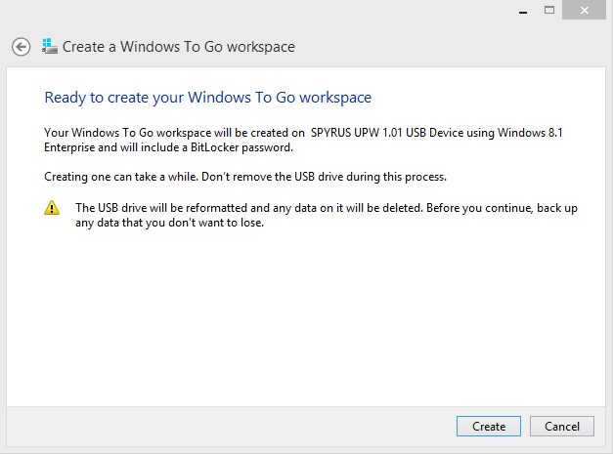

The USB drive is reformatted and all data is deleted. This process typically takes less than one hour.

The **Choose a boot option** page appears when the process completes.

1. Choose a boot (startup) option, and select **Yes** to modify the Windows Boot Manager configuration to boot automatically from your Windows To Go workspace when the drive is connected to this host computer.

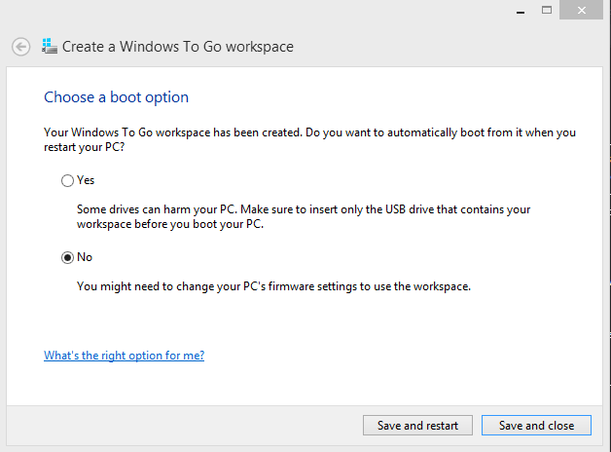

NOTE: *To change the boot option after running the Create a Windows To Go workspace wizard, on the Start menu search for Change Windows To Go Startup Options, and then select the boot option you prefer on the Change Windows To Go Startup Options page.*

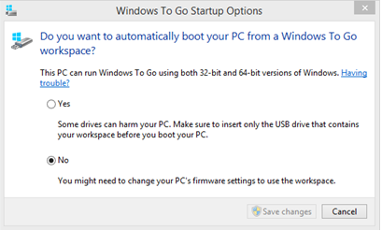

1. When provisioning is complete, select **Save and restart** to restart the host computer.

If you remotely access a corporate network from the Windows To Go drive, you may need to download and install your company VPN after your first logon using the new Windows To Go drive.

You can join a Windows To Go workspace to an Active Directory domain, if your company has one. When you boot the Windows To Go drive for the first time, you are prompted to create a local administrator account and then log on with this account. If you want, you can add your domain user account to the local administrators group. Then you can log on for full access to business data, email, and resources.

# Suspending BitLocker on the host computer

If the host computer is protected by BitLocker, and if you are switching the boot order permanently in the BIOS or UEFI startup device options, you must suspend BitLocker protection before switching the boot order on the host computer. Otherwise, you will trigger the BitLocker recovery key screen when you try to boot back to the internal hard drive. After switching the boot order, you must resume BitLocker protection for the internal drive.

How you suspend BitLocker depends on the operating system that you are using.

## Using a Windows 7 host

1. Select **Start**, and then select **Control Panel**.
2. Select System and Security, and then select BitLocker Drive Encryption.
3. In the **BitLocker Drive Encryption** dialog box, select **Suspend Protection**.

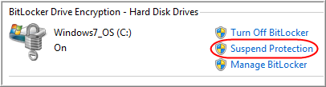

NOTE: *To resume protection after switching the boot order, select* ***Resume Protection*** *on the* ***BitLocker Drive Encryption*** *page.*

## Using a Windows 8.x or Windows 10 host

1. Press **Windows logo key+X** keyon the keyboard, and then select **Control Panel**.
2. In Control Panel, select **System and Security**, and then select **BitLocker Drive Encryption**.
3. On the **BitLocker Drive Encryption** page, select **Suspend protection**.

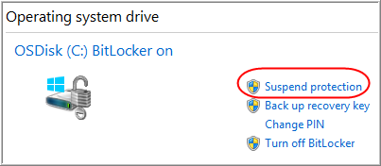

NOTE: *To resume protection after switching the boot order, select* ***Resume protection*** *on the* ***BitLocker Drive Encryption*** *page.*

# Updating the configuration

When you connect a Windows To Go workspace to a new host computer and restart the host computer, Windows To Go automatically detects and applies the needed configuration updates before you log on to Windows.

After you log on, you may be prompted to go to Windows Update to ensure that the Windows To Go workspace has the latest device drivers.

## Check for updates on a Windows 10 workspace

1. On the **Start** menu, select **Settings**.
2. Select Update or Recovery, then select Windows Update.
3. Select **Check for updates**.

# Getting apps from the Windows Store

For Windows To Go images that are running Windows 10 or 8.1, there is no difference in Windows Store behavior between a standard Windows installation and a Windows To Go installation. Windows Store apps can roam among multiple PCs on a Windows To Go drive.

# For more information

## For more great productivity guidance, visit…

<http://microsoft.com/ITShowcase/Productivity>

## Microsoft IT Showcase

<http://www.microsoft.com/ITShowcase>

## Windows

<http://windows.microsoft.com>

For more information about Microsoft products or services, call the Microsoft Sales Information Center at (800) 426-9400. In Canada, call the Microsoft Canada Order Centre at (800) 933-4750. Outside the 50 United States and Canada, please contact your local Microsoft subsidiary. To access information via the web, go to:

<http://www.microsoft.com>

© 2015 Microsoft Corporation. All rights reserved. Microsoft and Windows are either registered trademarks or trademarks of Microsoft Corporation in the United States and/or other countries. The names of actual companies and products mentioned herein may be the trademarks of their respective owners. This document is for informational purposes only. MICROSOFT MAKES NO WARRANTIES, EXPRESS OR IMPLIED, IN THIS SUMMARY.