SiCoPR
(pronounced si-copper) · Si (Signal Integrity), Co (COM), P (Python), and R
Channel Operating Margin in Python — a complete tutorial and reference
A Python port of the IEEE 802.3ck/dj COM (Channel Operating Margin) MATLAB reference tool with R programming extensions for reports and visualizations. Covering the COM engine, its configuration surface, the equalizer-search study layer, and the R reporting tools.
Version 1.2 · 30 August 2026
IEEE 802.3ck / 802.3dj · port of com_ieee8023_4p15p0.m, with 4p16p0 supported behind a version switch

Contents
Contents 2
1 Introduction 6
1.1 What this is 6
1.2 What it adds beyond the MATLAB tool 6
1.3 How to read this document 6
2 Installation and first run 8
2.1 Requirements 8
2.2 What ships, and what does not 8
2.3 Running COM 8
2.4 Where output goes 10
3 Architecture 11
3.1 The assembly model 11
3.2 Dependency injection 11
3.3 Search instrumentation 11
3.4 Modules that sit beside the engine 12
3.5 Repository layout 12
4 Inputs 13
4.1 The configuration spreadsheet 13
4.2 S-parameter files 13
4.3 Package cases 14
5 Configuration: the parameters that matter 15
5.1 Signalling and test limits 15
5.2 Equalizer sweeps 15
5.3 Noise, jitter and crosstalk 15
5.4 Package, die and termination 16
5.5 Output flags 16
6 Feature reference 17
6.1 Transmit FFE 17
6.2 CTLE 17
6.3 Decision feedback equalization 17
6.4 Receive FFE (MMSE) 17
6.5 MLSE 18
6.6 Crosstalk 18
6.7 ERL and TDR 18
6.8 Frequency-domain metrics 18
6.9 Receiver calibration 18
6.10 C2M: VEO and VEC 18
6.11 Error propagation 18
7 Outputs 19
7.1 The result block 19
7.2 results.csv 19
7.3 Figures 19
7.4 Engineering .mat export 23
8 The equalizer-search study 24
8.1 Three search methods 24
8.2 Why FOM is not the whole story 24
8.3 Comparing methods on one channel 24
8.4 Recomputing true COM near the optimum 25
8.5 Running a corpus 25
8.6 Results to date 26
8.7 Diagnosing history dependence 27
9 The R reporting layer 28
9.1 Single-run engineering dashboard 28
9.2 Single-channel search comparison 28
9.3 Corpus report 29
9.4 Building the review deck 30
10 Development workflow 31
10.1 Changing behaviour 31
10.2 The test suites 31
10.3 Conventions worth knowing 31
11 Verification status and limitations 32
11.1 What has been verified 32
11.2 Limitations 32
Appendix A COM concepts 34
A.1 What COM measures 34
A.2 The equalizer chain 34
A.3 FOM versus COM 34
A.4 Reading a result 34
Appendix B Complete configuration parameter index 36
Signalling & test limits (23) 36
EQ search control (5) 37
Equalization — TX FFE (12) 37
Equalization — CTLE (14) 37
Equalization — DFE & MLSE (14) 38
Equalization — RX FFE (10) 38
Receiver filter & windowing (11) 38
Noise, jitter & crosstalk (19) 39
Package, die & termination (30) 39
Channel / S-parameter handling (16) 40
Frequency-domain metrics (ILD/ICN) (8) 40
ERL / TDR / reflection (14) 41
Statistical / PDF construction (16) 41
Error propagation (3) 42
RX calibration (4) 42
Skew (5) 42
Output, reporting & execution (28) 42
Other / advanced (15) 43
Appendix C Command reference 44
C.1 Running COM 44
C.2 The search study 44
C.3 Reports 44
C.4 Development 44

1 Introduction
This document describes a Python implementation of the IEEE 802.3 COM (Channel Operating Margin) reference tool, together with a study layer and reporting tools built on top of it.

1.1 What this is
The engine is a function-for-function translation of com_ieee8023_4p15p0.m and the adaptive-local-search branch. It is not a reimplementation, a simplification, or an approximation. It takes the same inputs — the same .xlsx configuration spreadsheet and the same .s4p Touchstone files — and produces the same outputs.
The translation is close enough that the Python source can be navigated by MATLAB line number: 311 comments in the engine carry explicit MATLAB line references back to their source function.

1.2 What it adds beyond the MATLAB tool
Four things exist here that have no MATLAB counterpart:
- Per-function verification. Each translated function has its own implementation file and its own test, run against MATLAB behaviour. 890 tests.
- Search instrumentation. The equalizer optimiser can log every candidate it considers or prunes, opt-in and with no effect on any COM result. This makes the search itself measurable.
- A study and reporting layer. Tools that compare equalizer-search methods across channels, recompute true COM for near-optimal candidates, and render interactive HTML reports.
- A configuration editor. A local web application (python gui/app.py) that shows a configuration as a channel schematic, edits it, picks the input channels, runs the engine with its output streamed live, and displays the results — including the interactive R dashboard. It writes workbooks without disturbing their formulas or package blocks. See gui/README.md.

1.3 How to read this document
The main body assumes you are comfortable with SerDes equalization and the COM methodology. It concerns itself with the software: how it is built, how to drive it, and what every feature does.
If you want… | Go to
A refresher on what COM actually measures | Appendix A
To install and run something immediately | Chapter 2
To understand how the code is organised before editing it | Chapter 3
To set up a configuration correctly | Chapters 4–5, Appendix B
To know what a specific feature does | Chapter 6
To interpret the outputs | Chapter 7
The equalizer-search comparison work | Chapters 8–9
To change the code | Chapter 10
To know how far to trust the numbers | Chapter 11
Every configuration keyword the engine reads | Appendix B
A one-page command cheat sheet | Appendix C

A note on trust
COM is a pass/fail criterion. Chapter 11 states plainly what has and has not been verified in this implementation. Read it before relying on a number in a submission.

2 Installation and first run

2.1 Requirements
Python 3.9 or newer (developed and tested on 3.14). Dependencies:
Package | Required | Used for
numpy | yes | all numerical computation
scipy | yes | signal processing, interpolation, special functions, linear algebra
openpyxl | yes | reading the .xlsx configuration spreadsheet
matplotlib | figures only | plots, written when SAVE_FIGURES is enabled
python-pptx | tools only | building the review deck from corpus results

python -m venv .venv
.venv\Scripts\Activate.ps1 # Windows PowerShell
# source .venv/bin/activate # macOS / Linux
pip install -r requirements.txt
The R reporting layer (Chapter 9) additionally needs, inside R:
install.packages(c("plotly", "htmltools", "jsonlite", "R.matlab"))
There is nothing to build. The tool runs directly from the assembled engine.

2.2 What ships, and what does not
What ships, and what does not
The port ships; the correlation data does not. The engine, its tests, the tooling and the BSD-3-Clause MATLAB reference sources under matlab/ are all in the repository. NOT included are the channel S-parameters (tests/0_...), the COM configuration workbooks (tests/1_... and tests/ALS_test_configs/) and the MATLAB reference result workbooks (tests/2_...). Those are IEEE 802.3 contributions and are not ours to redistribute -- and neither are the two places their numbers had been distilled into, so tests/oracles/ (per-stage MATLAB values) and report_data/ (the comparison tables) are excluded as well. Generated outputs are also absent: report_figs/, com_python_results/, report_docs/ and the data files under corpus_results/ and sweep_results/ are all reproducible from the code.
A fresh clone is fully functional without them: the unit suite runs and passes, and the tests that need correlation data skip cleanly and say so. The data is only needed to reproduce the 208-case correlation.
Every input is publicly available. The channels come from the IEEE 802.3dj public-area contributions weaver_3dj_02_2311 (Arista), akinwale_3dj_01_2310 and akinwale_3dj_02_2311 (Intel), lim_3dj_07_2309 (Intel/Molex), lim_3dj_04_230629 (Intel/TE Connectivity) and lim_3dj_03_230629 (Intel/Amphenol). README.md section 1 gives the directory each one unpacks into. The COM configuration workbooks and the MATLAB reference results come from the COM ad hoc rather than a numbered contribution; you can also substitute your own configuration and your own MATLAB run, since the harness only needs a config per package case and a result workbook in the standard column layout.
Run python tools/matlab_compare.py --validate first: it reports which of the 208 cases it can and cannot resolve, so a partial download tells you what is missing before you spend hours running.

2.3 Running COM
python sicopr.py <config.xlsx> <thru.s4p> [--fext f1.s4p ...] [--next n1.s4p ...] [--export-mat]
[--matlab-version {4p15p0,4p16p0}] [--eye-under-mlse]
The THRU (victim) channel is required. Crosstalk aggressors are optional: use --fext for FEXT and --next for NEXT, each accepting multiple files. Add --export-mat to also write an engineering snapshot for R analysis (Section 7.4).

The canonical example
The 802.3ck C2M configuration run against its reference channel. Neither file is in the repository (see "What ships, and what does not" above); the command has the same shape for any configuration and channel pair:
python sicopr.py "config_com_ieee8023_93a=3ck_d3p1_120g_C2M_tp1a_9_11_30_21.xlsx" \
"Tx_PCB_4dB_OSFP_22dB_OSFP_4dB_PCB_Rx_TP0_TP5_VendorX_thru1.s4p"
The run reports its progress through the equalizer search, then prints one result block per package test case:
Running COM: config_com_ieee8023_93a=3ck_d3p1_120g_C2M_tp1a_9_11_30_21.xlsx
FEXT: 0, NEXT: 0
C2M_eval_ --Tx_PCB_... Causality correction = -47.3 dB (not applied)
C2M_eval_ --Tx_PCB_... Truncation ratio = -54.2 dB
optimize_fom: 1 gffe x 14 CTLE x 7 g_DC_HP x 396 TXFFE x 1 itick = 38808 evals
C2M pass 1/2
CTLE 1/14 g_dc=-13.00 best_FOM=-inf dB
** new best FOM = 1.810 dB (CTLE 3, TXFFE 12, itick=0)
** new best FOM = 2.325 dB (CTLE 3, TXFFE 71, itick=0)
...
[com_plots] 12 figures written this run (12 present) -> results\...\case_02
--- Case 1 ---
COM_dB = 3.5664
VEO_mV = 11.5800
VEC_dB = 9.4540
FOM_ILD = 0.6588
ICN_mV = 0.0000
Result = PASS (threshold 3.0 dB)
--- Case 2 ---
COM_dB = 3.0184
VEO_mV = 8.4200
VEC_dB = 10.6464
Result = PASS (threshold 3.0 dB)
This is real output from the current code. If your run reproduces 3.5664 dB for Case 1, the installation is working correctly.

Reading the progress lines
Line | Meaning
optimize_fom: … = N evals | The size of the equalizer search space for this case — the product of the GFFE, CTLE, g_DC_HP, TX-FFE and sampling-phase sweeps.
C2M pass 1/2 | C2M configurations run the optimiser twice; the second pass re-runs with the VEO test relaxed if the first found no viable setting.
** new best FOM | The optimiser found a better figure of merit. The trailing values identify the CTLE index, TX-FFE candidate and sampling phase.
Causality correction / Truncation ratio | Diagnostics from S-parameter conditioning. Reported whether or not a correction was applied.

2.4 Where output goes
With SAVE_FIGURES and CSV_REPORT enabled in the configuration, each package case writes to results/<config-name>_<date>/case_NN/.
Output | Content
results.csv | per-case metrics: port order, impedance estimates, ERL, ICN, fitted IL
02_insertion_loss.png, 02_return_loss.png | channel frequency response
03_filters_main_vs_display.png | receiver filter chain
04_sbr_full.png, 04_sbr_zoom.png | single-bit (pulse) response
06_eq_vs_uneq_sbr.png | equalized vs unequalized pulse response
06_fom_convergence.png | FOM progress through the equalizer search
07_pdfs.png | noise and interference probability densities
08_eye_contour.png, 08_*_bathtub.png | statistical eye and bathtub curves
09_contribution_pie.png | breakdown of the noise/ISI budget
Table 1. Per-case outputs written when figures and CSV reporting are enabled.

3 Architecture

3.1 The assembly model
The runnable engine, sicopr.py, is generated, not hand-edited. Each MATLAB function is translated in its own directory alongside its own verification test, and an assembler concatenates the verified implementations into the single module.
com_functions/fn/<name>/py_impl.py <- the editable translation
com_functions/fn/<name>/test_verify.py <- its verification test
|
| python assemble_sicopr.py
v
sicopr.py <- generated engine (do not edit)
Component | Scale
Per-function directories | 157
Top-level functions in the assembled engine | 431
Lines in sicopr.py | 18,762
Comments carrying MATLAB line references | 311
Dependency-injection points | 161
Unit tests | 890 passing
Table 2. Scale of the port as of August 2026 (post-correlation).
The reason for this structure is verification. A single 18,000-line file is difficult to review against a MATLAB original; 157 small files, each with a test pinned to the behaviour of one MATLAB function, is tractable.

3.2 Dependency injection
Functions do not call their collaborators directly. They receive them as keyword arguments, wired at run time:
_wired_optimize_fom = partial(optimize_fom,
_OptFom_Build_TXFFE_fn=OptFom_Build_TXFFE,
_OptFom_Calc_FOM_fn=_wired_OptFom_Calc_FOM,
_OptFom_Local_Search_fn=OptFom_Local_Search,
_OptFom_Adaptive_Local_Search_fn=OptFom_Adaptive_Local_Search,
...)
This mirrors MATLAB's flat function namespace, but it also has a practical consequence: a study can substitute one function without touching anything else. Pinning the equalizer search to a single operating point — which is how the FOM-to-COM probe in Chapter 8 works — is done by replacing exactly one injected function.

3.3 Search instrumentation
Off by default, and it cannot change a COM result
Both loggers below are disabled unless a path is assigned. When enabled they observe and record; they do not participate in any calculation.

Hook | Records
sicopr.SWEEP_LOG_CSV | One row per TX-FFE candidate considered, for any search method: method label, GFFE/CTLE/LP/TXFFE indices, tap vector, candidate FOM, running best FOM, winning sampling phase and cursor, evaluated vs pruned, and the reason for a prune.
sicopr.SWEEP_METHOD_LABEL | The label written into the method column.
sicopr.ALS_LOG_CSV | Adaptive-search internals per iteration: adaptive radius, deterministic radius, raw and weighted L1/L2 tap distances, the hard cap, and the candidate/best state that produced the decision.

These logs are the data source for everything in Chapter 8. Without them the search is a black box that emits one number.

3.4 Modules that sit beside the engine
Module | Role
com_plots.py | figure generation; imported by sicopr.py when SAVE_FIGURES is set
com_mat_export.py | engineering .mat snapshot; imported by sicopr.py under --export-mat
assemble_sicopr.py | builds sicopr.py from the per-function sources

The first two are imported by the engine, which is why they live beside sicopr.py rather than in tools/. Moving them would break figure export and the .mat snapshot.

3.5 Repository layout
Path | Contents
sicopr.py | the assembled engine
com_functions/fn/ | per-function sources and tests (157 functions)
tools/ | study layer: sweep, probe, corpus, diagnostics, deck builder
R/ | interactive HTML reporting
matlab/ | MATLAB reference sources
docs/ | audit findings, fix summary, feature plan
dev/ | audit and interface-check scripts (the development prompts and state ledgers are kept local, not published)
gui/ | the configuration editor: a local web app for building configs, running the engine and viewing results
tests/ | standalone cross-check scripts, run directly rather than via pytest
sweep_results/, corpus_results/ | study outputs, each with its own results document

4 Inputs

4.1 The configuration spreadsheet
COM is driven by an IEEE 802.3-format .xlsx spreadsheet. The engine reads the COM_Settings sheet as parameter/value columns. Start from a working-group reference sheet rather than building one from scratch.
Every value the engine consumes is read through a single helper, which is why a complete and authoritative parameter index can be generated directly from the source (Appendix B). The engine reads 249 distinct keywords, of which 15 are mandatory. The index below documents 247 of them; “COM Version” (see §8) and “Overwrite Minimum Radius” were added after it was compiled and are documented in the repository instead.
xls_parameter(parameter, name, eval_if_string=False, default_value=<sentinel>)
param.f_b = xls_parameter(parameter, 'f_b', True) # mandatory: no default
param.N_b = xls_parameter(parameter, 'N_b', True) # mandatory
param.levels = xls_parameter(parameter, 'levels', True, 4) # optional, default 4
OP.SAVE_FIGS = xls_parameter(parameter, 'SAVE_FIGURES', False, 0) # optional
Mandatory means "no default", not a flag
A parameter is mandatory precisely when the call supplies no default value — the reader then raises an error if the keyword is missing from the sheet. The third argument is eval_if_string, which controls whether a text cell is evaluated as a MATLAB expression (so that entries like [1 3 2 4] or 1e9*[1:5] work). It is easy to misread as a required flag; it is not one.

For an optional keyword, an absent row and a row set to the listed default behave identically. The 15 mandatory keywords are: A_DD, b_max(1), c(0), Delta_f, DER_0, eta_0, f_b, f_min, g_DC, Include PCB, L, N_b, R_LM, sigma_RJ and SNR_TX.

4.2 S-parameter files
Four-port Touchstone. The differential port order defaults to [1 3 2 4]; override it with the Port Order keyword if your files differ.
Automatic port-order detection
When Port Order is empty, zero, contains NaN, or is not a single 4-element vector (for example a per-package [1 2 3 4; 1 3 2 4] matrix), the order is detected from the S-parameters themselves using through-energy and a phase-delay near/far test. The resolved order is reported as output_args.port_order and written into results.csv.

Crosstalk aggressor files use the same format; the differential Sdd21 becomes the coupling response. FEXT and NEXT files are supplied separately because they enter the noise budget differently.

4.3 Package cases
A configuration may define several package/board cases. Each is solved independently and reported as its own result block and its own output directory. The canonical example above defines two, which is why it prints Case 1 and Case 2.

5 Configuration: the parameters that matter
This chapter covers the parameters you will actually set. It is not the complete list — Appendix B is, and is generated from the source so it cannot drift. Because COM is a pass/fail criterion, treat Appendix B as the authority and this chapter as orientation.

5.1 Signalling and test limits
Keyword | Sets | Notes
f_b | signalling rate (baud) | required
levels | modulation levels | 2 = NRZ, 4 = PAM4
specBER | target BER | sets the Q used for the margin
samples_per_ui | time resolution | higher costs run time roughly linearly
COM Pass threshold | pass/fail level in dB | conventionally 3 dB
Min_VEO_Test | minimum vertical eye opening | C2M gating
PHY / PMD_type | which limit set applies | e.g. C2M vs KR

5.2 Equalizer sweeps
These define the search space. Their product is the number of candidates the optimiser must consider, and it grows quickly — the canonical example above reports 38,808 evaluations.
Keyword group | Sets
tx_ffe_cm<N>_values, tx_ffe_cp<N>_values | the TX-FFE tap grid, one list per pre-/post-cursor tap
ctle_gdc_values, CTLE_fz, CTLE_fp1, CTLE_fp2 | the CTLE bank: DC gain sweep and the pole/zero set per entry
g_DC_HP_values, f_HP | the high-pass (second-stage) CTLE sweep
N_b | number of DFE taps
ffe_pre_tap_len, ffe_post_tap_len, ffe_tap_step_size | RX-FFE geometry and quantisation
Local Search | 0 = exhaustive grid; N > 0 enables pruning with radius N
Non-zero Local Search Method | 0 = legacy fixed-radius prune, 1 = adaptive (Chapter 8)

The two search keywords are the subject of Chapter 8
Local Search and Non-zero Local Search Method together select one of three search strategies. They change how long a run takes; whether they change the answer is exactly the question Chapter 8 measures.

5.3 Noise, jitter and crosstalk
Keyword | Sets
sigma_RJ, A_DD | random and deterministic jitter
eta_0 | receiver noise spectral density
SNR_TX | transmitter SNR
A_v, A_fe, A_ne | victim / FEXT / NEXT amplitudes
A_ft, A_nt | ICN amplitudes for the FEXT and NEXT integrals
AC_CM_RMS, ACCM_MAX_Freq | common-mode noise contribution

5.4 Package, die and termination
Keyword | Sets
PKG_NAME / package cases | named or per-case package definitions
z_p (TX), z_p (RX) | package trace lengths
z_bp (TX), z_bp (RX), z_bp (NEXT), z_bp (FEXT) | board segment lengths
C_d, C_p, C_b, C_v | die, pad, board and via capacitances
R_d, R_0, Z_t | die resistance, reference and termination impedance
IDEAL_TX_TERM, IDEAL_RX_TERM | bypass the termination model
INC_PACKAGE | include the package model at all

5.5 Output flags
Keyword | Effect
SAVE_FIGURES | write the per-case PNG figures
CSV_REPORT | write results.csv per case
DISPLAY_WINDOW | show figures interactively as well as saving them
Display frequency domain | compute and report the FD metrics (ILD, ICN)
COM_CONTRIBUTION | produce the noise/ISI contribution breakdown
DO_NOT_COMPUTE_COM | run the analysis but skip the final COM evaluation

6 Feature reference
Every major feature of the MATLAB tool is implemented. This chapter describes what each does, how to enable it, and anything worth knowing before relying on it. Section 11.2 notes which features are covered by an end-to-end run and which are unit-tested only.

6.1 Transmit FFE
The TX-FFE grid is built from one value list per tap. Pre-cursor taps are named cm1, cm2, … and post-cursor taps cp1, cp2, …; the cursor is derived so that the tap set sums to unity.
A tap that is single-valued and zero is treated as absent
The grid builder drops a leading pre-cursor tap whose only value is 0 and shifts the cursor position accordingly. This matters if you pin a configuration programmatically: collapsing a tap list to [0.0] changes the cursor index and the shape of the tap matrix, not just the search size.

6.2 CTLE
The CTLE bank is a list of DC gains with matching pole/zero entries, swept as a unit. A second high-pass stage is swept independently through g_DC_HP_values.
The qualification matrix (gqual, g2qual) can disable specific gain combinations, which the optimiser then skips entirely. This is why the number of candidates actually evaluated is often lower than the nominal grid product.

6.3 Decision feedback equalization
N_b sets the number of DFE taps, with bmax/bmin bounding them. Floating DFE extends this: a smaller number of fixed taps plus a group of floating taps placed where the residual ISI actually is.
Keyword | Role
N_b | fixed DFE tap count
bmax, bmin | per-tap bounds
Floating_DFE | enable floating taps
N_bmax, N_bg, N_bf | floating group geometry
N_tail_start | where the tail region begins

6.4 Receive FFE (MMSE)
Enabled with RxFFE and FFE_OPT_METHOD = 'MMSE'. Tap geometry comes from the ffe_* keywords, and the optimiser solves for the tap values rather than sweeping them.
FFE_OPT_METHOD = 'WIENER-HOPF' is intentionally non-functional
Its helper is undefined in the MATLAB reference itself, so the Python port reproduces that gap rather than inventing behaviour. Use 'MMSE'.

6.5 MLSE
Maximum-likelihood sequence estimation is applied after the main COM evaluation and reports both the original and MLSE-adjusted COM, along with the delta between them and the pre/post detection error ratios.

6.6 Crosstalk
FEXT and NEXT aggressors are supplied on the command line and enter the noise budget through their differential coupling responses. Integrated crosstalk noise (ICN) is reported separately in results.csv, and the FD metrics section reports the MDNEXT and MDFEXT components.

6.7 ERL and TDR
Effective return loss is computed from a TDR-derived reflection response, reported per port and combined. Governed by the ERL/TDR keyword group (Appendix B), including the reflection weighting terms and the tail region controls.

6.8 Frequency-domain metrics
Enabled by Display frequency domain. Produces insertion-loss deviation (ILD) and integrated crosstalk noise over the band defined by f_1, f_2 and the ILD-specific f_2_ILD, plus the fitted insertion loss at Nyquist reported in results.csv.

6.9 Receiver calibration
With RX_CALIBRATION the run calibrates receiver noise against a reference PSD rather than using the configured value directly. Used to establish the noise floor a receiver must meet rather than to evaluate a channel.

6.10 C2M: VEO and VEC
C2M configurations evaluate vertical eye opening and vertical eye closure alongside COM, and run the optimiser in two passes — the second relaxes the VEO test if the first found no viable equalizer setting. Both appear in the result block.

6.11 Error propagation
DFE error propagation can be modelled either with a simple analytic model or the fuller burst-based treatment, selected by "Use simple error propagation model", with a configurable COM margin applied to the result.

7 Outputs

7.1 The result block
Printed per package case, and the primary answer:
Field | Meaning
COM_dB | the channel operating margin
VEO_mV | vertical eye opening (C2M)
VEC_dB | vertical eye closure (C2M)
FOM_ILD | insertion-loss-deviation figure of merit
ICN_mV | integrated crosstalk noise; zero when no aggressors were supplied
Result | PASS or FAIL against COM Pass threshold

7.2 results.csv
One row per case, carrying the quantities that are awkward to read from the console: the resolved port order, impedance estimates, per-port and combined ERL, crosstalk ICN components, and the fitted insertion loss at Nyquist.

7.3 Figures
The figures below are from the canonical run in Section 2.3 — real output, not illustrations. They are written per case when SAVE_FIGURES is enabled.
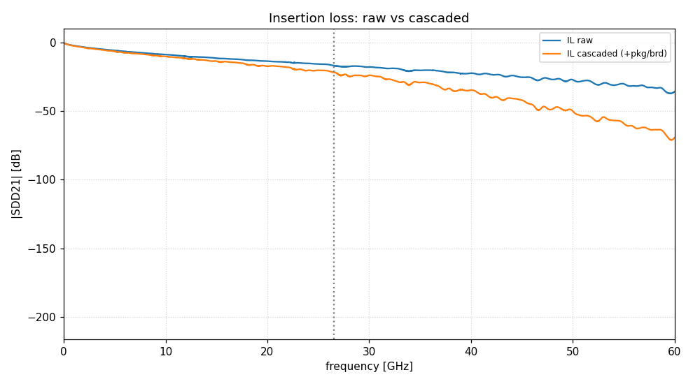
Figure 1. Channel insertion loss. The first thing to check when a result looks wrong: if the channel is not what you think it is, nothing downstream is meaningful.
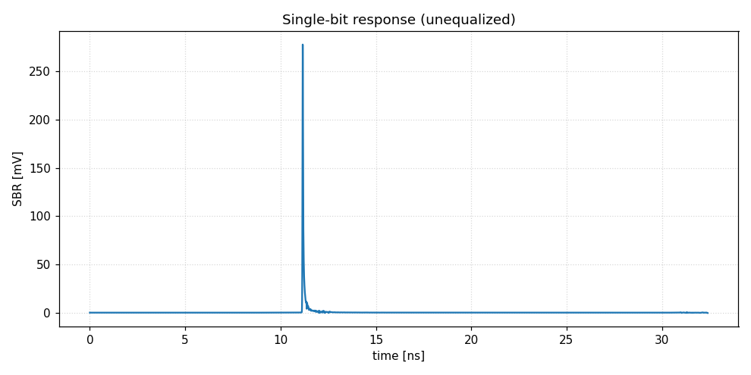
Figure 2. Single-bit (pulse) response. The cursor, pre-cursor and post-cursor ISI visible here are what the equalizer chain is working against.
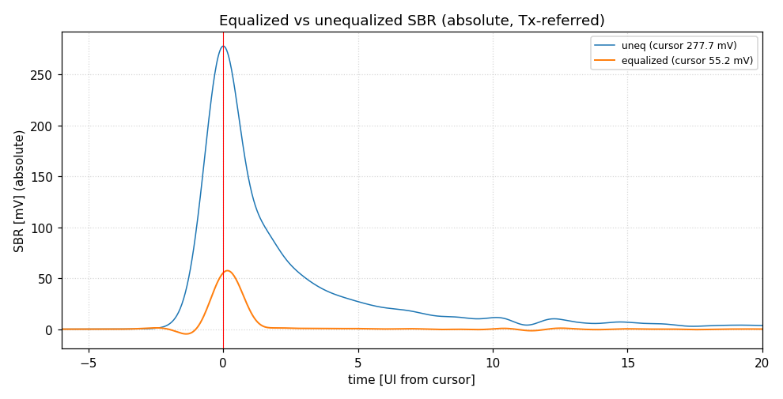
Figure 3. Equalized versus unequalized pulse response — the effect of the winning TX-FFE / CTLE / DFE setting.
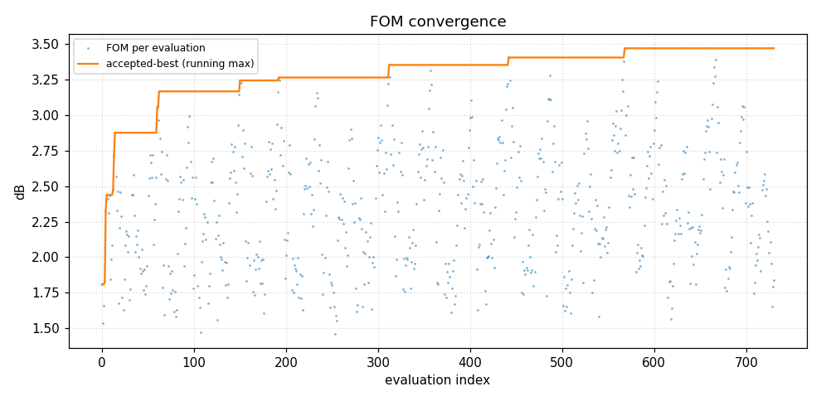
Figure 4. FOM through the equalizer search. Chapter 8 is, in effect, an investigation of how much of this search is actually necessary.
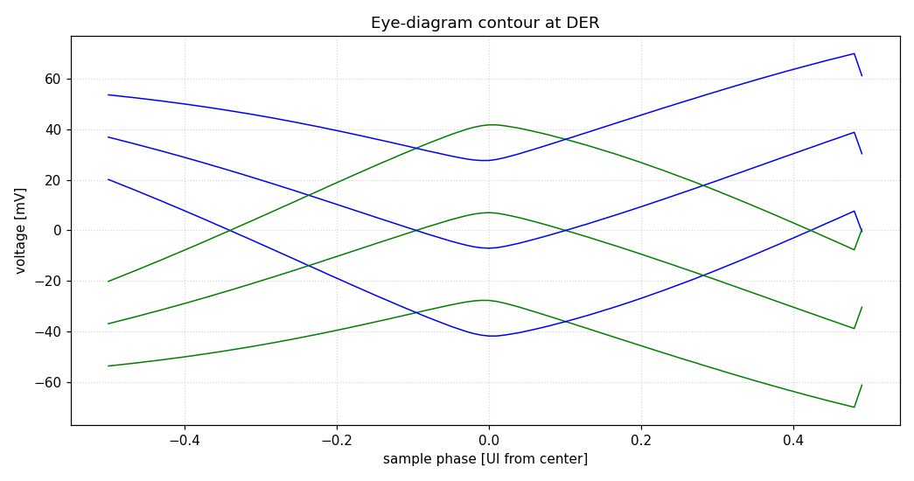
Figure 5. Statistical eye contour at the target BER.
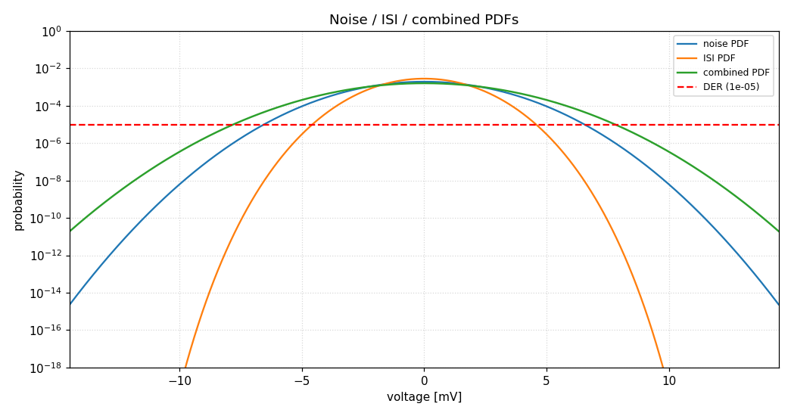
Figure 6. Noise and interference probability densities. COM is derived from the tail of the combined distribution, which is why a Gaussian approximation is not sufficient.
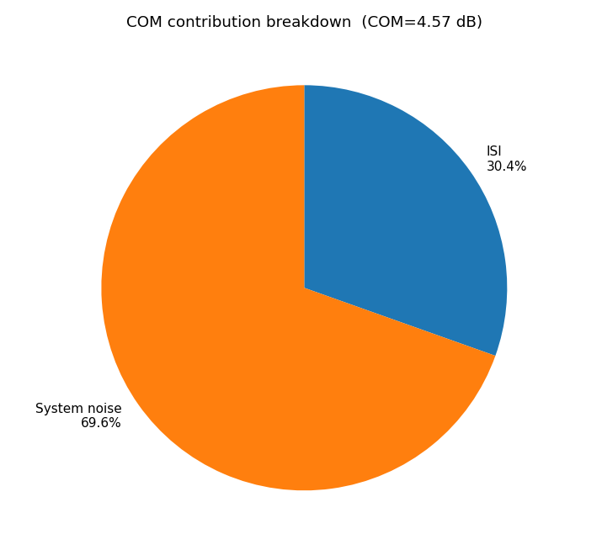
Figure 7. Contribution breakdown — where the margin is being spent.

7.4 Engineering .mat export
Adding --export-mat writes a MATLAB v5 snapshot per case alongside the standard outputs. It is an additive debug export: it changes no COM result, report or figure.
It captures the intermediate quantities the run already computed:
- Frequency-domain equalizer chain H_channel, H_ctle, H_ch_ctle, H_ffe, H_tx, H_final, plus crosstalk H_next / H_fext.
- Time domain per-stage impulse and pulse responses.
- Statistics the eye/BER contour and the combined and component noise PDF/CDF.
- Metrics and provenance all COM metrics, a self-describing config struct, and run metadata including timestamp, versions and input files.
It also adds FOM_gauss_dB — the COM you would get if the combined interference-plus-noise distribution were purely Gaussian. The gap to COM_dB quantifies the non-Gaussian tail penalty.
What is measured versus what is reconstructed
H_channel, H_ctle and H_ch_ctle are genuine captured responses. H_ffe is evaluated from the selected TX-FFE taps, and H_tx / H_final are their products. DFE is a time-domain term and is deliberately absent from the FD chain. Each file records this in meta.notes.

8 The equalizer-search study
The optimiser must choose a TX-FFE / CTLE / DFE setting before COM can be evaluated. Doing that exhaustively is expensive, so the tool offers pruned alternatives. Whether pruning changes the answer is a question worth settling with measurement rather than assumption, and this chapter is the tooling built to settle it.

8.1 Three search methods
Method | Configuration | Behaviour
Full grid | Local Search = 0 | Exhaustive. The reference answer.
Legacy local search | Local Search = N, Non-zero Local Search Method = 0 | Prunes candidates outside a fixed radius of the current best.
Adaptive local search | Local Search = N, Non-zero Local Search Method = 1 | Radius grows and shrinks with recent FOM improvement; prunes on a weighted L1/L2 tap-space distance from the current best.

8.2 Why FOM is not the whole story
The search optimises FOM. The pass/fail criterion is COM.
COM is deliberately not computed during the search — evaluating it per candidate would mean the full PDF/CDF convolution on every grid point. It is evaluated once at the end, from the winning setting. FOM is therefore a proxy, and any pruning method is safe only to the extent that COM is flat across the top of the FOM surface.

That makes two separate questions, and the tooling answers both:
- Does pruning change COM? Compare methods on the same channel — Section 8.3.
- Is FOM a faithful proxy for COM at all? Recompute true COM for the top-K candidates by FOM — Section 8.4. This cost is paid by every method, including the exhaustive grid.

8.3 Comparing methods on one channel
python tools/sweep_compare.py <config.xlsx> <thru.s4p> \
--local-search 2 --max-ctle 3 --max-tap-vals 3
The --max-ctle and --max-tap-vals options shrink the grid so the exhaustive reference stays tractable; they must be identical across anything you intend to compare. Output lands in sweep_results/:
File | Contents
full_grid_log.csv, legacy_log.csv, adaptive_log.csv | per-candidate trajectory, one row per TX-FFE candidate considered
adaptive_radius_log.csv | adaptive-search internals per iteration
summary.json | per-method COM, best FOM, evaluated/skipped counts, speedup, the winning EQ point, and whether each method matched the full grid

8.4 Recomputing true COM near the optimum
python tools/fom_com_probe.py <config.xlsx> <thru.s4p> \
--sweep-dir sweep_results --top-k 20
This takes the top-K candidates by FOM, pins the search to each one in turn, and computes its actual COM. It reports the rank correlation between FOM and COM, and the COM regret — how much COM is given up by trusting the FOM ranking.
Use at least K = 20
With small K the Spearman correlation can only take a handful of values and carries almost no information. K = 20 is what produces a trustworthy coefficient.

8.5 Running a corpus
A single channel can only ever say "no difference here". A distribution needs many channels, which is what the corpus driver produces.
# estimate cost and list channels without running anything
python tools/corpus_sweep.py <config.xlsx> --channel-dir <dir> --dry-run
# run it
python tools/corpus_sweep.py <config.xlsx> --channel-dir <dir>
# re-aggregate existing results without recomputing
python tools/corpus_sweep.py --aggregate-only --out corpus_results
Option | Effect
--methods full_grid,adaptive | drop legacy; saves roughly 40% of the time
--probe-top-k N | per-channel probe depth; 0 skips the proxy measurement
--crosstalk | include matching FEXT/NEXT files per channel
--threshold 3.0 | the pass/fail level used for flip detection
--limit N | only the first N channels
--force | re-run channels already complete

Runs are checkpointed per channel, so an interrupted corpus resumes rather than restarting, and a channel that fails is logged and skipped rather than killing a multi-hour run. Expect roughly an hour per channel for all three methods at a realistic grid size.

What it reports
The aggregation deliberately leads with the tail rather than the mean. A good average proves little; a single channel that turns a passing margin into a failing one would sink a proposal.
- Delta COM distribution median, P95 and maximum absolute deviation from the full grid, plus a count of channels that matched exactly.
- Operating point agreement how many channels selected the identical EQ setting, not merely a similar score.
- Pass/fail flips channels where a pruned method lands on the opposite side of the threshold from the exhaustive grid. Reported with the channel named.
- Regret and rank correlation the FOM-as-proxy cost, per channel and aggregated.

8.6 Results to date
Seven channels spanning 100–1400 mm, three methods, at a reduced but consistent grid:
Metric | Adaptive | Legacy
Channels with COM identical to full grid | 7 / 7 | 7 / 7
Maximum |delta COM| | 0.000000 dB | 0.000000 dB
Same winning EQ operating point | 7 / 7 | 7 / 7
Median speedup | 12.9x | 1.27x
Speedup range | 11.75 – 15.10x | 1.19 – 1.40x
Grid actually evaluated | ~7% | ~81%
Pass/fail flips at 3 dB | none | none
Table 3. Corpus result, August 2026. Delta COM is exactly zero — identical to all 17 significant digits, not merely small.
The winning EQ setting moves with channel length across the corpus, so the agreement is not an artifact of a constant answer: the pruned search tracks a genuinely shifting optimum while skipping most of the work.
Corroborated since on a second, independent corpus. Nine channels spanning all four families — chosen to include every case where this implementation and MATLAB pick a different sampling phase, i.e. the hardest available — were run against an exhaustive full grid. Adaptive local search was bit-identical on FOM, COM and sampling phase, 9 of 9, and the sanity check FOM(full grid) >= FOM(adaptive) holds 9/9. Two figures in this paragraph have since moved and are quoted here only as the state at the time: the runtime saving was then a median 113x, but the later engine optimisation (§11.1) sped the full grid up more than the pruned search, so the honest current figure is about 13x; and the sampling-phase divergences this corpus was built to probe were subsequently root-caused to a Tx FFE search-space mismatch between the two engines, not to pruning. The result that pruning is not responsible stands — it was simply not the whole answer.

The proxy measurement
Metric | Value
Spearman rho (FOM, COM), range across channels | 0.770 – 0.952
Channels where the FOM winner is also the COM winner | 7 / 7
Median COM regret | 0.000000 dB
Maximum COM regret | 0.000000 dB
True COM optimum found at FOM rank, every channel | 1

A correction, and what it teaches
An earlier version of this table reported a maximum regret of 0.035892 dB, the FOM winner losing on 2 of 7 channels, and rho spanning 0.60–0.81 — and concluded that the regret was the unavoidable cost of using FOM as the objective at all. That conclusion was wrong. Those numbers came from a run that predates the engine defects the MATLAB correlation later found and fixed; regenerated on the corrected engine, the regret is zero on every channel and the FOM argmax is the COM argmax every time. The regret was substantially an artifact of the defects, not a property of FOM. What survives is narrower: rho never reaches 1, so the FOM ordering is imperfect deeper down the list — but a FOM-driven search only uses the top of it, and there the two agree.

What this does not establish
One channel family (same topology, varying only cable length), one configuration, thru-only. These are correlated samples, not seven independent channels. The pass/fail flip test is also weakly exercised, though the reason has inverted: on the pre-fix engine six of the seven failed COM, so almost nothing sat near the threshold; on the corrected engine all seven pass, spanning 4.45–6.72 dB, so almost nothing sits near it from the other side. Either way this corpus contains no boundary cases, and "no flips" is reassuring rather than conclusive.

8.7 Diagnosing history dependence
tools/hist_dep_repro.py solves one operating point twice — once with a single candidate evaluated, once with many — and diffs the complete engine state at the moment COM computation begins. If COM ever appears to depend on how many candidates the search happened to visit, this is the tool that localises it.
A COM value that changes with search history rather than with the selected operating point is a serious defect: it makes results depend on a path that is invisible in the answer. This harness exists because that class of problem is otherwise very hard to see.

9 The R reporting layer
Three R scripts turn the outputs into interactive HTML. All use plotly, so every point is hoverable — which matters when the question is "what exact equalizer setting produced that point?".
install.packages(c("plotly", "htmltools", "jsonlite", "R.matlab"))

9.1 Single-run engineering dashboard
Rscript R/com_analysis.R results/<...>/<config-name>_case01.mat
Consumes the --export-mat snapshot and produces a single HTML page covering the channel frequency response, the CTLE bank and the selected CTLE, impulse and pulse responses, the statistical eye with BER density, the equalizer contribution breakdown, and collapsible tables of the full results and configuration.
This is the tool for understanding one run in depth.

9.2 Single-channel search comparison
Rscript R/sweep_compare.R sweep_results
Reads the per-candidate logs and renders the search itself: best-so-far FOM against candidates evaluated, the winning sampling phase, TX-FFE tap-space coverage coloured by FOM, and parallel coordinates over all equalizer dimensions. Sections that need data a run did not produce degrade to an explanatory note rather than failing.
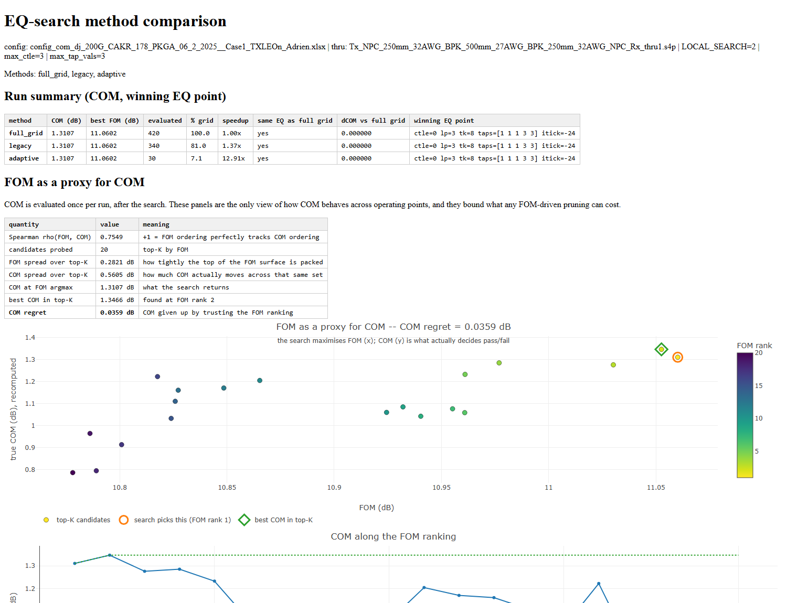
Figure 8. Single-channel report. The convergence and coverage panels answer whether a pruned method reached the same optimum, and which regions of tap space it never visited.

9.3 Corpus report
Rscript R/corpus_report.R corpus_results
The N-channel counterpart, organised around the two questions a reviewer actually asks: does pruning change COM, and how bad is the worst case.
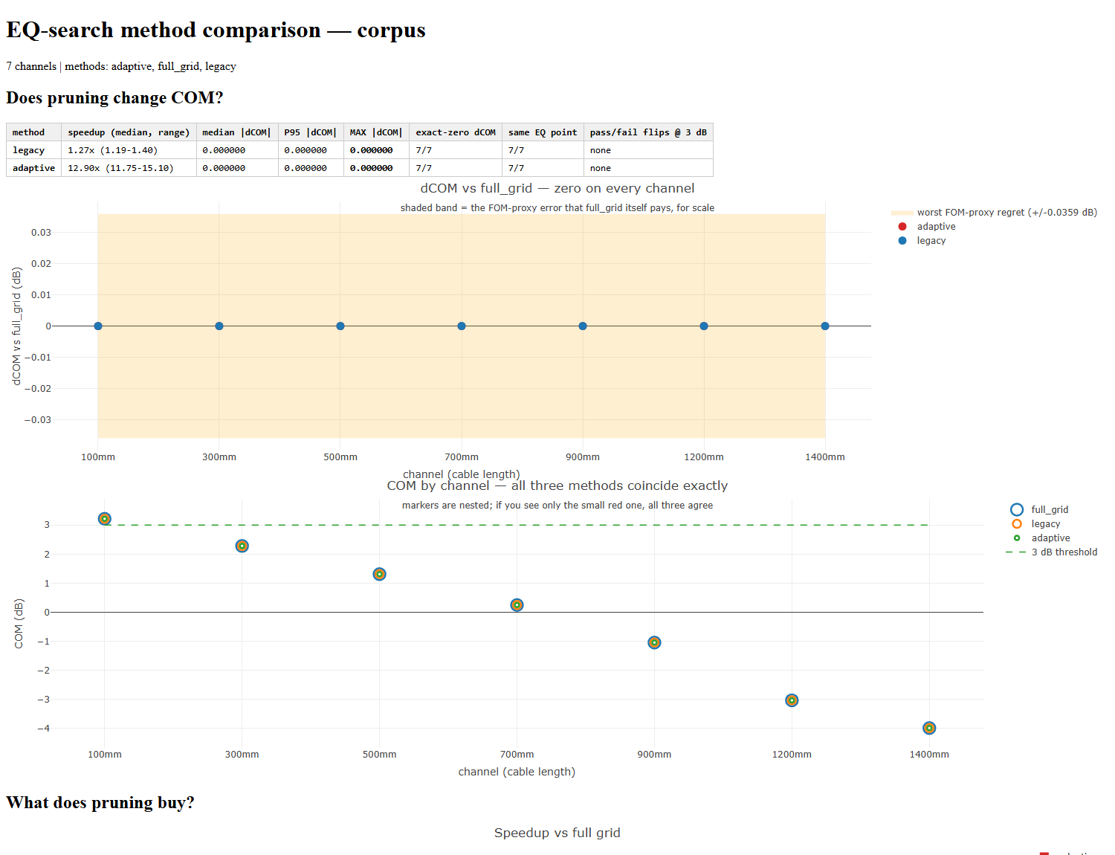
Figure 9. Corpus report. Two presentation problems are solved deliberately here: the delta-COM panel is banded at the FOM-proxy scale so that "exactly zero" is legible in context, and the COM-by-channel markers are nested so three coincident methods remain visible rather than hiding one another.

9.4 Building the review deck
python tools/build_pptx.py
Generates a slide deck from the corpus artifacts. Because it reads the result files rather than hard-coded values, re-running it after a new corpus updates every number in the deck automatically.

10 Development workflow

10.1 Changing behaviour
Never edit sicopr.py directly
It is generated. An edit there will be silently destroyed the next time anyone runs the assembler.

# 1. edit the per-function source
# com_functions/fn/<name>/py_impl.py
# 2. test that function alone
python -m pytest com_functions/fn/<name>/test_verify.py -q
# 3. regenerate the engine
python assemble_sicopr.py
# 4. run the full suite
python -m pytest com_functions/fn -q

10.2 The test suites
Suite | How to run | Notes
com_functions/fn | python -m pytest com_functions/fn -q | the main suite; 890 tests
tests/ | python tests/<name>.py | Mixed: test_smoke.py, test_checkpoints.py and test_end_to_end.py ARE pytest modules; every other file is a standalone script. Do not point pytest at the directory — the scripts call sys.exit() at import, so collection aborts, pytest reports "no tests ran" AND STILL EXITS 0. Nothing runs and nothing complains.
everything | powershell -ExecutionPolicy Bypass -File tests/run_all.ps1 | The full harness, and what to run before committing: pre-flight audit, assembly, interface checks, unit tests, then every cross-check script. Dispatches both kinds of file above correctly. Current totals: 890 per-function tests, and 656 checks across 31 audit scripts with 25 accepted divergences.

10.3 Conventions worth knowing
Cross-cutting guards Four audit scripts guard defect classes the per-function tests cannot see, each built from a real failure and verified by re-introducing it. test_reference_leaks.py catches writes to a parameter the function never returns — MATLAB passes structs by value, Python by reference, and five of the eight engine defects were this class; it caught a new instance during the 4p16p0 port. test_inlined_copies.py compares each of the 178 inlined copies of 70 functions against its canonical version, because a fix to py_impl.py reaches only one of them. test_optimization_invariants.py pins what the speed work depends on and found a live cache-aliasing defect. test_matlab_stage_oracles.py holds 208 cases x 35 scalars plus 14 vector families taken from the reference workbooks — the only tests in the repo that assert against MATLAB rather than against Python.
- MATLAB line references Most functions carry a comment naming the MATLAB source lines they translate. Keep these accurate — they are how the port is reviewed.
- One-based versus zero-based Several structures hold MATLAB-style 1-based indices deliberately, to keep the translation legible. Convert at the point of use rather than changing what is stored, and check what a value already is before indexing with it.
- Value versus reference semantics MATLAB assigns structs by value; Python assigns references. Where the original relies on copy-on-assign, the port must copy explicitly. This class of difference does not surface in unit tests — and it proved to be the most damaging one in the port: five of the eight engine defects found by the 208-case MATLAB correlation were instances of it. The worst, a by-reference OP leak in process_sxp, let a TDR-only truncation threshold escape into every later stage and biased FOM low on 95.7% of cases while the whole unit suite stayed green.

11 Verification status and limitations

11.1 What has been verified
Every major feature is implemented and unit-tested against the MATLAB source: TX-FFE, CTLE, DFE, RX-FFE (MMSE), floating DFE and floating RX-FFE taps, MLSE, crosstalk (FEXT/NEXT and ICN), common-mode modal masks, receiver calibration, frequency-domain processing, ERL/TDR, and TD-ILN/RILN. The unit suite is green at 890 tests, and the 802.3ck configuration runs end to end once its workbook and channel are in place.
A structured conversion audit classified all 157 MATLAB functions (146 equivalent, 11 divergent; docs/AUDIT_FINDINGS.md). That audit is necessary but was not sufficient: the largest defect in the port — the process_sxp reference leak — was not in its ledger, and one EQUIVALENT verdict was later proven wrong. Treat its verdicts as evidence rather than proof.
Correlation against the MATLAB reference is the primary numeric evidence: 208 cases from com_ieee8023_4p15p0, across four channel families, with and without crosstalk. Run on the configurations exactly as supplied, FOM is bit-exact on 198 of 208, COM on 199, the sampling tick on 200, with max |ΔCOM| 0.185 dB. Run with each crosstalk condition on the settings its own reference was produced with (see §11.2), FOM, COM and the sampling tick are ALL bit-exact on 208 of 208, with max |ΔCOM| = 3.3e-14 dB — double-precision noise rather than agreement to a tolerance — and no pass/fail disagreements. Fifteen engine-level defects were found and fixed by this exercise, none of which the unit suite could see. The largest single class is MATLAB-by-value versus Python-by-reference (six of the fifteen); the last one closed was a banker's-rounding tie that dropped a single ISI sample. Detail in MATLAB_Correlation_Review.md.
MATLAB version support The engine emulates com_ieee8023_4p15p0 by default, and that default is deliberate: the 208 reference workbooks are 4p15p0 output, so it is the version the parity result above is evidence for. Pass --matlab-version 4p16p0 (or set sicopr.COM_MATLAB_VERSION, or a COM Version keyword in the config) to emulate the newer release. 4p16p0 is a small delta — 146 of 152 function bodies unchanged, 6 changed, 3 added, none removed — and the three additions are the adaptive local search, now adopted into the released mainline rather than living in a branch.
Measured 4p16p0 impact The same 208 cases have been run in both modes. 210 of 213 output columns are identical on every case, and no COM, FOM, VEO, VEC, itick or ERL value moves. Two columns change: peak_uneq_pulse_mV and steady_state_voltage_mV are now multiplied by the channel amplitude A, which 4p15p0 applied to the impulse response but not to the pulse response built from it — the new values are the corrected ones. Two further changes the corpus could not reach were measured separately on a config with a 1584-point Tx FFE grid: the Clip Method default moving from Fast to Slow shifts COM by about +0.007 dB and FOM by +0.22 dB, but only for configs that omit the keyword; and the adaptive search minimum radius moving from 1 to 2 gives a bit-identical answer while evaluating 4.3x the candidates. Detail in docs/MATLAB_4p16p0_CHANGES.md and docs/MATLAB_4p16p0_IMPACT.md.
The engine was subsequently optimised to roughly 4.5-5x its previous speed (208-case corpus: 16.1 h of CPU time down to about 3.5 h, versus 14.4 h for the MATLAB reference on its own machine). Accuracy was the gate: every reported COM, VEO and VEC value is bit-identical before and after, verified by re-running the full corpus after each change rather than sampling. Measurement noise on this machine is about 13%, so treat the multiplier as approximate.

11.2 Limitations
End-to-end MATLAB cross-check: done
208 reference cases from Hansel D’silva’s com_ieee8023_4p15p0 runs were compared case by case. FOM is bit-exact on 198/208, COM on 135/208, and the sampling phase on 200/208; max |delta COM| is 0.176 dB and rms 0.019 dB, with 2 pass/fail disagreements, both within 0.02 dB of the threshold. Eight engine defects were found and fixed in the process. Reproduce with tools/matlab_compare.py; the write-up is MATLAB_Correlation_Review.md.

- Coverage of end-to-end paths Only the C2M TX-FFE/CTLE/DFE path is exercised end to end by a real configuration. The remaining features are implemented and unit-tested but not covered by an end-to-end run.
- Results predating August 2026 The fifteen engine fixes of August 2026 changed COM materially — the largest removed a systematic FOM bias affecting 95.7% of cases. On the 802.3ck configuration the shift is about 0.1 dB (Case 1 3.5664 → 3.4694 dB), enough to move Case 2 from PASS to FAIL. Regenerate rather than comparing against archived output.
- Reference configuration is partly reconstructed The strongest parity result (§11.1) pairs the with-crosstalk condition with a swept Tx FFE grid and adaptive minimum radius 2. That is a reconstruction inferred from the reference output, not a configuration that was supplied: the two reference workbooks were evidently produced with different Tx FFE settings, and only the without-crosstalk one was sent. It is supported by reproducing MATLAB’s tap vector, sampling phase and FOM on all ten cases that diverged under the supplied config, and by a 2x2 control in which each condition is near-exact on its own settings and materially worse on the other’s. Open question with the MATLAB author; report both the as-supplied and the settings-aligned figures.
- Residual in the COM PDF path Closed. The systematic bias was an off-by-one in the ADC-clip sampling phase (docs/COM_PDF_RESIDUAL.md); the last remaining case, wXtalk_T4_R10 at +0.0076 dB, was a separate defect — Python's round() is banker's rounding where MATLAB's rounds half away from zero, and nui = round(len/M) in get_pdf landed on a tie, dropping one ISI sample. With both fixed, COM is bit-exact on all 208 settings-aligned cases.
- FFE_OPT_METHOD = 'WIENER-HOPF' Intentionally non-functional; its helper is undefined in the MATLAB reference. Use MMSE.
- FAST_NOISE_CONV A speed approximation that lumps small noise taps into a single Gaussian. The exact path is the default and is recommended for reported results.
- GUI file pickers Not ported. File lists are always passed on the command line.
- Adaptive-search constants The adaptive method carries about ten hand-tuned values — shrink factors, distance weights, the L2/L1 ratio, the CTLE window — whose provenance is not documented in the source. Expect this to be asked about.

Appendix A COM concepts
A short refresher for readers who are new to the methodology. Experienced SerDes engineers can skip this.

A.1 What COM measures
COM expresses, in decibels, the ratio between the available signal amplitude and the total impairment amplitude at the decision point, evaluated at a target bit error ratio. Above the threshold — conventionally 3 dB — the channel is deemed able to support the link.
COM = 20 * log10( A_signal / A_noise_and_interference )
The denominator is not a simple RMS sum. It is derived from the tail of a convolved probability distribution combining residual inter-symbol interference, crosstalk, jitter-induced noise and receiver noise. That is why a Gaussian approximation understates the impairment, and why the calculation is expensive.

A.2 The equalizer chain
Stage | Where | What it does
TX FFE | transmitter | pre-distorts the launched pulse to counter downstream loss; taps are swept over a configured grid
CTLE | receiver, analog | continuous-time linear boost, selected from a bank of gain/pole/zero settings
RX FFE | receiver, digital | feed-forward equalization, tap values solved rather than swept
DFE | receiver, digital | cancels post-cursor ISI using already-decided symbols; cannot help with pre-cursor ISI
MLSE | receiver, digital | sequence estimation applied after the main evaluation

A.3 FOM versus COM
Searching the equalizer space directly on COM is impractical, because each evaluation requires the full statistical convolution. The tool therefore optimises a cheaper figure of merit and computes COM once, at the end, for the winning setting.
This substitution is the reason Chapter 8 exists. FOM is a proxy, and the measured rank correlation between FOM and COM across channels runs between 0.60 and 0.81 — informative, but not faithful.

A.4 Reading a result
- COM_dB the margin. Compared against COM Pass threshold.
- VEO / VEC vertical eye opening and closure; C2M configurations gate on these in addition to COM.
- ICN integrated crosstalk noise. Zero when no aggressor files were supplied — which means a run without crosstalk is not a crosstalk-free result, it is an unevaluated one.
- Package cases a configuration may define several; each is solved and reported independently, and all must pass.

Appendix B Complete configuration parameter index
Every keyword the engine reads from the configuration spreadsheet, extracted directly from the source so that it cannot drift from the implementation. Grouped by function; within each group, alphabetical.
Mandatory keywords have no default: the run stops if they are absent from the sheet. Everything else falls back to the listed Default, so an absent row and a row set to that value behave identically. Attribute is where the value lands internally — search for it when tracing behaviour through the code. A * in the Eval column means a text cell is evaluated as a MATLAB expression, so entries such as [1 3 2 4] or 1e9*[1:5] are accepted.
Mandatory keywords are listed first within their group and marked in bold.

Signalling & test limits (23)
Spreadsheet keyword | Default | Eval | Attribute
● DER_0 | MANDATORY |  | param.specBER
● f_b | MANDATORY |  | param.fb
● L | MANDATORY |  | param.levels
CDR | 'MM' |  | OP.CDR
Clip Method | 'Fast' |  | param.clip_method
COM Pass threshold | 0 |  | param.pass_threshold
DER_CDR | 1e-2 | * | param.DER_CDR
EH_max | np.inf | * | param.Max_VEO
EH_min | 0 | * | param.Min_VEO
EH_min_test | 0 | * | param.Min_VEO_Test
ERL Pass threshold | 0 |  | param.ERL_pass_threshold
M | 32 | * | param.samples_per_ui
Max burst length calculated | 0 |  | OP.nburst
Min_VEO_Test | param.Min_VEO_Test | * | param.Min_VEO_Test
PHY | OP.PMD_type |  | OP.PHY
PMD_type | 'C2C' |  | OP.PMD_type
Sigma BBN step | 5e-3 |  | OP.sigma_bn_STEP
T_h | param.T_O | * | param.T_O
T_O | 0 | * | param.T_O
T_r | 8e-3 | * | OP.transmitter_transition_time
T_r_filter_type | 0 |  | OP.T_r_filter_type
T_r_meas_point | 0 |  | OP.T_r_meas_point
VEC Pass threshold | 0 |  | param.VEC_pass_threshold

EQ search control (5)
Spreadsheet keyword | Default | Eval | Attribute
Local Search | 0 | * | param.LOCAL_SEARCH
Non-zero Local Search Method | 0 | * | param.NonZeroLSMethod
Optimize_loop_speed_up | 0 | * | OP.Optimize_loop_speed_up
sample_adjustment | [0, 0] | * | param.ts_sample_adj_range
TS_SRCH_MODE | 'full-sweep' |  | OP.TS_SRCH_MODE

Equalization — TX FFE (12)
Spreadsheet keyword | Default | Eval | Attribute
● c(0) | MANDATORY |  | param.tx_ffe_c0_min
c(-1) | 0 | * | param.tx_ffe_cm1_values
c(-2) | 0 | * | param.tx_ffe_cm2_values
c(-3) | 0 | * | param.tx_ffe_cm3_values
c(-4) | 0 | * | param.tx_ffe_cm4_values
c(1) | 0 | * | param.tx_ffe_cp1_values
c(2) | 0 | * | param.tx_ffe_cp2_values
c(3) | 0 | * | param.tx_ffe_cp3_values
crusor_gain | 0 | * | param.cursor_gain
Dynamic TXFFE | 1 |  | OP.dynamic_txffe
ffe_main_cursor_min | 1 | * | param.ffe_main_cursor_min
preset_txffe | [] | * | preset_txffe

Equalization — CTLE (14)
Spreadsheet keyword | Default | Eval | Attribute
● g_DC | MANDATORY | * | param.ctle_gdc_values
CTLE_type | 'CL93' |  | param.CTLE_type
f_hp | 0 | * | param.f_hp
f_HP_P | [] | * | —
f_HP_PZ | [] | * | —
f_HP_Z | [] | * | —
f_z | param.fb / 4 / 1e9 | * | —
G2_Qual | [] | * | g2qual_raw
g_DC_HP | [] | * | param.g_DC_HP_values
G_Qual | [] | * | gqual_raw
GDC_MIN | 0 | * | param.GDC_MIN
INCLUDE_CTLE | 1 |  | OP.INCLUDE_CTLE
kappa1 | 1 | * | param.kappa1
kappa2 | 1 | * | param.kappa2

Equalization — DFE & MLSE (14)
Spreadsheet keyword | Default | Eval | Attribute
● N_b | MANDATORY |  | param.ndfe
B_float_RSS_MAX | 0 | * | param.B_float_RSS_MAX
b_max(2..N_b) | 0.2 | * | bmax2
b_min(1) | -param.bmax[0] | * | bmin1
b_min(2..N_b) | -float(bmax2_arr[0]) | * | bmin2
bmaxg | 0.2 | * | param.bmaxg
FloatingDFE_Development | 1 |  | OP.FloatingDFE_Development
LIMIT_JITTER_CONTRIB_TO_DFE_SPAN | False |  | OP.LIMIT_JITTER_CONTRIB_TO_DFE_SPAN
MLSE | OP.MLSD |  | OP.MLSE
N_b_step | 0 | * | param.dfe_delta
N_bf | 6 | * | param.N_bf
N_bg | 0 | * | param.N_bg
N_bmax | param.ndfe | * | param.N_bmax
N_f | param.ndfe | * | param.N_bmax

Equalization — RX FFE (10)
Spreadsheet keyword | Default | Eval | Attribute
ffe_backoff | 0 | * | param.ffe_backoff
FFE_OPT_METHOD | 'MMSE' |  | OP.FFE_OPT_METHOD
ffe_post_tap1_max | 0.7 | * | param.ffe_post_tap1_max
ffe_post_tap_len | 0 | * | param.ffe_post_tap_len
ffe_pre_tap1_max | 0.7 | * | param.ffe_pre_tap1_max
ffe_pre_tap_len | 0 | * | param.ffe_pre_tap_len
ffe_tap_step_size | 0 | * | param.ffe_tap_step_size
ffe_tapn_max | 0.7 | * | param.ffe_tapn_max
RXFFE FLOAT CTL | 'FOM' |  | OP.RXFFE_FLOAT_CTL
RXFFE TAP CONSTRAINT | 'Unity Cursor' |  | OP.RXFFE_TAP_CONSTRAINT

Receiver filter & windowing (11)
Spreadsheet keyword | Default | Eval | Attribute
Bessel_Thomson | False |  | OP.Bessel_Thomson
BTorder | 4 |  | param.BTorder
Butterworth | 1 |  | OP.Butterworth
f_r | 4 | * | param.f_r
INCLUDE_TX_RX_FILTER | 1 |  | OP.INCLUDE_FILTER
RC_end | param.fb * param.f_r |  | param.RC_end
RC_Start | param.fb / 2 |  | param.RC_Start
TDR_Butterworth | True |  | OP.TDR_Butterworth
Tukey_Window | 0 | * | param.Tukey_Window
ZERO_PAD | 0 |  | OP.ZERO_PAD
zero_pad_tukey_window_in_fb | 0 | * | param.zero_pad_tukey_window_in_fb

Noise, jitter & crosstalk (19)
Spreadsheet keyword | Default | Eval | Attribute
● A_DD | MANDATORY |  | param.A_DD
● eta_0 | MANDATORY |  | param.eta_0
● sigma_RJ | MANDATORY |  | param.sigma_RJ
A_fe | 0.5 | * | param.a_fext
A_ft | param.a_fext | * | param.a_icn_fext
A_ne | 0.5 | * | param.a_next
A_nt | param.a_next | * | param.a_icn_next
A_v | 0.5 | * | param.a_thru
AC_CM_RMS | 0 | * | param.AC_CM_RMS
ACCM_MAX_Freq | param.fb | * | param.ACCM_MAX_Freq
add_rx_noise | param.pass_threshold | * | param.add_rx_noise
Do_Colored_Noise | 1 |  | OP.Do_Colored_Noise
Do_White_Noise | 0 |  | OP.Do_White_Noise
Do_XT_Noise | 1 |  | OP.Do_XT_Noise
FFE_SNR | 1 |  | OP.FFE_SNR
Noise_Crest_Factor | 0 | * | param.Noise_Crest_Factor
num_ui_RXFF_noise | 2048 | * | param.num_ui_RXFF_noise
sigma_r | 0.020 | * | param.sigma_r
SNR_TXwC0 | 0 |  | OP.SNR_TXwC0

Package, die & termination (30)
Spreadsheet keyword | Default | Eval | Attribute
board_tl_gamma0_a1_a2 | np.array([0.0, 4.114e-4, 2.547e... | * | param.brd_gamma0_a1_a2
board_tl_tau | 6.191e-3 | * | param.brd_tau
board_Z_c | 109.8 | * | param.brd_Z_c
C_b | 0 | * | param.C_bump
C_d | 0 | * | param.C_diepad
C_p | 0 | * | param.C_pkg_board
C_v | 0 | * | param.C_v
D_p | 4 | * | param.D_p
IDEAL_RX_TERM | False |  | OP.IDEAL_RX_TERM
IDEAL_TX_TERM | False |  | OP.IDEAL_TX_TERM
imb_C_fctr | 1 | * | param.imb_C_fctr
imb_Z_fctr | 1 | * | param.imb_Z_fctr
INC_PACKAGE | True |  | OP.INC_PACKAGE
inc_reflect_board | 0 |  | OP.inc_reflect_board
L_s | 0 | * | param.L_comp
package_tl_gamma0_a1_a2 | np.array([0.0, 1.734e-3, 1.455e... | * | param.pkg_gamma0_a1_a2
package_tl_tau | 6.141e-3 | * | param.pkg_tau
package_Z_c | _default_Zc_str | * | raw_zc
PKG_NAME | '' |  | param.PKG_NAME
PKG_Tx_FFE_preset | 0 | * | param.PKG_Tx_FFE_preset
R_0 | 50 |  | param.Z0
R_d | [50, 50] | * | param.R_diepad
TDR_duration | 5 |  | OP.TDR_duration
TDR_W_TXPKG | 0 |  | OP.TDR_W_TXPKG
z_bp (FEXT) | 72 | * | param.z_bp_fext
z_bp (NEXT) | 72 | * | param.z_bp_next
z_bp (RX) | 151 | * | param.z_bp_rx
z_bp (TX) | 151 | * | param.z_bp_tx
z_p select | 1 | * | OP.pkg_len_select
Z_t | param.Z0 | * | param.Z_t

Channel / S-parameter handling (16)
Spreadsheet keyword | Default | Eval | Attribute
● Delta_f | MANDATORY |  | param.max_freq_step
● f_min | MANDATORY |  | param.max_start_freq
AUTO_TFX | 0 |  | OP.AUTO_TFX
Enforce Causality | 0 |  | OP.ENFORCE_CAUSALITY
Enforce Causality DIFF_TOL | 1e-3 |  | OP.EC_DIFF_TOL
Enforce Causality pulse start tolerance | 0.01 |  | OP.EC_PULSE_TOL
Enforce Causality REL_TOL | 1e-2 |  | OP.EC_REL_TOL
fixture delay time | -1 | * | param.tfx
flim | 1000e9 | * | param.flim
flip | 0 | * | param.flip
FORCE_TR | False |  | OP.FORCE_TR
fraction_of_F_range_start_extrap_from | 0.75 | * | OP.fraction_of_F_range_start_extrap_from
Port Order | [1, 3, 2, 4] | * | param.snpPortsOrder
Report_Modal_ERL | '0' |  | OP.Report_Modal_ERL
S-parameter magnitude extrapolation policy | 'linear_trend_to_DC' |  | OP.interp_sparam_mag
S-parameter phase extrapolation policy | 'extrap_cubic_to_dc_linear_to_inf' |  | OP.interp_sparam_phase

Frequency-domain metrics (ILD/ICN) (8)
Spreadsheet keyword | Default | Eval | Attribute
delta_IL | 1 |  | param.delta_IL
Display frequency domain | OP.GET_FD |  | OP.GET_FD
f_1 | param.max_start_freq / 1e9 | * | param.f1
f_2 | param.fb / 1e9 | * | param.f2
f_2_ILD | param.f2 / 1e9 | * | param.f2_ild
f_f | 4 | * | param.f_f
f_n | 4 | * | param.f_n
f_v | 4 | * | param.f_v

ERL / TDR / reflection (14)
Spreadsheet keyword | Default | Eval | Attribute
beta_x | 0 |  | param.beta_x
COMPUTE_RILN | 0 |  | OP.COMPUTE_RILN
COMPUTE_TDILN | OP.COMPUTE_RILN |  | OP.COMPUTE_TDILN
ERL | False |  | OP.ERL
ERL_FOM | 1 |  | OP.RL_norm_test
ERL_ONLY | 0 |  | OP.ERL_ONLY
Grr | param.Grr_limit |  | param.Grr
Grr_limit | 1 |  | param.Grr_limit
Gx | 0 |  | param.Gx
N_bx | param.ndfe | * | param.N_bx
rho_x | 0.618 |  | param.rho_x
TDR | False |  | OP.TDR
TDR_f_BT_3db | 0.4730 | * | param.fb_BT_cutoff
TR_TDR | 8e-3 | * | param.TR_TDR

Statistical / PDF construction (16)
Spreadsheet keyword | Default | Eval | Attribute
BBN Q factor | 5 |  | OP.BBN_Q_factor
Force BBN Q factor | False |  | OP.force_BBN_Q_factor
Force PDF bin size | 0 |  | OP.force_pdf_bin_size
Histogram_Window_Weight | 'rectangle' |  | OP.Histogram_Window_Weight
Impulse response truncation threshold | 1e-3 |  | OP.impulse_response_truncation_threshold
N_qb | 0 | * | param.N_qb
N_tail_start | 0 | * | param.N_tail_start
N_tc | param.trunc | * | param.trunc
P_peak | param.specBER | * | param.P_peak
P_qc | 2 * param.specBER | * | param.P_qc
PDF bin size | 1e-5 |  | OP.BinSize
Q | 0 | * | param.Q
Q_budget_adj | 0 | * | param.Q_budget_adj
QL | _ql_default | * | param.QL
Qr | param.sigma_r | * | param.Qr
trunc | 128 | * | param.trunc

Error propagation (3)
Spreadsheet keyword | Default | Eval | Attribute
Error propagation COM margin | 0 |  | OP.COM_EP_margin
MLSD | 0 |  | OP.MLSD
Use simple error propagation model | False |  | OP.use_simple_EP_model

RX calibration (4)
Spreadsheet keyword | Default | Eval | Attribute
● SNR_TX | MANDATORY | * | param.SNDR
PSDRXCAL | False |  | OP.PSDRXCAL
RX_CALIBRATION | False |  | OP.RX_CALIBRATION
SNDR_REF | 0 |  | OP.SNDR_REF

Skew (5)
Spreadsheet keyword | Default | Eval | Attribute
Rxnskew | 0 | * | param.Rxnskew
Rxpskew | 0 | * | param.Rxpskew
skew_ps | 0 | * | param.skew_ps
Txnskew | 0 | * | param.Txnskew
Txpskew | 0 | * | param.Txpskew

Output, reporting & execution (28)
Spreadsheet keyword | Default | Eval | Attribute
BREAD_CRUMBS | False |  | OP.BREAD_CRUMBS
BREAD_CRUMBS_FIELDS | '' |  | OP.BREAD_CRUMBS_FIELDS
CM_MASK_REPORT | 0 |  | OP.CM_MASK_REPORT
COM_CONTRIBUTION | 0 |  | OP.COM_CONTRIBUTION_CURVES
CSV_REPORT | True |  | OP.CSV_REPORT
DIAGNOSTICS | False |  | OP.DEBUG
DISPLAY_WINDOW | True |  | OP.DISPLAY_WINDOW
DO_NOT_COMPUTE_COM | 0 |  | OP.DO_NOT_COMPUTE_COM
EW | False |  | OP.EW
EXE_MODE | 1 |  | OP.EXE_MODE
exit if deployed | 0 |  | OP.exit_if_deployed
FT_COOP | False |  | OP.FT_COOP
NO_COM | OP.DO_NOT_COMPUTE_COM |  | OP.DO_NOT_COMPUTE_COM
PLOT_CM | 0 |  | OP.PLOT_CM
RESULT_DIR | '' |  | result_dir
RIT_REF_PTR | 'clause_179' |  | OP.RIT_REF_PTR
RUNTAG | '' |  | OP.RUNTAG
SAVE_CONFIG2MAT | 0 |  | OP.SAVE_CONFIG2MAT
SAVE_FIGURE_to_CSV | False |  | OP.SAVE_FIGURE_to_CSV
SAVE_FIGURES | False |  | OP.SAVE_FIGURES
SAVE_KEYWORD_FILE | 0 |  | OP.SAVE_KEYWORD_FILE
SAVE_TD | False |  | OP.SAVE_TD
SHOW_BRD | 0 |  | OP.SHOW_BRD
TDECQ | 0 |  | OP.TDECQ
TDMODE | OP.TDMODE |  | OP.TDMODE
TIME_AXIS | 'UI' |  | OP.TIME_AXIS
TIMESTAMP | 0 |  | OP.TIMESTAMP
WRITE_CSV_TRANSPOSED | 0 |  | OP.WRITE_CSV_TRANSPOSED

Other / advanced (15)
Spreadsheet keyword | Default | Eval | Attribute
● b_max(1) | MANDATORY |  | —
● Include PCB | MANDATORY |  | OP.include_pcb
● R_LM | MANDATORY |  | param.R_LM
f_p1 | param.fb / 4 / 1e9 | * | —
f_p2 | param.fb / 1e9 | * | —
N | 0 |  | OP.N
N_p | 400 | * | param.N_p
N_v | param.ndfe | * | param.N_v
Raised_Cosine | 0 |  | OP.Raised_Cosine
S_tn_w_AM | 0 |  | param.S_tn_w_AM
samples_for_C2M | 100 | * | param.samples_for_C2M
T_k | 0.6 |  | OP.T_k
ts_anchor | 0 | * | param.ts_anchor
USE_ETA0_PSD | 0 |  | OP.USE_ETA0_PSD
WC_PORTZ | False |  | OP.WC_PORTZ

247 of the engine’s 249 keywords, 15 of them mandatory (marked ●).

Appendix C Command reference

C.1 Running COM
# basic run
python sicopr.py <config.xlsx> <thru.s4p>
# with crosstalk aggressors
python sicopr.py <config.xlsx> <thru.s4p> --fext f1.s4p f2.s4p --next n1.s4p
# with the engineering .mat snapshot for R analysis
python sicopr.py <config.xlsx> <thru.s4p> --export-mat
# emulate MATLAB 4p16p0 instead of the 4p15p0 default
python sicopr.py <config.xlsx> <thru.s4p> --matlab-version 4p16p0
# eye contour + timing bathtub even with MLSE on (plotting only)
python sicopr.py <config.xlsx> <thru.s4p> --export-mat --eye-under-mlse

C.2 The search study
# three methods on one channel
python tools/sweep_compare.py <config.xlsx> <thru.s4p> \
--local-search 2 --max-ctle 3 --max-tap-vals 3
# true COM for the top-20 FOM candidates
python tools/fom_com_probe.py <config.xlsx> <thru.s4p> \
--sweep-dir sweep_results --top-k 20
# corpus: estimate first, then run
python tools/corpus_sweep.py <config.xlsx> --channel-dir <dir> --dry-run
python tools/corpus_sweep.py <config.xlsx> --channel-dir <dir>
# re-aggregate without recomputing
python tools/corpus_sweep.py --aggregate-only --out corpus_results
# diagnose COM that depends on search history
python tools/hist_dep_repro.py

C.3 Reports
Rscript R/com_analysis.R results/<...>/<name>_case01.mat # single run, from .mat
Rscript R/sweep_compare.R sweep_results # one channel, 3 methods
Rscript R/corpus_report.R corpus_results # N channels
python tools/build_pptx.py # review deck
Rscript may not be on PATH. If it is not, invoke it by full path, for example "C:\Program Files\R\R-4.4.1\bin\Rscript.exe".

C.4 Development
python -m pytest com_functions/fn/<name>/test_verify.py -q # one function
python assemble_sicopr.py # regenerate sicopr.py
python -m pytest com_functions/fn -q # full suite (890)
python tests/<name>.py # standalone checks

