|  |  |  |  |  |
| --- | --- | --- | --- | --- |
| ERDC/CHL TR/SR/CR-21-?? |  |  | ERDC-CastleLogo1 | |
|  |  | Navigation Systems (NavSys) Research Program  Encouraging USACE Implementation of ECA using Pre-ECA Screening Tool and Fracture Resistance Screening Tool | |
| Coastal and Hydraulics Laboratory |  |  | Travis B. Fillmore | July 2021 |
|  |  | C:\Users\RDCHLTBF\AppData\Local\Microsoft\Windows\INetCache\Content.MSO\43EAA933.tmp | |
|  |  | Approved for public release; distribution is unlimited. | |

**The US Army Engineer Research and Development Center (ERDC)** solves the nation’s toughest engineering and environmental challenges. ERDC develops innovative solutions in civil and military engineering, geospatial sciences, water resources, and environmental sciences for the Army, the Department of Defense, civilian agencies, and our nation’s public good. Find out more at [www.erdc.usace.army.mil](http://www.erdc.usace.army.mil).

To search for other technical reports published by ERDC, visit the ERDC online library at <https://erdclibrary.on.worldcat.org/discovery>.

|  |  |
| --- | --- |
| Navigation Systems (NavSys) Research Project | ERDC/CHL TR/SR/CR-21-??  July 2021 |
| Encouraging USACE Implementation of ECA using Pre-ECA Screening Tool and Fracture Resistance Screening Tool | |
| Travis B. Fillmore  Coastal and Hydraulics Laboratory US Army Engineer Research and Development Center 3909 Halls Ferry Road Vicksburg, MS 39180-6199 | |
| Final report | |
| Approved for public release; distribution is unlimited. | |
| Prepared for Headquarts, U.S. Army Corps of Engineers Washington, D.C. 20314-1000  Under Project ####, “Project Title” | |

Abstract

**DISCLAIMER:** The contents of this report are not to be used for advertising, publication, or promotional purposes. Citation of trade names does not constitute an official endorsement or approval of the use of such commercial products. All product names and trademarks cited are the property of their respective owners. The findings of this report are not to be construed as an official Department of the Army position unless so designated by other authorized documents.

**DESTROY THIS REPORT WHEN NO LONGER NEEDED. DO NOT RETURN IT TO THE ORIGINATOR.**

The United States Army Corps of Engineers (USACE) manages a large inventory of hydraulic steel structures (HSS). These HSS are aging and upon inspection many show signs of damage including large discontinuities in their members, which threaten the HSS operation. Simply repairing every discontinuity will ensure continued HSS operation, but may be unnecessarily expensive. Therefore, USACE seeks to balance its constrained budget with safe reliable HSS operation.

One balancing method is the concept of fitness-for-service (FFS). In FFS, a discontinuity is evaluated using an acceptance criteria based on the principles of structural analysis and fracture mechanics called an engineering condition assessment (ECA) that decide whether it is “fit-for-service.” If a discontinuity is fit-for-service the HSS will continue regular operations while if it is not fit-for-service the discontinuity will be considered a defect and repaired.

However, the USACE has not widely adopted ECA. In the face of resource constraints, engineers often choose to conservatively repair without considering ECA. This report seeks to alleviate the difficulty in committing resources to an ECA in two ways: 1) by providing logical justification for performing an ECA and 2) reducing the resources necessary for analysis by providing a fracture resistance screening tool.

Contents

Abstract ii

Figures and Tables iv

Preface vi

1 Introduction 1

1.1 Background 2

1.2 Objectives 3

1.3 Approach 3

2 Pre-ECA Screening Tool to Justify Implementation of Engineering Critical Assessment on a Hydraulic Steel Structure 5

2.1 Practical Assessment of HSS Actions 7

2.1.1 Yes-No Procedures 10

2.2 Risk Assessment of HSS Actions 12

2.2.1 Likelihood of Failure Procedure 15

2.2.2 Consequence procedures 16

3 Fracture Resistance Screening Tool 19

3.1 Introduction 19

3.2 Methodology 20

3.3 Examples 25

3.3.1 Through-Thickness Discontinuity 25

3.3.2 Edge discontinuity 28

3.3.3 Surface discontinuity 30

4 Conclusions and Recommendations 40

4.1 Conclusions 40

4.2 Recommendations 40

5 References 41

Unit Conversion Factors 42

Report Documentation Page

Figures and Tables

Figures

Figure 1. Connectivity of figure flowcharts for screening tool 6

Figure 2. ECA Screening Tool Applied to Inspection/Planned outage or Changed Operating Conditions 7

Figure 3. Practical-based flowchart for doing nothing, performing ECA, or repairing 10

Figure 4. Determining if resources are available to do ECA 12

Figure 5. Determining if there is enough time to do FFS 12

Figure 6. Risk-based flowchart for ECA or repair 15

Figure 7. Estimating probability HSS fails FFS evaluation () 16

Figure 8. Calculating ECA cost ( of HSS 17

Figure 9. Calculating repair cost ( of HSS 17

Figure 10. Calculating financial consequence of failure ( of HSS 18

Figure 11. Discontinuity found to be fracture resistant fit-for-service 21

Figure 12. FAD cost function regions 23

Figure 13. FAD curve in dark blue and curves for component with constant loading and varying surface flaw length in legend 25

Figure 14. Edge discontinuity bending stress DLAD curve in dark blue, with points resulting from Error! Reference source not found. represented as black x’s. 25

Figure 15. Through-thickness discontinuity definition 26

Figure 16. Through-thickness discontinuity DLAD curve family covering all loading situations. HAZ 27

Figure 17. Through-thickness discontinuity DLAD curve family covering all loading situations. Not HAZ 28

Figure 18. Edge discontinuity definition 29

Figure 19. Edge discontinuity DLAD curve family covering all loading situations. HAZ 30

Figure 20. Edge discontinuity DLAD curve family covering all loading situations. Not HAZ 30

Figure 21. Surface discontinuity definition. 32

Figure 22. Surface discontinuity DLAD curve family with , covering all loading situations. HAZ 34

Figure 23. Surface discontinuity DLAD curve family with , covering all loading situations. Not HAZ 34

Figure 24. Surface discontinuity DLAD curve family with , covering all loading situations. HAZ 35

Figure 25. Surface discontinuity DLAD curve family with , covering all loading situations. Not HAZ 36

Figure 26. Surface discontinuity DLAD curve family with , covering all loading situations. HAZ 37

Figure 27. Surface discontinuity DLAD curve family with , covering all loading situations. Not HAZ 37

Figure 28. Surface discontinuity DLAD curve family with , covering all loading situations. HAZ 38

Figure 29. Surface discontinuity DLAD curve family with , covering all loading situations. Not HAZ 39

Tables

**No table of figures entries found.**

Preface

This study was conducted for the Headquarters, U.S. Army Corps of Engineers (HQUSACE) under the Navigation Systems (NavSys) Research Program. The technical monitor was Morgan Johnston.

The work was performed by the Harbors, Entrances, & Structures Branch of the Navigation Division, U.S. Army Engineer Research and Development Center, Coastal and Hydraulics Laboratory (ERDC-CHL). At the time of publication of this report, Chad Bounds was Branch Chief; Ashley Frey was Division Chief; and Charles E. Wiggins was the Technical Director for Civil Works. The Deputy Director of ERDC-CHL was Keith Flowers, and the Director was Ty Wamsley.

The Commander of ERDC was COL Teresa A. Schlosser, and the Director was Dr. David W. Pittman.

# Introduction

The United States Army Corps of Engineers (USACE) manages a large inventory of hydraulic steel structures (HSS) as part of flood-risk management and navigational infrastructure, two primary missions of USACE. These HSS are old and upon inspection many show signs of damage including large discontinuities in their members, which threaten the HSS operation. Simply repairing every discontinuity will ensure continued HSS operation, but may be unnecessarily expensive. Therefore, USACE seeks to balance its constrained budget with safe reliable HSS operation.

One powerful tool to meet this obligation is the concept of fitness-for-service (FFS). A discontinuity is evaluated using an acceptance criteria based on the principles of structural analysis and fracture mechanics called an engineering critical assessment (ECA) that decide whether it is “fit-for-service.” If a discontinuity is fit-for-service the HSS will continue regular operations while if it is not fit-for-service the discontinuity is considered a defect and will be repaired.

However, the USACE has not widely adopted ECA. Engineers often choose to conservatively repair without considering ECA. Often this choice may be fairly logical since many have no experience with ECA, would need training, and even with training an ECA takes time for analysis and resources for non-destructive testing (NDT) and material testing.

## Background

An ECA is the implementation of an acceptance criteria that is based on an analytical, computationally based process, employing the principles of structural analysis and fracture mechanics to the assessment of discontinuities to determine FFS. An ECA includes assessing all modes of failure (typically: strength, instability, fracture) and material damage mechanisms (typically: fatigue, corrosion) (BS7910 2013). FFS implies that a particular structure is suitable for continued service considering all the unique and inherent conditions applicable to that specific structure (i.e. loading, discontinuities, material, environment, etc.).

In this report discontinuities necessitate ECA’s to determine if a structure is FFS. A discontinuity is an interruption of the typical structure of a material, such as lack of homogeneity in its mechanical, metallurgical, or physical characteristics. A discontinuity is not necessarily a defect (AWS 2010). A defect is a discontinuity or discontinuities which, by nature or accumulated effect render a part or product unable to meet the minimum applicable standards or specifications. A defect designates rejectability.

HSS are intended to receive an in-depth inspection at the initiation of their lifecycle. Following this in-depth inspection, they must be visually inspected every five years unless dewatering is required, in which case they may be inspected up to every 25 years (USACE 2009). These inspections focus on fracture critical members. It is in the context of these scheduled inspections, or at any other time new information questioning FFS becomes available, that an ECA is performed.

To this end the USACE issued an engineering manual EM 1110-2-6054 for the inspection, evaluation, and repair of HSS which incorporates FFS (USACE 2001). USACE is currently developing updated guidance on this topic. The engineering manual references the British Standards Institution for several FFS methods (BSI 1980). The British Standards Institution has maintained and updated their FFS procedures to the present day resulting in the BS7910 (BS7910 2013) procedures often used in HSS when an ECA is performed (Dexter, et al. 2007).

Other FFS standards include FITNET (GKSS 2006), R6 (EDF Energy 2015), and API579 (ASME/API 2016). FITNET has been discontinued by the European Union and incorporated into BS7910. R6 is directed at the UK’s nuclear energy, but again BS7910 is consistently compared to R6 and needed modifications are made in BS7910. The API579 is very focused on pressure vessels but gives a fairly unique perspective from BS7910.

The BS7910 provides three options for assessment of fracture based on R6 (Hadley 2011) and the failure assessment diagram (FAD) (Milne, Ritchie and Karihaloo 2003). The FAD provides a capacity curve that gives the allowable fracture ratio given the load ratio . Then for a particular discontinuity and are calculated and if they fall under the FAD curve, the structure is considered FFS given the discontinuity. The BS7910 Option 1 fracture assessment using the FAD is the easiest technically to perform, but the most conservative. If a certain discontinuity fails Option 1, Option 2 can be performed, which is more technically challenging (requiring detailed stress-strain information) and less conservative. Option 3 is the most technically challenging and least conservative, and unlikely to be used for HSS due to the difficulty in use.

Because of the API579’s narrow focus on pressure vessels, the levels for assessment of fracture can be less technically demanding than the BS7910. The API579 level 2 assessment is almost equivalent to BS7910 option 1. API579 level 1 therefore represents a simplified procedure not available in BS7910, but formulated specifically for pressure vessels. In this basic level of assessment, charts are used to provide curves with temperature in the x-axis and discontinuity length in the y-axis. If a discontinuity is found to lie below these curves, it is considered FFS.

## Objectives

This report seeks to alleviate the related difficulty in committing resources to an ECA in two ways: 1) by providing logical and financial justification for performing an ECA and 2) reducing the resources necessary for analysis by providing a fracture resistance screening tool.

## Approach

A screening tool provides the logical justification for performing an ECA in section 2. Section 2.1 gives some practical guidance that may rule out an ECA, and ultimately comparing the risk of ECA and repairing in section 2.2 to aid in making an informed final decision.

Section 3 provides the fracture resistance screening tool. Section 3.2 recasts the existing BS7910 Option 1 FAD analysis to a simplified HSS specific procedure, requiring only loading and discontinuity size to determine FFS. Section 3.3 gives some example charts for a certain material and plate geometry.

# Pre-ECA Screening Tool to Justify Engineering Critical Assessment on Hydraulic Steel Structure

While an ECA is important, it has costs and requires time that can be difficult to balance with its benefits. Therefore, this report contains a screening tool intended to guide the reader through a logical decision process to determine whether an ECA should or should not be performed on an HSS.

Figure 1 provides a flowchart overview of the Pre-ECA Screening Tool. It references and connects all flowcharts that form the tool. The screening tool may result in one of three possible responses given a specific HSS and discontinuity: 1) do nothing, 2) repair, or 3) perform ECA to assess FFS.

First, Figure 2 addresses how the screening tool could be used in the two broad categories of 1) an inspection leads to the discovery of a discontinuity and 2) a change in operating conditions changes the loading on a previously assessed discontinuity. Figure 2 considers some best practice actions such as reviewing the HSS lifecycle file, and identifying fracture critical areas beforehand to assist in the inspection.

Linked to Figure 2 is the first phase of the screening tool (Figure 3), which assesses practical decision-making factors like human resources availability. This practical phase may confirm or rule out the action do nothing for the structure. This contrasts with the second phase of the screening tool based on risk (Figure 6) which depends heavily on calculation and decides between repair and ECA.

Figure 6. Risk-based flowchart for ECA or repair

Start

Figure 2. ECA Screening Tool Applied to Inspection/Planned outage or Changed Operating Conditions

Figure 3. Practical-based flowchart for doing nothing, performing ECA, or repair

Figure 8. Calculating ECA cost () of HSS

Figure 9. Calculating repair cost () of HSS

Figure 10. Calculating financial consequence of failure (COF) of HSS

Figure 4. Determining if resources are available to do ECA

Figure 5. Determining if there is enough time to do FFS

Figure 7. Estimating probability HSS fails FFS evaluation ()

End

Figure 1. Connectivity of figure flowcharts for screening tool

The screening process begins with understanding under what situations one might want to determine FFS of an HSS. Situations might include a standard five-year hands-on visual inspection identifying a discontinuity, a maintenance lock dewatering identifying a discontinuity, or a necessary change in operating conditions on an HSS with a known discontinuity. Figure 2 addresses these situations. Some additional conditions where a discontinuity might manifest itself include inspections following a barge impact, or when observed operational abnormalities during usage initiate the need for an inspection.

Obtain Structure File

Identify fracture critical areas

Identify past observed discontinuities

Determine if do ECA, repair, or do nothing. Figure 3

Start

End

Inspection/planned outage?

Perform inspection

Yes

No

Use ECA for asset management

Ensure resources and time for ECA (Figure 4, Figure 5)

Figure 2. ECA Screening Tool Applied to Inspection/Planned outage or Changed Operating Conditions

## Practical Assessment of HSS Actions

The practical phase of the screening tool (Figure 3) details the logic that decides between do nothing, repair, or further analysis is needed to decide between repair and do ECA. Much information are gathered at this step including consequence of failure (costs and difficult-to-price factors), and whether the resources necessary for ECA are available.

It is assumed that only fracture critical members will be inspected (USACE 2009), so no discontinuities should be found that will not cause HSS failure. If a discontinuity is found to be a defect, it will be in a fracture critical region and cause HSS failure. In the practical phase, the first order of business is to assess what the consequence of failure is for the HSS. Consequence of failure includes the actual costs to USACE, surrounding towns, and the barge industry, denoted and described in Figure 10. The consequence of failure also includes difficult-to-price factors such as high risk to human life and environmental damage. For the case when the financial and difficult-to-price consequences of failure are considered small, the recommended action is to do nothing. The priority for repair or replacement is low due to low consequences and those structures with high risk can more quickly be repaired. Conversely, lower reliability for these low-risk structures is acceptable and thus the acceptance criteria is less. Such low-risk structures likely represent a small percentage of the total HSS inventory and this approach should be rare.

Next, sizing of the crack and loading conditions allows one to assess whether it is within design code limits. Design code limits tend to be more conservative than ECA, so if a discontinuity meets design code it is FFS.

Next, some practical considerations arise as to whether ECA can be performed such as whether the right personnel are available, whether enough time is available, and whether the HSS steel type is discernable. These concerns should not be put off until a discontinuity is located and this screening is performed. Such an approach would too often result in ECA never being performed. Rather, the program manager should be on top of HSS conditions and using the ECA as an asset management tool. The program manager should ensure before inspection that resources and time are available as shown in Figure 2.

Material information for ECA?

Cannot perform ECA with resources available, REPAIR

Decide between ECA and repair,

Figure 6

Start from Figure 2

Resources for ECA?

Time for ECA?

Determine resources available for ECA. Figure 4

Determine time for ECA. Figure 5 Figure 5

End, return to Figure 2

Yes

No

Yes

Yes

No

Is failure acceptable?

Find costs of consequence of failure (, Figure 10) and find costs for repair (, Figure 9). Also assess difficult-to-price consequences of failure.

Do nothing and modify maintenance schedule

No

Yes

Discontinuity in design code limits?

Yes

No

No

Figure 3. Practical-based flowchart for doing nothing, performing ECA, or repairing

### Yes-No Procedures

The following procedures are referenced in Figure 3. These may result in simple no’s that prevent performance of the ECA.

Within time horizon, NDT specialist available? at branch, division, USACE, or concting level?

Note salary, time until available, contracting lead time

Insufficient personnel to do FFS

Personnel are available to do FFS

Note salary, time until available and contracting lead time

Note salary time until available and contracting lead time

Start from Figure 3

Within time horizon, BS7910 specialist available at branch, division, USACE, or contracting level?

Is material testing necessary?

Within time horizon, mat. Testing specialist available at branch, division, USACE, or contracting level?

End, return to Figure 3

No

Yes

No

Yes

No

Yes

No

Yes

Figure 4. Determining if resources are available to do ECA

Determine time horizon

Not enough time to do ECA for current access

How long for people availability and to do NDT, ECA and possibly materials testing?

Start from Figure 3

Time to do NDT and FFS < time horizon?

End, return to Figure 3

Yes

No

Figure 5. Determining if there is enough time to do FFS

## Risk Assessment of HSS Actions

The flowcharts in Figure 6 details the logic for deciding between repair and ECA based on risk. The risk of choosing to repair ( is

|  |  |
| --- | --- |
|  | (1) |

Because if repair is chosen then the probability of incurring the repair cost is . Next, risk of ECA () is

|  |  |
| --- | --- |
| , | (2) |

Where is the likelihood that the HSS defect will cause failure. Choosing the action with the minimum risk will optimize USACE resource allocation. Another complication affecting these calculations is that and change depending on the time horizon considered. Therefore, one should consider those time horizons which are most reasonable to do nothing, repair, and perform ECA on the HSS. Then, the most preferable course of action should be taken over time horizons and the decision to do nothing, perform ECA, or repair.

Repair for time horizon

Perform ECA evaluation for time horizon

Estimate probability HSS fails before next inspection: Figure 7

Choose time horizon to repair or ECA

Choose most preferable course of action (may be cheapest)

Confident that ?

Are there more possible time horizons to repair or ECA?

Start from Figure 3

End, return to Figure 3

No

No

Yes

Yes

Find (Figure 8) and (Figure 9)

Find and

Figure 6. Risk-based flowchart for ECA or repair

### Likelihood of Failure Procedure

The most difficult to estimate value in the screening is . The following procedure in Figure 7 considers the probability of failure from fracture and/or fatigue. The techniques rely on existing techniques in BS7910 and are described in more detail in section 3.

One of the main reasons that is so hard to predict is that the discontinuity dimensions are hard to accurately estimate visually. For instance, the discontinuity type may be difficult to discern. If one side of a through-thickness crack is not observed, it may be assumed to be a surface crack. If an embedded crack partially breaks the surface, the crack length may be underestimated as the crack observed at the surface.

Additionally, the discontinuity dimensions may be difficult to estimate. For a surface discontinuity (Figure 21) the depth is unknown. If available, magnetic particle testing may help to estimate the length. More advanced UT is recommended for depth sizing of all discontinuities and length sizing for embedded discontinuities. Surface methods can be used for surface breaking cracks. UT has shown to be unreliable for surface testing but there are certain steps that can be taken to increase accuracy. BS 710 has some good guidelines on NDT and use of partial safety factors. Ultimately, the engineer must use expert judgement as to the discontinuity type and discontinuity dimension at this step.

A helpful exercise for the engineer is to calculate the at which repair and performing ECA have the same risk: . The engineer can then decide if they are confident that the for this discontinuity greater than . If yes then the discontinuity should be repaired. If not, then an ECA should be performed to more accurately assess the structure’s FFS.

Determine years and number of cycles HSS in service

Engineer uses expert opinion to estimate as likelihood that the true discontinuity size is less than

Make final assessment of probability HSS would fail FFS by next inspection (). Fatigue and corrosion will increase likelihood of failure

Record contributing factors to fracture failure (fatigue, corrosion, etc.)

Start from Figure 6

Figure 6

End, return to Figure 6

Figure 6

Find loads , , , and for component

Generate discontinuity length assessment diagram (DLAD) in section 3

Using DLAD find largest allowable discontinuity length () given loading

Figure 7. Estimating probability HSS fails FFS evaluation ()

### Consequence procedures

The best decision between doing nothing, repairing, or doing an ECA has the lowest risk. The consequence of each decision needs to be determined, which Figure 8, Figure 9, and Figure 10 help to calculate.

Find cost to do NDT

Start from Figure 6

Find cost to do materials testing

Find cost to do ECA (including COTS FFS software)

Find cost of delays to barge industry, for time horizon considered, will FFS extend dewatering?

Sum the costs

End, return to Figure 6

Figure 8. Calculating ECA cost ( of HSS

Find material cost

Start from Figure 6

Find cost of delays to barge industry (often sunk cost during outage)

Sum the costs

End, return to Figure 6

Find labor cost (may be sunk cost during outage)

Figure 9. Example calculating repair cost ( of HSS (for illustration).

Find cost to repair or replace HSS as appropriate

Start from Figure 3

Find cost of damage to USACE infrastructure outside HSS

Find liability to downstream non-USACE infrastructure, including environmental

Find cost of delays to barge industry

Sum the costs

End, return to Figure 3

Figure 10. Calculating financial consequence of failure ( of HSS

# Fracture Resistance Screening Tool

## Introduction

The ECA procedures within the BS7910, for example, provide evaluations for discontinuities. The evaluation requires the use of several equations, requiring time and resources and making difficult the intuitive discernment the connection between an inspected discontinuity and its status as fitness-for-service. The strength of this technique is its generality. In the BS7910, increasing options from 1 to 3 removes assumptions, increases accuracy, reduces conservative results, and significantly increases analysis workload. The API579 level 1 discontinuity evaluation presents a simplified analysis for pressure vessels that provides a template for what can be developed for HSS. However, the API579 level 1 simplified analysis may be too simplified to add value to an ECA for HSS. In general, the API579 level 1 simplified analysis assumes the evaluation of pressurized components containing crack like flaws where the component is not in the creep range, dynamic loading effects are not significant, the crack-like flaw is subject to loading conditions that will not result in crack growth, the component is a flat plate, cylinder, or sphere, the component is of a certain range of sizes, the crack is of a certain range of sizes and orientations, the loading is from pressure that produces only a membrane stress field, the pressure is the result of temperature differences, the welds are single-V or Double-V, and the material is carbon steel.

This section seeks to reduce the ECA-for-fracture-resistance workload by making simplifying assumptions particular to HSS. This analysis is named, within the BS7910 context, the fracture resistance screening tool. It can be considered an “Option 0” for fracture resistance because of the reduced technical effort. This screening tool is achieved using a diagram that relates loading to the allowable discontinuity length, which is called a discontinuity length assessment diagram (DLAD) through the rest of this document. This research leverages the FAD techniques to common discontinuities inspected on HSS in USACE to create DLAD’s, reducing the generality but improving the ease in using the FAD chart.

The tool takes material, component, and discontinuity properties as inputs, making many charts possible given types of steel and size of components within USACE. Therefore, this tool is a research code which produces charts, rather than a series of charts broadly applicable to all USACE HSS. The uncertainty of the “Option 0” methodology is currently unknown, but is highly related to the BS7910 failure assessment diagram from which it is derived. The research code is available at (Fillmore 2022).

Some auxiliary benefits of this tool are the ability to perform sensitivity studies and to determine the minimum discontinuity size that needs to be detected and measured to find defects that would rend the structure not FFS.

## Methodology

Failure assessment diagrams assess discontinuities for fracture resistance. For a discontinuity the fracture ratio is found relating the severity of the discontinuity to the capacity of the component to handle the discontinuity. The load ratio is also found relating the stress level to that stress level required to cause plastic collapse. If the coordinate is within the failure assessment diagram (FAD), the component is considered fracture resistant and fit-for-service. An example of this is shown in Figure 11. It is assumed that mild steel, as noted below, is being evaluated with discontinuous yielding and little else is known about the steel material properties. Therefore, the FAD curve is created using BS7910 option 1 equations 25, 29, 30, 31, 32, and 33:

|  |  |
| --- | --- |
| for | (3) |
| for | (4) |

|  |  |
| --- | --- |
| for | (5) |

|  |  |
| --- | --- |
| for | (6) |

Where , , and . The assumed mild steel material properties are yield stress , ultimate stress , and modulus of elasticity . The point was arbitrarily chosen without reference to an actual discontinuity.

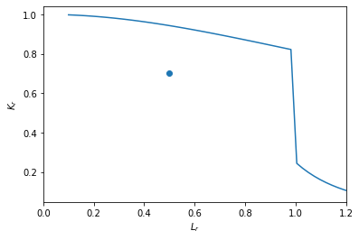

Figure 11. Discontinuity found to be fracture resistant fit-for-service

For DLAD creation it is always assumed 1) that no secondary bending stress occurs and where discontinuities lie within heat affected zones no relaxation of residual stress has occurred so that the secondary membrane stress is , and 2) that when calculating structural discontinuities and local stress concentrations are ignored.

is calculated from BS7910 equation 40 as

|  |  |
| --- | --- |
|  | (7) |

Where refers to any discontinuity values that vary with discontinuity size and is the reference stress in accordance with BS7910 Annex P, which is dependent on discontinuity type. is calculated from BS7910 equation 38 as

|  |  |
| --- | --- |
|  | (8) |

Where is the plasticity correction factor, is the stress intensity factor at the current discontinuity size due to primary loads in accordance with BS7910 Annex M, is the stress intensity factor at the current discontinuity size due to primary loads in accordance with BS7910 Annex M, and the constant is the fracture toughness taking account of any ductile tearing following initiation. is calculated (from BS7910 equation M.4) assuming no structural discontinuities or local stress concentrations as

|  |  |
| --- | --- |
|  | (9) |

Where , , , and depend on the discontinuity. is calculated (from BS7910 equation M.4 assuming no structural discontinuities or local stress concentrations as

|  |  |
| --- | --- |
|  | (10) |

The plasticity correction factor is calculated from equations R.4, R.5, R.6, R.7, and R.8 in BS7910 Annex R

|  |  |
| --- | --- |
|  | (11) |

Where it is assumed for plane stress, for , and for .

|  |  |
| --- | --- |
|  | (11) |

Where .

When many are calculated a parametric curve is produced where and . These parametric functions may not create a function over , possibly having multiple discontinuity lengths at which a certain is achieved. Finding the discontinuity parameters (for given ) at which these parametric functions intersect the option 1 FAD curve piecewise function gives the y-values in the DLAD curves.

This intersection point is found by minimizing the cost function according to region as shown in Figure 12:

|  |  |
| --- | --- |
|  | (12) |

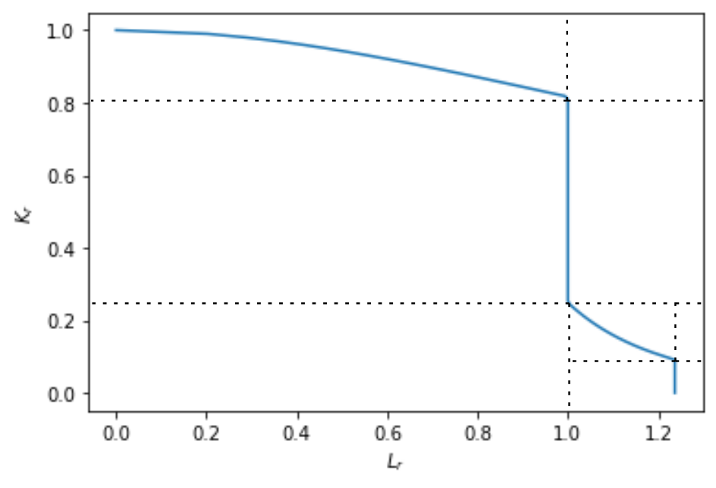

Region 7

Region 6

Region 5

Region 4

Region 3

Region 2

Region 1

Figure 12. FAD cost function regions

An example will now help to clarify this process. The same material properties as Figure 11 are used to calculate the FAD curve. The geometry and discontinuity properties edge discontinuity , , varies, and are used to calculate using equations (18) and (7) and using equations (17), (18), (8), (9), and (10). Figure 13 shows several plots. First, the discontinuity is an edge discontinuity with length as defined in Figure 18. The option 1 FAD curve is plotted as well as a sequence of parametric curves corresponding to a certain value of with varying discontinuity length . The constant ratio shows that there is only membrane loading and no bending. As this ratio becomes smaller more bending is introduced until at the loading is entirely bending with no membrane. Therefore, with the entire spectrum of loading is considered.

Follow the orange curve ( ) from the x-axis up to the FAD curve. Near the x-axis, the discontinuity length is small, and as it nears the FAD curve the discontinuity length gets larger. When the orange curve intersects the FAD curve the discontinuity length is , the maximum allowable discontinuity length for and . The resulting pair is one point in the DLAD shown in Figure 14. Figure 14 shows five examples of such intersections which generate five loading- discontinuity length pairs on Figure 14. When these pairs are connected with a line, the DLAD for bending stress is generated in Figure 14. While increasing load does reduce allowable discontinuity length, the slope is shallow so that large load allowable discontinuity lengths are not much smaller than those for small loads.

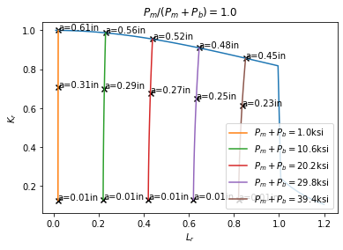

Figure 13. FAD curve in dark blue and curves for component with constant loading and varying surface flaw length in legend

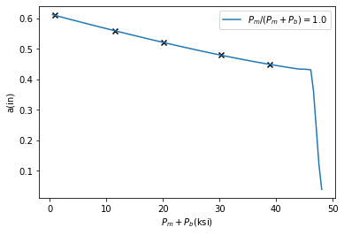

Figure 14. Example DLAD curve in dark blue, with points resulting from Figure 13 represented as black x’s.

Figure 14 covers results for bending stress in an edge discontinuity, but this can be generalized somewhat more to include the spectrum from pure bending stress () to pure membrane stress (). The resulting DLAD family is shown in Figure 16. The allowable discontinuity length lengthens as the stress profile changes to bending stress, maxing out at and then shortening slightly at pure bending.

## Examples

A number of examples intended to help cover the cases an inspector might see on a certain component are now generated. For these examples a number of common parameters are used including , ultimate stress , modulus of elasticity , , , and .

### Through-Thickness Discontinuity

The first case an inspector may see is a discontinuity through the thickness of a plate that does not lie on the edge of the plate. The through thickness discontinuity geometry is illustrated in Figure 15. This discontinuity may lie in or outside the HAZ of a weld. The through-thickness discontinuity dependent parameters are defined in BS7910 section M.3.1 as

|  |  |
| --- | --- |
| , | (13) |

|  |  |
| --- | --- |
| . | (14) |

The through-thickness discontinuity reference stress is defined from BS7910 section P.5.1 as

|  |  |
| --- | --- |
| . | (15) |

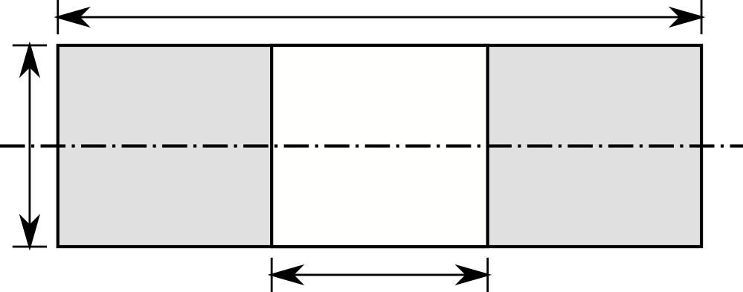

Axis for plane of bending

Figure 15. Through-thickness discontinuity definition

Solving for the intersections between the through-thickness parametric equations and the option 1 FAD produces Figure 16 for through-thickness discontinuities in a HAZ region and Figure 17 for through-thickness discontinuities outside a HAZ region.

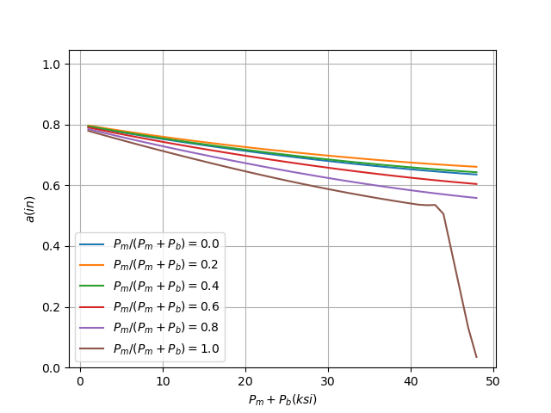

Figure 16. Through-thickness discontinuity DLAD curve family covering all loading situations. HAZ

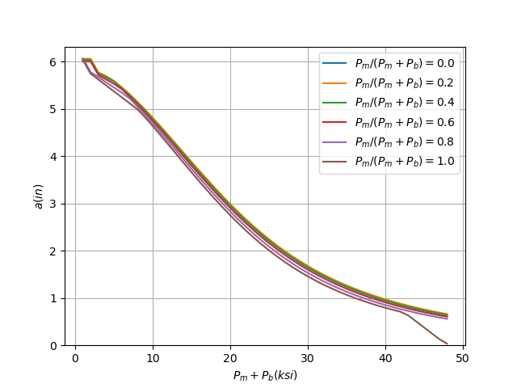

Figure 17. Through-thickness discontinuity DLAD curve family covering all loading situations. Not HAZ

### Edge discontinuity

The second case an inspector may see is a discontinuity through the thickness of a plate that lies on the edge of the plate. The edge discontinuity geometry is illustrated in Figure 18. This discontinuity may lie in or outside the HAZ of a weld. The edge discontinuity dependent parameters are defined in BS7910 section M.3.2 as

|  |  |
| --- | --- |
| , | (16) |

|  |  |
| --- | --- |
| . | (17) |

The edge discontinuity reference stress is defined in BS7910 section P.5.2 as

|  |  |
| --- | --- |
|  | (18) |

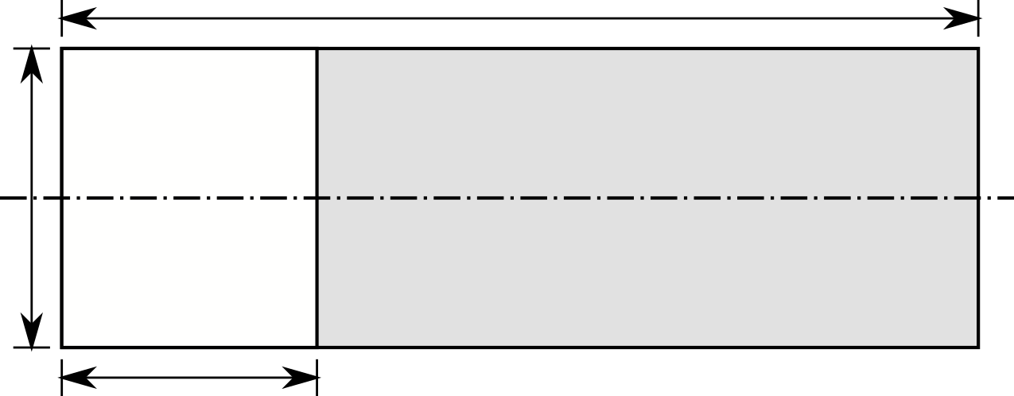

Axis for plane of bending

Figure 18. Edge discontinuity definition

Solving for the intersections between the edge parametric equations and the option 1 FAD produces Figure 19 for edge discontinuities in a HAZ region and Figure 20 for edge discontinuities outside a HAZ region.

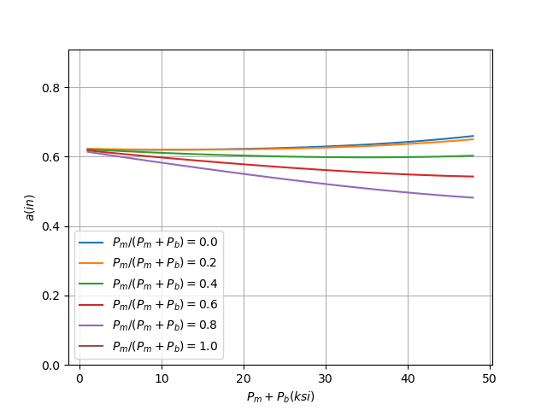

Figure 19. Edge discontinuity DLAD curve family covering all loading situations. HAZ

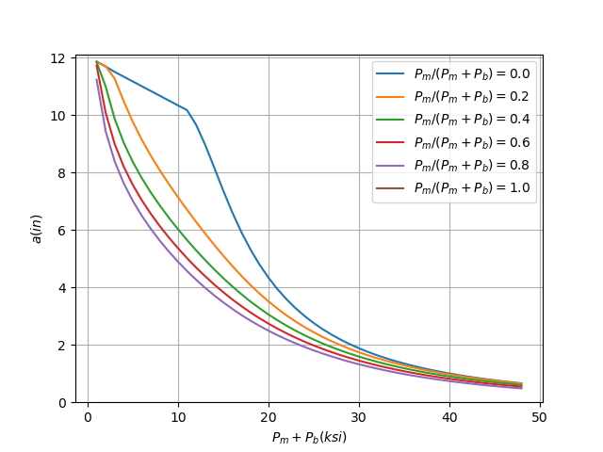

Figure 20. Edge discontinuity DLAD curve family covering all loading situations. Not HAZ

### Surface discontinuity

The second case an inspector may see is a discontinuity on the surface of a plate. The surface discontinuity geometry is illustrated in Figure 21. This discontinuity may lie in or outside the HAZ of a weld. The surface discontinuity dependent parameters are defined in BS7910 section M.4.1 as

|  |  |
| --- | --- |
| , | (19) |

|  |  |
| --- | --- |
| , | (20) |

|  |  |
| --- | --- |
| , | (21) |

Where for : , , , , , and , and for : , , , , , and . The angle can vary from to , but the maximum resulting value is used for . The bending factor is calculated as

|  |  |
| --- | --- |
| , | (22) |

Where for : , , , and , and for : , , , and . Finally the reference stress is defined in BS7910 section P.6.1 as

|  |  |
| --- | --- |
|  | (23) |

Where for and for .

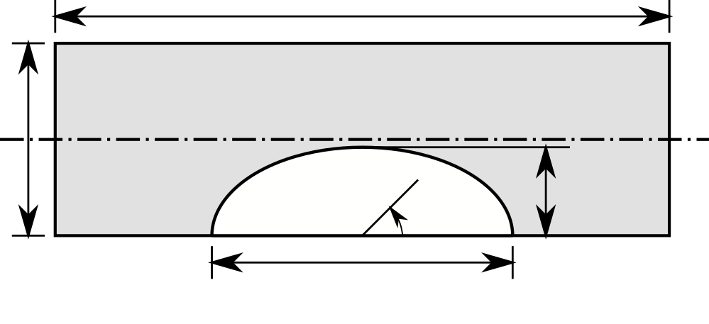

Axis for plane of bending

Figure 21. Surface discontinuity definition.

The surface discontinuity depth varies and provides further complexity to the DLAD representation. To represent several values of , we consider several values . This gives four times the number of DLAD plots for surface discontinuities as for edge discontinuities.

Solving for the intersections between the through-thickness parametric equations and the option 1 FAD produces Figure 22 for surface discontinuities in a HAZ region and , Figure 23 for surface discontinuities outside a HAZ region and , Figure 24 for surface discontinuities in a HAZ region and Figure 25 for surface discontinuities outside a HAZ region and , Figure 26 for surface discontinuities in a HAZ region and Figure 27 for surface discontinuities outside a HAZ region and , Figure 28 for surface discontinuities in a HAZ region and , and Figure 29 for surface discontinuities outside a HAZ region and .

Notice the lack of smoothness in these curves. In some situation,s such as the peaks in Figure 24, results from the switch from the solution lying in the FAD region to the solution lying in . Since the FAD chart is itself piecewise here the solution is not smooth. Other situations like the random spike in the red curve in Figure 22 results from challenges to finding the intersection between the parametric equations (not function) and the option 1 FAD curve. There may be more than one intersection of the curves, so finding the smallest intersection consistently may be challenging for the computer algorithms. Therefore, users of these charts generated from code should mentally smooth such spikes down to ensure the discontinuity lengths are conservative.

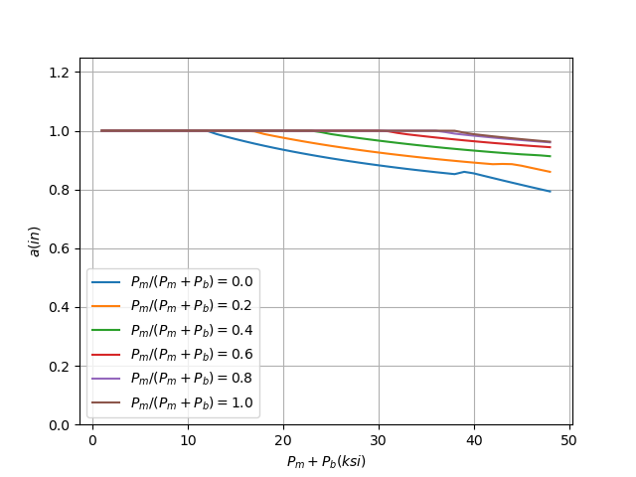**Figure 22. Surface discontinuity DLAD curve family with , covering all loading situations. HAZ**

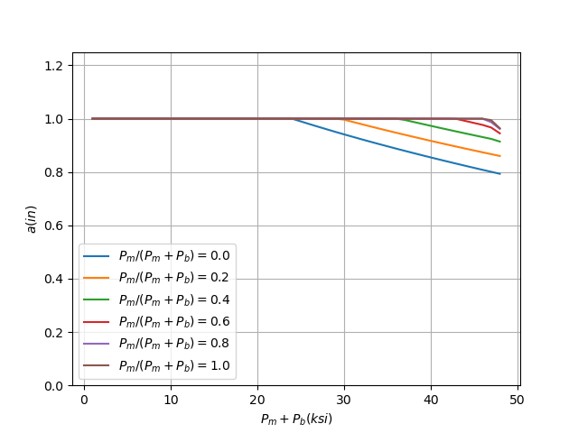

Figure 23. Surface discontinuity DLAD curve family with , covering all loading situations. Not HAZ

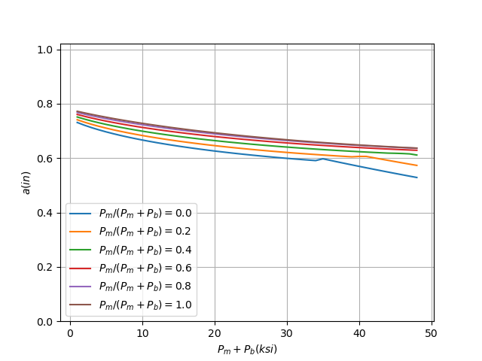

Figure 24. Surface discontinuity DLAD curve family with , covering all loading situations. HAZ

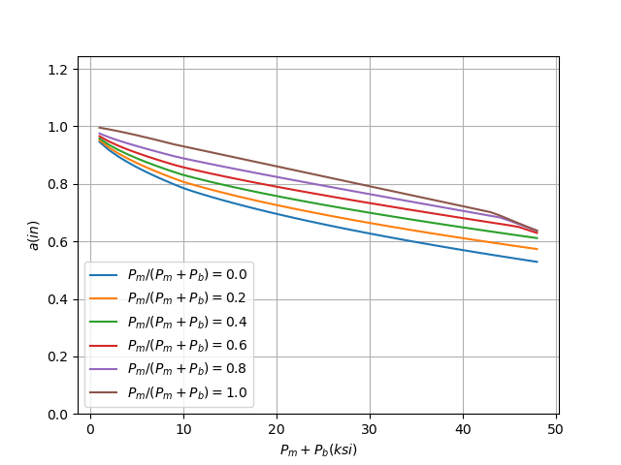

Figure 25. Surface discontinuity DLAD curve family with , covering all loading situations. Not HAZ

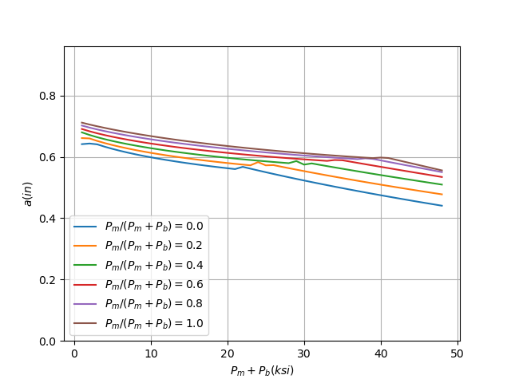

Figure 26. Surface discontinuity DLAD curve family with , covering all loading situations. HAZ

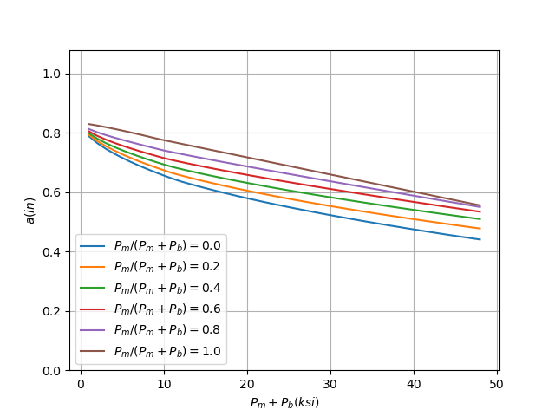

Figure 27. Surface discontinuity DLAD curve family with , covering all loading situations. Not HAZ

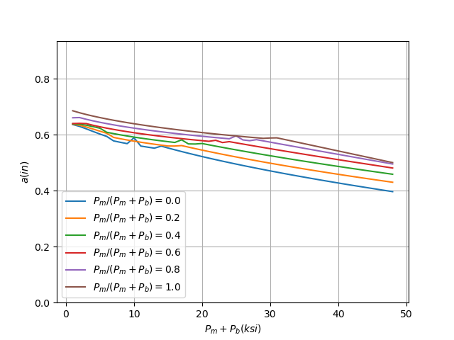

Figure 28. Surface discontinuity DLAD curve family with , covering all loading situations. HAZ

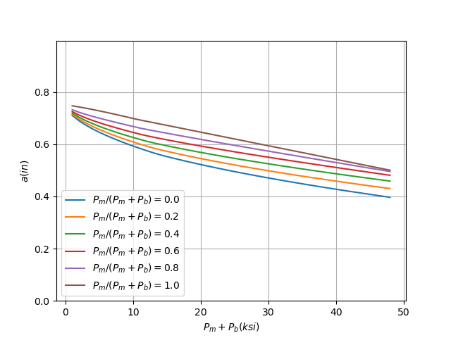

Figure 29. Surface discontinuity DLAD curve family with , covering all loading situations. Not HAZ

# Conclusions and Recommendations

body

## Conclusions

This report has proposed some procedures to improve implementation of ECA for HSS in USACE. First, a pre-ECA screening tool was developed to justify expenditure of time and money on ECA of HSS. Second, a code was developed to perform simplified ECA for fracture resistance in HSS.

## Recommendations

The pre-ECA screening tool should be tested in the field to help evaluate whether an ECA is necessary given the discovery of a discontinuity. The first practitioners will help to refine the tool to better meet the needs of USACE.

The fracture resistance screening tool should be tested in the field as the first step when evaluating fractures for FFS. The first practitioners can help make more assumptions to make the tool easier to use and create a series of permanent charts applicable to all USACE HSS.

# References

ASME/API. 2016. *API 579-1/ASME FFS -1 Fitness for Service .* Washington, D.C.: API Publishing Services.

AWS. 2010. *AWS A3.* Miami, FL: American Welding Society.

BS7910. 2013. *Guide to methods for assessing the acceptability of flaws in metallic structures.* British Standards Institution.

BSI. 1980. *BS PD6493: Guidance on Some Methods for the Derivation of Acceptance Levels for.* London: British Standards Institution.

Dexter, Robert J., Hussam Mahmoud, Joseph A. Padula, and Guillermo A. Riveros. 2007. *Fitness-for-purpose evaluation of hydraulic steel structures.* Vicksburg, MS: GSL, ERDC.

EDF Energy. 2015. "R6: Assessment of the integrity of structures containing defects." Gloucester.

GKSS. 2006. "FITNET Final Technical Report." http://www.eurofitnet.org./FITNETFinalTechnRepwithProjManagement30Jan07.pdf.

Hadley, I. 2011. "Fracture assessment methods for welded structures." In *Fracture and Fatigue of Welded Joints and Structures*, by Kenneth A. Macdonald, 60-90. Woodhead Publishing.

2003. "7.03." In *Comprehensive Structural Integrity*, by R.O. Milne, B. Ritchie and B. Karihaloo. Elsevier.

USACE. 2001. *EM: Inspection, Evaluation, and Repair of Hydraulic Steel Structures.* Washington, D.C.: Department of the Army, U.S. Army Corps of Engineers.

USACE. 2009. *ER 1110-2-8157: Engineering and Design Responsibility for Hydraulic Steel Structures.* Washington, D.C.: USACE Headquarters.

Unit Conversion Factors

| Multiply | By | To Obtain |
| --- | --- | --- |
| degrees (angle) | 0.01745329 | radians |
| feet | 0.3048 | meters |
| foot-pounds force | 1.355818 | joules |
| inches | 0.0254 | meters |
| inch-pounds (force) | 0.1129848 | newton meters |
| kilopounds (force) | 4.4482216 | kilonewtons |
| pounds (force) | 4.448222 | newtons |
| pounds (force) per foot | 14.59390 | newtons per meter |
| pounds (force) per inch | 175.1268 | newtons per meter |
| pounds (force) per square foot | 47.88026 | pascals |
| pounds (force) per square inch | 6.894757 | kilopascals |
| square feet | 0.09290304 | square meters |
| square inches | 6.4516 E-04 | square meters |
| square miles | 2.589998 E+06 | square meters |
| square yards | 0.8361274 | square meters |

EDITOR WILL INSERT SF298 REPORT DOCUMENTATION FORM BEFORE FINAL REVIEW.